Supplemental material
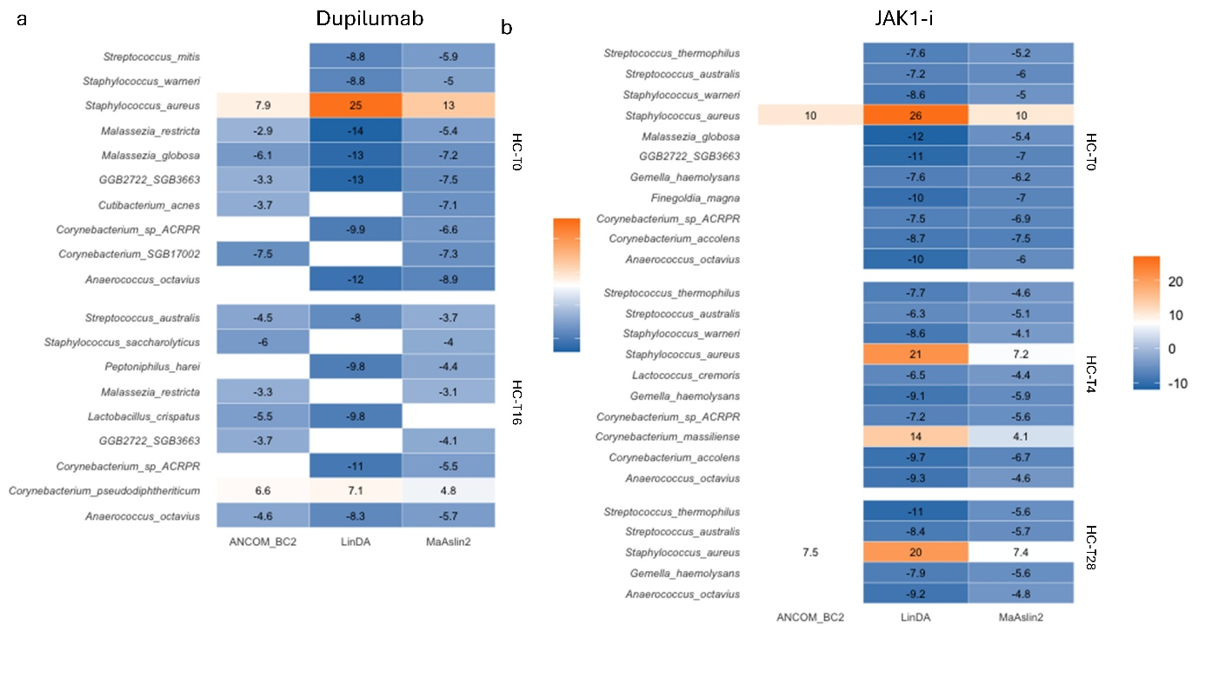
Figure S1. Log2 (fold) changes in differential abundance analysis of the lesional skin microbiome
Abbreviations: HC: healthy controls, JAK1-i: Janus kinase selective-1 inhibitor, T0: baseline, T4: 4 weeks of treatment, T16: 16 weeks of treatment, T28: 28 weeks of treatment.

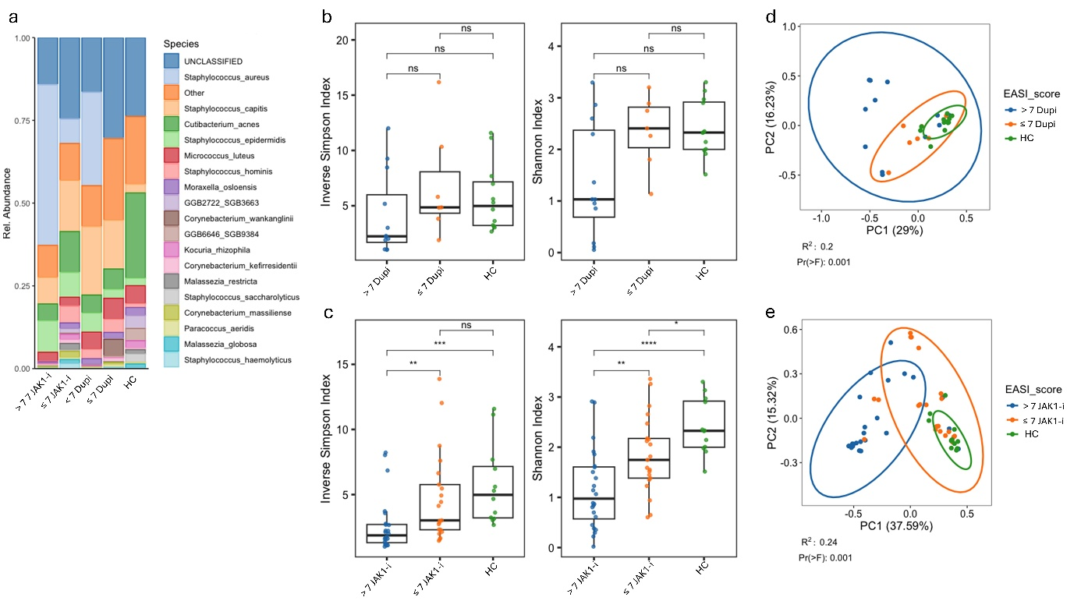
Figure S2. Microbiome changes in lesional skin, stratified by disease severity
a: Mean relative abundance top-20 most abundant species (including the ‘Other’ and ‘Unclassified’ groups). b and c: alpha diversity expressed by Inverse Simpson and Shannon diversity index. d and e: beta diversity in Bray-Curtis dissimilarity PcoA plot.
Box and whisker plot represents the mean, minimum and maximum values. Significant p-values are indicated with * (p<0.05), ** (p<0.01), *** (p<0.001), **** (p<0.0001).
Abbreviations: Dupi: dupilumab, HC: healthy controls, JAK1-i: Janus kinase selective-1 inhibitor, ns: nonsignificant, Rel.: relative, T0: baseline, T3: 4 weeks of treatment, T16: 16 weeks of treatment, T28: 28 weeks of treatment, ≤7: Eczema Area and Severity Index ≤7, >7: Eczema Area and Severity Index >7.

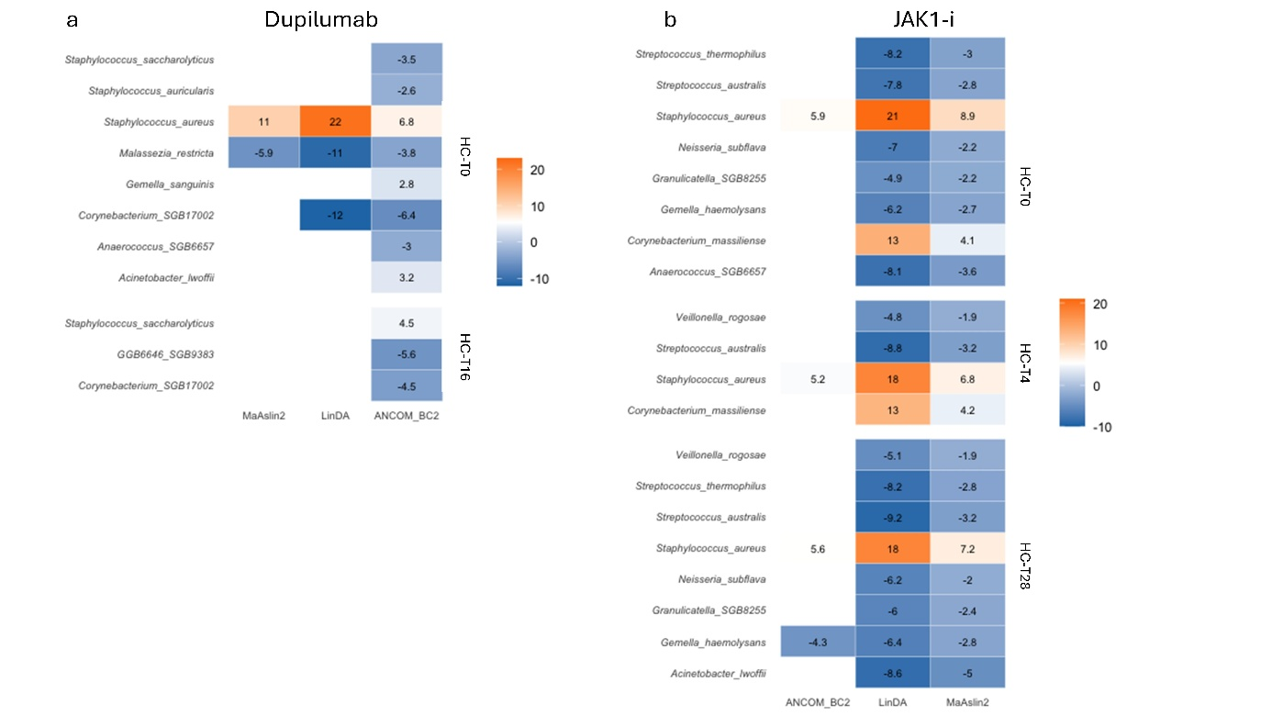
Figure S3. Log2 (fold) changes in differential abundance analysis of the lesional skin microbiome
Abbreviations: HC: healthy controls, JAK1-i: Janus kinase selective-1 inhibitor, T0: baseline, T4: 4 weeks of treatment, T16: 16 weeks of treatment, T28: 28 weeks of treatment.

