Development of a one-step semi-homogeneous fluorescent method for multi-screening of sulfonamides in milk
Su Han Wang ¹, Peng Lei Cui ², Jian Ping Wang ¹ ∗,
¹ College of Veterinary Medicine, Hebei Agricultural University, Baoding Hebei, China 071000
² College of Science, Hebei Agricultural University, Baoding Hebei, China 071000

Figure S1. Detection result of the positive milk sample by liquid chromatography tandem mass spectrometry method.
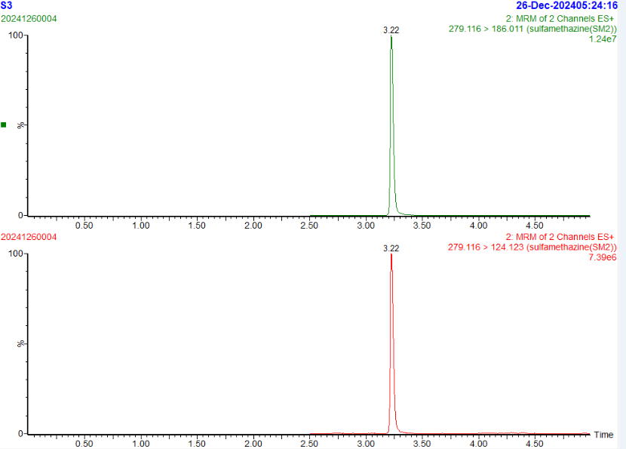
Sulfamethazine standard (12.5 ng/mL)

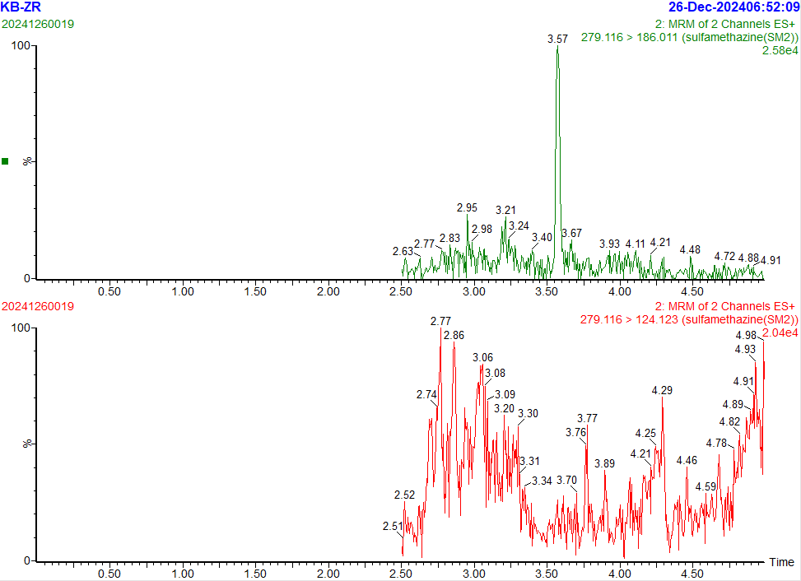
Blank milk sample
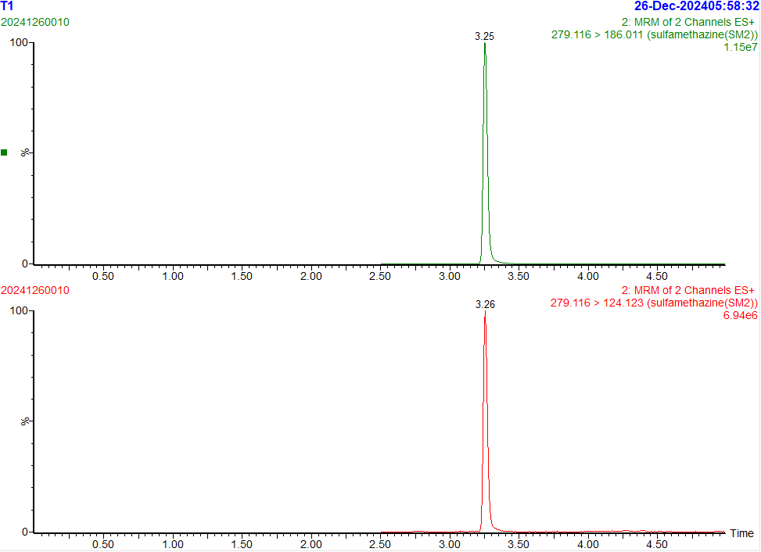
The positive milk sample containing sulfamethazine (24.4 ng/mL)

∗ Corresponding author. Jian Ping Wang, E-mail: chinawangjp@hebau.edu.cn

