From Explainable Machine Learning to Physics-Guided Design Rules for Inorganic Phosphors

Dilshod Nematov ^{a,b*}, Makhmadzoir Kayumov ^{a**}, Anushervon Ashurov ª, Amondulloi Burkhonzoda ^{a***}, Sherali Murodzoda ª, Mekhrdod Kurboniyon ^{a,b}, Ning Wen ^{c}, Jia Li^{d}, Atthar Luqman Ivansyah ^{e}, Peng Wang ^{b}, Chong-Geng Ma ^{b}, Nguyen Hai Chau ^{f}, Tomoyuki Yamamoto ^{g,h}

ª S.U. Umarov Physical-Technical Institute of NAST, Dushanbe 734063, Tajikistan
^{b} School of Optoelectronic Engineering & CQUPT-BUL Innovation Institute, Chongqing University of Posts and Telecommunications, Chongqing 400065, China
^{c} Shandong Provincial Key Laboratory of Green and Intelligent Building Materials, University of Jinan, Jinan 250022, China
^{d} College of Engineering Physics, Shenzhen Technology University, Shenzhen 518118, China
^{e} Inorganic and Physical Chemistry Research Group, Department of Chemistry, Faculty of Mathematics and Natural Sciences, Bandung Institute of Technology, Bandung, 40132, Indonesia
^{f} Faculty of Information Technology, VNU University of Engineering and Technology, Hanoi, 144, Vietnam
^{g} Kagami Memorial Research Institute for Materials Science and Technology, Waseda University, Tokyo, 169-0051, Japan
^{h} Faculty of Science and Engineering, Waseda University, Tokyo, 169-8555, Japan
Corresponding author’s E-mail: *dilnem@mail.ru (D. Nematov); ** raufovi@list.ru (M. Kayumov); ***amondullo.burkhonzoda@mail.ru (A. Burkhonzoda)

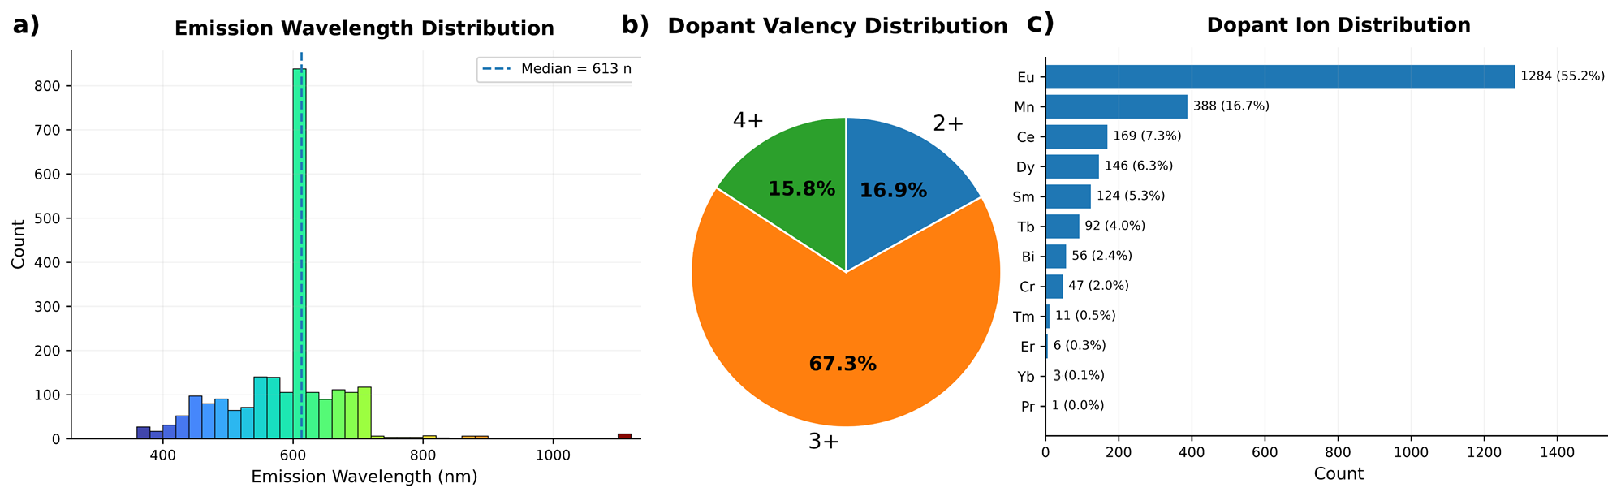
Figure S1. Statistical characteristics of the curated phosphor database: (a) distribution of emission wavelengths, (b) distribution of dopant ions, (c) publication trend of the collected phosphor studies, and (d) distribution of dopant valency.
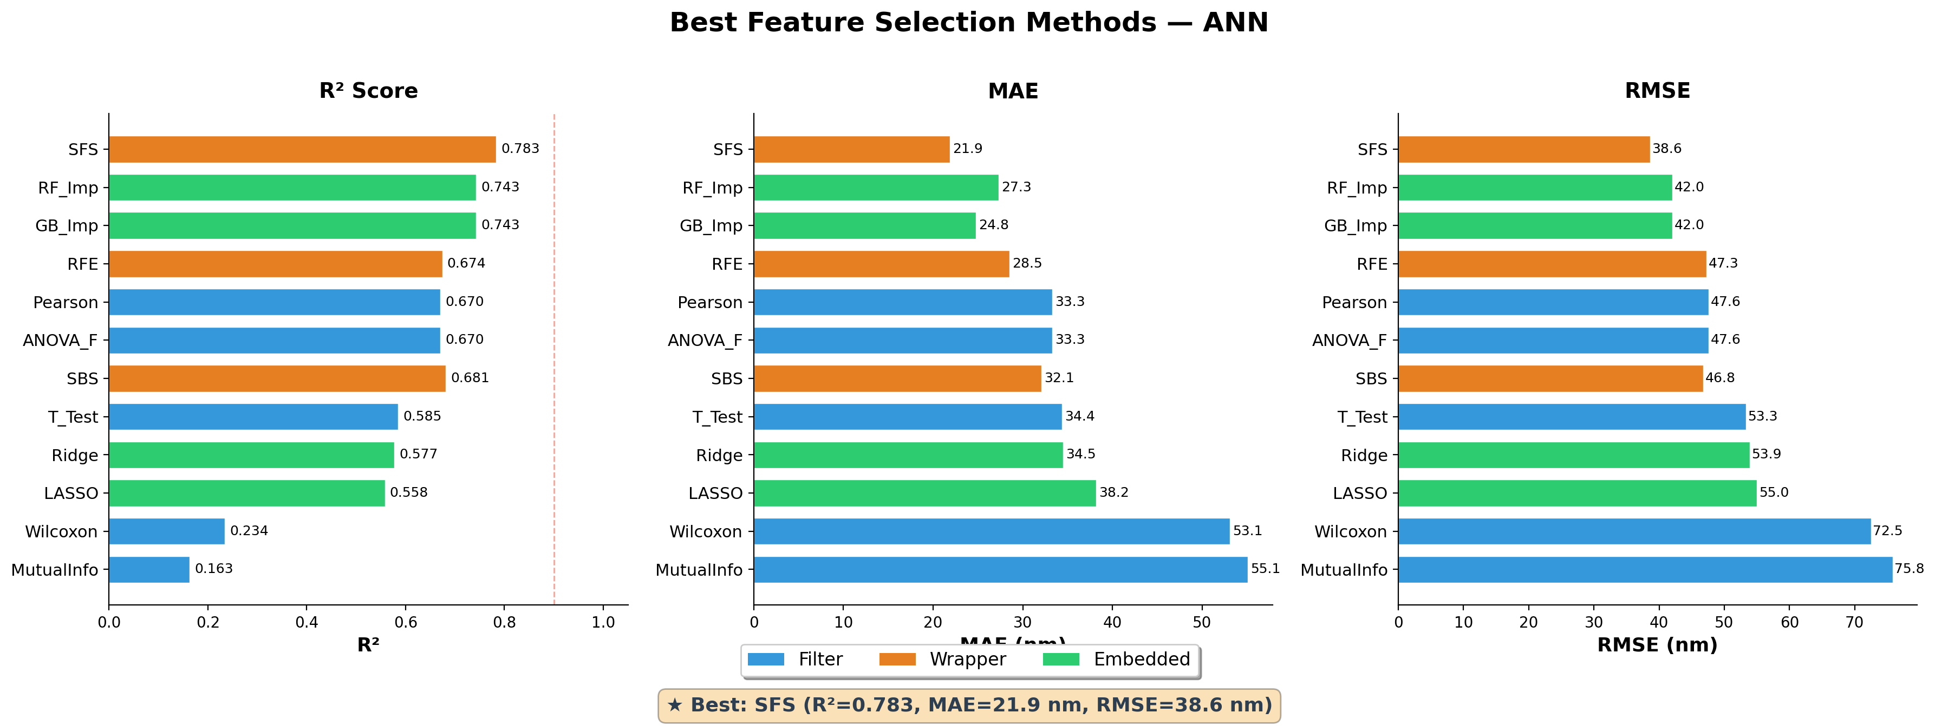
Figure S2. Preliminary comparison of feature-selection strategies obtained during the methodological development stage. These results are provided for methodological context and were not used to define the final seven-descriptor representation.

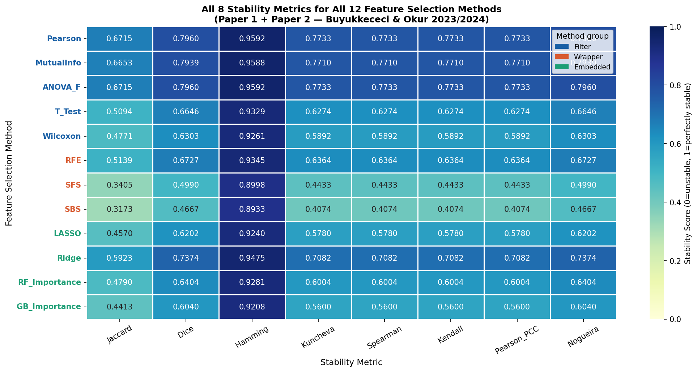
Figure S3. Stability assessment of twelve feature-selection algorithms on an independent dataset from our previous studies using eight complementary stability metrics. The stability patterns are similar across the datasets, indicating that the evaluation procedure is not strongly dependent on the dataset used.
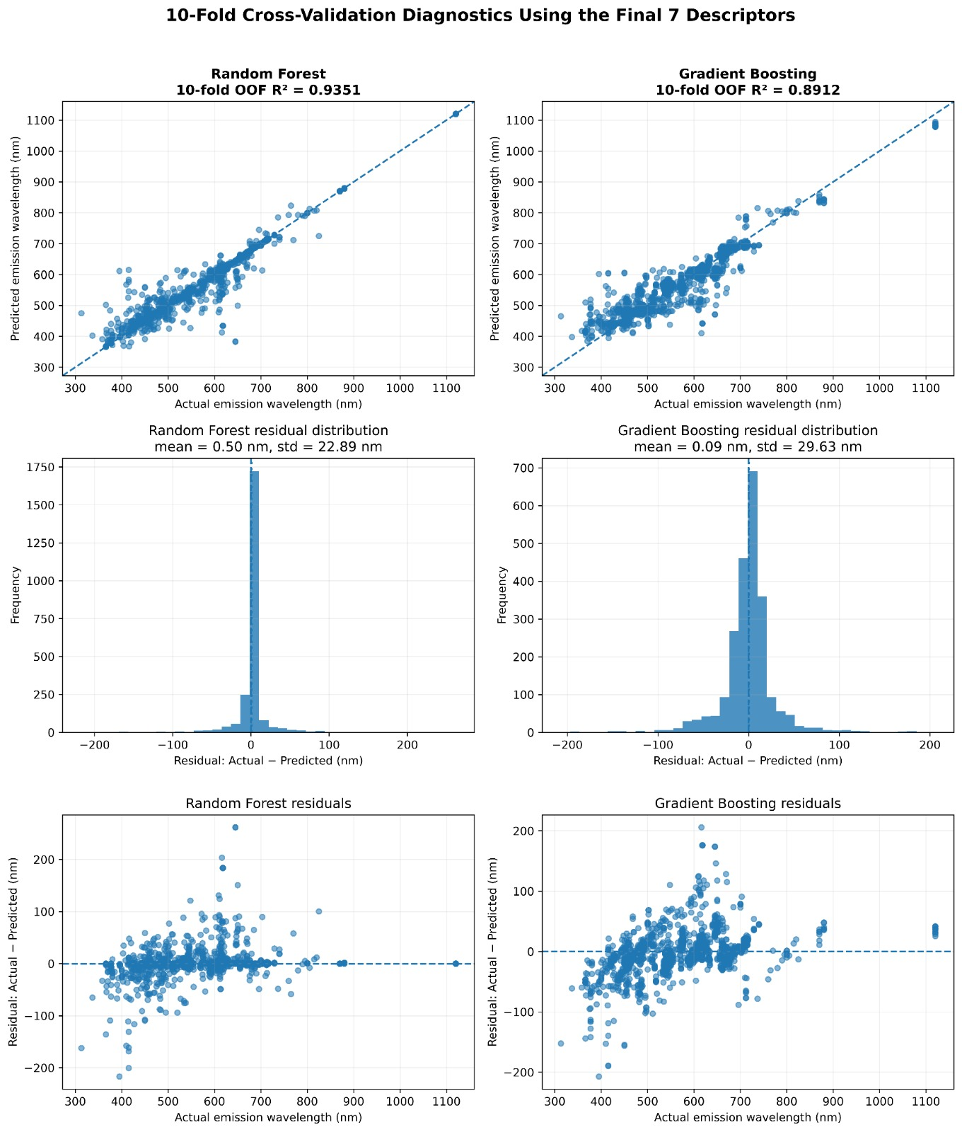
Figure S4. Prediction diagnostics of the optimized seven-descriptor RF and GB models based on pooled 10-fold cross-validation out-of-fold predictions.

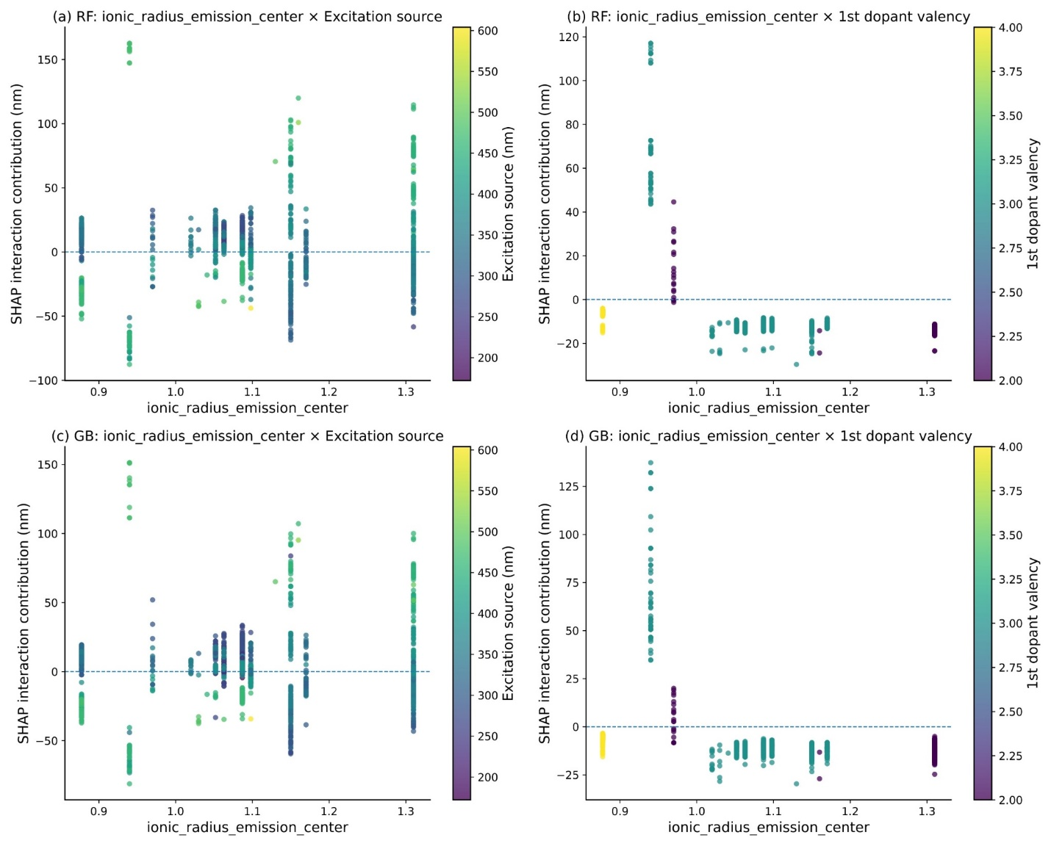
Figure S5. SHAP interaction dependence plots for the two strongest pairwise interactions in the optimized seven-descriptor RF and GB models: (a,c) ionic_radius_emission_center vs. excitation source; (b,d) ionic_radius_emission_center vs. 1st dopant valency. Vertical axis: SHAP interaction contribution (nm); color: interacting descriptor value.
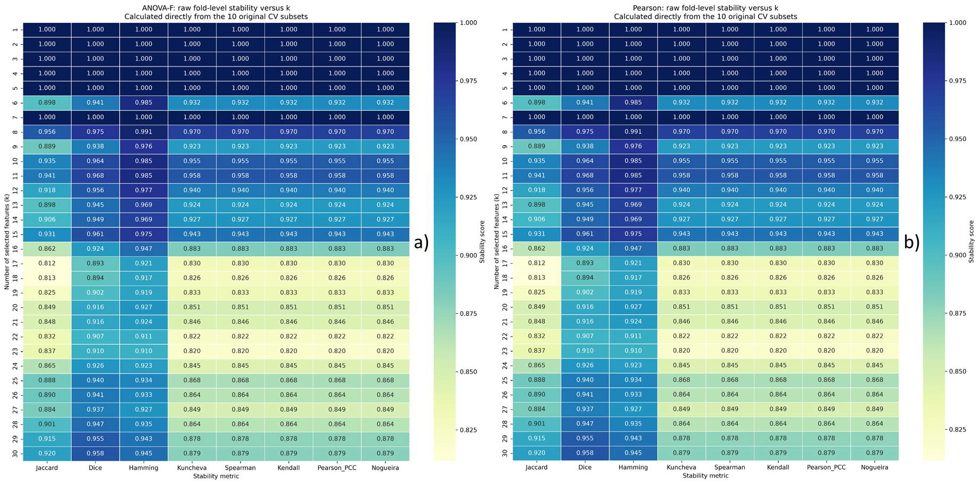
Figure S6. Stability-versus-k analysis for filter-based feature-selection methods: (a) ANOVA-F and (b) Pearson correlation
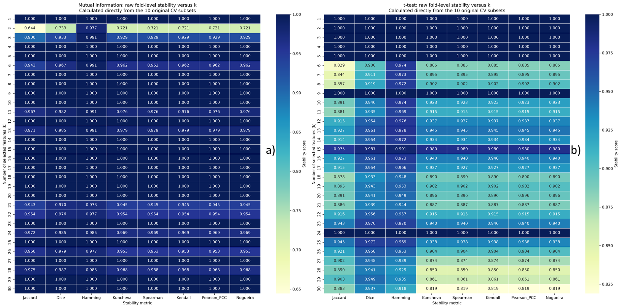
Figure S7. Stability-versus-k analysis for information-based and statistical filter methods: (a) Mutual Information and (b) t-test

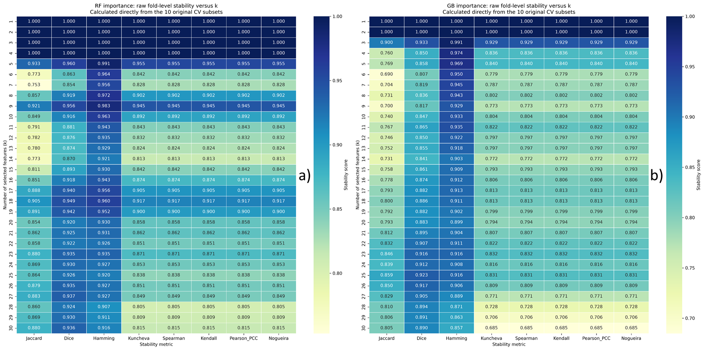
Figure S8. Stability-versus-k analysis for model-based ranking methods: (a) RF importance and (b) GB importance
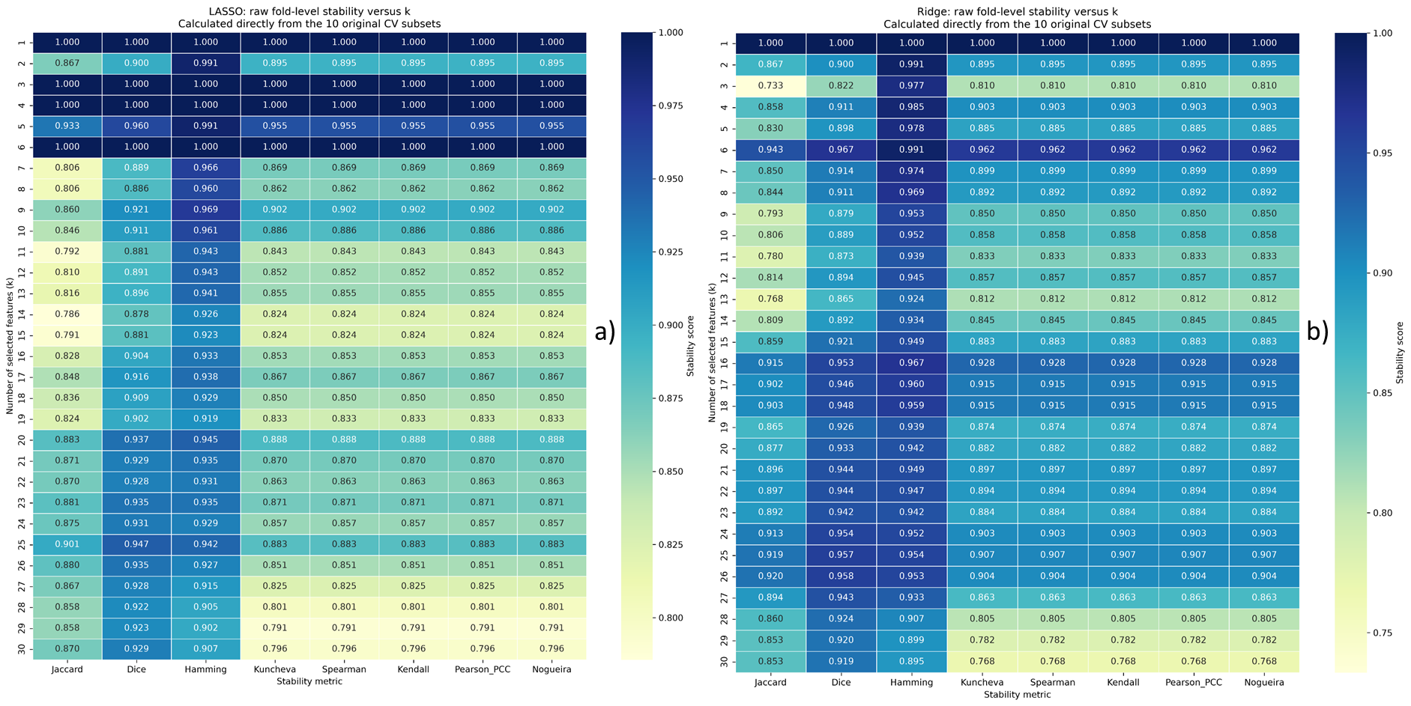
Figure S9. Stability-versus-k analysis for regularization-based feature-selection methods: (a) LASSO and (b) Ridge
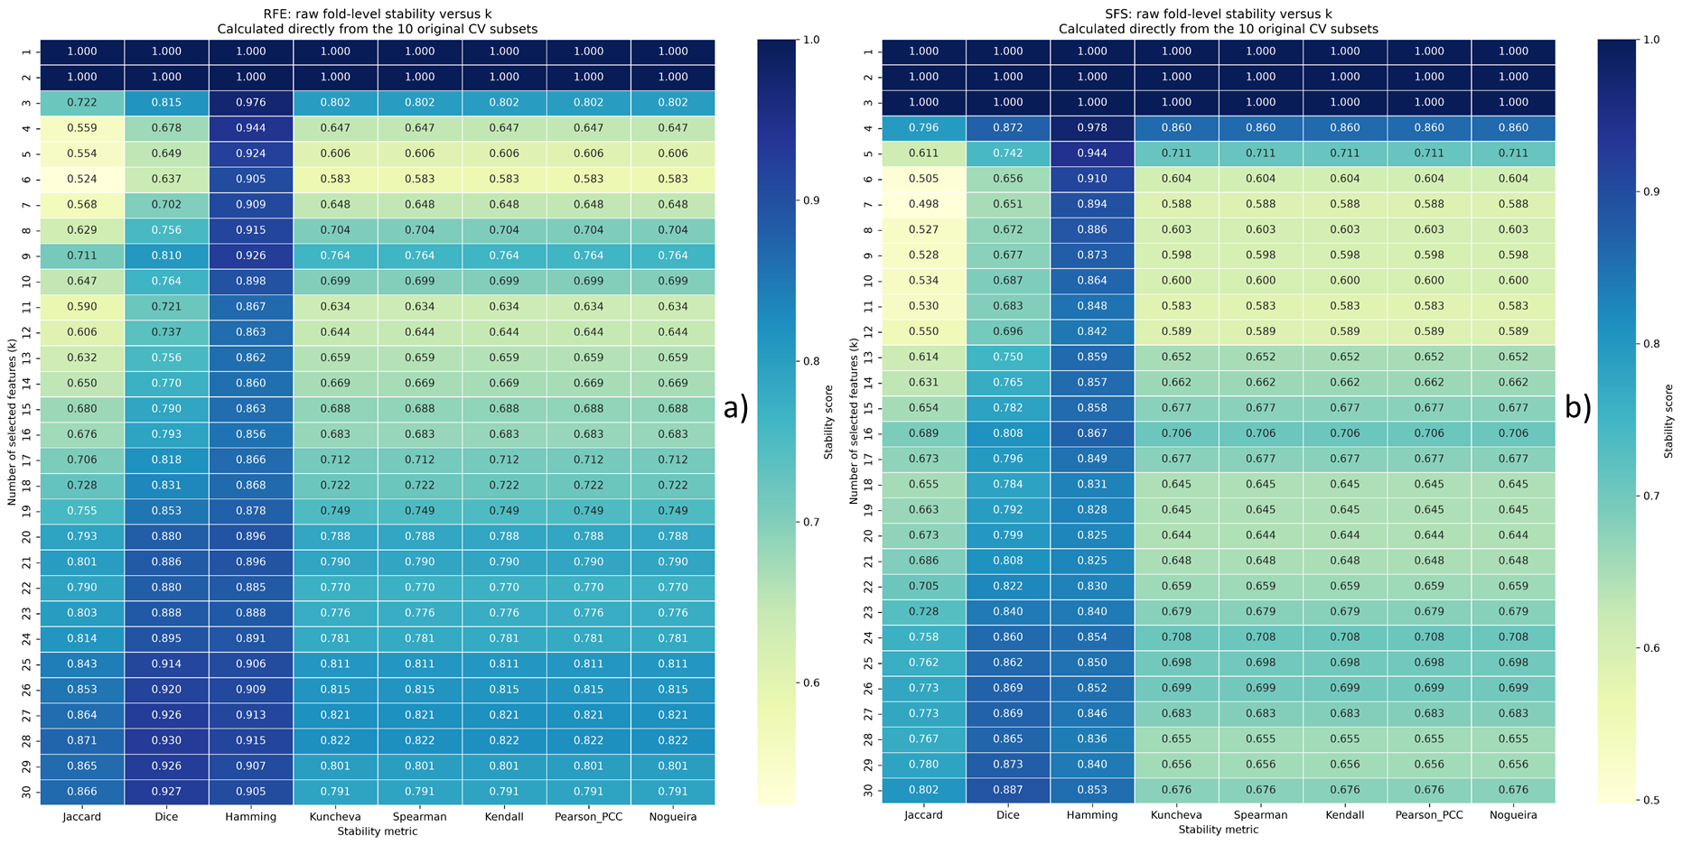
Figure S10. Stability-versus-k analysis for sequential feature-selection methods: (a) Recursive Feature Elimination (RFE) and (b) Sequential Forward Selection (SFS)

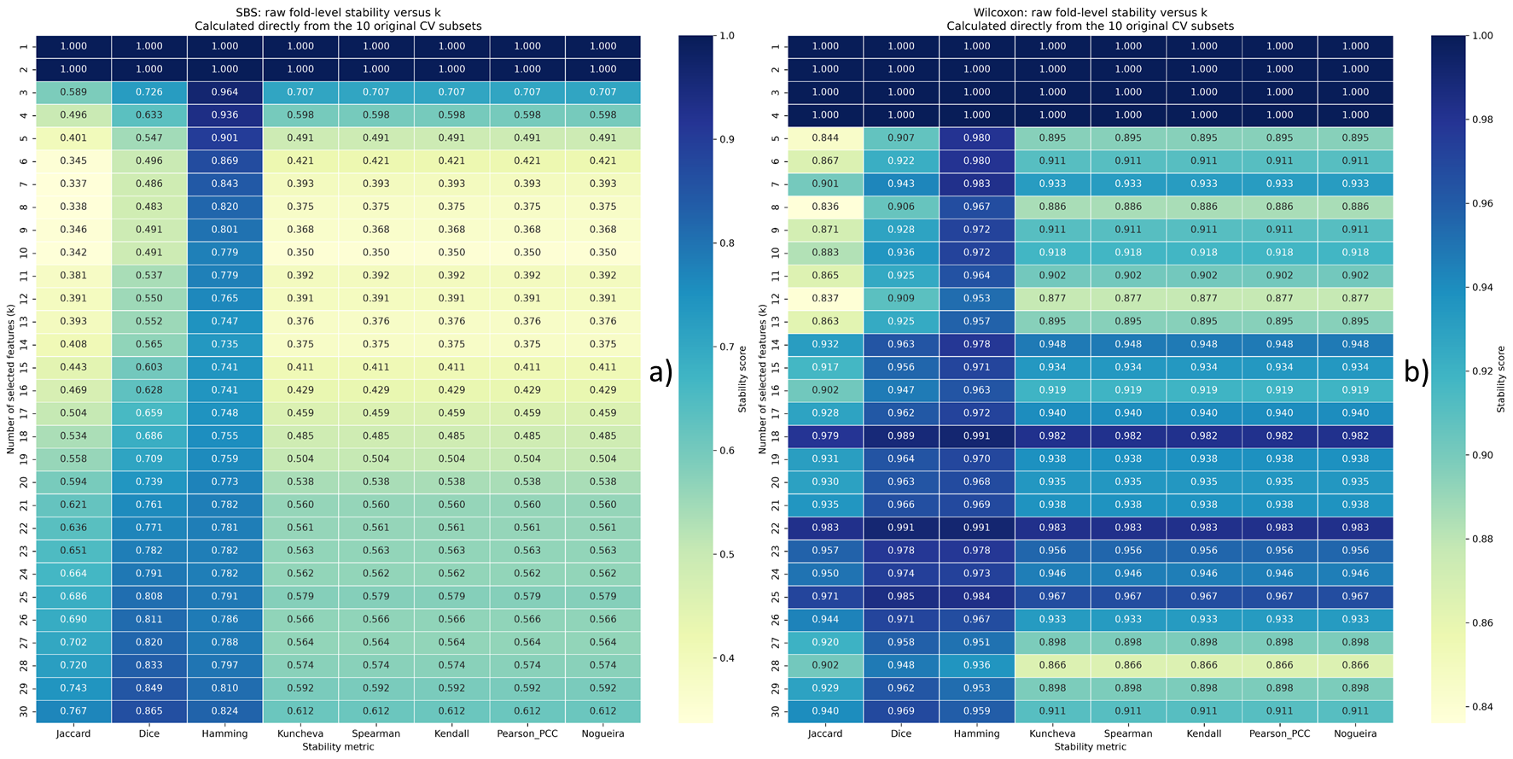
Figure S11. Stability-versus-k analysis for sequential backward search and statistical rank-based methods: (a) Sequential Backward Selection (SBS) and (b) Wilcoxon

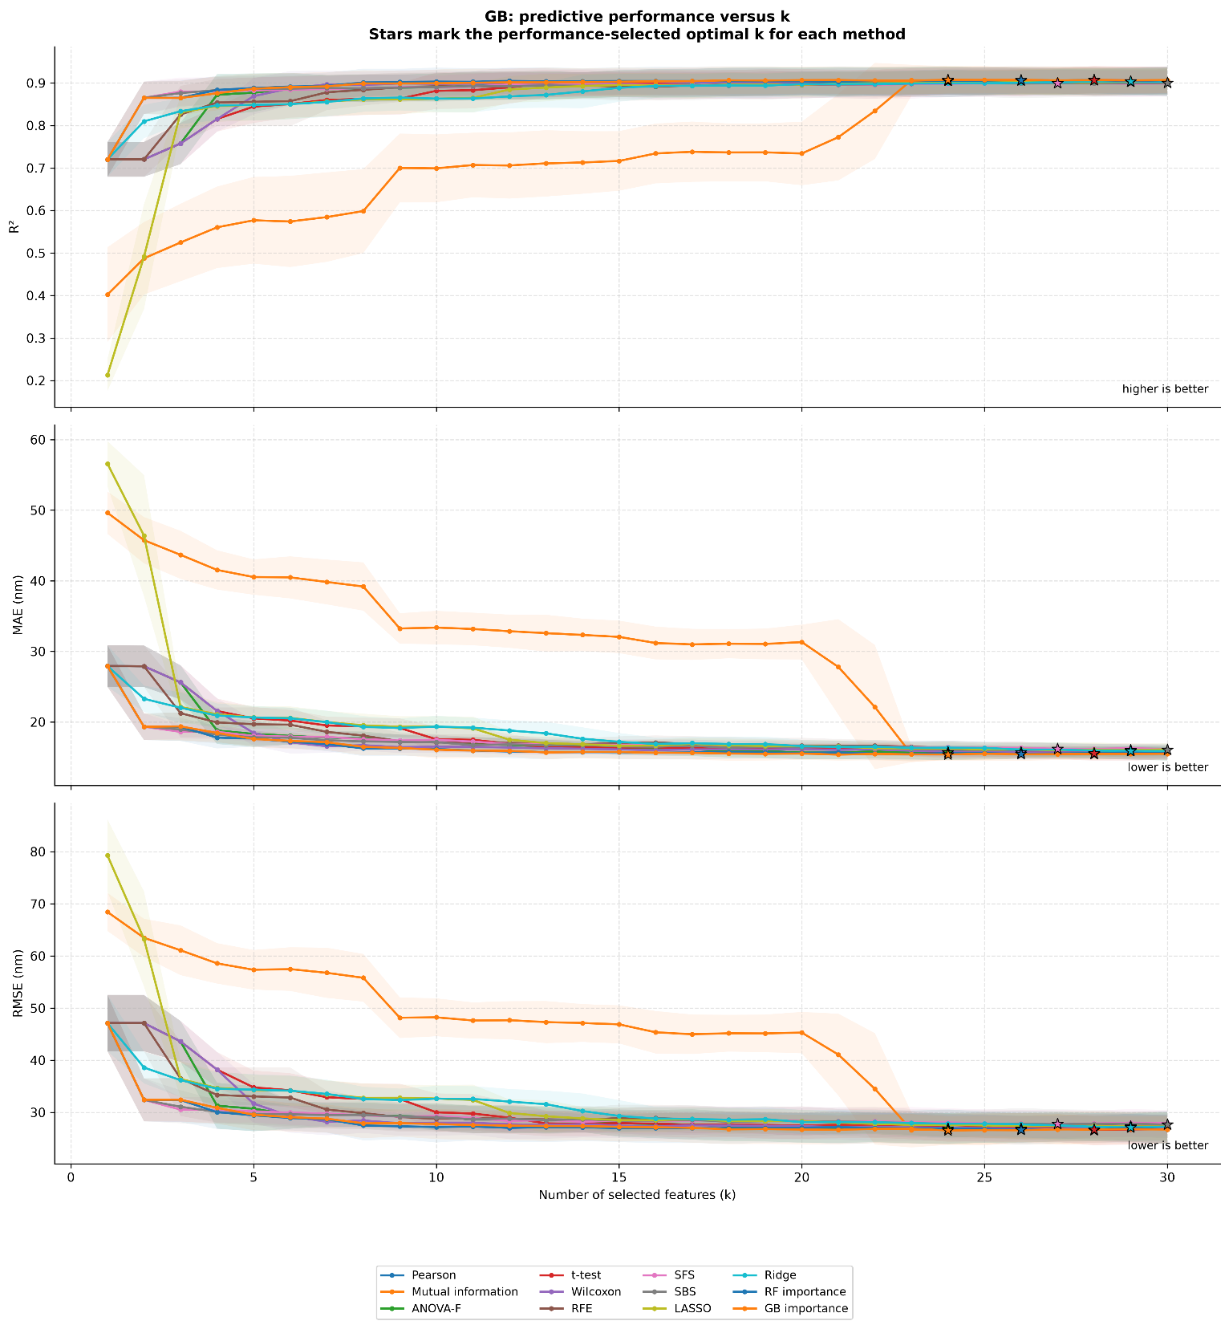
Figure S12. Predictive performance of GB models as a function of the number of selected descriptors (k).

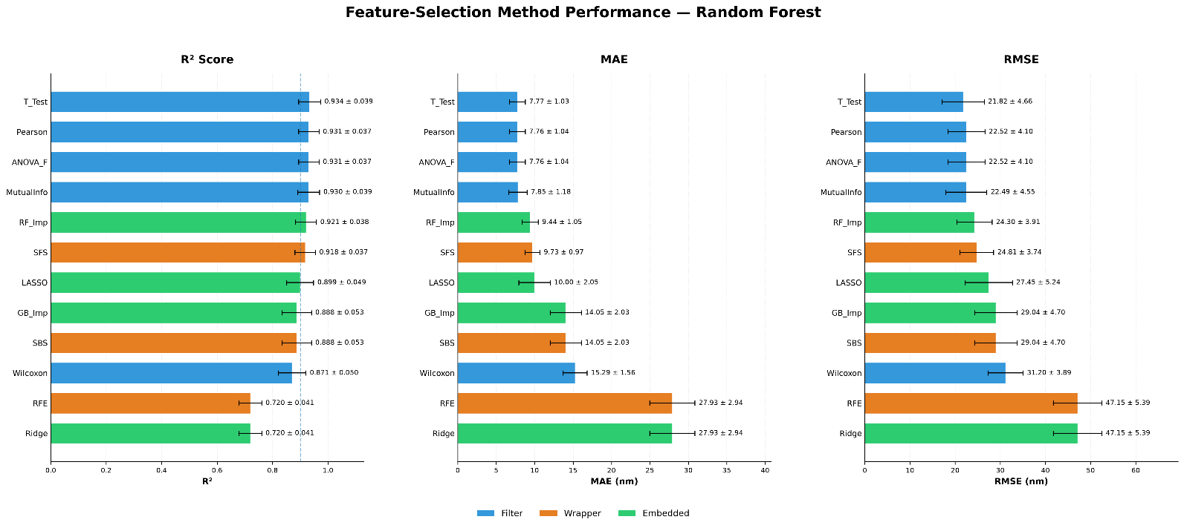
Figure S13. Comparative predictive performance of RF models obtained using the twelve feature-selection methods. Mean R², MAE, and RMSE values with corresponding standard deviations are shown across the ten folds of the 10-fold cross-validation on the training set.

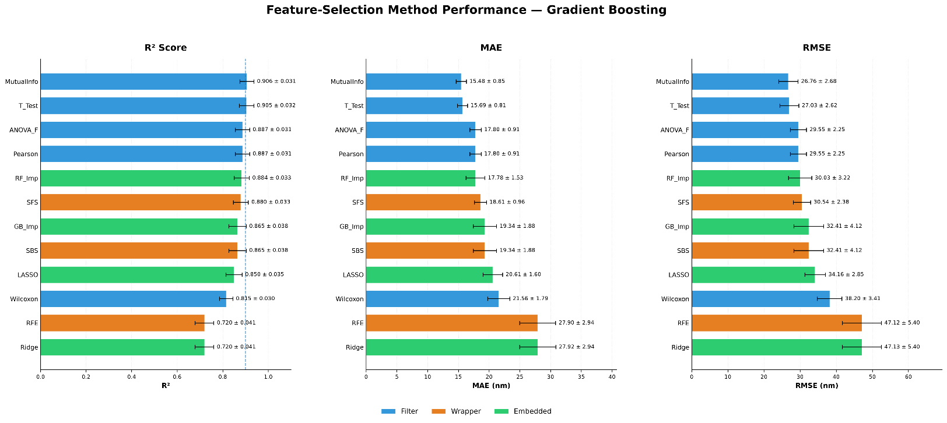
Figure S14. Comparative predictive performance of GB models obtained using the twelve feature-selection methods. Mean R², MAE, and RMSE values with corresponding standard deviations are shown across the ten folds of the 10-fold cross-validation on the training set.

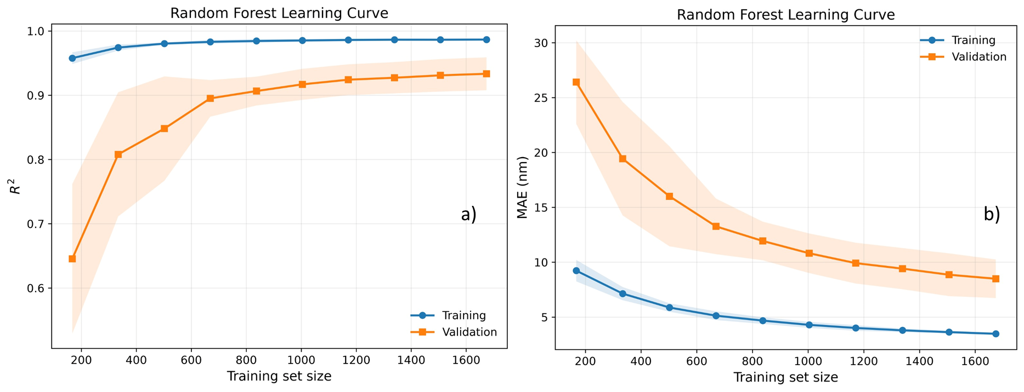
Figure S15. Learning curves of the optimized seven-descriptor Random Forest model evaluated using the training dataset with 10-fold cross-validation: (a) R² and (b) MAE as functions of training-set size. Shaded regions indicate the variability across cross-validation folds.

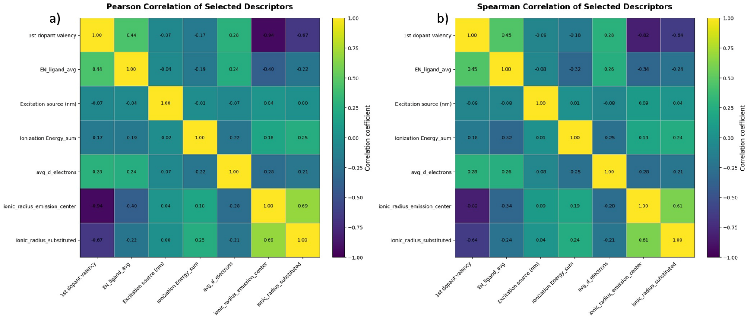
Figure S16. Pairwise correlation structure among the seven descriptors of the optimized compact RF model evaluated using (a) Pearson linear correlation coefficients and (b) Spearman rank-correlation coefficients.

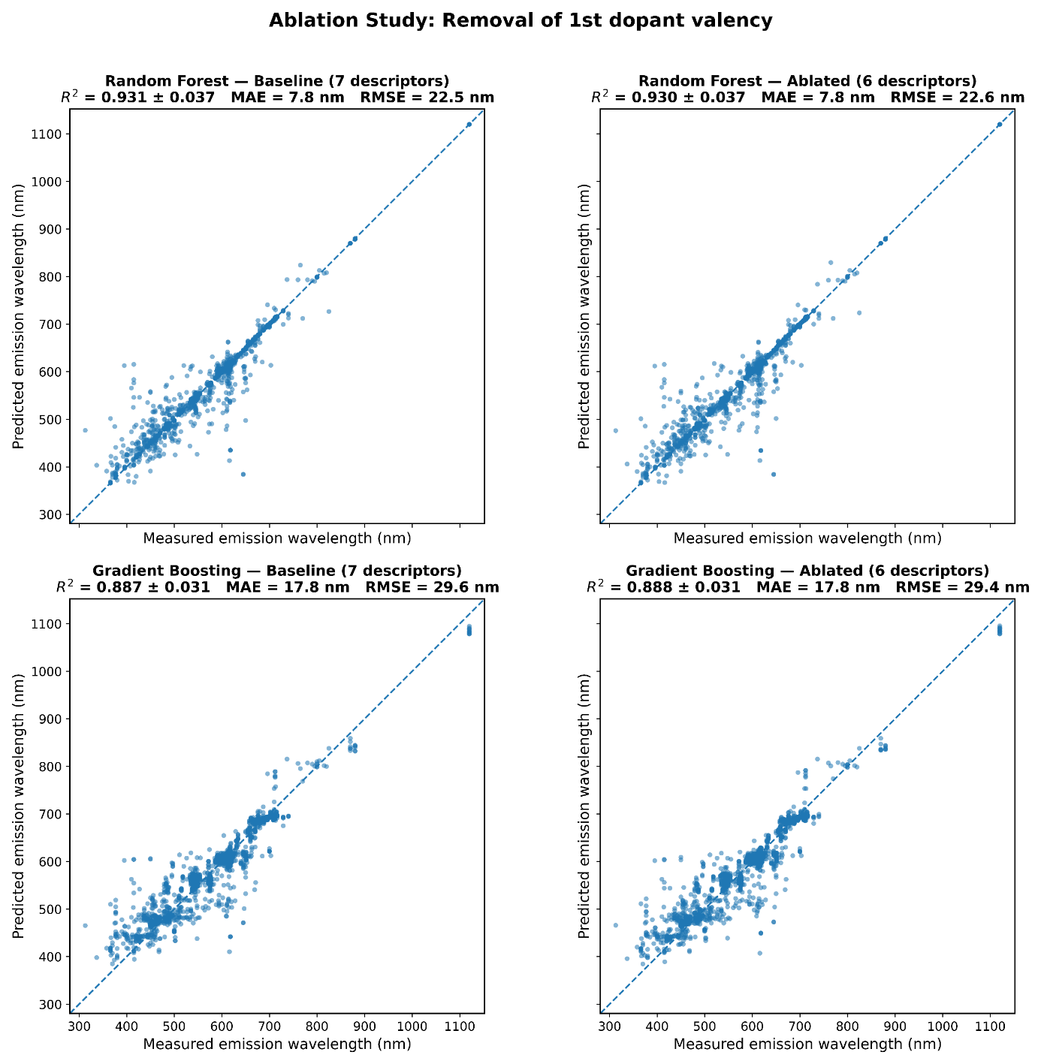
Figure S17. Ablation analysis of 1st_dopant_valency: (a) RF with 6 descriptors (excluding 1st_dopant_valency), (b) GB with 6 descriptors (excluding 1st_dopant_valency). Predicted versus measured emission wavelengths are shown for 10-fold cross-validation out-of-fold predictions. The values in parentheses indicate mean cross-validated R², MAE, and RMSE across folds.

Table S1. Final hyperparameters used for the optimized RF and GB models in the seven-descriptor representation.
HYPERPARAMETER | RF | GB
n_estimators | 100 | 100
random_state | 42 | 42
criterion | squared_error | friedman_mse
max_depth | None | 3
learning_rate | - | 0.10
subsample | - | 1.0
min_samples_split | 2 | 2
min_samples_leaf | 1 | 1
min_weight_fraction_leaf | 0.0 | 0.0
max_features | 1.0 | None
max_leaf_nodes | None | None
min_impurity_decrease | 0.0 | 0.0
bootstrap | True | -
oob_score | False | -
max_samples | None | -
validation_fraction | - | 0.10
n_iter_no_change | - | None
tol | - | 1×10⁻⁴
ccp_alpha | 0.0 | 0.0
warm_start | False | False
verbose | 0 | 0
n_jobs | −1 | -

Table S2. Optimal performance-selected descriptor number, mean 10-fold cross-validated predictive performance, and fold-level stability of the RF models obtained with different feature-selection algorithms.
METHOD | k | R² | MAE  (nm) | RMSE (nm) | Stability | 10/10
ANOVA-F | 25 | 0.934 | 7.59 | 22.03 | 0.887 | No
GB importance | 24 | 0.934 | 7.60 | 21.75 | 0.843 | No
LASSO | 30 | 0.930 | 7.85 | 22.52 | 0.835 | No
Mutual information | 27 | 0.930 | 7.85 | 22.49 | 1.000 | Yes
Pearson | 25 | 0.934 | 7.59 | 22.03 | 0.887 | No
RFE | 13 | 0.929 | 8.00 | 22.89 | 0.693 | No
RF importance | 16 | 0.934 | 7.70 | 21.75 | 0.885 | No
Ridge | 30 | 0.932 | 7.96 | 22.81 | 0.813 | No
SBS | 23 | 0.933 | 7.96 | 22.11 | 0.690 | No
SFS | 20 | 0.934 | 8.01 | 21.77 | 0.725 | No
t-test | 20 | 0.934 | 7.80 | 21.80 | 0.908 | No
Wilcoxon | 16 | 0.932 | 7.74 | 22.27 | 0.926 | No

Table S3. Optimal performance-selected descriptor number, mean 10-fold cross-validated predictive performance, and fold-level stability of the GB models obtained with different feature-selection algorithms.
METHOD | k | R² | MAE (nm) | RMSE (nm) | Stability | 10/10
ANOVA-F | 24 | 0.905 | 15.68 | 26.90 | 0.867 | No
GB importance | 24 | 0.907 | 15.41 | 26.55 | 0.843 | No
LASSO | 29 | 0.903 | 16.03 | 27.30 | 0.830 | No
Mutual information | 28 | 0.907 | 15.47 | 26.62 | 0.973 | No
Pearson | 24 | 0.905 | 15.68 | 26.90 | 0.867 | No
RFE | 29 | 0.903 | 15.88 | 27.30 | 0.838 | No
RF importance | 26 | 0.907 | 15.47 | 26.64 | 0.874 | No
Ridge | 29 | 0.904 | 15.90 | 27.14 | 0.823 | No
SBS | 30 | 0.900 | 16.07 | 27.68 | 0.690 | No
SFS | 27 | 0.900 | 16.20 | 27.79 | 0.738 | No
t-test | 28 | 0.906 | 15.57 | 26.69 | 0.876 | No
Wilcoxon | 26 | 0.906 | 15.69 | 26.90 | 0.944 | No

Table S4. Optimal fully reproducible (10/10) descriptor subsets for RF. Only subsets reproduced identically across all ten cross-validation folds were retained; for each feature-selection method, the fully stable subset with the highest mean cross-validated R² is reported.
METHOD | k | R² | MAE | RMSE | Stability | 10/10
ANOVA_F | 7 | 0.9308 | 7.7805 | 22.5479 | 1.000 | Yes
GB Importance | 2 | 0.8860 | 14.0501 | 29.0363 | 1.000 | Yes
LASSO | 6 | 0.9002 | 9.9750 | 27.3743 | 1.000 | Yes
Mutual information | 27 | 0.9305 | 7.8475 | 22.4921 | 1.000 | Yes
Pearson | 7 | 0.9308 | 7.7805 | 22.5479 | 1.000 | Yes
RFE | 2 | 0.7206 | 27.9302 | 47.1470 | 1.000 | Yes
RF Importance | 4 | 0.9207 | 9.4287 | 24.3105 | 1.000 | Yes
Ridge | 1 | 0.7199 | 27.9301 | 47.1466 | 1.000 | Yes
SBS | 2 | 0.8876 | 14.0501 | 29.0363 | 1.000 | Yes
SFS | 3 | 0.9179 | 9.7310 | 24.8099 | 1.000 | Yes
t test | 24 | 0.9339 | 7.7706 | 21.8122 | 1.000 | Yes
Wilcoxon | 4 | 0.8708 | 15.2866 | 31.2018 | 1.000 | Yes
Selection rule: only rows with Fully_identical_10_of_10 = True were retained. For each feature-selection method and regressor, the fully stable subset with the highest mean cross-validated R² was selected for this summary. All retained subsets therefore have a stability score of 1.000nm and complete 10/10 reproducibility.

Table S5. Optimal fully reproducible (10/10) descriptor subsets for GB. Only subsets reproduced identically across all ten cross-validation folds were retained; for each feature-selection method, the fully stable subset with the highest mean cross-validated R² is reported.
METHOD | k | R² | MAE | RMSE | Stability | 10/10
ANOVA_F | 7 | 0.8872 | 17.7962 | 29.5544 | 1.000 | Yes
GB Importance | 2 | 0.8651 | 19.3384 | 32.4091 | 1.000 | Yes
LASSO | 6 | 0.8503 | 20.5862 | 34.1568 | 1.000 | Yes
Mutual Information | 30 | 0.9065 | 15.4752 | 26.7593 | 1.000 | Yes
Pearson | 7 | 0.8872 | 17.7962 | 29.5544 | 1.000 | Yes
RFE | 2 | 0.7203 | 27.9007 | 47.1216 | 1.000 | Yes
RF Importance | 4 | 0.8837 | 17.7903 | 30.0488 | 1.000 | Yes
Ridge | 1 | 0.7202 | 27.9216 | 47.1265 | 1.000 | Yes
SBS | 2 | 0.8651 | 19.3384 | 32.4091 | 1.000 | Yes
SFS | 3 | 0.8797 | 18.6081 | 30.5403 | 1.000 | Yes
T Test | 24 | 0.9044 | 15.7076 | 27.0592 | 1.000 | Yes
Wilcoxon | 4 | 0.8152 | 21.5604 | 38.1952 | 1.000 | Yes
Selection rule: only rows with Fully_identical_10_of_10 = True were retained. For each feature-selection method and regressor, the fully stable subset with the highest mean cross-validated R² was selected for this summary. All retained subsets therefore have a stability score of 1.000 and complete 10/10 reproducibility.

Table S6. Fold-level reproducibility of the seven-descriptor subset identified using Pearson correlation and ANOVA-F criteria.
METHOD | k | Folds | Selected descriptor set | Reproducibility
Pearson | 7 | 1–10 | ionic_radius_emission_center, excitation_source, 1st_dopant_valency, ionic_radius_substituted, avg_d_electrons, EN_ligand_avg, ionization_energy_sum | 10/10
ANOVA-F | 7 | 1–10 | ionic_radius_emission_center, excitation_source, 1st_dopant_valency, ionic_radius_substituted, avg_d_electrons, EN_ligand_avg, ionization_energy_sum | 10/10

