Supplementary Materials for

Multi-year El Niño events tied to the North Pacific Oscillation

This PDF file includes:
Supplementary Table 1. Observed multi-year El Niño/La Niña events for the period 1950−2020.
Supplementary Table 2. Observed single-year El Niño events for the period 1950−2020.
Supplementary Table 3. Description of the selected 29 models from the CMIP5/6 archives.
Supplementary Figure 1. Time series of the Niño3.4 index (°C) for the period 1950–2020.
Supplementary Figure 2. Forecasts of the Niño3.4 index respectively from February 2014 and February 2015 by operational forecasting models compiled at the IRI/CPC (International Research Institute for Climate and Society/Climate Prediction Center).
Supplementary Figure 3. The JFM(0) SLP anomalies prior to multi-year El Niño events in observations.
Supplementary Figure 4. The JFM(0) SST anomalies prior to multi-year El Niño events in observations.
Supplementary Figure 5. Lead‐lag correlations of the JFM(0) NPO index (blue line; scale on the right y axis) with 3‐month‐averaged Niño3.4 index.
Supplementary Figure 6. Regression with respect to the JFM(0) NPO index.
Supplementary Figure 7. Evolutions of SST anomalies for multi-year El Niño events.
Supplementary Figure 8. The atmospheric teleconnections of the CP and EP ENSO.
Supplementary Figure 9. Relationships among the NPO, SLP_{HI}, and PMM indices.
Supplementary Figure 10. Evolutions of SST and SLP anomalies composited for multi-year El Niño events from JFM(0) to JFM(2) derived from different SST and SLP datasets.
Supplementary Figure 11. JFM(1) SST and SLP anomalies of individual multi-year El Niño events.
Supplementary Figure 12. Evolutions of SST and SLP anomalies composited for the NPO-preceded single-year El Niño events in observations.
Supplementary Figure 13. Composite structures of JFM(1) SST anomalies for the NPO-preceded and non-NPO-preceded CP El Niño events.
Supplementary Figure 14. Evolutions of SST and SLP anomalies composited for the observed CP El Niño events without the preceding NPO in observations.
Supplementary Figure 15. Effects of the NPO on the frequency ratio of multi-year El Niño/La Niña events in the CMIP5/6 models.
Supplementary Figure 16. Evolutions of SST and SLP anomalies composited for the NPO-preceded multi-year El Niño events in the CMIP5/6 models.
Supplementary Figure 17. The imposed NPO forcing in numerical experiments.
Supplementary Figure 18. The JFM(0) SST anomalies prior to multi-year La Niña events in observations.
Supplementary Figure 19. The JFM(0) SLP anomalies prior to multi-year La Niña events in observations.
Supplementary Figure 20. Evolutions of multi-year La Niña events preceded by the negative NPO event alone in the CMIP5/6 models.

Supplementary Table 1. Observed multi-year El Niño/La Niña events for the period 1950−2020.

Multi-year El Niño events (5) | Multi-year La Niña event (7)
1957/58/59, 1968/69/70, 1986/87/88, 2014/15/16, 2018/19/20 | 1954/55/56, 1970/71/72, 1973/74/75, 1983/84/85, 1998/99/2000, 2007/08/09, 2010/11/12

Supplementary Table 2. Observed single-year El Niño/La Niña events for the period 1950−2020.

Single-year El Niño events (14) | Single-year La Niña event (6)
1951/52, 1963/64, 1965/66, 1972/73, 1976/77, 1977/78, 1982/83, 1991/92, 1994/95, 1997/98, 2002/03, 2004/05, 2006/07, 2009/10 | 1950/51, 1964/65, 1988/89, 1995/96, 2017/18, 2020/21

Supplementary Table 3. Description of the selected 29 models from the CMIP5/6 archives. The 23 CMIP5/6 models whose RCP4.5 and RCP8.5 simulations are available are indicated by the asterisk.

Archive | Model Number | Model name | Model center
CMIP5 | 1 | ACCESS1-3* | CSIRO-BOM/Australia
CMIP5 | 2 | CMCC-CM* | CMCC/Italy
CMIP5 | 3 | CESM1-CAM5* | NSF-DOE-NCAR/United States
CMIP5 | 4 | CMCC-CMS* | CMCC/Italy
CMIP5 | 5 | CNRM-CM5* | CNRM-CERFACS/France
CMIP5 | 6 | FGOALS-g2* | LASG-IAP/China
CMIP5 | 7 | GFDL-CM3* | NOAA-GFDL/USA
CMIP5 | 8 | GISS-E2-H* | NASA-GISS/USA
CMIP5 | 9 | GISS-E2-R-CC* | NASA-GISS/USA
CMIP5 | 10 | GISS-E2-R* | NASA-GISS/USA
CMIP5 | 11 | IPSL-CM5B-LR* | IPSL/France
CMIP5 | 12 | IPSL-CM5A-MR* | IPSL/France
CMIP5 | 13 | MPI-ESM-MR* | MPI-M/Germany
CMIP6 | 14 | ACCESS-ESM1_5* | CSIRO-ARCCSS/Australia
CMIP6 | 15 | AWI_CM_1_1_LR | AWI/Germany
CMIP6 | 16 | BCC_ESM1 | BCC/China
CMIP6 | 17 | CAMS_CSM1_0* | CAMS/China
CMIP6 | 18 | CAS_ESM2_0* | CAS/China
CMIP6 | 19 | CESM2-FV2 | NCAR/United States
CMIP6 | 20 | CIESM* | THU/China
CMIP6 | 21 | E3SM-1-1 | E3SM-Project/United States
CMIP6 | 22 | GISS_E2_1_G* | NASA-GISS/USA
CMIP6 | 23 | GISS_E2_1_G_CC | NASA-GISS/USA
CMIP6 | 24 | HadGEM3-GC31-LL* | MOHC/UK
CMIP6 | 25 | IITM-ESM* | CCCR-IITM/India
CMIP6 | 26 | MCM-UA-1-0* | UA/USA
CMIP6 | 27 | MIRPC6* | MIROC/Japan
CMIP6 | 28 | MRI-ESM2-0* | SNU/Korea
CMIP6 | 29 | SAM0-UNICON | SNU/Korea

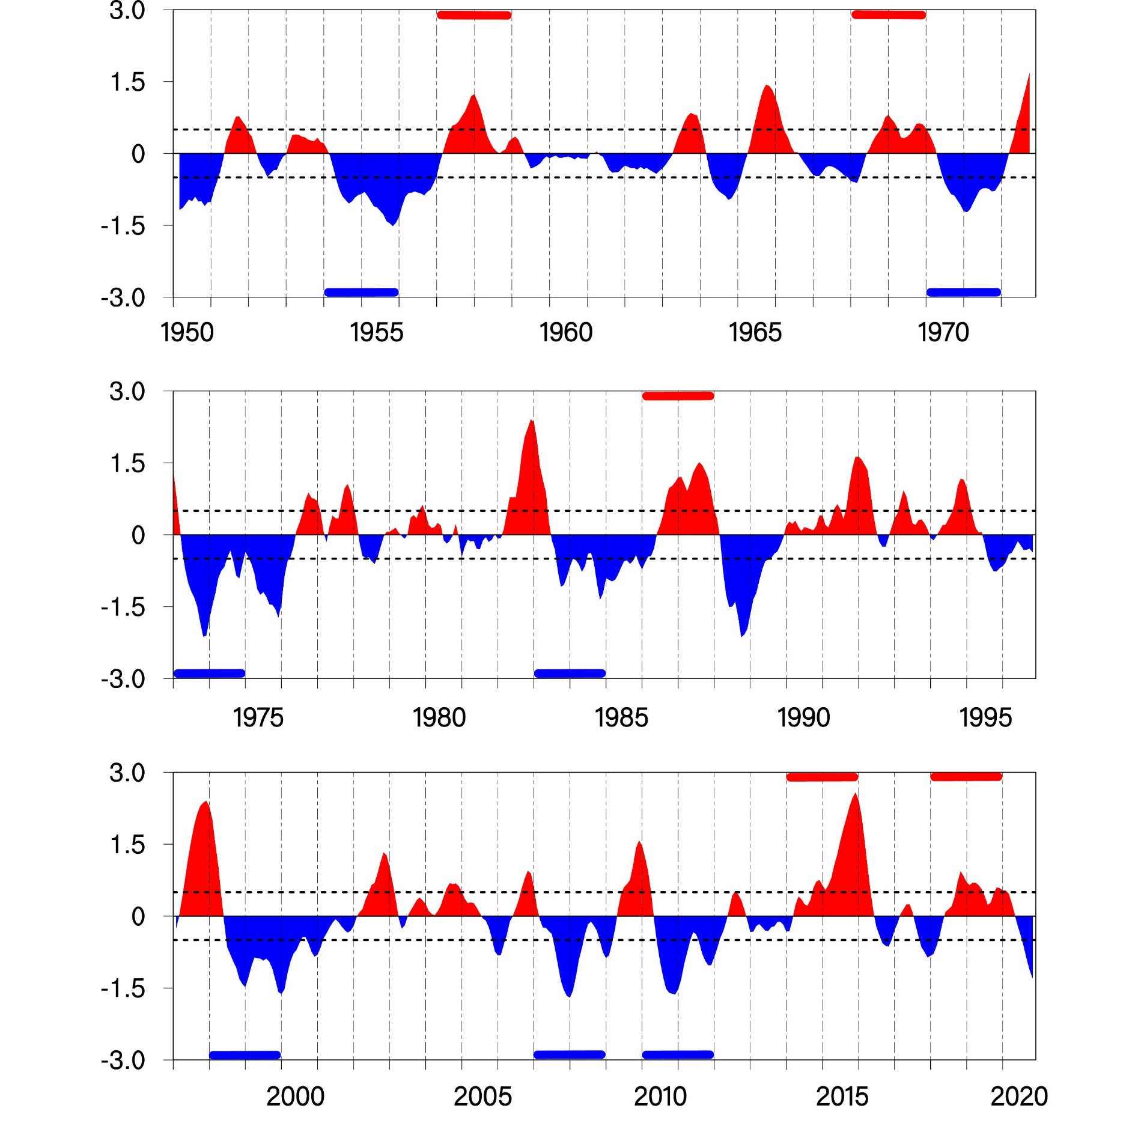
Supplementary Figure 1. Time series of the Niño3.4 index (°C) for the period 1950–2020. Years 0 and 1 of multi-year El Niño events are indicated by thick horizontal red lines along the time axis, and years 0 and 1 of multi-year La Niña events are given by thick horizontal blue lines. The time series is smoothed with a 3-month running-mean filter.

Supplementary Figure 2. Forecasts of the Niño3.4 index respectively from February 2014 and February 2015 by operational forecasting models compiled at the IRI/CPC (International Research Institute for Climate and Society/Climate Prediction Center). (a) Forecasts starting from February 2014. (b) Forecasts starting from February 2015. In (a,b), observations are indicated by the large red dot.

Supplementary Figure 3. The JFM(0) SLP anomalies prior to multi-year El Niño events in observations. (a−e) The JFM(0) SLP anomalies for the 5 observed multi-year El Niño events, respectively. (f) The normalized JFM(0) NPO index for the 5 observed multi-year El Niño events.

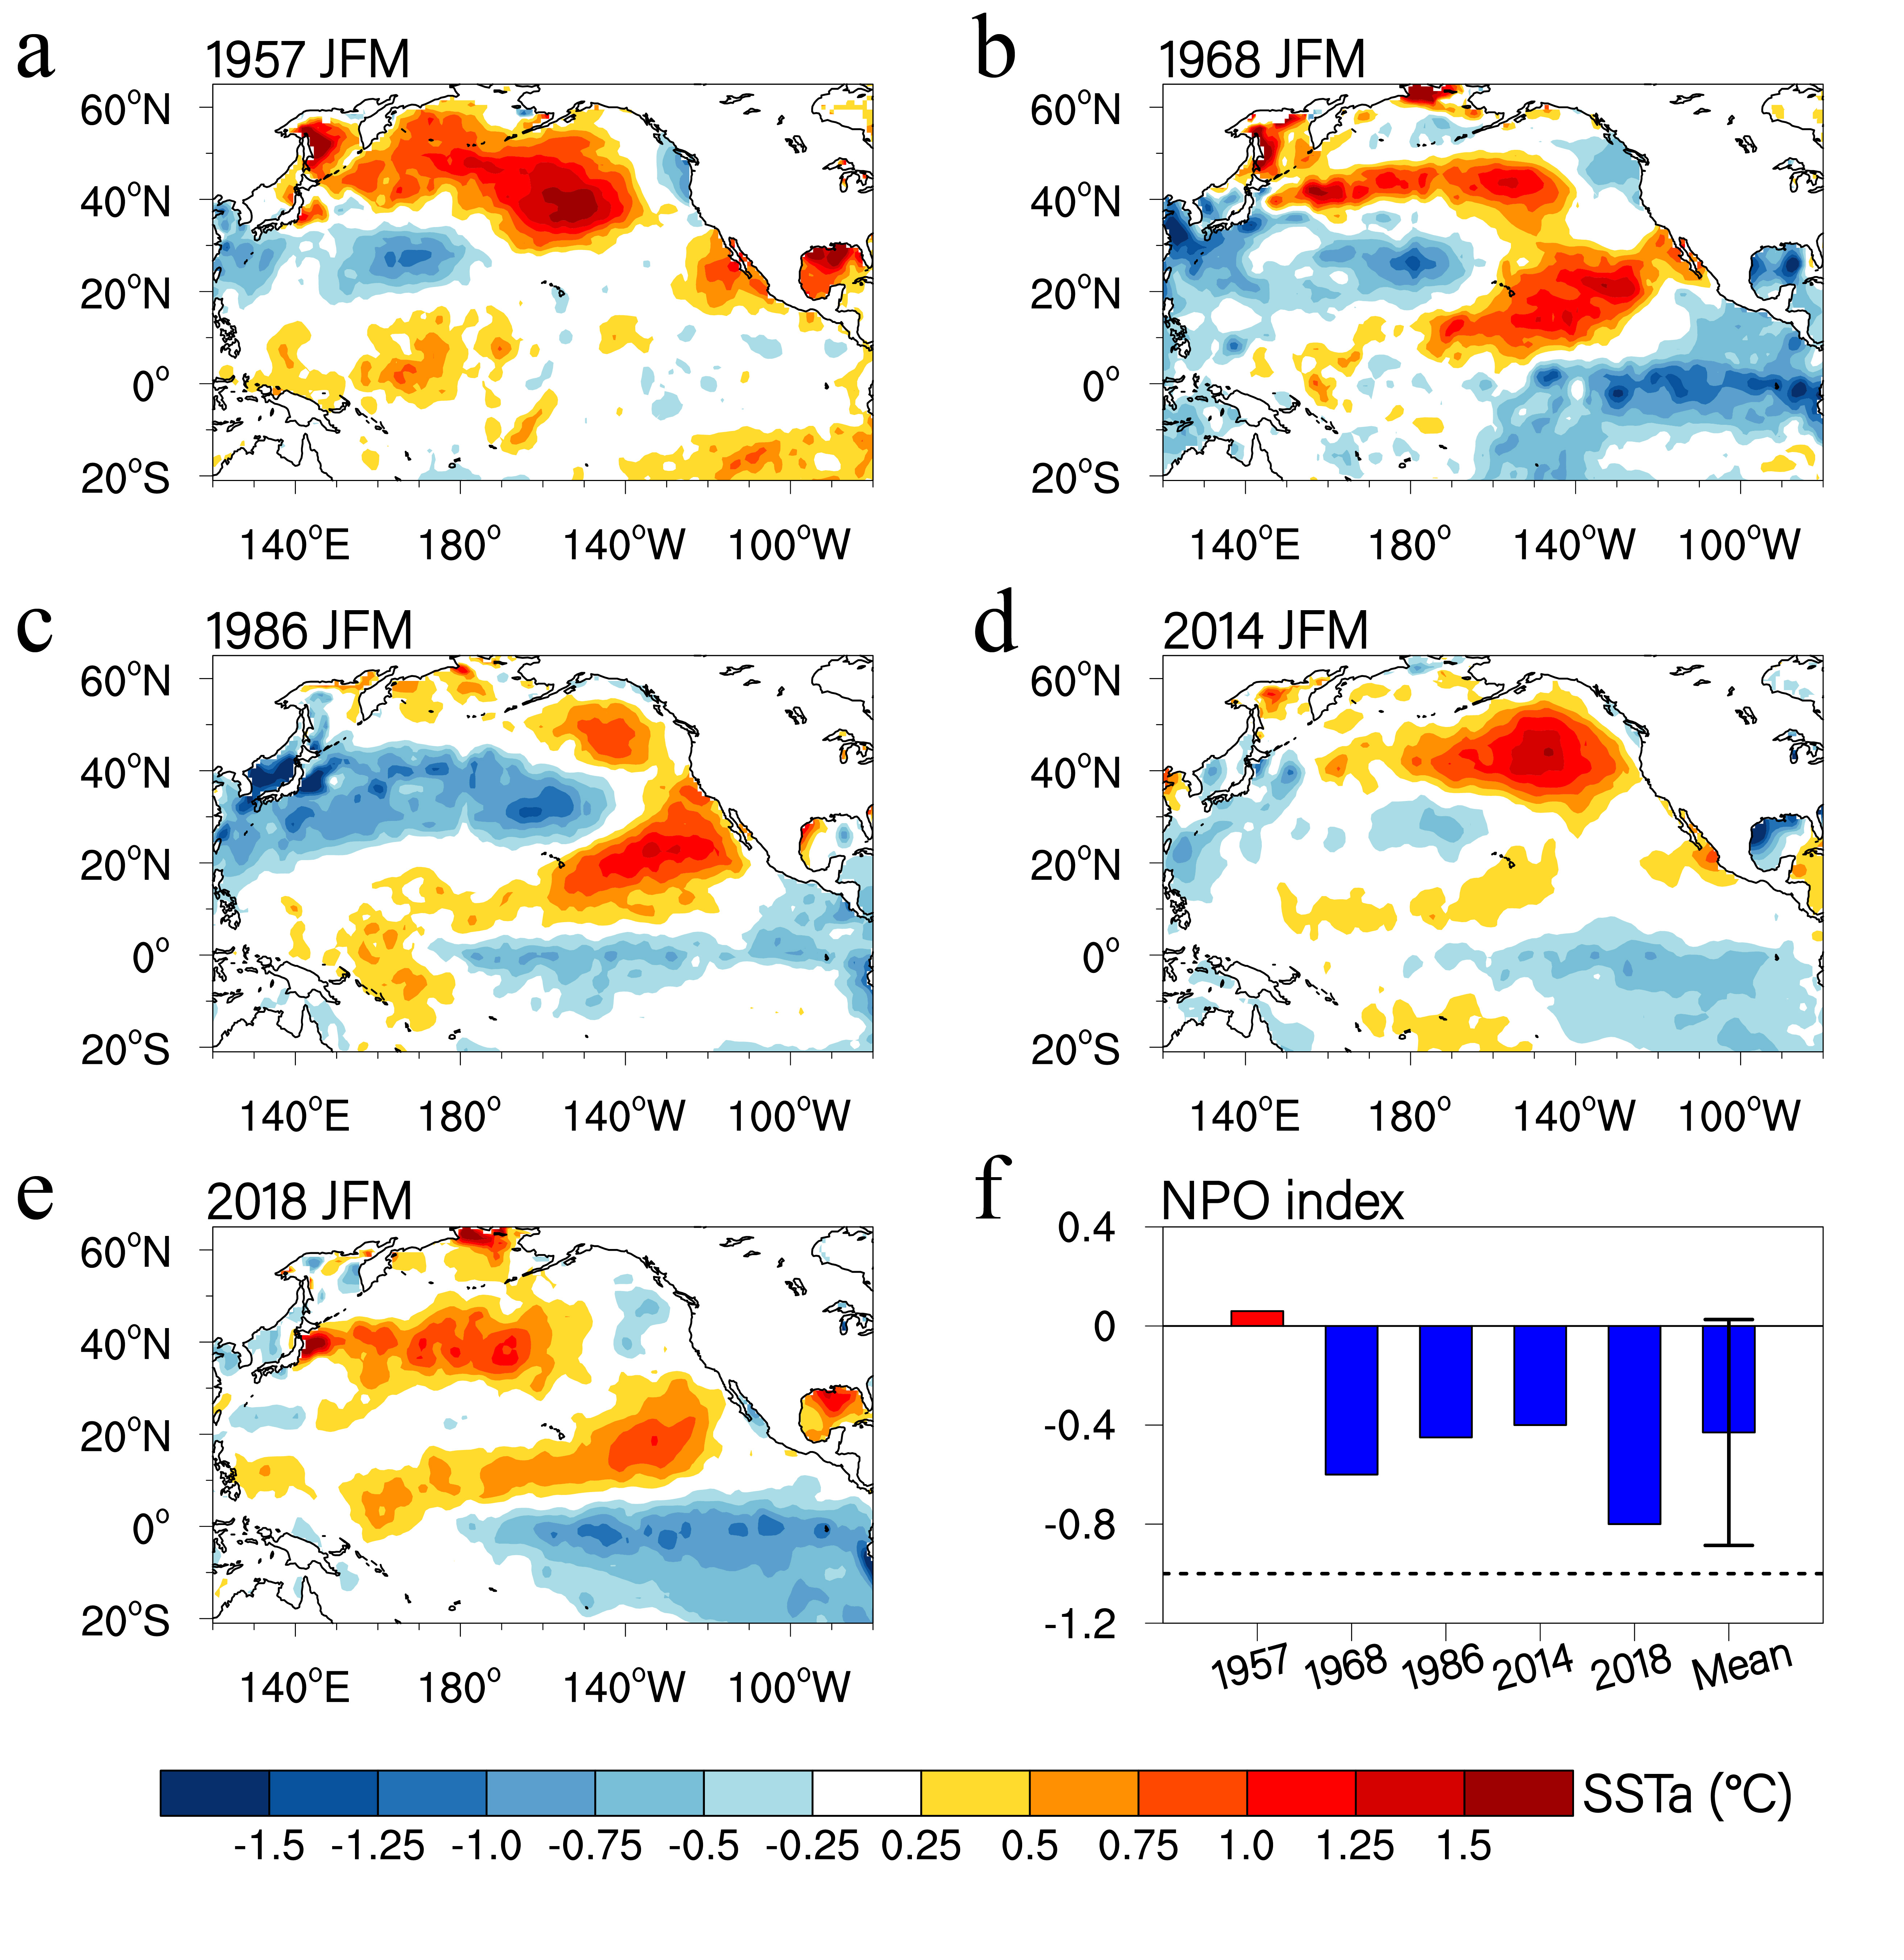
Supplementary Figure 4. The JFM(0) SST anomalies prior to multi-year El Niño events in observations. (a−e) The JFM(0) SST anomalies for the 5 observed multi-year El Niño events, respectively. (f) The JFM(0) Niño3.4 index (°C) for the 5 observed multi-year El Niño events.

Supplementary Figure 5. Lead‐lag correlations of the JFM(0) NPO index (blue line; scale on the right y axis) with 3‐month‐averaged Niño3.4 index. Lead‐lag correlations of the JFM(1) Niño3.4 index (red line; scale on the left y axis) with 3‐month‐averaged Niño3.4 index are also shown as a contrast. The horizontal red (blue) dashed line shows the 95% confidence levels for correlations of the JFM(1) Niño3.4 (JFM(0) NPO) index with 3‐month‐averaged Niño3.4 index.

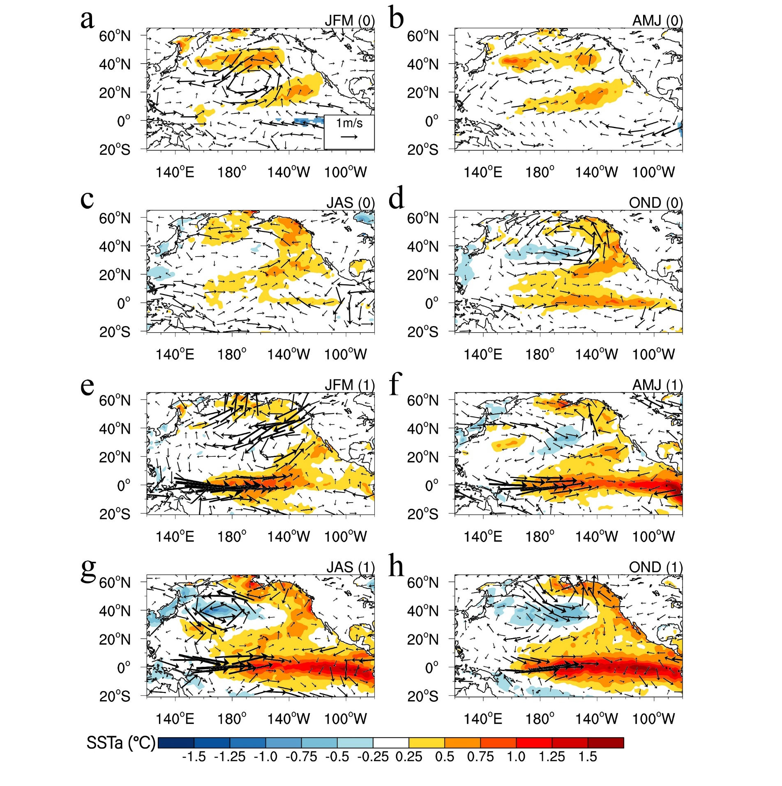
Supplementary Figure 6. Regression with respect to the JFM(0) NPO index. (a−i) Regressions of 3-month-averaged SST (shaded) and 850 hpa winds (vector) for JFM(0) concurrent with the NPO index (a), and several lead times [AMJ(0) (b), JAS(0) (c), OND(0) (d), JFM(1) (e), AMJ(1) (f), JAS(1) (g), and OND(1) (i)]. Only SST and 850 hPa wind anomalies significant at the 95% confidence level are shown.

Supplementary Figure 7. Evolutions of SST anomalies for multi-year El Niño events. (a,b) Longitude-time plot of equatorial (5°S−5°N) SST anomalies from year (0) to year (2) composited for the NPO-preceded multi-year El Niño events in observations and CMIP5/6 models (MME), respectively. (c) Ensemble-mean difference in equatorial (5°S−5°N) SST anomalies from year (0) to year (2) between the positive NPO forcing and CTRL experiments. In (a,b,c), the reference longitude of 155°E is indicated by the green vertical line, and only SST anomalies significant at the 95% confidence level are shown.

Supplementary Figure 8. The atmospheric teleconnections of the CP and EP ENSO. (a) Regressions of SLP anomalies (hPa) onto JFM values of the standardized CP ENSO index. (b) As in (a) but for regressions of SLP anomalies onto the standardized EP ENSO index. (c) Time series of the SLP index over the Hawaiian region (SLP_{HI}; 158°W–135°W, 13°N–24°N) (red line) and the CP ENSO index (black line). Indices are normalized by their standard deviations and are correlated R=-0.56 (significant at the 99.9% confidence level). In (a,b), only SLP anomalies significant at the 95% confidence level are shown.
Supplementary Figure 9. Relationships among the NPO, SLP_{HI}, and PMM indices. (a) Time series of the JFM NPO index and the JFM SLP index over the Hawaiian region (SLP_{HI}; 158°W–135°W, 13°N–24°N). (b) Time series of the JFM SLP_{HI} index and the following MAM PMM index. (c) Time series of the JFM NPO index and the following MAM PMM index. (d) Correlations among the NPO, SLP_{HI}, and PMM indices, and ** indicates significant at the 99% confidence level.

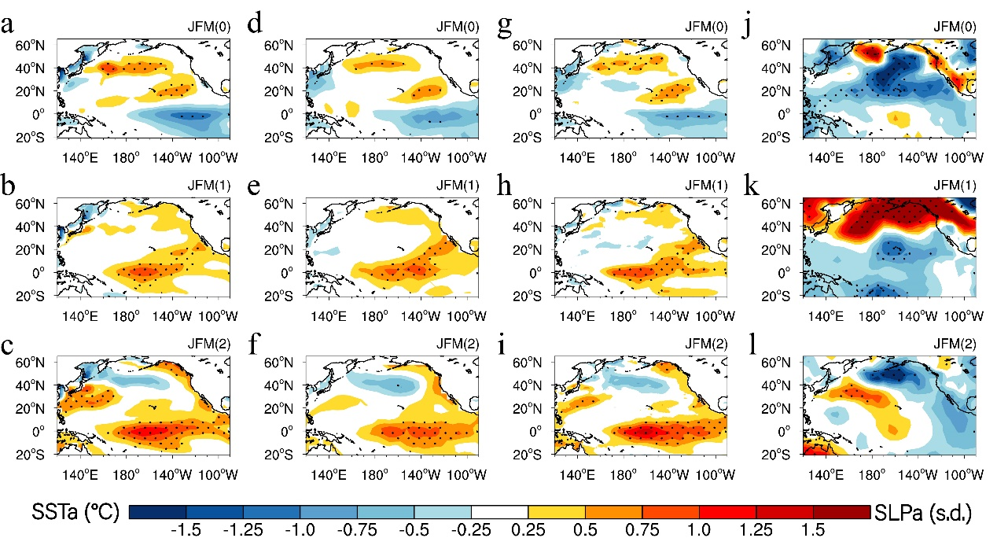
Supplementary Figure 10. Evolutions of SST and SLP anomalies composited for multi-year El Niño events from JFM(0) to JFM(2) derived from different SST and SLP datasets. (a,b,c) Evolutions of SST anomalies derived from the ERSST dataset. (d,e,f) Evolutions of SST anomalies derived from the Kaplan SST dataset. (g,h,i) Evolutions of SST anomalies derived from the COBE SST dataset. (j,k,l) Evolutions of SLP anomalies derived from the HadSLP dataset. In (a−l), dots indicate SST and SLP anomalies significant at the 95% confidence level.

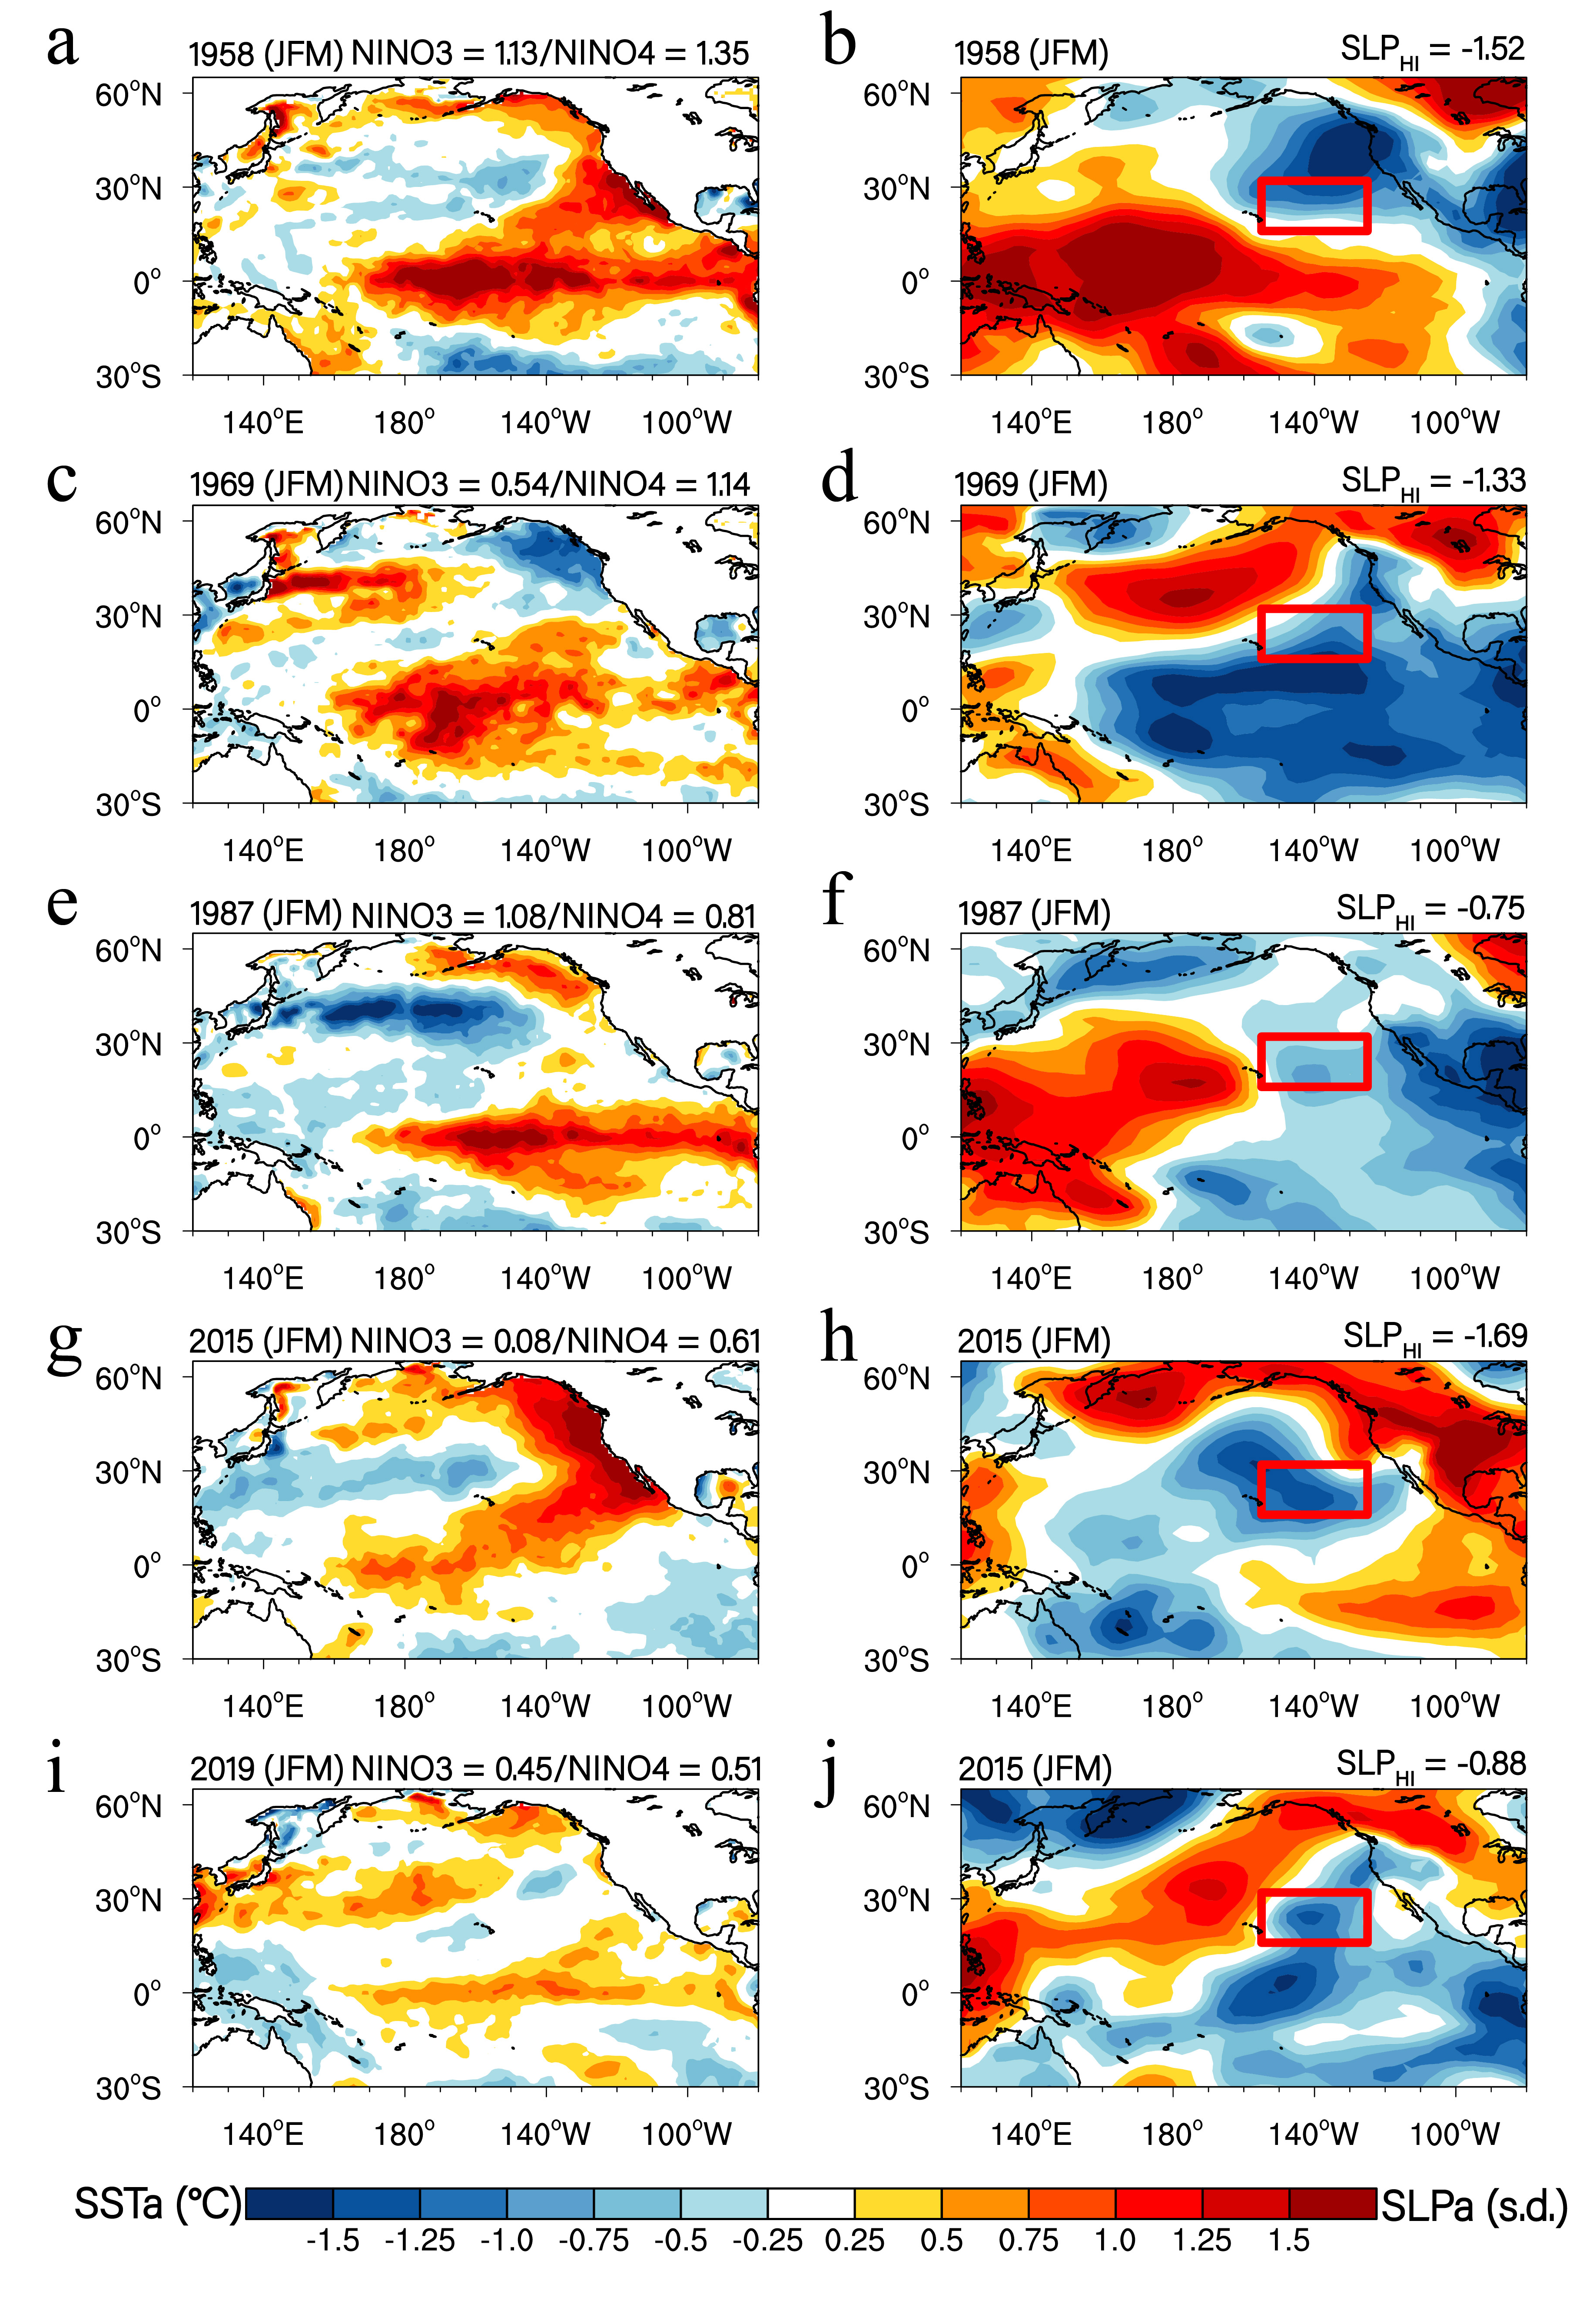
Supplementary Figure 11. JFM(1) SST and SLP anomalies of individual multi-year El Niño events. (a,b) JFM 1958 SST and SLP anomalies, respectively. (c,d) JFM 1969 SST and SLP anomalies, respectively. (e,f) JFM 1987 SST and SLP anomalies, respectively. (g,h) JFM 2015 SST and SLP anomalies, respectively. (i,j) JFM 2019 SST and SLP anomalies, respectively. In (a,c,e,g,i), the Niño3 and Niño4 indices are provided in the top right. For these 5 multi-year El Niño events, the Niño4 index is greater than or is comparable to the Niño3 index during JFM(1), indicating a typical CP El Niño pattern or a mixed pattern of CP and EP El Niño. In (b,d,f,h,j), the SLP index over the Hawaiian region (SLP_{HI}; 158°W–135°W, 13°N–24°N) is provided in the top right.

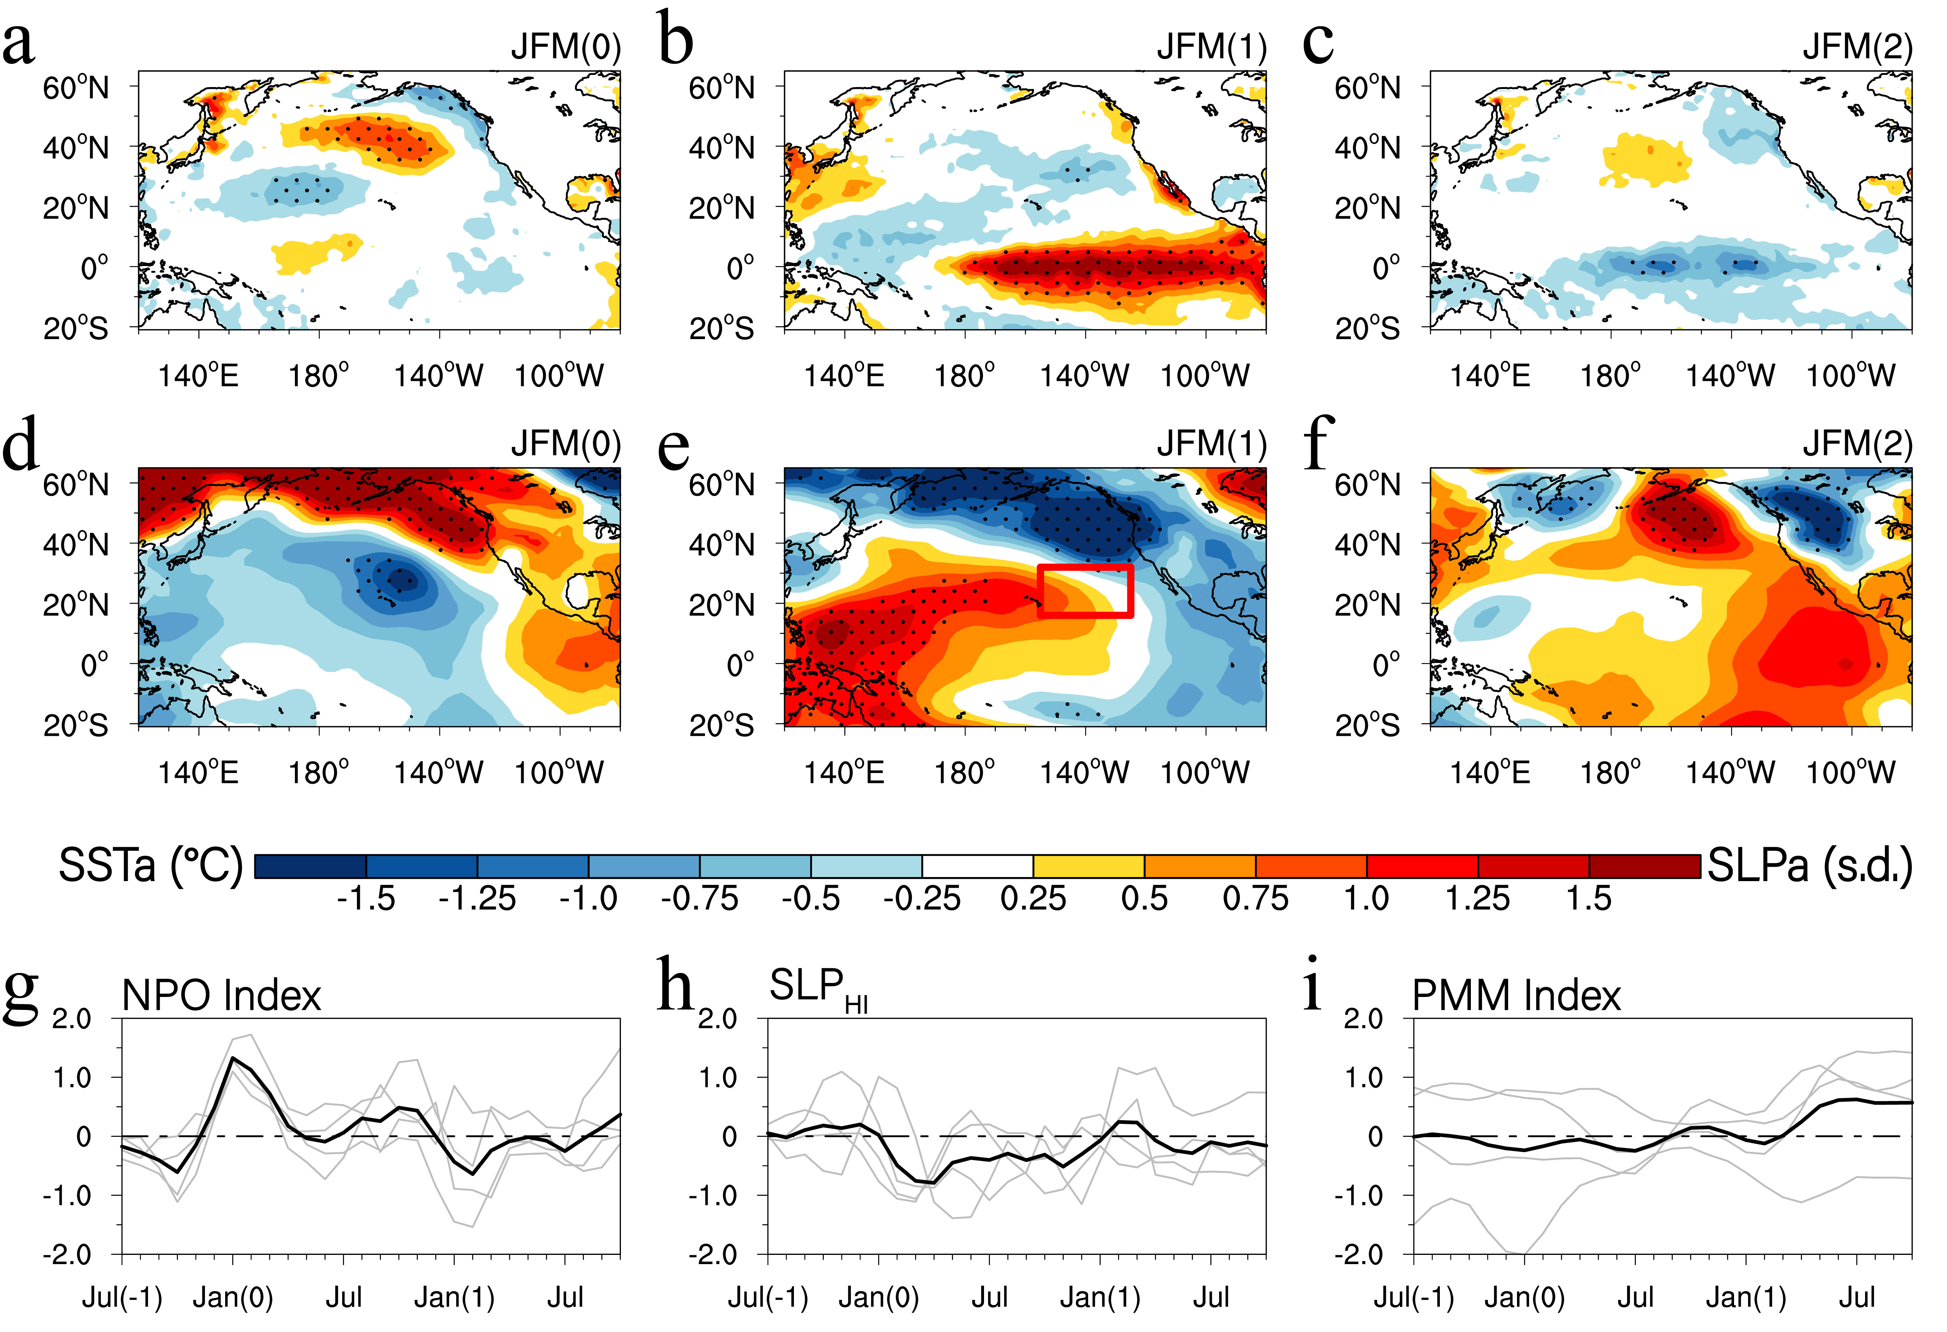
Supplementary Figure 12. Evolutions of SST and SLP anomalies composited for the NPO-preceded single-year El Niño events in observations. (a,b,c) JMF(0), JFM(1), and JFM(2) SST anomalies, respectively. (d,e,f) JMF(0), JFM(1), and JFM(2) SLP anomalies, respectively. (g,h,i) Temporal evolutions of the NPO index, the SLP index over the Hawaiian region (SLP_{HI}), and the PMM index, respectively. The red box in e denotes region used to compute the SLP index over the Hawaiian region (SLP_{HI}; 158°W–135°W, 13°N–24°N). In (a−f), dots indicate SST and SLP anomalies significant at the 95% confidence level. In (g,h,i), the gray curves indicates individual evolutions of various indices.

Supplementary Figure 13. Composite structures of JFM(1) SST anomalies for the NPO-preceded and non-NPO-preceded CP El Niño events. (a) Composite structures of JFM(1) SST anomalies for the NPO-preceded CP El Niño events. (b) As in (a), but for composite structures of JFM(1) SST anomalies for CP El Niño events alone without the preceding NPO events (non-NPO-preceded CP El Niño events). (c) Composite differences of JFM(1) SST anomalies between the NPO-preceded and non-NPO-preceded CP El Niño events. In (a−c), dots indicate SST anomalies significant at the 95% confidence level, and the green contours denote climatological 28°C isotherm line which depicts an area for the western Pacific warm pool during JFM.

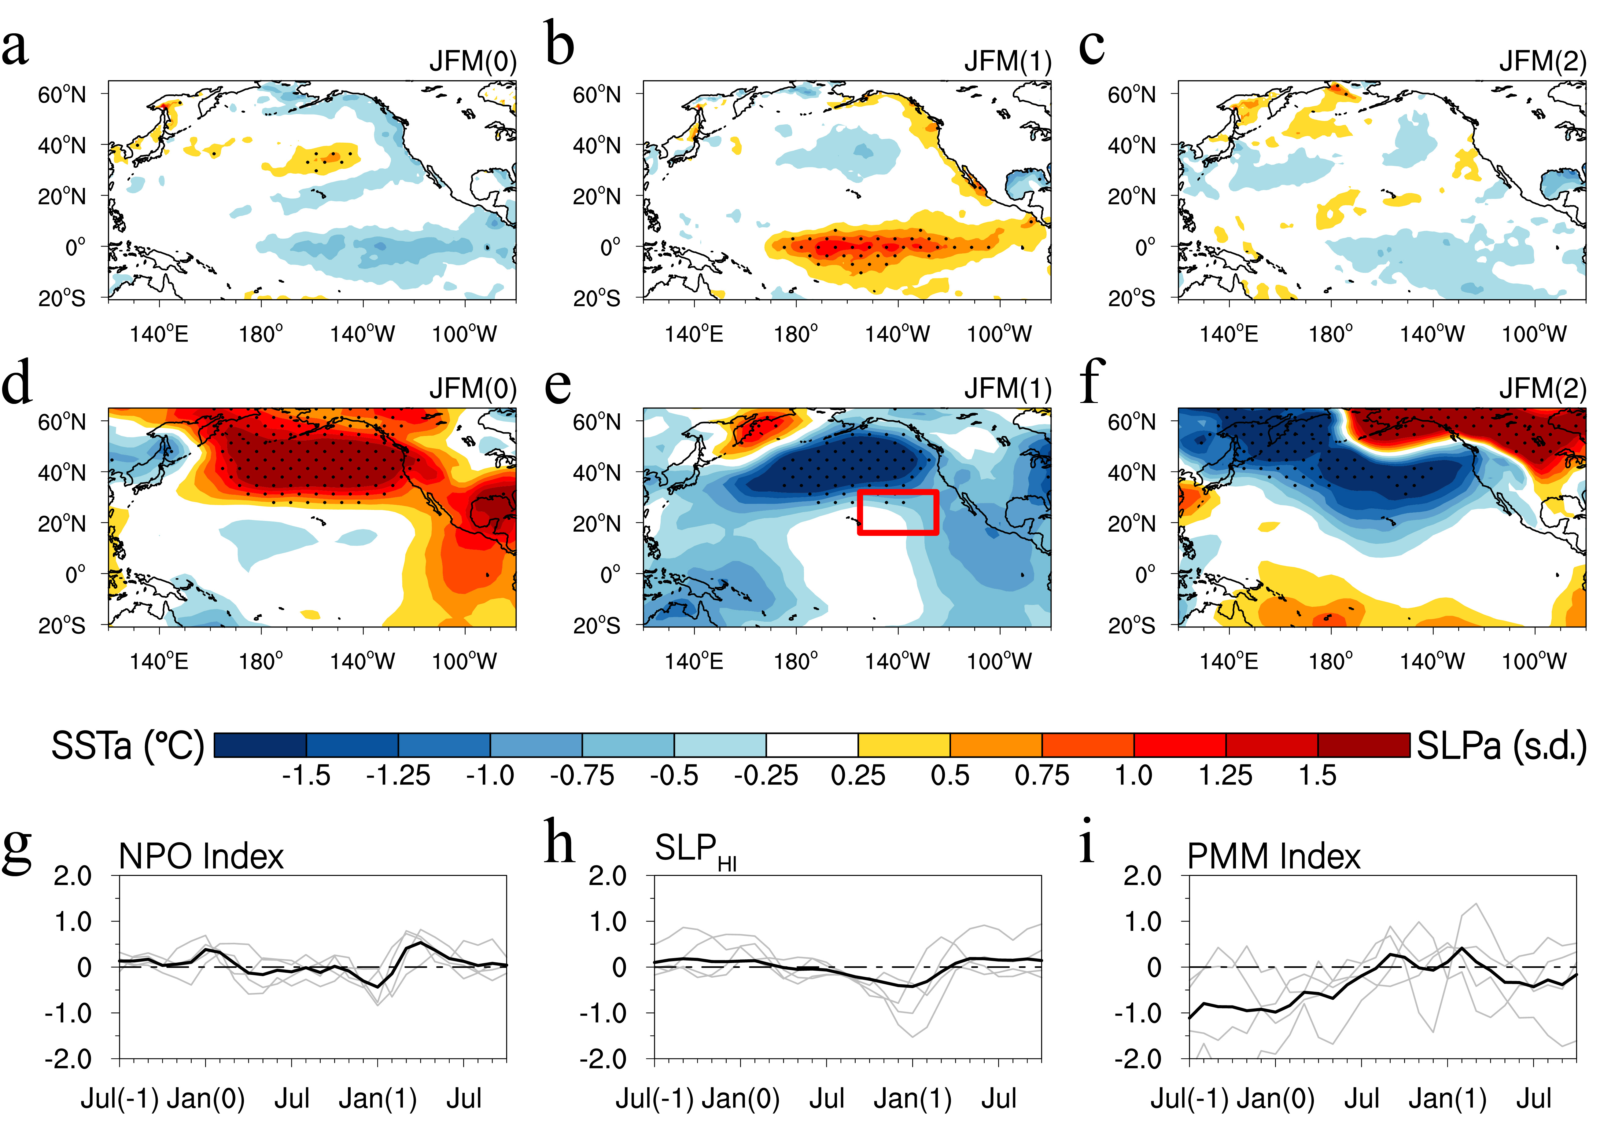
Supplementary Figure 14. Evolutions of SST and SLP anomalies composited for the observed CP El Niño events without the preceding NPO in observations. (a,b,c) JMF(0), JFM(1), and JFM(2) SST anomalies, respectively. (d,e,f) JMF(0), JFM(1), and JFM(2) SLP anomalies, respectively. (g,h,i) Temporal evolutions of the NPO index, the SLP index over the Hawaiian region (SLP_{HI}), and the PMM index, respectively. The red box in e denotes region used to compute the SLP index over the Hawaiian region (SLP_{HI}; 158°W–135°W, 13°N–24°N). In (a−f), dots indicate SST and SLP anomalies significant at the 95% confidence level. In (g,h,i), the gray curves indicates individual evolutions of various indices.

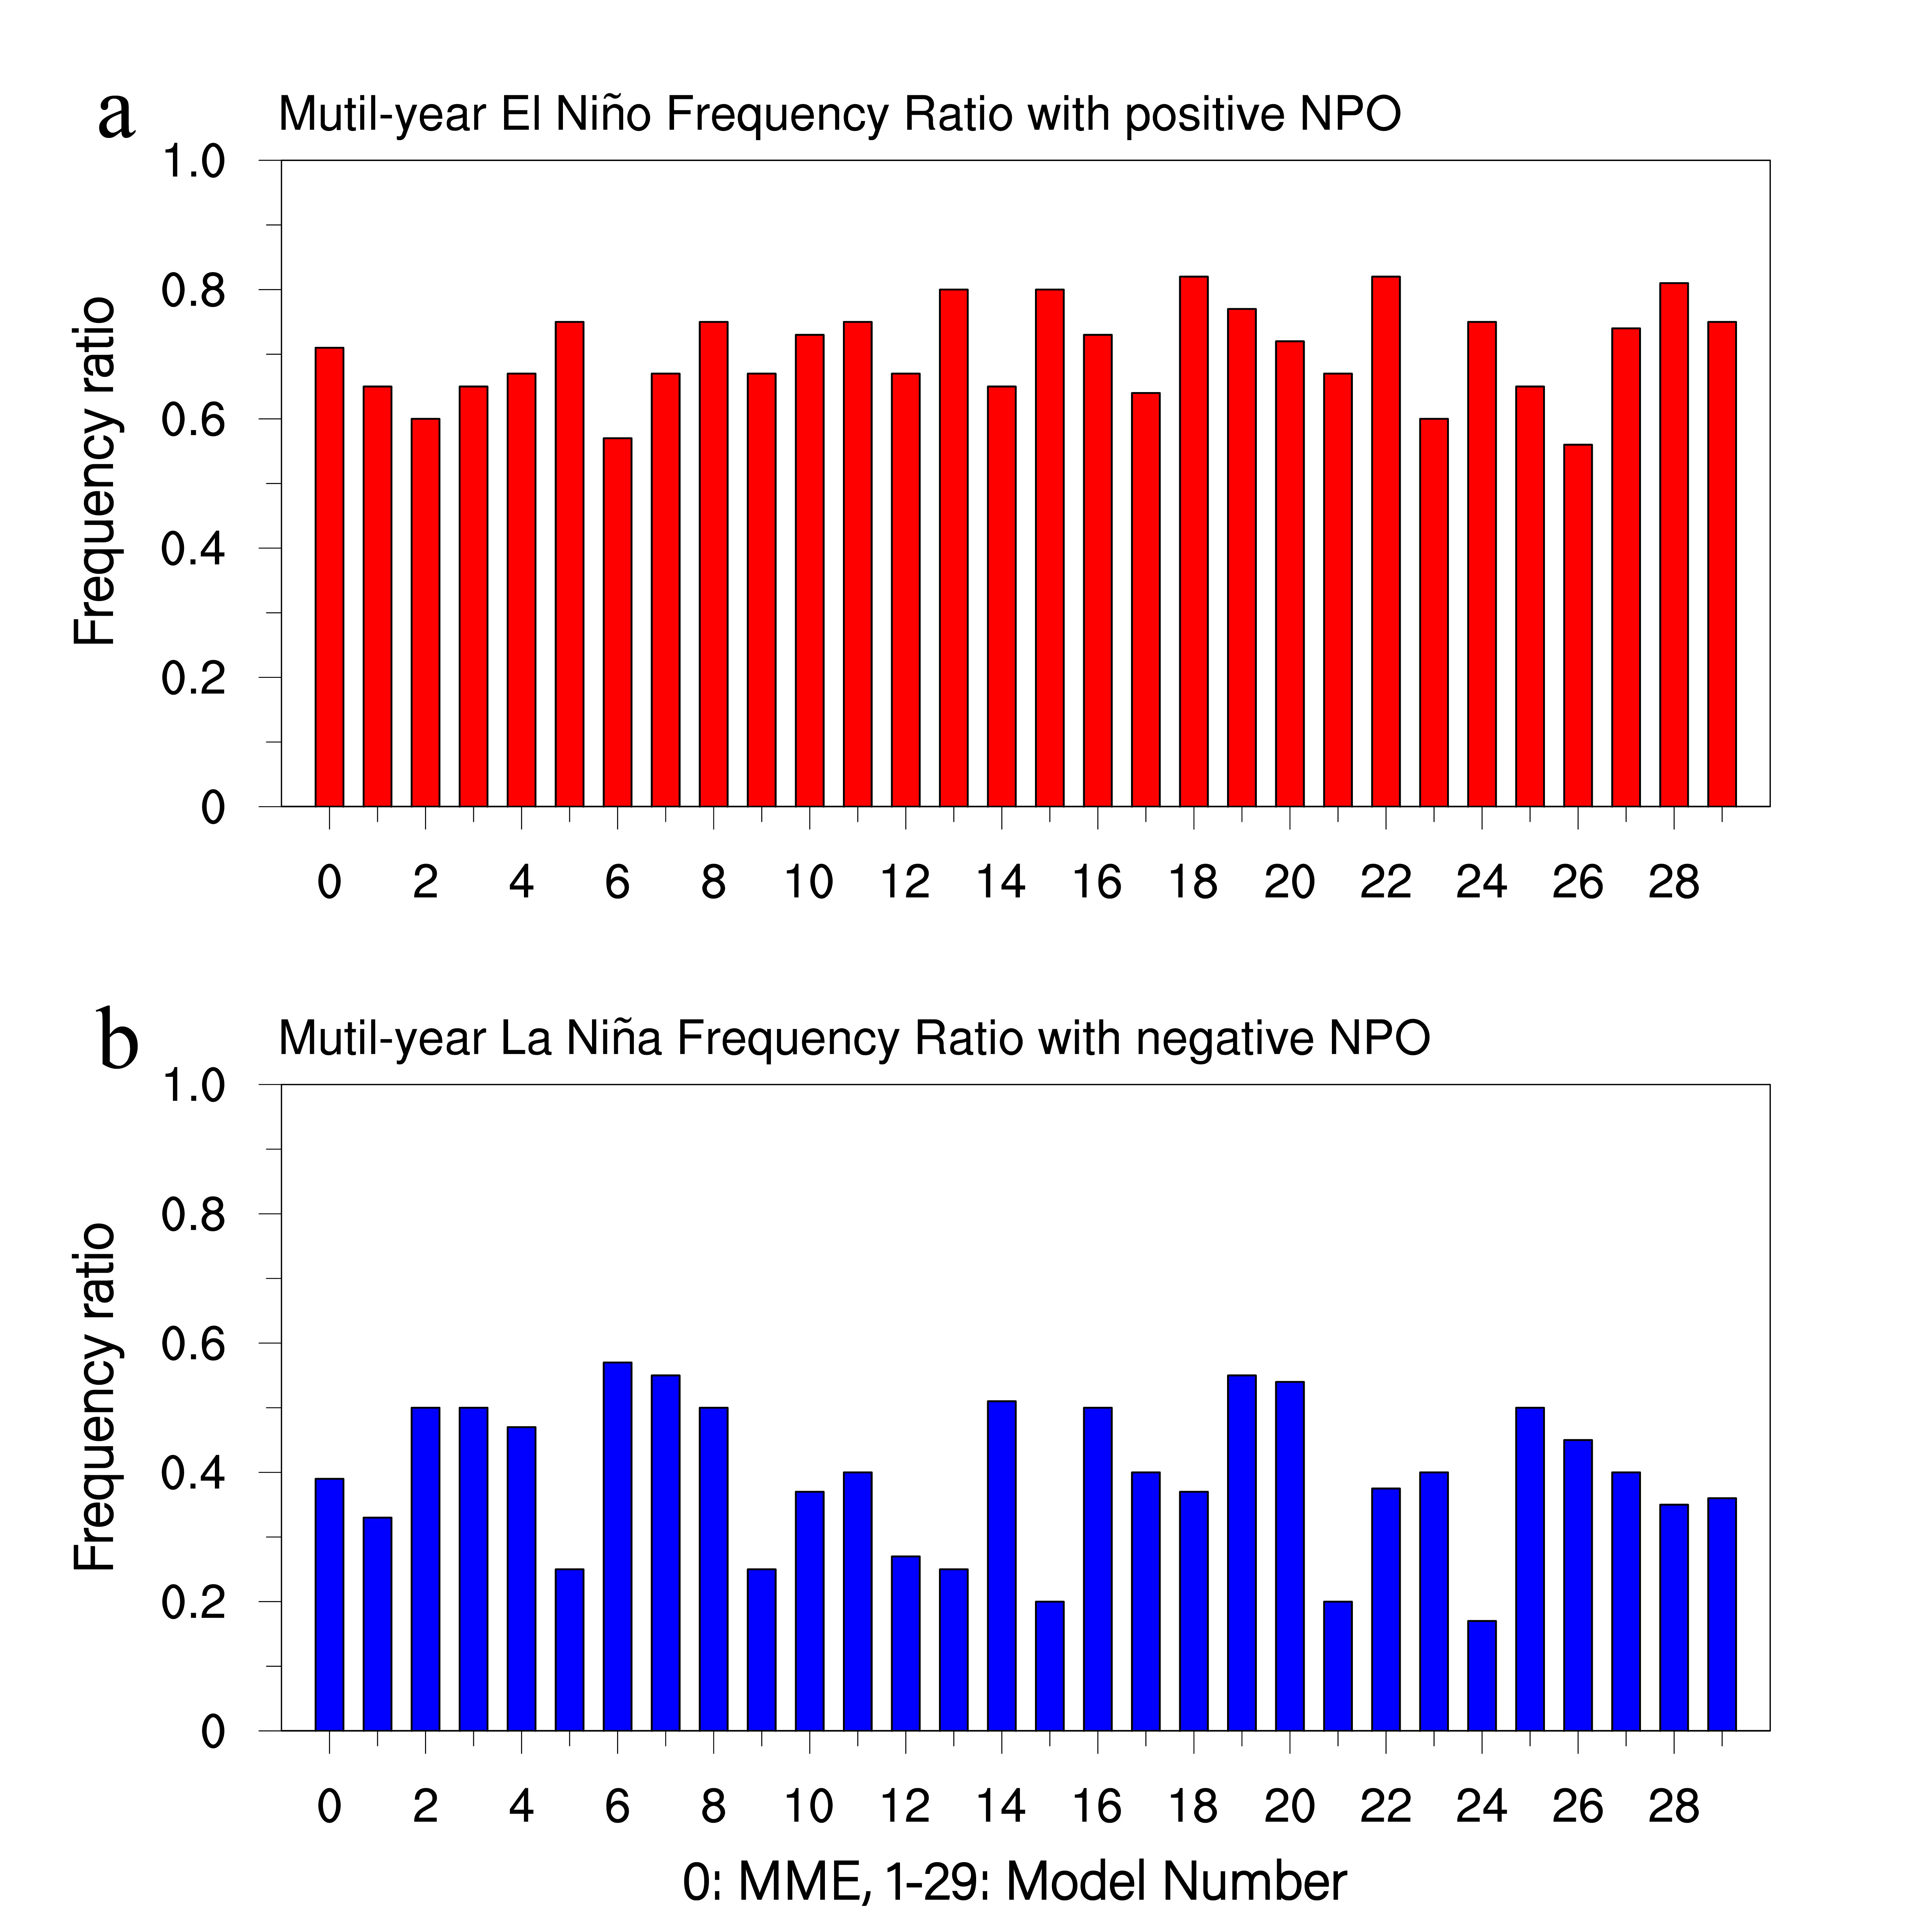
Supplementary Figure 15. Effects of the NPO on the frequency ratio of multi-year El Niño/La Niña events in the CMIP5/6 models. (a) The ratio of multi-year El Niño events when the positive NPO event occurs during the JFM(0). (b) As in (a) but for multi-year La Niña cases. The number 0 in the x-axis denotes MME, and numbers 1−29 denote individual climate models.

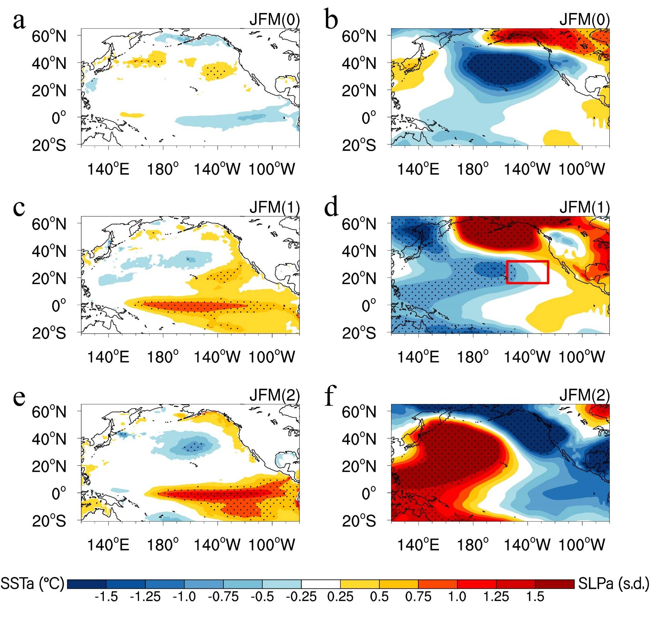
Supplementary Figure 16. Evolutions of SST and SLP anomalies composited for the NPO-preceded multi-year El Niño events in the CMIP5/6 models. (a,b) The JFM(0) SST and SLP anomalies, respectively. (c,d) The JFM(1) SST and SLP anomalies, respectively. (e,f) The JFM(2) SST and SLP anomalies, respectively. The red box in d denotes region used to compute the SLP index over the Hawaiian region (SLP_{HI}; 158°W–135°W, 13°N–24°N). In (a−f), dots indicate SST and SLP anomalies significant at the 95% confidence level.

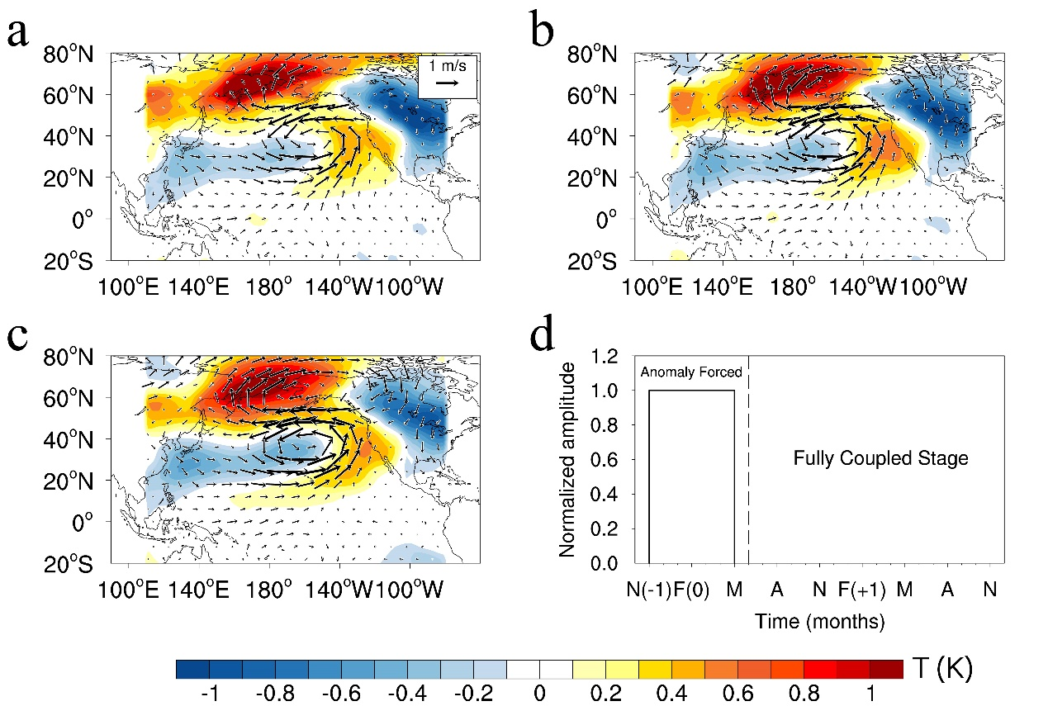
Supplementary Figure 17. The imposed NPO forcing in numerical experiments. (a) The spatial pattern of the NDJFMAM-averaged air temperature (K; shaded) and wind (m s^{–1}; vectors) forcings added to the climatological forcing and applied to each ensemble member in the NPO forcing experiment. The NDJFMAM-averaged air temperature and wind forcings are obtained by regressing air temperature and wind anomalies at 1000 hPa onto the concurrent NPO index. (b) As in (a) but for 925 hPa. (c) As in (a) but for 850 hPa. (d) Time evolution of the forcing applied during the assimilation stage (from November(−1) to May(0)) and the fully coupled stage of the NPO forcing experiment (from June(0) to December(1)).

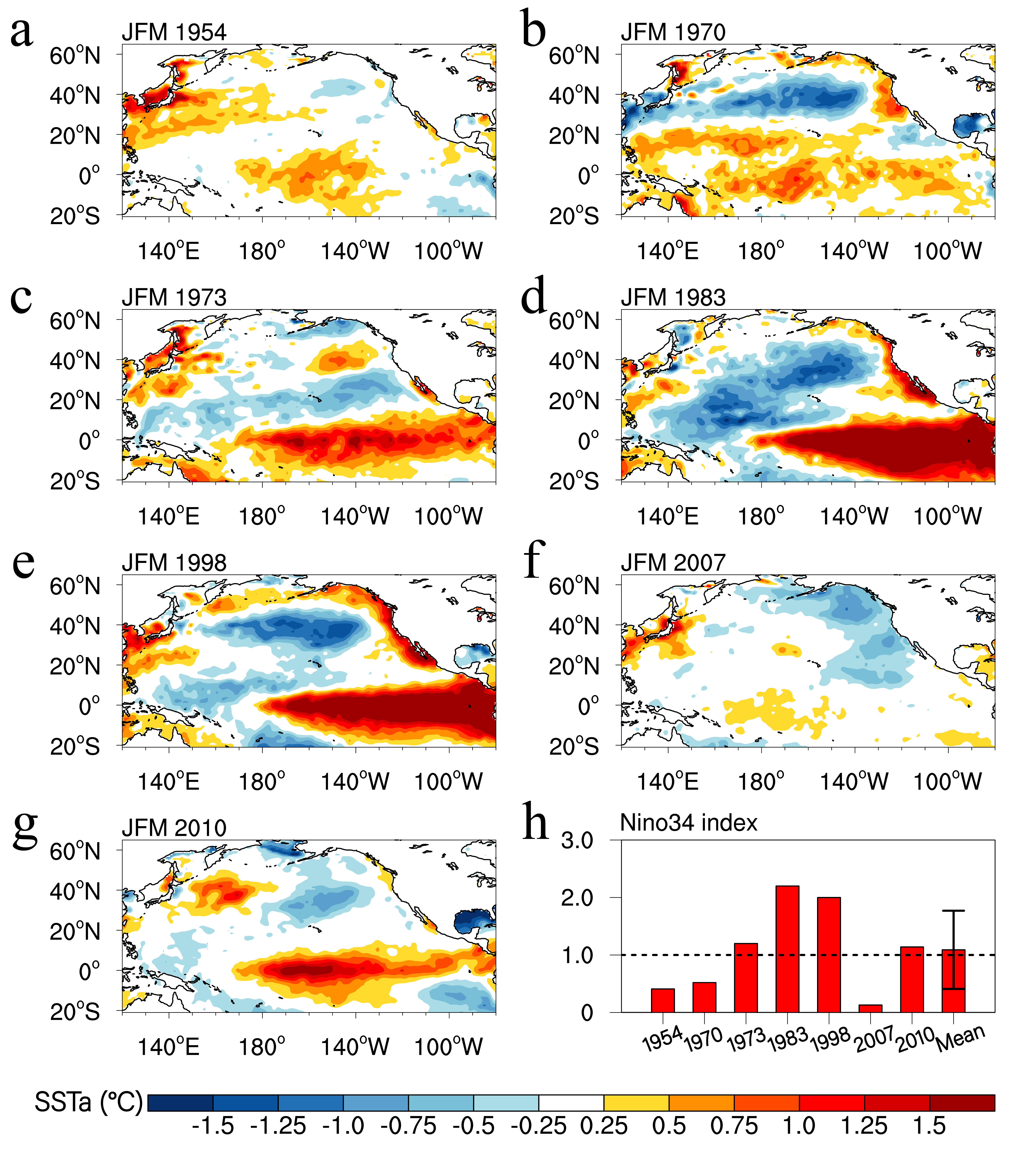
Supplementary Figure 18. The JFM(0) SST anomalies prior to multi-year La Niña events in observations. (a−g) The JFM(0) SST anomalies for the 7 observed multi-year La Niña events. (h) The JFM(0) Niño3.4 index (°C) for the 7 observed multi-year La Niña events.

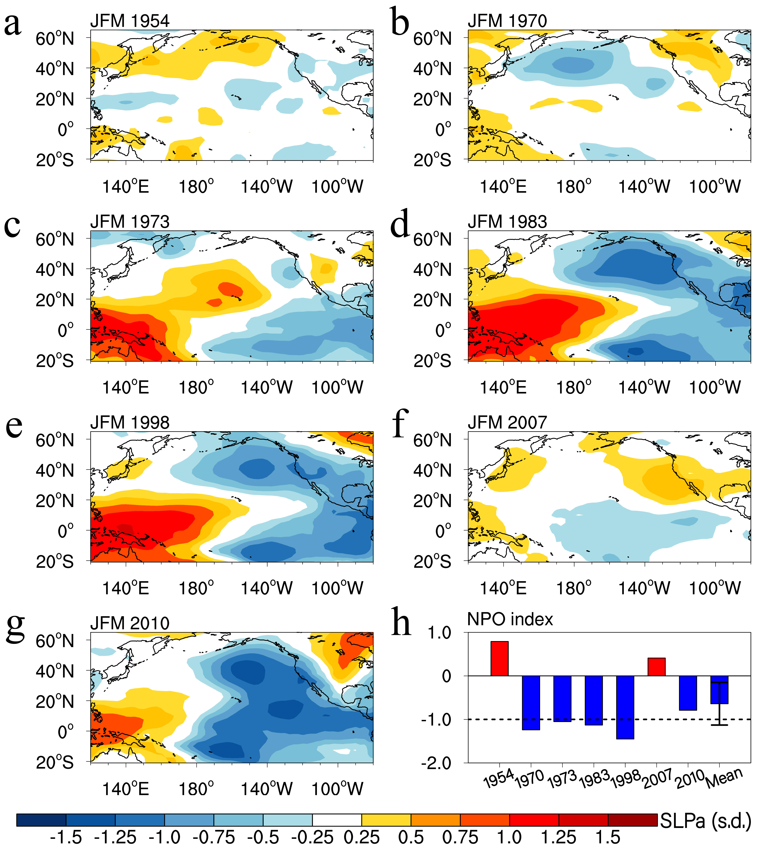
Supplementary Figure 19. The JFM(0) SLP anomalies prior to multi-year La Niña events in observations. (a−g) The JFM(0) SLP anomalies for the 7 observed multi-year La Niña events. (h) The normalized JFM(0) NPO index for the 7 observed multi-year La Niña events.

Supplementary Figure 20. Evolutions of multi-year La Niña events preceded by the negative NPO event alone in the CMIP5/6 models. (a) Longitude-time plot of equatorial SST anomalies from year (0) to year (2) composited for multi-year La Niña events. Only SST anomalies significant at the 95% confidence level are shown, and the reference longitude of 155°E is indicated by the green vertical line. (b,c,d) Temporal evolutions of the NPO index, the SLP index over the Hawaiian region (SLP_{HI}), and the PMM index from July(−1) to October(1). In (b,c,d), the colored shading indicates interquartile ranges between the 25th and 75th percentiles.

