Table S1. Characteristics of the External Validation Cohorts by PET Acquisition Modality
Characteristic | External PET/MR | External PET/CT
Participants, n | 50 | 38
Age, years, mean ± SD | 68.7 ± 9.8 | 68.1 ± 7.9
Female, n (%) | 25 (50.0) | 17 (44.7)
PET scanner | UIH uPMR 790 | UIH uMI 510
Visual read
Negative, n (%) | 22 (44.0) | 13 (34.2)
Intermediate, n (%) | 4 (8.0) | 4 (10.5)
Positive, n (%) | 24 (48.0) | 21 (55.3)
Data are presented as mean ± SD or n (%). Scanner models are reported separately for each modality-specific dataset. Abbreviations: PET/CT, positron emission tomography/computed tomography; PET/MR, positron emission tomography/magnetic resonance; SD, standard deviation; UIH, United Imaging Healthcare.

Table S2. Centiloid Values by PET/MR Scanner and Visual-Read Category
Visual-read category | Scanner 1 |  | Scanner 2 |  | (Scanner 2 – Scanner 1) mean difference (95% CI) | P value
 | No. | Mean (SD) | No. | Mean (SD)
Visually negative | 22 | 13.8 (11.9) | 25 | 4.2 (16.1) | −9.6 (−17.6 to −1.5) | .024
Visually intermediate | 4 | 45.4 (20.6) | 4 | 24.0 (34.5) | −21.4 (−64.4 to 12.6) | .337
Visually positive | 24 | 83.6 (23.4) | 23 | 61.4 (35.9) | −22.2 (−42.6 to −3.1) | .017
Values are expressed in Centiloid units unless otherwise indicated. Mean differences were calculated as Scanner 2 (GE Healthcare) minus Scanner 1 (UIH uPMR 790). Confidence intervals were estimated using participant-cluster bootstrap. P values were calculated using Welch tests. The comparison for visually intermediate scans was descriptive because of the small subgroup size, and these scans were not included in cutoff derivation. Abbreviations: CI, confidence interval; SD, standard deviation.

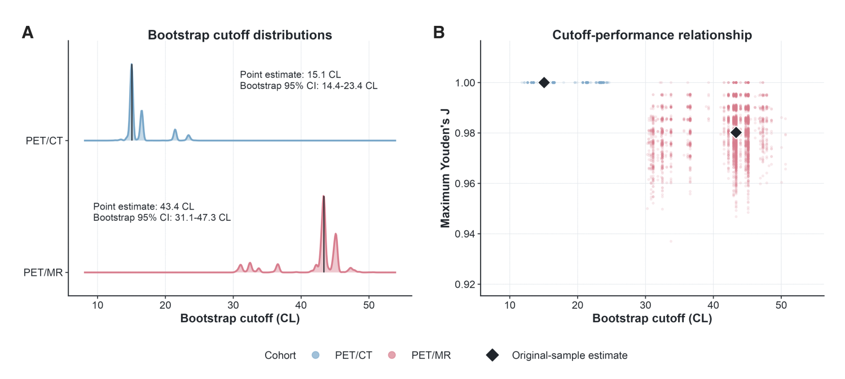
Figure S1. Bootstrap Stability of the Modality-Specific Single Cutoffs
Participant-clustered bootstrap resampling with 5000 replicates was performed separately in the derivation PET/CT and PET/MR cohorts; visual-intermediate examinations were excluded. A, Distributions of maximum-Youden cutoffs. Original estimates (95% bootstrap CIs) were 15.1 CL (14.4–21.9) for PET/CT and 43.4 CL (31.1–46.7) for PET/MR. B, Relationship between replicate-specific cutoffs and maximum Youden indices. Points represent successful replicates; black diamonds indicate original-sample estimates. PET/CT frequently retained a maximum Youden index of 1.00 across several cutoffs, whereas PET/MR showed greater variability. Abbreviations: CL, Centiloid; PET/CT, positron emission tomography/computed tomography; PET/MR, positron emission tomography/magnetic resonance.
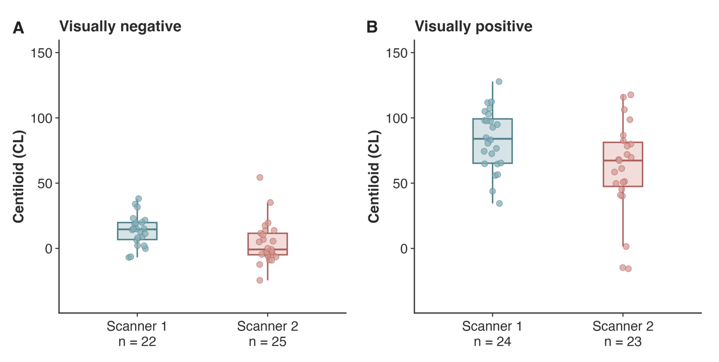
Figure S2. Centiloid Values by PET/MR Scanner in Visually Negative and Positive Scans
Centiloid distributions are shown by scanner for visually negative (A) and visually positive (B) participants. Scanner 1 denotes the UIH uPMR 790, and Scanner 2 denotes the GE Healthcare PET/MR system. Points represent individual participants; box plots show medians and interquartile ranges. Sample sizes are provided below each scanner. Abbreviations: UIH, United Imaging Healthcare.

