Supporting Information for
Antibiotic Source Apportionment in Stream Sediments Using PMF with Combined Antibiotic and Heavy Metal(loid) Profiles
Jinwook Kim ª, Youngkyu Hong ª, Hojin Jung ^{b}, Jeongmin Lee ^{b}, and Sungchul Kim ^{b,*}
ª Institute of Agricultural Science, Chungnam National University, Daejeon 34134, Republic of Korea
^{b} Department of Bio-Environmental Chemistry, Chungnam National University, Daejeon 34134, Republic of Korea

*Corresponding author: Sungchul Kim; Email: sckim@cnu.ac.kr

Contents
Number of Pages: 46
Number of Texts: 6
Number of Tables: 18
Number of Figures: 4

Text S1. Sample preparation for antibiotic analysis
Collected solid samples, including soil, sediment, livestock manure, and livestock manure compost, were freeze-dried and sieved through a 2.0 mm standard sieve prior to analysis. For extraction, 1.0 g of the freeze-dried sample was weighed into a 50 mL centrifuge tube, followed by the addition of 10 mL of McIlvaine buffer (pH 4.0), 10 mL of methanol, and 250 μL of 5% (w v⁻¹) Na₂-EDTA solution. The mixture was shaken at 150 rpm for 15 min, followed by centrifugation at 4,000 rpm for 15 min, and the supernatant was transferred to a 250 mL Erlenmeyer flask. The remaining solid residue was extracted once more using the same procedure, for a total of two extraction steps, and the resulting supernatants were combined in the same flask. Approximately 40 mL of combined extract was then diluted with HPLC-grade water to a final volume of 120 mL, vacuum-filtered through a 0.22 μm cellulose acetate membrane filter, and further purified by solid-phase extraction (SPE).
Liquid manure-based fertilizer samples were diluted 1:50 (v v⁻¹) with HPLC-grade water, whereas WWTP and LMTF effluent samples were diluted 1:10 (v v⁻¹) with HPLC-grade water. All diluted liquid samples were then vacuum-filtered through a 0.22 μm cellulose acetate membrane filter. An aliquot of 120 mL of each diluted sample was then mixed with 500 μL of 5% (w v⁻¹) Na₂-EDTA solution, and the pH was adjusted to pH 2.5 using 40% (v v⁻¹) sulfuric acid. The pretreated liquid samples were then purified by SPE.
The pretreated solid and liquid samples were subjected to SPE using a vacuum manifold. Before sample loading, the SPE cartridge was conditioned sequentially with 3.0 mL of methanol, 3.0 mL of 0.5 M hydrochloric acid, and 3.0 mL of HPLC-grade water. During this process, the sorbent was kept from drying, and the flow rate was maintained at approximately 2 mL min⁻¹. The prepared sample was then loaded onto the cartridge through a Teflon tube at a flow rate of 4 mL min⁻¹. After the entire sample had passed through the cartridge, the cartridge was washed three times with 3.0 mL of HPLC-grade water (total volume, 9.0 mL).
A 15 mL glass centrifuge tube containing the internal standard (0.05 mL, 0.24 mg L⁻¹) was placed on the SPE manifold, and the antibiotics were eluted from the cartridge with two 2.5 mL portions of methanol, giving a total elution volume of 5.0 mL. The extract was then concentrated under a gentle stream of nitrogen at below 40℃ to a final volume of approximately 0.05 mL. Subsequently, 0.07 mL of HPLC-grade water was added, and the mixture was vortexed to ensure homogeneity. The mixture was filtered by centrifugation using a 0.22 μm Spin-X nylon filter tube (Corning, NY, USA) at 13,000 rpm for 1 min. The resulting filtrate (0.12 mL) was transferred to a 2.0 mL amber glass vial fitted with a 0.25 mL insert and stored at −20℃ until LC-MS/MS analysis.

Text S2. Assessment of heavy metal(loid) contamination using pollution indices
The concentrations of heavy metal(loid)s detected in stream sediments from the study area were evaluated using the enrichment factor (EF) and geo-accumulation index (I_{geo}). Because no existing background concentration data were available for stream sediments in the study area, samples were collected from a site near the headwaters of the Muhan Stream that was considered to be unaffected by anthropogenic heavy metal(loid) inputs, and these concentrations were used as background values in this study.
The EF was used as an index of anthropogenic enrichment in stream sediments. EF is based on the normalization of metal concentrations to a conservative element that is relatively less affected by geological factors, including grain size, mineral composition, and organic matter content (Barbieri, 2016; Zonta et al., 1994). By reducing the influence of natural background variability, this approach allows anthropogenic inputs to be evaluated more clearly. The EF was calculated using Eq. (1):
$$\begin{aligned}{\text{EF}}_{\text{i}}\text{ =} \frac{{\text{(}{\text{C}}_{\text{i}}\text{/}{\text{C}}_{\text{ref }}\text{)}}_{\text{sample}}}{{\text{(}{\text{C}}_{\text{i}}\text{/}{\text{C}}_{\text{ref}}\text{ )}}_{\text{background}}} \text{\#} \#\left(\text{Eq. 1}\right)\end{aligned}$$
where C_{i} is the concentration of heavy metal(loid) i in the sample, and C_{ref} is the concentration of the conservative element. EF values of less than 2 indicate deficiency to minimal enrichment. The EF value is obtained by comparing the ratio of the target metal to the conservative element in the sample with the corresponding ratio in the background material. Commonly used conservative elements include Al, Fe, Mn, Sc, and Ti. Among these, Al is the most widely used because it is a major constituent of clay minerals, occurs stably in sediments, and is minimally affected by variations in grain size (Guo et al., 2010; Kemp et al., 1976; Liu et al., 2019). Accordingly, Al was used as the conservative element in this study, and the calculated EF values were used as an index for quantitatively assessing anthropogenic enrichment relative to background conditions (Zhang and Liu, 2002).
The I_{geo}, originally proposed by Muller (1969), is a method for quantitatively evaluating the degree of heavy metal(loid) contamination in sediments by comparing measured concentrations with historical or geochemical background levels. I_{geo} was calculated using Eq. (2):
$$\begin{aligned}{\text{I}}_{\text{geo, }\text{i}}\text{ = }{\text{log}}_{\text{2}}\left(\frac{{\text{C}}_{\text{i}}}{\text{1.5×}{\text{B}}_{\text{i}}}\right) \#\left(\text{Eq. 2}\right)\end{aligned}$$
where C_{i} is the concentration of heavy metal(loid) i in the sample, and B_{i} is the geochemical background concentration of the corresponding element. The constant 1.5 is introduced as a correction factor to account for natural variability, including lithologic differences among different crustal materials. In general, I_{geo} values ≤ 0 indicate uncontaminated conditions, whereas values > 1 indicate increasing levels of contamination, with I_{geo} > 5 representing extremely contaminated conditions.

Text S3. PMF analysis
Prior to PMF analysis, a concentration matrix, X = [x_{ij}], was constructed, where x_{ij} represents the concentration of species j in sample i. Method detection limit (MDL) and uncertainty data were also compiled for each analyte. Values below the detection limit (BDL), denoted as BDL_{ij}, were replaced according to Eq. (3), whereas missing values were replaced with the analyte-specific median or geometric mean.
$$\begin{aligned}{\text{BDL}}_{\text{ij}}\text{ = }\frac{{\text{MDL}}_{\text{j}}}{\text{2}}\#\left(\text{Eq. 3}\right)\end{aligned}$$
The uncertainty, uᵢⱼ, was calculated for each sample i and species j to reflect measurement reliability in the PMF analysis. For uncertainty estimation, the MDL for each species j was used as the reference value. If x_{ij} exceeded the MDL, the value was treated as a quantified concentration, and the uncertainty uᵢⱼ was calculated using the commonly applied error fraction (EF) according to Eq. (4). If the measured concentration x_{ij} was less than or equal to the MDL for that species, the concentration was replaced with one-half of the MDL, and the corresponding uncertainty uᵢⱼ was set to five-sixths of the MDL, as shown in Eq. (5). For missing values, the uncertainty uᵢⱼ was set to four times the substituted concentration.
$$\begin{aligned}{\text{u}}_{\text{ij}}\text{ =}\sqrt{{\left({\text{EF}}_{\text{j}} {\text{x}}_{\text{ij}}\right)}^{\text{2}}\text{+} {\left(0.5\text{×}{\text{MDL}}_{\text{j}}\right)}^{\text{2}}}\#\left(\text{Eq. 4}\right)\end{aligned}$$
$$\begin{aligned}{\text{u}}_{\text{ij}}\text{ = }\frac{\text{5}}{\text{6}}\text{×}{\text{MDL}}_{\text{j}}\text{\#}\#\left(\text{Eq. 5}\right)\end{aligned}$$
where the error fraction, EF_{j}, was determined on the basis of analytical quality control information for each species, including replicate measurements, standard reference materials, calibration uncertainty, and sampling conditions. The resulting uᵢⱼ values were used in the PMF analysis to weight individual observations according to their associated uncertainties.
Text S4. Detailed ecological risk assessment and PMF-based factor attribution
The potential ecological risks of antibiotics in sediments were evaluated using risk quotients (RQs), defined as the ratio of the measured environmental concentration (MEC) to the predicted no-effect concentration (PNEC). Given the limited availability of chronic toxicity data for benthic organisms, the PNEC_{sediment} values required for RQ calculation were estimated by applying the equilibrium partitioning method to PNEC_{water} derived from aquatic toxicity data.
Aquatic toxicity data were obtained from the U.S. EPA ECOTOX Knowledgebase. NOEC and EC₁₀ values related to growth, survival, and reproduction were preferentially selected as toxicity endpoints, and chronic LOEC values were used directly when suitable NOEC or EC₁₀ values were unavailable (Batley et al., 2014). When multiple comparable values were available for the same species, the geometric mean was used as the representative value for that species.
For antibiotics with chronic toxicity data encompassing at least three major taxonomic groups and five or more species (Fan et al., 2022), species sensitivity distributions (SSDs) were constructed and HC₅ values were estimated using the ‘ssdtools’ package in R (version 4.4.1). For these antibiotics, PNEC_{water} was calculated by dividing the estimated HC₅ by an assessment factor (AF) (Eq. 6, Table S8). An AF of 3 was applied to CTC, OTC, SMZ, and SMX, which were supported by chronic toxicity data with relatively broad taxonomic coverage, whereas an AF of 5 was applied to TC and TYL because their datasets showed more limited taxonomic representation and therefore involved greater uncertainty in SSD-based PNEC derivation (Lee et al., 2020; Li et al., 2023). For SPM, SDZ, and STZ, which did not meet the minimum data requirements for SSD construction, a deterministic approach was used, in which PNEC_{water} was derived by dividing the lowest reliable chronic toxicity value by an AF (Eq. 7, Table S9). The AFs were selected according to the number of trophic levels represented by the available chronic toxicity data, resulting in AF values of 100, 50, and 50 for SPM, SDZ, and STZ, respectively (Nam et al., 2012).
$$\begin{aligned}{\text{PNEC}}_{\text{water}}\text{ = }\frac{{\text{HC}}_{\text{5}}}{\text{AF}}\#\left(\text{Eq. }\text{6}\right)\end{aligned}$$
$$\begin{aligned}{\text{PNEC}}_{\text{water}}\text{ = }\frac{\text{The lowest toxicity value}}{\text{AF}}\#\left(\text{Eq. }\text{7}\right)\end{aligned}$$
PNEC_{sediment} was estimated from PNEC_{water} using the equilibrium partitioning method (Eq. 8), assuming equilibrium between sediment and porewater (Voznakova et al., 2025). Here, KOC is the organic carbon partition coefficient estimated using the KOCWIN module in EPI Suite (version 4.1).
$$\begin{aligned}{\text{PNEC}}_{\text{sediment}}\text{ = (0.783 + 0.0217 × KOC) × }{\text{PNEC}}_{\text{water}}\#\left(\text{Eq. }\text{8}\right)\end{aligned}$$
The RQ for each antibiotic was calculated as the ratio of MEC_{sediment} to PNEC_{sediment} (Eq. 9). An RQ of 1 or greater was considered to indicate a potential ecological risk associated with the corresponding antibiotic, whereas an RQ below 1 was considered to indicate low ecological concern in this screening-level assessment.
$$\begin{aligned}\text{RQ = }\frac{{\text{MEC}}_{\text{sediment}}}{{\text{PNEC}}_{\text{sediment}}}\#\left(\text{Eq. }\text{9}\right)\end{aligned}$$
To apportion the screening-level ecological risk among the source-related factors resolved by PMF, the antibiotic-specific RQ at each site was multiplied by the contribution of each factor at that site (G), and the resulting values were summed across all sites (Eq. 10). The factor-specific compositional fraction of the corresponding antibiotic (F) was then applied to calculate the factor-attributed risk quotient for each antibiotic (RQ_{source}). The relative risk contribution of each factor was calculated by dividing the sum of RQ_{source} values for that factor by the sum across all five factors and expressing the result as a percentage. Because RQ_{source} values were aggregated across the 12 sampling sites, they were interpreted as relative screening indicators across the sampled sites rather than as watershed-wide estimates of ecological risk. RQ_{source} was interpreted as a factor-attributed screening indicator conditional on the PMF factor interpretation, rather than as an independently validated estimate of source-specific ecological risk.
$$\begin{aligned}{\text{RQ}}_{\text{source}}\text{ = F}\sum{\text{(RQ×G)}}\#\left(\text{Eq. }\text{10}\right)\end{aligned}$$

Text S5. Determining the optimal factor solution for the antibiotic-based PMF model
Prior to applying the PMF model using antibiotics as the sole input variables, the optimal number of factors was evaluated based on model fit and the interpretability of the resulting factor patterns. The number of factors is a key parameter in PMF because it governs both the structure of the solution and its interpretability (Brown et al., 2015). If too few factors are selected, distinct pollution sources may be combined into a single factor, reducing separation among factors and potentially leading to unrealistic estimates of source contributions. In contrast, selecting too many factors may result in similar or redundant factor contributions and factors without practical meaning, making interpretation ambiguous. To determine an appropriate number of factors within a reasonable range, this study considered the PCA results together with the interpretability of the resulting PMF solutions. The PCA results identified four principal components with a cumulative explained variance exceeding 70%, which was used only as a preliminary reference for defining a reasonable range of factor numbers. Accordingly, three- to five-factor solutions were examined, and the final factor number was determined based on PMF diagnostics and source interpretability. The S/N ratios of the nine antibiotic variables ranged from 6.0 to 8.6, and all were categorized as ‘Strong’ in the PMF model. Therefore, no variables required downweighting or exclusion.
Because the PMF model requires an iterative trial-and-error process, the base model was run repeatedly, and the resulting solutions were examined to identify the optimal configuration. Specifically, the number of factors varied from three to five, and for each factor number the model was run 100 times under random seed conditions to evaluate solution variability and stability. The resulting Q_{true} and Q_{robust} values were then used to assess changes in model fit as the number of factors increased. In addition, two error estimation methods, displacement of factor elements (DISP) and classical bootstrap (BS), were applied to evaluate model uncertainty and reproducibility. The model diagnostics and error estimation results for each factor solution are presented in Table S12.
The Q_{robust} values were 396.8, 230.1, and 130.3 for the three-factor (F3), four-factor (F4), and five-factor (F5) models, respectively, whereas the corresponding Q_{true} values were 423.6, 235.0, and 131.2. The Q values decreased as the number of factors increased, indicating improved model fit. The ratios of Q_{robust} to Q_{true} were 0.94, 0.98, and 0.99 for F3, F4, and F5, respectively, showing a progressive convergence toward 1 as the number of factors increased. Because all ratios were greater than 0.9, the results indicated that the solutions were not strongly affected by outliers overall (Baumann et al., 2008). According to the DISP analysis, DISP % dQ (ΔQ−Q) was 0.000 for both F3 and F5, whereas the four-factor model showed a small decrease in Q (−0.213%). The decrease observed for F4 was well below the 1% level considered indicative of a potentially important decrease in Q (Brown et al., 2015). In addition, no factor swaps were observed for any factor solution under dQ_{max} values of 4, 8, 15, and 25, indicating limited rotational ambiguity across the evaluated solutions. Bootstrap analysis was then performed with 500 runs for each factor solution, using a minimum correlation coefficient (R value) of 0.6. The mapping rates to the base run were 91.7% for F3, 97.7% for F4, and 95.8% for F5, all exceeding 90%. These results indicate that the factors resolved in the bootstrap runs corresponded well to those of the base run and that factor reproducibility was acceptable across all model configurations.
Overall, the diagnostic results did not indicate substantial rotational instability or poor bootstrap reproducibility for any of the evaluated solutions. Because the diagnostic metrics alone did not identify a clearly superior factor number, source interpretability and site-specific contribution patterns were additionally considered in selecting the final solution. This evaluation showed that, in the three-factor solution, some factors showed high contributions not only at sites associated with the source suggested by their factor composition, but also at sites influenced by other types of pollution sources, making source interpretation ambiguous. The four-factor solution reduced this inconsistency, although it remained for some factors. In contrast, the five-factor solution allowed clearer source interpretation and was therefore selected for additional evaluation, including a more detailed assessment of model performance.
The coefficients of determination (R²) were greater than 0.60 for all antibiotic variables, indicating that the model adequately explained the observed data. Residual analysis showed that more than 93% of the uncertainty-scaled residuals fell within ±2, indicating that most observations were reproduced without large scaled residuals. Rotational stability was also examined by testing multiple Fpeak values between −1 and +1. No meaningful improvement was observed at any value other than Fpeak = 0, indicating that the model converged stably without additional rotation. The reproducibility of the five-factor solution was further evaluated across the 100 random-seed runs. The run with the lowest Q_{robust} was used as the reference, and factors from the remaining 99 runs were matched one-to-one based on Pearson correlations of factor profiles expressed as percent of species sum. The same factor matching was subsequently retained to evaluate the reproducibility of factor contributions, thereby avoiding rematching based on contribution patterns. The median correlations of factor profiles ranged from 0.408 to 0.948, while those of factor contributions ranged from 0.681 to 0.978. These results indicate that the factor profiles and site-specific contribution patterns were generally reproducible across repeated random-seed runs, with some variability among individual factors (Table S13). Based on these results, the five-factor solution was selected as the final solution for source apportionment.
After final model selection, the five factors were interpreted by considering both factor composition and their spatial correspondence with known pollution sources in the study area. Factor assignments were not based solely on the contribution patterns of individual antibiotics. For example, when a factor showed high contributions from antibiotics commonly used in livestock production, its site-specific contributions were examined to determine whether they were elevated near livestock-related facilities. This complementary spatial information helped clarify the correspondence between the resolved factors and known pollution sources and supported the source interpretation.

Text S6. Determining the optimal factor solution for the integrated PMF model
This study constructed an integrated PMF model incorporating heavy metal(loid)s as additional variables to evaluate whether the additional variables could provide complementary contrasts for factor interpretation. The S/N ratios of all variables included in the integrated PMF model ranged from 6.0 to 9.0, with all variables classified as ‘Strong’. Therefore, no variables required downweighting or exclusion.
To ensure consistency with the antibiotic-based PMF model, the integrated PMF model was evaluated using the same criteria, and the diagnostic results for the three- to five-factor solutions are presented in Table S18. The results showed that both Q_{robust} and Q_{true} decreased markedly as the number of factors increased. Q_{robust} decreased from 647.5 for F3 to 432.8 for F4 and 268.9 for F5, while Q_{true} decreased from 683.3 for F3 to 272.4 for F5. The Q_{robust} and Q_{true} ratios ranged from 0.95 to 0.99 across the evaluated factor solutions, indicating that the solutions were not strongly affected by outliers overall. The DISP analysis also showed % dQ values of 0.000 for all factor solutions, and no factor swaps were observed under any dQ_{max} condition. The absence of decreases in Q and factor swaps in the integrated model indicates that rotational ambiguity remained minimal after the inclusion of heavy metal(loid)s. Bootstrap analysis further supported the reproducibility of the integrated model. The mapping rates to the base run were 97.0% for F3, 95.5% for F4, and 95.6% for F5. These values were generally comparable to those of the antibiotic-based model (F3: 91.7%, F4: 97.7%, and F5: 95.8%), with a higher mapping rate for F3 and slightly lower but still high mapping rates for F4 and F5. Overall, the high bootstrap mapping rates (>95%) indicate that the integrated PMF solutions were reproducible across bootstrap resamples.
Similar to the antibiotic-based model, inconsistencies between factor composition and site-specific contributions decreased as the number of factors increased. The five-factor solution therefore provided the clearest source interpretation and was selected for additional evaluation.
In the five-factor solution, all variables showed coefficients of determination (R²) greater than 0.60, as in the antibiotic-based model, and more than 92% of the uncertainty-scaled residuals fell within ±2. Stable model convergence was also achieved without adjustment of the Fpeak value. These diagnostics indicated that the five-factor solution maintained stable model performance after the inclusion of heavy metal(loid)s. The reproducibility of this solution was subsequently evaluated using the same random-seed procedure described for the antibiotic-based model in Text S5. Median factor-profile correlations ranged from 0.793 to 0.934, and median factor contribution correlations ranged from 0.705 to 0.972 (Table S13). For Factor 4, the integrated model showed a higher median within-model profile correlation (0.918) than the antibiotic-based model (0.408), consistent with greater stability of the resolved profile across random-seed runs. Overall, the factor profiles and site-specific contribution patterns were generally reproducible across repeated random-seed runs. Based on these diagnostic results, the five-factor solution was selected as the final solution for source apportionment.
After model selection, source assignments for the five factors were made by jointly considering factor-specific contaminant profiles (percent of species sum and percent of factor total) and site-specific factor contributions in relation to the distribution of known pollution sources in the study area. Spatial correspondence was used to assess interpretive coherence rather than as an independent validation of source-apportionment accuracy.

Table S1. Physicochemical properties of the 11 selected antibiotics.
Class  Compound  (abbreviation) | Molecular formula  and weight (g mol⁻¹) | Water solubility  (25 ℃, mg mL⁻¹) | pK_{a}ª | Log K_{ow}^{b}
Penicillins
Ampicillin  (AMP) | C₁₆H₁₉N₃O₄S  349.40 | 0.605 | 2.5 / 7.1 | −1.13
Penicillin G  (PNG) | C₁₆H₁₈N₂O₄S  334.39 | 0.285 | 3.42 | 1.83
Tetracyclines
Chlortetracycline  (CTC) | C₂₂H₂₃ClN₂O₈  478.88 | 0.259 | 3.3 / 7.4 / 9.3 | −0.62
Oxytetracycline  (OTC) | C₂₂H₂₄N₂O₉  460.43 | 0.313 | 3.3 / 7.3 / 9.1 | −1.12
Tetracycline  (TC) | C₂₂H₂₄N₂O₈  444.43 | 0.231 | 3.3 / 7.7 / 9.7 | −1.25
Macrolides
Spiramycin  (SPM) | C₄₃H₇₄N₂O₁₄  843.05 | 0.196 | 7.88 / 9.28 | 1.87
Tylosin  (TYL) | C₄₆H₇₇NO₁₇  916.10 | 0.211 | 3.31 / 7.50 | 2.5
Sulfonamides
Sulfadiazine  (SDZ) | C₁₀H₁₀N₄O₂S  250.28 | 0.601 | 2.10 / 6.28 | −0.09
Sulfamethazine  (SMZ) | C₁₂H₁₄N₄O₂S  278.33 | 0.230 | 2.28 / 7.42 | 0.79
Sulfamethoxazole  (SMX) | C₁₀H₁₁N₃O₃S  253.28 | 0.459 | 1.83 / 5.57 | 0.89
Sulfathiazole  (STZ) | C₉H₉N₃O₂S₂  255.32 | 0.921 | 2.08 / 7.07 | 0.05
References: ª Boukhelkhal et al. (2015); Lin et al. (1997); Qiang and Adams (2004); ^{b} Sayers et al. (2021).
Table S2. Antibiotic sales by livestock species in South Korea (tons).
Antibioticª | Species | 2018 | 2019 | 2020 | 2021 | 2022
Ampicillin  (AMP) | Cattle | 10.4 | 11.0 | 12.3 | 14.4 | 13.1
Ampicillin  (AMP) | Swine | 23.2 | 23.4 | 25.6 | 28.3 | 22.6
Ampicillin  (AMP) | Poultry | 21.3 | 25.7 | 26.5 | 31.3 | 23.6
Ampicillin  (AMP) | Aquaculture | 4.6 | 4.3 | 3.4 | 4.2 | 3.7
Penicillin G  (PNG) | Cattle | 5.2 | 3.9 | 3.6 | 3.7 | 2.9
Penicillin G  (PNG) | Swine | 21.9 | 16.7 | 11.6 | 11.1 | 9.8
Penicillin G  (PNG) | Poultry | 1.0 | 0.9 | 1.0 | 0.8 | 0.8
Penicillin G  (PNG) | Aquaculture | 0.0 | 0.0 | 0.0 | 0.0 | 0.0
Chlortetracycline  (CTC) | Cattle | 6.7 | 3.9 | 4.3 | 3.6 | 3.1
Chlortetracycline  (CTC) | Swine | 53.1 | 54.0 | 57.0 | 57.3 | 54.5
Chlortetracycline  (CTC) | Poultry | 17.5 | 11.5 | 14.1 | 14.2 | 12.5
Chlortetracycline  (CTC) | Aquaculture | 0.0 | 0.0 | 0.0 | 0.0 | 0.0
Oxytetracycline  (OTC) | Cattle | 6.0 | 12.2 | 3.4 | 2.9 | 2.8
Oxytetracycline  (OTC) | Swine | 6.7 | 9.6 | 4.0 | 4.8 | 4.1
Oxytetracycline  (OTC) | Poultry | 3.2 | 3.1 | 2.8 | 2.8 | 2.8
Oxytetracycline  (OTC) | Aquaculture | 154.0 | 69.9 | 84.8 | 124.5 | 105.0
Spiramycin  (SPM) | Cattle | 0.1 | 0.1 | 0.1 | 0.1 | 0.1
Spiramycin  (SPM) | Swine | 1.5 | 1.4 | 1.4 | 1.3 | 1.0
Spiramycin  (SPM) | Poultry | 0.0 | 0.0 | 0.0 | 0.0 | 0.0
Spiramycin  (SPM) | Aquaculture | 0.0 | 0.0 | 0.0 | 0.0 | 0.0
Tylosin  (TYL) | Cattle | 5.3 | 5.3 | 6.5 | 5.5 | 4.2
Tylosin  (TYL) | Swine | 44.3 | 49.1 | 50.0 | 58.9 | 63.5
Tylosin  (TYL) | Poultry | 3.7 | 3.7 | 3.1 | 2.7 | 1.9
Tylosin  (TYL) | Aquaculture | 0.0 | 0.0 | 0.0 | 0.0 | 0.0
ª Sales data for tetracycline (TC) are not presented because TC has not been sold in South Korea since 2009; Source: 2023 National Antimicrobial Use and Resistance Monitoring - Animals and Livestock Products, Section 1. “Sales of antimicrobials for livestock and pets” based on a survey by the Korea Veterinary Pharmaceutical Association.

Table S2. (continued).
Antibiotic | Species | 2018 | 2019 | 2020 | 2021 | 2022
Sulfadiazine  (SDZ) | Cattle | 0.2 | 0.2 | 0.0 | 0.0 | 0.1
Sulfadiazine  (SDZ) | Swine | 4.2 | 4.5 | 4.3 | 3.9 | 5.3
Sulfadiazine  (SDZ) | Poultry | 0.0 | 0.0 | 0.0 | 0.0 | 0.0
Sulfadiazine  (SDZ) | Aquaculture | 7.7 | 6.5 | 4.9 | 5.4 | 5.9
Sulfamethazine  (SMZ) | Cattle | 0.4 | 0.3 | 0.5 | 0.4 | 0.3
Sulfamethazine  (SMZ) | Swine | 10.2 | 13.0 | 13.0 | 14.2 | 13.9
Sulfamethazine  (SMZ) | Poultry | 0.2 | 0.0 | 0.0 | 0.0 | 0.0
Sulfamethazine  (SMZ) | Aquaculture | 0.0 | 0.0 | 0.0 | 0.0 | 0.0
Sulfamethoxazole  (SMX) | Cattle | 0.9 | 1.4 | 1.7 | 1.4 | 0.8
Sulfamethoxazole  (SMX) | Swine | 13.2 | 13.9 | 13.0 | 13.6 | 11.6
Sulfamethoxazole  (SMX) | Poultry | 8.8 | 8.0 | 6.9 | 6.0 | 6.2
Sulfamethoxazole  (SMX) | Aquaculture | 0.0 | 0.0 | 0.0 | 0.0 | 0.0
Sulfathiazole  (STZ) | Cattle | 0.9 | 0.3 | 0.1 | 0.1 | 0.1
Sulfathiazole  (STZ) | Swine | 24.8 | 20.8 | 12.3 | 5.3 | 2.7
Sulfathiazole  (STZ) | Poultry | 0.8 | 0.2 | 0.0 | 0.0 | 0.0
Sulfathiazole  (STZ) | Aquaculture | 0.0 | 0.0 | 0.0 | 0.0 | 0.0

Table S3. Geographic information of sampling points and chemical properties of sediment samples in Muhan Stream.
Sampling | Latitude | Longitude | pHª | EC | T-C | T-N | T-P | Cl⁻ | SO₄²⁻
Points | Latitude | Longitude | 1:5 | dS m⁻¹ | g kg⁻¹ | g kg⁻¹ | mg kg⁻¹ | mg kg⁻¹ | mg kg⁻¹
1 | 36.73481 | 126.83851 | 6.13 | 0.74 | 10.28 | 1.13 | 211.1 | 210.53 | 89.33
2 | 36.73764 | 126.84280 | 6.93 | 1.04 | 6.35 | 0.45 | 371.3 | 128.80 | 157.76
3 | 36.73825 | 126.84625 | 6.27 | 1.27 | 18.83 | 2.05 | 403.0 | 91.50 | 112.67
4 | 36.74210 | 126.84630 | 6.63 | 0.41 | 6.38 | 0.47 | 163.2 | 126.80 | 57.83
5 | 36.74448 | 126.84585 | 6.21 | 0.63 | 8.42 | 0.82 | 279.0 | 42.07 | 80.80
6 | 36.74610 | 126.84690 | 6.42 | 14.28 | 17.60 | 3.53 | 526.5 | 397.50 | 11924.57
7 | 36.74783 | 126.84692 | 5.36 | 0.71 | 9.57 | 1.01 | 278.2 | 58.35 | 80.30
8 | 36.74960 | 126.84379 | 8.07 | 15.47 | 9.07 | 0.23 | 467.7 | 87.14 | 814.75
9 | 36.75091 | 126.83883 | 5.61 | 0.85 | 15.49 | 1.37 | 254.6 | 123.90 | 75.40
10 | 36.75412 | 126.83672 | 7.71 | 1.39 | 3.26 | 0.39 | 122.0 | 301.50 | 199.54
11 | 36.75710 | 126.83279 | 7.25 | 2.79 | 6.98 | 0.70 | 186.6 | 236.38 | 1257.05
12 | 36.76180 | 126.83150 | 5.58 | 1.37 | 30.43 | 2.86 | 306.3 | 93.65 | 96.91
ª Chemical properties of sediments were determined as follows: pH and EC were measured in a 1:5 sediment-to-ultrapure water suspension; Total carbon (T-C) and total nitrogen (T-N) contents were determined using an elemental analyzer; Total phosphorus (T-P) was quantified by ICP-OES (iCAP PRO X Duo, Thermo Fisher Scientific, Waltham, MA, USA) after aqua regia digestion; Water-soluble Cl⁻ and SO₄²⁻ were extracted with ultrapure water and analyzed by ion chromatography (Dionex Aquion, Thermo Fisher Scientific, USA); All values are presented as means of triplicate measurements.

Table S4. LC-MS/MS parameters used for antibiotic analysis.
Instrument | Parameter | Conditions
HPLC | Column | Zorbax Eclipse Plus C18  (3.5 μm, 4.6×150 mm)
HPLC | Guard column | Security Guard Cartridge Kit
HPLC | Column temperature | 25℃
HPLC | Mobile phase | A: 0.1% (v v⁻¹) formic acid in HPLC-water  B: 0.1% (v v⁻¹) formic acid in acetonitrile
HPLC | Flow rate | 0.7 mL min⁻¹
HPLC | Injection volume | 5 μL
HPLC | Gradient | Time | Mobile phase
HPLC | Gradient | (min) | A (%) | B (%)
HPLC | Gradient | 0  2  8  10  11  11.1  15 | 90  90  50  100  0  90  90 | 10  10  50  0  100  10  10
MS/MS | Mode | Electrospray Ionization (ESI)
MS/MS | Polarity | Positive (+)
MS/MS | Scan type | Multiple reaction monitoring (MRM)
MS/MS | Curtain Gas | 30 psi
MS/MS | Collision Gas | High
MS/MS | Ion source-temperature | 500℃
MS/MS | Ion spray voltage | 5500 V

Table S5. Mass spectrometer parameters with multiple reaction monitoring (MRM) transitions for multi-residue analysis of selected antibiotics.
Class | Compound | Precursor ion | Product ion | DPª | EP^{b} | CE^{c} | CXP^{d}
Class | Compound | (m z⁻¹) | (m z⁻¹) | (V) | (V) | (V) | (V)
Internal standard | Simeton^{e} |  | 124.1^{f} |  |  | 27 | 6
Internal standard | Simeton^{e} | 198.1 | 128.1 | 71 | 10 | 27 | 22
Internal standard | Simeton^{e} |  | 100.1 |  |  | 39 | 18
Penicillins | AMP |  | 106.1 |  |  | 41 | 14
Penicillins | AMP | 349.9 | 192.0 | 6 | 10 | 21 | 24
Penicillins | AMP |  | 113.9 |  |  | 41 | 8
Penicillins | PNG |  | 217.0 |  |  | 19 | 12
Penicillins | PNG | 334.9 | 202.0 | 136 | 10 | 31 | 24
Penicillins | PNG |  | 91.0 |  |  | 67 | 16
Tetracyclines | CTC |  | 444.0 |  |  | 31 | 24
Tetracyclines | CTC | 479.0 | 462.1 | 66 | 10 | 23 | 12
Tetracyclines | CTC |  | 260.0 |  |  | 73 | 18
Tetracyclines | OTC |  | 426.1 |  |  | 27 | 18
Tetracyclines | OTC | 461.1 | 443.2 | 36 | 10 | 19 | 22
Tetracyclines | OTC |  | 201.1 |  |  | 49 | 12
Tetracyclines | TC |  | 410.1 |  |  | 29 | 20
Tetracyclines | TC | 445.1 | 427.1 | 26 | 10 | 19 | 28
Tetracyclines | TC |  | 154.2 |  |  | 37 | 14
Macrolides | SPM |  | 174.2 |  |  | 27 | 8
Macrolides | SPM | 843.5 | 540.3 | 101 | 10 | 19 | 14
Macrolides | SPM |  | 101.0 |  |  | 23 | 10
Macrolides | TYL |  | 772.4 |  |  | 45 | 4
Macrolides | TYL | 916.5 | 174.2 | 61 | 10 | 45 | 22
Macrolides | TYL |  | 83.1 |  |  | 129 | 2
Sulfonamides | SDZ |  | 156.0 |  |  | 21 | 8
Sulfonamides | SDZ | 251.0 | 92.0 | 1 | 10 | 33 | 12
Sulfonamides | SDZ |  | 65.0 |  |  | 61 | 6
Sulfonamides | SMZ |  | 186.0 |  |  | 23 | 10
Sulfonamides | SMZ | 279.0 | 124.0 | 1 | 10 | 29 | 12
Sulfonamides | SMZ |  | 65.0 |  |  | 67 | 8
Sulfonamides | SMX |  | 156.0 |  |  | 21 | 14
Sulfonamides | SMX | 254.0 | 92.0 | 1 | 10 | 33 | 10
Sulfonamides | SMX |  | 65.0 |  |  | 61 | 6
Sulfonamides | STZ |  | 155.9 |  |  | 21 | 18
Sulfonamides | STZ | 255.9 | 92.0 | 21 | 10 | 33 | 12
Sulfonamides | STZ |  | 65.0 |  |  | 63 | 6
ª DP: declustering potential; ^{b} EP: entrance potential; ^{c} CE: collision energy; ^{d} CXP: collision cell exit potential; ^{e} Internal standard used for the quantification of antibiotics; ^{f} Bold product ion was used for quantification.

Table S6. Summary of method validation for antibiotic quantification in sediment.
Antibiotic | Linearity | MDLª | LOQ^{b} | Recovery | RSD
Antibiotic | (R²) | (ng kg⁻¹) | (ng kg⁻¹) | (%) | (%)
Ampicillin | 0.9973 | 13.2 | 42.0 | 73.5 | 3.5
Penicillin G | 0.9998 | 8.5 | 27.0 | 78.9 | 9.1
Chlortetracycline | 0.9955 | 2.9 | 9.3 | 90.0 | 1.6
Oxytetracycline | 0.9978 | 8.7 | 27.6 | 110.0 | 12.7
Tetracycline | 0.9977 | 8.2 | 26.3 | 111.6 | 2.9
Spiramycin | 0.9916 | 1.2 | 4.0 | 84.7 | 7.7
Tylosin | 0.9988 | 4.9 | 15.6 | 99.5 | 2.2
Sulfadiazine | 0.9998 | 5.9 | 18.9 | 77.2 | 9.9
Sulfamethazine | 0.9939 | 2.9 | 9.2 | 89.2 | 5.1
Sulfamethoxazole | 0.9989 | 11.9 | 37.8 | 88.7 | 5.5
Sulfathiazole | 0.9971 | 3.6 | 11.3 | 82.0 | 3.6
ª MDL: method detection limit; ^{b} LOQ: limit of quantification.

Table S7. Wavelengths used for ICP-OES analysis for each heavy metal(loid) and summary of method validation results in sediment.
Element | Wavelength | Linearity | MDLª | LOQ^{b} | Recovery | RSD
Element | (nm) | (R²) | (μg kg⁻¹) | (μg kg⁻¹) | (%) | (%)
As | 193.759 | 0.9999 | 0.69 | 2.31 | 77.7 | 2.4
Cd | 226.502 | 0.9988 | 0.07 | 0.22 | 97.6 | 2.9
Co | 228.616 | 0.9997 | 0.22 | 0.72 | 73.0 | 1.7
Cr | 283.563 | 1.0000 | 0.99 | 3.31 | 94.4 | 3.9
Cu | 324.754 | 0.9999 | 1.41 | 4.71 | 91.6 | 3.3
Mn | 259.373 | 0.9994 | 0.22 | 0.74 | 78.6 | 2.2
Ni | 231.604 | 1.0000 | 0.68 | 2.27 | 85.4 | 3.5
Pb | 220.353 | 1.0000 | 1.17 | 3.91 | 93.4 | 2.6
V | 292.402 | 0.9990 | 1.94 | 6.47 | 71.7 | 1.6
Zn | 213.856 | 0.9998 | 0.59 | 1.96 | 84.5 | 1.2
ª MDL: method detection limit; ^{b} LOQ: limit of quantification.

Table S8. Toxicological data of target antibiotics collected from the ECOTOX database used to derive SSDs.
Antibiotics | Species | Species | Effect | Endpoint test | Endpoint | Exposure | Value
Antibiotics | group |  |  |  |  | (day) | (mg L⁻¹)
Chlortetracycline | Algae | Microcystis aeruginosa | Population | Population growth rate | NOEC | 10 | 0.50
 |  | Raphidocelis subcapitata | Population | Population growth rate | EC10 | 2 | 0.03
 |  | Scenedesmus acutus | Population | Population growth rate | LOEC | 10 | 0.50
 | Invertebrates | Daphnia magna | Reproduction | Progeny numbers | NOEC | 21 | 0.41
 |  | Moina macrocopa | Reproduction | Time to first progeny | NOEC | 7 | 16.70
 | Fish | Oryzias latipes | Mortality | Survival | NOEC | 100 | 40.00
 | Plants | Lemna gibba | Reproduction | Progeny numbers | NOEC | 7 | 0.03

Table S8. (continued).
Antibiotics | Species | Species | Effect | Endpoint test | Endpoint | Exposure | Value
Antibiotics | group |  |  |  |  | (day) | (mg L⁻¹)
Oxytetracycline | Algae | Anabaena flos-aquae | Population | Abundance | NOEC | 6 | 0.03
 |  | Chlamydomonas reinhardtii | Population | Abundance | NOEC | 7 | 0.10
 |  | Microcystis aeruginosa | Population | Abundance | NOEC | 6 | 0.03
 |  | Raphidocelis subcapitata | Population | Biomass | EC10 | 3 | 0.47
 |  | Synechococcus leopoliensis | Population | Abundance | NOEC | 6 | 0.25
 | Invertebrates | Daphnia magna | Reproduction | Progeny numbers | NOEC | 21 | 3.08
 | Fish | Cyprinus carpio | Growth | Weight | NOEC | 50 | 75.00
 |  | Ictalurus punctatus | Growth | Condition index | NOEC | 77 | 50.00
 |  | Oryzias latipes | Mortality | Survival | NOEC | 40 | 50.00
 | Plants | Egeria densa | Growth | Relative growth rate | NOEC | 42 | 0.02
 |  | Lemna minor | Population | Abundance | LOEC | 7 | 1.00
 |  | Lemna gibba | Population | Carotenoid content | NOEC | 7 | 0.03

Table S8. (continued).
Antibiotics | Species | Species | Effect | Endpoint test | Endpoint | Exposure | Value
Antibiotics | group |  |  |  |  | (day) | (mg L⁻¹)
Tetracycline | Algae | Microcystis aeruginosa | Population | Biomass | LOEC | 7 | 0.10
 |  | Raphidocelis subcapitata | Population | Population growth rate | EC10 | 3 | 0.03
 | Invertebrates | Brachionus calyciflorus | Mortality | Lifespan | NOEC | 12 | 22.40
 |  | Daphnia magna | Reproduction | Fecundity | LOEC | 84 | 0.10
 | Plants | Lemna gibba | Population | Chlorophyll B conc. | NOEC | 7 | 0.03
Tylosin | Algae | Raphidocelis subcapitata | Population | Biomass | LOEC | 3 | 0.06
 | Invertebrates | Brachionus calyciflorus | Reproduction | Progeny numbers | NOEC | 12 | 22.40
 |  | Brachionus plicatilis | Reproduction | Progeny numbers | NOEC | 12 | 20.10
 |  | Daphnia magna | Reproduction | Progeny numbers | NOEC | 21 | 45.00
 | Plants | Lemna gibba | Population | Biomass | NOEC | 7 | 0.10

Table S8. (continued).
Antibiotics | Species | Species | Effect | Endpoint test | Endpoint | Exposure | Value
Antibiotics | group |  |  |  |  | (day) | (mg L⁻¹)
Sulfamethazine | Algae | Raphidocelis subcapitata | Population | Biomass | NOEC | 3 | 1.00
 |  | Chlorella vulgaris | Population | Abundance | NOEC | 4 | 5.00
 |  | Chrysosporum ovalisporum | Population | Biomass | NOEC | 2 | 20.00
 | Invertebrates | Daphnia magna | Reproduction | Progeny numbers | NOEC | 21 | 1.56
 |  | Moina macrocopa | Mortality | Survival | NOEC | 7 | 16.7
 | Fish | Oryzias latipes | Growth | Weight | NOEC | 40 | 20.00
 | Plants | Lemna gibba | Population | Biomass | NOEC | 7 | 0.30
Sulfamethoxazole | Algae | Raphidocelis subcapitata | Population | Biomass | LOEC | 3 | 0.80
 | Invertebrates | Daphnia magna | Reproduction | Progeny numbers | LOEC | 21 | 0.12
 |  | Tetrahymena pyriformis | Population | Population growth rate | NOEC | 1 | 253.27
 | Fish | Danio rerio | Growth | Condition index | NOEC | 21 | 0.53
 | Plants | Lemna gibba | Growth | Weight | NOEC | 7 | 0.01

Table S9. Toxicological data of target antibiotics collected from the ECOTOX database used to derive PNEC.
Antibiotics | Species | Species | Effect | Endpoint test | Endpoint | Exposure | Value
Antibiotics | group |  |  |  |  | (day) | (mg L⁻¹)
Spiramycin | Algae | Anabaena cylindrica | Population | Chlorophyll A conc. | LOEC | 5 | 0.03*
 |  | Chlorella pyrenoidosa | Population | Abundance | LOEC | 4 | 2.00
Sulfadiazine | Algae | Chrysosporum ovalisporum | Population | Phycocyanin | NOEC | 7 | 5.00
 | Invertebrates | Daphnia magna | Reproduction | Progeny numbers | EC10 | 21 | 8.80
Sulfathiazole | Invertebrates | Daphnia magna | Reproduction | Progeny numbers | NOEC | 21 | 2.22
 |  | Moina macrocopa | Reproduction | Progeny numbers | NOEC | 7 | 3.70
 | Fish | Oryzias latipes | Mortality | Hatch | NOEC | 10 | 50.00
* Chronic toxicity data used for PNEC derivation are presented, with the lowest reliable value (in bold) used to calculate the PNEC.

Table S10. Descriptive statistics of antibiotic concentrations in the sediments.
Classª | Antibiotic | Min | Max | Mean | Median | SD | CV
Classª | Antibiotic | (μg kg⁻¹) |  |  |  |  | (%)
Tetracyclines | CTC | 0.03 | 5.76 | 2.39 | 2.18 | 1.75 | 73.5
 | OTC | 0.05 | 2.52 | 0.60 | 0.20 | 0.80 | 134.3
 | TC | 0.03 | 0.95 | 0.37 | 0.19 | 0.34 | 93.3
Macrolides | SPM | 0.01 | 1.60 | 0.26 | 0.14 | 0.44 | 167.5
 | TYL | 0.02 | 2.15 | 0.39 | 0.23 | 0.57 | 147.2
Sulfonamides | SDZ | 0.10 | 2.06 | 0.86 | 0.75 | 0.75 | 87.0
 | SMZ | 0.04 | 2.04 | 0.66 | 0.51 | 0.57 | 85.9
 | SMX | 0.04 | 0.36 | 0.15 | 0.14 | 0.09 | 65.9
 | STZ | 0.02 | 0.51 | 0.14 | 0.09 | 0.15 | 105.2
ª Penicillin class antibiotics AMP and PNG were not detected in the Muhan Stream sediment samples and thus were not included in this table.

Table S11. Antibiotic concentrations detected in river sediments in China.
Antibiotic | Antibiotic concentrations (μg kg⁻¹)
Antibiotic | Yangtze | Xiaoqing | Xiong'an | Huangpu | Chaobai
CTC | <LOD–12.21 | ND–51.10 | - | ND–6.30 | 10.2–89.8
OTC | <LOD–18.18 | ND–20.67 | - | 0.60–18.6 | 12.0–77.7
TC | <LOD–3.59 | ND–<LOQ | - | ND–21.7 | 13.3–58.3
SPM | - | - | ND–0.21 | - | -
TYL | - | - | ND–1.60 | - | 0.34–0.95
SDZ | <LOD–0.83 | ND–3.46 | ND | 0.07–0.71 | 0.8–2.86
SMZ | <LOD–0.12 | - | ND–5.77 | 0.20–2.70 | 0.22–3.74
SMX | <LOD–0.13 | ND–4.48 | ND–0.58 | 0.05–0.60 | 0.04–0.27
STZ | - | ND | ND | ND–0.6 | -
References | (Chen et al., 2022) | (Dong et al., 2022) | (Fu et al., 2022) | (Chen and Zhou, 2014) | (Zhang et al., 2020)

Table S12. Diagnostic summary of the antibiotic-based PMF model.
Diagnostic | 3 Factors (F3) | 4 Factors (F4) | 5 Factors (F5)
Q_{robust} | 396.8 | 230.1 | 130.3
Q_{robust} range (100 runs) | 396.8–467.2 | 230.1–301.9 | 130.3–177.8
Q_{true} | 423.6 | 235.0 | 131.2
Q_{true} range (100 runs) | 422.0–509.9 | 235.0–324.1 | 131.2–183.1
Q_{robust}/Q_{true} | 0.94 | 0.98 | 0.99
DISP % dQ (ΔQ−Q) | 0.000 | −0.213 | 0.000
DISP swaps by factor | 0; 0; 0 | 0; 0; 0; 0 | 0; 0; 0; 0; 0
BS mapping (%) | 91.7 | 97.7 | 95.8

Table S13. Random-seed reproducibility of the selected five-factor PMF solutions.
Model | Factor | Factor profile | Factor contribution
Model | Factor | Pearson’s r ª | Pearson’s r
Antibiotic-based PMF model | F1 | 0.827 (0.677–1.000) | 0.811 (0.769–1.000)
Antibiotic-based PMF model | F2 | 0.917 (0.759–1.000) | 0.947 (0.918–1.000)
Antibiotic-based PMF model | F3 | 0.948 (0.782–1.000) | 0.978 (0.872–1.000)
Antibiotic-based PMF model | F4 | 0.408 (0.268–1.000) | 0.685 (0.028–1.000)
Antibiotic-based PMF model | F5 | 0.755 (0.682–1.000) | 0.681 (0.306–1.000)
Integrated model | F1 | 0.934 (0.709–0.977) | 0.868 (0.633–0.974)
Integrated model | F2 | 0.896 (0.859–0.984) | 0.883 (0.682–0.959)
Integrated model | F3 | 0.793 (0.543–0.831) | 0.972 (0.952–0.981)
Integrated model | F4 | 0.918 (0.671–0.992) | 0.729 (0.512–0.990)
Integrated model | F5 | 0.875 (0.743–0.977) | 0.705 (0.646–0.915)
ª Values are presented as median (IQR) across the remaining 99 random-seed runs relative to the reference run.

Table S14. Site-specific factor contributions (%) estimated by the antibiotic-based and heavy metal(loid)-integrated PMF models.
Antibiotic-based PMF model
 | F1 | F2 | F3 | F4 | F5
S1 | 63.7 | 16.8 | 0.0 | 19.5 | 0.0
S2 | 35.8 | 27.8 | 0.0 | 31.1 | 5.3
S3 | 52.9 | 0.0 | 3.2 | 39.7 | 4.3
S4 | 0.0 | 56.4 | 0.0 | 0.0 | 43.6
S5 | 44.2 | 12.4 | 0.3 | 28.6 | 14.6
S6 | 0.0 | 53.9 | 22.1 | 23.9 | 0.0
S7 | 20.9 | 0.0 | 28.3 | 38.0 | 12.8
S8 | 6.3 | 12.1 | 10.2 | 0.0 | 71.4
S9 | 0.0 | 0.0 | 33.4 | 34.3 | 32.4
S10 | 20.2 | 0.9 | 77.2 | 1.7 | 0.0
S11 | 5.3 | 11.4 | 69.3 | 0.0 | 14.0
S12 | 0.0 | 0.0 | 39.5 | 21.2 | 39.3
Heavy metal(loid)-integrated PMF model
 | F1 | F2 | F3 | F4 | F5
S1 | 70.5 | 0.0 | 0.7 | 9.4 | 19.4
S2 | 30.7 | 19.6 | 0.0 | 20.6 | 29.0
S3 | 56.3 | 2.4 | 4.1 | 0.0 | 37.2
S4 | 4.9 | 92.6 | 0.6 | 0.0 | 1.9
S5 | 26.1 | 71.8 | 0.0 | 2.1 | 0.0
S6 | 14.5 | 0.0 | 15.2 | 70.3 | 0.0
S7 | 16.1 | 9.0 | 29.3 | 0.0 | 45.5
S8 | 0.0 | 0.0 | 18.9 | 21.8 | 59.2
S9 | 0.0 | 26.8 | 29.5 | 0.0 | 43.7
S10 | 17.0 | 0.0 | 82.3 | 0.7 | 0.0
S11 | 0.0 | 60.8 | 39.2 | 0.0 | 0.0
S12 | 1.8 | 25.2 | 48.7 | 0.0 | 24.4

Table S15. Descriptive statistics of heavy metal(loid) concentrations in the sediments.
 | Min | Max | Mean | Median | SD | CV | BLª
 | (mg kg⁻¹) |  |  |  |  | (%) | (mg kg⁻¹)
As | 0.4 | 6.7 | 2.8 | 2.3 | 1.9 | 69.0 | 2.3
Cd | 1.2 | 2.1 | 1.6 | 1.6 | 0.3 | 17.0 | 0.6
Co | 6.4 | 10.9 | 8.6 | 8.3 | 1.5 | 17.3 | 7.1
Cr | 43.2 | 85.3 | 65.3 | 63.8 | 13.2 | 20.2 | 64.1
Cu | 7.9 | 72.5 | 29.7 | 24.8 | 18.5 | 62.1 | 7.7
Mn | 295.8 | 573.4 | 394.8 | 360.6 | 87.2 | 22.1 | 361.0
Ni | 18.5 | 42.1 | 31.3 | 32.6 | 7.1 | 22.8 | 27.5
Pb | 11.0 | 33.1 | 20.3 | 21.4 | 6.5 | 32.0 | 8.0
V | 21.3 | 33.3 | 26.0 | 25.1 | 4.1 | 15.8 | 17.4
Zn | 54.6 | 400.6 | 171.2 | 135.1 | 98.6 | 57.6 | 28.7
ª Background level (concentration).

Table S16. Descriptive statistics of antibiotic concentrations in antibiotic pollution source samples.
Sample  group | Statistics | Antibiotic concentrations (μg kg⁻¹ or μg L⁻¹)
Sample  group | Statistics | AMP | PNG | CTC | OTC | TC | SPM | TYL | SDZ | SMZ | SMX | STZ
Cattle  manure  (n = 3)ª | N quantified | 0 | 2 | 3 | 3 | 3 | 2 | 3 | 0 | 3 | 3 | 2
Cattle  manure  (n = 3)ª | Min |  | 31.22 | 114.10 | 13.10 | 69.40 | 3.50 | 13.80 |  | 145.00 | 1.77 | 121.80
Cattle  manure  (n = 3)ª | Max | <LOQ^{b} | 52.52 | 2587.30 | 30.50 | 248.70 | 11.70 | 57.40 | <LOQ | 525.10 | 7.30 | 468.00
Cattle  manure  (n = 3)ª | Mean |  | 41.87 | 1008.33 | 24.33 | 141.23 | 7.60 | 29.27 |  | 307.47 | 4.93 | 294.90
Cattle  manure  (n = 3)ª | SD |  | 15.06 | 1371.43 | 9.74 | 94.81 | 5.80 | 24.40 |  | 195.96 | 2.85 | 244.80
Swine  manure  (n = 3) | N quantified | 3 | 3 | 3 | 3 | 3 | 3 | 3 | 3 | 3 | 3 | 3
Swine  manure  (n = 3) | Min | 0.04 | 0.45 | 600.10 | 4.14 | 15.00 | 0.44 | 54.53 | 0.03 | 132.83 | 5.15 | 3.55
Swine  manure  (n = 3) | Max | 0.88 | 0.88 | 1882.08 | 9.40 | 685.89 | 1.84 | 143.34 | 0.18 | 879.90 | 10.35 | 16.00
Swine  manure  (n = 3) | Mean | 0.33 | 0.60 | 1217.64 | 7.21 | 243.48 | 1.05 | 101.92 | 0.09 | 424.29 | 7.44 | 8.84
Swine  manure  (n = 3) | SD | 0.47 | 0.24 | 642.27 | 2.74 | 383.21 | 0.72 | 44.71 | 0.08 | 399.67 | 2.65 | 6.44
Poultry  manure  (n = 3) | N quantified | 3 | 3 | 3 | 3 | 3 | 3 | 3 | 3 | 3 | 3 | 3
Poultry  manure  (n = 3) | Min | 78.89 | 66.89 | 142.70 | 28.09 | 18.19 | 2.13 | 4.81 | 1.53 | 1.48 | 12.95 | 2.76
Poultry  manure  (n = 3) | Max | 590.77 | 105.85 | 1050.44 | 132.18 | 40.23 | 6.12 | 13.02 | 3.87 | 4.56 | 45.54 | 7.64
Poultry  manure  (n = 3) | Mean | 336.96 | 89.59 | 584.36 | 73.28 | 25.69 | 4.61 | 7.73 | 2.63 | 3.07 | 28.44 | 5.67
Poultry  manure  (n = 3) | SD | 255.97 | 20.26 | 454.36 | 53.38 | 12.59 | 2.17 | 4.59 | 1.18 | 1.54 | 16.36 | 2.57
ª The stated n represents the total number of samples collected, while descriptive statistics were calculated only from quantifiable concentrations; ^{b} <LOQ indicates concentrations below the limit of quantification (LOQ).
Table S16. (continued).
Sample  group | Statistics | Antibiotic concentrations (μg kg⁻¹ or μg L⁻¹)
Sample  group | Statistics | AMP | PNG | CTC | OTC | TC | SPM | TYL | SDZ | SMZ | SMX | STZ
Compost  (n = 4) | N quantified | 0 | 2 | 4 | 2 | 3 | 4 | 4 | 3 | 4 | 3 | 3
Compost  (n = 4) | Min | <LOQ | 41.37 | 27.09 | 5.41 | 4.53 | 9.13 | 8.04 | 0.05 | 10.40 | 12.98 | 3.15
Compost  (n = 4) | Max | <LOQ | 64.25 | 139.39 | 14.41 | 62.73 | 11.88 | 43.98 | 0.15 | 48.29 | 21.78 | 118.19
Compost  (n = 4) | Mean | <LOQ | 52.81 | 72.89 | 9.91 | 27.91 | 10.44 | 19.70 | 0.09 | 32.01 | 17.17 | 47.81
Compost  (n = 4) | SD | <LOQ | 16.18 | 53.80 | 6.36 | 30.74 | 1.38 | 16.53 | 0.06 | 17.27 | 4.42 | 61.68
Soil  (n = 6) | N quantified | 0 | 0 | 6 | 4 | 5 | 0 | 0 | 0 | 4 | 0 | 0
Soil  (n = 6) | Min | ND^{c} | ND | 4.13 | 0.36 | 0.26 | <LOQ | <LOQ | <LOQ | 0.06 | <LOQ | <LOQ
Soil  (n = 6) | Max | ND^{c} | ND | 203.36 | 14.85 | 11.31 | <LOQ | <LOQ | <LOQ | 4.34 | <LOQ | <LOQ
Soil  (n = 6) | Mean | ND^{c} | ND | 49.96 | 6.17 | 5.82 | <LOQ | <LOQ | <LOQ | 1.31 | <LOQ | <LOQ
Soil  (n = 6) | SD | ND^{c} | ND | 76.35 | 6.55 | 5.37 | <LOQ | <LOQ | <LOQ | 2.04 | <LOQ | <LOQ
Liquid  fertilizer  (n = 5) | N quantified | 2 | 0 | 5 | 5 | 5 | 4 | 5 | 5 | 5 | 0 | 5
Liquid  fertilizer  (n = 5) | Min | 0.51 | <LOQ | 14.65 | 28.00 | 22.33 | 0.14 | 0.23 | 0.15 | 0.32 | <LOQ | 0.97
Liquid  fertilizer  (n = 5) | Max | 0.77 | <LOQ | 296.53 | 94.57 | 211.01 | 0.63 | 6.44 | 1.53 | 38.86 | <LOQ | 46.38
Liquid  fertilizer  (n = 5) | Mean | 0.64 | <LOQ | 84.66 | 53.26 | 79.84 | 0.47 | 1.98 | 0.50 | 16.15 | <LOQ | 14.11
Liquid  fertilizer  (n = 5) | SD | 0.19 | <LOQ | 120.86 | 27.10 | 75.78 | 0.22 | 2.57 | 0.58 | 19.01 | <LOQ | 19.32
^{c} ND indicates not detected, below the limit of detection (LOD).

Table S16. (continued).
Sample  group | Statistics | Antibiotic concentrations (μg kg⁻¹ or μg L⁻¹)
Sample  group | Statistics | AMP | PNG | CTC | OTC | TC | SPM | TYL | SDZ | SMZ | SMX | STZ
WWTP  effluent  (n = 1) | - | <LOQ | ND | <LOQ | 0.07 | 0.03 | <LOQ | <LOQ | <LOQ | 0.31 | 0.05 | 0.12
LMTF  effluent  (n = 1) | - | <LOQ | ND | 0.08 | 0.28 | 0.21 | 0.01 | 0.01 | 0.01 | 0.01 | 0.04 | 0.03

Table S17. Descriptive statistics of heavy metal(loid) concentrations in antibiotic pollution source samples.
Sample  group | Statistics | Heavy metal(loid) concentrations (mg kg⁻¹ or mg L⁻¹)
Sample  group | Statistics | As | Cd | Co | Cr | Cu | Mn | Ni | Pb | V | Zn
Cattle  manure  (n = 3) | Min | 1.60 | 0.61 | 2.02 | 12.34 | 36.12 | 1258.87 | 5.25 | 4.59 | 5.21 | 198.57
Cattle  manure  (n = 3) | Max | 1.99 | 0.74 | 2.74 | 16.12 | 43.92 | 1553.23 | 6.52 | 5.76 | 6.88 | 254.32
Cattle  manure  (n = 3) | Mean | 1.79 | 0.65 | 2.37 | 14.04 | 41.32 | 1387.59 | 5.84 | 5.25 | 6.21 | 224.32
Cattle  manure  (n = 3) | SD | 0.20 | 0.07 | 0.36 | 1.92 | 4.50 | 150.61 | 0.64 | 0.60 | 0.88 | 28.12
Swine  manure  (n = 3) | Min | 1.00 | 0.72 | 3.07 | 56.23 | 92.87 | 480.11 | 16.26 | 3.91 | 3.72 | 622.58
Swine  manure  (n = 3) | Max | 2.11 | 2.00 | 4.49 | 91.19 | 264.66 | 699.26 | 46.15 | 21.71 | 9.77 | 2463.94
Swine  manure  (n = 3) | Mean | 1.51 | 1.37 | 3.78 | 71.63 | 181.99 | 579.11 | 28.92 | 10.33 | 6.32 | 1272.07
Swine  manure  (n = 3) | SD | 0.56 | 0.64 | 0.71 | 17.84 | 86.07 | 111.10 | 15.46 | 9.88 | 3.11 | 1033.58
Poultry  manure  (n = 3) | Min | 1.70 | 1.19 | 4.94 | 33.44 | 369.42 | 1146.87 | 17.00 | 6.05 | 15.18 | 615.18
Poultry  manure  (n = 3) | Max | 2.96 | 2.21 | 8.95 | 70.30 | 536.01 | 1374.92 | 33.08 | 9.98 | 26.10 | 697.50
Poultry  manure  (n = 3) | Mean | 2.19 | 1.65 | 6.41 | 48.90 | 480.19 | 1256.75 | 23.50 | 7.81 | 19.53 | 652.53
Poultry  manure  (n = 3) | SD | 0.68 | 0.52 | 2.21 | 19.13 | 95.93 | 114.25 | 8.47 | 2.00 | 5.79 | 41.69
Compost  (n = 4) | Min | 2.29 | 1.38 | 3.05 | 37.12 | 233.76 | 661.94 | 11.18 | 3.99 | 4.40 | 761.54
Compost  (n = 4) | Max | 2.94 | 1.52 | 3.57 | 42.93 | 280.42 | 818.43 | 12.77 | 6.04 | 5.51 | 935.50
Compost  (n = 4) | Mean | 2.58 | 1.46 | 3.33 | 39.44 | 255.05 | 726.09 | 11.75 | 5.20 | 4.88 | 835.58
Compost  (n = 4) | SD | 0.27 | 0.06 | 0.24 | 2.63 | 20.56 | 67.28 | 0.70 | 0.87 | 0.50 | 75.54

Table S17. (continued).
Sample  group | Statistics | Heavy metal(loid) concentrations (mg kg⁻¹ or mg L⁻¹)
Sample  group | Statistics | As | Cd | Co | Cr | Cu | Mn | Ni | Pb | V | Zn
Soil  (n = 6) | Min | 2.38 | 2.58 | 7.53 | 45.11 | 26.07 | 453.24 | 10.80 | 6.27 | 29.36 | 88.73
Soil  (n = 6) | Max | 3.87 | 5.87 | 24.36 | 108.21 | 96.97 | 910.25 | 36.27 | 12.82 | 122.83 | 210.09
Soil  (n = 6) | Mean | 3.32 | 4.70 | 19.22 | 79.87 | 73.38 | 752.82 | 23.52 | 9.32 | 90.37 | 136.71
Soil  (n = 6) | SD | 0.57 | 1.19 | 6.21 | 24.66 | 28.05 | 162.44 | 9.83 | 2.55 | 32.61 | 51.39
Liquid  fertilizer  (n = 5) | Min | 0.16 | 0.01 | 0.11 | 1.69 | 8.54 | 2.35 | 0.98 | 0.20 | 0.07 | 31.04
Liquid  fertilizer  (n = 5) | Max | 0.28 | 0.10 | 0.43 | 2.46 | 110.89 | 20.46 | 7.76 | 2.15 | 0.17 | 156.48
Liquid  fertilizer  (n = 5) | Mean | 0.24 | 0.05 | 0.26 | 2.08 | 54.72 | 8.00 | 3.56 | 0.89 | 0.10 | 80.65
Liquid  fertilizer  (n = 5) | SD | 0.05 | 0.04 | 0.12 | 0.35 | 44.25 | 7.17 | 3.14 | 0.94 | 0.04 | 48.43
WWTP  effluent  (n = 1) | - | 0.01 | 0.00 | 0.05 | 0.45 | 0.10 | 2.40 | 1.55 | 0.02 | 0.00 | 0.40
LMTF  effluent  (n = 1) | - | 0.22 | 0.30 | 0.14 | 4.77 | 6.96 | 12.79 | 1.20 | 0.60 | 0.19 | 44.50

Table S18. Diagnostic summary of the integrated PMF model including heavy metal(loid)s.
Diagnostic | 3 Factors (F3) | 4 Factors (F4) | 5 Factors (F5)
Q_{robust} | 647.5 | 432.8 | 268.9
Q_{robust} range (100 runs) | 647.5–826.2 | 432.8–534.5 | 268.9–320.7
Q_{true} | 683.3 | 440.7 | 272.4
Q_{true} range (100 runs) | 683.3–872.2 | 440.6–564.0 | 272.4–326.4
Q_{robust}/Q_{true} | 0.95 | 0.98 | 0.99
DISP % dQ (ΔQ−Q) | 0.000 | 0.000 | 0.000
DISP swaps by factor | 0; 0; 0 | 0; 0; 0; 0 | 0; 0; 0; 0; 0
BS mapping (%) | 97.0 | 95.5 | 95.6

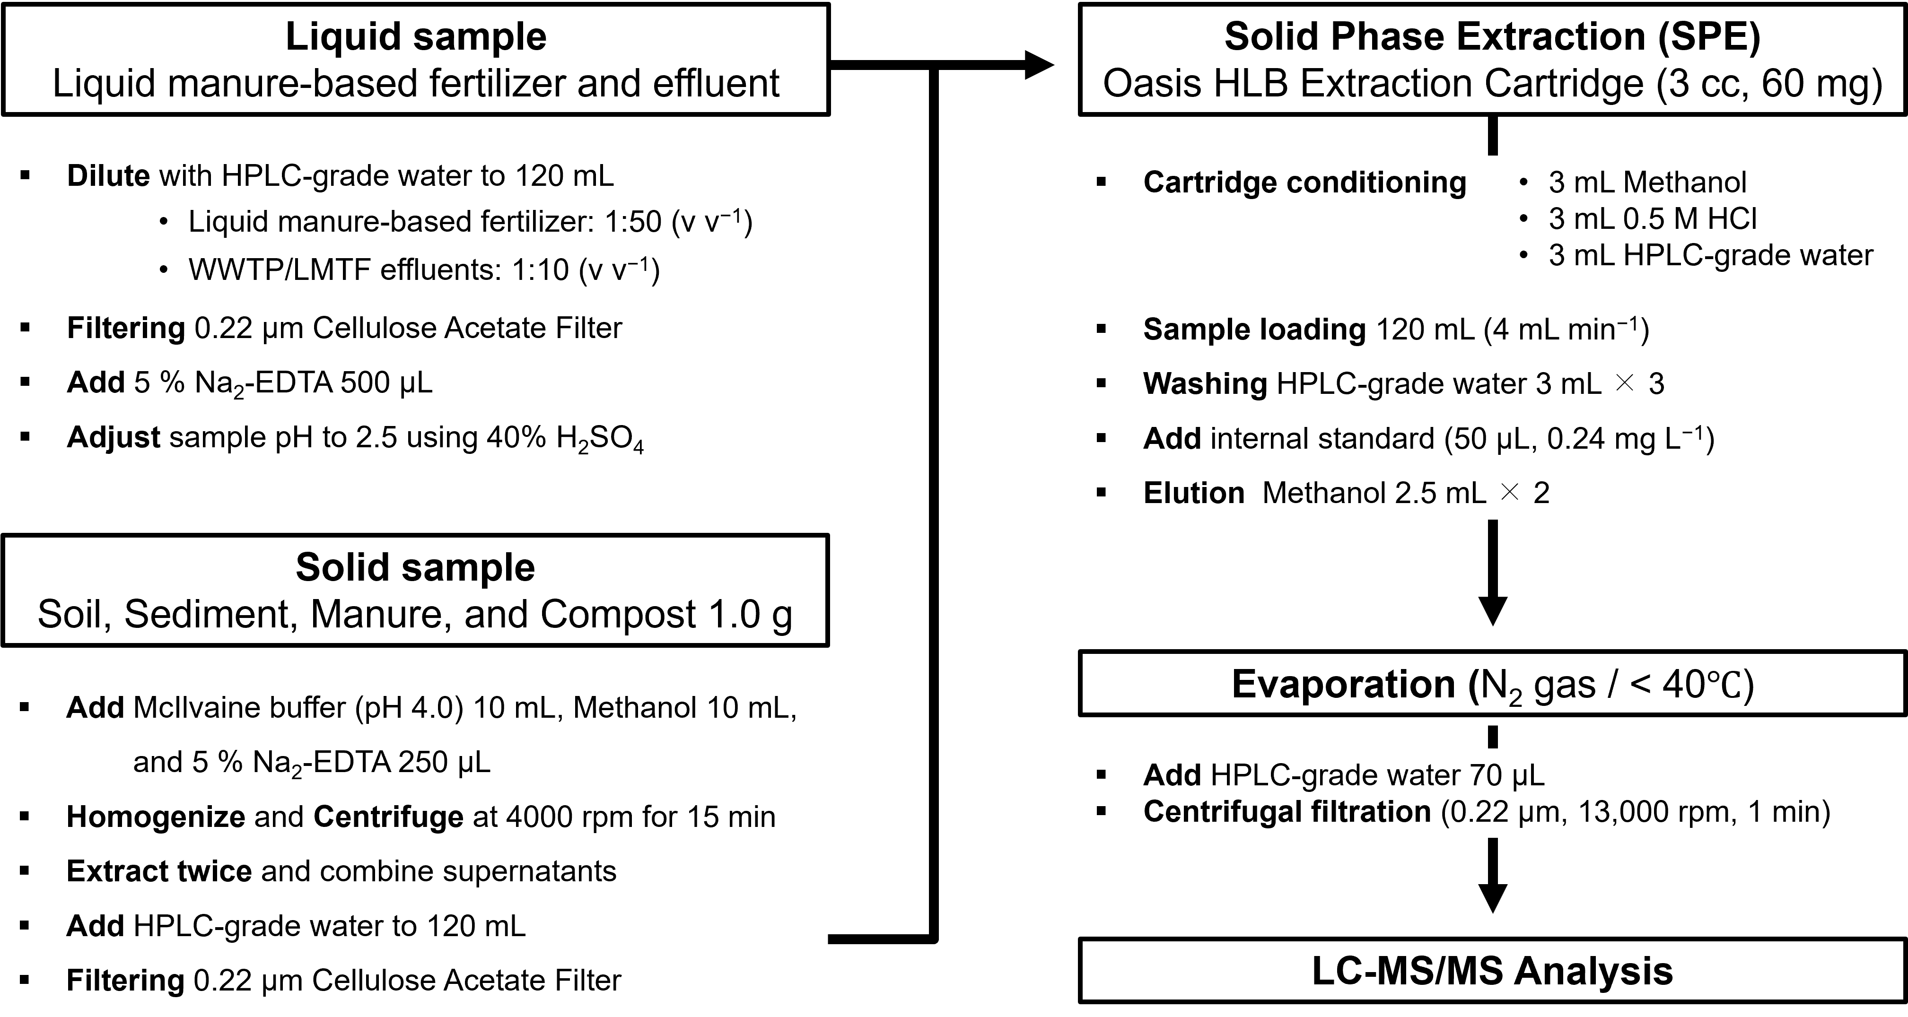
Fig. S1. Flow diagram of the analytical procedure for determination of antibiotics in environmental samples.

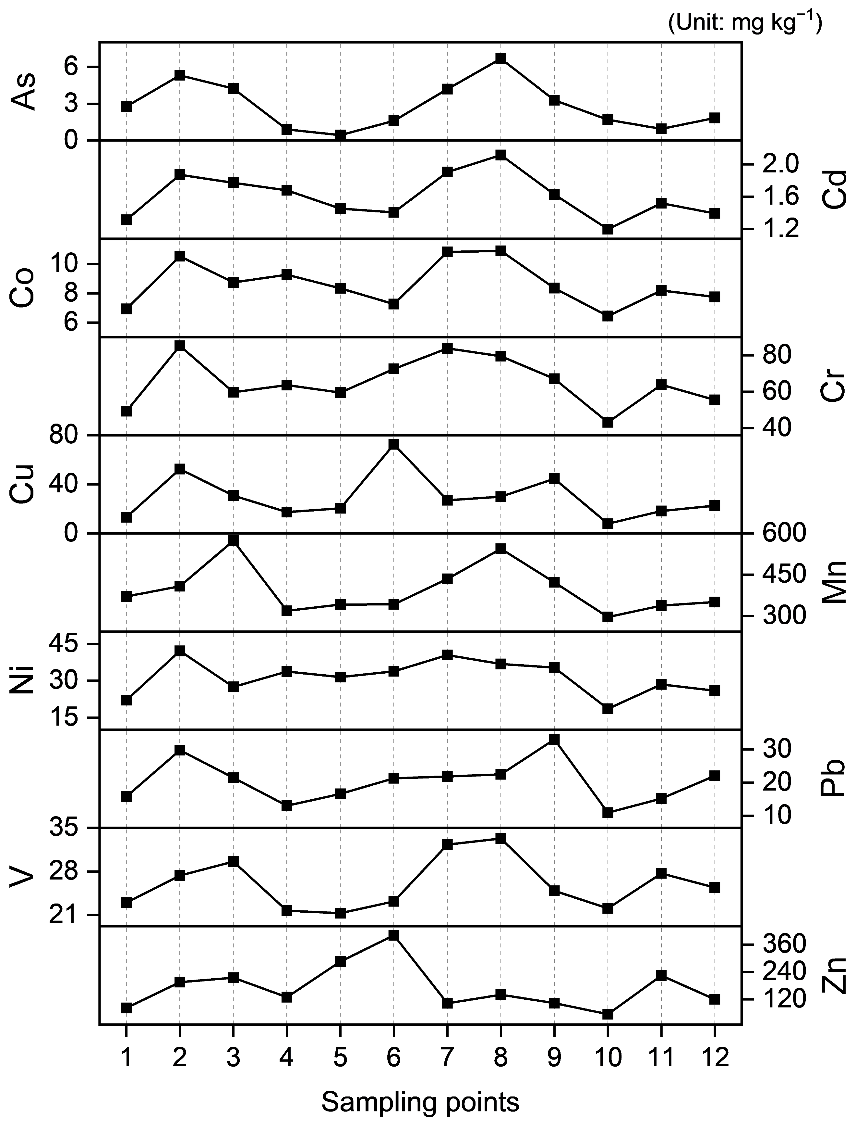
Fig. S2. Distribution patterns of heavy metal(loid)s across sampling points in sediments from Muhan Stream.

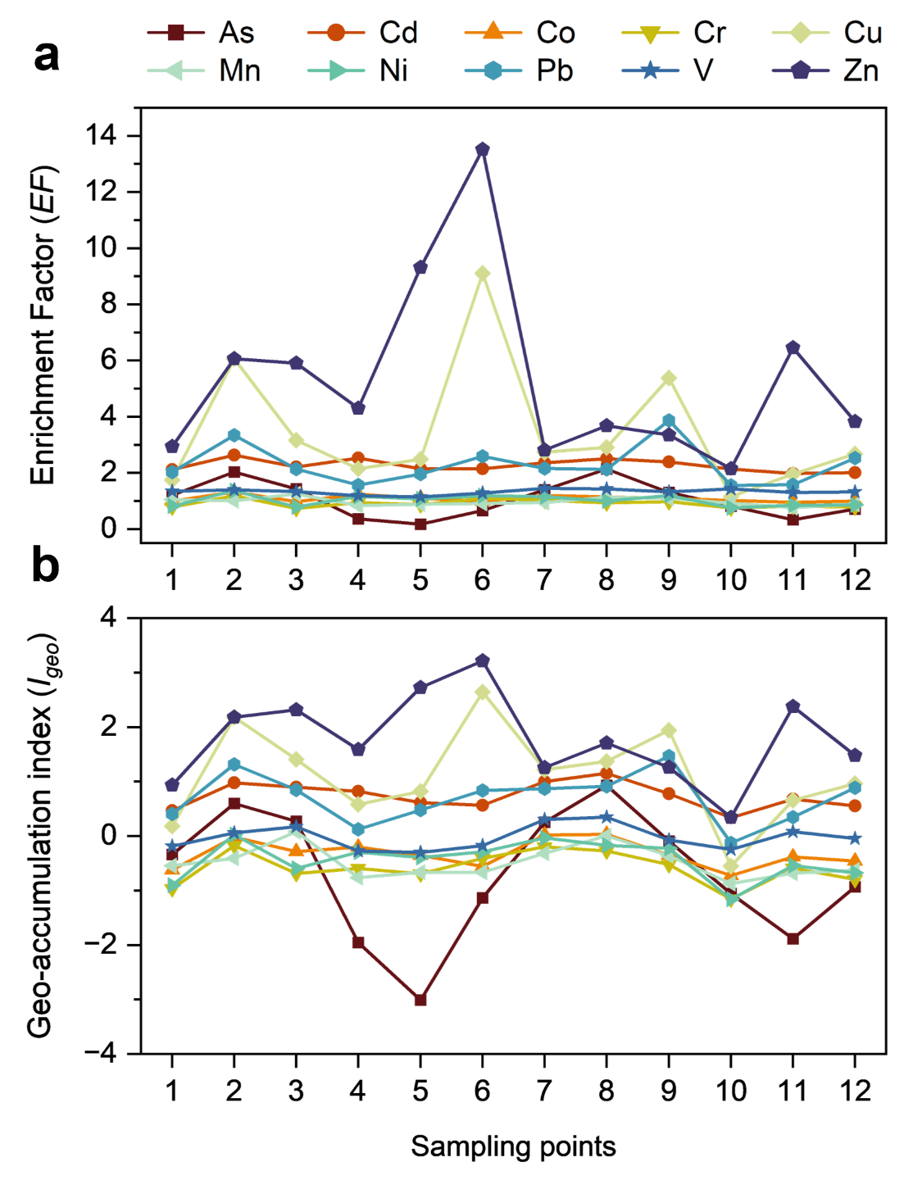
Fig. S3. Spatial variations in (a) enrichment factor (EF) and (b) geo-accumulation index (I_{geo}) for heavy metal(loid)s in the Muhan Stream sediments.

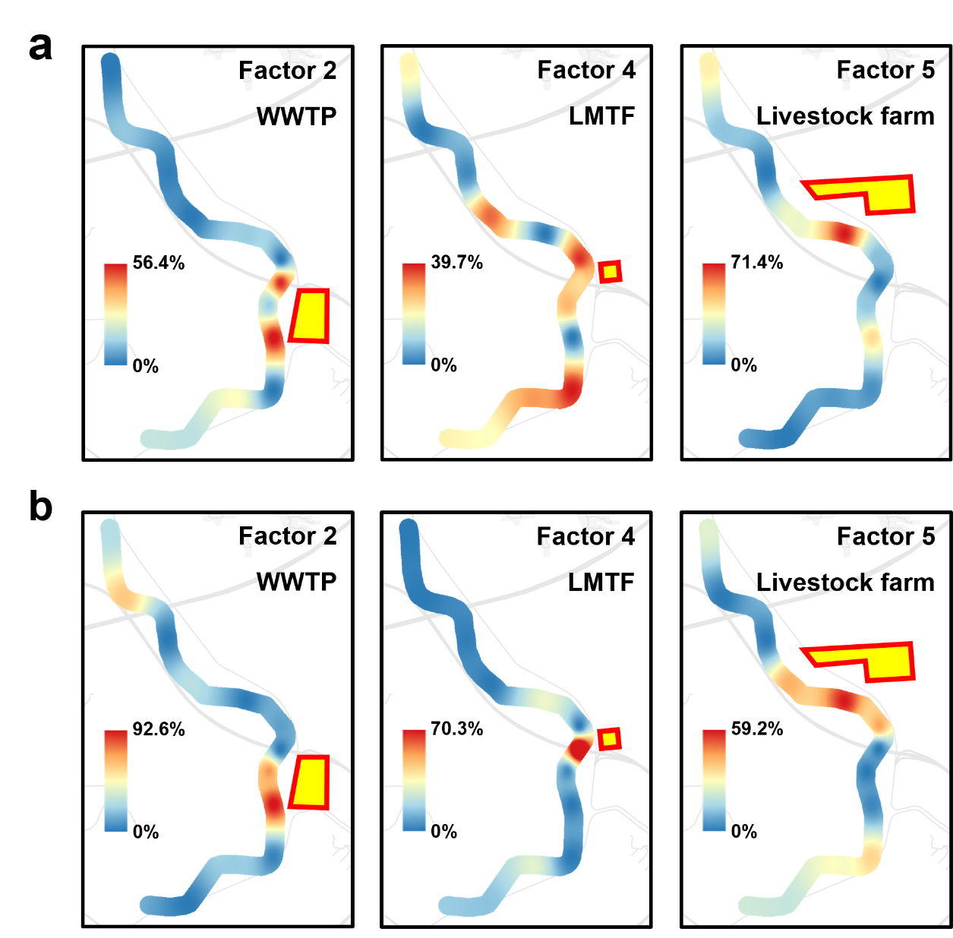
Fig. S4. GIS-based comparison of source-related factor contributions derived from two PMF models in sediments from Muhan Stream. Contribution patterns from (a) the antibiotic-based PMF model and (b) the integrated PMF model based on antibiotics and heavy metal(loid)s are shown. Site-specific factor contributions were spatially interpolated using inverse distance weighting (IDW). Color scales indicate site-specific factor contributions (%) and were independently scaled to the maximum contribution observed for each factor. Red-outlined areas indicate the locations or areas of the corresponding pollution sources.

References
Barbieri, M. (2016). The importance of enrichment factor (EF) and geoaccumulation index (Igeo) to evaluate the soil contamination. Journal of Geology & Geophysics, 5, 1–4. https://doi.org/10.4172/2381-8719.1000237.
Batley, G., Van Dam, R., Warne, M. S. J., Chapman, J., Fox, D., Hickey, C., & Stauber, J. (2014). Technical rationale for changes to the method for deriving Australian and New Zealand water quality guideline values for toxicants. Australian Government Standing Council on Environment and Water, Canberra.
Baumann, K., Jayanty, R., & Flanagan, J. B. (2008). Fine particulate matter source apportionment for the chemical speciation trends network site at Birmingham, Alabama, using positive matrix factorization. Journal of the Air & Waste Management Association, 58, 27–44. https://doi.org/10.3155/1047-3289.58.1.27.
Boukhelkhal, A., Benkortbi, O., Hamadeche, M., Hanini, S., & Amrane, A. (2015). Removal of amoxicillin antibiotic from aqueous solution using an anionic surfactant. Water, Air, & Soil Pollution, 226, 323. https://doi.org/10.1007/s11270-015-2587-z.
Brown, S. G., Eberly, S., Paatero, P., & Norris, G. A. (2015). Methods for estimating uncertainty in PMF solutions: Examples with ambient air and water quality data and guidance on reporting PMF results. Science of the Total Environment, 518, 626–635. https://doi.org/10.1016/j.scitotenv.2015.01.022.
Chen, K., & Zhou, J. (2014). Occurrence and behavior of antibiotics in water and sediments from the Huangpu River, Shanghai, China. Chemosphere, 95, 604–612. https://doi.org/10.1016/j.chemosphere.2013.09.119.
Chen, Y., Jiang, C., Wang, Y., Song, R., Tan, Y., Yang, Y., & Zhang, Z. (2022). Sources, environmental fate, and ecological risks of antibiotics in sediments of Asia’s longest river: a whole-basin investigation. Environmental Science & Technology, 56, 14439–14451. https://doi.org/10.1021/acs.est.2c03413.
Dong, W., Ci, M., Yan, X., Wang, Y., Zhang, G., Xu, W., Gao, X., Xie, K., & Wang, W. (2022). Antibiotics in the surface water and sediment from the tributaries of the Xiaoqing River, China: Occurrence, distribution and risk assessment. Desalination and Water Treatment, 247, 229–243. https://doi.org/10.5004/dwt.2022.28003.
Fan, H., Wang, Y., Liu, X., Wang, Y. Y. L., Kazmi, S. S. U. H., Ohore, O. E., Liu, W., & Wang, Z. (2022). Derivation of predicted no-effect concentrations for thirty-five pharmaceuticals and personal care products in freshwater ecosystem. Frontiers in Marine Science, 9, 1043792. https://doi.org/10.3389/fmars.2022.1043792.
Fu, C., Xu, B., Chen, H., Zhao, X., Li, G., Zheng, Y., Qiu, W., Zheng, C., Duan, L., & Wang, W. (2022). Occurrence and distribution of antibiotics in groundwater, surface water, and sediment in Xiong'an New Area, China, and their relationship with antibiotic resistance genes. Science of the Total Environment, 807, 151011. https://doi.org/10.1016/j.scitotenv.2021.151011.
Guo, W., Liu, X., Liu, Z., & Li, G. (2010). Pollution and potential ecological risk evaluation of heavy metals in the sediments around Dongjiang Harbor, Tianjin. Procedia environmental sciences, 2, 729–736. https://doi.org/10.1016/j.proenv.2010.10.084.
Kemp, A., Thomas, R., Dell, C., & Jaquet, J. M. (1976). Cultural impact on the geochemistry of sediments in Lake Erie. Journal of the Fisheries Board of Canada, 33, 440–462. https://doi.org/10.1139/f76-065.
Lee, M. S., Lee, J. H., An, Y. J., Park, C. H., Lee, S. H., Park, J. H., Lee, J. K., & Park, T. J. (2020). Development of water quality criteria for arsenic to protect aquatic life based on species sensitivity distribution. Ecotoxicology and Environmental Safety, 189, 109933. https://doi.org/10.1016/j.ecoenv.2019.109933.
Li, H., Meng, F., & Li, A. (2023). Ecological risk assessment for xylenes and propylbenzenes in aquatic environment using a species sensitivity distribution approach. Ecotoxicology and Environmental Safety, 261, 115106. https://doi.org/10.1016/j.ecoenv.2023.115106.
Lin, C. E., Chang, C. C., & Lin, W. C. (1997). Migration behavior and separation of sulfonamides in capillary zone electrophoresis III. Citrate buffer as a background electrolyte. Journal of Chromatography A, 768, 105–112. https://doi.org/10.1016/S0021-9673(97)00010-1.
Liu, D., Lin, B., Kandasamy, S., Wang, H., Liu, Q., Zou, W., Zhu, A., Zou, J., Lou, J. Y., & Shi, X. (2019). Geochemical appraisal of chemical weathering and metal contamination in coastal surface sediments, off northwest Hainan Island, the Gulf of Tonkin. Frontiers in Marine Science, 6, 363. https://doi.org/10.3389/fmars.2019.00363.
Muller, G. (1969). Index of geoaccumulation in sediments of the Rhine River.
Nam, S. H., Lee, W. M., & An, Y. J. (2012). Derivation of ecological protective concentration using the probabilistic ecological risk assessment applicable for Korean water environment:(I) Cadmium. Toxicological Research, 28, 129–137. https://doi.org/10.5487/TR.2012.28.2.129.
Qiang, Z., & Adams, C. (2004). Potentiometric determination of acid dissociation constants (pKa) for human and veterinary antibiotics. Water Research, 38, 2874–2890. https://doi.org/10.1016/j.watres.2004.03.017.
Sayers, E. W., Beck, J., Bolton, E. E., Bourexis, D., Brister, J. R., Canese, K., Comeau, D. C., Funk, K., Kim, S., & Klimke, W. (2021). Database resources of the national center for biotechnology information. Nucleic Acids Research, 49, D10. https://doi.org/10.1093/nar/gkaa892.
Voznakova, A., Antao-Geraldes, A. M., & Canle, M. (2025). Pharmaceuticals in the Douro basin: Occurrence, distribution, and ecological risk. Journal of Environmental Chemical Engineering, 119181. https://doi.org/10.1016/j.jece.2025.119181.
Zhang, J., & Liu, C. (2002). Riverine composition and estuarine geochemistry of particulate metals in China—weathering features, anthropogenic impact and chemical fluxes. Estuarine, Coastal and Shelf Science, 54, 1051–1070. https://doi.org/10.1006/ecss.2001.0879.
Zhang, Y., Chen, H., Jing, L., & Teng, Y. (2020). Ecotoxicological risk assessment and source apportionment of antibiotics in the waters and sediments of a peri-urban river. Science of the Total Environment, 731, 139128. https://doi.org/10.1016/j.scitotenv.2020.139128.
Zonta, R., Zaggia, L., & Argese, E. (1994). Heavy metal and grain-size distributions in estuarine shallow water sediments of the Cona Marsh (Venice Lagoon, Italy). Science of the Total Environment, 151, 19–28. https://doi.org/10.1016/0048-9697(94)90482-0.

