Supporting Information

In Situ Investigation of Water Splitting Mechanisms in Non-Thermal Plasma
Shani Har Lavanª, Sharona Atlas^{a,b}, Avi Lehrerª, Illya Rozenbergª, Amir Kaplan^{a,b}* amirk@nrcn.org.il, Joshua H. Barabanª* jbaraban@bgu.ac.il
- Department of Chemistry, Ben-Gurion University of the Negev, 1 Ben-Gurion Blvd., Beer-Sheva 8410501, Israel
- Department of Chemical Engineering, Nuclear Research Center Negev, P.O. Box 9001, Beer-Sheva, 84190, Israel

Table of Contents
S1. Experimental setup 1
S2. Quantification protocol and species mass balance 2
Baseline calibration (without plasma; the "OFF" state) 2
Species deconvolution and flow calculation when the plasma is applied (the “ON” state) 2
S3. Parameter definitions 3
S4. Supporting results 3
References: 8

S1. Experimental setup
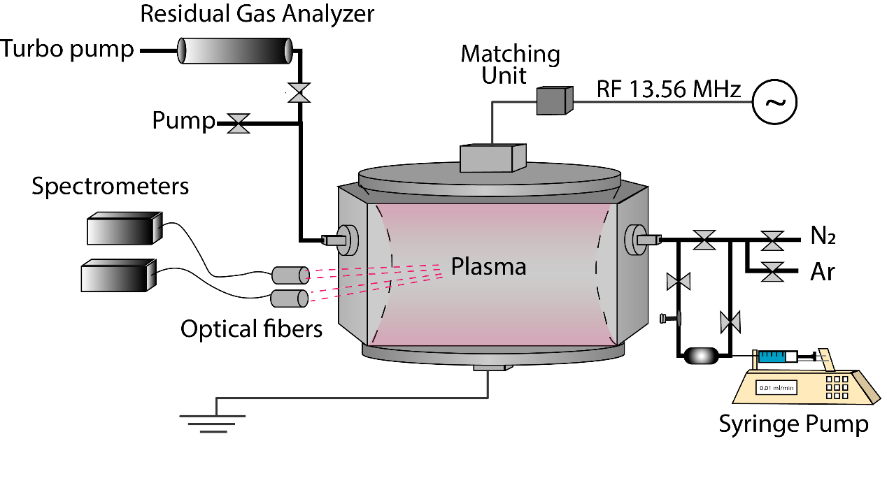
Fig. S1 Schematic diagram of the experimental setup. The injection gas line loop is heated by a heating coil all the way to the chamber to prevent condensation.

S2. Quantification protocol and species mass balance
To quantify the absolute flow rates (in SCCM) of reactants and plasma-generated products from Residual Gas Analyzer (RGA) ion counts, a two-step procedure was established. First, baseline calibration curves were obtained under plasma "off" conditions for parent species (H₂, H₂O, and O₂). Second, a deconvolution framework was applied to distinguish ions generated via electron-impact fragmentation on the RGA filament from those directly produced by the plasma (H, OH, and O radicals).
Baseline calibration (without plasma; the "OFF" state)
Direct flow calibration was performed using H₂ (2–20 SCCM in Ar carrier gas), H₂O liquid injection (0.005–0.025 mL min⁻¹ in Ar), and O₂ (2-20 SCCM in Ar carrier gas). The resulting ion counts (recorded as partial pressures in Torr) established linear calibration curves relating parent-ion signals (m/z = 2 for H₂⁺, m/z = 18 for H₂O⁺, and m/z = 32 for O₂) directly to flow rates (Fig. S2). These straightforward calibration curves were subsequently useful for calibrating the effusion of unstable species as well.
H₂⁺, H₂O⁺, OH⁺, H⁺, O⁺: Under plasma "off" conditions, water vapor introduced into the chamber undergoes fragmentation on the hot tungsten filament of the RGA (70 eV) according to:
$$H_{2}O+e^{-}→ H_{2}^{+}, H_{2}O^{+}, {OH}^{+},{ H}^{+}, { O}^{+}$$
To establish the reference fragmentation fingerprint of H₂O on the RGA filament:
- The H₂O⁺ signal (m/z = 18) was measured and converted to flow rate via the H₂O calibration curve (Fig. S2).
- The relative contributions of daughter ions (H₂⁺, H₂O⁺, OH⁺, H⁺, O⁺) resulting from filament-induced H₂O dissociation were calculated using literature partial ionization cross-sections [1-8]. This provides baseline fragmentation ratios relative to the parent H₂O⁺ signal, accounting for minor background H₂ present in the stainless-steel chamber.

Species deconvolution and flow calculation when the plasma is applied (the “ON” state)
Detected RGA signals represent a superposition of unreacted parent molecules, direct plasma-generated radicals (H, OH, O), and filament fragmentation products. The net ion counts (represented by $I$) of plasma-generated species were deconvoluted in an iterative hierarchy as follows:
  - Water dissociation correction: The contribution of unreacted H₂O to m/z = 17 (OH⁺), m/z = 1 (H⁺), and m/z = 2 (H₂⁺) was calculated by scaling the measured H₂O⁺ signal (m/z = 18) using the baseline fragmentation ratios established in the "OFF" state.
  - Hydrogen signal isolation: The net H₂⁺ partial pressure originating from the reactor was calculated by subtracting the filament-generated H₂⁺ (derived from H₂O fragmentation) from the total measured m/z = 2 signal.
  - Radical signal deconvolution (H, OH, O): Direct radical products were quantified by subtracting all secondary filament fragmentation contributions from the primary measured signals. For example, the net hydrogen radical signal is calculated as:
$$I_{H^{+} net=}I_{measured \frac{m}{z}=1}-I_{\left(H_{2}O→H^{+}\right)}-I_{\left(H_{2}→H^{+}\right)}-I_{\left(OH→H^{+}\right)}$$

Flow rate conversion:
- Flow rates for H₂O, H₂, and O₂ were obtained directly from their deconvoluted partial pressures using the "OFF" state calibration curves.
- For reactive radical species (H, OH, O), absolute flow rates were derived by combining partial pressure relationships with corrections based on Graham's law of effusion (Q ∝P /$\sqrt{m}$ ), validated against multi-flow baseline measurements (4 and 8 SCCM).

S3. Parameter definitions
The water conversion to hydrogen % and energy efficiency are defined following equations (1) and (4) from Ref. 9.

S4. Supporting results
Fig S2. Water (black), hydrogen (blue), and oxygen (red) calibration curves recorded at an Ar flow rate of 100 SCCM, linking direct RGA partial pressure (Torr) measurements to flow rate (SCCM), after background subtraction.
Fig S3. Water splitting products overview from the FLAME-S at 100 SCCM Ar, 100 W. (a) without water (b) with water at 0.01 ml/min. Ar I refers to the first spectral series, i.e. for neutral Ar.
Fig. S4. The m/z species measured with the RGA with (red) and without (black) plasma. During plasma operation, a clear reduction in the H₂O and OH signals was observed, indicating their consumption in water-splitting reactions. The combined in situ OES and ex situ RGA measurements confirm that the detected hydrogen and oxygen-containing species originate from plasma-driven water dissociation in the reactor.
Fig S5. Qualitative comparison of the effect of carrier gas (Ar and N₂) on the H₂ signal as a function of water injection rate. The injection rates above the data points units are ml/min.
Fig S6. The emission of argon and nitrogen plasmas. Nitrogen fluorescence suppresses that of water-related plasma species such OH radical, H atom and H₂.
Reaction information, H₂ | Production |  | Losses
Plasma power (W) | e + H₂O H₂ + O⁻ | H₂⁺ + H₂O H₂O⁺ + H₂ | e +H₂ e + H + H | H₂ + H₂⁺ H₃⁺ + H
50 | 91.95% | 4.40% | 97.64% | 1.76%
100 | 73.68% | 22.67% | 91.46% | 7.59%
150 | 57.85% | 38.03% | 86.14% | 13.03%
200 | 46.67% | 48.26% | 81.58% | 17.55%
250 | 38.80% | 55.09% | 77.75% | 21.36%

Table S1. The most influential reaction on production and loss processes for H₂ as a function of power (50- 250 W). Reactions not listed in the table account for the remaining percentage, such that the total contribution sums to 100%.

Reaction information OH | Production |  |  | Losses
Plasma power (W) | e + H₂O e + OH + H*_{(n=2)} | e + H₂O e +H+OH | H + HO₂ 2OH | OH + H₂O₂ HO₂ + H₂O | OH + OH H₂O₂
50 | 53.75% | 24.79% | 11.64% | 74.23% | 18.38%
100 | 52.65% | 23.27% | 14.90% | 70.38% | 21.40%
150 | 52.35% | 22.57% | 16.16% | 68.49% | 22.72%
200 | 52.39% | 22.20% | 16.59% | 67.46% | 23.29%
250 | 52.53% | 21.97% | 16.68% | 66.63% | 23.65%

Table S2. The most influential reaction on production and loss processes for OH as a function of power (50- 250 W). Reactions not listed in the table account for the remaining percentage, such that the total contribution sums to 100%.

Reaction information H | Production |  | Losses
Plasma power (W) | H*_{(n=2)} H | e + H₂O e + H + OH | OH⁻+H H₂O + e | H + HO₂ 2OH
50 | 67.10% | 30.68% | 55.13% | 40.47%
100 | 67.33% | 28.97% | 41.40% | 47.95%
150 | 67.07% | 27.66% | 34.29% | 49.67%
200 | 66.64% | 26.61% | 29.92% | 49.61%
250 | 66.13% | 25.75% | 26.82% | 49.10%

Table S3. The most influential reaction on production and loss processes for H atom as a function of power (50- 250 W). Reactions not listed in the table account for the remaining percentage, such that the total contribution sums to 100%.

Fig S7. N₂ as a probe (2 SCCM) to assess the rotational temperature of the plasma residuals in Ar/H₂O plasma.
Fig S8. N₂ as a probe (2 SCCM) to assess the vibrational temperature of the plasma residuals in Ar/H₂O plasma.

References:
[1] Song, Mi-Young, et al. "Cross sections for electron collisions with H₂O." Journal of Physical and Chemical Reference Data 50.2 (2021).‏
[2] Brook, E., M. F. A. Harrison, and A. C. H. Smith. "Measurements of the electron impact ionisation cross sections of He, C, O and N atoms." Journal of Physics B: Atomic and Molecular Physics 11.17 (1978): 3115-3132.‏
[3] Thompson, W. R., M. B. Shah, and H. B. Gilbody. "Single and double ionization of atomic oxygen by electron impact." Journal of Physics B: Atomic, Molecular and Optical Physics 28.7 (1995): 1321-1330.‏
[4] Tian, Cechan, and C. R. Vidal. "Electron impact ionization of and: contributions from different dissociation channels of multiply ionized molecules." Journal of Physics B: Atomic, Molecular and Optical Physics 31.24 (1998): 5369-5381.‏
[5] Sharma, R., and S. P. Sharma. "Direct and dissociative ionization cross section of oxygen molecule from threshold to 10 KeV." Int. J. Eng. Adv. Technol.(IJEAT) 8.6s3 (2019): 1365-1368.‏
[6] Straub, H. C., et al. "Absolute partial cross sections for electron-impact ionization of H₂, N₂, and O₂ from threshold to 1000 eV." Physical Review A 54.3 (1996): 2146.‏
[7] Tarnovsky, V., H. Deutsch, and K. Becker. "Electron impact ionization of the hydroxyl radical." The Journal of chemical physics 109.3 (1998): 932-936.‏
[8] McConkey, J. W., et al. "Electron impact dissociation of oxygen-containing molecules–A critical review." Physics Reports 466.1-3 (2008): 1-103.‏
[9] Zhang, Hao, et al. "Rotating gliding arc assisted water splitting in atmospheric nitrogen." Plasma Chemistry and Plasma Processing 36.3 (2016): 813-834.‏

