Supplement material

Table S1 Zeaxanthin production potential of bacteria from the Flavobacteriaceae
177 genera were checked for genome sequencing information, and 115 genomes were detected for zeaxanthin production, 62 genera contain the whole three enzymes for zeaxanthin production. N, none; T, positive for coding genes of three enzymes (phytoene desaturase, lycopene beta-cyclase, beta-carotene 3-hydroxylase) in zeaxanthin biosynthesis.
Genus from Flavobacteriaceae | Genome state | Zeaxanthin production
Actibacter | N
Aequorivita
Aestuariibaculum
Aestuariicola | N
Aestuariimonas | N
Aestuariivivens | N
Algibacter
Algitalea | N
Altibacter
Altuibacter | N
Amniculibacterium
Antarcticibacterium |  | T
Antarcticimonas | N
Aquaticitalea | N
Aquibacter | N
Aquimarina |  | T
Arcticiflavibacter
Arenibacter |  | T
Arenitalea |  | T
Ascidiaceibacter | N
Ascidianibacter | N
Ascidiimonas | N
Aurantiacicella | N
Aurantibacter
Aurantivirga | N
Aureibaculum |  | T
Aureicoccus |  | T
Aureimarina | N
Aureisphaera | N
Aureitalea
Aureivirga | N
Avrilella
Bizionia |  | T
Capnocytophaga
Cellulophaga
Cellulophaga |  | T
Changchengzhania
Citreibacter | N
Citreitalea | N
Coccinimonas | N
Coccinistipes | N
Cochleicola
Coenonia | N
Confluentibacter |  | T
Coraliitalea | N
Corallibacter | N
Costertonia
Croceibacter |  | T
Croceimarina | N
Croceitalea |  | T
Croceivirga |  | T
Daejeonia | N
Dokdonia |  | T
Eudoraea |  | T
Euzebyella |  | T
Faecalibacter | N
Feifantangia | N
Flagellimonas |  | T
Flavicella
Flavimarina |  | T
Flaviramulus
Flavivirga
Flavobacterium |  | T
Flavococcus | N
Formosa
Frondibacter | N
Fulvibacter | N
Gaetbulibacter |  | T
Galbibacter
Gangjinia | N
Gelatiniphilus | N
Gelidibacter |  | T
Geojedonia | N
Gillisia |  | T
Gilvibacter
Gramella |  | T
Haloflavibacter |  | T
Haloanella | N
Hanstruepera
Hoppeia | N
Hwangdonia | N
Hyunsoonleella |  | T
Ichthyenterobacterium
Ilumomonas | N
Imtechella
Jejudonia
Jejuia |  | T
Joostella
Kordia |  | T
Kriegella
Lacinutrix |  | T
Leeuwenhoekiella |  | T
Leptobacterium |  | T
Litoribaculum | N
Lutaonella | N
Lutibacter
Lutimonas | N
Mangrovimonas
Maribacter |  | T
Mariniflexile |  | T
Marinirhabdus
Marinitalea | N
Maripseudobacter |  | T
Maritimimonas | N
Marixanthomonas
Meridianimaribacter
Mesoflavibacter |  | T
Mesohalobacter |  | T
Mesonia |  | T
Muricauda |  | T
Muriicola |  | T
Myroides |  | T
Namhaeicola | N
Neptunitalea
Nonlabens |  | T
Oceanihabitans
Oceanistipes | N
Ochrovirga pacifica
Olleya |  | T
Orabacterium | N
Paramesonia | N
Patiriisocius
Paucihalobacter |  | T
Pelagihabitans |  | T
Pibocella | N
Planktosalinus | N
Polaribacter |  | T
Pontimicrobium
Pontirhabdus
Poritiphilus |  | T
Postechiella | N
Pricia |  | T
Pseudobizionia
Pseudofulvibacter | N
Pseudotenacibaculum | N
Pseudozobellia |  | T
Psychroflexus |  | T
Psychroserpens |  | T
Pustulibacterium |  | T
Robertkochia
Robiginitalea |  | T
Sabulilitoribacter | N
Salegentibacter |  | T
Salinimicrobium
Saonia
Sediminibacter |  | T
Sediminicola
Seonamhaeicola
Siansivirga |  | T
Sinomicrobium
Snuella | N
"Spodiobacter" | N
Spongiiferula | N
Spongiimicrobium |  | T
Spongiivirga |  | T
Spongitalea | N
Subsaxibacter | N
Subsaximicrobium
Sufflavibacter | N
Sungkyunkwania | N
Taeania | N
Tamlana
Tenacibaculum
Ulvibacter |  | T
Ulvibacterium |  | T
Urechidicola
Vaginella
Wenyingzhuangia
Winogradskyella |  | T
Wocania
Xanthobacillum | N
Xanthomarina
Yeosuana |  | T
Zeaxanthinibacter |  | T
Zhouia
Zobellia |  | T
Zunongwangia |  | T
Total: 177 genera | 115 genomes were checked | 62 genomes have all three enzymes

Table S2 Cellular fatty acids of strain R38^{T} and reference type strains
Strains: 1, R38^{T}; 2, Leptobacterium flavescens 22160^{T}; 3, Spongiivirga citrea 32990^{T}. ND, not detected; -, lower than 1% total fatty acid content.
Fatty acids | 1 | 2. | 3
C_{13:1}ω3c | 5.2 | 2.2 | 1.3
C_{14:0} | 2.4 | ND | ND
C_{15:0} | 4.9 | 7.5 | 4.2
C_{15:0} aldehyde | ND | 1.6 | ND
Anteiso-C_{15:0} | 1.1 | 1.0 | 1.0
Iso-C_{15:0} | 42.4 | 43.3 | 31.2
Iso-C_{15:1}ω6c | 15.6 | 17 | 27.7
C_{16:0} | 4.4 | 4.2 | 1.2
Iso-C_{16:0} | 4.1 | 3.4 | 1.4
C_{16:1}ω3c | 1.2 | ND | ND
C_{16:1}ω6c | 2.7 | 4.9 | 7.4
C_{16:2} DMA | 7.8 | 9.4 | 19.6
C_{16:4}ω3c | 1.9 | - | -
Iso-C_{17:0} | 0.3 | - | ND
Anteiso-C_{17:1} ω7c | 1.5 | 2.0 | 1.0
Iso-C_{17:1} ω9c | 2.3 | 1.6 | 2.2

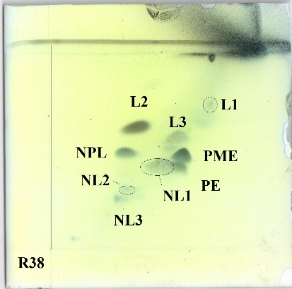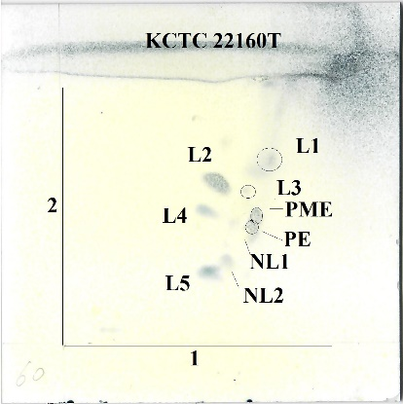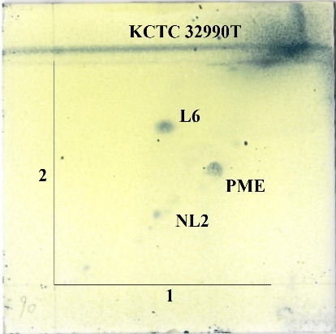
Fig.S1 Two dimensional thin-layer chromatography of polar lipids of strain R38^{T} and related type strains. Lipids were determined by spraying with molybdophosphoric acid, molybdenum blue, ninhydrin, α-naphthol/sulphuric acid and Dragendorff's reagent. PME, phosphatidylmathylethanolamine; PE, phosphatidylethanolamine; NL, unidentified ninhydrin positive lipid; NPL, unidentified ninhydrin positive phospholipid; L, unidentified lipid.

Gaetbulibacter cluster 7 genera
Flaviramulus cluster 2 genera
Algibacter cluster 5 genera
Olleya
Lacinutrix
Mesoflavibacer
Flavivirga aquimarina EC2D5^{T}(NR_157724)
Ichthyenterobacterium magnum Th6^{T}(NR_134750)
Bizionia cluster 4 genera
Gilvibacter sediminis Mok-1-36^{T}(NR 041451)
Spongiivirga citrea KCTC 32990^{T}(NR 134814)
Aquimarina
Salinimicrobium
Gillisia limnaea DSM 15749^{T}(NR 042141)
Salegentibacter echinorum HD4^{T}(NR 126228)
Zunongwangia cluster 2 genera
Fulvibacter tottoriensis MTT-39^{T}(NR 041572)
Prasibacter corallicola R38^{T}(MN908337)
Leptobacterium flavescens KCTC22160^{T}(NR_114257)
Pseudotenacibaculum haliotis FDZSB0410^{T}(NR_151976)
Lutibacter
Escherichia coli ATCC 11775^{T}(X80725)
100
99
97
88
85
99
63
98
63
56
99
72
85
57
51
50
50
0.05
Fig.S2 Neighbor-joining phylogenetic tree based on the 16S rRNA gene sequences of strain R38^{T} and related taxa. Sequences from the Escherichia coli was used as out group. Numbers at nodes indicate percentages of 1000 bootstrap resamplings; only values above 50% are shown. Bar, 0.05 substitutions per nucleotide position.

Algibacter cluster 8 genera
Gaetbulibacter cluster 3 genera
Gaetbulibacter aestuarii KYW382^{T}(NR_125554)
Flaviramulus ichthyoenteri Th78T(NR_118464)
Flaviramulus basaltis H35^{T}(NR_043753)
Flaviramulus aestuariivivens OITF-51^{T}(NR_157630)
Mariniflexile
Mariniflexile ostreae TYO-10^{T}(NR_126311)
Confluentibacter lentus HJM-3^{T}(NR_148660)
Snuella lapsa JC2132^{T}(NR_117856)
Yeosuana aromativorans GW1-1^{T}(NR_043102)
Olleya
Lacinutrix
Mesoflavibacter
Biziona cluster 6 genera
Gilvibacter sediminis Mok-1-36^{T}(NR 041451)
Fulvibacter tottoriensis MTT-39^{T}(NR 041572)
Pseudotenacibaculum haliotis FDZSB0410^{T}(NR 151976)
Lutibacter
Aquimarina
Salinimicrobium
Gillisia limnaea DSM 15749^{T}(NR 042141)
Salegentibacter echinorum HD4^{T}(NR 126228)
Zunongwangia
Prasibacter corallicola R38^{T}(MN908337)
Leptobacterium flavescens KCTC 22160^{T}(NR 114257)
Escherichia coli ATCC 11775^{T}(X80725)
97
79
96
96
98
55
85
88
65
74
87
66
87
55
Fig.S3 Maximum-parsimony phylogenetic tree based on the 16S rRNA gene sequences of strain R38T and related taxa. Sequences from the Escherichia coli was used as out group. Numbers at nodes indicate percentages of 1000 bootstrap resamplings; only values above 50% are shown.

Clade I
Clade II
Spongiivirga citrea KCTC 32990^{T}(JAABOQ000000000)
Clade III
Pustulibacterium marinum CGMCC 1.12333^{T}(GCA_900116665)
Imtechella halotolerans K1^{T}(GCA_000260835)
Leptobacterium flavescens KCTC 22160^{T}(JAABOO000000000)
Prasibacter corallicola R38^{T}(WXYP00000000)
Aureitalea marina NBRC 107741^{T}(GCA_002943755)
Aureicoccus marinus SG-18^{T}(GCA_002954325)
R33 (WXYO00000000)
Robiginitalea biformata HTCC2501^{T}(GCA_000024125)
Muriicola jejuensis KCTC 22299^{T}(JAABOP000000000)
Robertkochia marina CC-AMO-30D^{T}(GCA_004799345)
Sinomicrobium oceani CGMCC 1.12145^{T}(GCA_900119185)
Zhouia amylolytica CGMCC 1.6114^{T}(GCA_900116365)
Joostella marina DSM 19592^{T}(GCA_000260115)
Galbibacter marinus ck-I2-15^{T}(GCA_000300875)
Kordia algicida OT-1^{T}(GCA_000154725)
Clade IV
Flavobacterium psychrophilum JIP02/86^{T}(GCA_000064305)
Myroides odoratimimus PR63039^{T}(GCA_001481655)
Myroides odoratus DSM 2801^{T}(GCA_000243275)
Capnocytophaga ochracea DSM 7271^{T}(GCA_000023285)
Clade V
Escherichia coli K12 (GCA_000005845)
88
92
92
92
92
92
62
60
92
92
92
92
92
92
90
72
92
92
80
0.5
Fig.S4 Phylogenetic tree inferred using UBCGs (concatenated alignment of 92 core genes). Gene support indices (GSIs) is given at branching points. Bar, 0.5 substitution per position. Mesoflavibacter happened to Clade I.

