Supplementary Information
Exposure-Route-Driven Four-Stage Computational Toxicology Assessment Paradigm for Cosmetic Ingredient Safety Evaluation
Initial Screening and Hazard Identification
The target chemical, homosalate (HMS; CAS No. 118-56-9; C₁₆H₂₂O₃), was evaluated using its canonical SMILES string (CC1CC(CC(C1)(C)C)OC(=O)C2=CC=CC=C2O). Initial structural alerts and hazard identification were first performed using Toxtree v3.1.0 (https://toxtree.sourceforge.net/index.html). To comprehensively profile the multi-toxicity endpoints of HMS, the US EPA Hazard Cheminformatics Module (HCM) was used (Vegosen and Martin 2020). The HCM aggregates hazard data from public repositories, literature, and US EPA T.E.S.T. QSAR models, covering human health, ecotoxicity, and environmental fate. Toxicity is stratified qualitatively across five tiers (inconclusive, low, medium, high, and very high), with data provenance explicitly categorized as authoritative, screening, or QSAR-derived. Additional specific toxicological predictions were conducted using the VEGA platform v1.2.6 (https://www.vegahub.eu/). Furthermore, to evaluate the endocrine-disrupting potential of HMS, an in silico high-throughput screening was performed using the EDC Profiler web server (http://www.edcprofiler.cn/service/edcprofiler) (Qiu et al. 2026) and EPA WebTEST (US EPA 2025; https://comptox.epa.gov/dashboard/predictions).

In silico Prediction of Skin Permeation
To evaluate the dermal absorption potential of HMS, the skin permeability coefficient (log Kp) was predicted using two in silico tools: the DERMWIN™ model within the US EPA EPI Suite™ (US EPA 2012) and the SwissADME web server (Daina et al. 2017). Both predictive modules are fundamentally based on the empirical quantitative structure-activity relationship (QSAR) model proposed by Potts and Guy (1992), which estimates log Kp as a linear function of molecular weight (MW) and lipophilicity (log P or log Kow). Specifically, the DERMWIN™ model utilized its internally estimated log Kow value (6.16) as the lipophilicity input. In contrast, the SwissADME platform calculated the skin permeation based on its XLOGP3 value (5.05) derived from multiple predictive methods. The discrepancy in the input lipophilicity descriptors between the two tools was recorded for subsequent comparative analysis.

In silico Prediction of Metabolic Enzymes and Metabolites
To elucidate the metabolic fate of HMS following dermal absorption, a sequential in silico workflow was employed to predict its primary metabolizing enzymes and subsequent metabolites. First, the substrate specificity of HMS toward major cytochrome P450 (CYP) enzymes was evaluated using two advanced, independent deep learning-based platforms: ADMETlab 3.0 (Fu et al. 2024) and Deep-PK (Myung et al. 2024). The canonical SMILES string of HMS was submitted to both web servers. ADMETlab 3.0 utilizes a multi-task directed message passing neural network combined with molecular descriptors (DMPNN-Des), while Deep-PK employs directed message passing neural networks (D-MPNN) integrated with graph-based signatures. A consensus strategy was applied wherein HMS was identified as a high-confidence substrate of a specific CYP isoform only if both platforms yielded consistent positive predictions.
Subsequently, based on the consensus identification of the primary metabolizing enzyme, the BioTransformer platform (Djoumbou-Feunang et al. 2019) was utilized to simulate the CYP-mediated oxidative metabolism and predict the resulting metabolite structures. BioTransformer integrates a knowledge-based approach with machine learning (specifically the CypReact module for CYP substrate specificity) to generate biotransformation products. The SMILES string of HMS was input into the BioTransformer web service, and the CYP450 metabolism prediction module was selected to simulate Phase I oxidative transformations. The predicted metabolites, along with their associated reaction types, catalyzing enzymes, and metabolic pathways, were retrieved and analyzed to map the metabolic profile of HMS. The ten predicted first-generation metabolites and the parent compound were subsequently submitted to EDC Profiler and WebTEST for nuclear receptor screening, to evaluate the reshaping of the hazard profile by metabolic transformation (Figs. S6-S8). Beyond CYP-mediated oxidation, GLORYx (de Bruyn Kops et al. 2021) was applied to predict additional Phase I metabolic reactions of HMS, and an ester bond hydrolysis pathway was identified; the predicted hydrolysis products are listed in Table S3.

Molecular docking
The three-dimensional structures of HMS, C6, C8, and C9 were obtained with ChemBioOffice Ultra 14.0. The MMFF94 protocol was used for ligand standardization and minimization, with the maximum number of iterations set to 5,000. The crystal structures of the ERα ligand-binding domain (PDB code 3ERT) and the PR ligand-binding domain (PDB code 1A28) were obtained from the Protein Data Bank. Molecular docking was performed with AutoDock 4 (Morris et al. 2009), as implemented in MGL Tools 1.5.7, using the Lamarckian genetic algorithm. Polar hydrogen atoms were added to the receptor and Kollman charges were assigned. Grid boxes were set to 40 × 40 × 40 Å with a spacing of 0.375 Å. PyMOL 2.3.2 and Discovery Studio 4.0 were used for analysis of the docking results.

Table S1. Prediction results of HMS skin sensitization based on VEGA 1.2.6
Model Methodology | Type Prediction | Results | Reliability | ADI
CAESAR | QSAR statistics | Sensitizer | MODERATE | 0.773
IRFMN-JRC | QSAR statistics | NON-Sensitizer | LOW | 0（out-of-domain invalid）
NCSTOX | Consensus | Sensitizer | MODERATE/Low | 0.674
CONCERT/Kode | Fragment | Active | MODERATE | 0.855
CONCERT/SarPy | SAR rules | Active | LOW | 0.642
TOXTREE | SAR rules | No class found | — | ADI check failed
Note: ADI, applicability domain index (VEGA); higher ADI values indicate greater confidence in the prediction. The IRFMN-JRC prediction was considered invalid because HMS was outside the model's applicability domain.

Table S2. Prediction results of Phase I metabolites of HMS based on BioTransformer
Compound | SMILES | Molecular formula | Mass | ALogP | Biosystem | Enzyme(s) | Reaction | Precursor | Structure
C1 | O=C(OC1CC(C)CC(C)(C)C1)C=2C=C(C=CC2O)O | C16H22O4 | 278.1518 | 3.7187 | Human | CYP1A2; CYP2A6; CYP2B6; CYP2C8; CYP2C9; CYP2C19; CYP2D6; CYP2E1; CYP3A4 | p-Hydroxylation of phenol | Homosalate | 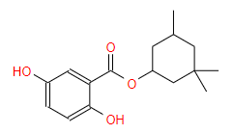
C2 | O=C(OC1C(C(C)CC(C)(C)C1)O)C=2C=CC=CC2O | C16H22O4 | 278.1518 | 3.0867 | Human | CYP1A2; CYP2C8; CYP2C9; CYP2C19; CYP2D6; CYP3A4 | Hydroxylation of alicyclic secondary carbon | Homosalate | 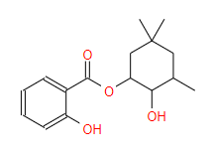
C3 | O=C(OC1CC(C)C(C(C)(C)C1)O)C=2C=CC=CC2O | C16H22O4 | 278.1518 | 2.9517 | Human | CYP1A2; CYP2C8; CYP2C9; CYP2C19; CYP2D6; CYP3A4 | Hydroxylation of alicyclic secondary carbon | Homosalate | 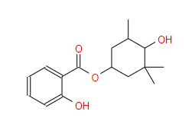
C4 | O=C(OC1CC(C)CC(C)(C)C1O)C=2C=CC=CC2O | C16H22O4 | 278.1518 | 3.1542 | Human | CYP1A2; CYP2C8; CYP2C9; CYP2C19; CYP2D6; CYP3A4 | Hydroxylation of alicyclic secondary carbon | Homosalate | 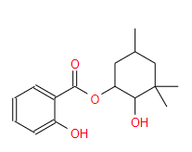
C5 | O=C(OC1CC(C)CC(C)(C)C1)C=2C(=CC=CC2O)O | C16H22O4 | 278.1518 | 3.7187 | Human | CYP1A2; CYP2C8; CYP2C9; CYP2C19; CYP2D6; CYP3A4 | Hydroxylation of benzene on carbon ortho to electron donating group | Homosalate | 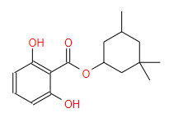
C6 | O=C(OC1CC(C)CC(C)(C)C1)C=2C=CC(=CC2O)O | C16H22O4 | 278.1518 | 3.7187 | Human | CYP1A2; CYP2C8; CYP2C9; CYP2D6; CYP3A4 | Hydroxylation of benzene on carbon para to electron donating group | Homosalate | 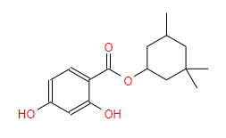
C7 | O=C(OC1CC(C)CC(C)(C)C1)C=2C=CC=C(C2O)O | C16H22O4 | 278.1518 | 3.7187 | Human | CYP1A2; CYP2A6; CYP2B6; CYP2C8; CYP2C9; CYP2C19; CYP2D6; CYP2E1; CYP3A4 | O-Hydroxylation of phenol | Homosalate | 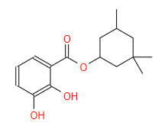
C8 | O=C(OC1CC(C)(CC(C)(C)C1)O)C=2C=CC=CC2O | C16H22O4 | 278.1518 | 2.5786 | Human | CYP2A6; CYP2B6; CYP2C8; CYP2C9; CYP2D6; CYP3A4 | Hydroxylation of penultimate aliphatic tertiary carbon | Homosalate | 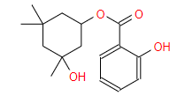
C9 | O=C(OC1CC(C)CC(C)(CO)C1)C=2C=CC=CC2O | C16H22O4 | 278.1518 | 2.8954 | Human | CYP2B6; CYP2C8; CYP2C9; CYP2C19; CYP2D6; CYP3A4 | Hydroxylation of methyl carbon adjacent to aliphatic ring | Homosalate | 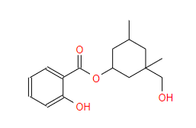
C10 | O=C(OC1CC(CO)CC(C)(C)C1)C=2C=CC=CC2O | C16H22O4 | 278.1518 | 2.8279 | Human | CYP2B6; CYP2C8; CYP2C9; CYP2C19; CYP2D6; CYP3A4 | Hydroxylation of methyl carbon adjacent to aliphatic ring | Homosalate | 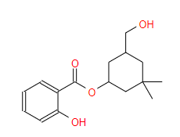
Note: Metabolites were generated with the CYP450 (Phase I oxidative metabolism) module of BioTransformer. Oxidation-site categories: aromatic ring hydroxylation (C1, C5–C7); alicyclic hydroxylation (C2–C4, C8); methyl hydroxylation (C9, C10). ALogP values are those reported by the BioTransformer output.

Table S3. Prediction results of the Phase I ester hydrolysis products of HMS based on GLORYx
Compound | SMILES | Molecular formula | Mass | priority_score | Reaction | Structure
Salicylic acid | O=C(O)C1CCCCC1O | C7H6O3 | 138.0317 | 0.18 | hydrolysis_(ester) | 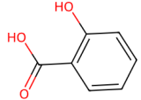
3,3,5-Trimethylcyclohexanol | CC1CC(O)CC(C)(C)C1 | C9H18O | 142.1358 | 0.18 | hydrolysis_(ester) | 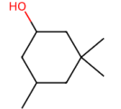
Note: Hydrolysis products were generated with the Phase I module of GLORYx (de Bruyn Kops et al. 2021); priority scores are those reported by the GLORYx output.

Table S4. Molecular docking results of HMS/C6/C8/C9 with PR receptor (PDB 1A28)
Compound | Hydrogen Bond (Residue, Å) | Hydrophobic Interaction (Residues) | Docking Energy (kcal/mol)
HMS | LEU718 (1.7 Å) | LEU715, LEU718, LEU721, MET759, PHE778, PHE794, LEU797, MET801, LEU887, CYS891, PHE905 | -6.04
C6 | GLN725 (2.1 Å); LEU718 (1.9 Å) | LEU715, LEU718, LEU721, PHE794, LEU797, MET801, CYS891, PHE905 | -6.53
C8 | GLY722 (3.0 Å); LEU718 (1.8 Å); ASN719 (2.0 Å) | LEU721, MET756, MET759, CYS891, LEU797, LEU887, PHE905 | -6.18
C9 | LEU718 (2.0 Å); ASN719 (1.9 Å) | MET756, CYS891, LEU797, LEU887, PHE905 | -5.79
Note: Hydrogen-bond distances are given in Å; docking energies in kcal/mol (more negative values indicate stronger predicted binding).

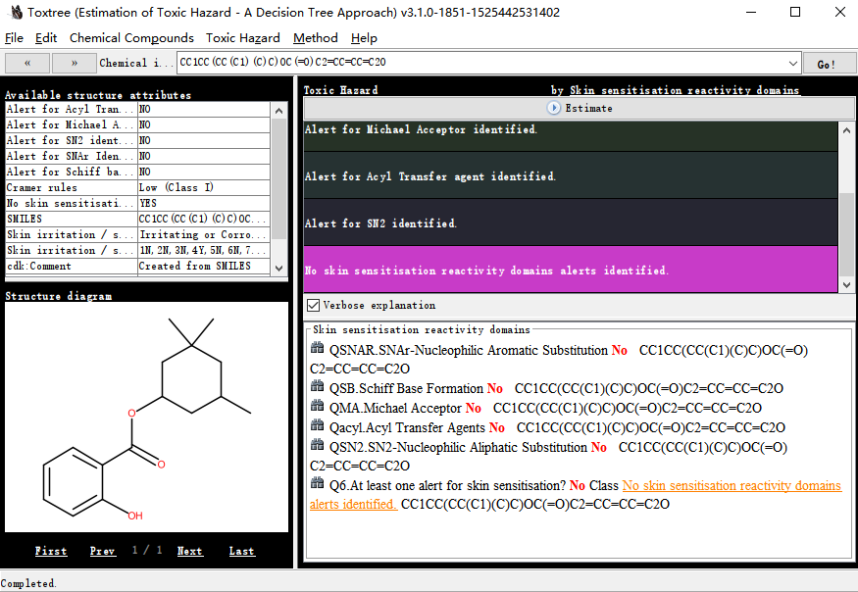
Fig. S1. Toxicological hazard prediction of HMS based on Toxtree
Fig. S2. Hazard prediction of HMS based on the EPA Hazard Cheminformatics Module (HCM)

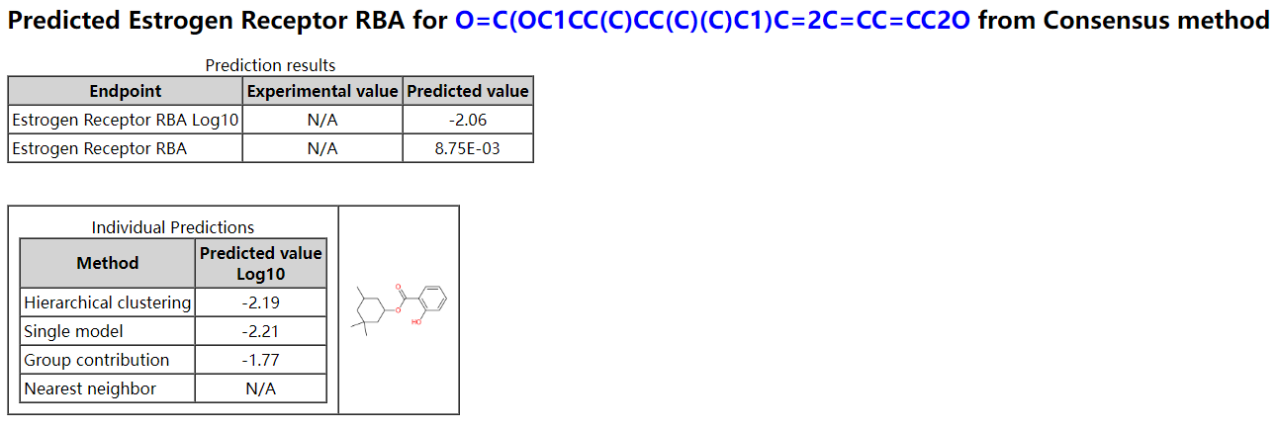
Fig. S3. Toxicity prediction of HMS using the EPA WebTEST platform.
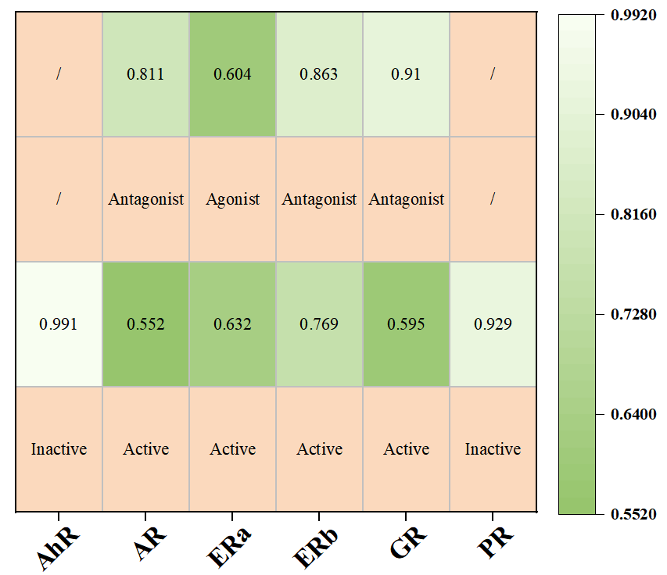
Fig. S4. Endocrine disrupting compound (EDC) screening results of HMS using EDC Profiler.
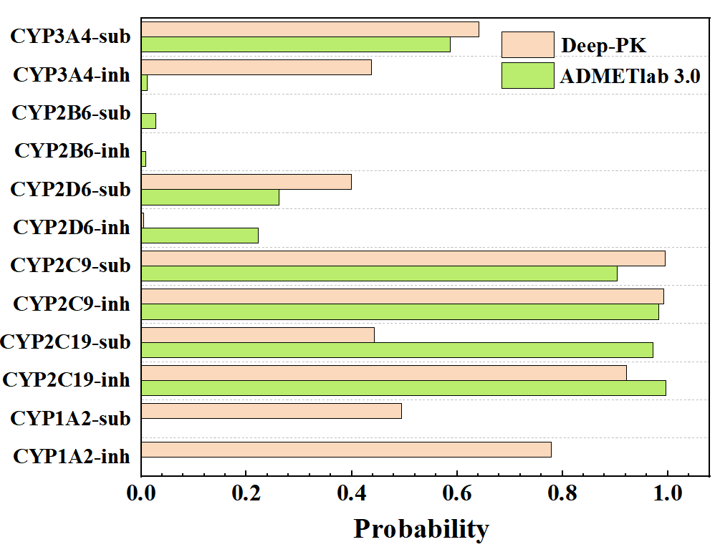
Fig. S5. Prediction results of the interaction probabilities of HMS with the CYP450 enzyme system based on the dual platforms ADMETlab 3.0 and Deep-PK.
Fig. S6. EDC Profiler nuclear receptor activity predictions for metabolites C1–C6.
Fig. S7. EDC Profiler nuclear receptor activity predictions for metabolites C7–C10.
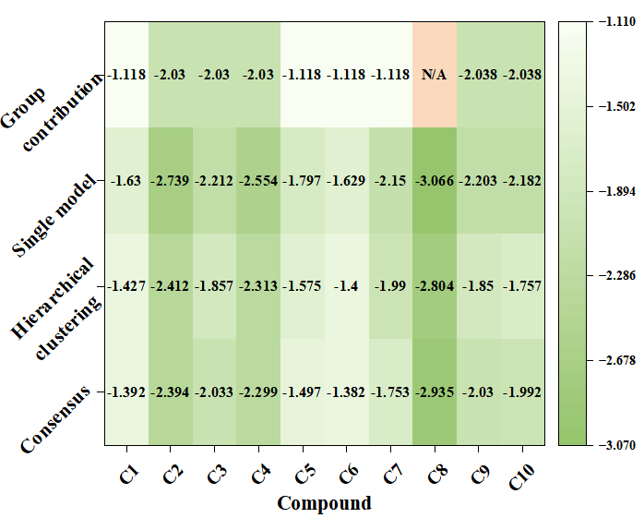
Fig. S8. WebTEST prediction results for HMS and its ten first-generation oxidative metabolites.
Fig. S9. Binding interactions of C6 (left), HMS (middle), and C8 (right) with the ERα ligand-binding domain (PDB 3ERT).

Reference
Daina A, Michielin O, Zoete V (2017) SwissADME: a free web tool to evaluate pharmacokinetics, drug-likeness and medicinal chemistry friendliness of small molecules. Sci Rep 7(1):42717. https://doi.org/10.1038/srep42717
de Bruyn Kops C, Šícho M, Mazzolari A et al (2021) GLORYx: prediction of the metabolites resulting from phase 1 and phase 2 biotransformations of xenobiotics. Chem Res Toxicol 34(2):286–299. https://doi.org/10.1021/acs.chemrestox.0c00224
Djoumbou-Feunang Y, Fiamoncini J, Gil-de-la-Fuente A et al (2019) BioTransformer: a comprehensive computational tool for small molecule metabolism prediction and metabolite identification. J Cheminform 11(1):2. https://doi.org/10.1186/s13321-018-0324-5
Fu L, Liu L, Li S et al (2024) ADMETlab 3.0: an updated comprehensive online ADMET prediction platform enhanced with broader coverage, improved performance, API functionality and decision support. Nucleic Acids Res 52:W422–W431. https://doi.org/10.1093/nar/gkae236
Morris GM, Huey R, Lindstrom W et al (2009) AutoDock4 and AutoDockTools4: automated docking with selective receptor flexibility. J Comput Chem 30(16):2785–2791. https://doi.org/10.1002/jcc.21256
Myung Y, de Sá AGC, Ascher DB (2024) Deep-PK: deep learning for small molecule pharmacokinetic and toxicity prediction. Nucleic Acids Res 52:W469–W475. https://doi.org/10.1093/nar/gkae254
Potts RO, Guy RH (1992) Predicting skin permeability. Pharm Res 9(5):663–669. https://doi.org/10.1023/A:1015810312465
Qiu Y, Cui S, Zhang H et al (2026) EDC Profiler: a high-throughput screening server for identifying endocrine disrupting chemicals toward multiple nuclear receptors. Environ Sci Technol 60(19):14023–14034. https://doi.org/10.1021/acs.est.5c18135
US EPA (2012) Estimation Programs Interface Suite™ (EPI Suite™), version 4.11. US Environmental Protection Agency, Washington, DC. https://www.epa.gov/tsca-screening-tools/epi-suitetm-estimation-program-interface
US EPA (2025) User's guide for WebTEST (version 1.0) (web-services toxicity estimation software tool). https://comptox.epa.gov/dashboard/predictions
Vegosen L, Martin TM (2020) An automated framework for compiling and integrating chemical hazard data. Clean Technol Environ Policy 22(2):441–458. https://doi.org/10.1007/s10098-019-01795-w

