Supplementary materials

Table S1. The sequences of siRNAs against STAT3.
siRNA | sequence(5’-3’)
siRNA-1 sense | CCACUUUGGUGUUUCAUAATT
siRNA-1 antisense | UUAUGAAACACCAAAGUGGTT
siRNA-2 sense | GCAACAGAUUGCCUGCAUUTT
siRNA-2 antisense | AAUGCAGGCAAUCUGUUGCTT
siRNA-3 sense | CCCGUCAACAAAUUAAGAATT
siRNA-3 antisense | UUCUUAAUUUGUUGACGGGTT
siRNA-4 sense | GCGUCCAGUUCACUACUAATT
siRNA-4 antisense | UUAGUAGUGAACUGGACGCTT
si-NC sense | UUCUCCGAACGUGUCACGUTT
si-NC antisense | ACGUGACACGUUCGGAGAATT

Table S2. PCR primer sequences for ChIP
Site of Aldh1a1 promoter | Fw_sequence(5’-3’) | Rv_sequence(5’-3’)
-1998 to - 1825 | CAGGTGTGGTAACCTGTCTCC | GTCCAGGCGATGAAAGCTCA
-1844 to - 1566 | TTGAGCTTTCATCGCCTGGA | CTTTGACTCCCCCGTGTCTT
-1666 to - 1447 | ACTGATTTCCTGAAAGCCTTGTCCTG | AGCCGAAACCTGTGATAAGTGTATGC
-1576 to - 1048 | GGGAGTCAAAGGCATTGGGA | TGTTTGCCCAAATCAGGTGC
-1283 to - 847 | AAAGCAGTTGATGCTTGAACCC | TTGTTTGCCCAAATCAGGTGC
-1197 to - 633 | GGAGTCAGACTGGCCTGAAA | GCCAGCAGGACTTTTAGGGA
-1007 to - 798 | AGGGGAATTGGCAAGTTTCA | GCAGGGCTTCCAAACAATTC
-652 to +31 | TCCCTAAAAGTCCTGCTGGC | CAGGTGACTGGCTCAGCAAT

Table S3. PCR primer sequences for verification of CKO mice
primer | sequence(5’-3’)
Vil1-ProF1 | GTGTTTGGTTTGGTTTCCTCTGCATAAGA
Cre5R1 | GCAGGCAAATTTTGGTGTACGGTCA
Cre3F1 | GCGCTGGAGTTTCAATACCGGAGAT
MT1-tR1 | CCAAAGGACCCGTTCGACAATACTCGTAA

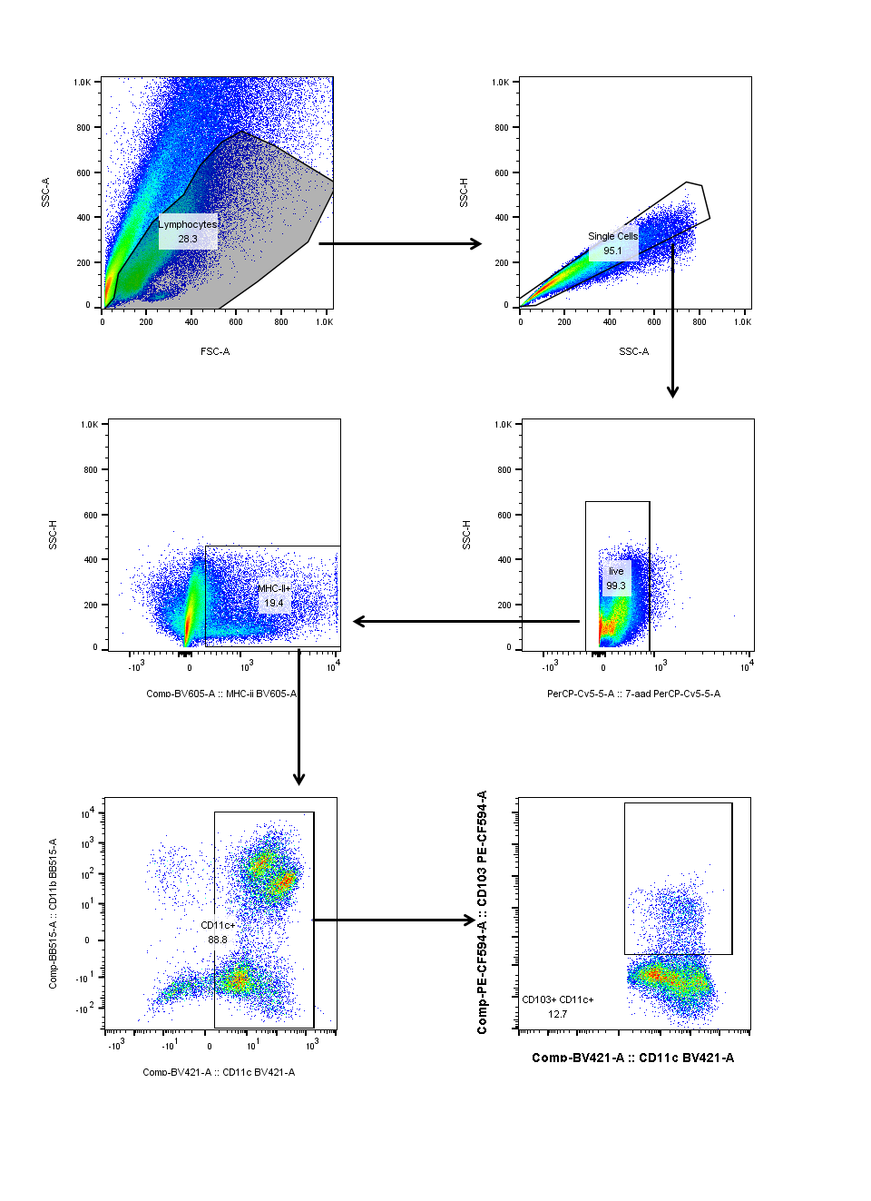
Figure S1. Gating strategies for identification of CD103+DCs.
Colonic lamina propria cells and hepatic leukocytes were stained and analyzed for CD11c, CD11b, MHC II and CD103, together with 7-AminoactinomycinD (7-AAD, PerCP) to exclude dead cells.

Figure S2. Identification of conditional knockout of STAT3 in CECs in CKO mice.
(A) RNA from tail of WT and CKO mice was extracted and PCR was performed to identify the genotype. The primer sequence is shown in supplementary table S3. (B) Representative IHC of STAT3 in colon WT and CKO mice. (C) Western blot analysis of expressions of STAT3 in different tissues or organs in WT and CKO mice.

