The Minimum Scan Time for Gated Myocardial Perfusion Imaging Using a Dedicated Ultrafast Solid-state Cardiac Camera
Journal name: Clinical and Translational Imaging
Dong Zhao^{1,†}, Shuwei Sun^{1,†}, Wang Tingyu¹, Jingbin Song¹, Xiao Bi¹, Ting Ye¹,Yuan Wang¹, Xiaodan Xu¹，Shulin Yao¹, Jiajin Liu^{1,}*, Ruimin Wang^{1,}*
1 Department of Nuclear Medicine, The First Medical Centre, Chinese PLA General Hospital, Beijing 100853, China
† These authors contributed to the work equally.
Corresponding to: Ruimin Wang, MD
E-mail: wrm@yeah.net
Professor, Department of Nuclear Medicine, The First Medical Center of PLA General Hospital, No. 28 Fuxing Road, Haidian District, Beijing, 100853, China

Correspondence may also be addressed to: Jiajin Liu
E-mail: liujiajin301@163.com
Department of Nuclear Medicine, The First Medical Center of PLA General Hospital, No. 28 Fuxing Road, Haidian District, Beijing, 100853, China

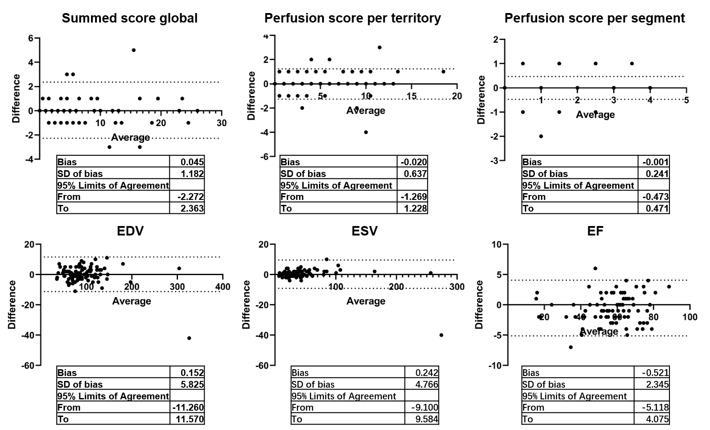
Supplementary Fig. 1 Bland-Altman analysis of perfusion and function parameters between 3-min and 6-min scan. EDV: end-diastolic volume; ESV: end-systolic volume; EF: ejection fraction.
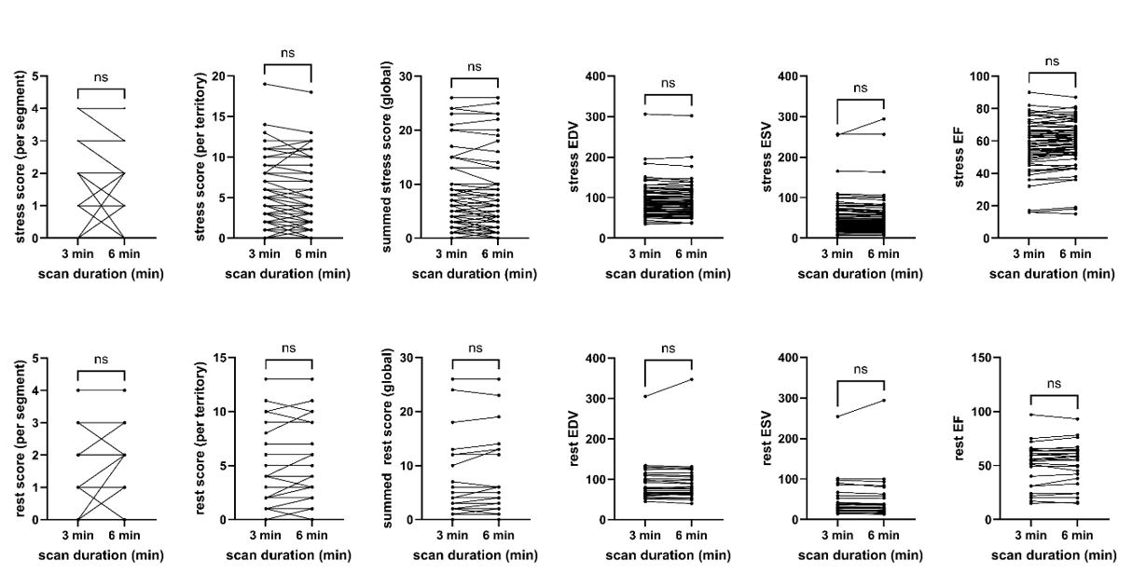
Supplementary Fig. 2 Subgroup analysis of perfusion and left ventricular function parameters between 3-min and 6-min scans in stress (upper panel) and rest (lower panel) dataset. EDV: end-diastolic volume; ESV: end-systolic volume; EF: ejection fraction. (P <0.05, ns: no significant difference)
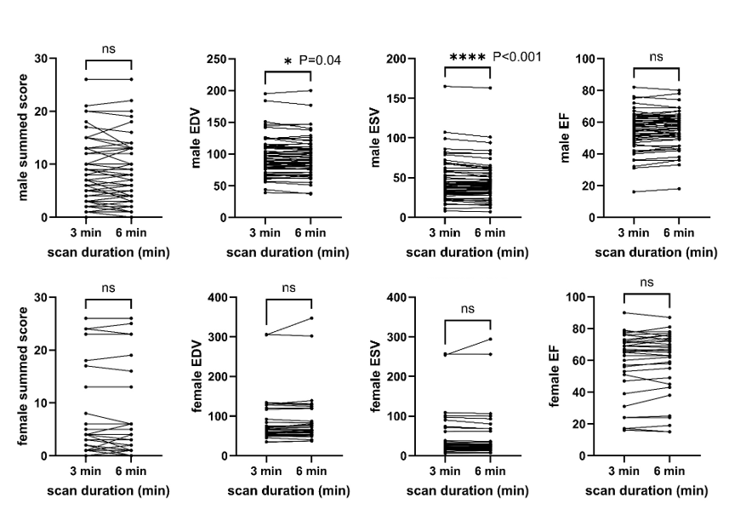
Supplementary Fig. 3 Subgroup analysis of perfusion and LV function parameters between 3-min and 6-min scans in male (upper panel) and female (lower panel) patients. EDV: end-diastolic volume; ESV: end-systolic volume; EF: ejection fraction. (* P <0.05, ns: no significant difference)
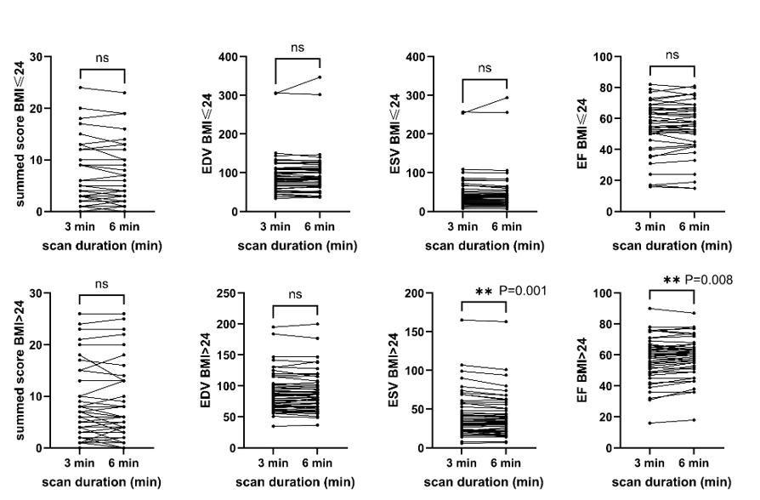
Supplementary Fig. 4 Subgroup analysis of perfusion and LV function parameters between 3-min and 6-min scans in small BMI (upper panel) and big BMI (lower panel) patients. EDV: end-diastolic volume; ESV: end-systolic volume; EF: ejection fraction. (* P <0.05, ns: no significant difference)
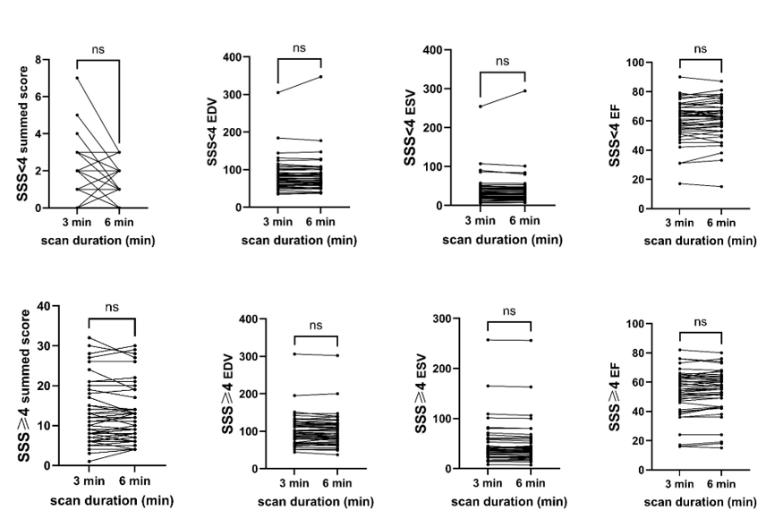
Supplementary Fig. 5 Subgroup analysis of perfusion and LV function parameters between 3-min and 6-min scans in normal perfusion (SSS<4) (upper panel) and defected perfusion (SSS≥4) (lower panel) patients. EDV: end-diastolic volume; ESV: end-systolic volume; EF: ejection fraction. (* P <0.05, ns: no significant difference)

