Additional file 1

Additional figures
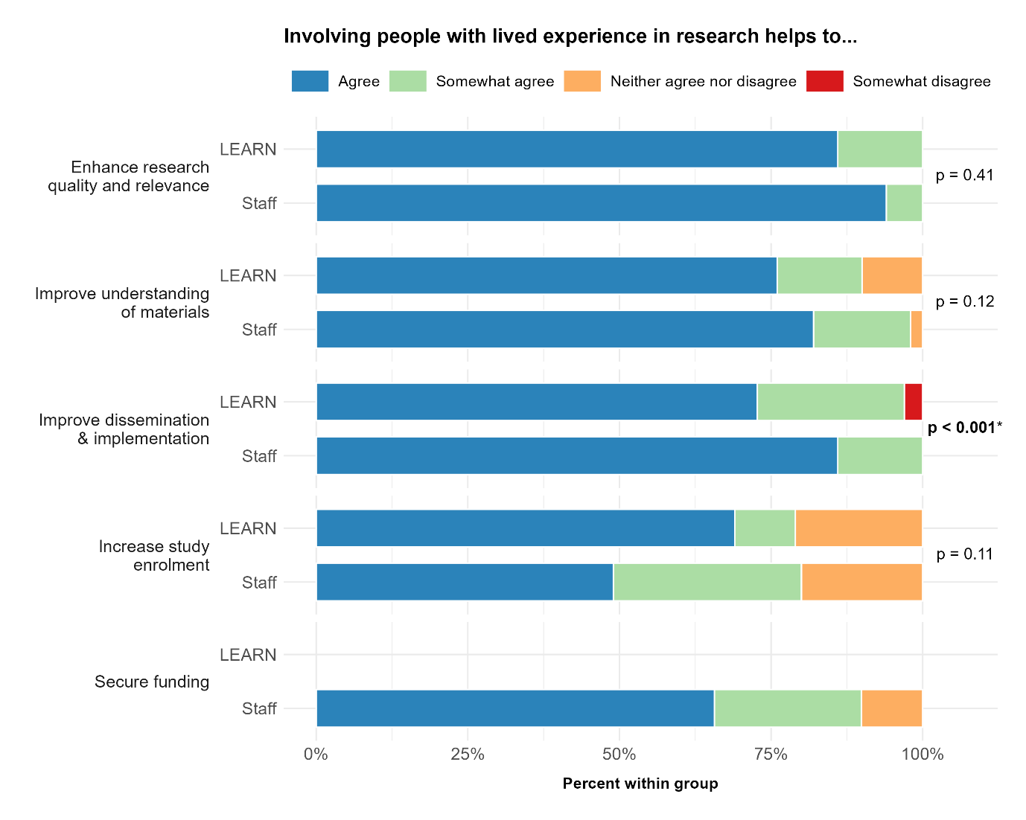
Figure A1. Percentage distributions of staff and LEARN member agreement ratings for each benefit of lived experience engagement in research. Significant fisher’s exact test (p < 0.05) indicated with bold and asterisk.

Additional tables
Table A1. Sample characteristics of Matilda Centre staff.
Staff (n=52) |  | N | %
Gender
 | Female | 46 | 88.5
 | Male | 6 | 11.5
 | Non-Binary | 0 | 0
Age
 | 18-34 | 38 | 73.1
 | 35-44 | 10 | 19.2
 | 45+ | 4 | 7.7
Years with the centre/network
 | <1 year | 14 | 26.9
 | 1-3 years | 17 | 32.7
 | 4+ | 21 | 40.4
Area/s of Work (not mutually exclusive)
 | Prevention | 29 | 55.8
 | Translation & implementation | 23 | 44.2
 | Early intervention | 15 | 28.8
 | Treatment | 12 | 23.1
 | Centre operations & admin | 10 | 19.2
 | Epidemiology/biostatistics | 8 | 15.4
Role
 | Professional Staff/Operations | 29 | 55.8
 | Academic Staff | 18 | 34.6
 | Research Student | 5 | 9.6
Note. ‘Not mutually exclusive’ indicates that participants could select multiple response options.
Table A2. Sample characteristics of LEARN members.
LEARN members (n=37) |  | N | %
Gender
 | Female | 24 | 64.9
 | Male | 11 | 29.7
 | Non-binary | 1 | 2.7
 | Prefer not to answer | 1 | 2.7
Age
 | 18-24 | 6 | 16.2
 | 25-34 | 5 | 13.5
 | 35-44 | 8 | 21.6
 | 45-54 | 10 | 27.0
 | 55-64 | 5 | 13.5
 | 65+ | 3 | 8.1
Years with the Network
 | <1 year | 12 | 32.4
 | 1-3 years | 19 | 51.4
 | 4-5 years | 5 | 13.5
 | >5 years | 1 | 2.7
Diversity (not mutually exclusive)
 | Aboriginal or Torres Strait Islander | 4 | 10.8
 | Culturally and linguistically diverse | 5 | 13.5
 | Gender or sexuality diverse | 8 | 21.6
 | None of the above | 19 | 51.4
 | Prefer not to say | 2 | 5.4
Residential Area
 | Metropolitan | 23 | 62.2
 | Regional | 9 | 24.3
 | Rural/Remote | 5 | 13.5
Employment (not mutually exclusive)
 | Part-time | 10 | 27.0
 | Student | 9 | 24.3
 | Peer Worker | 8 | 21.6
 | Casual | 7 | 18.9
 | Full-time | 6 | 16.2
 | Retired | 4 | 10.8
 | Unemployed | 3 | 8.1
 | Volunteer | 2 | 5.4
 | Self-Employed | 1 | 2.7
Note. ‘Not mutually exclusive’ indicates that participants could select multiple response options.
Table A3. LEARN member engagement in research prior to joining LEARN.
LEARN members (n=37) |  | n | %
Have you previously been engaged in research in any capacity? (n=36)
 | Yes | 22 | 61.1
 | No | 14 | 38.9
Considering the spectrum of Lived Experience engagement in research, in what capacity have you been engaged previously? (n=22)
 | Consultation | 3 | 13.6
 | Advisory group | 4 | 18.2
 | Co-design | 5 | 22.7
 | Co-production | 6 | 27.3
 | LE led | 1 | 4.5
 | LE owned | 3 | 13.6
How frequently have you worked with researchers to help design a study? (n=22)
 | Never | 6 | 27.3
 | Very rarely (once or twice in life) | 6 | 27.3
 | Rarely (once every 2-3 years) | 3 | 13.6
 | Sometimes (at least once a year) | 3 | 13.6
 | Often (more than once a year) | 1 | 4.5
 | Regularly (monthly to weekly) | 3 | 13.6
What is your preferred mode of engagement? (n=36)
 | Online meetings | 18 | 50.0
 | Face-to-face meetings | 6 | 16.7
 | Ad-hoc opportunity emails | 4 | 11.1
 | Monthly emails | 4 | 11.1
 | Hybrid | 4 | 11.1
Note. Where number of respondents differed from total sample size due to non-responses, the final sample size used in calculations is provided.
Table A4. LEARN member engagement in research at the Matilda Centre.
LEARN members (n=37) |  | n | %
Have you heard from the Matilda Centre in the past 12 months? (n=36)
 | Yes | 29 | 80.6
 | No | 7 | 19.4
What was the nature of the communication you received? (n=21)
 | Invitation to provide feedback or input on a research project or research component (e.g. grant applications, resources) | 11
 | Invitation to participate in research | 4
 | Invitation to join an advisory group | 3
 | Invitation to join a judging panel | 2
 | Invitation to a training opportunity | 1
How did you find the process of being linked to research opportunities via GLEE? (n=20)
 | Positive | 20 | 100.0
 | Negative | 0 | 0.0
To what extent did you enjoy your experience/s of research engagement? (n=14)
 | Very much so | 8 | 57.1
 | Quite a bit | 5 | 35.7
 | Somewhat | 1 | 7.1
 | Not very | 0 | 0
 | Not at all | 0 | 0

Table A5. Staff member experiences of engaging with LEARN
 |  | n | %22
To what extent do you think the quality of research at the Matilda Centre has improved since LEARN was established? |  | 46
 | Very much so | 2 | 4.4
 | Quite a bit | 9 | 19.6
 | Somewhat | 6 | 13.0
 | Not very | 1 | 2.2
 | Not sure/I don’t know | 28 | 60.9
Have you/your team engaged with LEARN in the last two years? |  | 45
 | Yes | 5 | 11.1
 | No | 22 | 48.9
 | Unsure | 18 | 40
At what stage did your project engage with LEARN? |  | 5
 | Forming ideas | 1 | 20.0
 | Analysis of data | 0 | 0
 | Preparing grant applications | 1 | 20.0
 | Recruitment and follow-up strategies | 0 | 0
 | Development of an intervention (e.g. reviewing content, brainstorming ideas, wording/phrasing, animations, infographics etc) | 2 | 40.0
 | Development of measures | 0 | 0
 | Ethics application | 0 | 00
 | Dissemination | 0
 | Other – reviewed case studies | 1 | 20.0
How easy was it to engage/work with LEARN? |  | 5
 | Extremely easy | 4 | 80.0
 | Somewhat easy | 1 | 20.0
 | Neither easy nor difficult | 0 | 0
 | Somewhat difficult | 0 | 0
 | Extremely difficult | 0 | 0
To what extent did feedback improve the project? |  | 5
 | Very much so | 3 | 60.0
 | Quite a bit | 2 | 40.0
 | Somewhat | 0 | 0
 | Not very | 0 | 0
 | Not at all | 0 | 0
How easy was it to implement LEARN’s feedback? |  | 5
 | Very much so | 3 | 60.0
 | Quite a bit | 2 | 40.0
 | Somewhat | 0 | 0
 | Not very | 0 | 0
 | Not at all | 0 | 0
How much of LEARN’s feedback did you use? |  | 5
 | All | 0 | 0
 | A lot | 5 | 100
 | A little | 0 | 0
 | Not much | 0 | 0
 | None | 0 | 0
Was the feedback better than you expected? |  | 5
 | It was better than I expected | 2 | 40.0
 | It was about what I expected | 3 | 60.0
 | It wasn’t as good as I expected | 0 | 0

Table A6. Where do you think the Matilda Centre is currently placed on the spectrum of Lived Experience engagement?
 | Consultation | Advisory Group | Co-Design | Co-Production | Lived Experience Led | Lived Experience Owned | Fisher’s exact test
 | % | % | % | % | % | % | p-value
Staff (n=46) | 2  (n=1) | 48  (n=22) | 33 (n=15) | 13  (n=6) | 4  (n=2) | 0 | 0.008
LEARN (n=22) | 14  (n=3) | 32  (n=7) | 9  (n=2) | 23  (n=5) | 23  (n=5) | 0

Table A7. Where would you like the Matilda Centre to be placed on the spectrum of Lived Experience engagement?
 | Consultation | Advisory Group | Co-Design | Co-Production | Lived Experience Led | Lived Experience Owned | Fisher’s exact test
 | % | % | % | % | % | % | p-value
Staff  (n=46) | 2  (n=1) | 11  (n=5) | 13  (n=6) | 35  (n=16) | 28  (n=13) | 11  (n=5) | 0.266
LEARN  (n=23) | 0 | 9  (n=2) | 4  (n=1) | 26  (n=6) | 26  (n=6) | 35  (n=8)

Table A8. Importance and Benefits of Lived Experience Engagement in Research
 |  | Disagree | Somewhat disagree | Neither agree nor disagree | Somewhat agree | Agree | Fisher’s exact test
LE engagement in research helps to… |  | % | % | % | % | % | p
Enhance research quality and relevance | STAFF  (n=49) | 0 | 0 | 0 | 6 | 94 | 0.41
Enhance research quality and relevance | LEARN  (n=29) | 0 | 0 | 0 | 14 | 86
Improve participants’ understanding of materials & measures | STAFF  (n=49) | 0 | 0 | 2 | 16 | 82 | 0.12
Improve participants’ understanding of materials & measures | LEARN  (n=29) | 0 | 0 | 10 | 14 | 76
Improve dissemination & implementation | STAFF  (n=49) | 0 | 0 | 0 | 14 | 86 | <0.001
Improve dissemination & implementation | LEARN  (n=29) | 0 | 3 | 0 | 24 | 72
Increase study enrolment | STAFF  (n=49) | 0 | 0 | 20 | 31 | 49 | 0.11
Increase study enrolment | LEARN  (n=29) | 0 | 0 | 21 | 10 | 69
Secure funding | STAFF  (n=49) | 0 | 0 | 10 | 24 | 65

Table A9. How important do you think it is to have people with living and lived experience involved in research? Why/why not?
 | Not at all | Not very | Somewhat | Quite a bit | Very much so
 | % | % | % | % | %
Staff | 0 | 0 | 2 | 10 | 88 (n=44)
LEARN | 0 | 0 | 0 | 7 (n=2) | 93 (n=27)
Staff open-text (n=50) |  |  | LEARN open-text (n=29)
Unique perspective/user expertise | 13 | 26% | User expertise/insider knowledge | 14 | 48.2%
Relevance, quality and impact of research | 16 | 32% | Avoiding researcher bias | 5 | 17.2%
Address end-user/target population needs and priorities | 6 | 12% | Empowerment | 5 | 17.2%
Avoid assumptions/biases of top-down research | 5 | 10% | Impact on outcomes/services | 1 | 3.4%
Meaningful outcomes | 4 | 8%
Empowerment | 1 | 2%

Table A10. At which stage/s of a research project do you think it is most beneficial/useful for people with LE to provide feedback?
 | Staff  (n=50) | LEARN
 | % | %
Forming ideas | 90 | 88
Grant applications | 50 | 62
Designing protocols | 72 | 77
Development of interventions | 90 | 96
Development of measures | 44 | 73
Ethics applications | 32 | 69
Data analysis | 30 | 65
Recruitment & follow-up strategies | 62 | 73
Dissemination | 72 | 73

Table A11. What are the perceived barriers to/challenges of LE engagement for traditional researchers?
 | Disagree | Somewhat disagree | Neither agree nor disagree | Somewhat agree | Agree
Involving people with LE in my research makes it difficult to… | % | % | % | % | %
Maintain robust scientific design  (n=42) | 26 | 26 | 26 | 19 | 2
Ensure diverse representation  (n=41) | 0 | 5 | 7 | 68 | 20
Find funding to support the process  (n=37) | 16 | 14 | 24 | 38 | 8
Find the time to invest in the process  (n=43) | 19 | 16 | 14 | 35 | 16
Ensure involvement is not just tokenistic  (n=44) | 14 | 16 | 18 | 34 | 18

Table A12. What skills and capacities do people with LE develop through engagement in research? What skills and capacities are those with LE wanting to develop?
 | Have developed (n=26) | Want to develop (n=26)
Public Speaking | 15 (n=4) | 54 (n=14)
Critical thinking | 50 (n=13) | 54 (n=14)
Confidence | 42 (n=11) | 54 (n=14)
Empowerment | 42 (n=11) | 39 (n=10)
Leadership | 39 (n=10) | 65 (n=17)
Mental health literacy | 50 (n=13) | 39 (n=10)
Research skills | 27 (n=7) | 77 (n=20)
None | 15 (n=4) | 4 (n=1)

