Supporting Information

Transferrin-mediated pulmonary GATA3 siRNA Delivery in a Murine Model of Allergic Asthma

Anny Nguyen¹, Min Jiang¹, Joschka T. Müller¹, Muge Molbay¹, Simone P. Carneiro¹, Dana Matzek², Adrian P. E. Kromer¹, Diana Leidy Porras-Gonzalez³, Gerald Burgstaller³, Bastian Popper², and Olivia M. Merkel^{1,4}

¹ Department of Pharmacy, Ludwig-Maximilians-University Munich, Germany
² Biomedical Center, Core Facility Animal Models, LMU München, Munich, Germany
³ Helmholtz Munich Comprehensive Pneumology Center (CPC-M) Member of the German Center for
Lung Research (DZL), Munich, Germany
⁴ Ludwig-Maximilians-University Munich, Member of the German Center for Lung Research (DZL)

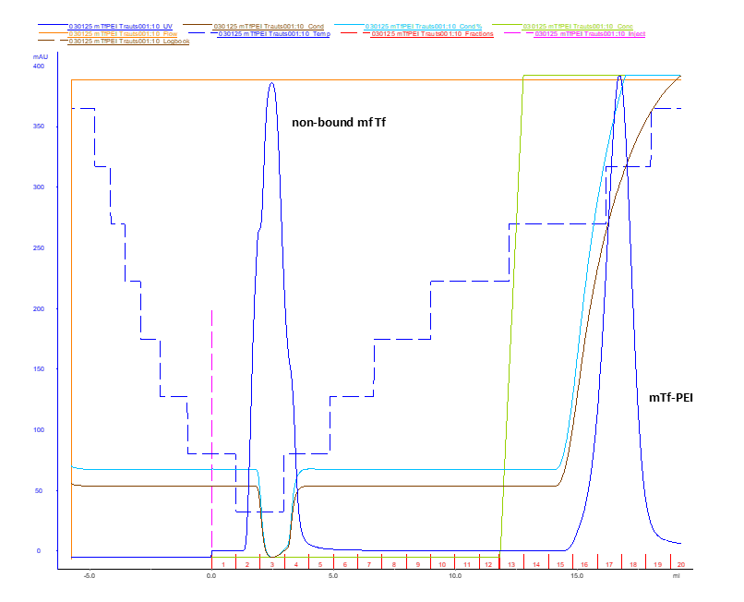
Figure S1. ÄKTA chromatogram showing purification of Tf–PEI conjugates.

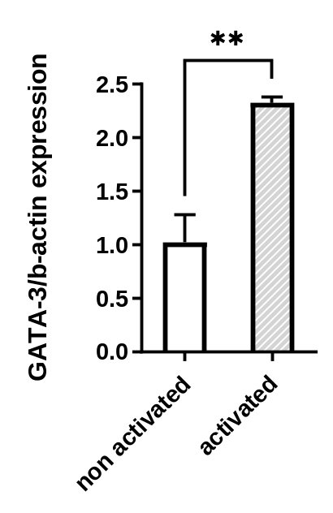
Figure S2. GATA3 mRNA levels of murine PCLS after 72 hours of activation.
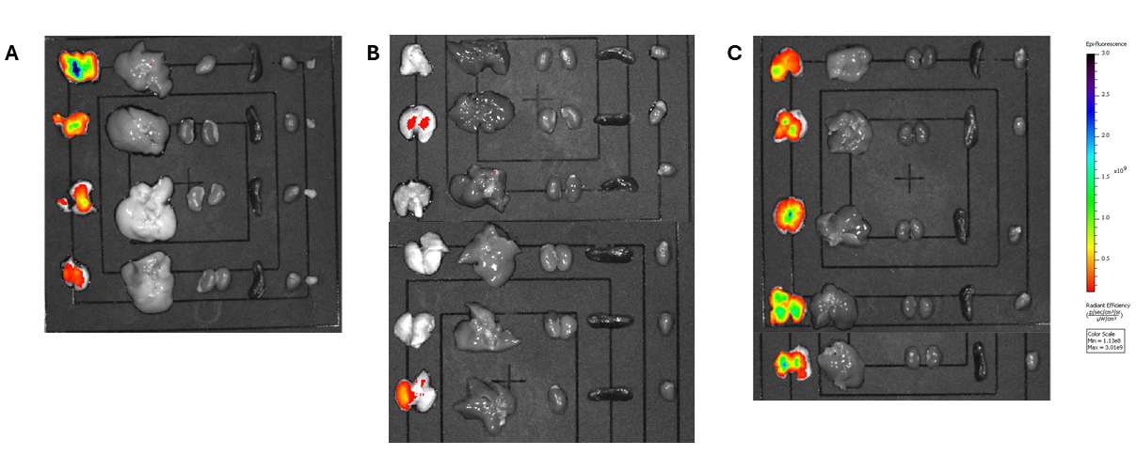
Figure S3. Organ distribution after intratracheal administration of Alexa Fluor 647–labeled siRNA formulated with A) Tf–PEI, B) free siRNA, and C) PEI.

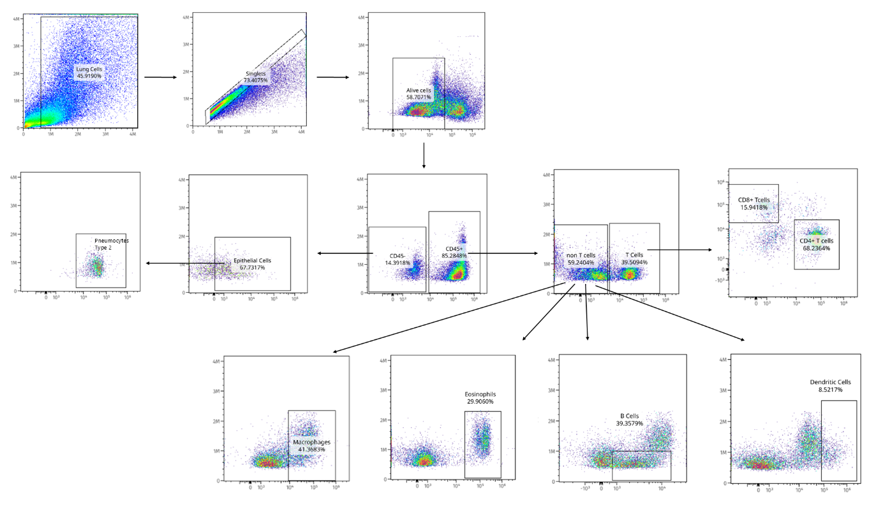
Figure S4. Gating strategy for identifying distinct lung cell populations.

