Supplementary information
Fig. S1. Spearman’s correlation coefficients between soil properties and vegetation characteristics, and soil bacterial (B) and fungal (F) diversity. The diversity indices include ACE, Chao1, and Shannon indices; AN, soil alkali-hydrolytic nitrogen, AP, soil available phosphorus, FDis, Functional Divergence index, H_{plant}, Shannon index of plants, LC_{CWM}, community weighted mean of leaf carbon, LN_{CWM}, community weighted mean of leaf nitrogen, LP_{CWM}, community weighted mean of leaf phosphorus, OC, soil organic carbon, SLA_{CWM}, community weighted mean of specific leaf area, S_{plant}, the species richness of plants, SMC, soil moisture content, TN, soil total nitrogen, TP, soil total phosphorus.
Fig. S2. The relative abundance of bacterial (a) and fungal (b) taxa across N gradient treatments. The most differentially abundant taxa of bacteria under different N addition based on a linear discriminant analysis effect size method. Colored dots represent the taxa with a significantly different abundance across all levels of N addition. From the center outward the kingdom, phylum, class, order, family, genus, and species levels are presented, respectively. The colored nodes represent the significantly discriminant taxon compared with other N levels. Yellow circles represent nonsignificant differences in abundance across N treatments. Only taxa meeting the linear discriminant analysis significance threshold of > 4 are shown.
Fig. S3. PCoA of plant (a), bacterial (b), and fungal (c) communities (species or OTU level) based on Bray-Curtis distances.
Table S1 Permutational multivariate analysis of variance (PERMANOVA) results for differences in microbial community composition under N addition treatments.
Fig. S4. Comparison of average habitat niche width of dominant bacterial (a) and fungal (b) taxa (relative abundance > 0.01%) under different N addition treatments. The ns indicates no significant difference (P > 0.05).
Table S2 The analysis of C-score for bacterial (B) and fungi (F) community.

Fig. S1. Spearman’s correlation coefficients between soil properties and vegetation characteristics, and soil bacterial (B) and fungal (F) diversity. The diversity indices include ACE, Chao1, and Shannon indices; AN, soil alkali-hydrolytic nitrogen, AP, soil available phosphorus, FDis, Functional Divergence index, H_{plant}, Shannon index of plants, LC_{CWM}, community weighted mean of leaf carbon, LN_{CWM}, community weighted mean of leaf nitrogen, LP_{CWM}, community weighted mean of leaf phosphorus, OC, soil organic carbon, SLA_{CWM}, community weighted mean of specific leaf area, S_{plant}, the species richness of plants, SMC, soil moisture content, TN, soil total nitrogen, TP, soil total phosphorus.

Fig. S2. The relative abundance of bacterial (a) and fungal (b) taxa across N gradient treatments. The most differentially abundant taxa of bacteria under different N addition based on a linear discriminant analysis effect size method. Colored dots represent the taxa with a significantly different abundance across all levels of N addition. From the center outward the kingdom, phylum, class, order, family, genus, and species levels are presented, respectively. The colored nodes represent the significantly discriminant taxon compared with other N levels. Yellow circles represent nonsignificant differences in abundance across N treatments. Only taxa meeting the linear discriminant analysis significance threshold of > 4 are shown.

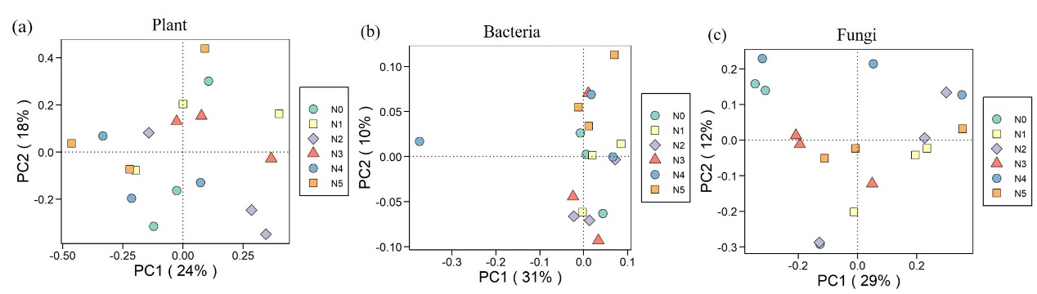 Fig. S3. PCoA of plant (a), bacterial (b), and fungal (c) communities (species or OTU level) based on Bray-Curtis distances.

Table S1 Permutational multivariate analysis of variance (PERMANOVA) results for differences in microbial community composition under N addition treatments.

 | F | Variation (R²) | Pr (>F)
Plant composition  Bacterial composition | 1.1343  0.8685 | 0.3209  0.2657 | 0.273  0.879
Fungal composition | 1.3873 | 0.3633 | 0.060

Fig. S4. Comparison of average habitat niche width of dominant bacterial (a) and fungal (b) taxa (relative abundance > 0.01%) under different N addition treatments. The ns indicates no significant difference (P > 0.05).
Table S2 The analysis of C-score for bacterial (B) and fungi (F) community.

 | C-score_{obs} | C-score_{sim} | SES | P
B_N0 | 0.03598 | 0.03654 | -1.4818 | > 0.05
B_N1 | 0.34767 | 0.34278 | 2.4912 | > 0.05
B_N2 | 0.04064 | 0.04032 | 0.73697 | > 0.05
B_N3 | 0.03496 | 0.03502 | -0.45234 | > 0.05
B_N4 | 0.04278 | 0.04238 | 1.6537 | > 0.05
B_N5 | 0.03345 | 0.03259 | 5.6119 | < 0.001
F_N0 | 0.08846 | 0.08516 | -0.76122 | > 0.05
F_N1 | 0.12733 | 0.12708 | 0.10544 | > 0.05
F_N2 | 0.14679 | 0.14610 | 0.46003 | > 0.05
F_N3 | 0.12555 | 0.12435 | 2.425 | 0.033
F_N4 | 0.09886 | 0.09592 | 5.0935 | < 0.001
F_N5 | 0.11405 | 0.11282 | 2.3412 | 0.027

