Supplementary Information for
Out-of-plane orbital torque from orbital-to-spin conversion
in a low-symmetry system
Yizhen Shao^{1#}, Kailin Yang^{1#}, Xiaobai Ning^{2*}, Siyuan Cheng¹, Peiyuan Yu¹,
Zhengjie Yan^{1,2}, Weifeng Ge¹, Daoqian Zhu^{1,2*}, Yuxuan Yao¹, Jie Zhang¹,
Guang Yang^{1,2}, Shouzhong Peng¹, Tianxiao Nie¹, Weisheng Zhao^{1,2*}
¹Fert Beijing Institute, School of Integrated Circuit Science and Engineering, Beihang University, Beijing, 100191, China.
²State Key Laboratory of Spintronics, Hangzhou International Innovation Institute,
Beihang University, Hangzhou, 11115, China.
#These authors contributed equally to this work
*Email: daoqian_zhu@buaa.edu.cn; ningxiaobai@buaa.edu.cn; weisheng.zhao@buaa.edu.cn

Supplementary Note S1. Magnetic characterization of the A1-CoPt/Ru bilayers
Supplementary Note S2. Discussion of in-plane effective field in the A1-CoPt/Ru bilayer and thermal contributions
Supplementary Note S3. Threefold field-free switching in A1-CoPt (12 nm)/CuO_{x} (6 nm) samples
Supplementary Note S4. Angular dependence of the out-of-plane effective field in the A1-CoPt/Ru (9 nm) devices
Supplementary Note S5. Relationship between the current shunting factor and the Ru thickness
Supplementary Note S6. Robust field-free switching against thermal noise with enhanced out-of-plane torque verified by macrospin simulations
Supplementary Note S7. Angular dependence of the current-induced field-free switching in A1-CoPt/Ru ($t_{Ru}$) devices
Supplementary Note S8. Power dissipation of field-free switching in A1-CoPt (12 nm)/Ru ($t_{Ru}$) devices

Supplementary Note S1. Magnetic characterization of the A1-CoPt/Ru bilayers
The representative out-of-plane magnetic hysteresis loop measured by vibrating-sample magnetometry (VSM) is square and exhibits a large remanent magnetization, confirming perpendicular magnetic anisotropy in the as-grown A1-CoPt/Ru film (Supplementary Fig. 1).
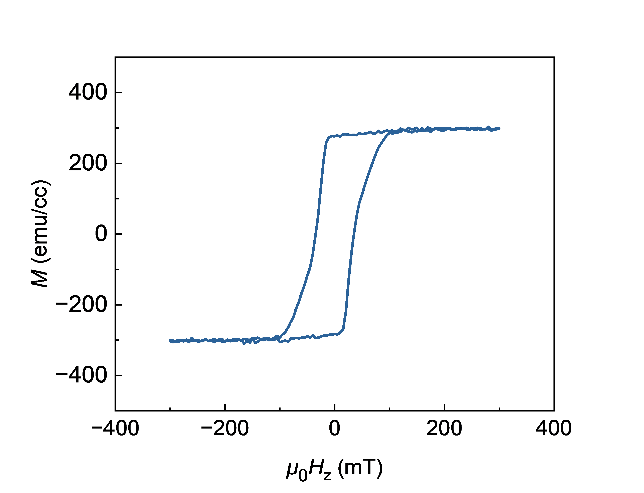
Supplementary Figure 1 | Out-of-plane magnetic hysteresis of an A1-CoPt/Ru(0 nm) film. Magnetization $M$ as a function of the perpendicular magnetic field $μ_{0}H_{z}$, measured by VSM at room temperature.
The effective anisotropy fields $μ_{0}H_{k}$ of the samples with different Ru thicknesses were determined by fitting the first-harmonic Hall signals:
$R_{ω}= R_{AHE}\sqrt{1−\frac{H_{x}^{2}}{H_{k}^{2}}}+BH_{x}+constant$,
where the linear term was included to account for the contribution arising from the crystal-dependent in-plane Hall effect.¹ Supplementary Fig. 2b shows that the extracted $μ_{0}H_{k}$ among the samples can be as strong as 1.5 T.
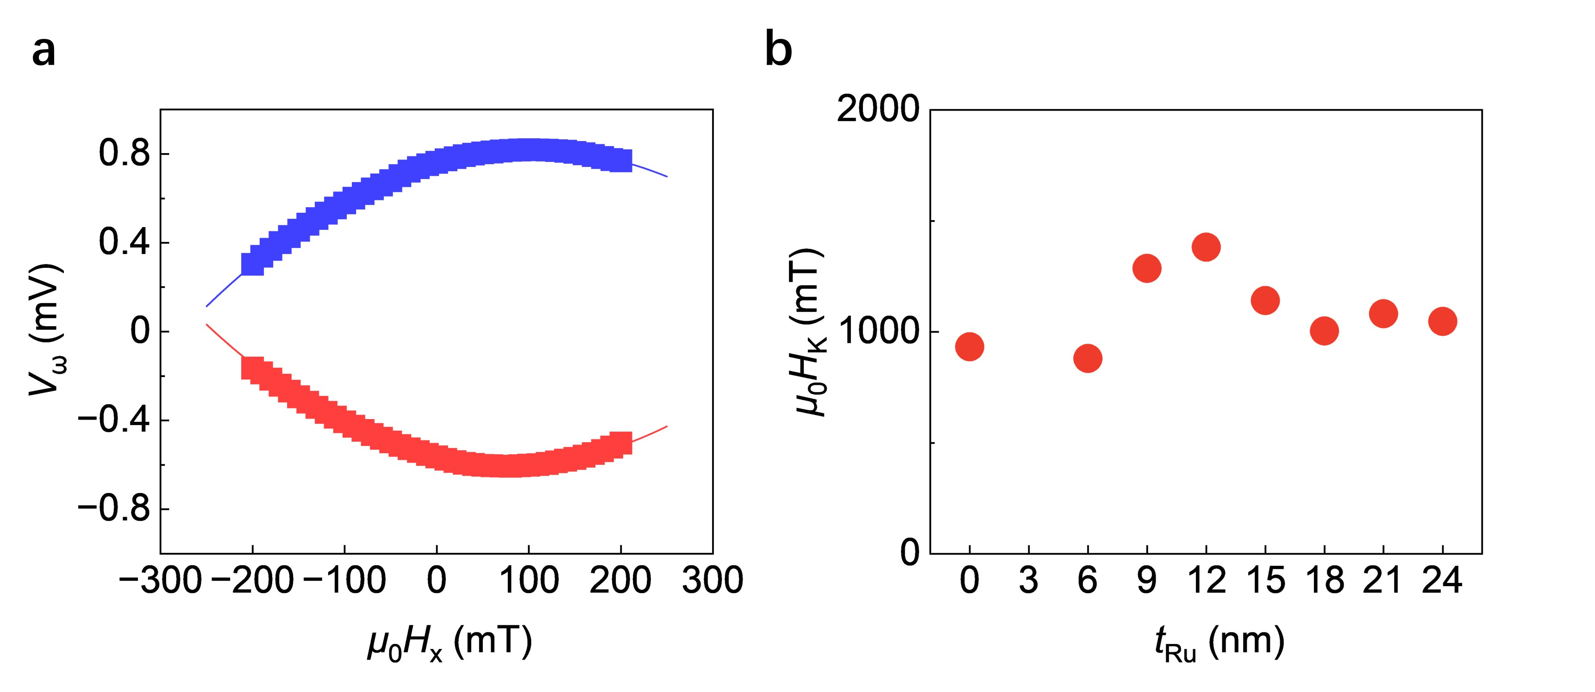
Supplementary Figure 2 | The effective anisotropy fields $μ_{0}H_{k}$ of the samples with different $t_{Ru}$. a, First-harmonic signal of CoPt single layer ($t_{Ru}=0 nm$). b, Fitting results of the samples with different $t_{Ru}$.
Anomalous Hall loops remain square for Hall bars patterned from $0°$ to $180°$ in $15°$increments (Supplementary Fig. 3). Thus, rotating the device with respect to the [11-2] crystallographic axis does not remove the perpendicular bistability required for the angle-dependent switching measurements.
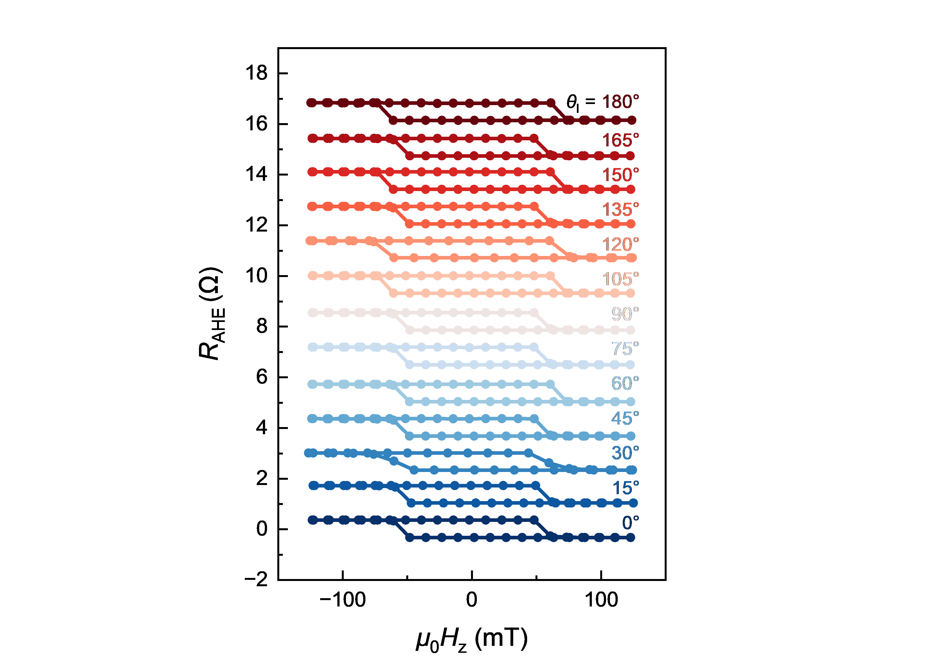
Supplementary Figure 3 | Anomalous Hall loops for different device orientations in A1-CoPt/Ru(9 nm) film. $R_{AHE}$ as a function of $μ_{0}H_{z}$ for Hall bars with $θ_{I}$ from $0°$ to $180°$ in $15°$increments.
The normalized anomalous Hall loops retain their perpendicular anisotropy throughout the Ru-thickness series (Supplementary Fig. 4a). The measured anomalous Hall resistance decreases with increasing $t_{Ru}$ (Supplementary Fig. 4b), consistent with progressively stronger electrical shunting through the Ru layer.
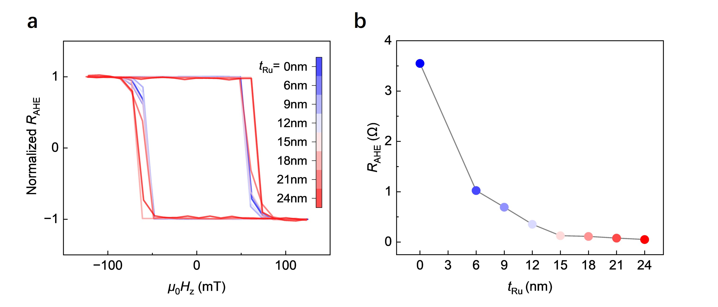
Supplementary Figure 4 | Ru-thickness dependence of the anomalous Hall response. a, Normalized anomalous Hall loops for A1-CoPt (12 nm)/Ru ($t_{Ru}$) with $t_{Ru}$ = 0, 6, 9, 12, 15, 18, 21 and 24 nm. b, $R_{AHE}$as a function of $t_{Ru}$. The line is a guide to the eye.

Supplementary Note S2. Determination of in-plane damping-like torque strength in the A1-CoPt/Ru bilayer with thermal contributions subtracted.
The harmonic Hall response was measured by sweeping the in-plane field $μ_{0}H_{x}$ after initializing the magnetization along $±z$. The first-harmonic voltage $V_{ω}$ shows angle-dependent displacements of its extrema (Supplementary Fig. 5a). Previous work has shown that a linear crystal-symmetry-dependent in-plane Hall term can be superposed on the quadratic anomalous Hall background, displacing the extrema and producing a $cos(3φ)$ angular dependence.¹ The threefold crystalline environment of our [111]-oriented A1-CoPt layer permits an analogous Hall contribution. We therefore regard the displacement as a first-harmonic Hall background and use the local curvature, rather than the absolute extremum position, in the damping-like-field extraction. This qualitative consistency supports a crystal-symmetry-dependent Hall response but does not by itself establish an out-of-plane torque.
The magnitude of the planar Hall resistance did not exceed 10% of the anomalous Hall resistance ($R_{PHE}$< 0.1$R_{AHE}$), so mixing from the planar-Hall/field-like term was neglected. The damping-like effective field was evaluated from the field derivatives of the harmonic signals using:
$μ_{0}H_{DL} = −2\frac{∂V_{2ω}}{∂μ_{0}H_{x}}/\frac{∂^{2}V_{ω}}{∂{(μ_{0}H_{x})}^{2}}$.
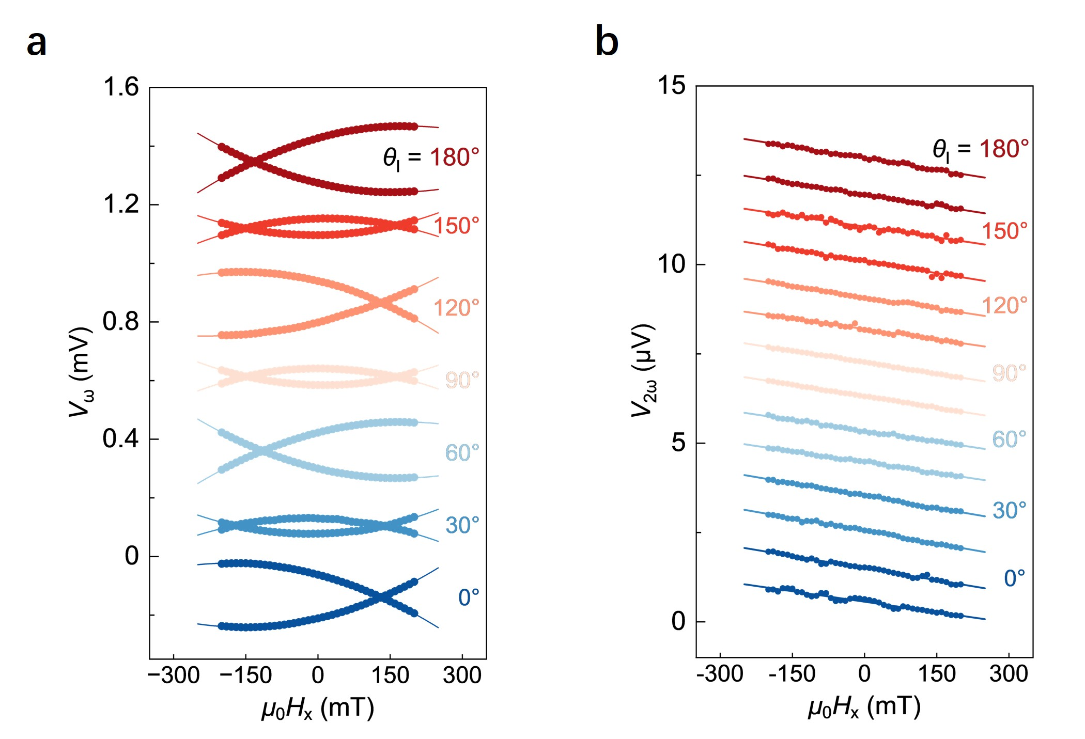
Supplementary Figure 5 | Harmonic Hall signals at different current orientations in A1-CoPt/Ru(9 nm) film. a, First-harmonic Hall voltage $V_{ω}$ as a function of $μ_{0}H_{x}$ after initializing the magnetization along opposite out-of-plane directions, measured at $θ_{I} = 0°, 30°, 60°, 90°, 120°, 150°$ and $180°$. The extrema exhibit angle-dependent horizontal displacements. b, Corresponding second-harmonic Hall voltage $V_{2ω}$ as a function of $μ_{0}H_{x}$. Solid lines are fits used to extract the damping-like effective field. Curves are vertically offset for clarity.
Anomalous-Nernst and spin-Seebeck effects can also contribute to the second-harmonic Hall voltage. To determine this thermal background, $V_{2ω}$ was measured over a large $μ_{0}H_{x}$ range for every Ru thickness (Supplementary Fig. 6). At high fields, the magnetization is driven close to the film plane and $V_{2ω}$ approaches a flattened segment. The offset $V_{offset}$ was obtained from this plateau and taken as the thermal voltage associated with the full in-plane magnetization projection. The normalized thermal contribution in samples with varying Ru thickness is summarized in Supplementary Fig. 7.
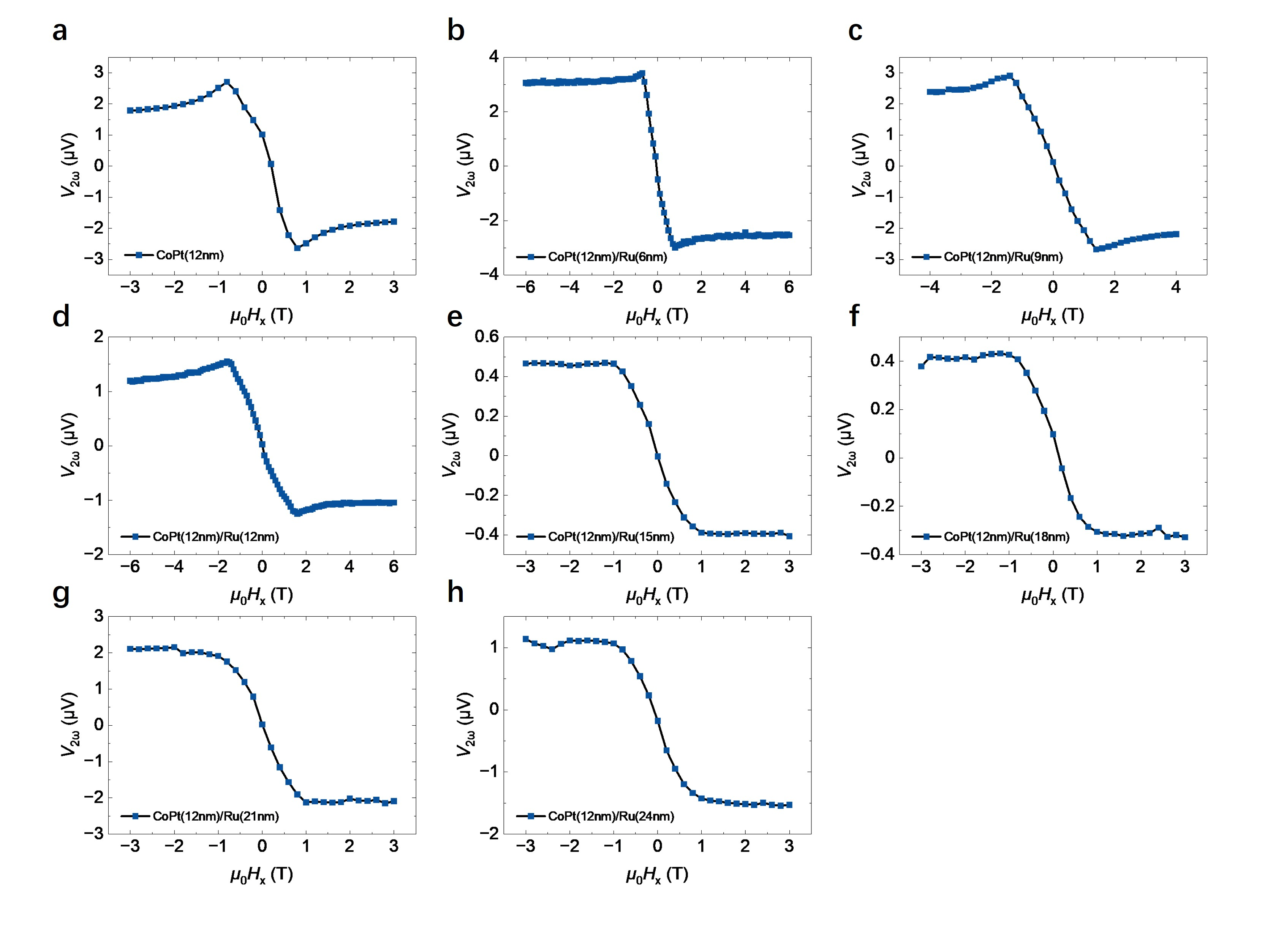
Supplementary Figure 6 | Large-field second-harmonic Hall response used to determine the thermal offset. $V_{2ω}$ as a function of $μ_{0}H_{x}$ for A1-CoPt(12 nm)/Ru($t_{Ru}$) with a-h, $t_{Ru}$= 0, 6, 9, 12, 15, 18, 21 and 24 nm, respectively. The offset of the flattened high-field segment defines $V_{offset}$ for the ANE/SSE correction. Harmonic measurements were performed using an AC current amplitude of 4 mA for $t_{Ru}$= 0 nm ($w$= 10 μm) samples, 8 mA for $t_{Ru}$= 6 - 18 nm samples ($w$= 10 μm), and 16 mA for $t_{Ru}$= 21, 24 nm samples ($w$= 5 μm), where $w$ denotes the width of Hall bar.
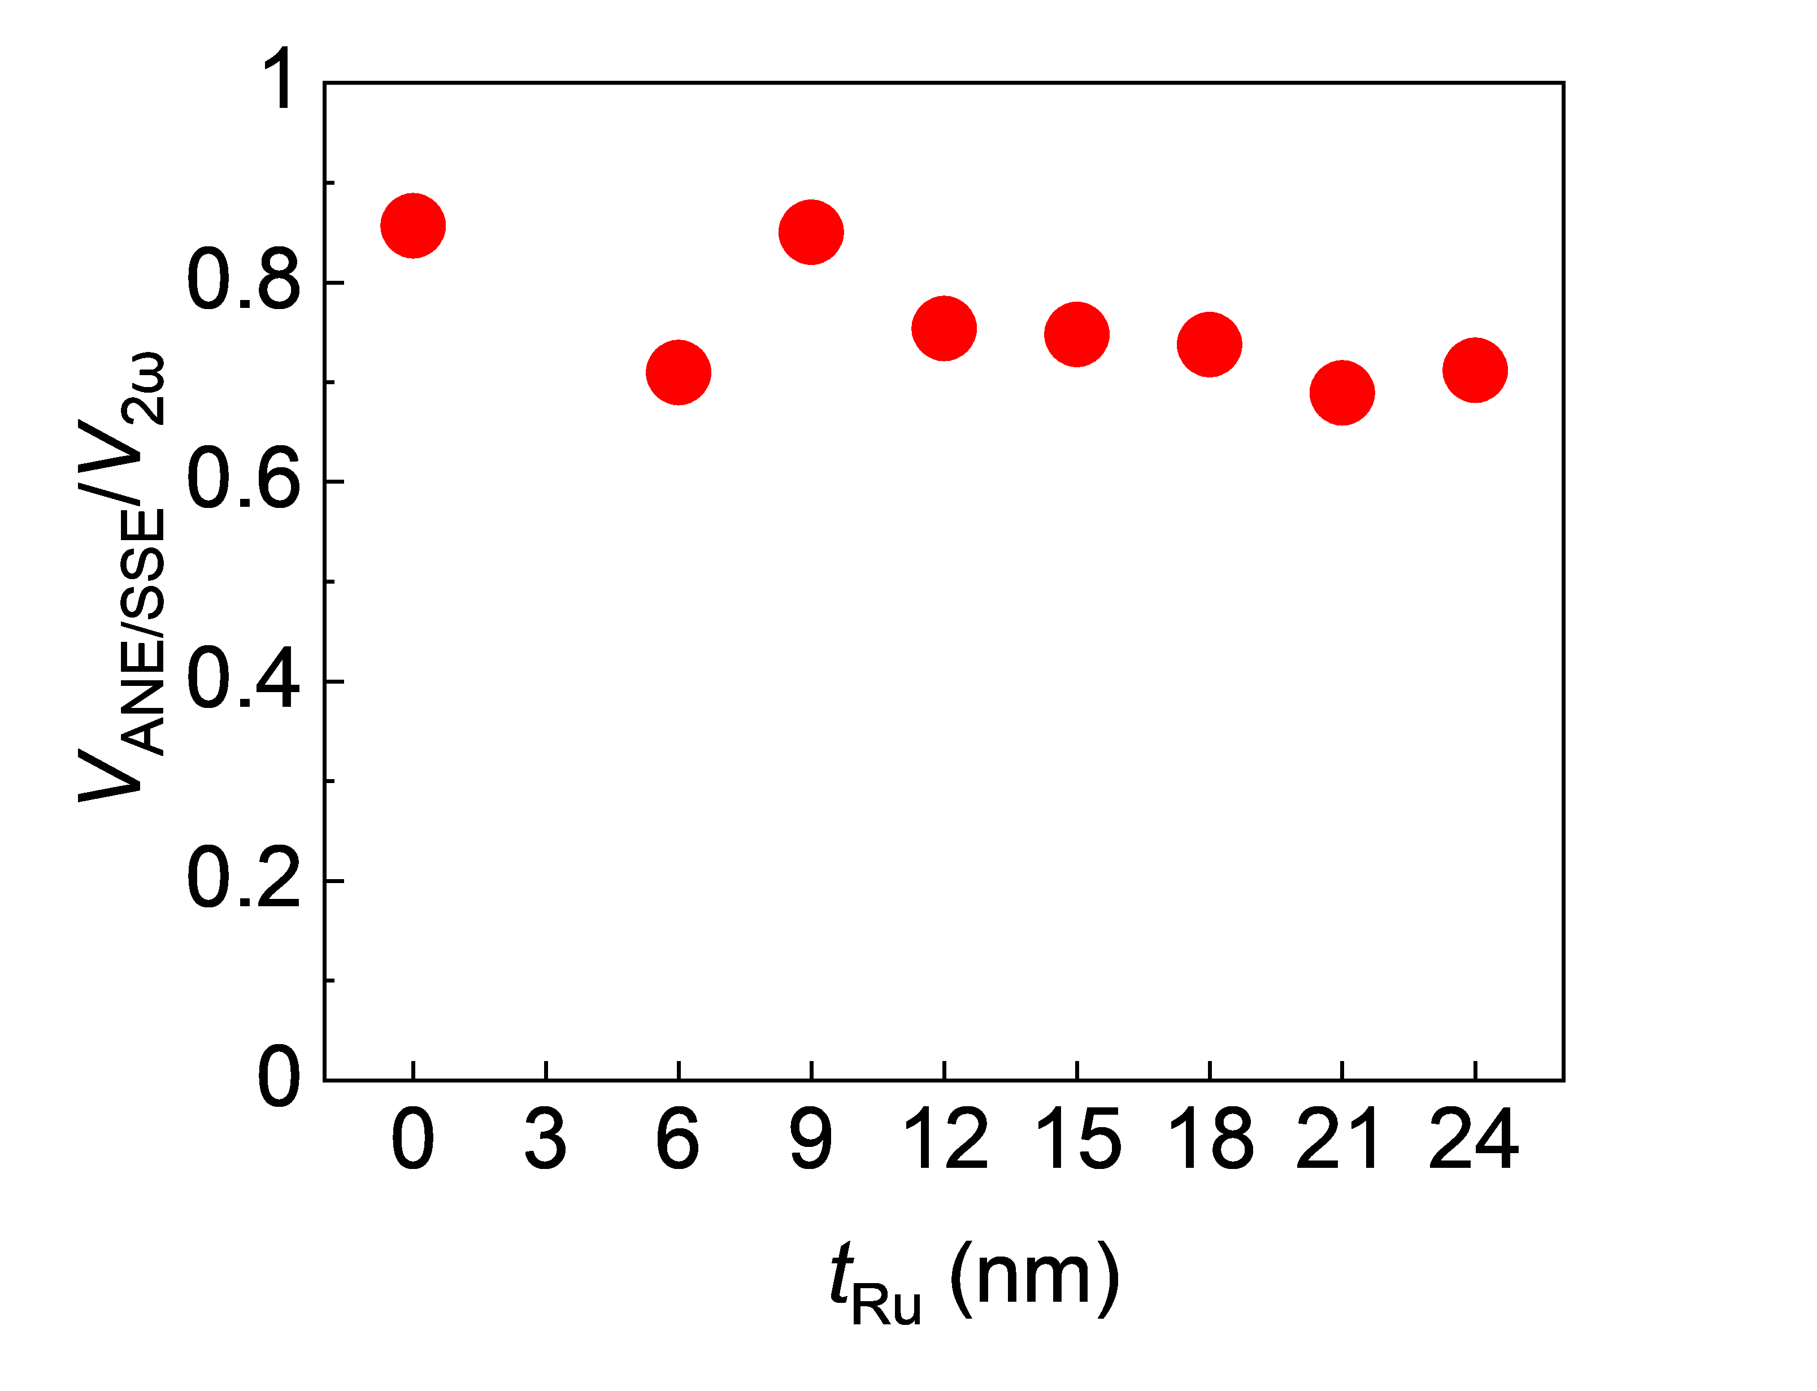
Supplementary Figure 7 | Ru-thickness dependence of the thermal contribution. Estimated ratio $V_{ANE/SSE}/V_{2ω}$as a function of $t_{Ru}$, obtained from the large-field offset.
Within the small-field range used for torque extraction, the in-plane magnetization component was approximated by $m_{x} ≈ H_{x}/H_{k}$. The thermal contribution was therefore estimated as $V_{ANE/SSE} = V_{offset}·(H_{x}/H_{k})$, where $μ_{0}H_{k}$ is the anisotropy field. The corrected small-field signal used to determine the in-plane effective field was $V_{2ω, SOT} = V_{2ω} − V_{offset}·(H_{x}/H_{k})$. This correction was applied independently to each sample before the small-field second-harmonic signal was fitted. Using this correction, we are able to subtract the thermal contributions and obtain the spin Hall angle $θ_{SH}$ shown in the main text.

Supplementary Note S3. Threefold field-free switching in A1-CoPt (12 nm)/CuO_{x} (6 nm) samples
We replaced Ru with Cu or naturally oxidized CuO_{x} to investigate the generality of orbital-to-spin conversion in low-symmetry systems. The CuO_{x} has been reported as an orbital current source through the OHE or interfacial orbital Rashba–Edelstein effect²⁻⁴. All devices exhibit field-free switching with an approximately threefold dependence on the in-plane current direction (Supplementary Figs. 8a and 8b) while the switching in CuO_{x} samples is more robust. We attributed this phenomenon to the enhancement of OT in the CuO_{x} samples while the threefold switching in A1-CoPt/Cu samples was mainly dominated by the spin current generated within the CoPt layer, which is relatively weak considering the current shunting effect. We also measured the effective out-of-plane magnetic field ${μ_{0}H}_{OOP}$ in these two samples when the input current is nearly their own switching threshold (Supplementary Figs. 8c and 8d). Clearly, while the loop shift is not obvious in the A1-CoPt/Cu device, the ${μ_{0}H}_{OOP}$ was measured to be 0.78 mT in A1-CoPt/CuO_{x} device. Consequently, we find a three-time enhancement of ${μ_{0}H}_{OOP}/J_{write}$ in the A1-CoPt/CuO_{x} than in the A1-CoPt/Cu device (Supplementary Fig. 8e). These results further show the generality of orbital-to-spin conversion and OT-driven field-free switching in low-symmetry systems.
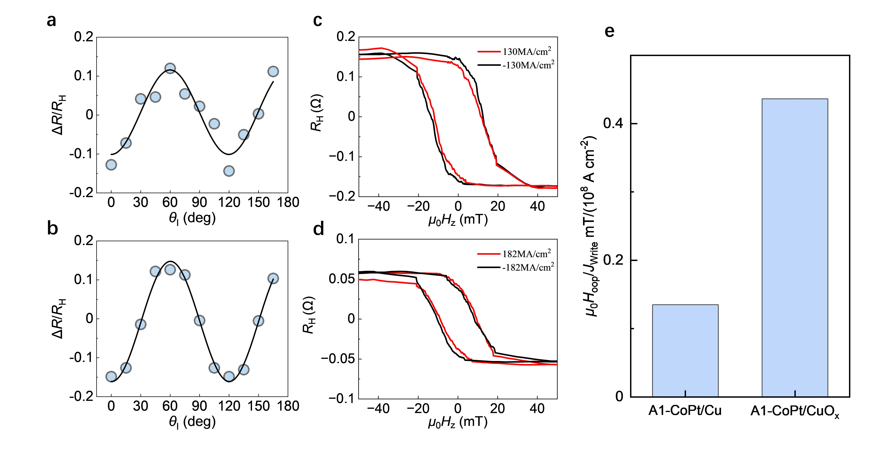
Supplementary Figure 8 | Threefold angle-dependent field-free switching in A1-CoPt (12 nm)/CuO_{x} (6 nm) and A1-CoPt (12 nm)/Cu (6 nm) devices. a, b, Normalized Hall-resistance change, $ΔR/R_{H}$, as a function of $θ_{I}$, for A1-CoPt/Cu (a) and A1-CoPt/CuO_{x} (6 nm) (b). The results show a similar trend to the Ru sample. The response still retains a 120° periodicity. c, d, $R_{H}$ as a function of $μ_{0}H_{z}$ during loop shift tests, for A1-CoPt/Cu (c) and A1-CoPt/CuO_{x} (d), corresponding to the devices in (a) and (b), respectively. e, Comparison of the out-of-plane effective field over current density, ${μ_{0}H}_{OOP}/J_{write}$. The value increases from approximately 0.13 mT/(10⁸ A cm⁻²) in A1-CoPt/Cu to approximately 0.44 mT/(10⁸ A cm⁻²) in A1-CoPt/CuO_{x}.

Supplementary Note S4. Angular dependence of the out-of-plane effective field in the A1-CoPt/Ru (9 nm) devices.
Current-induced loop shifts were measured at $θ_{I} = 60°, 90°, 120°$ and $150°$ by recording anomalous Hall loops under positive and negative writing currents (Supplementary Figs. 9-12). For each current, the loop centre was defined as $μ_{0}H_{centre}(I) =(μ_{0}H_{c, +} + μ_{0}H_{c, −})/2$, and the current-odd out-of-plane field as $μ_{0}H_{oop}(I) =(μ_{0}H_{centre, +I}− μ_{0}H_{centre, −I})/2$. The loop displacement is pronounced at the low-symmetry orientations and strongly reduced near the mirror-related orientations, consistent with the threefold angular dependence summarized in Fig. 3e.
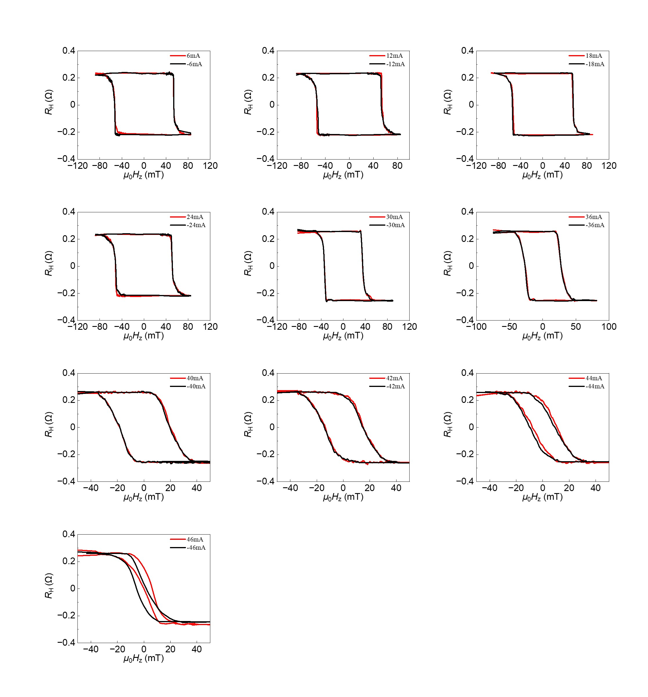
Supplementary Figure 9 | Current-induced anomalous Hall loop shifts in the A1-CoPt/Ru (9 nm) devices at $θ_{I} = 60°$. The input current $I_{Write}$ = 46 mA corresponds to a current density $J_{Write}$ of 45 MA/cm².
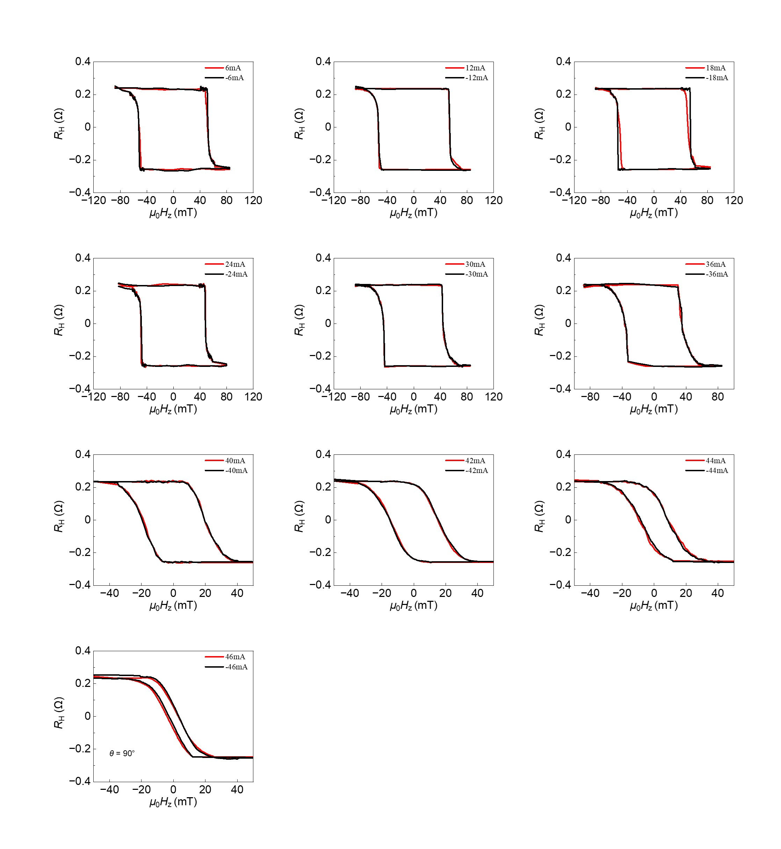
Supplementary Figure 10 | Current-induced anomalous Hall loop shifts in the A1-CoPt/Ru (9 nm) devices at $θ_{I} = 90°$. The input current $I_{Write}$ = 46 mA corresponds to a current density $J_{Write}$ of 45 MA/cm².
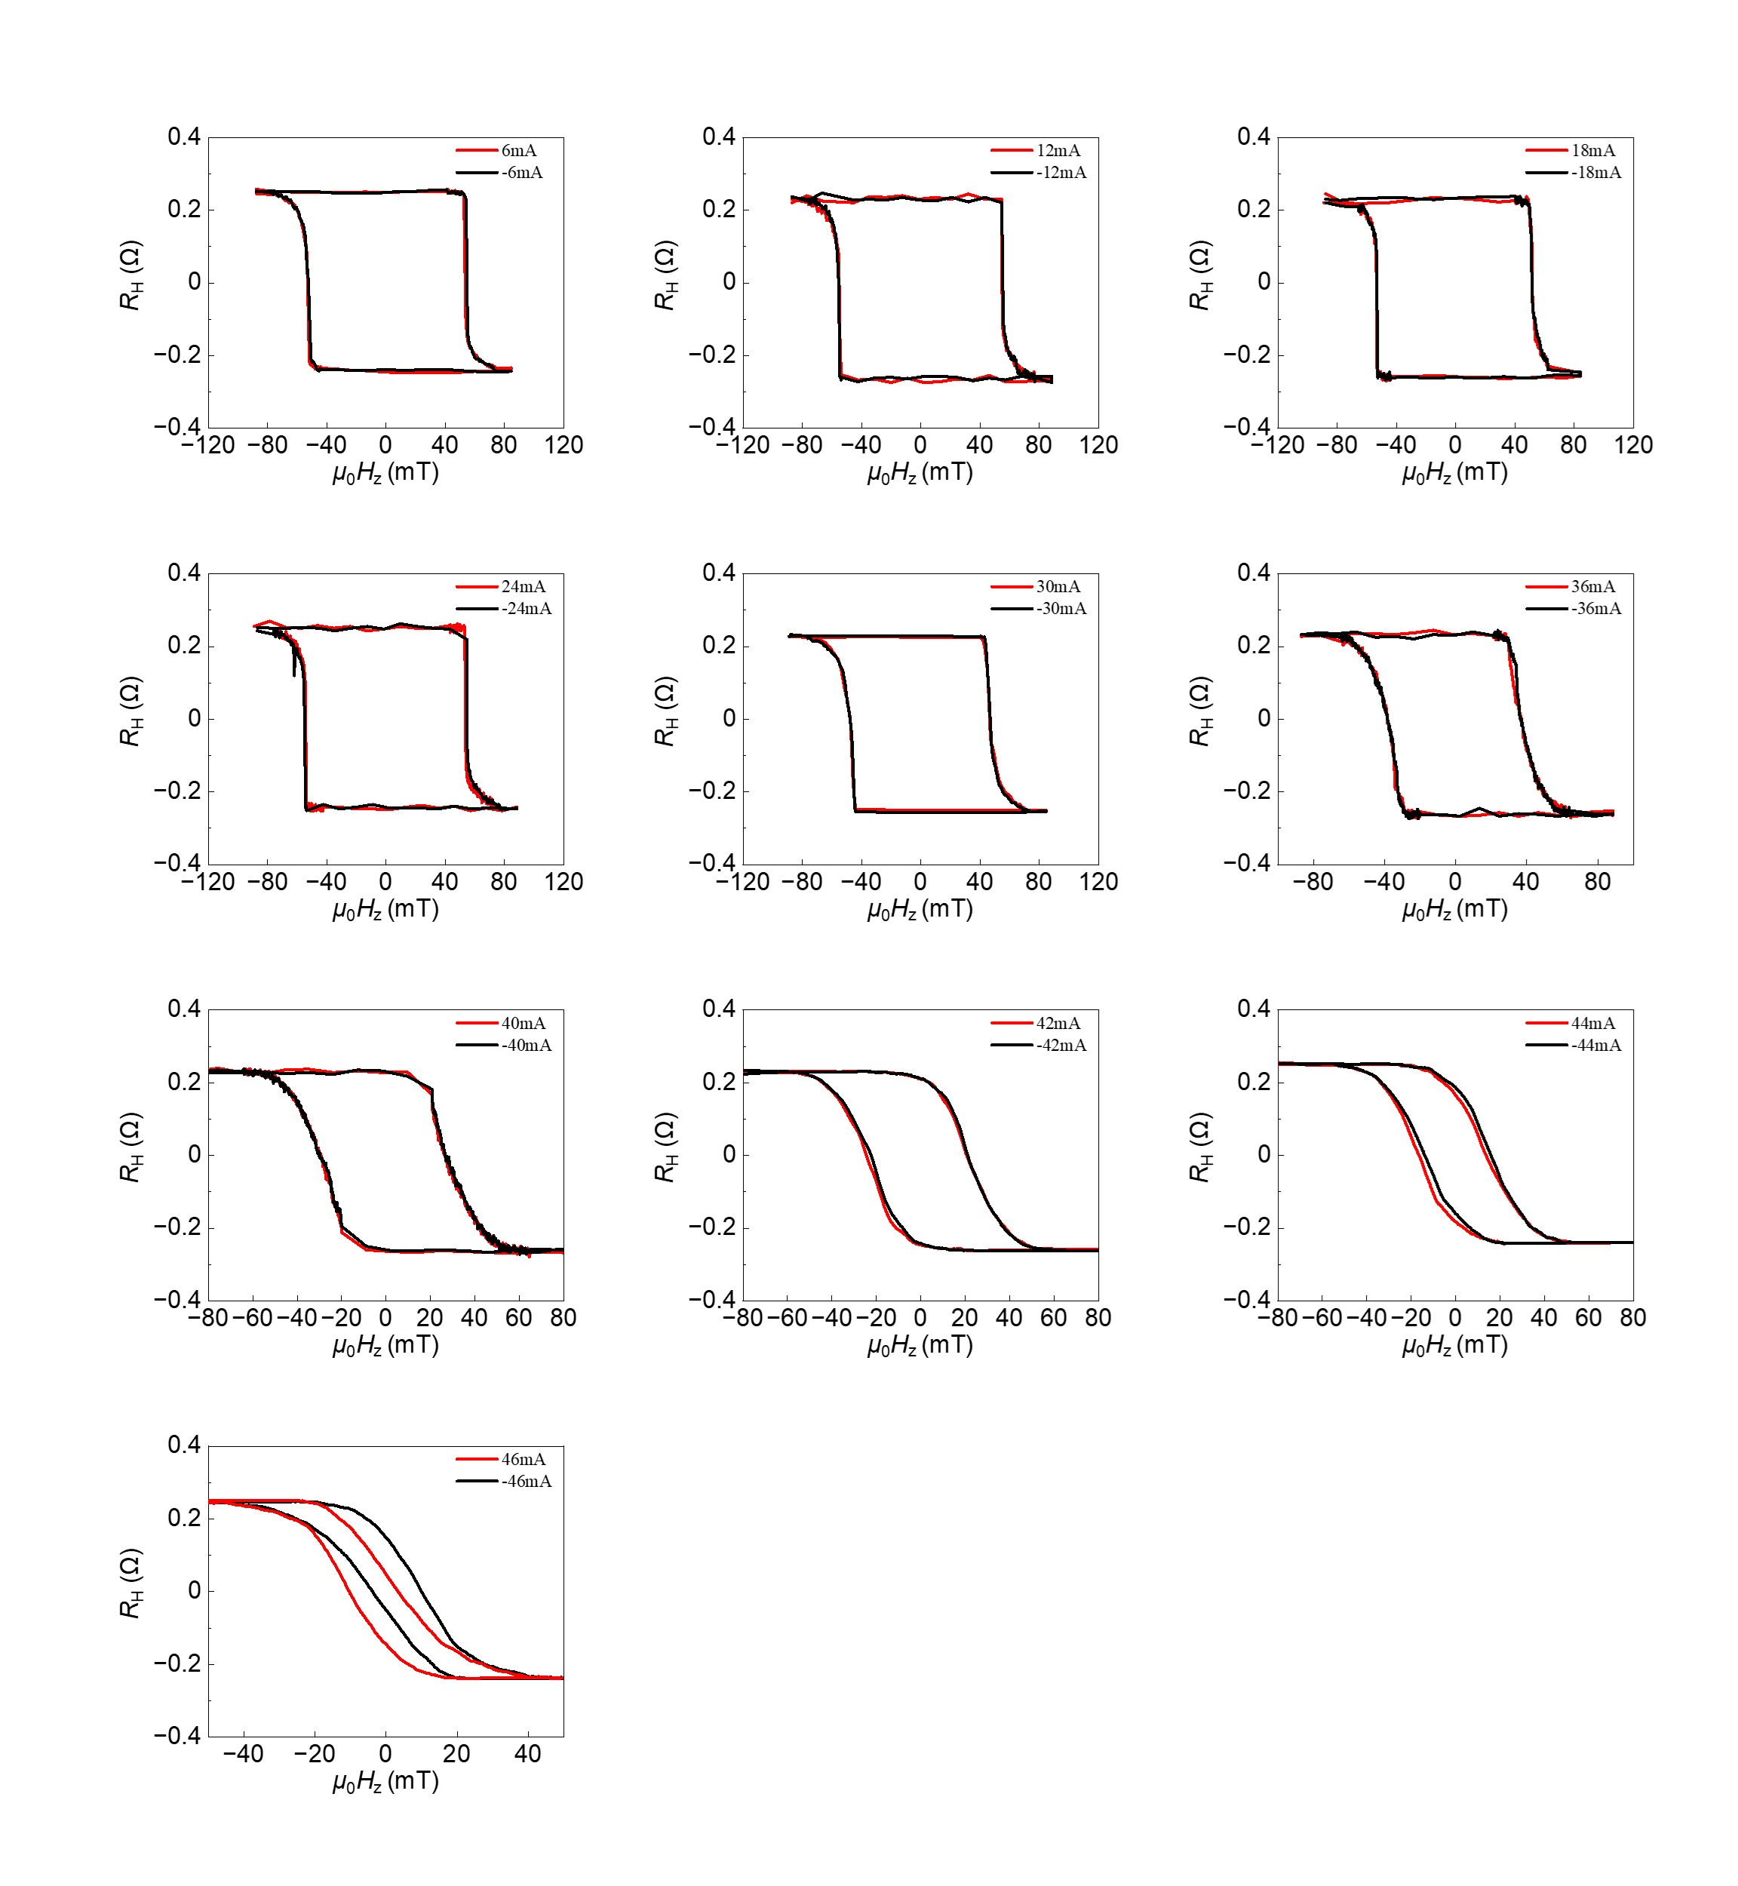
Supplementary Figure 11 | Current-induced anomalous Hall loop shifts in the A1-CoPt/Ru (9 nm) devices at $θ_{I} = 120°$. The input current $I_{Write}$ = 46 mA corresponds to a current density $J_{Write}$ of 45 MA/cm².
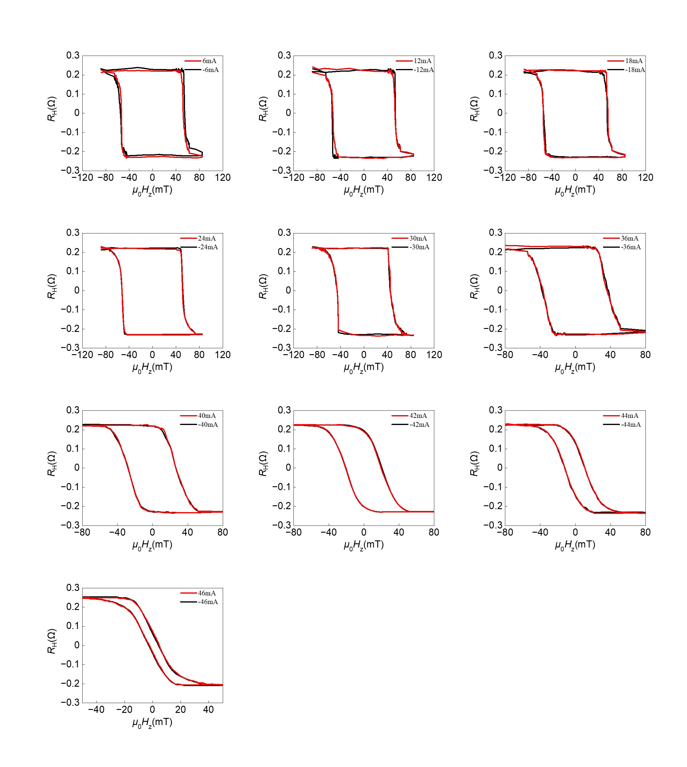
Supplementary Figure 12 | Current-induced anomalous Hall loop shifts in the A1-CoPt/Ru (9 nm) devices at $θ_{I} = 150°$. The input current $I_{Write}$ = 46 mA corresponds to a current density $J_{Write}$ of 45 MA/cm².

Supplementary Note S5. Relationship between the current shunting factor and the Ru thickness.
Supplementary Figs. 13 shows the current shunting factor $η$ of CoPt layer in A1-CoPt/Ru samples with different Ru thickness. The shunting factor $η$ is defined as $η=\frac{I_{CoPt}}{I_{write}}$.
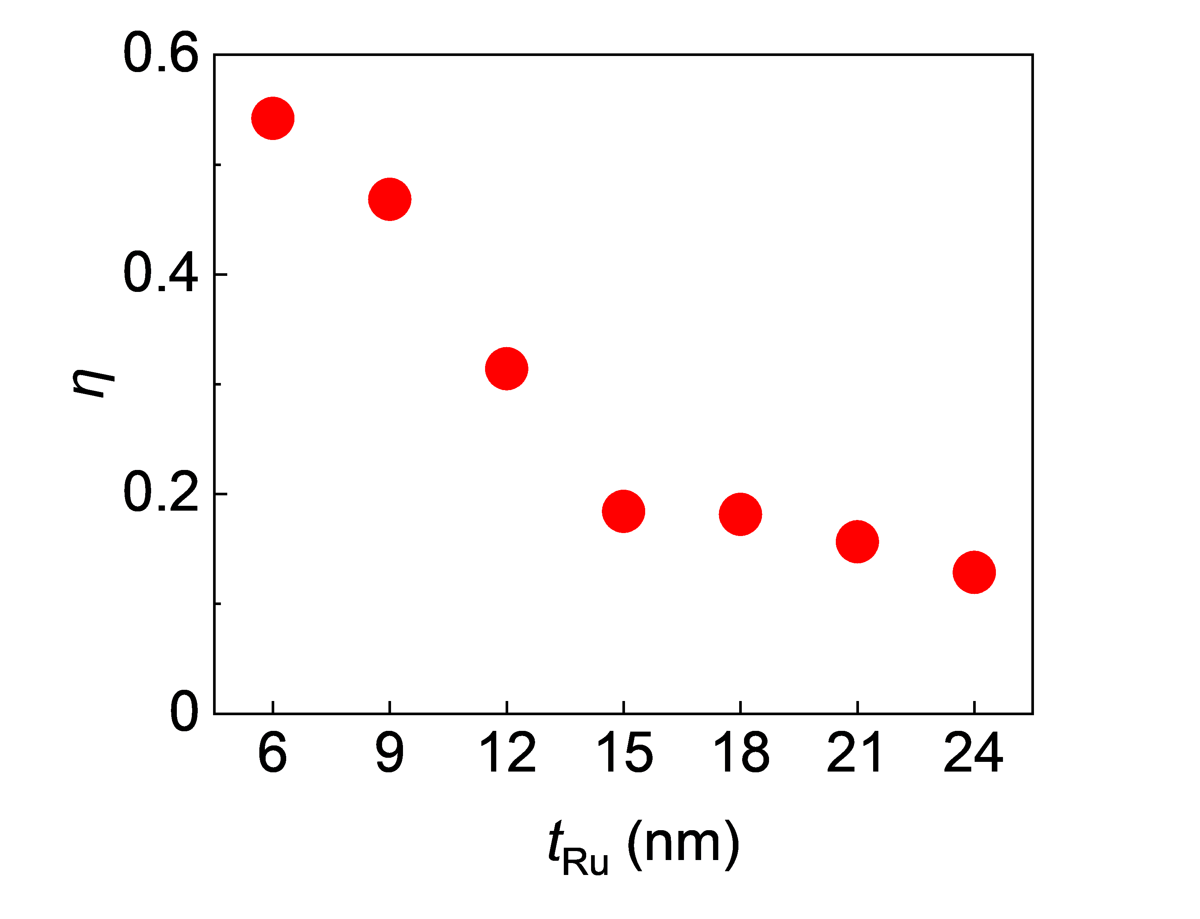
Supplementary Figure 13 | The current shunting factor $η$. As expected, $η$ is negatively correlated with $t_{Ru}$.

Supplementary Note S6. Robust field-free switching against thermal noise with enhanced out-of-plane torque verified by macrospin simulations.
It is critical to realize robust field-free switching of perpendicular magnetization against thermal noise. The emergence of out-of-plane torque $τ_{oop}$ in low-crystal-symmetry material systems gives a preferred switching direction of $m$ to +z or -z direction but does not permit robust switching because the relaxation process after removing the SOT or OT currents is completed under the joint effect of magnetic anisotropy, damping and thermal noise that is represented by three-dimensional random magnetic fields⁵. Consequently, it is possible to observe switching errors if the $τ_{oop}$ is not strong enough. Here, we show by macrospin simulations that the enhancement of ${μ_{0}H}_{OOP}/J_{write}$ with $t_{Ru}$, i.e., the unconventional orbital-to-spin conversion in A1-CoPt/Ru, could help realize the target of robust field-free switching against thermal noise.
The spin dynamics in A1-CoPt systems are depicted by the following Landau–Lifshitz–Gilbert (LLG) equation:
$$\frac{dm}{dt}=−γμ_{0}\left(m×H_{eff}\right)+α\left(m×\frac{dm}{dt}\right)+γμ_{0}H_{DLT}\left(m×σ×m\right)$$
$+γμ_{0}H_{3m}m×[\left(m_{y}E_{x}+m_{x}E_{y}\right)x+\left(m_{x}E_{x}−m_{y}E_{y}\right)y]$,
where the time derivative of the magnetization $m$ is contributed by the precessional torque, the damping torque, the damping-like OT (DLT) and the 3m torque originating from the three-fold symmetry in A1-CoPt system⁶. The $H_{eff}$ is the effective magnetic field including anisotropy field $H_{k,eff}$ and a fluctuating thermal field $H_{thermal}=η(step)\frac{1}{μ_{0}}\sqrt{\frac{2αk_{B}T}{γM_{s}∆V∆t}}$. Here, $μ_{0}$ is the vacuum permeability, $γ$ is the gyromagnetic ratio, $α$ is the Gilbert damping, $k_{B}$ is the Boltzmann constant, $T$ is the temperature, $M_{s}$ is the saturation magnetization, $∆V$ is the volume of the magnetic bit, $∆t$ is the simulation step and $η(step)$ is a random vector that changes every time step and satisfies a standard normal distribution. $H_{DLT }=\frac{J_{OT}θ_{SH}ℏ}{2et_{F}μ_{0}M_{s}}$ is the effective field of the DLT with elementary charge $e$, reduced Plank constant $ℏ$, FM layer thickness $t_{F}$, and spin Hall angle $θ_{SH}$. $H_{3m}$ is the effective of the 3m torque. $E=(E_{x},E_{y},0)$ is the direction of the applied in-plane electric field. In our simulations, we set $θ_{SH}=0.21$, $M_{s}=300 kA/m$, $t_{F}=4 nm$, $J_{OT}=667 MA∙{cm}^{−2}$, $T=300 K$, $∆V=4nm∙π∙{(60nm)}^{2}$, $∆t=1 ps$, $E=(1,0,0)$ denoting the low-symmetry direction, $H_{3m}=β_{3m}∙H_{DLT }$with $χ_{3m}$varying from 0 to 0.1.
As we can see in Supplementary Figs. 14a, when $β_{3m}=0.01$, though the magnetization $m$ can be quickly pulled to cross the xoy plane with $\overline{m_{z}}=0.0098$ at $t=0.2\sim 5 ns$, the fluctuating thermal fields finally drive the magnetization to -z direction, causing the write error. In stark contrast, $β_{3m}=0.1$ can guarantee robust switching to the +z direction, because of $\overline{m_{z}}=0.1$ at $t=0.2\sim 5 ns$, i.e., much stronger damping torque when removing the OT current. With $β_{3m}$ varying from 0 to 0.1, we calculate the corresponding switching probability. For each case, the switching probability was obtained by 20 individual tests. Our simulations show that $β_{3m}=0.05$ is likely to be the threshold for robust switching.
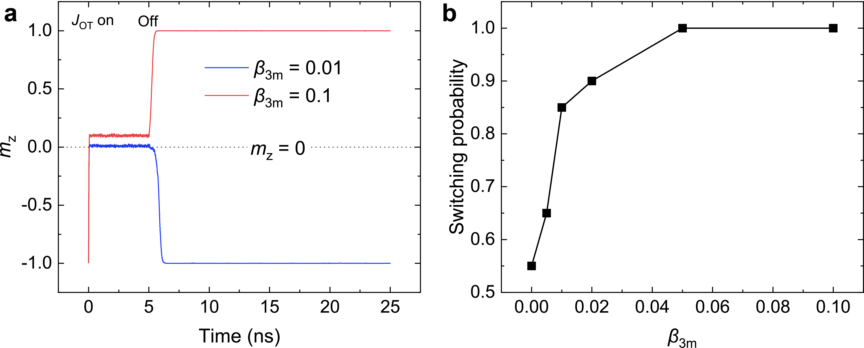
Supplementary Figure 14 | Macrospin simulations of field-free switching in the A1-CoPt/Ru system. a, Time traces of $m_{z}$ (z component of $m$) when $β_{3m}=0.1$ or $β_{3m}=0.01$ for one test. The OT pulse lasts for 5 ns. b, Switching probability as a function of $β_{3m}$.
In our A1-CoPt/Ru devices, the $β_{3m}$ reaches ~0.527 for $t_{Ru}=24 nm$, which exceeds the required threshold. We note that this large $β_{3m}$ is attributed to the unconventional orbital-to-spin conversion which takes places simultaneously with the typical $L_{y}$to $S_{y}$ conversion, otherwise Fig.4c in the main text suggest a much lower $β_{3m}$ of ~0.041. Therefore, it is important to enhance unconventional orbital-to-spin conversion for robust switching against thermal noise.

Supplementary Note S7. Angular dependence of the current-induced field-free switching in A1-CoPt/Ru ($t_{Ru}$) devices
Supplementary Fig. 15 summarizes the switching amplitude $ΔR$ for A1-CoPt (12 nm)/Ru ($t_{Ru}$) devices across the Ru-thickness series. All measured thicknesses retain an approximately threefold angular dependence, with pronounced responses along low-symmetry directions and suppressed responses near mirror-related directions. The phase and absolute sign, however, vary between samples.
We have verified that the sign of the effective spin Hall angle $θ_{SH}$ remains unchanged among samples with different $t_{Ru}$, which again indicates that the $L_{y}$ to $S_{y}$ conversion is independent of the crystal symmetry. In contrast, we tentatively associate the opposite polarity with different local stacking configurations of the terminal CoPt layers at the CoPt/Ru interface, which could happen during the film deposition process. Similar phenomenon has been reported in WTe₂/ Cr₂Ge₂Te₆, where the number of layers of the WTe₂, i.e., the interfacial terminal configurations, can control the sign of unidirectional spin Hall magnetoresistance (USMR)⁷. Therefore, subsequent comparisons use the angular periodicity and response magnitude and do not assign microscopic significance to the absolute sign. We also note that, however, this polarity change in our samples reflects directly the symmetry-mediated orbital-to-spin conversion process, as discussed in the main text. Therefore, in the main text (Fig. 4), we focus on the trend of absolute magnitude of ${μ_{0}H}_{OOP}/J_{write}$ with $t_{Ru}$.
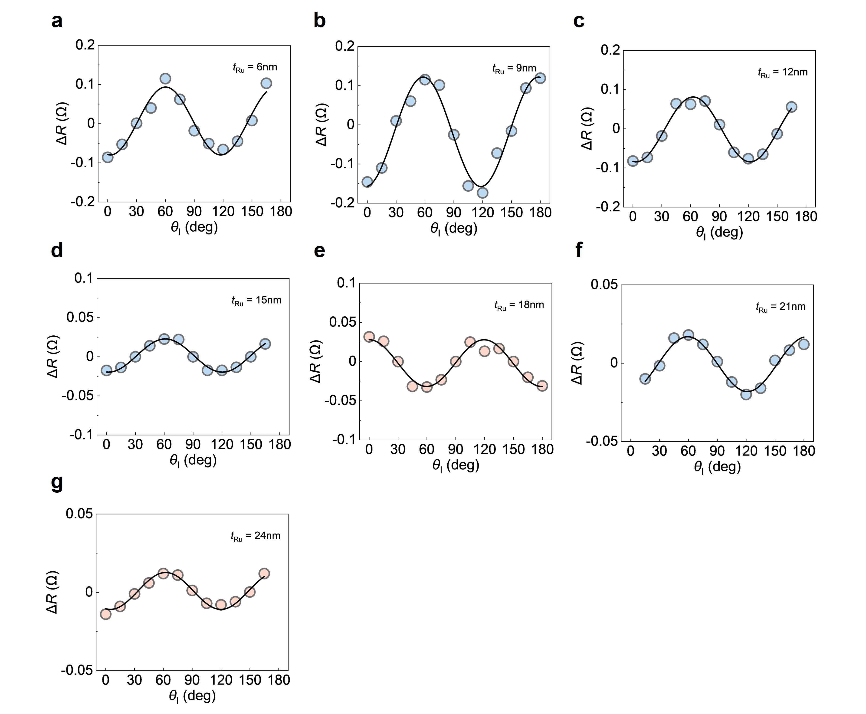
Supplementary Figure 15 | Ru-thickness evolution of the threefold switching response. Switching amplitude $ΔR$ as a function of $θ_{I}$ for A1-CoPt(12 nm)/Ru($t_{Ru}$) with a-g, $t_{Ru}$= 6, 9, 12, 15, 18, 21 and 24 nm, respectively. Solid lines are fits to a threefold cosine function. The response retains a $120°$ periodicity across the thickness series, while its overall sign may vary between samples because of different terminal Co/Pt stacking sequence.

Supplementary Note S8. Power dissipation of field-free switching in A1-CoPt (12 nm)/Ru ($t_{Ru}$) devices
Supplementary Fig. 16 shows the writing threshold density $J_{Write}$ and the power consumption $P_{sw}=I_{Write}^{2}R_{xx}$ of field-free switching in A1-CoPt (12 nm)/Ru ($t_{Ru}$) devices. As $t_{Ru}$ increases, the resistivity of the Ru layer decreases rapidly, leading to a marked reduction in the Joule heating effect. As SOT-switching in the DC regime is largely assisted by the thermal agitation, the largely reduced Joule heating effect could balance the influence of enhancement of OT in our devices, which we believe explains why the $J_{Write}$ does not decrease with $t_{Ru}$ but remains around 50 MA/cm² (Supplementary Fig. 16a). Even so, the total writing power consumption $P_{sw}$ still decreases with increasing $t_{Ru}$. At $t_{Ru}=$ 24nm, $P_{sw}$ is reduced by about 20% compared with that in single CoPt layer (Supplementary Fig. 16b), indicating the potential of integrating orbital effects for energy-efficient field-free switching.
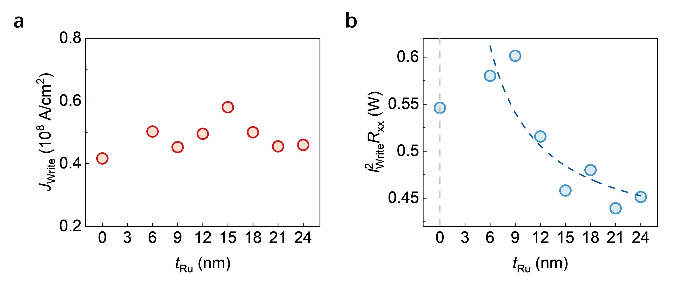
Supplementary Figure 16 | Ru-thickness dependence of the writing characteristics. a, Writing threshold density $J_{Write}$ as a function of $t_{Ru}$. b, Power consumption of field-free switching $P_{sw}=I_{Write}^{2}R_{xx}$, where $I_{Write}$ represents the write threshold and $R_{xx}$ represents the longitudinal resistance of the devices along the direction of $I_{Write}$. The dashed line guides the eye.

Supplementary References
- Liu, L. et al. Crystal symmetry-dependent in-plane Hall effect. Nano Letters 24, 733-740 (2024).
- Go, D., Jo, D., Gao, T. et al. Orbital Rashba effect in a surface-oxidized Cu film. Phys. Rev. B 103, L121113 (2021).
- Ding, S., Liang, Z., Go, D. et al. Observation of the orbital Rashba–Edelstein magnetoresistance. Phys. Rev. Lett. 128, 067201 (2022).
- Huang, Q., Liu, S., Yang, T. et al. Current-induced magnetization switching in light-metal-oxide/ferromagnetic-metal bilayers via orbital Rashba effect. Nano Letters 23, 11323–11329 (2023).
- Vansteenkiste A., Leliaert J., Dvornik M. et al. The design and verification of MuMax3. AIP Advances 4, 107133 (2014).
- Liu, L., Zhou, C., Zhao, T. et al. Current-induced self-switching of perpendicular magnetization in CoPt single layer. Nature Communications 13, 3539 (2022).
- Kao, I., Tang, J., Ortiz, G. et al. Unconventional unidirectional magnetoresistance in heterostructures of a topological semimetal and a ferromagnet. Nature Materials 24, 1049 (2025).

