Appendix 2: FAQs and background information to survey for
Disturbances Increase Net Carbon Emissions in the Arctic-Boreal Zone - An Expert Assessment

FAQs

- What is and is not a disturbance?

For the purposes of this survey, disturbance is defined as any relatively discrete event or set of events in time that disrupt ecosystem, community, or population structure, and/or changes resources, substrate availability, or the physical environment.

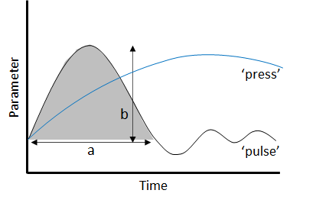
Hence, we focus here on ‘pulse’, or abrupt, rather than ‘press’, or gradual disturbance.

Fig 1: conceptualised trajectories of press event (blue line; not considered in this survey) and of pulse event (black line), with dimensions of pulse event indicated by arrows and labels.
(a) = pulse duration; (b) = pulse magnitude; b/a = abruptness. Adapted from Jentsch & White (2019).

According to the dimensions described in Fig. 1, pulse disturbances have shorter durations (a) and greater abruptness (b/a) compared to press disturbances (which are not considered here).

In this way we can distinguish between (for example) a drought which can be described as a ‘pulse’ disturbance, where plant tolerance to water deficit is overwhelmed and results in water stress and physiological disruption in affected vegetation. On the other hand, a longer duration and/or lower magnitude trend towards soil drying, resulting in reduced vegetation productivity, might be more correctly described as a ‘press’ drought event. Pulse disturbance should be considered in this survey; press events should not.

- Does this survey focus only on change caused directly by increasing temperatures?

No. Please consider whether and how your disturbance category has changed or will change over the specified timescale due to any and all drivers, including climate, anthropogenic drivers, and even other disturbances. You are very welcome to provide detail on the drivers you have considered in the additional notes section.

- What do you mean by ‘net carbon impact’?

Net carbon impact is defined here as the net result of carbon uptake from and release to the atmosphere driven by disturbance, where net release is positive (+) and net uptake is negative (-). This means that if changes in disturbances across the landscape result in release of 10 Tg C, but generate increased carbon uptake of 2 Tg C, the net carbon impact of those disturbances is 8 Tg C.

- What spatial domain is considered in this survey?
The domain considered throughout this survey comprises the Arctic and Boreal Forest/Taiga biomes combined (Fig. 2). This domain is hereafter referred to as the ‘Arctic-Boreal Zone’ (ABZ).
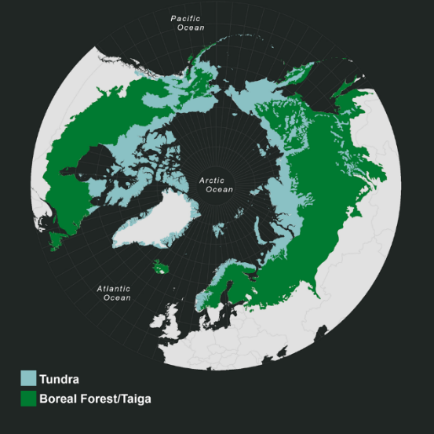

Fig 2: Tundra (blue) and boreal (green biomes). Together these comprise the domain to consider when responding to this survey. Ecoregions from Dinerstein et al,. (2017).

We ask that you consider the full terrestrial area of these biomes. This includes freshwater aquatic environments where these are affected by the disturbance in question. Coastal and marine environments, including subsea permafrost, are excluded.

- Which impacts of disturbance should I consider?
Please consider all impacts which can be clearly, causally linked to the disturbance in question. This includes impacts which are longer-term, or may be considered secondary, in addition to immediate, primary impacts. For example, in the case of fire, you would consider longer-term changes in carbon uptake due to changes in vegetation composition, in addition to carbon loss from combustion.

Some impacts may be clearly, causally linked to the disturbance in question, while also being a different pulse disturbance in their own right. For example, fire may result in more permafrost-related pulse disturbances (such as slumps or active layer detachments). We do not want to omit these important interactions from this survey; however we also do not want to ‘double-count’ them. Therefore, please do not explicitly factor impacts into your estimates which could be described as discrete, pulse disturbances events in their own right. In this example, you would therefore not include fire-induced slumps or active layer detachments in your estimates. You would, however, include fire-induced changes in active layer depth, as active layer thickening is not a discrete, pulse disturbance event. Instead, if you were completing the permafrost-related questionnaire, you would consider fire among the drivers of changes in permafrost-related disturbance regimes.

- What ‘is’ my disturbance category? What does it include?
Please find definitions and guidance relating to each disturbance category considered here, alongside a short, non-exhaustive list of examples of specific disturbance types.
Category | Definition/guidance | Examples
Fire | Any fire event, including holdover fires. In your answers, please consider additional direct but longer-term consequences of fire in addition to immediate impacts such as those associated with combustion. These longer-term consequences might include abiotic changes, such as altered ground temperature, or biotic changes, such as altered vegetation productivity. | Boreal fire  Tundra fire
Biotic | Pulse disturbances directly driven or caused by a biotic agent, such as an insect or herbivore. This excludes 'press' disturbances; such as background herbivory, and instead focuses on disturbances with higher-than-average abruptness (magnitude / duration). In your answers, please consider all direct consequences (including those which are not necessarily immediate) of biotic disturbance. For example, including inputs of insect frass and carcasses, in addition to the immediate impact of defoliation. | Defoliating insect outbreak  Bark beetle outbreak  Herbivory event
Weather- related | Pulse disturbances directly driven or caused by a weather event or multiple weather events. In your answers, please consider all direct consequences of weather-related disturbance (including those which are not necessarily immediate).  Often, the same type of weather-related disturbances may manifest either as a pulse disturbance (which should be considered here) or a press disturbance (which should not). For example, a drought may be correctly described as a pulse disturbance where plant tolerance to water deficit is overwhelmed during a relatively discrete period of dry conditions, resulting in water stress and relatively 'abrupt' (magnitude / duration) physiological disruption in affected vegetation. Alternatively, a drought may be more accurately termed as a press event when describing a longer duration and/or lower magnitude trend towards soil drying, resulting in reduced vegetation productivity. Relevant weather-related disturbances may be driven by a single variable (e.g. temperature extremes) or they may be multifactorial and/or be defined in part by the crossing of ecological thresholds (e.g. extreme winter warming). | Windthrow  Rain on snow  Frost drought  Spring/ summer frost  Extreme winter warming  Drought  Weather- related flooding/ inundation
Anthropogenic | Pulse disturbances directly driven or caused by human activity. This excludes 'press' disturbance; namely a consistent, background level of human activity, as well as subsistence activity and traditional ways of living. In your answers, please consider all direct consequences of anthropogenic disturbance (including those which are not necessarily immediate). These might, for example, include changes in soil moisture and vegetation composition following logging, in addition to the logging activity itself. | Logging  Oil and gas  Roads  Fire breaks  Power lines
Permafrost- related | Pulse disturbances directly driven or caused by permafrost changes. Not all permafrost disturbances can be accurately described as pulse disturbances. For example, active layer thickening would in most cases be described as a press disturbance, as this is an ongoing process (rather than a discrete event), and therefore does not have a higher-than-average 'abruptness' (magnitude / duration). In contrast, other types of permafrost disturbance (e.g. active layer detachment) can be described as pulse disturbances due to their comparatively high magnitudes and shorter, discrete durations. However, there is no absolute delineation between press and pulse, and some permafrost disturbances may be challenging to conceptualise as one or the other. When in doubt, we encourage participants to first consider 'discreteness'; a disturbance must be discrete (i.e. have a discernible beginning and end) to be a pulse disturbance. If a beginning and end can be discerned, informed judgement must be exercised as to whether the disturbance is of sufficient magnitude and/or sufficiently short duration to be justifiably described as a pulse disturbance. In your answers, please consider all direct consequences of permafrost disturbances (including those which are not necessarily immediate). Longer-term consequences might, for example, include altered vegetation composition. | Thermokarst formation  Active layer displacement  Retrogressive thaw slump  Gas Emission Crater formation  Permafrost- driven lake drainage

- What timeframe should I consider?

In questions 1 and 3 we ask you to estimate a change in the mean annual net carbon impact by a specified year, or across a specified time period (target), compared to a different specified time period (baseline). Hence we are asking for the difference between the target and the baseline.

We are asking you to consider both immediate and longer-term impacts of disturbance. This means that your estimated mean annual net carbon impact for a specified year may be influenced by disturbances which took place in previous years - if the impacts of those disturbances are sufficiently long-lived. This is not the same thing as a cumulative estimate, which would be an estimate of the total net impact of all disturbances up until the specified year. Instead we are asking for the mean annual value by the specified year, or across the specified time period.
Background information

Arctic-boreal warming: preindustrial to present

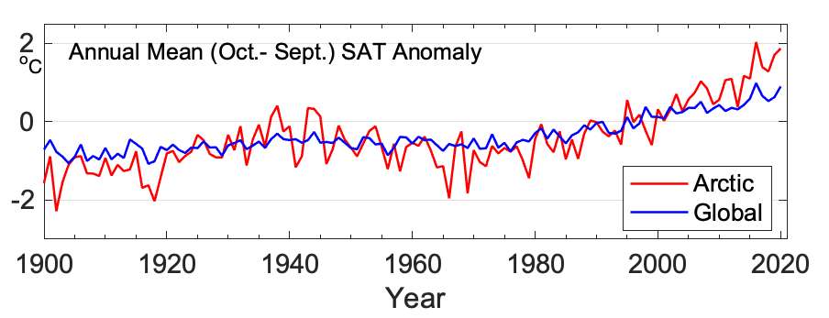
Arctic regions are now warming at more than double the global rate. Above 60°N, the mean surface air temperature anomaly for the 12-month period ending in September 2020 was 1.9°C higher than the 1981-2010 average, marking the 7th consecutive year in which surface air temperature anomalies were at least 1°C warmer than the 1981-2010 mean.
Fig 3: Mean annual SAT anomalies (°C) for terrestrial weather stations located in the Arctic (60-90° N) and globally for the 1900-2020 period, relative to the 1981-2010 means. Source: Arctic Report Card 2020, CRUTEM4 SAT data.

For the purposes of this survey, we define the preindustrial period as the period prior to which no or minimal anthropogenic climate change had occurred.

Our understanding of pan-Arctic and boreal carbon balance for this period is limited. Therefore, to minimise the impact of the uncertainty relating to carbon balance during this period, we request that you assume the annual net carbon impact* of disturbance during the preindustrial period was zero.

This means that prior to anthropogenic warming, carbon uptake and carbon release driven by permafrost-related disturbance were in equilibrium. Therefore, rather than conceptualising your estimates as the change in the net carbon impact of disturbance since (for example) 1870, please estimate the change since perturbation due to anthropogenic climate change = 0.

*Net carbon impact = the net result of carbon uptake and release driven by disturbance, where net release is positive (+) and net uptake is negative (-).

The ‘present day period’ is defined here as 2000-2020. Net annual carbon impact for the present day period thus refers to the average annual net carbon impact during 2000-2020.

Arctic-boreal warming: future scenarios

Three scenarios for future warming are considered in this survey:
- Scenario A: Global mean temperature increase is held below 2°C until at least 2100.
- Scenario B: Global mean temperature increase is held below 1.5°C until at least 2100.
- Scenario C: Global mean temperature increases in line with Representative Concentration Pathway (RCP) 8.5.

We recognise that scenarios A and B are rarely considered explicitly in the literature, where projections most often relate to RCPs, and that this may make responding to questions using these scenarios more challenging. Nonetheless, these scenarios are used here for the following reasons:

- Holding global average temperature increase to “well below 2°C above pre-industrial levels” and “pursuing efforts to limit the temperature increase to 1.5°C above pre-industrial levels” comprise the core mitigation goals of the Paris Agreement on climate change.
- Research directly addressing these goals, as well as the difference between 1.5°C and 2°C, therefore remains an important need.
- RCPs are not well understood outside of the scientific community. Therefore, they are less well suited to the purpose of highlighting the importance of under-represented processes in policy decision-making tools.

Warming projections: global average trends

Temperature projections for each of the above scenarios are illustrated in the below table and Figs 4-5 (overleaf).

Scenario | Description | Approximate global T increase (°C) by: |  | Primary post-2100 trend
Scenario | Description | 2050 | 2100 | Primary post-2100 trend
A | Global mean temperature increase held below 1.5°C by 2100 | 1.37 | 1.47 | Stable/downwards
B | Global mean temperature increase held below 2.0°C by 2100 | 1.69 | 1.75 | Stable/downwards
C | RCP 8.5 | 2.34 | 5.11 | Upwards

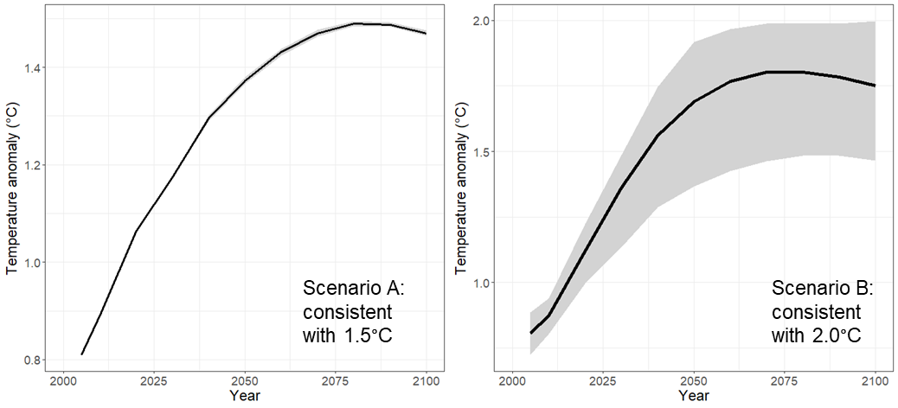
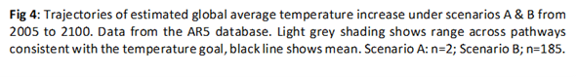
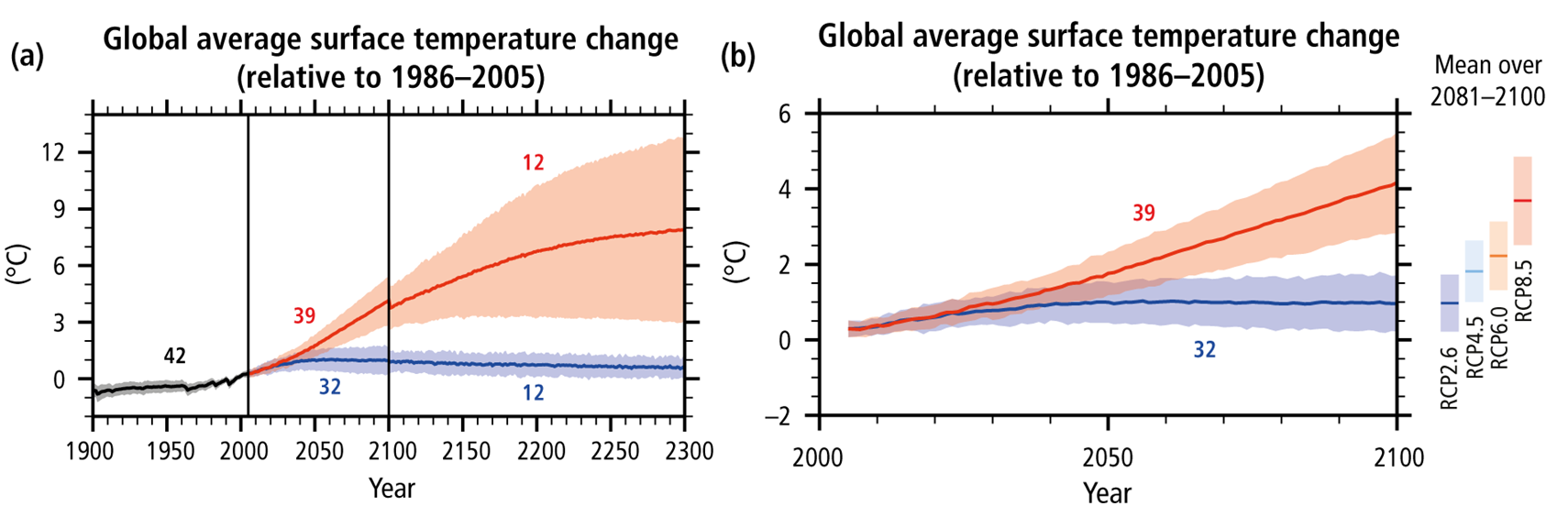
Fig 5: (a) Annual global average temperature change during the 1900–2300 period (relative to 1986–2005) from Coupled Model Intercomparison Project Phase 5 (CMIP5) concentration-driven experiments. Discontinuities at 2100 are due to different numbers of models and have no physical meaning. (b) same as (a) except for 2005-2100. Projections in both panels are shown for the multi-model mean (solid lines) and the 5% to 95% range across the distribution of individual models (shading) for scenarios RCP2.6 (blue) and RCP8.5 (red). The number of CMIP5 models used to calculate the multi-model mean is indicated.

Warming projections: spatial variation

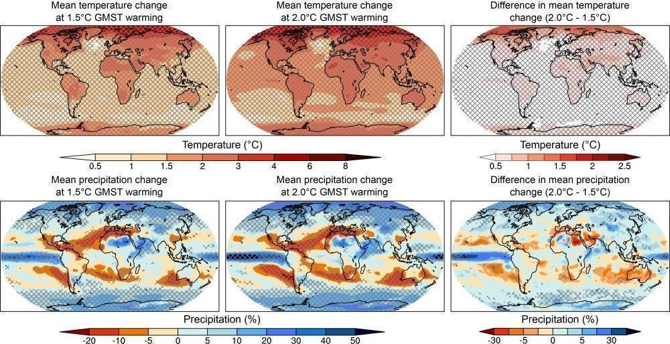
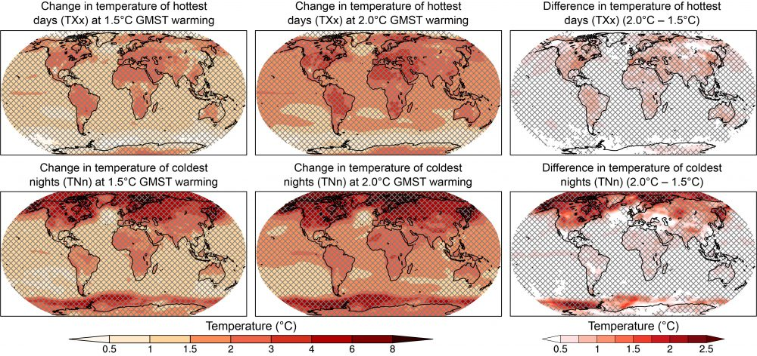
Fig. 6: Projected changes in mean temperature (top) and mean precipitation (bottom) at 1.5°C (left) and 2°C (middle) of global warming compared to the pre-industrial period (1861–1880), and the difference between 1.5°C and 2°C of global warming (right). Cross-hatching highlights areas where at least two-thirds of the models agree on the sign of change as a measure of robustness (18 or more out of 26). Figure from IPCC Special Report on Global Warming of 1.5 ºC
Aspects of disturbance regimes

Four characteristics of disturbance regimes are considered in this survey:
- Frequency: the temporal frequency of occurrence; how often a discrete disturbance event takes place at a given location.
- Extent: the average area affected by a discrete disturbance event; for example, in fig. 6 (below) nine discrete disturbance events are shown in green. The extent of each event is the area of the green circle, and the typical extent of this disturbance type would therefore be the average area of these nine circles.
- Range: the spatial range over which disturbance events occur; the spatial distribution of occurrence. For example, in fig. 6 (below) all nine disturbance events shown are within the North American boreal (outlined in blue). The range is therefore the North American boreal region.
- Severity: carbon release per unit area, where severity increases with increasing carbon release per unit area.
Fig. 7: Projected changes in temperature extremes at 1.5°C (left) and 2°C (middle) of global warming compared to the pre-industrial period (1861–1880), and the difference between 1.5°C and 2°C of global warming (right). Cross-hatching highlights areas where at least two-thirds of the models agree on the sign of change as a measure of robustness (18 or more out of 26). Figure from IPCC Special Report on Global Warming of 1.5 ºC
Projected changes in extremes at 1.5°C (left) and 2°C (middle) of global warming compared to the pre-industrial period (1861–1880), and the difference between 1.5°C and 2°C of global warming (right).
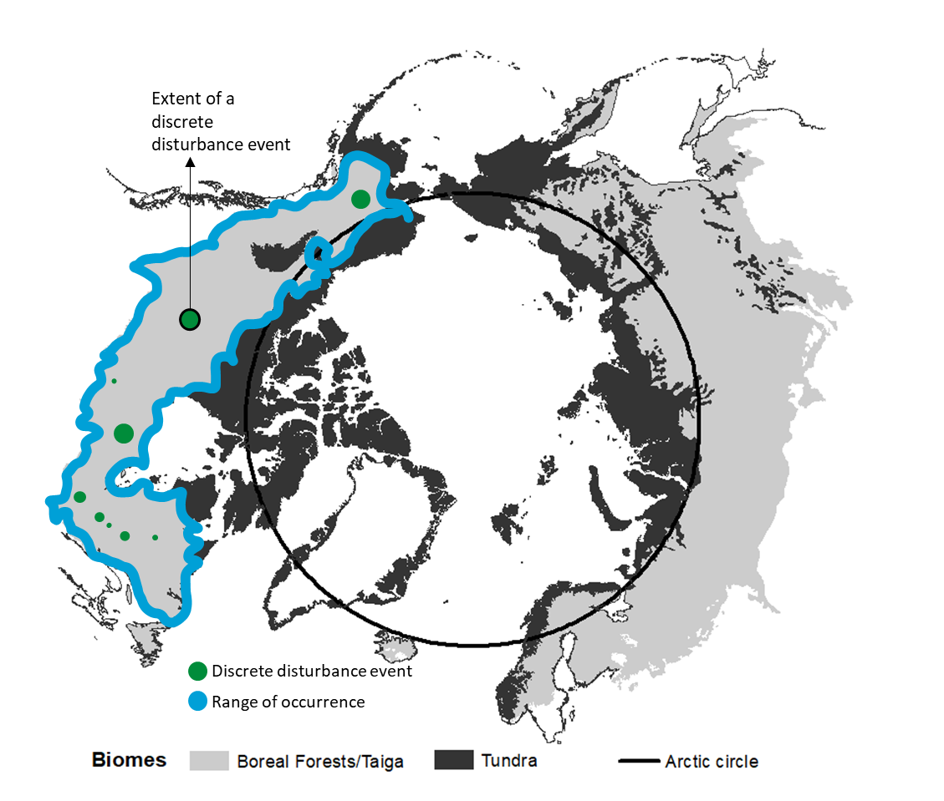
Fig. 6: Map of Tundra and Boreal biomes showing conceptual examples of range and extent.

Key literature

Special Report on the Ocean and Cryosphere in a Changing Climate

Special Report on Global Warming of 1.5 ºC. Chapter 3: Impacts of 1.5ºC global warming on natural and human systems

Snow, Water, Ice and Permafrost in the Arctic (SWIPA) - 2017

Schuur, E., McGuire, A., Schädel, C. et al. Climate change and the permafrost carbon feedback. Nature 520, 171–179 (2015). https://doi.org/10.1038/nature14338

Myers-Smith, I.H., Kerby, J.T., Phoenix, G.K. et al. Complexity revealed in the greening of the Arctic. Nat. Clim. Chang. 10, 106–117 (2020). https://doi.org/10.1038/s41558-019-0688-1

McGuire, A. D., Lawrence, D. M., Koven, C., et al. Dependence of the evolution of carbon dynamics in the northern permafrost region on the trajectory of climate change. Proceedings of the National Academy of Sciences, 115(15), 3882–3887 (2018). https://doi.org/10.1073/pnas.1719903115

