Supplementary Material for
Disturbances Increase Net Carbon Emissions in the Arctic-Boreal Zone - An Expert Assessment

Contents:
Table S1
Figures S1-S8
Table S1. Demographic information about survey respondents. Grey text indicates data not provided.

Category | Demographic | Anthropogenic | Biotic | Fire | Permafrost | Weather | All Categories
Career Stage | Mid | 4 | 7 | 10 | 8 | 3 | 32
Career Stage | Early | 3 | 3 | 7 | 8 | 1 | 22
Career Stage | Established | 1 | 1 | 2 | 4 | 5 | 13
Career Stage | Not Provided | 2 | 2 | 3 | 2 | 2 | 11
Gender | Male | 4 | 6 | 11 | 7 | 7 | 35
Gender | Female | 5 | 4 | 7 | 12 | 1 | 29
Gender | Not Provided | 1 | 3 | 4 | 3 | 3 | 14
Region | North America | 7 | 7 | 14 | 10 | 3 | 41
Region | Europe | 2 | 4 | 3 | 10 | 6 | 25
Region | Oceania |  |  | 1 |  |  | 1
Region | Russia |  |  | 1 |  |  | 1
Region | Asia |  |  | 1 |  |  | 1
Region | Not Provided | 1 | 2 | 2 | 2 | 2 | 9
Primary Research Approach | Modelling | 6 | 3 | 7 | 9 | 3 | 28
Primary Research Approach | Remote Sensing | 1 | 3 | 7 |  | 2 | 13
Primary Research Approach | Field Work | 1 | 2 | 1 | 6 | 1 | 11
Primary Research Approach | Remote Sensing/Modelling |  | 1 | 2 | 1 |  | 4
Primary Research Approach | Field Work/Modelling |  | 1 | 2 | 1 |  | 4
Primary Research Approach | Field Work/Remote Sensing |  |  |  |  | 1 | 1
Primary Research Approach | Field Work/Remote Sensing/Modelling |  |  |  |  | 1 | 1
Primary Research Approach | Not Provided | 2 | 3 | 3 | 5 | 3 | 16
Total |  | 10 | 13 | 21 | 22 | 11 | 77

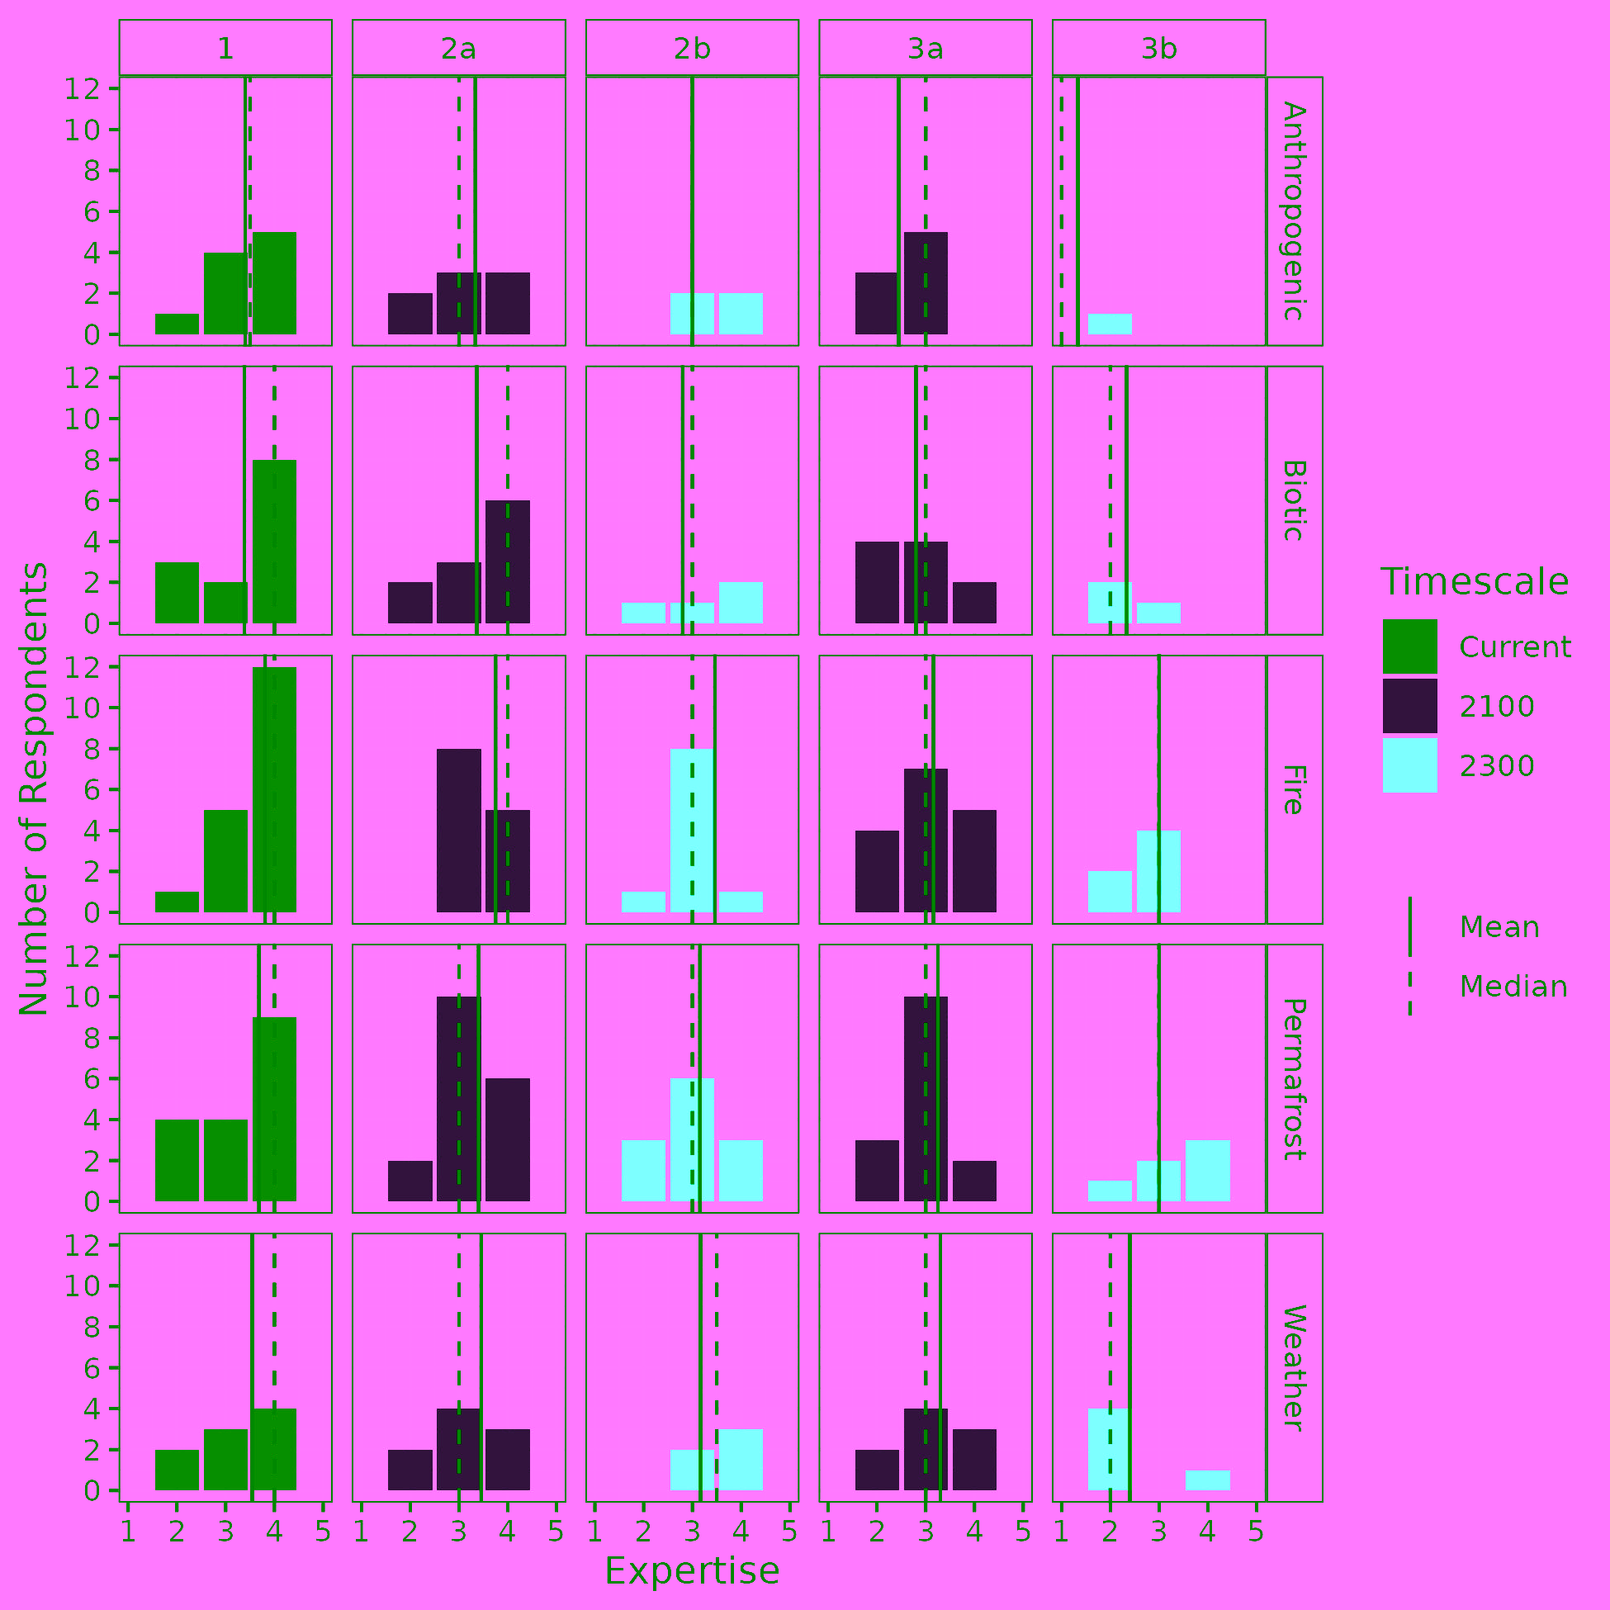
Figure S1. Self-rated expertise of the experts across disturbance types and survey questions on a scale of 1-5. A score of 1 indicates no directly relevant experience, while a score of 5 indicates the respondent has or is in the process of publishing on that exact survey question.

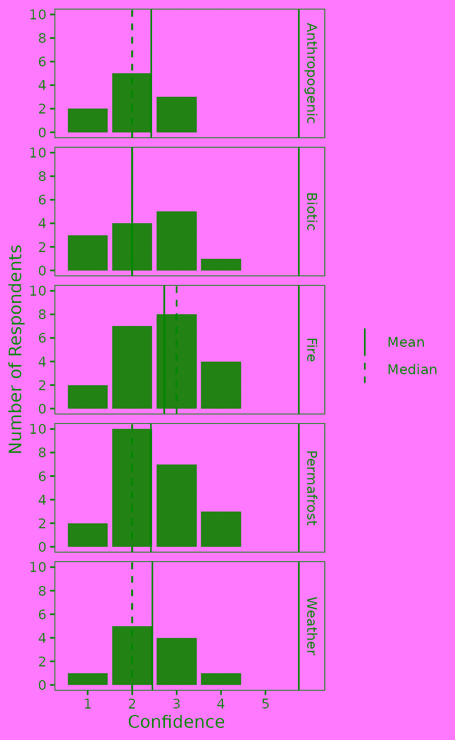
Figure S2. Respondent confidence across disturbance types for survey question 1.
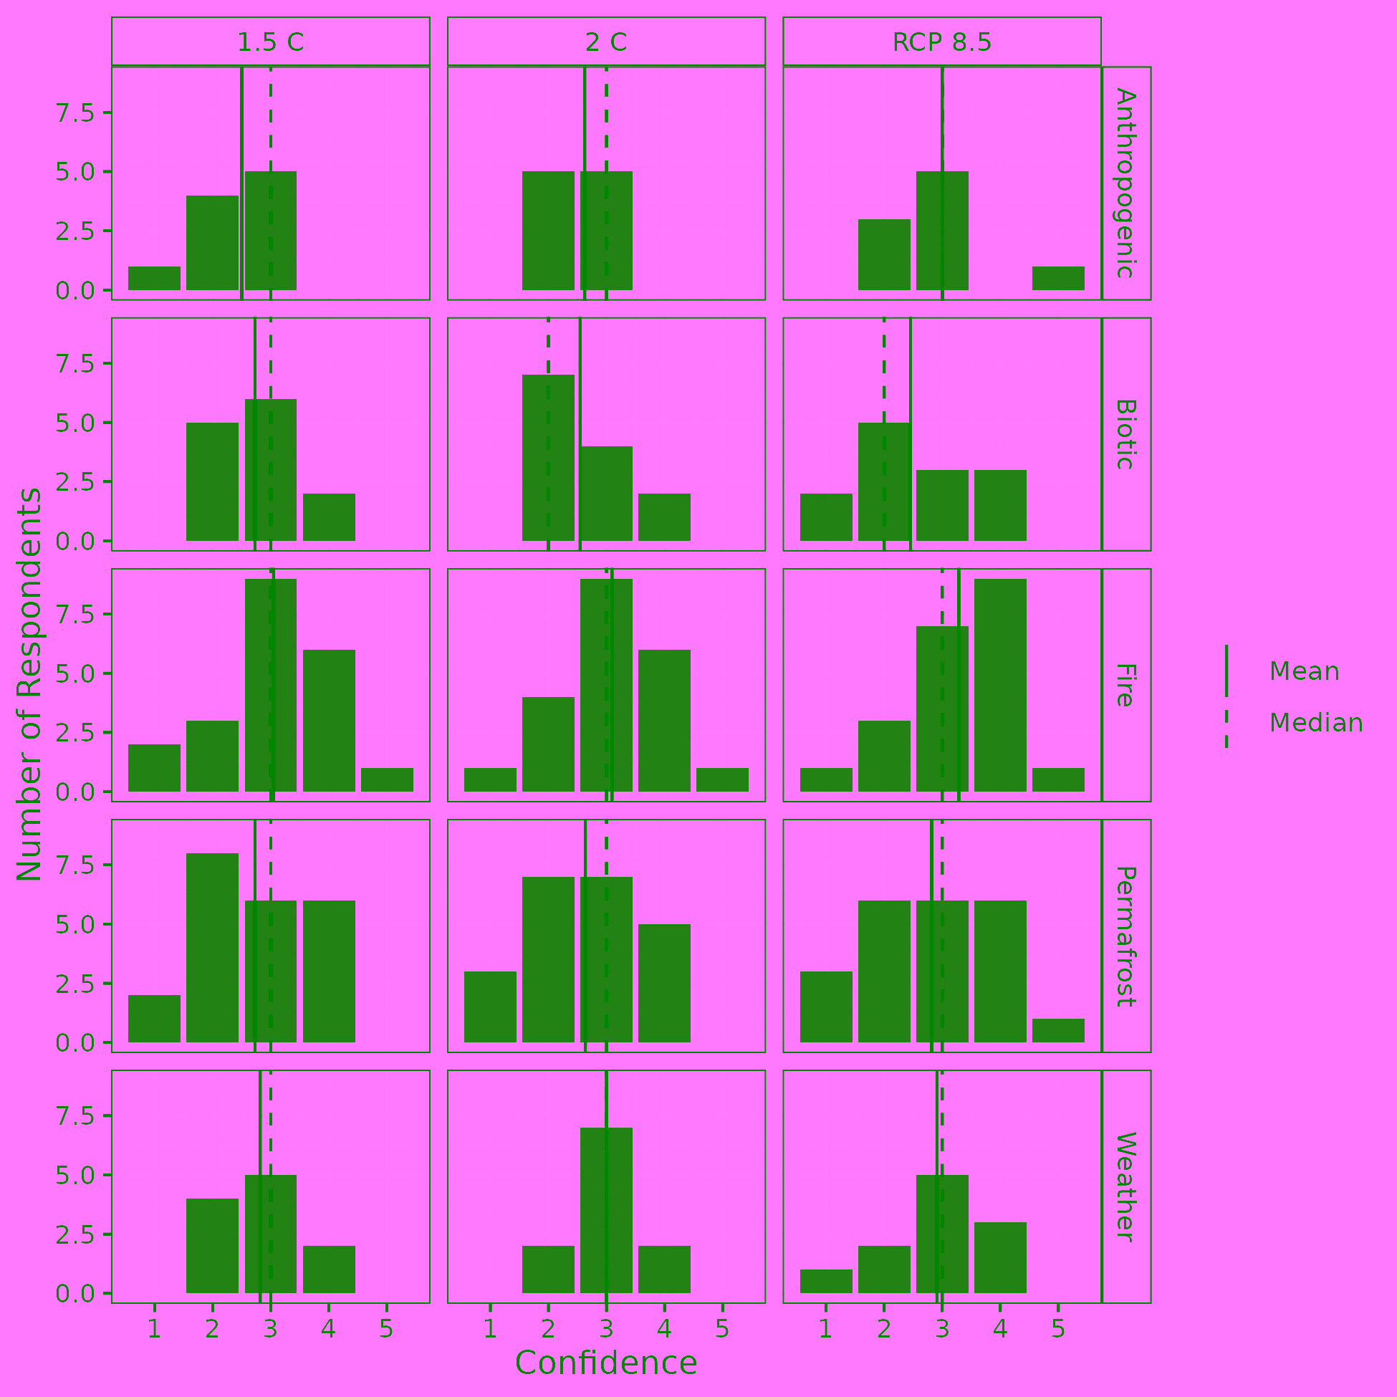
Figure S3. Respondent confidence across disturbance types and emissions scenarios for survey question 2a.
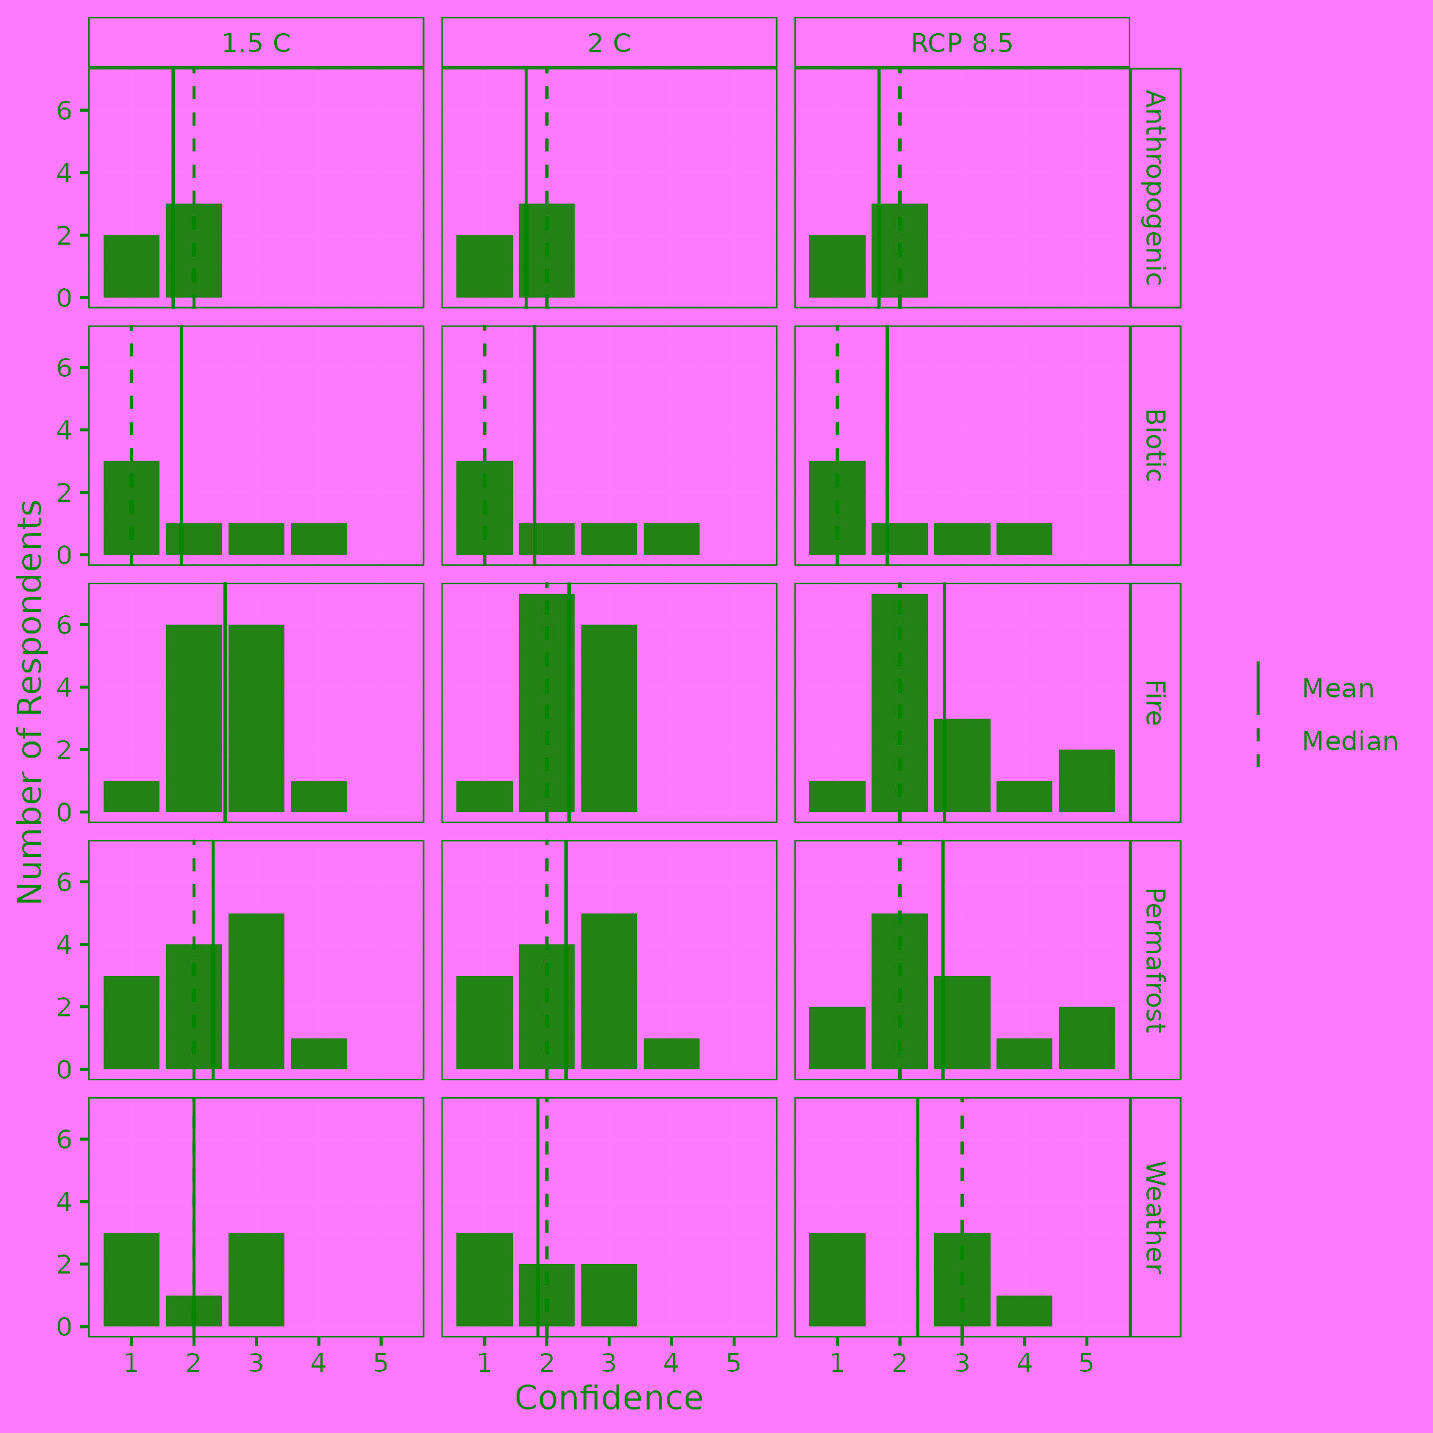
Figure S4. Respondent confidence across disturbance types and emissions scenarios for survey question 2b.
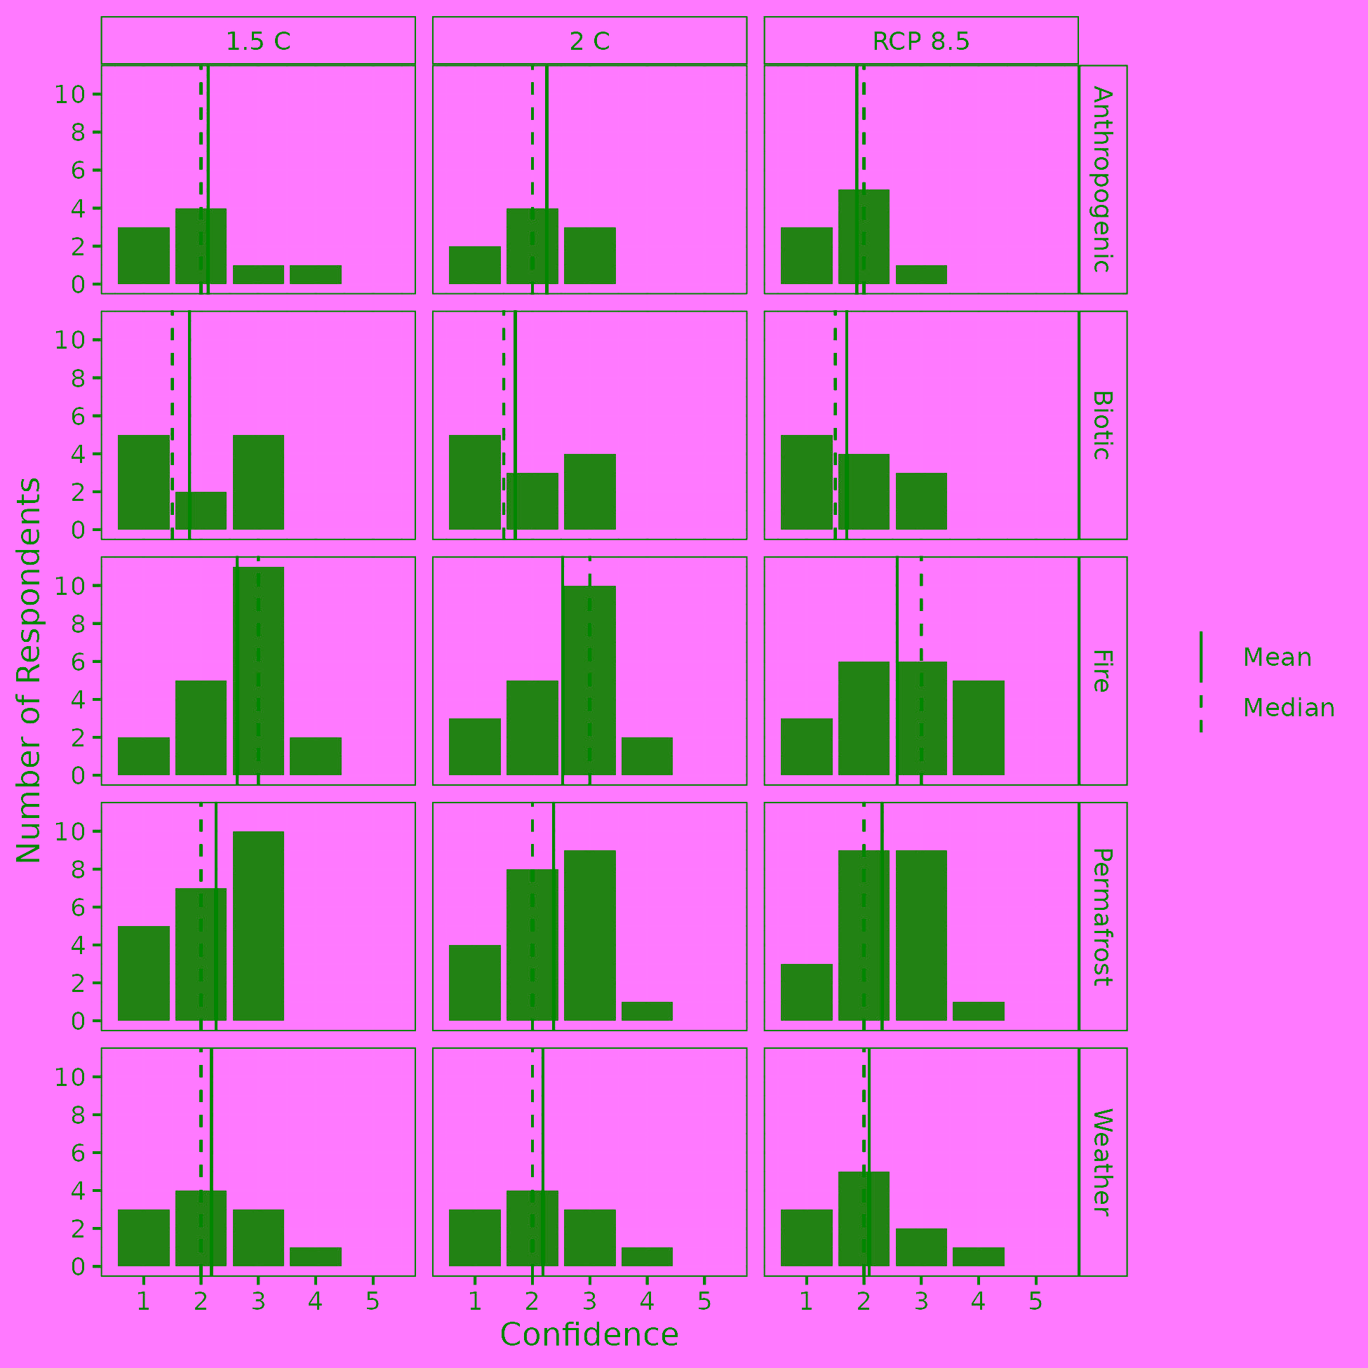
Figure S5. Respondent confidence across disturbance types and emissions scenarios for survey question 3a.
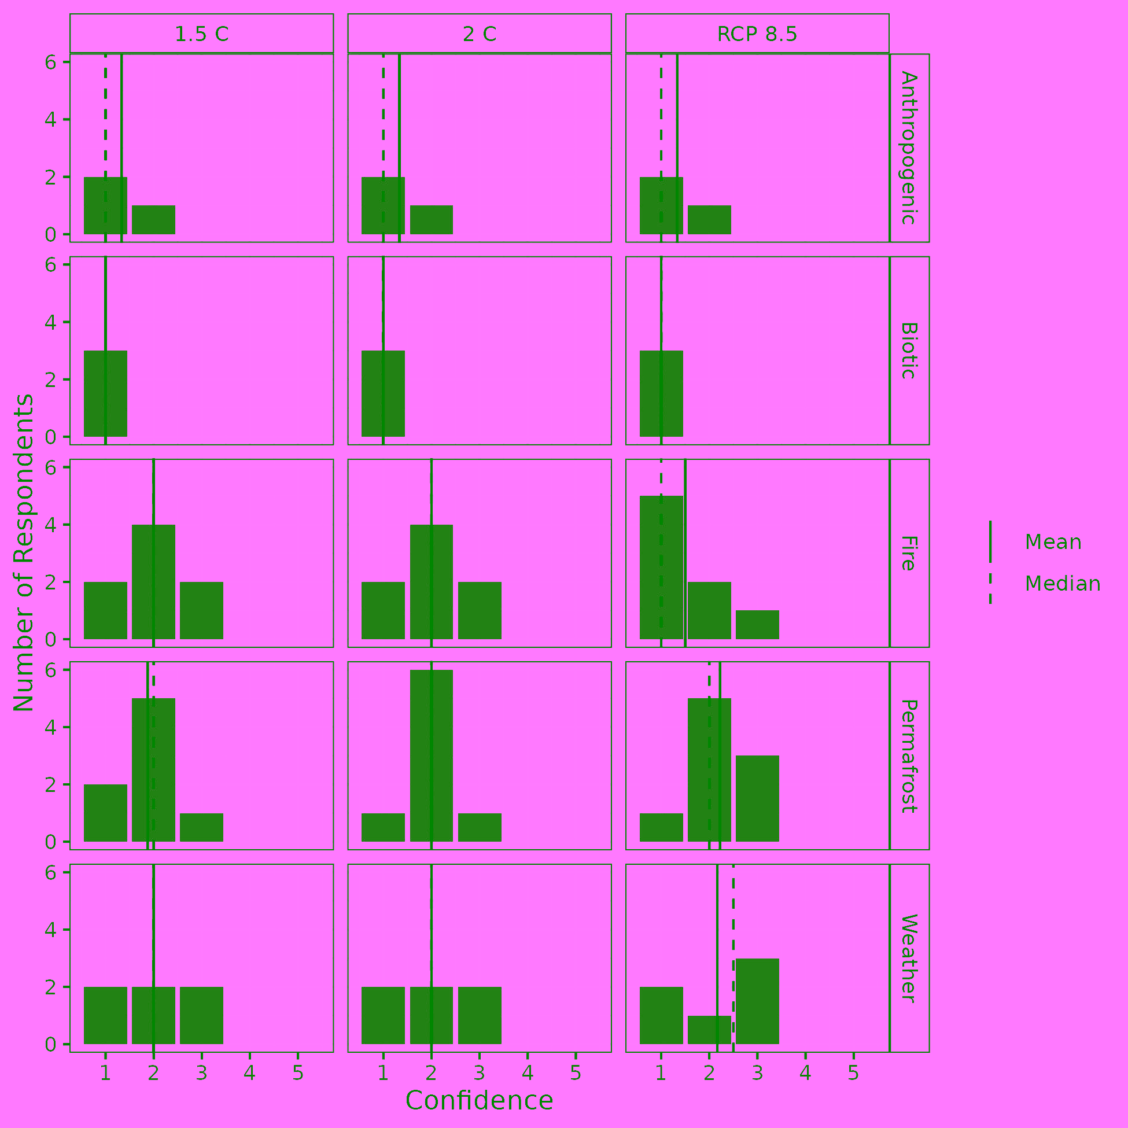
Figure S6. Respondent confidence across disturbance types and emissions scenarios for survey question 3b.
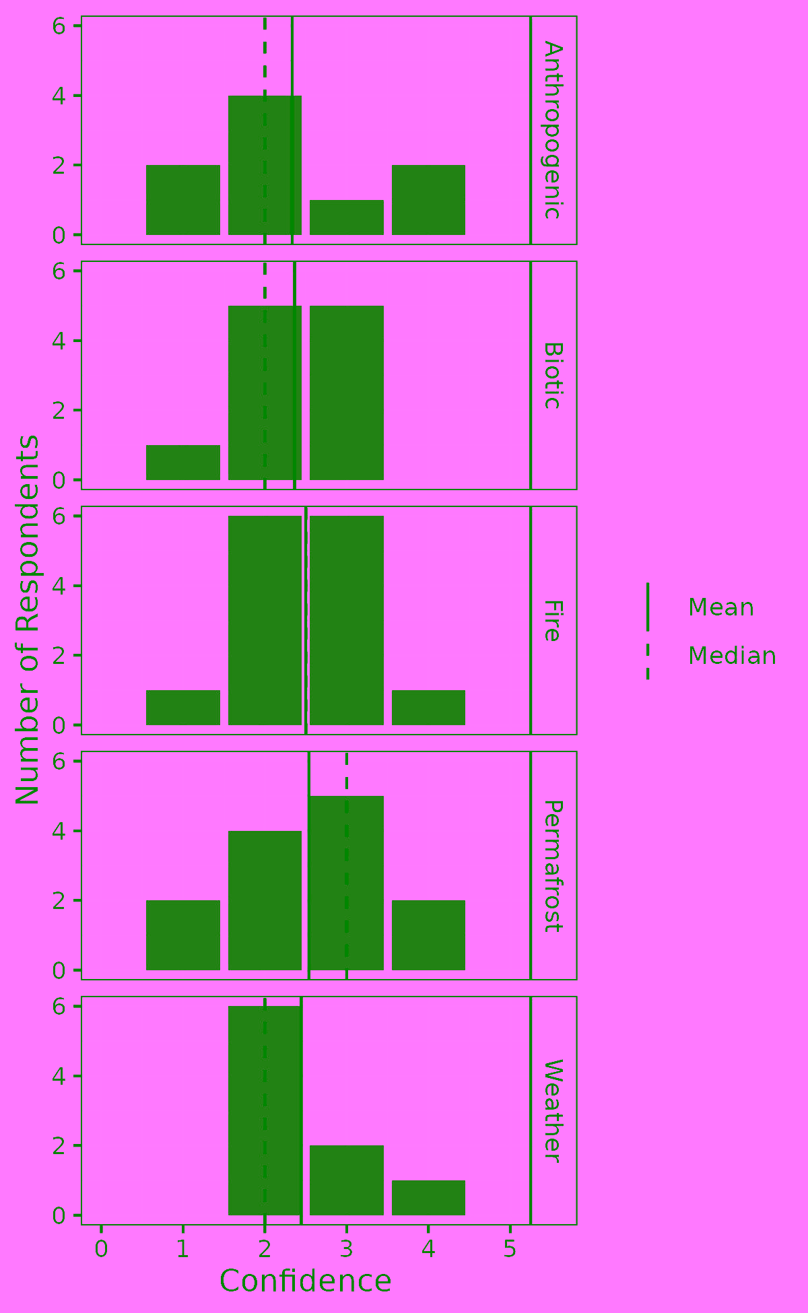
Figure S7. Respondent confidence across disturbance types for survey question 4.
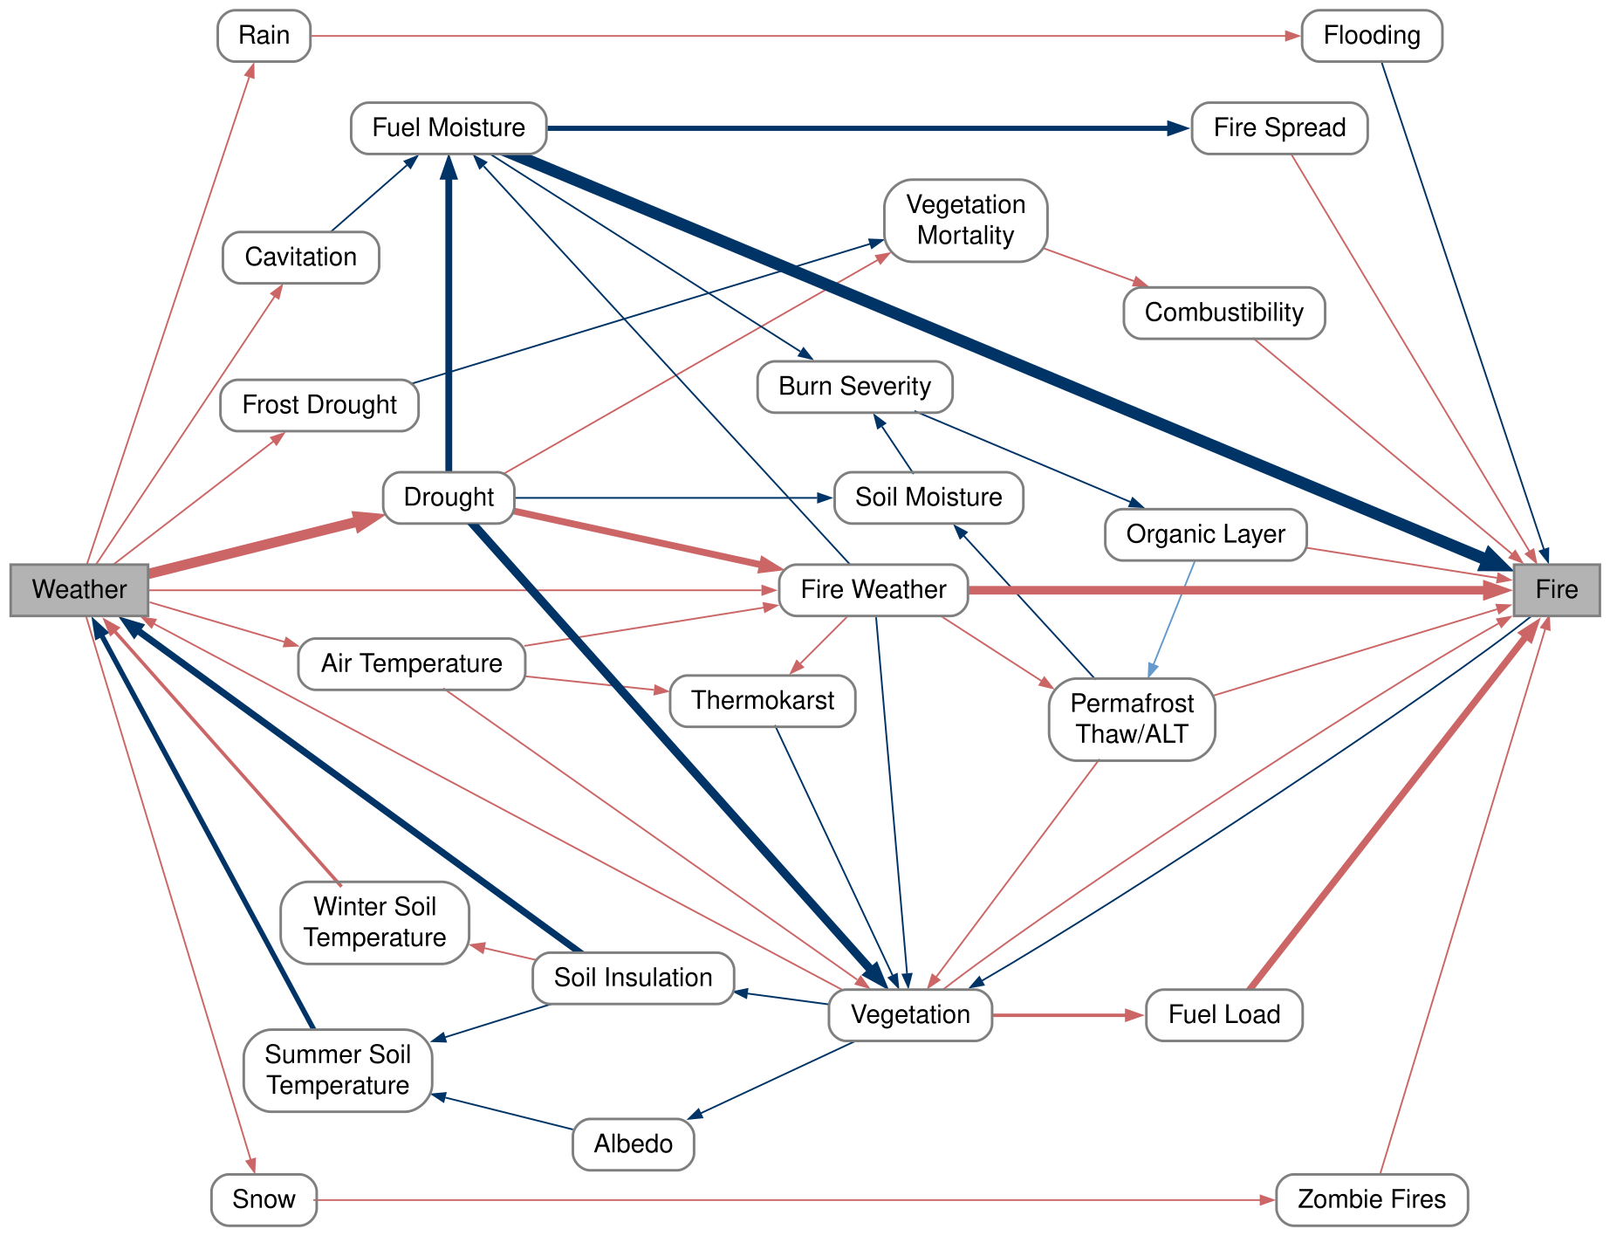
Figure S8. Flowchart of expert-informed interacting relationships between fire and weather disturbances. Blue arrows indicate a negative relationship for an individual relationship, while red arrows indicate a positive relationship. The sign of the relationship is indicative of a specific arrow, not an entire path. For example, increasing drought lowers fuel moisture and higher fuel moisture decreases fire such that, when combined, drought drives increases in fire. Relationship importance is indicated by arrow width, reflecting both the number of times the relationship appeared in individual flowcharts and the level of importance individuals attributed to it.

