Appendix 1: Example Survey for
Disturbances Increase Net Carbon Emissions in the Arctic-Boreal Zone - An Expert Assessment

Disturbance and Arctic-Boreal Carbon Balance: Survey Questions
Introduction
The primary goal of this survey is to assess the direction and magnitude of changes in the net impact of disturbance on the Arctic-Boreal carbon balance. We will also assess perceptions of related scientific confidence and uncertainty.
For the purposes of this survey, disturbance is defined as any relatively discrete event or set of events in time that disrupt ecosystem, community, or population structure, and/or changes in resources, substrate availability, or the physical environment*. Hence, we focus here on ‘pulse’, or abrupt, rather than ‘press’, or gradual disturbance. More detail regarding this definition can be found in the accompanying FAQs and background information.
Instructions
Your responses to the questions below should apply to the combined tundra and boreal biomes, hereafter referred to as the ‘Arctic-Boreal Zone’ (ABZ). Your responses should also apply across one category of disturbance; in this case ‘anthropogenic disturbance’. Please review the guidance provided in FAQ 6 regarding this disturbance category prior to completing the survey.
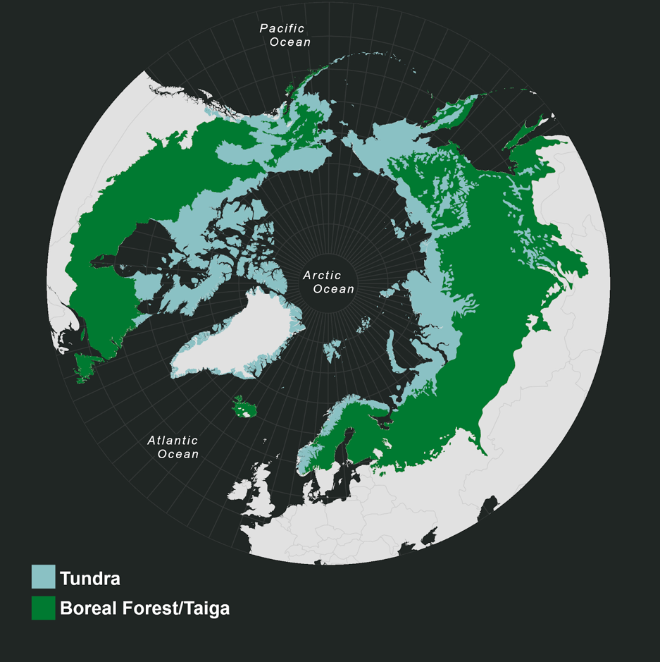
Figure 1: Tundra and boreal biomes; the domain considered throughout this expert assessment, and referred to collectively as the ‘Arctic-Boreal Zone’ (ABZ). Ecoregions from Dinerstein et al,. (2017).

We recognize that the processes underlying the questions in this survey are complex, vary across space and time, and may not be well understood. As such, we are asking only for your informed opinion. By administering this survey to scientists with the most applicable expertise, we hope to identify the likely directions, magnitudes, and uncertainties of climate change-driven changes in the net carbon impact of disturbance across this domain.

Please answer the survey questions in chronological order so far as is possible and practical. In addition to answering each question, you will have a chance to indicate your level of confidence and expertise concerning your answer, according to the scales defined below. You will also be able to provide any additional comments you would like to accompany your answers.

Confidence and expertise

The five-point scale used to describe ‘Expertise level’ is as follows:
1= I have little familiarity with the literature and I do not actively work on the issue.
2= I have some familiarity with the literature but haven't contributed/am not in the process of contributing to the literature on the issue.
3= I am familiar with the literature but haven't contributed/am not in the process of contributing to the literature on the issue.
4= I am familiar with the literature and have contributed or am in the process of contributing to literature on the issue.
5= I am familiar with the literature and have contributed or am in the process of contributing to literature directly addressing these particular questions.

The five-point scale used to describe ‘Confidence level’ is as follows:
1= My answer is my best guess but I am not confident in it; it could easily be far off the mark.
2= My answer is an educated guess; it could be far off the mark, but I have some confidence in it.
3= I am moderately confident in my answer; it surely isn’t precise, but it is likely in the correct range.
4= I am confident in my answer; the true value is likely to be somewhat different from my answer, but it is unlikely to be dramatically different.
5= Given current understanding, I would be surprised if my answer were far off from the true value.

Questions
In some of the questions below you will be asked to provide a subjective confidence interval around your best estimate of the true response value. This will be done by asking you to provide ‘Lower’ and ‘Upper’ estimates, representing the 5% and 95% quantiles, respectively, and together constituting a qualitative 90% confidence interval. In addition, you will be asked to provide your ‘even-chance’ estimate - your estimate of the median value, at which there is an even chance of the true value being greater or lower.

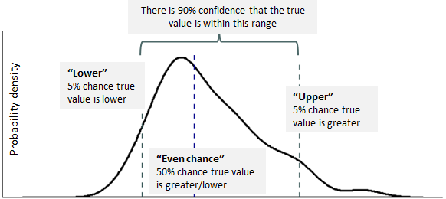
A conceptual illustration of these three estimates is provided below:
Figure 2: Conceptual illustration of where ‘lower’, ‘upper’ and ‘even-chance’ would fall on a probability density distribution.

You will be asked to fill out response tables such as the one below. Please fill these out completely, as is shown in the example below (example responses in red).

Increase/ decrease/no change | Magnitude of increase/decrease |  |  | Level of expertise  (1-5) | Level of confidence  (1-5)
Increase/ decrease/no change | Lower (5%) | Upper (95%) | Even chance | Level of expertise  (1-5) | Level of confidence  (1-5)
Increase | 5 | 15 | 7 | 4 | 2
What are the 1-3 largest sources of uncertainty in this estimate? |  |  | Additional comments
Measurements of X across Y geographic region are spatially and temporally sparse.  Variability in X is high.  The influence of changing climatic condition X on disturbance regime characteristic Y is unclear, and may vary with Z. |  |  | My estimates are based primarily on my study region (region X).

Question 1

- For the purpose of this question please assume that the mean annual net carbon impact* of anthropogenic disturbance prior to the initiation of anthropogenic warming was zero. This means that prior to anthropogenic warming, carbon uptake and carbon release driven by anthropogenic disturbance were in dynamic equilibrium.

What is the absolute value of the increase or decrease in the mean annual net carbon impact of anthropogenic disturbance during the present-day period (here defined as 2000 - 2020) compared to the period prior to anthropogenic warming (i.e. prior to ~1870)? Please give your estimates in Teragrams of carbon per year (Tg C yr-1).

- Please read FAQ 5 regarding the scope of disturbance impacts that should be considered prior to completing this question.

*Net carbon impact = the net result of carbon uptake and release driven by disturbance, where net release is positive (+) and net uptake is negative (-). More detail provided in background information.

Increase/ decrease/no change | Magnitude of increase/decrease in Tg C yr-1 |  |  | Level of expertise  (1-5) | Level of confidence  (1-5)
Increase/ decrease/no change | Lower | Upper | Even chance | Level of expertise  (1-5) | Level of confidence  (1-5)
What are the 1-3 largest sources of uncertainty in this estimate? |  |  | Additional comments

Question Two
The Paris Agreement includes goals to limit global average temperature increase to well below 2°C, and to pursue efforts to limit temperature increase to 1.5°C. Please consider scenarios where global average temperature change is consistent with these goals (scenarios A & B), and where global average temperature change is consistent with Representative Concentration Pathway (RCP) 8.5 (scenario C).
- More information and more detailed projections for these scenarios can be found in the accompanying background information

Table 1: Projected global temperature increase under each of these scenarios in 2050 and 2100.
Scenario | Description | Approximate global T increase (°C) by: |  | Primary post-2100 trend
Scenario | Description | 2050 | 2100 | Primary post-2100 trend
A | Global mean temperature increase held below 1.5°C by 2100 | 1.37 | 1.47 | Stable/downwards
B | Global mean temperature increase held below 2.0°C by 2100 | 1.69 | 1.75 | Stable/downwards
C | RCP 8.5 | 2.34 | 5.11 | Upwards

- For each of the scenarios A-C how would you expect the characteristics of anthropogenic disturbance regimes, as defined in the response table below, to change from the present day period (here defined as 2000 - 2020) to 2100?

- Additional explanation regarding the disturbance regime characteristics is in the accompanying background information.

Please respond using the following scale:
  - <5% (minimal) change: -
  - 5-20% (small) increase/decrease: ↑/↓
  - 20-50% (moderate) increase/decrease: ↑↑/↓↓
  - 50%+ (large) increase/decrease: ↑↑↑/↓↓↓
  - Unsure: ?
2100 | Frequency  (temporal frequency of occurrence) | Extent  (typical area affected by a disturbance) | Range  (range of occurrence; spatial distribution) | Severity  (carbon release per unit area) | Level of confidence  (1-5)
Example | ↑ | - | ↑ | ↑↑ | 4
A
B
C
What are the 1-3 largest sources of uncertainty in these estimates? |  |  | Additional notes |  | Level of expertise  (1-5)

- OPTIONAL QUESTION: For each of the scenarios A-C, and using the same scale defined above, how would you expect the characteristics of anthropogenic disturbance regimes, as defined in the response table below, to change from the present day period (here defined as 2000 - 2020) to 2300?

- This question is optional due to the long timescale under consideration. However, we would encourage you to respond if you feel able to do so.

2300 | Frequency  (temporal frequency of occurrence) | Extent  (typical area affected by a disturbance) | Range  (range of occurrence; spatial distribution) | Severity  (carbon release per unit area) | Level of confidence  (1-5)
Example | ↑ | - | ↑ | ↑↑ | 4
A
B
D
What are the 3 largest sources of uncertainty in these estimates? |  |  | Additional notes |  | Level of expertise  (1-5)

Question Three

- For each of the scenarios A-C defined in question 2, please estimate the absolute value of the increase or decrease in the mean annual net carbon impact* of anthropogenic disturbance by 2100 compared to the present day period (here defined as 2000 - 2020). Please respond in Teragrams of carbon per year.

*Net carbon impact = the net result of carbon uptake and release driven by disturbance, where net release is positive (+) and net uptake is negative (-). More detail provided in background information.

Scenario | Increase/ decrease/no change | Magnitude of increase/decrease by 2100 compared to the present day period in Tg C yr-1 |  |  | Level of confidence  (1-5)
Scenario | Increase/ decrease/no change | Lower | Upper | Even chance | Level of confidence  (1-5)
A
B
C
What are the 1-3 largest sources of uncertainty in these estimates? |  |  | Additional comments |  | Level of expertise  (1-5)

- OPTIONAL QUESTION: For each of the scenarios A-C, please estimate the absolute value of the increase or decrease in the mean annual net carbon impact* of anthropogenic disturbance by 2300 compared to the present day period (here defined as 2000 - 2020). Please respond in Teragrams of carbon per year.

- This question is optional due to the long timescale under consideration. However, we would encourage you to respond if you feel able to do so.

Scenario | Increase/ decrease/no change | Magnitude of increase/decrease by 2300 compared to the present day period in Tg C yr-1 |  |  | Level of confidence  (1-5)
Scenario | Increase/ decrease/no change | Lower | Upper | Even chance | Level of confidence  (1-5)
A
B
C
What are the 1-3 largest sources of uncertainty in these estimates? |  |  | Additional comments |  | Level of expertise  (1-5)

Question Four
- Please consider the diagram below. The two axes are labelled ‘availability of evidence’ and ‘consensus’, and each quadrant is labelled from ‘(a): established but incomplete’ to ‘(d): competing explanations’, according to these two dimensions. For your reference, a more detailed conceptualisation of each of these quadrants is provided at the end of this question.
With reference to this diagram, what is your opinion of the overall state of scientific understanding in relation to the following concepts?
Please indicate your responses by marking an ‘X’ on the diagram below and labelling this with the corresponding question number (see example (v)).
- If you prefer to complete the diagram by hand please send a scan or photo alongside your completed questionnaire document.

  - Spatial variability* of the mean annual net carbon impact of anthropogenic disturbance at regional and greater scales during the present day period.
  - Temporal variability* of the mean annual net carbon impact of anthropogenic disturbance at annual and longer scales during the present day period. i.e. our ability to separate interannual variation from any longer-term trend, and/or to quantitatively identify ‘extreme’ values.
  - The role of direct, primary climate change effects (including warming, altered precipitation regimes and soil moisture, and other directly climate-related changes) in driving the mean annual net carbon impact of anthropogenic disturbance at regional and greater scales during the present day period.
  - The role of secondary or downstream climate change effects (such as climate-driven changes in vegetation composition and productivity, animal or pathogen abundance, distribution or activity, or regimes of other disturbance types) in driving the mean annual net carbon impact of anthropogenic disturbance at regional and greater scales during the present day period (here defined as 2000 - 2020).
  - example
*Please consider the magnitude, but not the drivers, of variability.

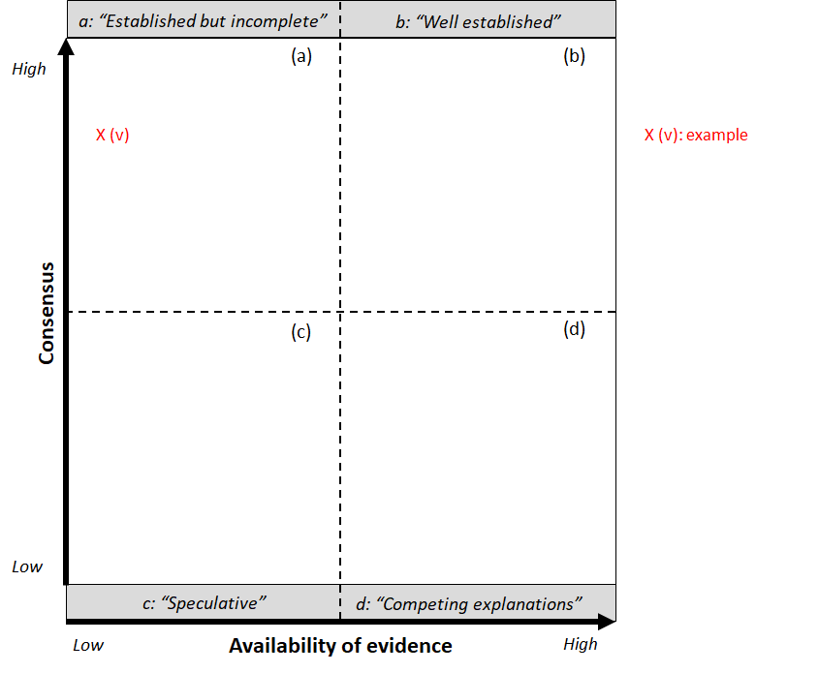
Figure 3: Availability of evidence plotted against consensus. Quadrants defined for guidance as: (a) “established but incomplete”; (b) “well-established”; (c) “speculative”; (d) “competing explanations”.

- Of the concepts (i) to (iv) outlined above, which presents the greatest barrier to accurately predicting the annual net carbon impact of anthropogenic disturbance across the Arctic-Boreal Zone (ABZ) during the 2050-2100 period?
Response

- Please imagine that all uncertainties in relation to the concepts (i) to (iv) outlined above are suddenly resolved; you now have a full and certain understanding of these concepts, and of their roles in determining the net carbon impact of anthropogenic disturbance.
In this imagined situation, how do you think your current estimates of future carbon emissions due to anthropogenic disturbance across the ABZ would change (if at all)?:
Please tick (✓) one box.
Decrease by a large amount (-50% or more) | Decrease by a moderate amount (-20-50%) | Change by a minimal amount  (<5%) | Increase by a moderate amount (+20-50%) | Increase by a large amount (+50% or more) | Confidence level  (1-5)

Additional information for question 4(a): Example conceptualisations of diagram quadrants*
“Well-established”: multiple lines of evidence support existing understanding; models incorporate relevant known processes; observations are largely consistent with models for important variables.
“Established but Incomplete”: current understanding is well founded, but the possibility of future changes is considerable; only one or a few lines of evidence support current understanding; models incorporate most known processes, although some parameterizations may not be well tested; observations are somewhat consistent with theoretical or model results but incomplete.
“Competing Explanations”: high variability combined with low measurement resolution leads to competing explanations; different model representations account for different aspects of observations or evidence, or incorporate different key processes or mechanisms.
“Speculative”: conceptually plausible processes or mechanisms haven’t received much attention in the literature, or are laced with uncertainty which is challenging to reduce; few observations exist

*adapted from Moss, R.H. and Schneider, S.H., 2000: Uncertainties in the IPCC TAR: Recommendations to lead authors for more consistent assessment and reporting. In: Guidance Papers on the Cross Cutting Issues of the Third Assessment Report of the IPCC [eds. R. Pachauri, T. Taniguchi and K. Tanaka], World Meteorological Organization, Geneva, pp. 33-51.]
Question Five (OPTIONAL)
Interactions with other disturbance types are sometimes identified as an important source of uncertainty in predicting the future net carbon impact of anthropogenic disturbance.
- Select the disturbance category or type, using FAQ 6 as a guide, that in your opinion has the greatest influence on the annual net carbon impact of anthropogenic disturbance during the present day period (here defined as 2000 - 2020).
Chosen disturbance category/type

- Qualitatively illustrate how this disturbance interacts with anthropogenic disturbance by completing the response flowchart below. Use solid arrows to indicate causation and dashed arrows to indicate annotation.
- Label the arrows ‘+’ or ‘-’ to indicate a positive (+) or negative relationship (-).
- Label the arrows which represent the processes with the greatest impact on the annual net carbon impact of anthropogenic disturbance 1-3, where ‘1’ indicates the process with the greatest impact.
A simple example of how to complete the flowchart is provided below:
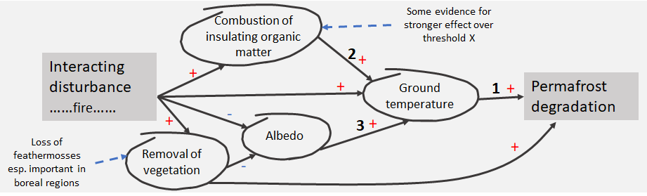
Response flowchart:
- If you prefer to complete this section by hand please send a scan or photo of your flowchart alongside your completed questionnaire document.

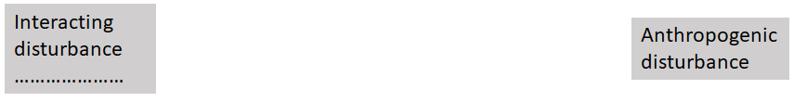

Question Six (OPTIONAL)
Please use this space to make any additional points that you feel are relevant or important but that have not already been covered above.
>

Background respondent information

Gender (optional):
Pronouns (optional):
This helps us understand the best way to address you.
E.g. she/her/hers.
Research discipline:
Career stage (early, mid, established):
Country of residence:
Primary geographic region(s) of expertise:
Have you previously participated in an expert assessment on any topic?
Please estimate the percentage of your time which is typically spent on:
- Field work.
- Remote sensing.
- Modelling, including statistical, process and other modelling approaches.
- Other (optional, please specify)

