ADDITIONAL FILE FIGURE S 1
Figure S 1. DHARMa simulated residual QQ plots for multilevel Gamma models. Lean in Emergency Departments Project, PROADI-SUS/Hospital Sírio-Libanês, Brazil, 2018–2023.
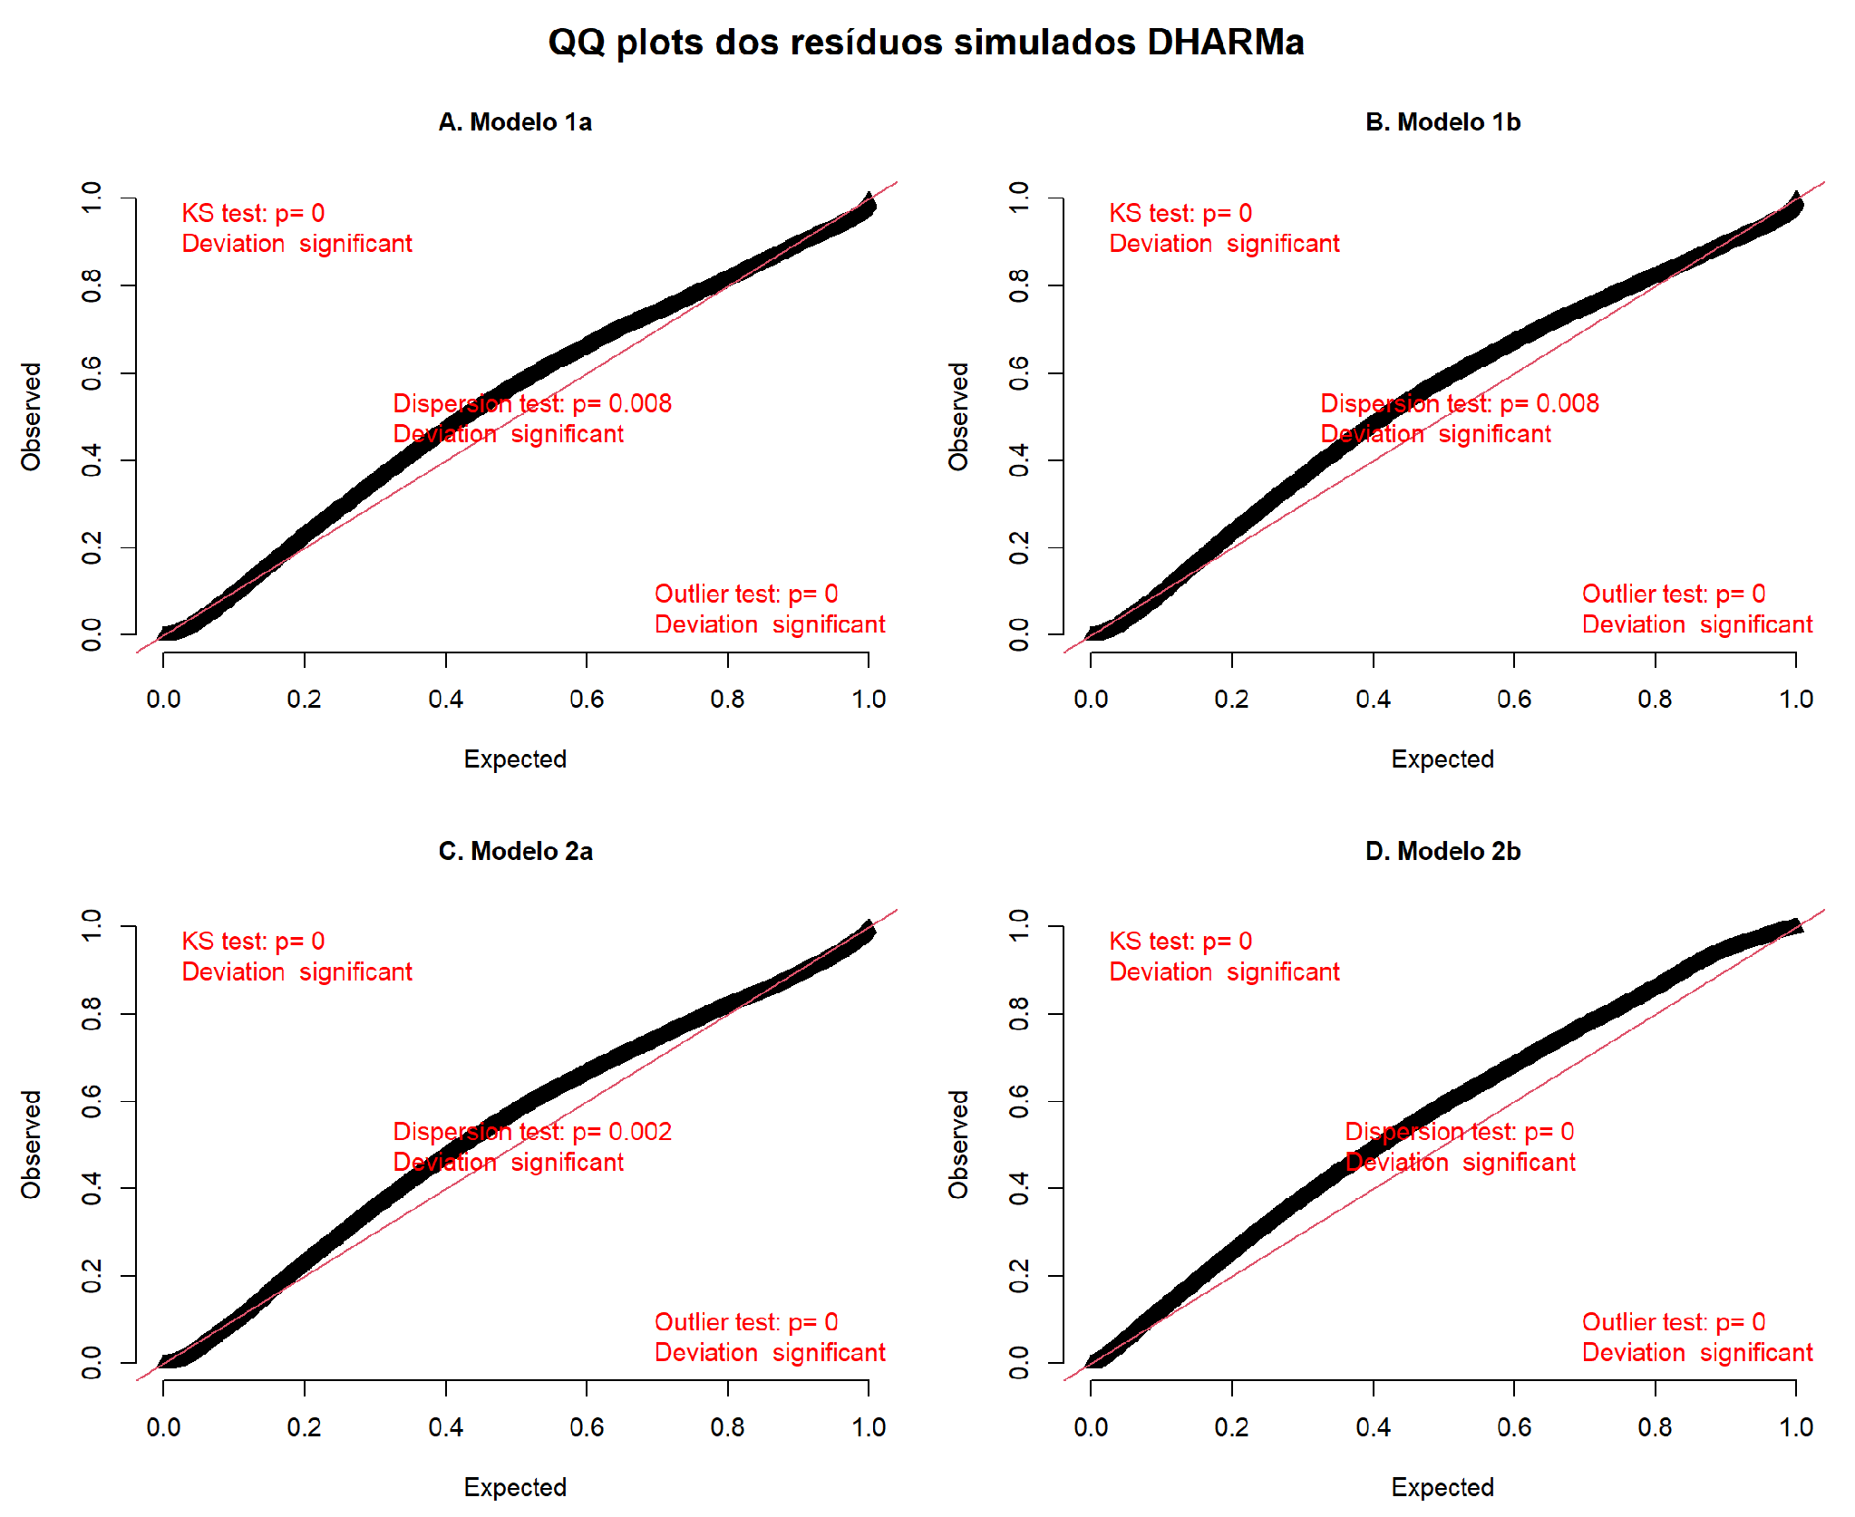
Figure S 1 presents the QQ plots of the simulated residuals generated by the DHARMa package for the four fitted models. In all models, deviations from the expected uniform distribution were observed, being most evident in Model 2b. Dispersion tests indicated underdispersion (statistics < 1), suggesting lower residual variability than expected. Outlier tests were also significant across all models; however, the number of observations classified as outliers was low relative to the sample size (163–204 records), indicating a limited impact on the dataset.

