Supplementary Information for
TOR inhibition drives accumulation of amino acids through transcriptional
activation in algae

Shivani Upadhyaya*¹, Suzanne M. Kosina², Samuel O. Purvine³, Kim Hixson^{3,4}, Athena A. Schepmoes³, Ritesh Mewalal⁵, Yu Zhang⁵, Ronan C. O’Malley^{5,6}, Leo Baumgart⁵, Ian K. Blaby^{5,2}, Mary S. Lipton³, Trent R. Northen², Krishna K. Niyogi^{1,7,8}, Melissa S. Roth*¹

¹ Department of Plant and Microbial Biology, University of California, Berkeley, CA 94720
² Environmental Genomics and Systems Biology Division, Lawrence Berkeley National Laboratory, Berkeley, CA 94720
³ Earth and Biological Sciences Division, Pacific Northwest National Laboratory, Richland, WA 99352
⁴ Institute of Biological Chemistry, Washington State University, Pullman, WA 99164
⁵ U.S. Department of Energy, Joint Genome Institute, Lawrence Berkeley National Laboratory, Berkeley, CA 94720
⁶ Department of Human Genetics, University of Chicago, Chicago, IL 60637
⁷ Howard Hughes Medical Institute, University of California, Berkeley, CA 94720
⁸ Molecular Biophysics and Integrated Bioimaging Division, Lawrence Berkeley National Laboratory, Berkeley, CA 94720

*Corresponding authors: Shivani Upadhyaya, Melissa S. Roth

Email: shivani.u@berkeley.edu, mroth@berkeley.edu

This file includes:
Supplementary Figures 1 to 11
Supplementary Methods
Supplementary References
Supplementary Data 1 to 22

Supplementary Figures

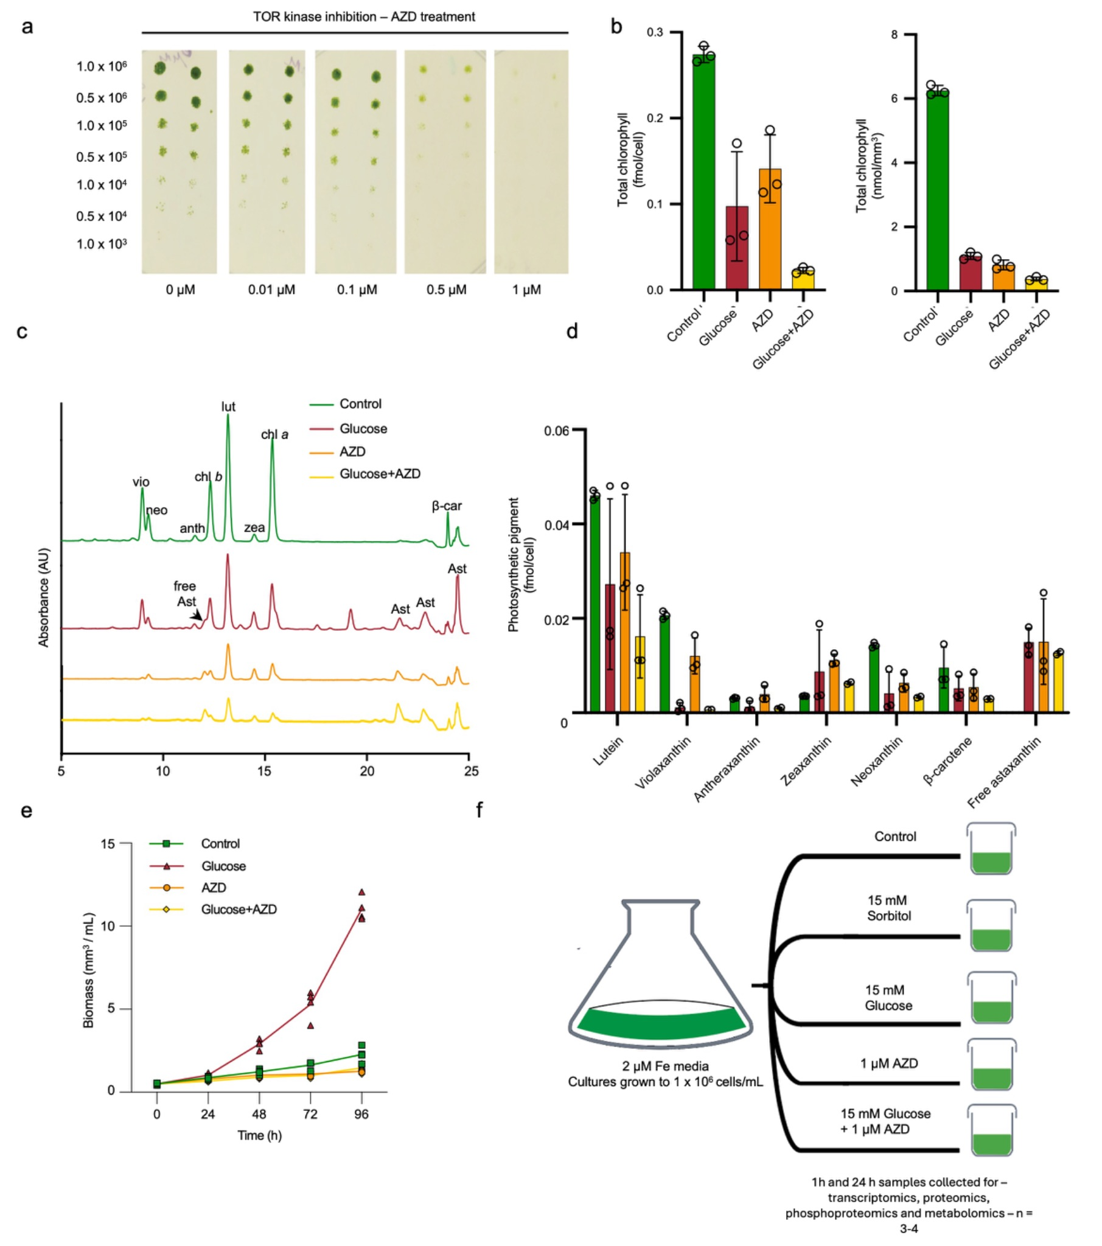

Supplementary Fig. 1. TOR inhibition titration, pigments, biomass, and the multiomics experimental design. (a) Wild-type C. zofingiensis cells were subjected to serial dilutions and spotted on CORE medium plates with AZD8055 (AZD). Plates were incubated at 25ºC under continuous illumination (100 µmol photons m⁻² s⁻¹). (b) Total chlorophyll (chlorophyll a and chlorophyll b) under different treatment conditions of 1 µM AZD, 100 mM glucose and 100 mM glucose + 1 µM AZD after 96 h normalized to cell number (fmol/cell) and biomass (nmol/mm³). Data represent means ± SD; n = 3 biological replicates. (c) Representative HPLC chromatograms from 2 mL of culture under treatments in (b). Peaks represent: vio, violaxanthin; , neoxanthin; anth, antheraxanthin; chl b, chlorophyll b; lut, lutein; zea, zeaxanthin; chl a, chlorophyll a; β-car, β-carotene; free Ast, free astaxanthin; Ast, esterified astaxanthin (d) Pigments are normalized to total biomass. Data represent means ± SD; n = 3 biological replicates. (e) Time course of culture biomass. Data represent means; n = 3-4 biological replicates. Cell density shown in Fig. 1B. (f) The multiomics experimental design includes the following treatments: control, 1 µM AZD, 15 mM glucose, 15 mM glucose + 1 µM AZD, and 15 mM sorbitol (as osmotic control). Samples were collected at 1 h and 24 h.

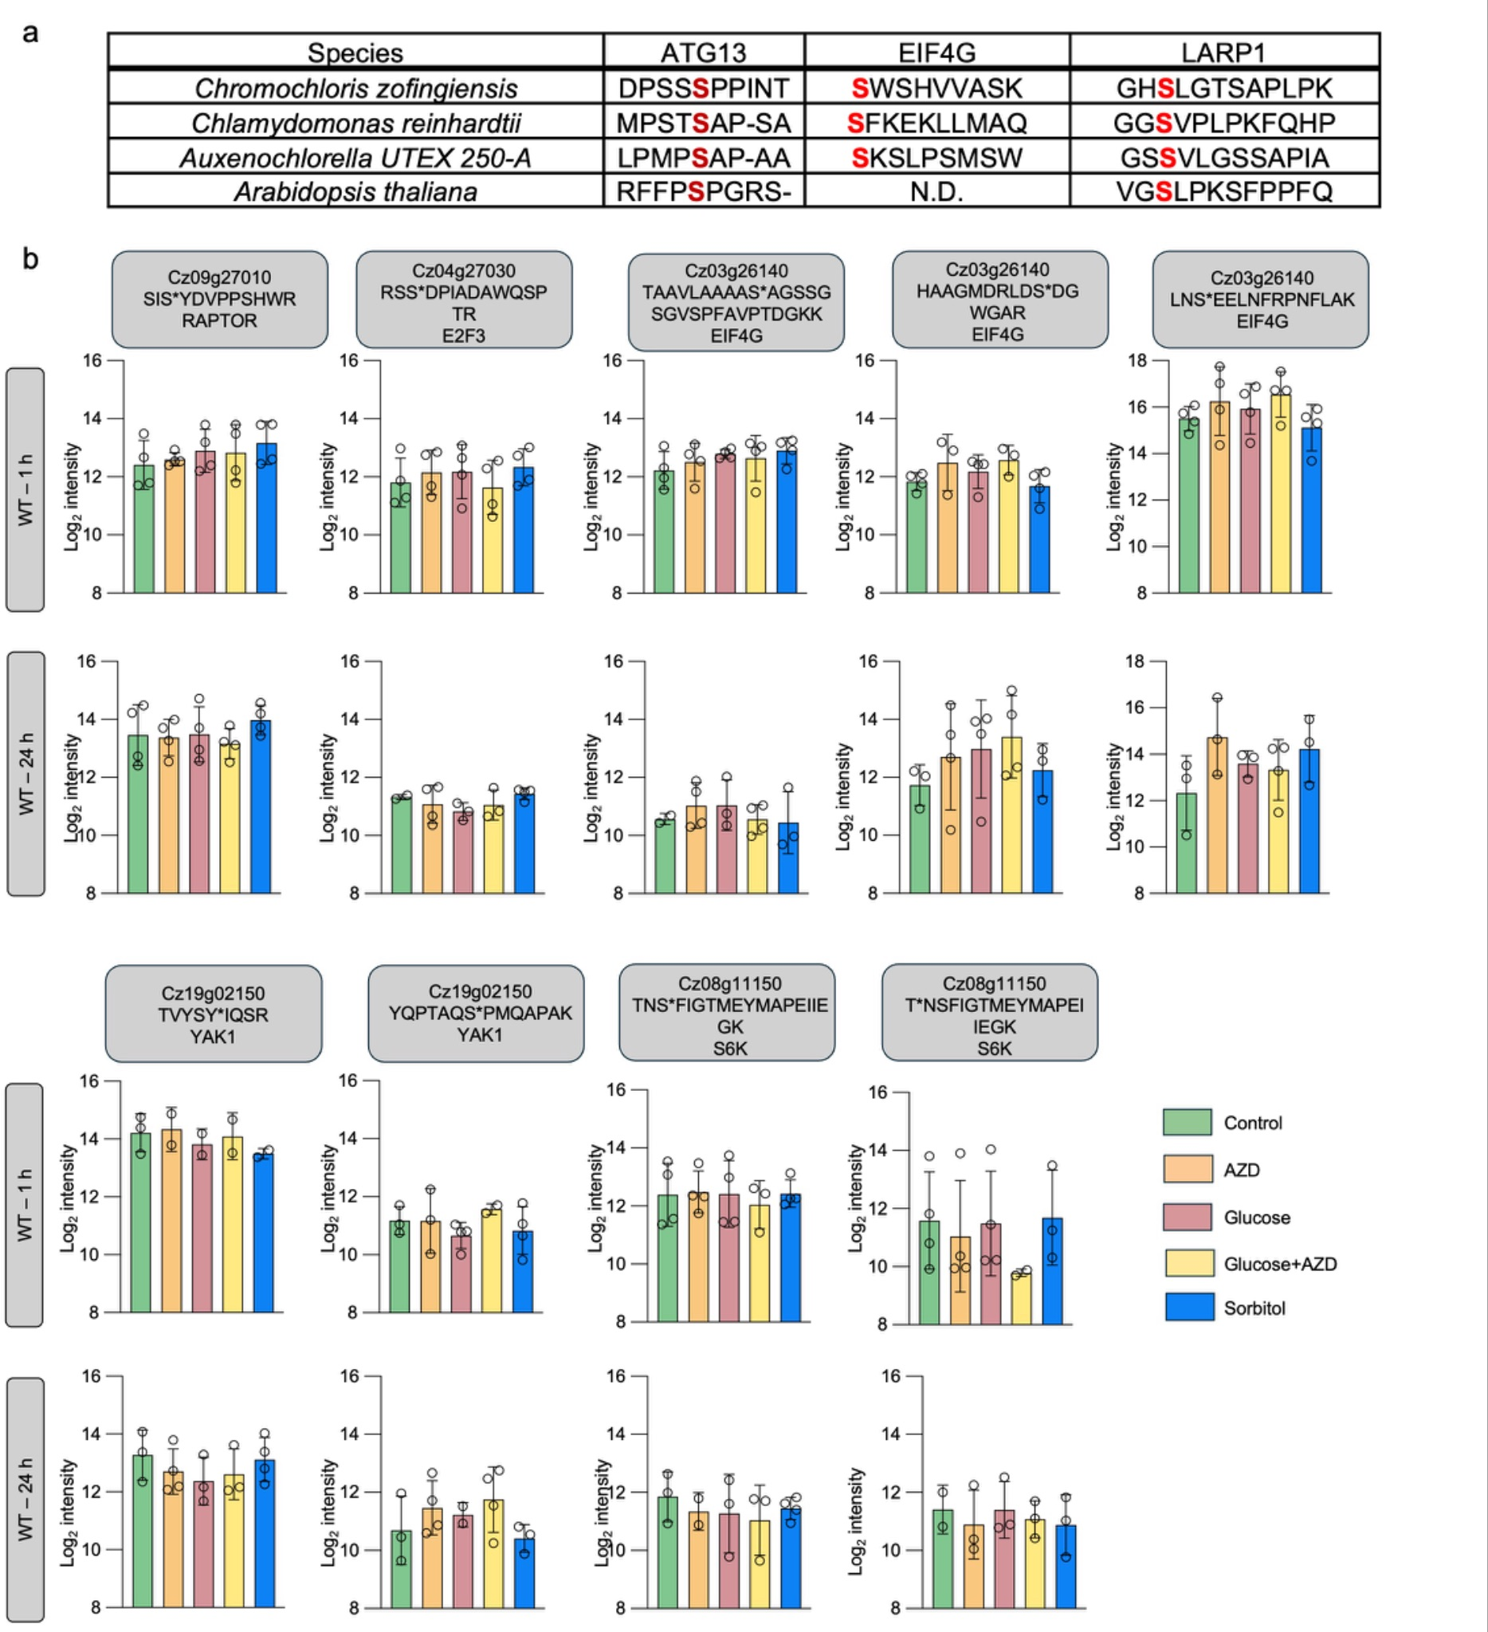

Supplementary Fig. 2. C. zofingiensis benchmark set of TOR targets. (a) Conservation of the detected phosphosite in four species for conserved targets. Red amino acid indicates phosphorylation detected at that site. (b) Log₂ intensities of phosphosites for conserved TOR targets RAPTOR, E2F3, EIF4G, YAK1, and S6K during TOR inhibition by 1 µM AZD treatment, 15 mM glucose addition, combined 15 mM glucose + 1 µM AZD treatment and sorbitol for WT. Data represent means ± SD; n = 2-4 biological replicates. See Fig. 2B for phosphosites with significant changes in ATG13, EIF4G, and LARP1.

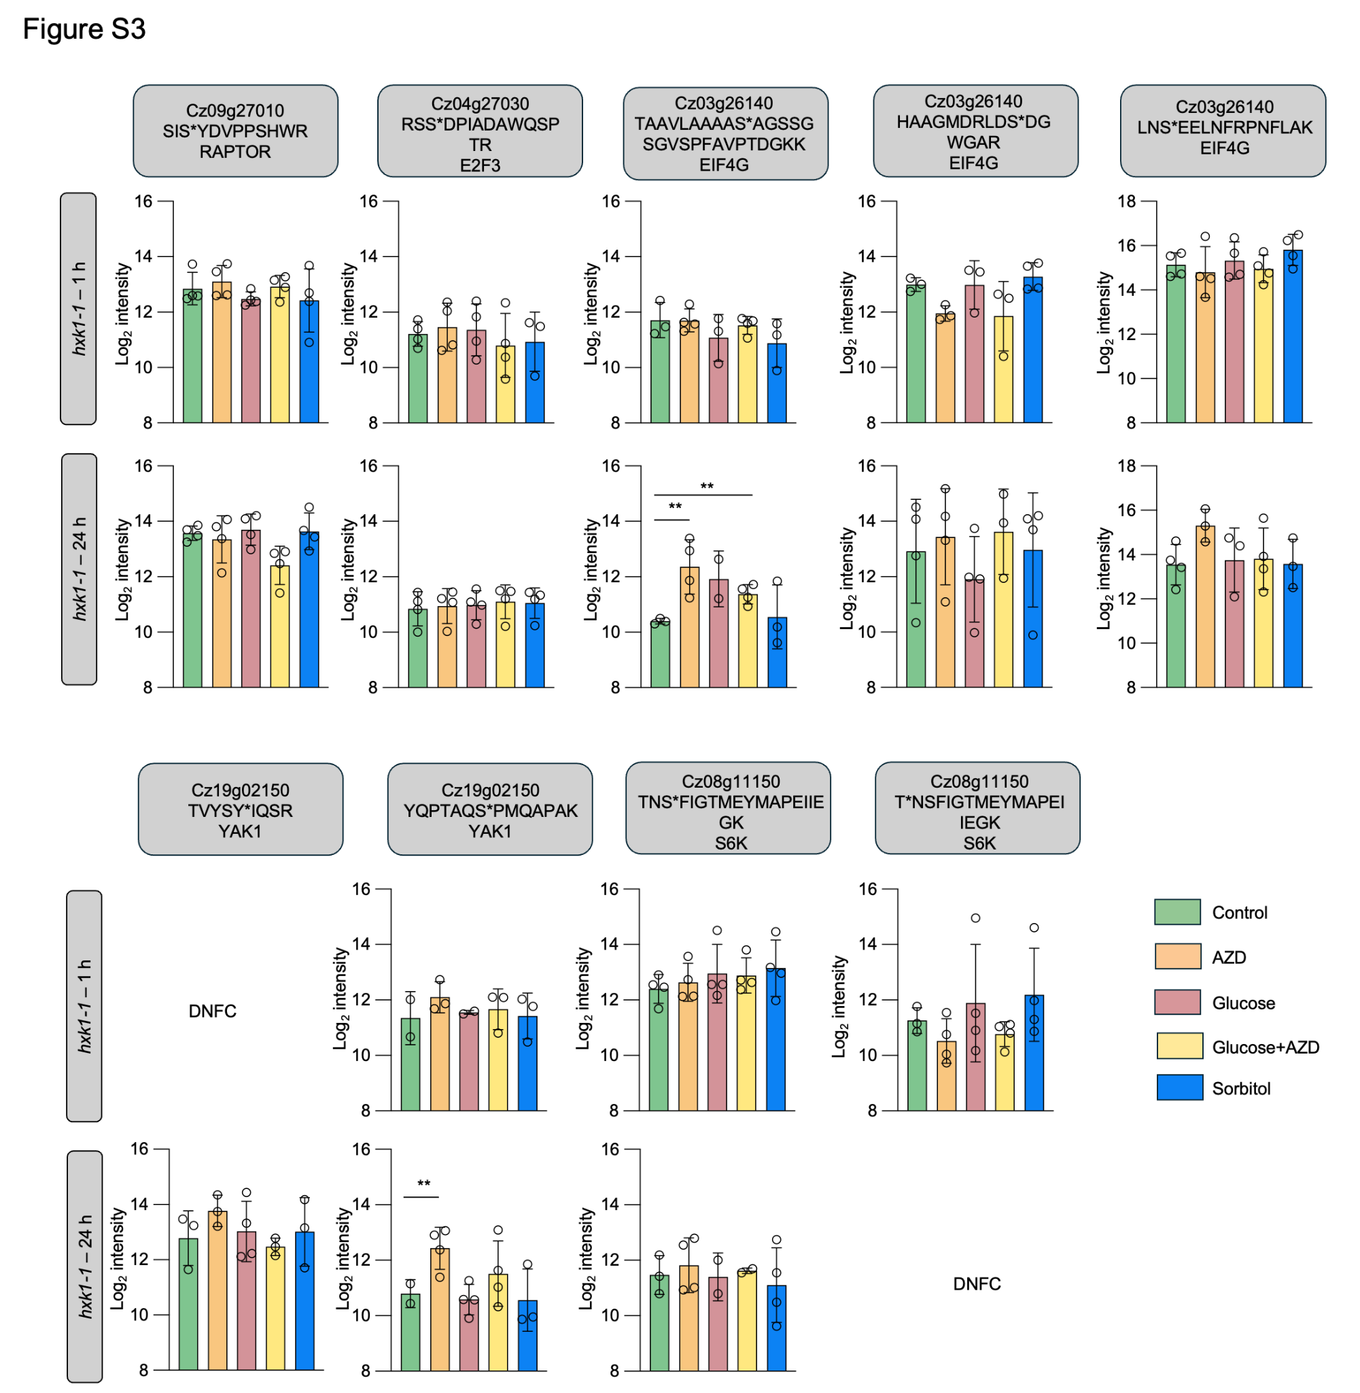

Supplementary Fig. 3. hxk1-1 benchmark set of TOR targets. Log₂ intensities of phosphosites for conserved TOR targets RAPTOR, E2F3, EIF4G, YAK1, and S6K during TOR inhibition by 1 µM AZD treatment, 15 mM glucose addition, combined 15 mM glucose + 1 µM AZD treatment and sorbitol for hxk1-1. Data represent means ± SD; n = 2-4 biological replicates; DNFC; Did Not Pass Filtering Criteria; **P ≤ 0.01 (moderated t-statistics). See Fig. 2B for phosphosites with significant changes in ATG13, EIF4G, and LARP1.

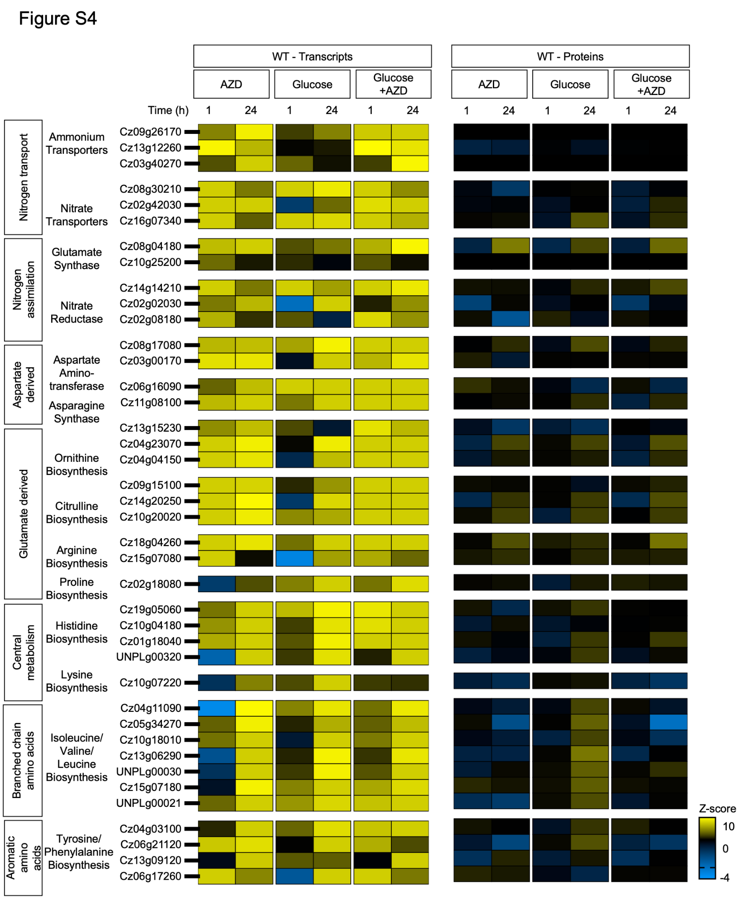

Supplementary Fig. 4. WT upregulation of de novo amino acid biosynthesis pathways during TOR inhibition. Heatmap of Z-scores of transcript and protein abundances of nitrogen assimilation and de novo amino acid biosynthesis genes during TOR inhibition by 1 µM AZD treatment, 15 mM glucose addition, and combined 15 mM glucose + 1 µM AZD treatment. The annotations for amino acid genes were obtained from previously published literature (19). Data represent means; n = 2-4 biological replicates (Supplementary Data 7).

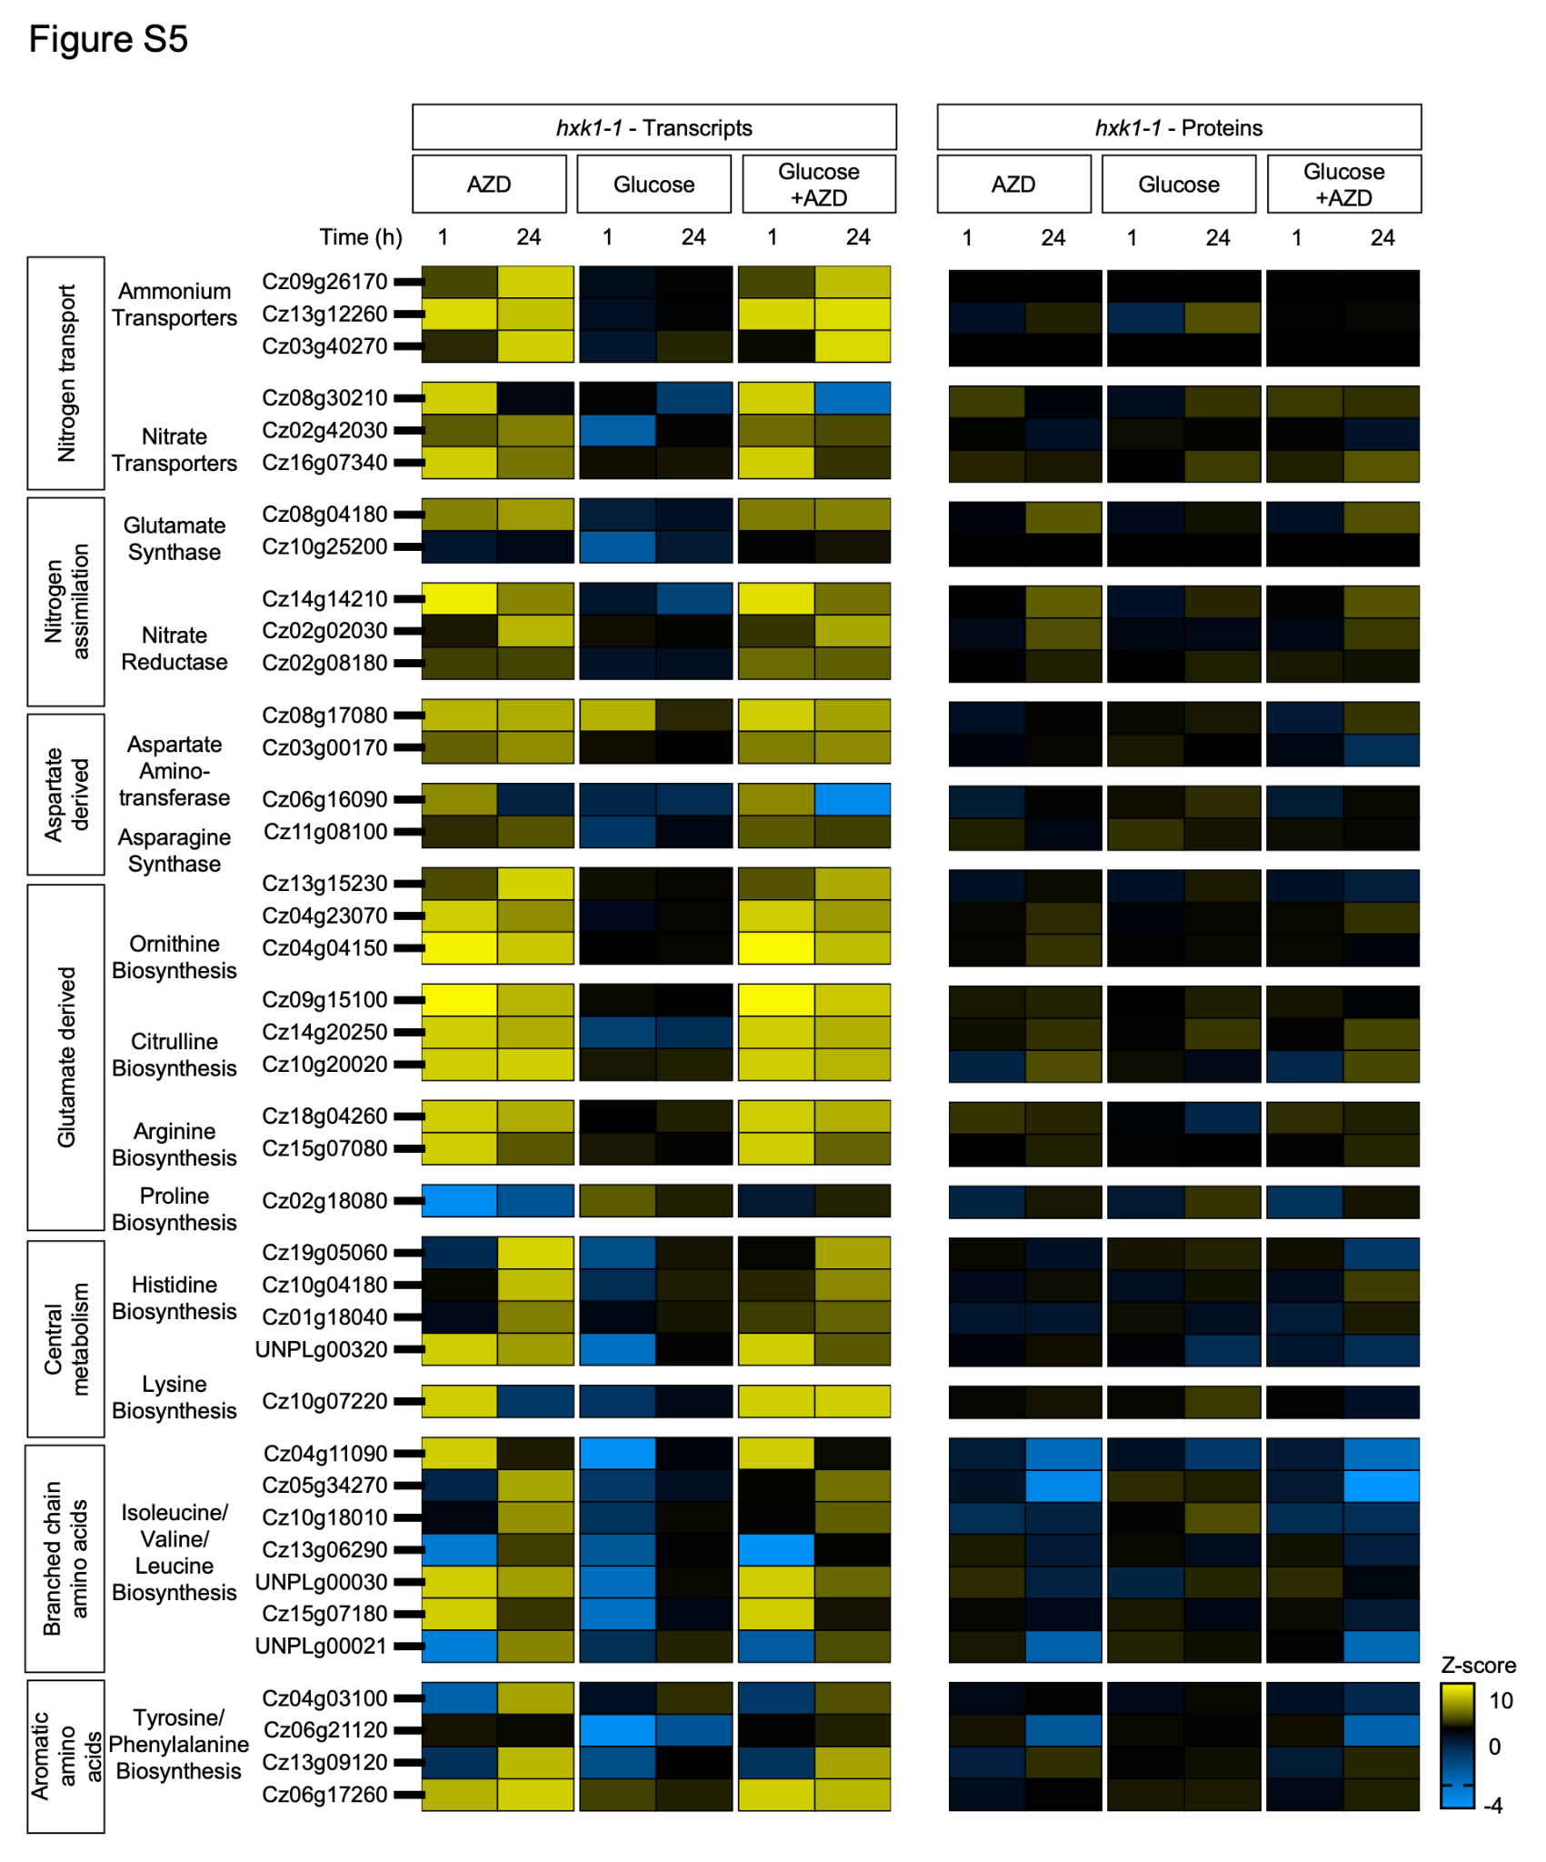

Supplementary Fig. 5. hxk1-1 upregulation of de novo amino acid biosynthesis pathways during TOR inhibition. Heatmap of Z-scores of transcript abundances and protein abundances of nitrogen assimilation and de novo amino acid biosynthesis genes during TOR inhibition by 1 µM AZD treatment, 15 mM glucose addition, and combined 15 mM glucose + 1 µM AZD treatment. The annotations for amino acid genes were obtained from previously published literature (16). Data represent means; n = 2-4 biological replicates (Supplementary Data 8).

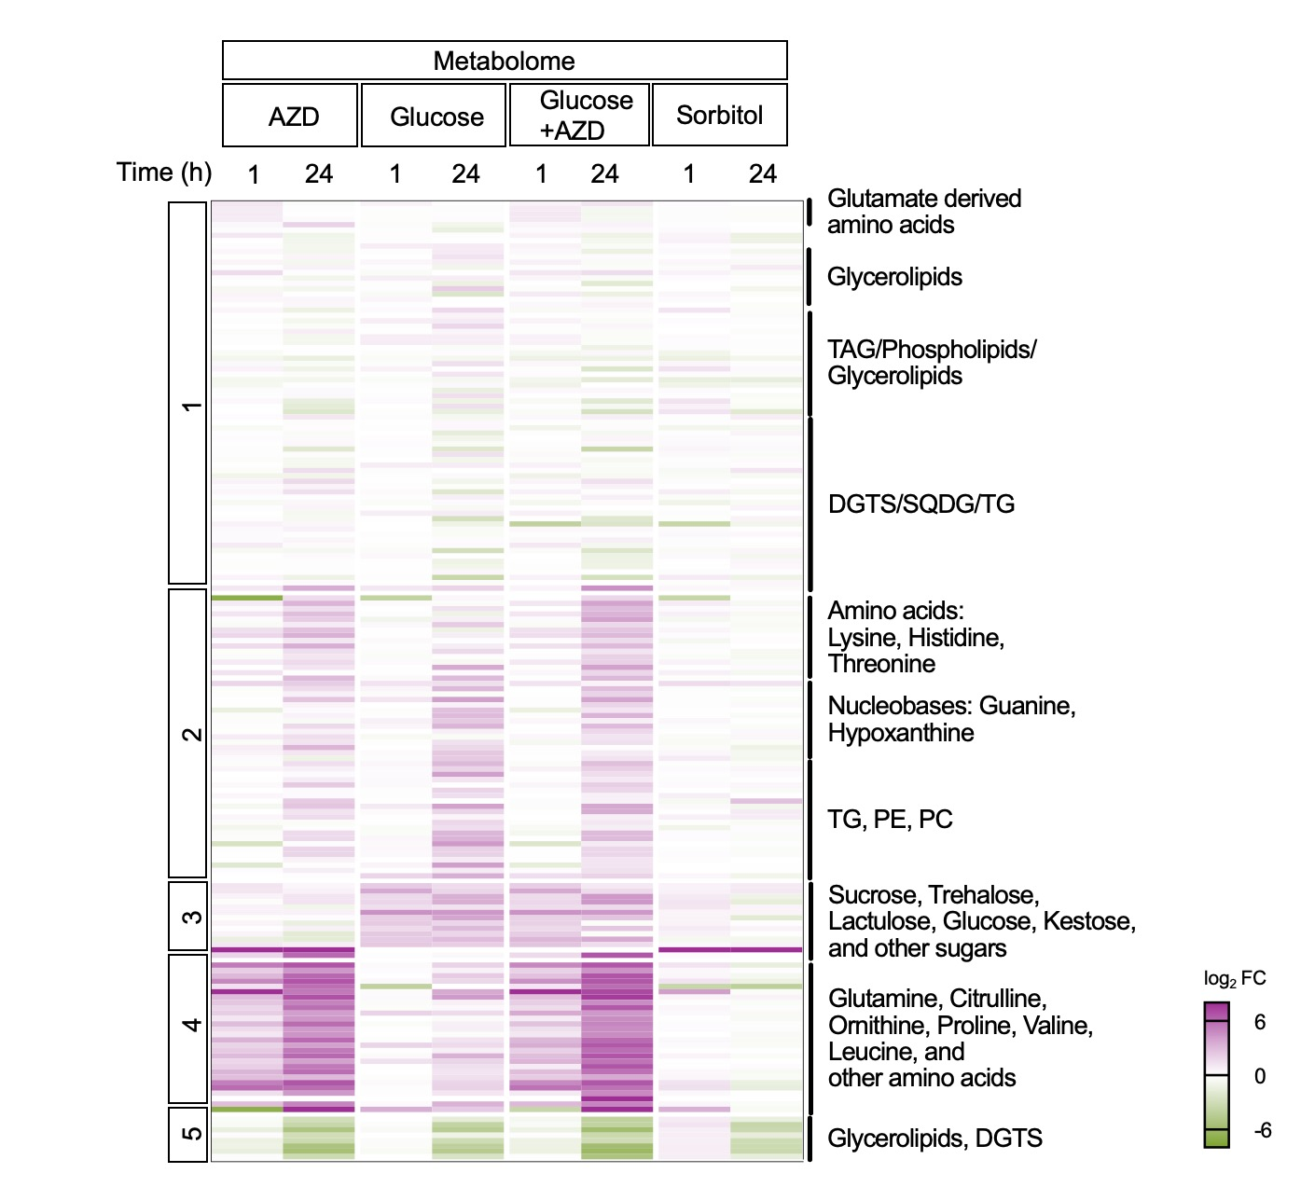
Supplementary Fig. 6. WT TOR inhibition leads to an increase in amino acids independent of glucose. Heatmap of log₂ fold change (FC) of metabolite intensities during TOR inhibition by 1 µM AZD treatment, 15 mM glucose addition, and combined 15 mM glucose + 1 µM AZD treatment. Samples clustered using k-means clustering. Clusters were annotated based on the metabolite classifications from GNPS (Supplementary Methods). Data represent means; n = 3-4 biological replicates (Supplementary Data 10).

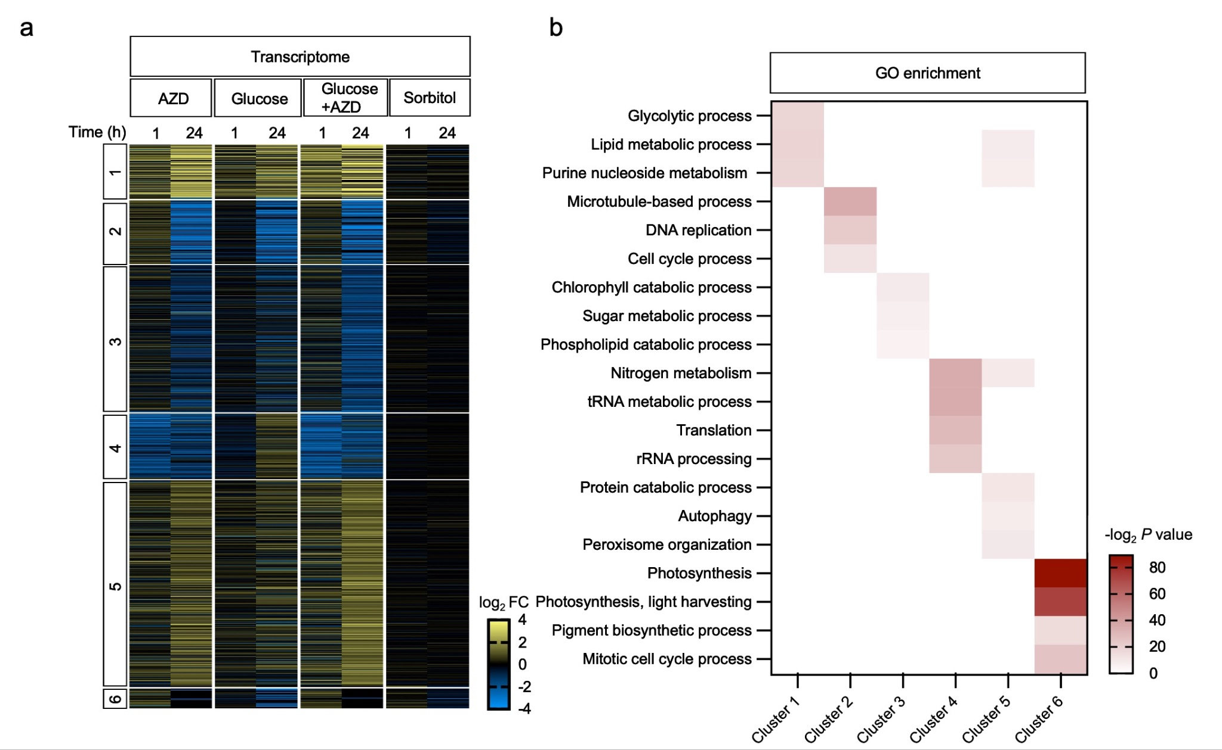
Supplementary Fig. 7. WT transcriptional clustering to identify transcription factors. (a) Heatmap of log₂ fold change (FC) of transcript counts during TOR inhibition by 1 µM AZD treatment, 15 mM glucose addition, and combined 15 mM glucose + 1 µM AZD treatment. Samples were clustered using k-means clustering. (b) GO term enrichment was performed for the six transcriptome clusters. Cluster 4 represents TOR associated genes. Data represent means; n = 3-4 biological replicates (Supplementary Data 16-18).

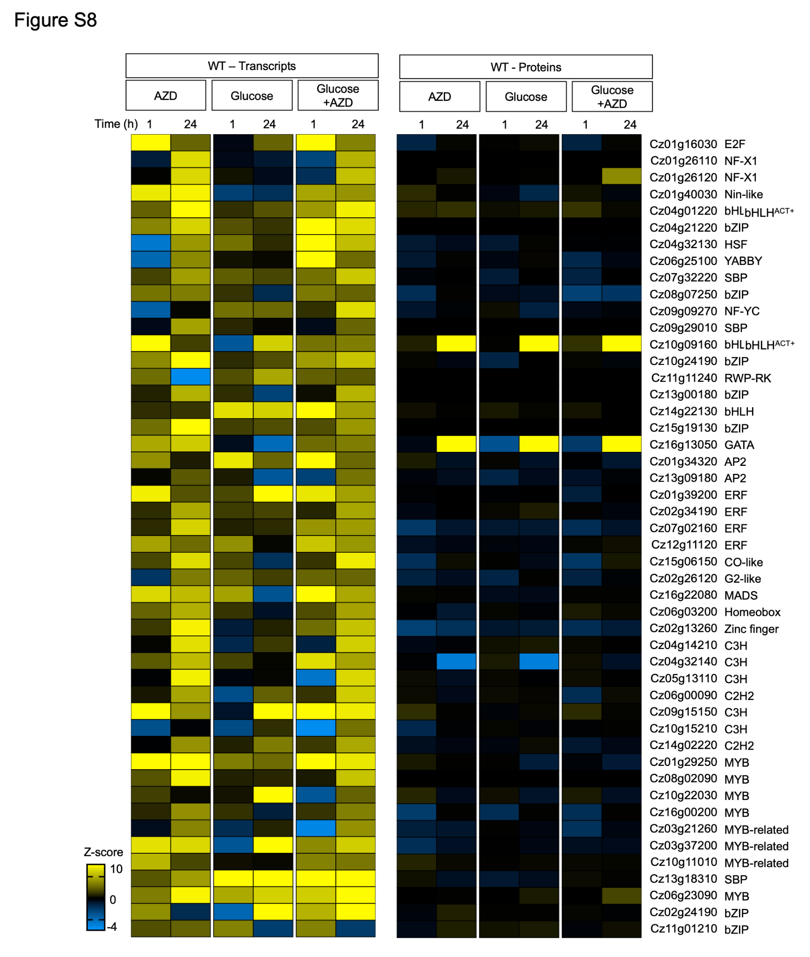
Supplementary Fig. 8. WT gene and protein expression changes for 48 transcription factors (TFs). Heatmap of Z-scores of transcript abundances and protein abundances of 48 TFs during TOR inhibition by 1 µM AZD treatment, 15 mM glucose addition, and combined 15 mM glucose + 1 µM AZD treatment. The annotations for the TF family (right) were obtained from previously published literature (16). Data represent means; n = 2-4 biological replicates (Supplementary Data 19).

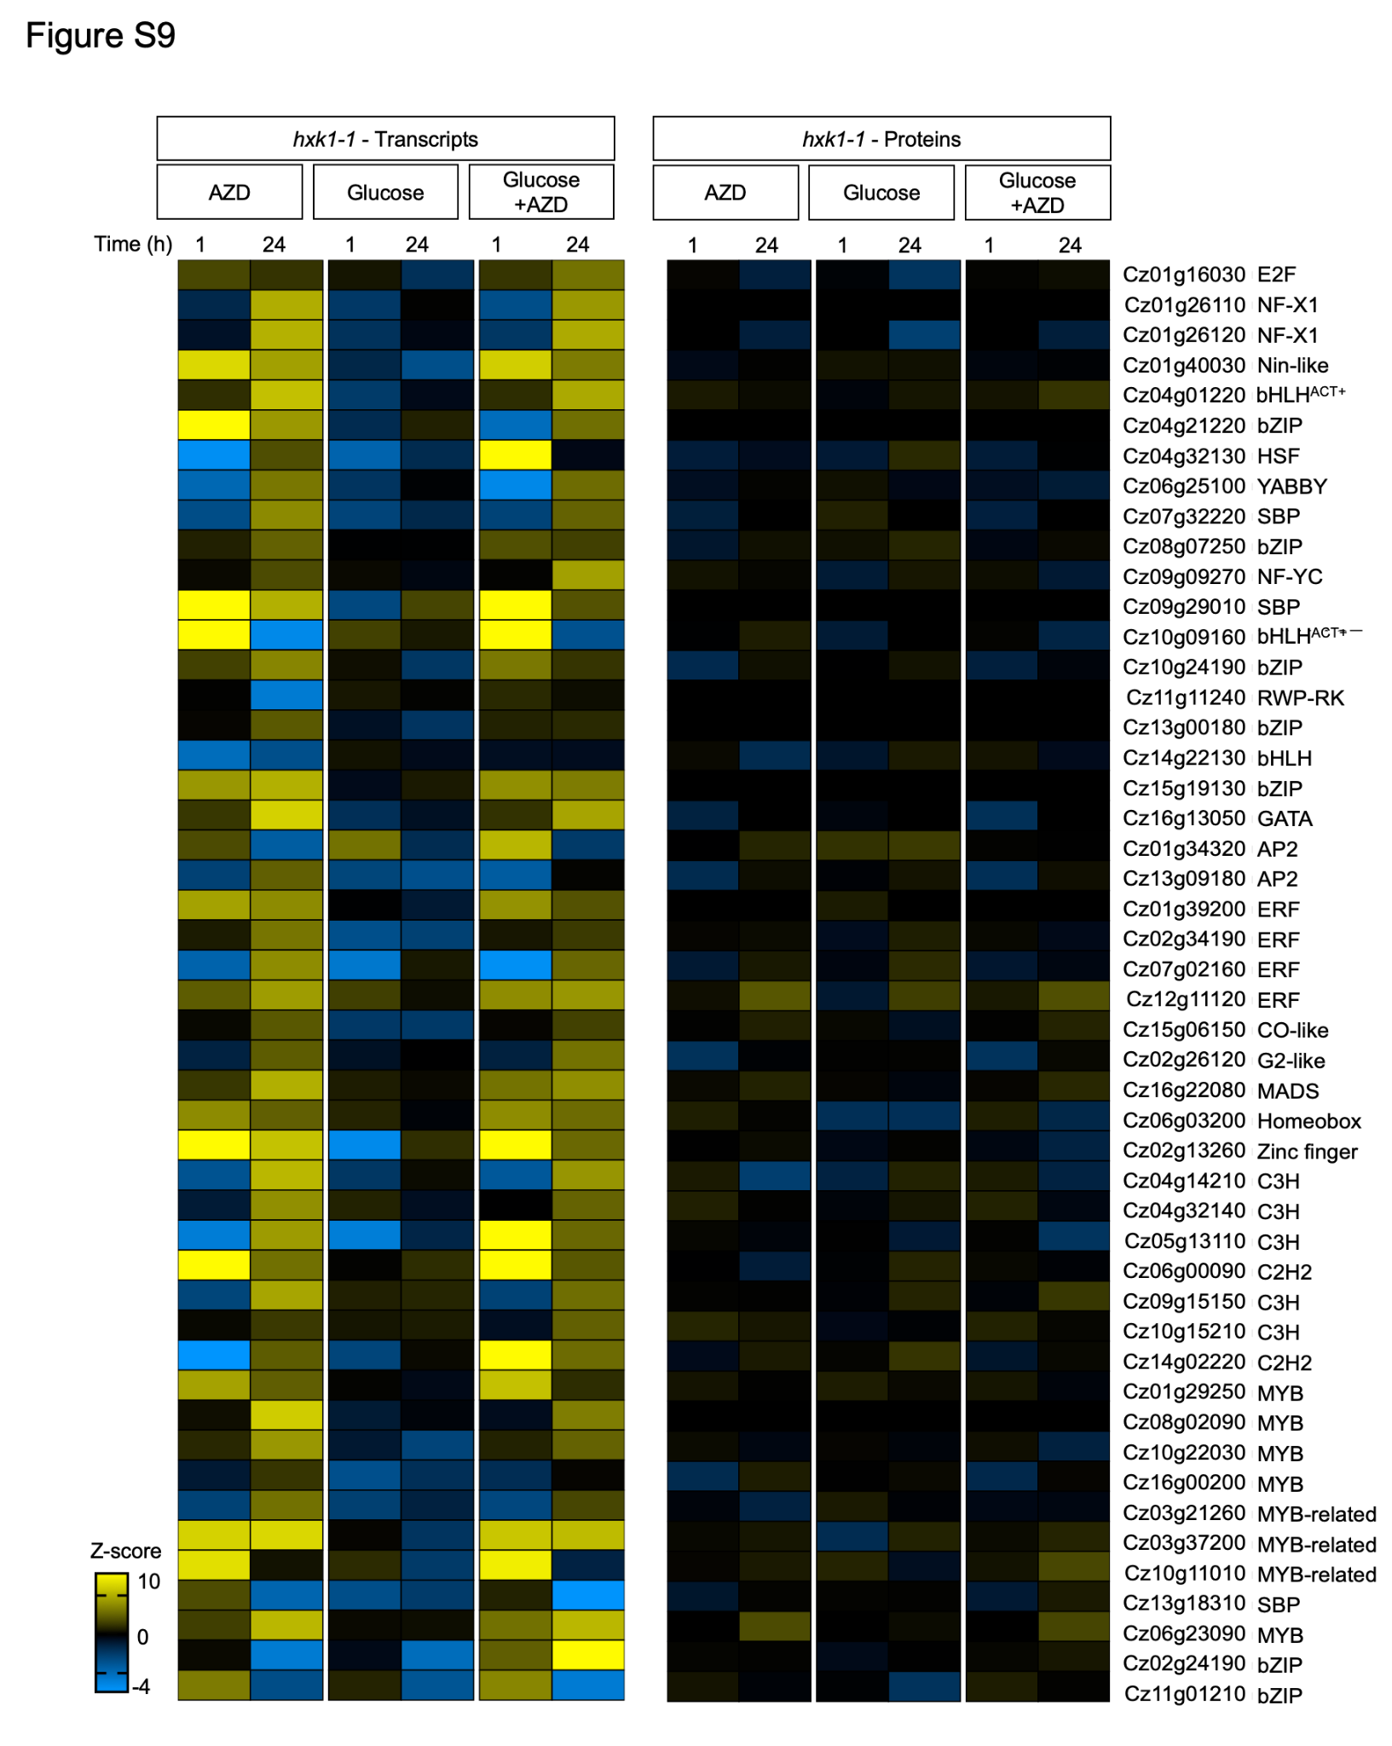
Supplementary Fig. 9. hxk1-1 gene and protein expression changes for 48 transcription factors. Heatmap of Z-scores of transcript abundances and protein abundances of 48 TFs during TOR inhibition by 1 µM AZD treatment, 15 mM glucose addition, and combined 15 mM glucose + 1 µM AZD treatment. The annotations for the TF family (right) were obtained from previously published literature (16). Data represent means; n = 3-4 biological replicates (Supplementary Data 19).

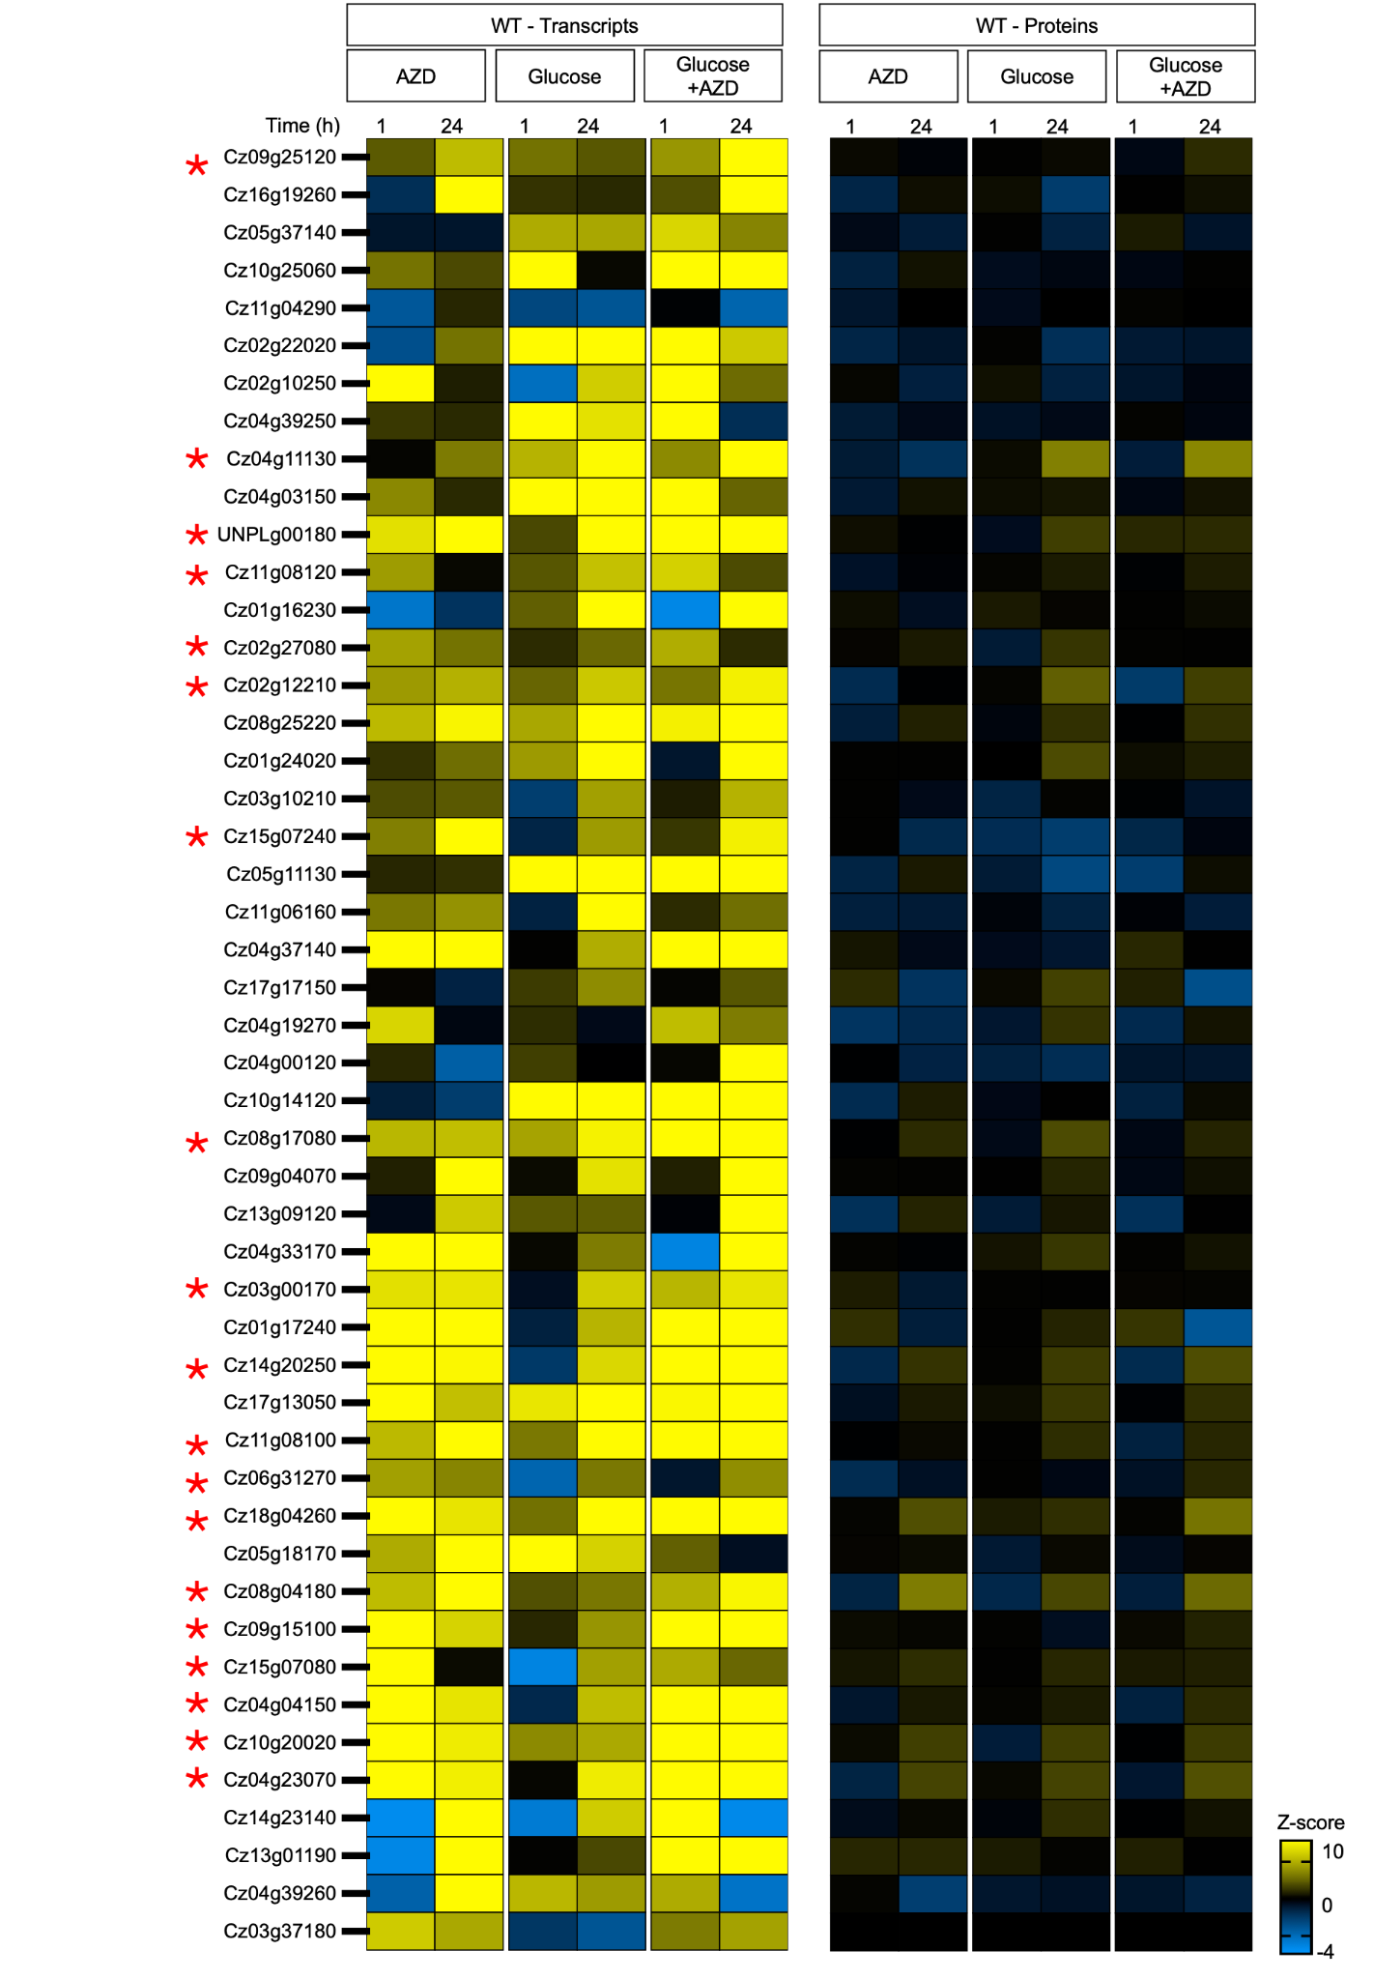
Supplementary Fig. 10. Gene and protein expression changes of selected amino acid biosynthesis genes bound by bHLH^{ACT+} in C. zofingiensis WT. Heatmap of Z-scores of transcript abundances and protein abundances of nitrogen assimilation and de novo amino acid biosynthesis genes during TOR inhibition by 1 µM AZD treatment, 15 mM glucose addition, and combined 15 mM glucose + 1 µM AZD treatment. Asterisk signifies genes selected in Fig. 6. Data represent means; n = 3-4 biological replicates (Supplementary Data 20).

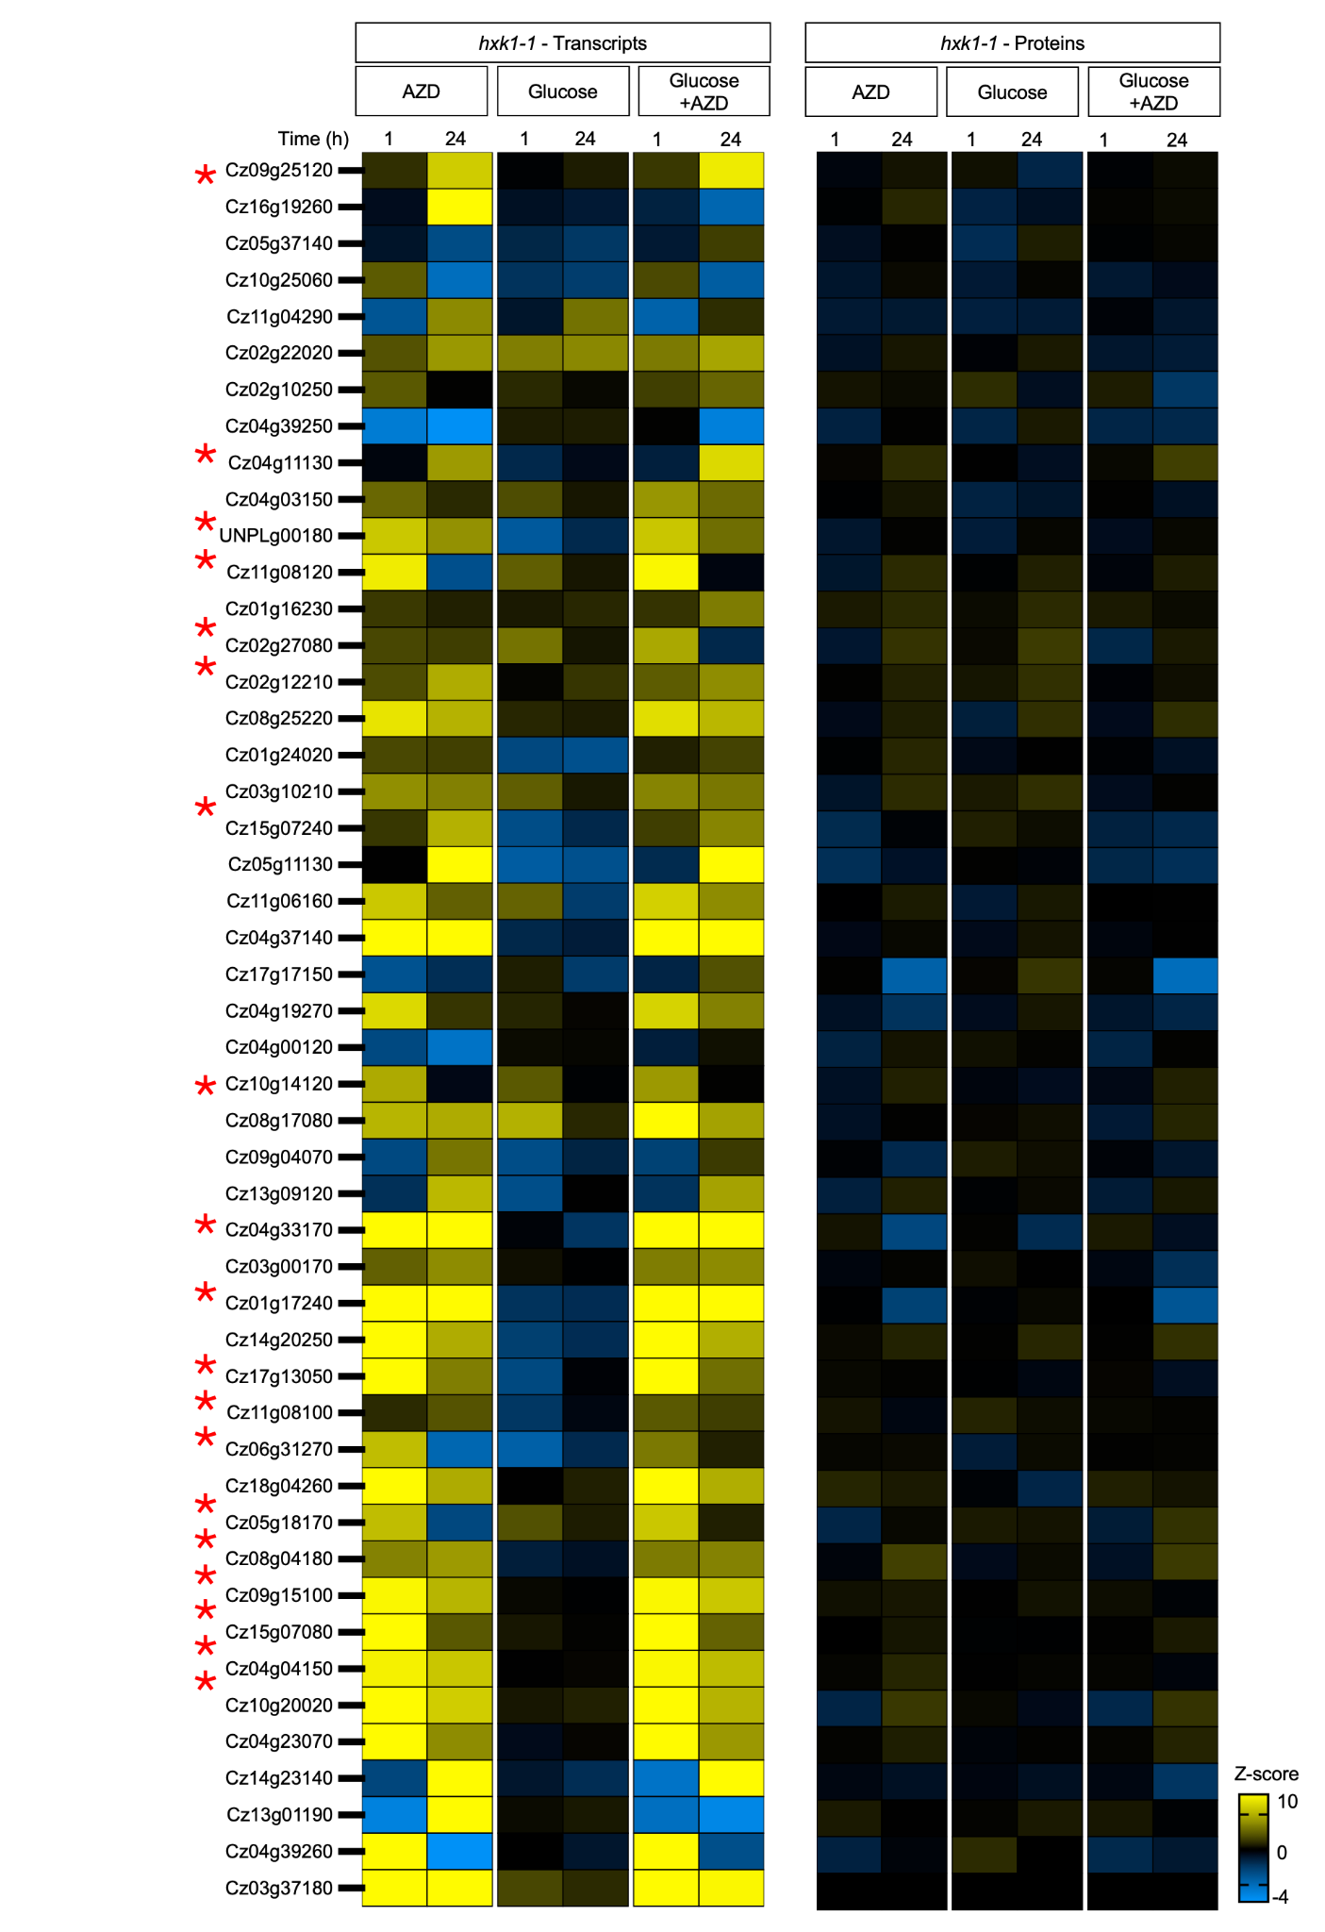
Supplementary Fig. 11. Gene and protein expression changes of selected amino acid biosynthesis genes bound by bHLH^{ACT+} in C. zofingiensis hxk1-1. Heatmap of Z-scores of transcript abundances and protein abundances of nitrogen assimilation and de novo amino acid biosynthesis genes during TOR inhibition by 1 µM AZD treatment, 15 mM glucose addition, and combined 15 mM glucose + 1 µM AZD treatment. Asterisk signifies genes selected in Fig. 6. Data represent means; n = 3-4 biological replicates (Supplementary Data 20).

Supplementary Methods

Strains, Growth Conditions, and sample collection for multiomics. Chromochloris zofingiensis SAG211-14 cultures¹ were grown on Chromochloris Optimized Ratio of Elements (CORE) medium specific for optimum growth². For all liquid cultures, 1 x 10⁵ cells mL⁻¹ were inoculated in 1 L media containing 2 µM iron (Fe) in CORE media at 25ºC, 100 µmol photons m⁻² s⁻¹ and grown until 1-2 X 10⁶ cells mL⁻¹ density before splitting into beakers. After overnight acclimation to beakers, replicate samples were treated with either 1 µM AZD, 15 mM glucose, or 15 mM sorbitol. Sorbitol was used as a control to distinguish osmotic responses from glucose responses. Cultures were collected at 1 h or 24 h for transcriptomics, proteomics/phosphoproteomics, and metabolomics. For 96 h experiments, cultures were treated with 100 mM glucose.

Growth, biomass, and photosynthesis measurements. Cell density and cell diameter for each treatment and time point were measured using the Multisizer 3 (Beckman Coulter). Cultures were diluted 50-fold in an isotonic solution and the number and volume of cells per mL were counted using a 50 µM glass aperture tube. Further analysis was manually performed for each treatment and time point to calculate the cell number/mL and volumetric biomass as previously described³.
For photosynthetic measurements, chlorophyll fluorescence of all samples was assayed using a Hansatech FMS2 system as previously described^{4,5}. Samples were dark adapted for 30 min in 15 mL falcon tubes. Using a syringe filter, equal biomass of culture for each treatment were filtered on a glass fiber filter and the F_{v}/F_{m} = (F_{m} − F_{o})/F_{m} or maximum quantum efficiency of PSII was measured by placing the filter on a leaf clip.

Pigments quantification. Cellular pigments were extracted and quantified using HPLC as described previously^{1,2,5}. Briefly, 2 mL of culture was collected by centrifugation at 10,000 x g for 5 min at 4ºC. Cells were homogenized with 500 µL of chilled 100% ethanol and lysing matrix D with the Fastprep-24 5G High-Speed Homogenizer (3x60s, 6.5 m/s, MP Biomedicals). Ethanol extraction was repeated four times and the lysate was then centrifuged for 5 min at 20,000xg at 4ºC. The supernatant was filtered with a 0.22 µm filter and run on an Agilent 1290 Infinity II HPLC system (250x4.6 mm I.D., S-5 µm) coupled to a C30 guard column (YMC America)²⁹. Pigments were detected at 445 nm and standards when available were used to verify pigments. Pigment concentration was calculated in pmol/mL of pigments, normalized with cell density or biomass and plotted using Prism 11.

RNA preparation. For RNA extraction, cells were collected at different time points by centrifugation (3200 g, 5 min at 4ºC) and frozen in liquid nitrogen. RNA extraction and purification was performed as previously described with certain modifications⁶. Briefly, 50 mL culture was pelleted via centrifugation (3,200 g, 5 min, 4°C) and the pellet was flash frozen in liquid nitrogen followed by fragmentation with a spatula on dry ice. Cells are then suspended in cold ethanol, transferred to Lysing Matrix D tubes, homogenized using the MP Biomedicals FastPrep-24TM 5G homogenizer (60 s, 6.5 m/s, 3 cycles), and lysed in fresh buffer containing SDS/proteinase K. The lysate is clarified by centrifugation, mixed with TRIzol (Thermo Scientific) and centrifuged to separate phases; the aqueous phase is combined with ethanol and loaded onto miRNeasy columns (Qiagen) under vacuum. After on-column DNase digestion (15 min, 30°C) RNA was eluted in water, precipitated with sodium acetate and ice-cold ethanol, incubated (−20°C, 30 min), and pelleted by centrifugation. The RNA pellet is washed with 70% ethanol, air-dried, and resuspended in RNase-free water. Finally, RNA quality is assessed via NanoDropTM (Thermo Scientific) spectrophotometry and a 2100 Bioanalyzer (Agilent) (RIN > 8, distinct 18S/28S peaks).

RNA quality assessment. The protocol followed the Qiagen Prep wash and elution steps with the substitution of microcentrifuge (30–60 s at 14,000 rpm) in place of a vacuum manifold. RNA quality and quantity were evaluated with an Agilent 2100 Bioanalyzer. Around 3 µg RNA was submitted to the Joint Genome Institute in NovoSeq S4 plates. Further steps involved creation of polyA selection-based cDNA library for 2X151 paired end read sequencing using Illumina NovoSeq. Following quality trimming of reads using the in-house JGI program BBDUK, samples had an average rRNA contamination of 0.3% and a genome mapping rate of 99.57%.

RNA-Seq analysis. The raw read fastq files were realigned to the updated genome annotation file published in (Cz.v.5.3.annotations.gff3⁷). For further analysis, a decoy aware transcriptome index was generated with the reference genome v5.3 using the salmon-index generator tool. Reads were quantified from fastq files using the salmon pseudoalignment tool (v1.10.2) and the GC bias of the genome was incorporated by passing the -gcBias flag in salmon. The transcripts per million counts obtained from salmon were then used for differential expression analysis using the DESeq2 package (v1.46.0) in R. Z-scores were derived by standardizing log₂ fold changes across all detected genes (subtracting the mean and dividing by the standard deviation of the log₂ FC distribution). PCAs of the regularized log₂ counts for the 500 genes with the highest variance were performed as discussed below. Heatmaps were generated in R with the ggplot2. k-means clustering was performed in R with the amap package (v0.8-14). Pathway annotations were downloaded from Phytozome’s BioMart (https://phytozome.jgi.doe.gov/biomart) and functional enrichment was performed in R using the hypergeometric distribution with BH multiple testing correction and a false discovery rate of 0.05. Heatmaps were generated in Prism 11 using the log₂ FC values obtained from DESeq2.

Proteomics sample preparation. Proteomics sample preparation was performed as previously described³. Briefly, ~50 mL of culture was centrifuged at 4000 rpm for 5 min at 4ºC. The supernatant was discarded and the pellet was flash frozen in liquid nitrogen. Pellets were shipped in dry ice and stored at -80°C. For protein extraction, each cell pellet was resuspended and disrupted in a bead mill homogenizer (OMNI International). After bead beating, the lysate was immediately placed on ice. To separate the proteins, metabolites, and lipids, cold chloroform:methanol (2:1) was pipetted into a microcentrifuge tube on ice and the sample was vortexed followed by centrifugation at 4°C. The protein interface had 1 mL of cold 100% methanol added to each sample, was vortexed and centrifuged again to pellet the protein. The methanol was then decanted off, and the samples were placed open in a fume hood to dry.
The protein pellet was dissolved in 8 M urea and vortexed into solution and the protein concentration was determined using a bicinchoninic acid (BCA) assay (Thermo Scientific). Following the assay, 10 mM dithiothreitol (DTT) was added, and the samples were incubated at 60°C with constant shaking at 800 rpm. Samples were then diluted 8-fold in preparation for trypsin digestion. 100 mM NH₄HCO₃, 1 mM CaCl₂ and sequencing-grade modified porcine trypsin (Promega) were added to all protein samples at a 1:50 (w/w) trypsin-to-protein ratio for 3 h at 37ºC with constant shaking at 450 rpm. Digested samples were desalted using a 4-probe positive pressure Gilson GX-274 ASPECTM system (Gilson Inc.) with Discovery C18 100 mg/1 mL solid phase extraction tubes (Supelco), using the following protocol: 3 mL of methanol was added for conditioning followed by 2 mL of 0.1% trifluoroacetic acid (TFA) in H₂O. The samples were then loaded onto each column followed by 4 mL of 95:5: H₂O: acetonitrile, 0.1% TFA. Samples were eluted with 1 mL 80:20 acetonitrile:H₂O, 0.1% TFA. The samples were concentrated down to ~100μL using a SpeedVac, and a final BCA assay was performed to determine the peptide concentration. An equal mass of each sample was aliquoted into fresh centrifuge tubes, dried completely in a SpeedVac and then stored at -80°C until isobaric labeling.

TMT isobaric tag labeling. Each sample was diluted in 500 mM HEPES, pH 8.5 to a concentration of 5 μg/μl and labeled using amine-reactive Thermo Scientific Tandem Mass Tag (TMT10) Isobaric Mass Tagging Kits (Thermo Scientific) according to the manufacturer’s instructions. Briefly, 250 μL of anhydrous acetonitrile was added to each 5 mg reagent, vortexed and allowed to dissolve for 5 min with occasional vortexing. Reagents were then added to the samples and incubated for 1 h at RT with shaking at 400 rpm. Each sample was then diluted to 2.5 μg/μl with 20% acetonitrile, and the reaction was quenched by adding 8 μL of 5% hydroxylamine to the sample with incubation for 15 min at RT with shaking at 400 rpm. The samples within each set were then combined and completely dried in the SpeedVac. Each of the samples were then cleaned using C18 50 mg/1 mL solid phase extraction tubes as described above and once again assayed with BCA to determine the final peptide concentration.

Phosphopeptide Enrichment. The TMT labeled peptides were subjected to phosphopeptide enrichment using magnetic nickel-nitriloacetic acid (Ni-NTA) beads (Qiagen) according to the manufacturer's protocol. Ni-NTA magnetic beads were washed three times with water and treated with 100 mM EDTA, pH 8.0 for 30 min. After removing the EDTA solution, beads were washed three times with water, and treated with 10 mM FeCl₃ for 30 min. After removing excess metal ions, the beads were washed three times with water and resuspended in 1:1:1 (v/v/v) acetonitrile/methanol/0.01% (v/v) acetic acid. Beads were then conditioned using resuspending/wash buffer containing 80% (v/v) acetonitrile and 0.1% (v/v) trifluoroacetic acid, followed by incubation with peptides (100 μg peptides in 200 μl of 80% (v/v) acetonitrile with 0.1% (v/v) trifluoroacetic acid) for 30 min. The beads were washed three times with the resuspending/wash buffer and the phosphopeptides were eluted with elution buffer containing 50% (v/v) acetonitrile and 2.5% (v/v) ammonia. The eluate containing phosphopeptides was immediately acidified with 10% (v/v) trifluoroacetic acid and concentrated by vacuum centrifugation prior to mass spectrometry analysis.

Mass-Spectrometry Based Proteomic Analysis of Samples. All peptide samples were analyzed using a Waters M-Class nanoAcquity LC system coupled to a Q Exactive HFX Orbitrap mass spectrometer (Thermo Fisher Scientific, Waltham, MA). Custom-made electrospray emitters were fabricated from chemically etched fused silica with dimensions of 150 μm outer diameter (OD) x 20 μm OD x 20 μm inner diameter (ID). Separation was performed on a 25-cm fused-silica capillary analytical column (360 μm OD x 75 μm ID) packed with 1.7 μm BEH C18 particles Waters (Milford, MA). Mass spectrometric analysis was performed on a Q Exactive HFX Orbitrap (Thermo Fisher Scientific, Waltham, MA) operating in data-dependent acquisition mode. Full MS scans were acquired at a resolution of 60,000 with a target of 3 × 10⁶ ions across a mass range of 300-1800 m/z. The top sixteen most abundant precursor ions were selected for higher-energy collisional dissociation (HCD) at a resolution of 45,000 with a target of 2 × 10⁵ ions. An isolation window of ±0.7 Th (total 1.4 Th) was applied prior to HCD fragmentation. HCD scans were conducted using a normalized collision energy of 30. Dynamic exclusion was set to 45 s to prevent repeated analysis of the same ions, and charge state screening was enabled to exclude unassigned ions, singly charged ions, and species with charge states of 7 or greater.

Peptide Identification and Quantification. MS/MS spectra were searched against decoy C. zofingiensis protein databases (Chromochloris_zofingiensis_AlternateHXKSequences_Westcott_2019-11-25 and
Chromochloris_zofingiensis_UCLA_v5.3.7) as well as a contaminants database (Tryp_Pig_Bov) using the MSGFPlus algorithm. Instrument raw files were converted to mzML format using MSConvert, and MzRefinery was used to re-calibrate MS2 scan parent m/z values. Search parameters included partial tryptic rules for both proteome and phosphopeptide data, with a ±20 ppm precursor mass tolerance. Fixed modifications were carbamidomethylation of cysteines (+57.0215 Da) and TMT labeling of lysines and peptide N-termini (+229.1629 Da). Allowed variable modifications were oxidation of methionine (+15.9949 Da). For phosphopeptide analysis, phosphorylation of serine, threonine, or tyrosine (+79.9663 Da) was additionally included as a variable modification, and the software AScore¹⁰ was used to localize phosphorylation sites. Peptides were filtered to a Q-value ≤ 0.01 (1% FDR) at the peptide level using the decoy approach¹¹. TMT reporter ions were extracted using the MASIC software¹² with a 0.003 Da fixed mass tolerance window for each expected TMT reporter ion as determined from each MS/MS spectrum. Abundance information was reported in the order of reporter ions as mixed, with samples randomized to reduce experimental bias.

Downstream analysis with phosphopeptide and protein abundances. For phosphoproteome and proteome analysis, raw data files with 1% FDR were used. Contaminant rows and blank columns were removed for analysis. The FDR threshold was applied solely at the identification stage, using spectral matching to predicted peptide masses, and does not constitute statistical support for differences in phosphopeptide abundance. Contaminant rows and blank columns were removed prior to analysis. Additionally, Phosphorylated serine (S*), threonine (T*), or tyrosine (Y*) containing peptides were specifically filtered from the entire dataset. Zero intensity values were treated as missing (NA) and were not imputed. Quantitative analysis was performed for WT at both 1 h and 24 h time points. For each time point, a peptide intensity matrix was constructed from log₂transformed TMT reporter ion intensities. Peptides were retained for statistical modelling if at least one treatment group contained a minimum of two non-missing observations while all other peptides were excluded from inference. Differential phosphopeptide abundance was assessed using a linear modelling framework implemented in the R package limma, with empirical Bayes moderation of variance estimates (eBayes)³¹, for low-replicate proteomics data. Briefly, a design matrix was constructed with no intercept term, treating each treatment group as a fixed factor with levels: None, AZD, glucose, glucose+AZD, and sorbitol. Pairwise contrasts were defined using makeContrasts and estimated using contrasts.fit, followed by empirical Bayes shrinkage. The following contrasts were tested for both 1 h and 24 h: AZD vs None, glucose vs None, glucose+AZD vs None, sorbitol vs None. The P values are calculated using moderated t-statistics as described in³¹. Multiple testing correction was applied per contrast using the Benjamini Hochberg (BH) procedure. Phosphopeptides were considered statistically significant at a P value ≤ 0.05. For the benchmark set of TOR targets, moderated P values were considered.
For visualisation, replicate intensities for each peptide were standardised row-wise to zero mean and unit variance (Z-score transformation), using the grand mean and standard deviation calculated across all replicates and treatment groups combined. Group-level Z-scores were then derived by averaging the standardised values within each treatment group. Contrast Z-scores, used to colour the heatmap, represent the difference in group mean Z-scores between two conditions and reflect relative displacement in units of within-peptide standard deviation. All statistical inference was performed independently on raw log₂ intensities using the limma eBayes framework described above. Log₂ fold change (log₂ FC), Z-scores, raw P values, and BH adjusted P values are provided for all tested peptides in Supplementary Data 1. For visualization, only peptides satisfying all filters for either timepoints were retained. Bar graphs with raw intensity values were plotted using Prism 11. Statistical significance (P ≤ 0.05) is indicated with an asterisk. To identify conserved phosphopeptides, known TOR kinase target proteins that were reported previously in C. reinhardtii and A. thaliana¹³⁻¹⁵ were extracted using a selective literature screen and blasted against the C. zofingiensis genome. The identified orthologs from C. zofingiensis were then aligned to both C. reinhardtii and A. thaliana proteins and the conserved phosphopeptides were reported. To report conservation of phosphosites in C. zofingiensis, C. reinhardtii, Auxenochlorella UTEX 250-A and A. thaliana, a sequence window of 8-12 residues surrounding the phosphosite was reported for selected targets of TOR kinase.
For global proteome analysis, peptide rollup was performed for all proteins to combine the intensities of all peptides of a protein. Contaminant rows and blank columns were removed for analysis. Rows with missing values were removed and further statistical analysis was performed on the resultant table of combined intensities as described above using the limma package. P values and Z-scores were calculated using moderated t-statistics and provided (Supplementary Data 2) For PCA analysis of the global proteome, the raw intensity values were log transformed, and percent variance was calculated using the prcomp function in R using the PCAtools package (v2.18.0). The first two principal component coordinates were then extracted and plotted through ggplot2 (v3.3.5) to provide shape and color features consistent with the variables. For statistical analysis of the global proteome, Z-scores and log₂ FC of the protein intensities were calculated for the above-mentioned contrasts and t-tests were performed in R to calculate the p value. A limit of quantitation (LOQ) was calculated per comparison as the mean of all averaged log₂ protein abundances across both conditions minus two standard deviations ( individual proteomics feature is the result of averaging (individual proteomics values are the result of averaging of a minimum of 2 protein intensity values), and only proteins exceeding the LOQ in comparable conditions were used to calculate protein Z-scores. Z-scores were computed using the same formula for both the proteomic and transcriptomic data and involves subtracting the mean log₂ fold change of all features in that comparison from the individual feature’s log₂ fold change, then dividing by the standard deviation of all log₂ fold changes in that comparison, thereby the resulting protein and transcript Z-scores are directly comparable. Pearson correlation was calculated between the Z-scores of transcript and protein for each gene. The correlation was plotted using Prism 11. Pathway enrichment was performed as described below.

Metabolomic sample preparation. For metabolite extraction, cells were pelleted at required time points for 5 min at 4000 rpm in a GeneMate 2 mL screw cap tubes. The supernatant was discarded and the cells were frozen in liquid nitrogen. Cell pellets were resuspended in 500µL water and pipetted up and down to break apart cell pellet; the suspended pellets were then immediately frozen at -80ºC and lyophilized. The dried material was homogenized for 5 s, 3 times with 10 s breaks to prevent overheating with a 3.2 mm stainless steel bead (BioSpec Products) in each tube using a Mini-Beadbeater (BioSpec Products). Homogenized dried cell material was then resuspended in 150µL of methanol with internal standards (Supplementary Data 11), vortexed 2x 10 s, ice bath sonicated for 15 min, centrifuged (10,000 rcf, 5 min, 10ºC), and then supernatants were filtered (0.22um pvdf) and transferred to amber glass vials for LCMS analysis. Briefly, metabolites were separated using hydrophilic liquid interaction chromatography on an Agilent 1290 HPLC and detected on a Thermo Q Exactive Hybrid Quadrupole-Orbitrap Mass spectrometer; LCMS parameters are available in Supplementary Data 11.

Metabolomics data analysis. Targeted annotations of amino acids were made using Metatlas^{26,27,28} to extract peak heights using known m/z, retention time and fragmentation spectra based on reference standards analyzed on the same method, identification were determined per the Metabolomics Standards Initiative¹⁸; outputs including evidence of identifications and peak heights are available in Supplementary Data 9, 12.
Feature-based molecular networking (FBMN) was performed as described before using MZmine2 and GNPS^{16,17}. Positive mode top GNPS annotations were accepted with cosine scores of MS/ MS spectral mirror match (MQScore) to library reference of >0.7. Additional filtering included removing known contaminants and adducts such as Phthalic anhydride, Diocytl phthalate and Benzyltetradecyldimethylammonium etc. Untargeted metabolites with retention time between 1 and 17.5 and with an MZErrorPPM values of less than 10 were used. Next, the NPClassifier determined metabolite classifications based on annotated features of biosynthetic pathways. For filtered features, peak heights with differential abundances between different treatments were compared to calculate log fold change values. The log₂ FC values were then clustered using k-means clustering as described below and the metabolite NPclassifier assignments from GNPS were labelled on the heatmap (Prism 11). Statistical analysis for log₂ FC data was done using either Student’s t-test (for treatments: control, AZD, glucose, and glucose+AZD), Dunnett’s test (for comparisons involving control vs AZD, cycloheximide (CHX), AZD+CHX, MG-132, and AZD+MG-132), and ANOVA with Tukey test (for comparisons involving combinations of binary treatments between control, AZD, CHX, AZD+CHX, MG-132, and AZD+MG-132) to calculate P values. Statistical calculations and plotting were performed using Prism 11.

Gene Ontology (GO), Pathway enrichment, and clustering analysis. GO annotation and pathway annotations per protein were downloaded from Phytozome’s BioMart. GO term enrichment was performed with the topGO package (v1) using Fisher's exact test. Pathway enrichment was calculated in R using the enricher function that performs a hypergeometric test with BH multiple testing correction (ClusterProfiler package in R)²⁵. GO terms and pathways were filtered using an FDR of ≤ 0.05 and the lists were generated in R. k-means clustering was performed in R with the amap package (v0.8-14). Functional annotations for pathway analysis in Fig. 3-5 were adapted from¹⁹.

DAP-seq experiment and analysis. The DAP-seq experiment was performed as per standardized protocol at the Joint Genome Institute^{20,21}. Briefly, genomic DNA (gDNA) was extracted from C. zofingiensis and UTEX 250-A cells using a CTAB protocol, fragmented to an average size of 150 bp and ligated with custom adapters. Coding sequence (CDS) of selected TFs were cloned into the pIX-HALO-PaqCI vector directly downstream of the HaloTagHalo-tagged. The T7 promoter driven HaloTag-fused TF CDSs were amplified by using primers pIX-Halo-T7-fwd (5′-GTGAATTGTAATACGACTCACTATAGGG)
and pIX-Halo-AfterPolyA-rev (5′-CAAGGGGTTATGCTAGTTATTGCTC), the resulting PCR products were purified, and the correct amplicon sizes were verified on a Fragment Analyzer system (Agilent). The TF proteins were then in vitro expressed using the TnT T7 Quick for PCR DNA system (Promega L5540) and bound to the Magne HaloTag Beads (Promega G7282) on a 96 well plate. The protein-bound beads were then incubated with C. zofingiensis and UTEX 250-A gDNA libraries and then gently washed to remove any unbound DNA. After the final wash, the beads were resuspended in diluted index primer mix and boiled at 95°C for 10 min to elute DNA off from beads. The eluate from each well was transferred to a new plate and mixed with the KAPA HiFi HotStart ReadyMix (Roche) for amplification. The PCR products were then gel purified and sequenced using Illumina NovaSeq 2X150 bp paired-end sequencing.
The sequencing fastq files were quality filtered and adapters were trimmed using BBTools and then aligned to the reference genome of C. zofingiensis v5.3.2 and UTEX 250-A genome provided by Sabeeha Merchant²⁴ using bowtie2 v2.4.2. The bam files were created using samtools v1.15.1²². The MACS3 v3.0.0a6 callpeak command was used to generate narrowPeak files, using a background control obtained from DAP-seq wells with a mock TF protein expression. Motifs were called using MEME suite v5.3.0²³ command with the reference genome nucleotide frequency as the background model. The first positional weight matrix motif identified by MEME motif caller (MEME-1) from the summit regions of the top peaks was used. TFs that performed poorly in the DAP assay were removed. Successful binding was calculated using the fraction of reads in peaks (FRIP) scores and only TFs with FRIP scores 0.05 were used for further analysis. The DAP-seq peaks identified in the analysis above were further processed to identify target genes for each TF. Using the gene annotation file (gff format), features corresponding to transcript/mRNA were filtered and assigned up to two gene targets. Finally, pathway enrichment was performed for the target genes of each TF using the ClusterProfiler package in R as previously described²⁵. For consistency in pathway enrichment of DAPseq target genes, C. zofingiensis and UTEX 250-A genes were annotated using the eggNOG mapper³⁰.

Orthology analysis and identification of conserved motifs in promoters. Orthologs of proteins in Fig. 6 were identified by BLAST in Phytozome for the following species: C. reinhardtii, UTEX 250-A, Volvox carteri, Monoraphidium neglectum, A. thaliana, Oryza sativa. For UTEX 250-A, access to the genome sequence and annotations was kindly provided by the Merchant group²⁴. For extraction of genome wide promoters, whole genomes and their annotation gff files were either downloaded from Phytozome or Phycocosm. To extract the upstream and downstream promoter regions, -2000 bp and +500 bp from the protein start site, geneIDs were provided in BioMart for each species and then manually searched for the presence or absence of the CACGTG motifs. Genome wide motif search was performed using command line programming in UNIX. Odds ratio and Fisher’s exact test were calculated for the analysis of target promoters using Prism 11.

Supplementary References
1. Roth, M. S. et al. Chromosome-level genome assembly and transcriptome of the green alga Chromochloris zofingiensis illuminates astaxanthin production. Proc. Natl. Acad. Sci. U.S.A. 114, E4296–E4305 (2017).
2. Jeffers, T. L. et al. An algal nutrient-replete, optimized medium for fast growth and high triacylglycerol accumulation. Plant Direct 9, e70106 (2025).
3. Jeffers, T. L. et al. Iron rescues glucose-mediated photosynthesis repression during lipid accumulation in the green alga Chromochloris zofingiensis. Nat. Commun. 15, 6046 (2024).
4. Roth, M. S. et al. Regulation of oxygenic photosynthesis during trophic transitions in the green alga Chromochloris zofingiensis. Plant Cell 31, 579–601 (2019).
5. Roth, M. S., Westcott, D. J., Iwai, M. & Niyogi, K. K. Hexokinase is necessary for glucose-mediated photosynthesis repression and lipid accumulation in a green alga. Commun. Biol. 2, 347 (2019).
6. Gallaher, S. D. & Roth, M. S. RNA purification from the unicellular green alga, Chromochloris zofingiensis. Bio-protocol 8, e2793 (2018).
7. Gallaher, S. D. et al. Widespread polycistronic gene expression in green algae. Proc. Natl. Acad. Sci. U.S.A. 118, e2017714118 (2021).
8. Wang, Y. et al. Reversed-phase chromatography with multiple fraction concatenation strategy for proteome profiling of human MCF10A cells. Proteomics 11, 2019–2026 (2011).
9. Eng, J. K., McCormack, A. L. & Yates, J. R. An approach to correlate tandem mass spectral data of peptides with amino acid sequences in a protein database. J. Am. Soc. Mass Spectrom. 5, 976–989 (1994).
10. Beausoleil, S. A., Villén, J., Gerber, S. A., Rush, J. & Gygi, S. P. A probability-based approach for high-throughput protein phosphorylation analysis and site localization. Nat. Biotechnol. 24, 1285–1292 (2006).
11. Elias, J. E. & Gygi, S. P. Target-decoy search strategy for increased confidence in large-scale protein identifications by mass spectrometry. Nat. Methods 4, 207–214 (2007).
12. Monroe, M. E., Shaw, J. L., Daly, D. S., Adkins, J. N. & Smith, R. D. MASIC: a software program for fast quantitation and flexible visualization of chromatographic profiles from detected LC-MS(/MS) features. Comput. Biol. Chem. 32, 215–217 (2008).
13. Werth, E. G. et al. Investigating the effect of target of rapamycin kinase inhibition on the Chlamydomonas reinhardtii phosphoproteome: from known homologs to new targets. New Phytol. 221, 247–260 (2019).
14. Roustan, V. & Weckwerth, W. Quantitative phosphoproteomic and system-level analysis of TOR inhibition unravel distinct organellar acclimation in Chlamydomonas reinhardtii. Front. Plant Sci. 9, 1590 (2018).
15. Van Leene, J. et al. Capturing the phosphorylation and protein interaction landscape of the plant TOR kinase. Nat. Plants 5, 316–327 (2019).
16. Novak, V. et al. Reproducible growth of Brachypodium in EcoFAB 2.0 reveals that nitrogen form and starvation modulate root exudation. Sci. Adv. 10, eadg7888 (2024).
17. Wang, M. et al. Sharing and community curation of mass spectrometry data with Global Natural Products Social Molecular Networking. Nat. Biotechnol. 34, 828–837 (2016).
18. Sumner, L. W. et al. Proposed minimum reporting standards for chemical analysis: Chemical Analysis Working Group (CAWG) Metabolomics Standards Initiative (MSI). Metabolomics 3, 211–221 (2007).
19. Liu, J. et al. Multiomics analysis reveals a distinct mechanism of oleaginousness in the emerging model alga Chromochloris zofingiensis. Plant J. 98, 1060–1077 (2019).
20. Baumgart, L. A. et al. Recruitment, rewiring and deep conservation in flowering plant gene regulation. Nat. Plants 11, 1514–1527 (2025).
21. O’Malley, R. C. et al. Cistrome and epicistrome features shape the regulatory DNA landscape. Cell 165, 1280–1292 (2016).
22. Li, H. et al. The Sequence Alignment/Map format and SAMtools. Bioinformatics 25, 2078–2079 (2009).
23. Bailey, T. L., Johnson, J., Grant, C. E. & Noble, W. S. The MEME Suite. Nucleic Acids Res. 43, W39–W49 (2015).
24. Craig, R. J. et al. Targeted genetic manipulation and yeast-like evolutionary genomics in the green alga Auxenochlorella. Plant Cell 37, koaf259 (2025).
25. Yu, G., Wang, L.-G., Han, Y. & He, Q.-Y. clusterProfiler: an R package for comparing biological themes among gene clusters. OMICS 16, 284–287 (2012).
26. Yao, Y. et al. Analysis of metabolomics datasets with high-performance computing and metabolite atlases. Metabolites 5, 431–442 (2015).
27. Bowen, B. P. & Northen, T. R. Dealing with the unknown: metabolomics and metabolite atlases. J. Am. Soc. Mass Spectrom. 21, 1471–1476 (2010).
28. Kieft, B. Metatlas. GitHub https://github.com/biorack/metatlas/ (2025).
29. Gupta, P., Sreelakshmi, Y. & Sharma, R. A rapid and sensitive method for determination of carotenoids in plant tissues by high performance liquid chromatography. Plant Methods 11, 5 (2015).
30. Cantalapiedra, C. P., Hernández-Plaza, A., Letunic, I., Bork, P. & Huerta-Cepas, J. eggNOG-mapper v2: functional annotation, orthology assignments, and domain prediction at the metagenomic scale. Mol. Biol. Evol. 38, 5825–5829 (2021).
31. Kammers, K., Cole, R. N., Tiengwe, C. & Ruczinski, I. Detecting significant changes in protein abundance. EuPA Open Proteomics 7, 11–19 (2015).

