Additional file 2
Antiseizure Medication Use and Multidimensional Biological Aging: A UK Biobank Study
BMC Pharmacology and Toxicology
Jiayi Xing, Siqi Ding, Zixian Zhou, Yiqian Li, Yuqian Li, Yuchen Xu, Jiaxin Li, Yuxi Zhang, Yifei Chen, Minghao Li, Ang Guo, Lechen Pan, Yuxia Luo, and Xinshi Wang
Corresponding author: Xinshi Wang, Department of Neurology, The First Affiliated Hospital of Wenzhou Medical University, Wenzhou, Zhejiang, China. Email: wang_xinshi@163.com
Supplementary Figures S1-S3

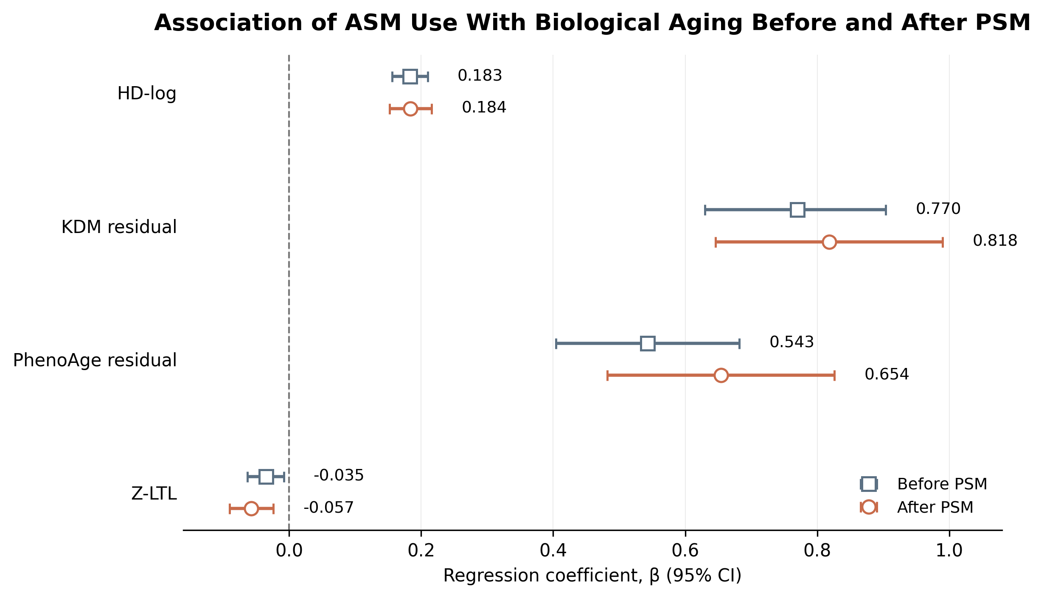
Fig. S1 Association between ASM use and biological aging indicators before and after propensity score matching. Forest plots show adjusted β coefficients and 95% CIs for HD-log, KDM residual, PhenoAge residual, and Z-LTL. Squares indicate estimates before matching and circles estimates after matching. Models were adjusted for age, sex, race/ethnicity, Townsend Deprivation Index, epilepsy status, smoking status, and alcohol intake.

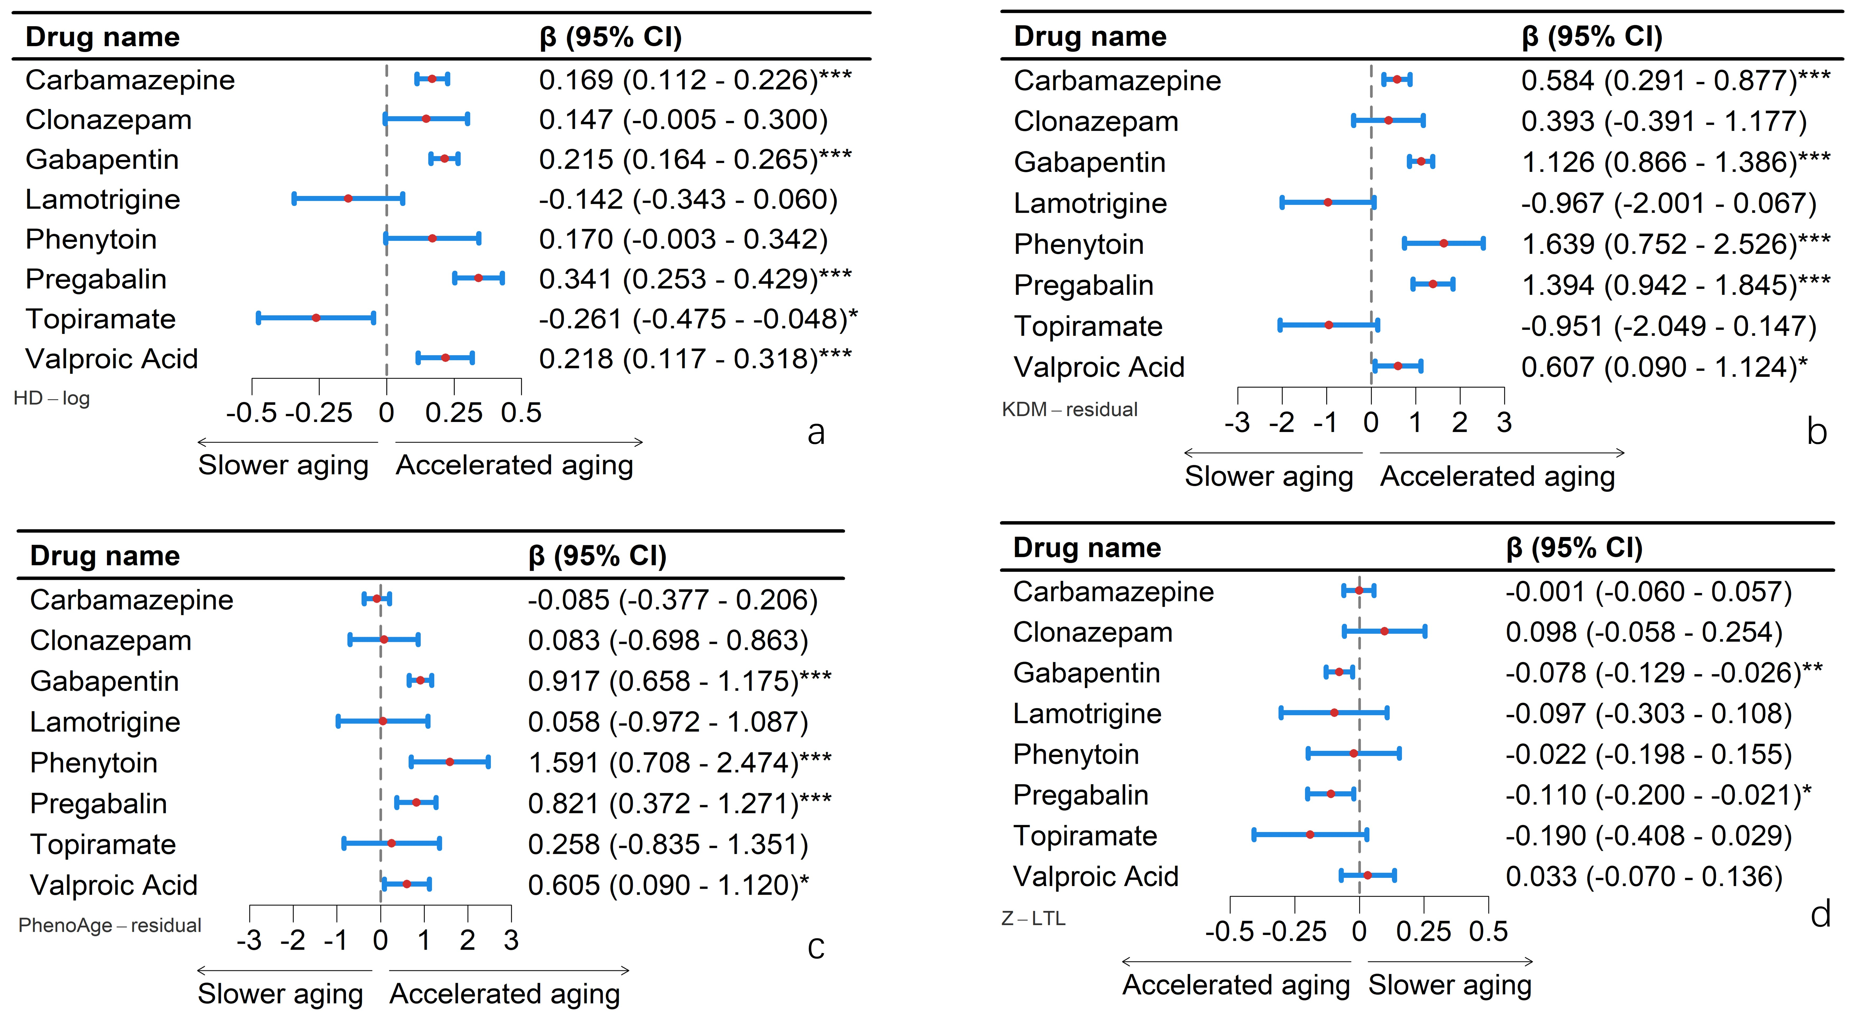

Fig. S2 Associations of individual ASM monotherapies with biological aging indicators before propensity score matching. Forest plots show adjusted β coefficients and 95% CIs comparing each monotherapy group with non-users. Positive coefficients indicate higher HD-log, KDM residual, or PhenoAge residual; negative coefficients for Z-LTL indicate shorter telomeres. Models were adjusted for age, sex, race/ethnicity, Townsend Deprivation Index, epilepsy status, smoking status, and alcohol intake.

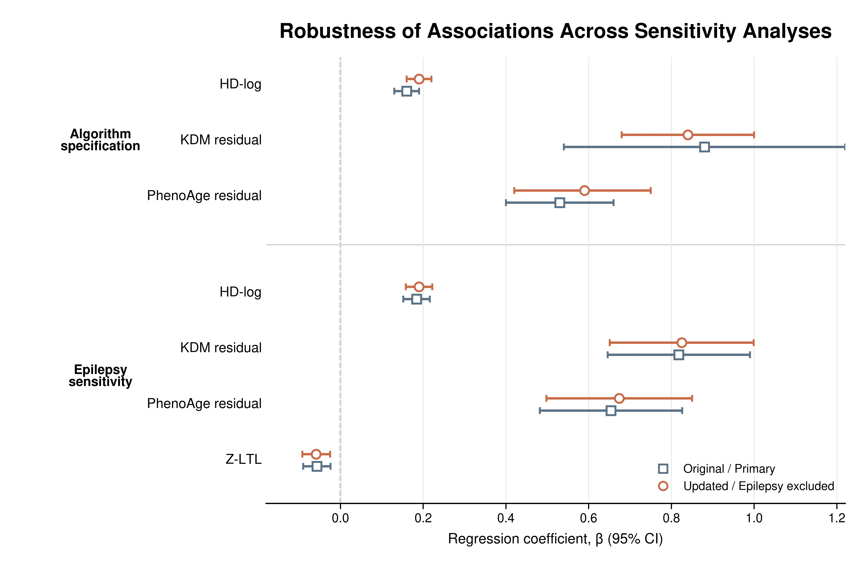

Fig. S3 Sensitivity analyses of associations between ASM use and biological aging indicators. Forest plots compare estimates from original and updated biological aging algorithms and from the primary and epilepsy-excluded analyses. Points indicate β coefficients and horizontal lines 95% CIs; the vertical dashed line indicates the null value (β = 0).

