Supplementary Information for
Ultrafast Dynamics of Pressure‑Activated Energy Funneling and Amplified Spontaneous Emission in Microscale Quasi-2D Perovskites

Shuaiqi Li‡, Linrui Li‡, Haiyang Hu, Xin Tang, Mingyu Pi, Yexiong Huang, Jingwen Yao, Haiyang Xu, Laizhi Sui*, Qing Zhang*, Zhenxiang Cheng*, Dingke Zhang*

¹ School of Physics and Optoelectronic Engineering, Chongqing Normal University, Chongqing 4 01331, China.
² State Key Laboratory of Molecular Reaction Dynamics and Dalian Coherent Light Source, Dalian Institute of Chemical Physics, Chinese Academy of Sciences, Dalian 116023, China.
³ State Key Laboratory of Integrated Optoelectronics, Northeast Normal University, Changchun 130024, China.
⁴ School of Materials Science and Engineering, Peking University, Beijing 100871, China.
⁵ Institute for Superconducting and Electronic Materials Faculty of Engineering and Information Sciences, University of Wollongong Innovation Campus, Squires Way, North Wollongong, NSW 2500, Australia.
‡These authors contributed equally to this work
* Corresponding author.

E-mail: lzsui@dicp.ac.cn, q_zhang@pku.edu.cn, cheng@uow.edu.au, zhangdk@cqnu.edu.cn

Keywords: quasi-2D perovskites, ASE, high-pressure, energy funneling, carrier dynamics

Experiment details
Sample preparation
Phenylethylammonium bromide (PEABr, 99.5% purity), formamidinium bromide (FABr, 99.9% purity), and lead bromide (PbBr₂, 99.99% purity) were procured from Xi’an Yuri Solar Co., Ltd. and used without further purification. The precursor solution was prepared by dissolving PEABr (55.3 mg), PbBr₂ (150.6 mg), and FABr (34.2 mg) in a molar ratio of 2:3:2 into 1 mL of methylacetate acetate (MAAc), followed by stirring at 60 ℃ for 8 hours to achieve a clear and homogeneous mixture. The protective layer was carefully removed from the PET film, after which the film was subjected to UV-ozone treatment for 30 minutes. Herein, (PEA)₂FA_{n-1}Pb_{n}Br_{3n+1} thin film was fabricated via a one-step spin-coating method under ambient air conditions. A volume of 150 μL of the (PEA)₂FA_{n-1}Pb_{n}Br_{3n+1} precursor solution (240 mg mL⁻¹) was spin-coated onto the PET substrate at 5000 rpm for 20 s to ensure uniform distribution. The substrate temperature was maintained constant at 70 ℃ throughout the spin-coating process. Subsequently, the film was annealed at 150 ℃ for 10 min to complete the fabrication.
Bulk PEA₂FAPb₂Br₇ single crystals were grown in HBr solution via the space-confined liquid-phase (STL) method. Specifically, PEABr (154.8 mg)，FABr (47.8 mg) and PbBr₂ (281.2 mg) were dissolved in 15 mL of HBr. The solution was heated to 90 ℃ and maintained at this temperature for 24 hours to ensure complete dissolution of the precursors. It was then gradually cooled to 65 ℃ at a rate of 1 ℃ h⁻¹, followed by further slow cooling to 25 ℃ at a rate of 0.1 ℃ h⁻¹, yielding high-quality bulk PEA₂FAPb₂Br₇ single crystals.
Sample characterizations
The structural properties of the (PEA)₂FA_{n-1}Pb_{n}Br_{3n+1} thin films and PEA₂FAPb₂Br₇ single crystals were characterized by X-ray diffraction (XRD) using a Rigaku D/MAX2500PC diffractometer with Cu Kα radiation source (λ = 0.15406 nm). Steady-state photoluminescence (PL) spectrum and steady-state absorption spectrum were acquired using an integrated micro-spectroscopy system (Gora-UVN-FL, Ideaoptics, China) equipped with 405 nm excitation laser and Halogen light source. The morphologies of the perovskite films were examined using SEM (TESCAN, MIRA3).
In situ high-pressure characterizations
High-pressure experiments were performed using a symmetrical diamond anvil cell (DAC) equipped with ultra-low fluorescence type II-a diamond anvils possessing a culet size of 800 μm. The sample was loaded into a chamber (approximately 400 μm in diameter and 30 μm in thickness) drilled at the center of a T301 stainless-steel gasket. Dimethylsilicone oil (viscosity 1000 ± 80 mPa·s, Macklin) was employed as the pressure-transmitting medium. Ruby spheres were co-loaded with the sample as a pressure calibrant, and the R1 fluorescence line was monitored for in situ pressure determination.
In Situ high-pressure ASE measurements were performed using a solid-state Nd:YAG laser (minite II Q-switched Nd:YAG) operating at a wavelength of 355 nm. The laser generated pulses with a duration of 7 nanoseconds at a repetition rate of 10 Hz. The pump energy was precisely quantified using a calibrated laser power and energy meter (Gentec). In situ steady-state high-pressure PL spectrum and in situ steady-state high-pressure absorption spectrum were characterized using the mcro-spectroscopy system described as above. In situ high-pressure Raman spectrum experiments was carried out on the Raman spectrophotometer that previously mentioned. In Situ Raman spectra were acquired using a 633 nm laser source through an integrated Raman spectrophotometer (LabRAM HR, Horiba, Japan). In situ high-pressure angle-dispersive X-ray diffraction (ADXRD) experiments were conducted at the BL15U1 beamline of the Shanghai Synchrotron Radiation Facility (SSRF). A pair of Kirkpatrick–Baez mirrors were employed to focus the monochromatic X-ray beam (wavelength = 0.6199 Å) onto the sample spot. In Situ high-pressure Transient Absorption Measurements were performed using a pump–probe spectroscopy system driven by a regenerative amplified Ti:sapphire laser system (Coherent Legend Elite HE+USP-1K-III, 35 fs, 1 kHz). The 355 nm pump pulses were generated by frequency conversion of a portion of the fundamental output through an optical parametric amplifier (OPA). A broadband probe pulse (400–800 nm) was produced by focusing the 800 nm laser pulse into a CaF₂ crystal. The temporal delay between the pump and probe pulses was controlled by a motorized linear delay stage. The pump and probe beams were spatially overlapped at the sample, which was enclosed in a diamond anvil cell. Changes in the transmitted probe light were detected using a fiber-coupled spectrometer (AvaSpec-ULS2048CL-EVO, Avantes).

Supplementary Figures
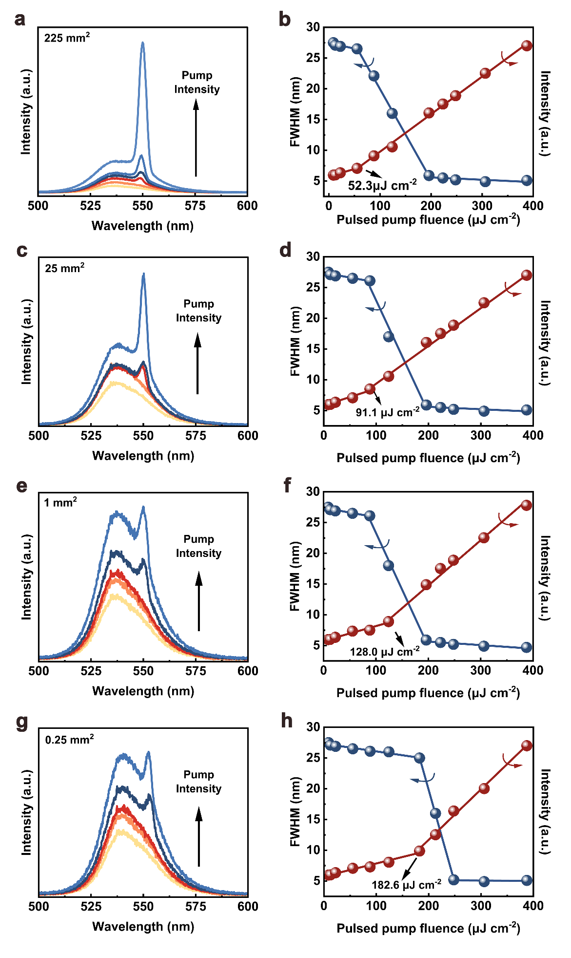
Fig. S1 Power-dependent emission spectra and output intensity and FWHM versus the pumped density of different film size.

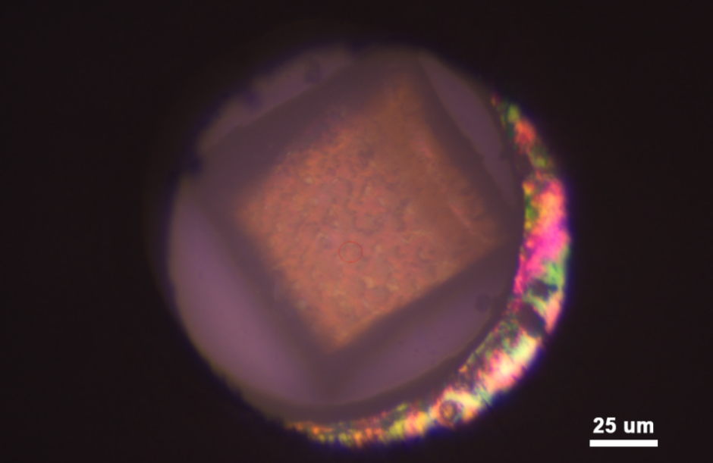
Fig. S2 Optical micrograph of (PEA)₂FA_{n-1}Pb_{n}Br_{3n+1} thin film in a DAC.

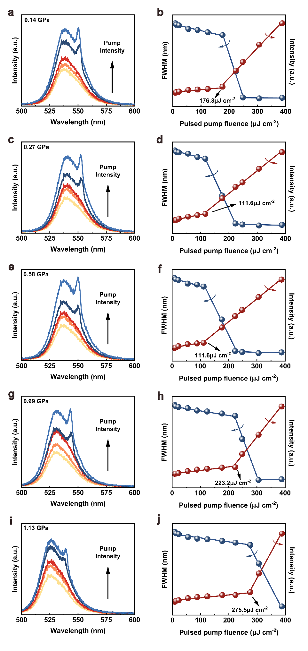
Fig. S3 Power-dependent emission spectra and output intensity and FWHM versus the pumped density at different pressure.
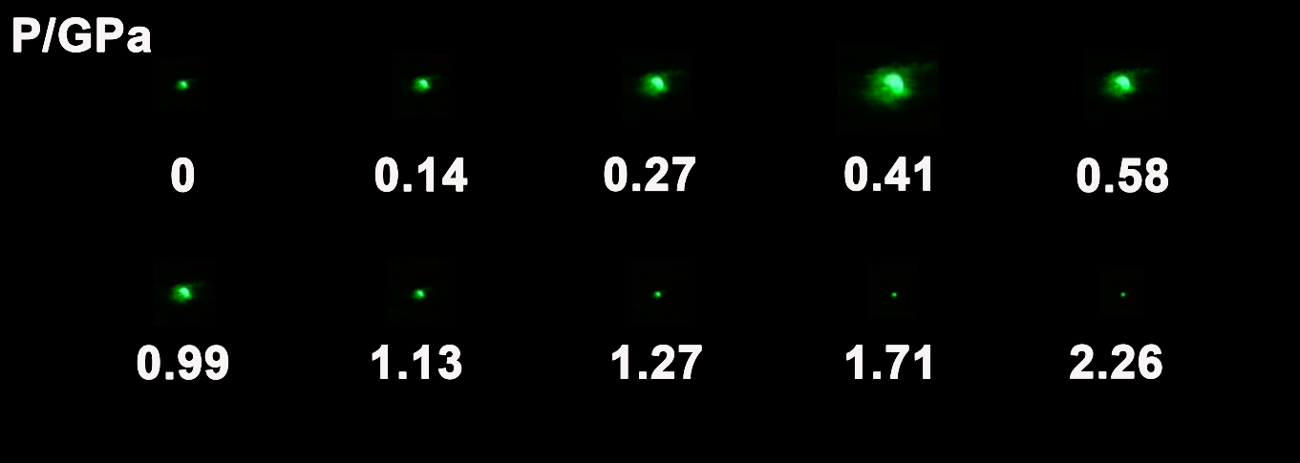
Fig. S4 PL micrographs of (PEA)₂FA_{n-1}Pb_{n}Br_{3n+1} thin film upon compression.

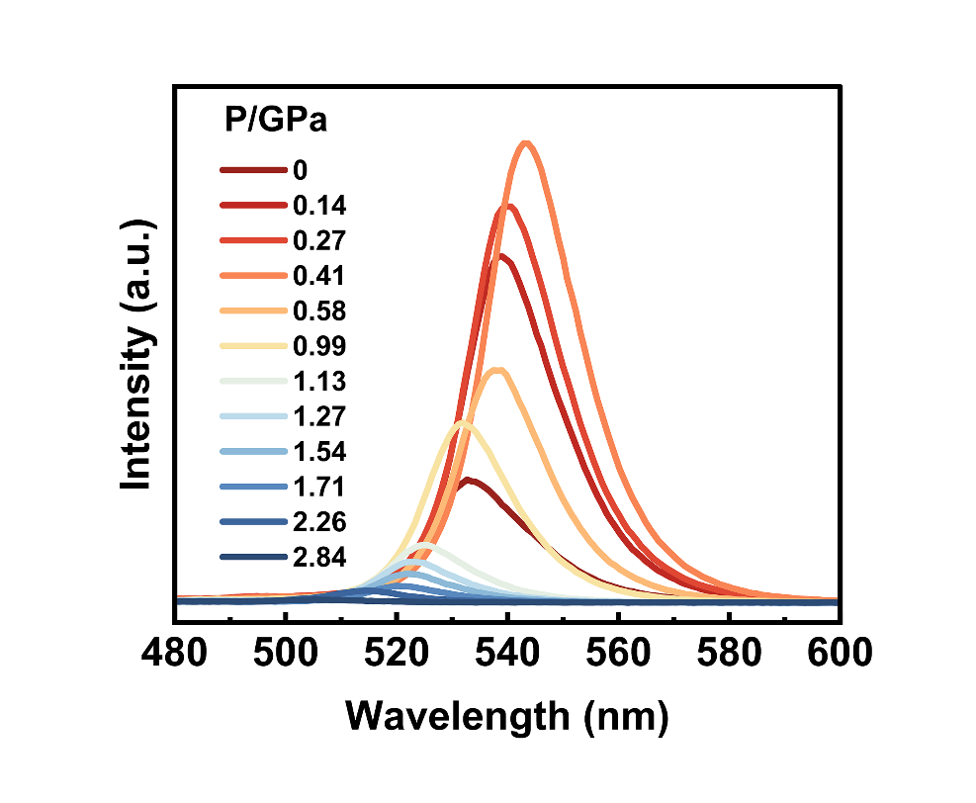
Fig. S5 Pressure-dependent PL spectra of (PEA)₂FA_{n-1}Pb_{n}Br_{3n+1} thin film upon compression.

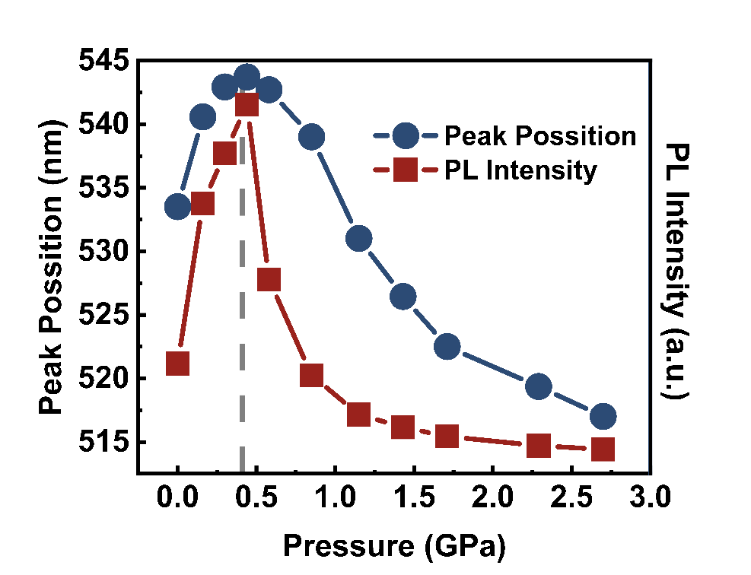
Fig. S6 Evolution of PL peak position and intensity of (PEA)₂FA_{n-1}Pb_{n}Br_{3n+1} thin film with applied pressure.

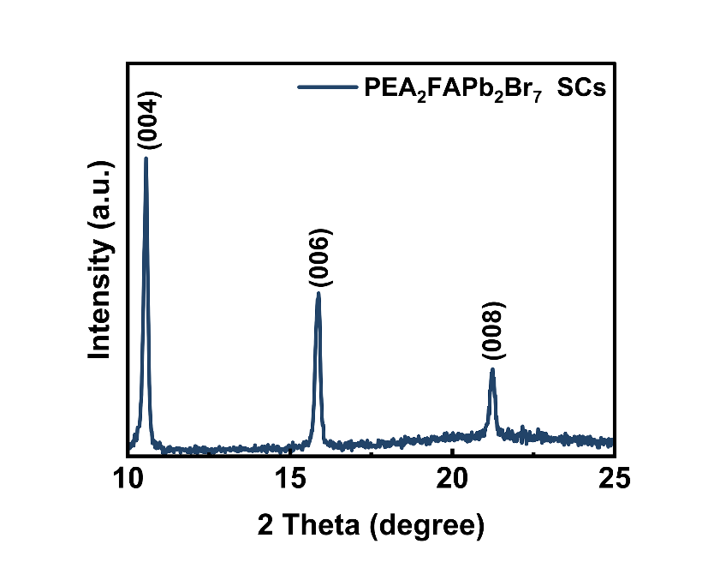
Fig. S7 XRD spectra of PEA₂FAPb₂Br₇ single crystals.

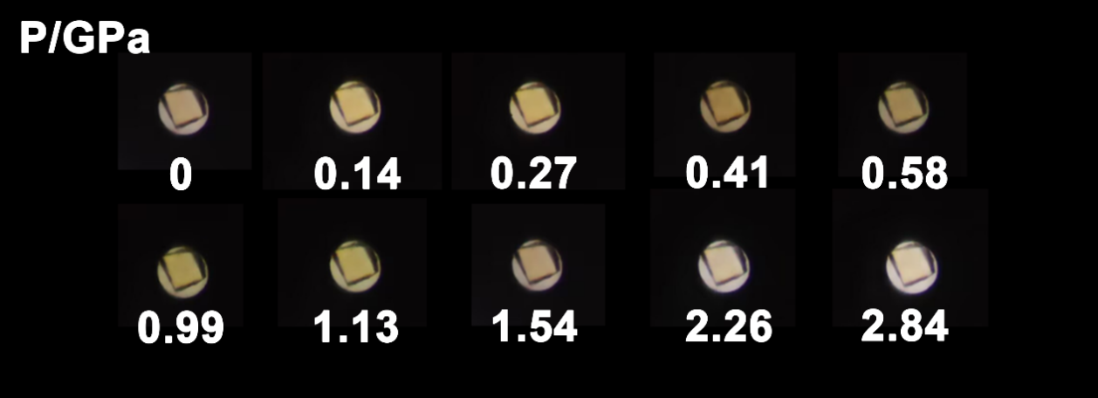
Fig. S8 Optical micrograph of (PEA)₂FA_{n-1}Pb_{n}Br_{3n+1} thin film in a DAC at selected pressure.

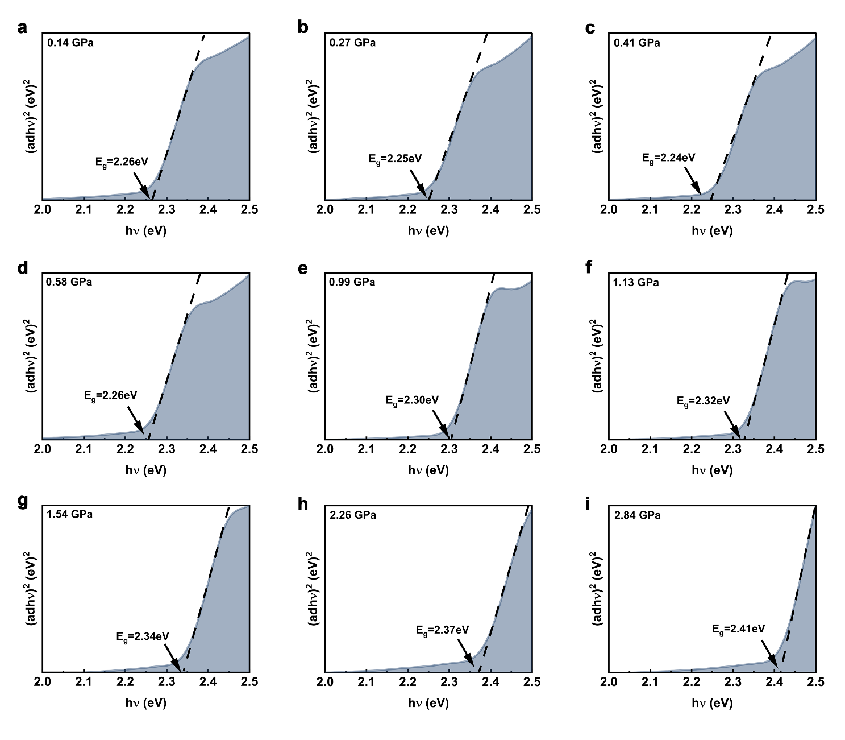
Fig. S9 Direct bandgap Tauc spectra of (PEA)₂FA_{n-1}Pb_{n}Br_{3n+1} thin film at different pressure.

Table. S1 Pressure coefficients (dω /dP, cm⁻¹/GPa) of the observed Raman modes in the low-pressure (0~0.41 GPa) and high-pressure (>0.41 GPa) regimes.
Raman modes (cm⁻¹) | dω /dP (cm⁻¹/GPa)
Raman modes (cm⁻¹) | 0~0.41 GPa | >0.41 GPa
159 | 8.2 | 7.7
189 | 8.8 | 8.6
489 | 8.7 | 8.4
710 | 8.2 | 7.5
2906 | 14.5 | 7.9
2966 | 19.2 | 9.1

