Supplemental information for:

Coupled structural evolution and elemental redistribution in zigzag Pt₃Fe nanowires revealed by in situ electrochemical liquid-cell TEM
Meng Li¹†, Jiawei Wan^{2,3}†, Ershuai Liu^{4,5}†, Xuan Hu⁶, Jiana Zheng^{2,3}, Kim Kisslinger¹, Walter S. Drisdell^{3,4}, Shaofan Li⁶, Fang Lu¹, Haimei Zheng^{2,3*}, Judith C. Yang^{1*}
1. Center for Functional Nanomaterials, Brookhaven National Laboratory, Upton, 11973, USA.
2. Department of Materials Science and Engineering, University of California, Berkeley, Berkeley, CA, 94720, USA.
3. Materials Sciences Division, Lawrence Berkeley National Laboratory, Berkeley, CA, 94720, USA.
4. Chemical Sciences Division, Lawrence Berkeley National Laboratory, Berkeley, CA, 94720, USA.
5. Liquid Sunlight Alliance, Lawrence Berkeley National Laboratory, Berkeley, CA, 94720, USA.
6. Department of Civil and Environmental Engineering, University of California, Berkeley, Berkeley, CA, 94720, USA.

*Corresponding authors. Emails: hmzheng@lbl.gov; jyang1@bnl.gov
†These authors contributed equally to this work.

Movie Captions
Movie S1: Operando EC-TEM observation of spatially heterogeneous morphological evolution of zigzag Pt₃Fe nanowires during HER. The corresponding electrochemical current was measured under a constant applied potential of V_{Pt} = -0.4 V.
Movie S2: Enlarged, drift-corrected view of a nanowire in movie S1, showing the spatially heterogenous morphological evolution of the zigzag Pt₃Fe nanowire during periods of reduced liquid thickness due to H₂ bubble formation.
Movie S3: Operando EC-TEM observation of nanoparticle nucleation and growth on zigzag Pt₃Fe nanowires during HER. The corresponding electrochemical current was measured under a constant applied potential of V_{Pt} = -0.4 V.
Movie S4: Enlarged, drift-corrected view of a nanowire section in movie S3 showing nanoparticle nucleation and growth on the zigzag Pt₃Fe nanowire during periods of reduced liquid thickness due to H₂ bubble formation.
Movie S5: Three-dimensional electron-tomography reconstruction of the zigzag Pt₃Fe nanowire. The reconstructed volume is viewed from different orientations, revealing the thin, plate-like three-dimensional morphology of the zigzag nanowire.

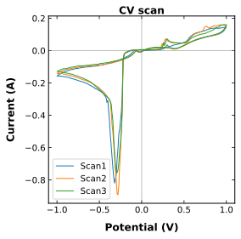
Figure S1| Cyclic voltammetry (CV) measurement of the Pt3Fe nanowire prior to the HER experiment. Three consecutive CV scans were acquired after stabilization of the electrolyte flow and electrical contact in 0.1 M KHCO₃. The reproducible cathodic response observed across the three scans was used to select the applied potential for the subsequent in situ EC-TEM experiment. A constant potential of V_{Pt}= -0.4 V was applied to the working electrode during operando imaging.

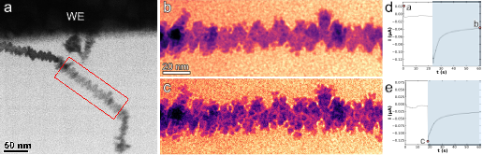
Figure S2| In situ ECTEM observation of nanoparticle growth during liquid rewetting. (a) EC-TEM image showing the location of the analyzed nanowire segment, marked by the red box. (b,d) Nanowire morphology (b) and corresponding electrochemical current (d) during the first HER period, immediately before liquid rewetting. (c,e) The same nanowire segment (c) and corresponding electrochemical current (e) during the second HER period following rewetting. Image (c) was acquired after an intervening 18 s reaction period in the rewetted, thicker liquid layer, followed by the formation of another H₂ bubble that locally thinned the liquid layer. Pronounced growth of the pre-existing surface nanoparticles between the two HER periods indicates that substantial particle growth occurred during the intervening period of increased liquid thickness.

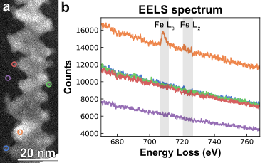
Figure S3|EELS characterization of the post reaction Pe₃Fe nanowire. (a) HAADF-STEM image of the post-reaction nanowire. Colored circles indicate the locations where EELS spectra were acquired. (b) EELS spectra collected from the corresponding locations. Pronounced Fe L₃ and Fe L₂ edges are observed only for the spectrum acquired from the nanowire substrate (orange), whereas no detectable Fe signal is observed from the newly formed surface nanoparticles, consistent with the Pt-rich composition revealed by EDX mapping.
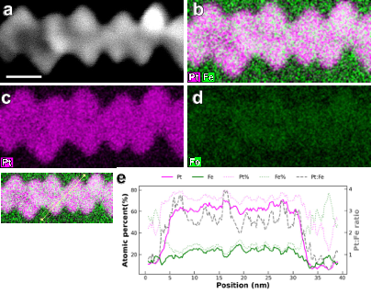
Figure S4| STEM-EDS characterization of a post reaction Pe₃Fe nanowire not connected to the electrode. (a-d) HAADF-STEM image and corresponding EDS maps of Pt+Fe, Pt and Fe maps of the post-reaction nanowire. Scale bar: 10 nm. (e) EDS line profile showing the atomic concentration across the nanowire. The Pt:Fe atomic ratio remains approximately 3:1, consistent with the as-synthesized Pt₃Fe nanowire. No detectable compositional segregation or Fe depletion is observed, indicating that the structural and compositional changes observed in electrically connected nanowires are induced by the electrochemical reaction rather than by exposure to the liquid environment.
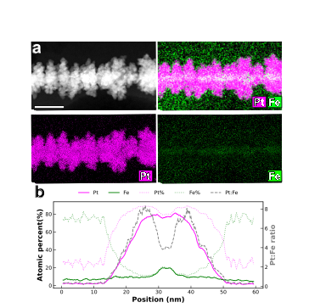
Figure S5| STEM-EDS characterization of the post-reaction Pe₃Fe nanowire on the electrode after prolonged HER. (a) HAADF-STEM image and corresponding EDS maps of Pt+Fe, Pt and Fe maps of the post-reaction nanowire. Scale bar: 20 nm. (b) EDS line profile showing the atomic concentration across the nanowire. Compared with the initial Pt₃Fe composition, prolonged electrochemical reaction results in extensive Fe leaching to the surroundings and the formation of a Pt-rich surface, consistent with the progressive surface restructuring observed by in situ EC-TEM.

Table S1. Summary of EXAFS fitting results for Pt₃Fe samples at various applied potentials vs. RHE in N₂-saturated 0.1 M KHCO₃ electrolyte.
Sample | Pt-Pt |  |  | Pt-Fe |  |  | E₀  (eV) | R factor
Sample | N_{Pt-Pt} | R_{Pt-Pt} | σ²_{Pt-Pt} (x10⁻³) | N_{Pt-Fe} | R_{Pt-Fe} | σ²_{Pt-Fe}  (x10⁻³) | E₀  (eV) | R factor
Pt foil | 12(fixed) | 2.764±0.002 | 4.6±0.3 | - |  |  | 7.8±0.4 | 0.008
pristine | 9.3±0.7 | 2.739±0.002 | 5.1±0.3 | 2.0±0.2 | 2.700±0.008 | 5.1±0.3 | 8.1±0.4 | 0.004
OCV | 9.6±1.2 | 2.744±0.004 | 5.1±0.6 | 1.8±0.3 | 2.703±0.015 | 4.8±0.8 | 8.4±0.7 | 0.016
0.54V | 10.1±1.0 | 2.740±0.003 | 5.6±0.4 | 1.6±0.3 | 2.696±0.012 | 5.6±0.4 | 8.2±0.5 | 0.009
0.24V | 9.7±1.1 | 2.747±0.004 | 4.8±0.5 | 1.7±0.3 | 2.690±0.013 | 4.5±0.8 | 8.4±0.6 | 0.013
-0.2V | 10.6±1.3 | 2.746±0.004 | 5.7±0.6 | 1.5±0.3 | 2.689±0.017 | 5.7±0.6 | 8.5±0.7 | 0.015

Figure S6|In situ FT-EXAFS spectra of Pt₃Fe nanowire samples at the K space and their fits collected at (a) pristine, (b) OCV, (c) 0.54V, (d) 0.24V and (e) -0.2V in N₂-satured 0.1M KHCO₃. Fits are performed at the Pt L₃ edge in R space, k^{1,2,3} weighting. 1.239<R<3.348 Å and Δk=3.144 – 13.808 Å⁻¹ were used for fitting. S₀² was fixed at 0.802 as obtained by the corresponding Pt reference foil.

Figure S7| In situ FT-EXAFS spectra of Pt₃Fe nanowire samples at the R space and their fits collected at (a) pristine, (b) 0.54V, and (c) 0.24V in N₂-satured 0.1M KHCO₃. Fits are performed at the Pt L₃ edge in R space, k^{1,2,3} weighting. 1.239<R<3.348 Å and Δk=3.144 – 13.808 Å⁻¹ were used for fitting. S₀² was fixed at 0.802 as obtained by the corresponding Pt reference foil.

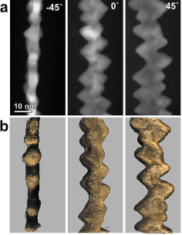
Figure S8| Electron tomography of the zigzag Pt₃Fe nanowire. (a) Representative HAADF-STEM images of the tilt-series acquired at -45˚, 0˚ and 45˚. (b) Corresponding views of the three-dimensional reconstruction at the same viewing angles. The reconstructed morphology reproduces the projection-dependent shape observed in the experimental HAADF-STEM images, supporting the fidelity of the 3D reconstruction. The reconstructed volume reveals a thin, plate-like three-dimensional morphology rather than a spiral-like structure. Scale bar: 10 nm.
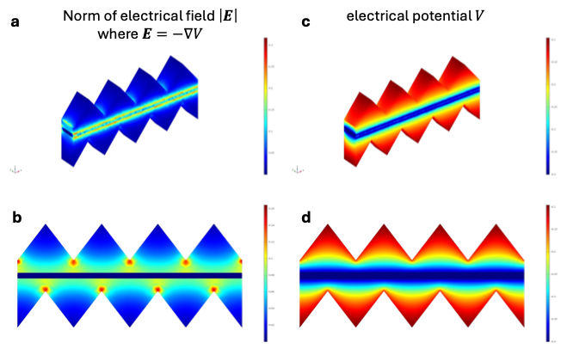
Figure S9| Electrostatic simulation of the zigzag Pt₃Fe nanowire. (a,b) 3D view (a) and cross-sectional slice (b) of the simulated electric-field magnitude. (c,d) 3D view(c) and cross-sectional slice (d) of the corresponding electric potential distribution. The electric-field magnitude exhibits pronounced localized enhancement at the high-curvature concave valleys of the zigzag nanowire, whereas the electric potential is highest near the outer convex tips of the zigzag morphology. Together, the simulations reveal a spatially heterogeneous electrostatic environment associated with the zigzag morphology.

