Supplement

Microbiota as a biomarker of tuberculosis treatment response: association with clinical history, inflammation and outcome

Table of Contents

Supplementary methods 2
Definitions 2
Pairwise α-diversity changes 2
Differential abundance testing 2
Supplementary results 3
Supplementary Table 1. Baseline β-diversity differences between cases and close contacts adjusted for demographic and clinical factors. 3
Supplementary Table 2. α- and β-diversity changes in cases and close contacts who did not report recent non-TB antibiotic use reflect patterns observed in the overall cohort. 4
Supplementary Figure 1. Number of participants and samples per time point. 5
Supplementary Figure 2. Pre-treatment α-diversity differences in cases versus close contacts 6
Supplementary Figure 3. Sputum microbiota differences in cases versus close contacts at months 6 and 18 7
Supplementary Figure 4. β-diversity over time in close contacts. 8
Supplementary Figure 5. Longitudinal trajectories of Clostridiales ASVs in stool of cases and close contacts 9
Supplementary Figure 6. Stool microbiota differences in cases versus close contacts at months 6 and 18 10
Supplementary Figure 7. Cytokines and soluble markers which are elevated in cases at baseline declines with treatment 11
Supplementary Figure 8. Residual cytokine expression in cases at month 18 12
Supplementary Figure 9. Significant microbiota-cytokine correlations in sputum and stool 13
References 14

Supplementary methods

Definitions
A close contact is a person who shared an enclosed space (i.e., household, congregate setting, workplace or social gathering place) for >15 min over a period of 24 h with the case. Close contacts were culture-negative or, if culture-contaminated, Xpert and/or Ultra-negative on a paired sputum and asymptomatic by WHO criteria.

Pairwise α-diversity changes
We compared α-diversity using two approaches: 1) between the index case and each contact (individual measures) and 2) between the index case and the mean of their contacts (aggregated measures) (Supplementary Figure 2). Within-group comparisons of α-diversity (restricted to participants with complete data) across time points were also done using the Friedman test with Dunn’s post-hoc correction.

Differential abundance testing
Differential abundance analysis was performed using edgeR on unrarefied count data, where counts were normalised using the trimmed mean of M-values (TMM) method. P-values were adjusted for multiple testing using the Benjamini–Hochberg false discovery rate (FDR) correction¹, and taxa with FDR-adjusted p-values <0.2 were considered statistically significant².

Supplementary results

Supplementary Table 1. Baseline β-diversity differences between cases and close contacts adjusted for demographic and clinical factors. β-diversity remained significant after individually adjusting for age, sex, HIV status, previous TB, TB severity, nicotine dependence, and alcohol use, indicating this difference was not attributable to these factors.

Model | Covariate R² | Covariate p | Group R² | Group p | n
Sputum
Unadjusted | - | - | 0.009 | 0.007 | 268
+ Age | 0.013 | 0.001 | 0.008 | 0.012 | 268
+ Sex | 0.004 | 0.299 | 0.008 | 0.006 | 268
+ HIV | 0.006 | 0.054 | 0.008 | 0.005 | 256
+ Prior TB | 0.004 | 0.422 | 0.008 | 0.023 | 258
+ TBScore II | 0.005 | 0.266 | 0.008 | 0.021 | 242
+ Fagerström | 0.011 | 0.001 | 0.009 | 0.004 | 268
+ AUDIT | 0.006 | 0.089 | 0.009 | 0.007 | 268
Stool
Unadjusted | - | - | 0.012 | 0.001 | 257
+ Age | 0.007 | 0.014 | 0.012 | 0.001 | 257
+ Sex | 0.008 | 0.011 | 0.013 | 0.001 | 257
+ HIV | 0.005 | 0.146 | 0.011 | 0.001 | 243
+ Prior TB | 0.005 | 0.136 | 0.011 | 0.002 | 247
+ TBScore II | 0.005 | 0.289 | 0.010 | 0.003 | 241
+ Fagerström | 0.006 | 0.027 | 0.013 | 0.001 | 257
+ AUDIT | 0.003 | 0.641 | 0.012 | 0.001 | 257
“Group” denotes cases versus close contacts
"+" denotes the unadjusted model with the addition of the specified covariate

Supplementary Table 2. α- and β-diversity changes in cases and close contacts who did not report recent non-TB antibiotic use reflect patterns observed in the overall cohort. Approximately 19% (11/59) of cases reported non-TB antibiotic use within six weeks of enrolment (consistent with a programmatic “trial-by-antibiotics”³) compared with 7% (13/179) of close contacts. To assess whether the observed changes in sputum and stool microbiota were attributable to TB treatment rather than antibiotic exposure, we excluded participants reporting recent non-TB antibiotic usage and re-assessed α- and β-diversity changes over time. Results were consistent with the main analysis (Figures 2 and 3), showing observed microbiota changes reflect TB treatment rather than confounding by non-TB antibiotic use.

 | Overall | Month 2* | Month 6* | Month 12* | Month 18*
Cases
Sputum α-diversity | <0.001 | 0.005 | >0.999 | >0.999 | >0.999
Sputum β-diversity | 0.001 | 0.001 | 0.001 | 0.074 | 0.102
Stool α-diversity | <0.001 | <0.001 | 0.011 | 0.968 | >0.999
Stool β-diversity | 0.001 | 0.001 | 0.002 | 0.001 | 0.002
Close contacts
Sputum α-diversity | 0.633
Sputum β-diversity | 0.002 |  | 0.135 |  | 0.001
Stool α-diversity | 0.561
Stool β-diversity | 0.854
*p-values are relative to baseline.
Supplementary Figure 1. Number of participants and samples per time point. Not all participants who attended a given visit were able to provide all specimen types.
Supplementary Figure 2. Pre-treatment α-diversity differences in cases versus close contacts. (A) Individual and (B) aggregated comparisons for sputum showing no differences. (C) Individual and (D) aggregated comparisons for stool showing higher α-diversity in cases.
Supplementary Figure 3. Sputum microbiota differences in cases versus close contacts at months 6 and 18. Although α-diversity was similar, β-diversity differed with many differentially abundant taxa in cases versus close contacts.
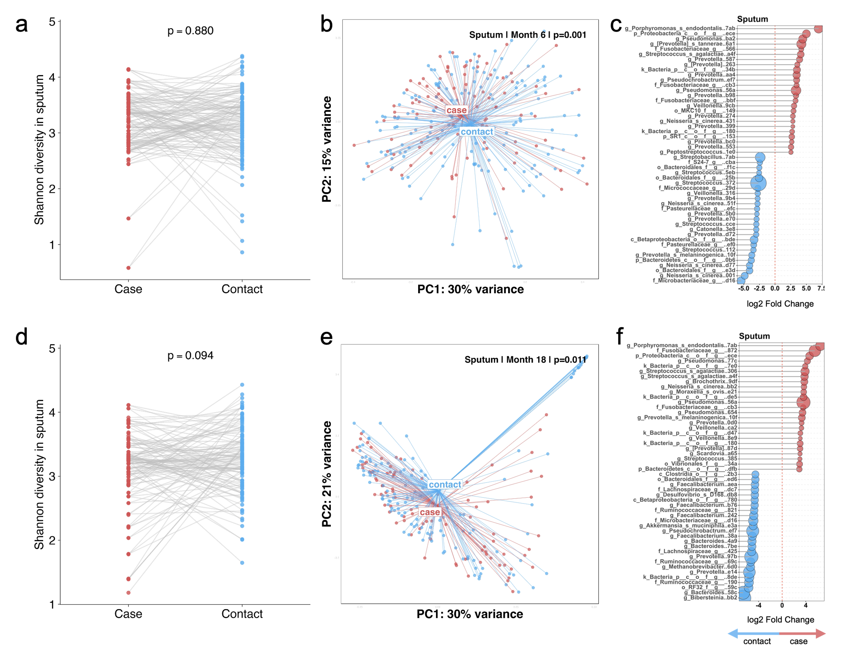

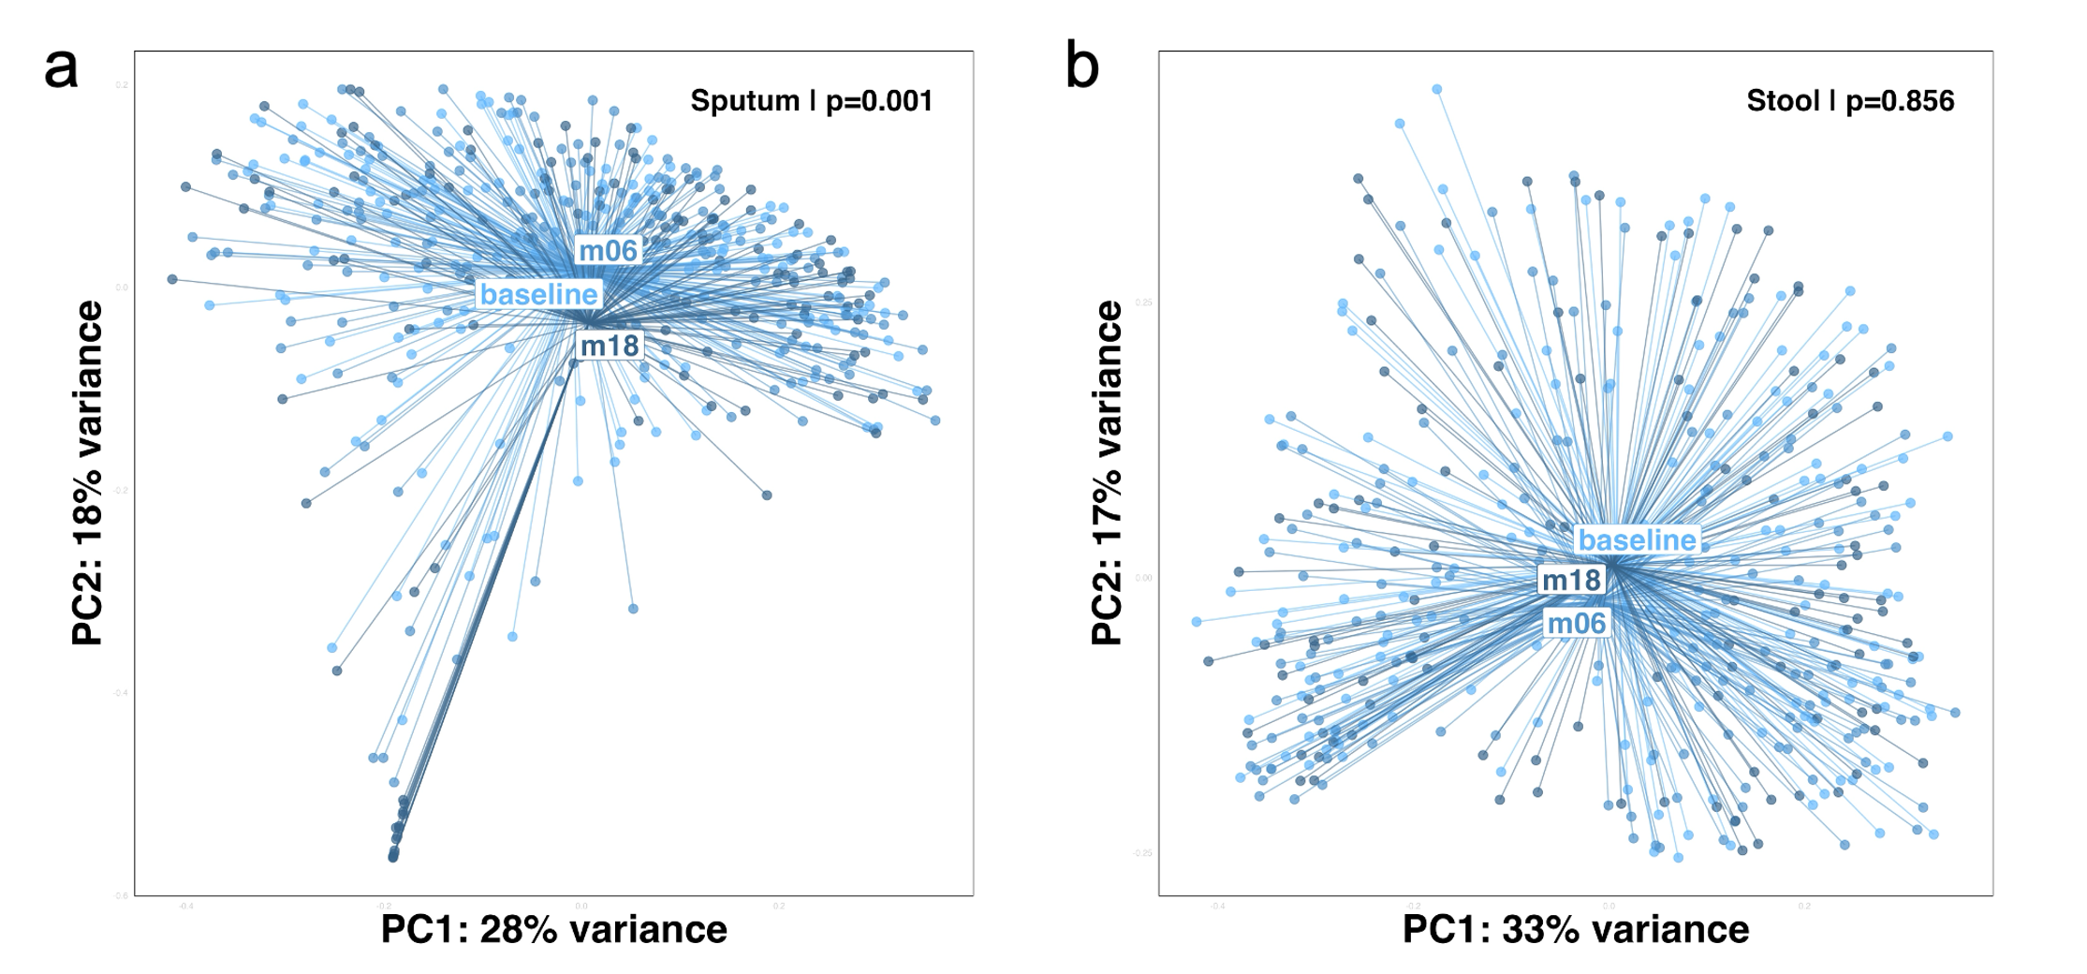
Supplementary Figure 4. β-diversity over time in close contacts.

Supplementary Figure 5. Longitudinal trajectories of Clostridiales ASVs in stool of cases and close contacts. Generalized additive models (GAMs) show relative abundance of seven Clostridiales ASVs over 18 months in cases (red) and close contacts (blue). Shaded bands denote 95% confidence intervals. Baseline p-values test for group differences before treatment; trajectory p-values test for differences over time between groups.

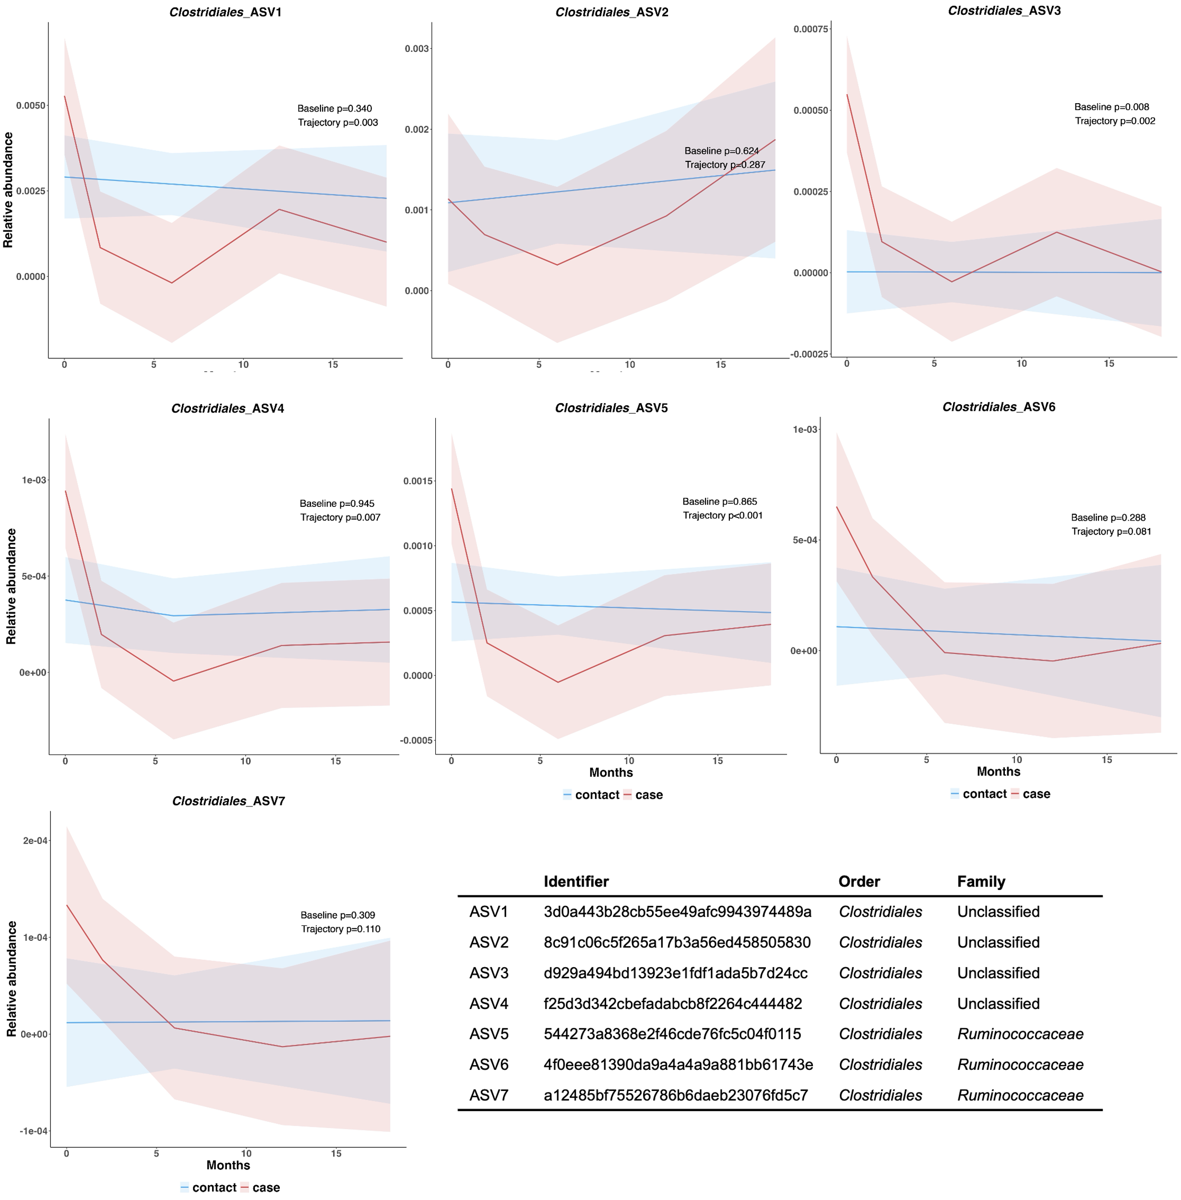

Supplementary Figure 6. Stool microbiota differences in cases versus close contacts at months 6 and 18. α-diversity differed at month 6 only, but β-diversity differed at both timepoints, with cases enriched with Bacteroidales at month 6 and Veillonella parvula at month 18, compared to close contacts.

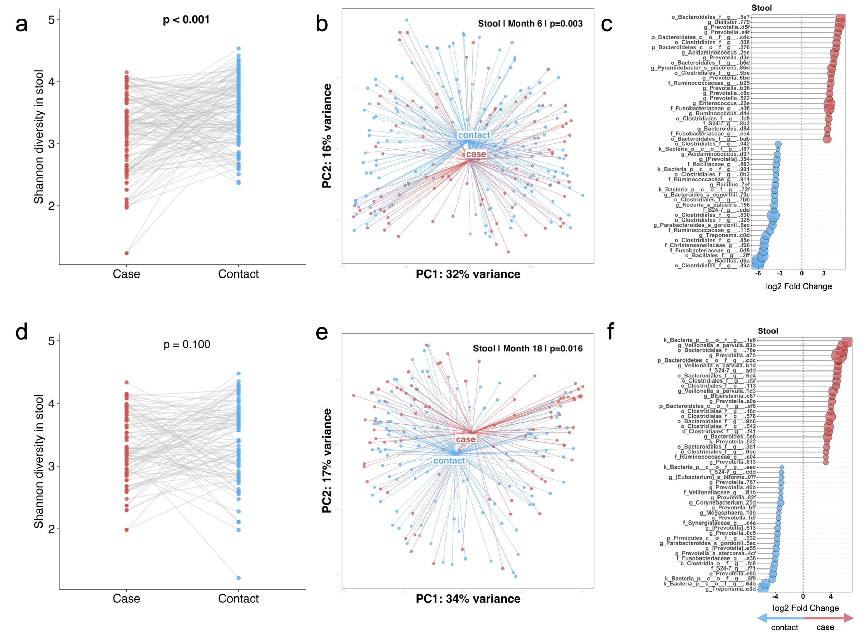
Supplementary Figure 7. Cytokines and soluble markers which are elevated in cases at baseline declines with treatment. (A) Principal component analysis (PCA) of overall expression in cases and close contacts at baseline. Each point represents one individual. (B) Comparison of between groups at baseline. (C) PCA of expression over time in cases. (D) Cases exhibit decreasing trajectories of expression over time.
Supplementary Figure 8. Residual cytokine expression in cases at month 18. Paired cytokine expression for close contacts at baseline and cases at month 18. Each circle represents an individual, and grey lines connect matched pairs. Differences were assessed using Wilcoxon matched-pairs signed-rank test (p<0.05). Cytokine expression was comparable between groups except for IL-4, IL-10, Procalcitonin and TIMP-3.
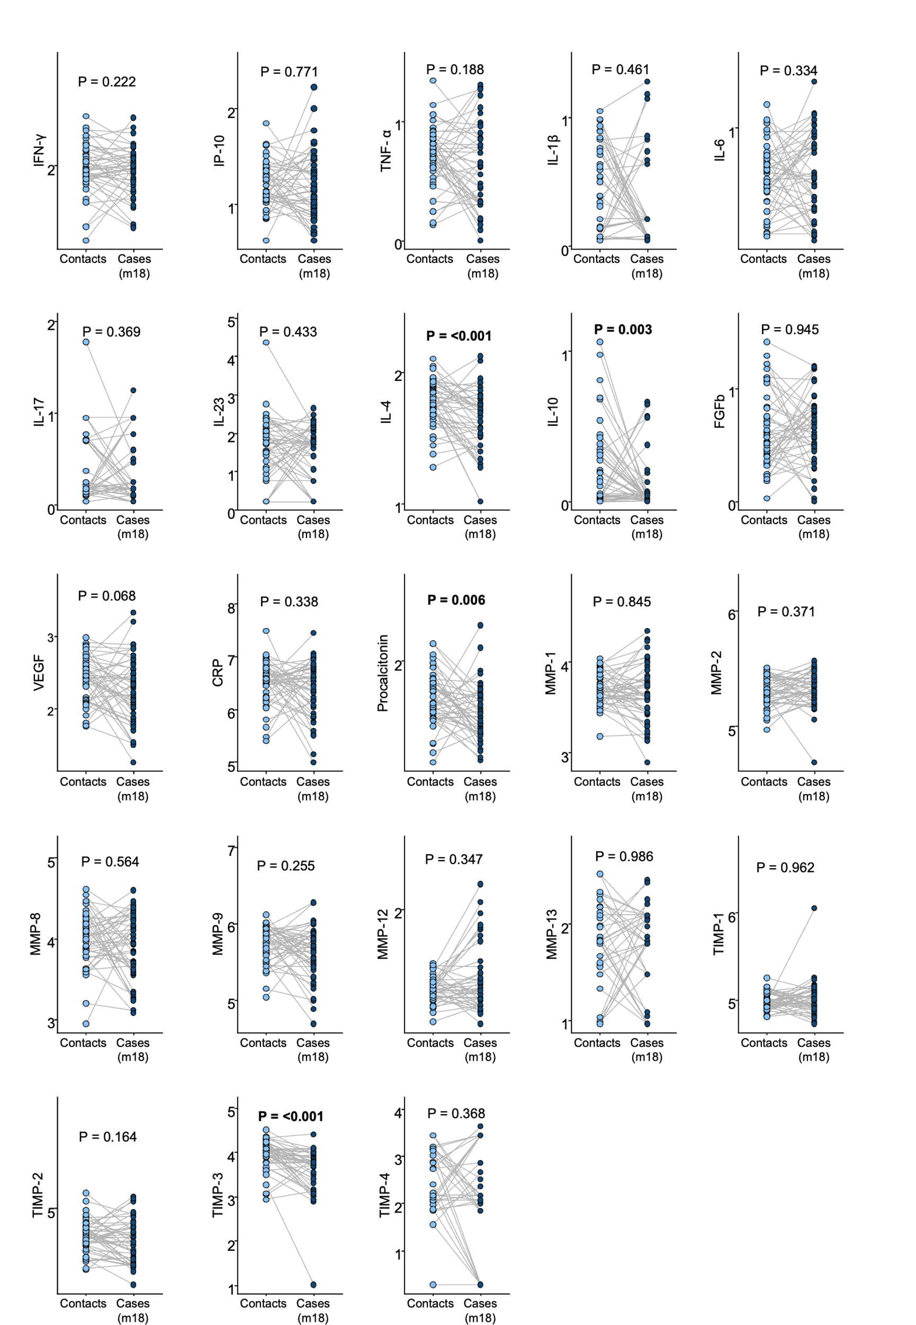
Supplementary Figure 9. Significant microbiota-cytokine correlations in sputum and stool. Correlations based on Spearman’s rank correlations; grey points represent samples; pink line indicates the fitted regression with 95% confidence interval.
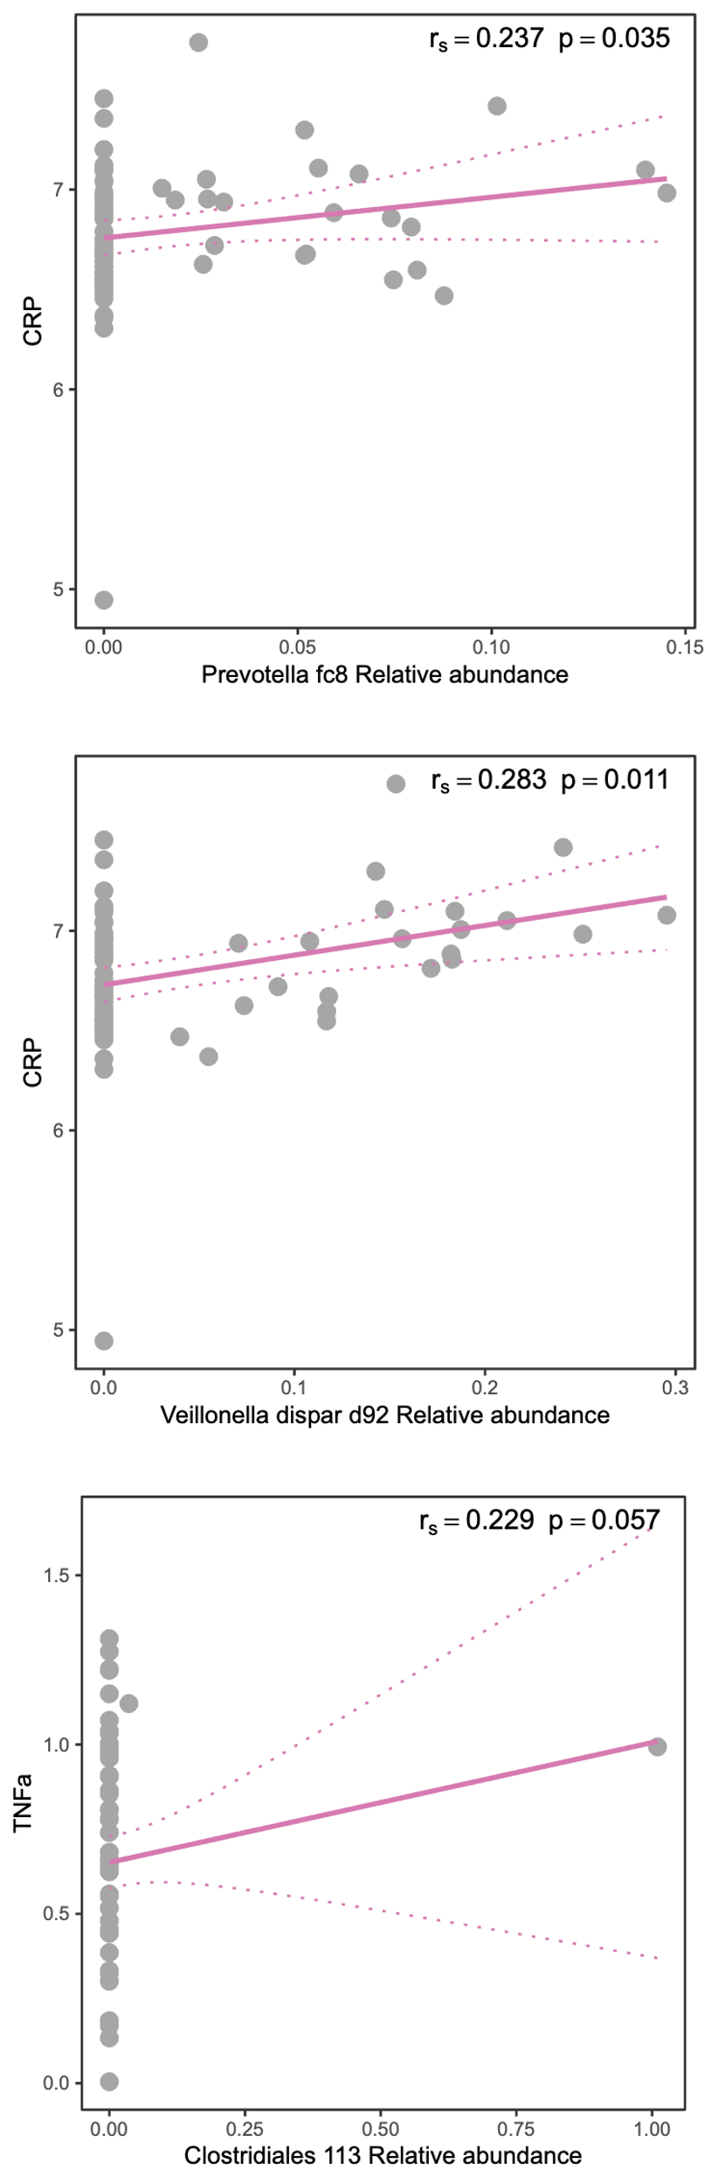

References

1. Reiner A, Yekutieli D, Benjamini Y. Identifying differentially expressed genes using false discovery rate controlling procedures. Bioinformatics 2003; 19(3): 368-75.
2. Seumois G, Zapardiel-Gonzalo J, White B, et al. Transcriptional profiling of Th2 cells identifies pathogenic features associated with asthma. The Journal of Immunology 2016; 197(2): 655-64.
3. Chikovore J, Boffa J, Moyo S, et al. Provider perspectives on empirical antibiotic treatment for tuberculosis-like symptoms in South Africa’s private general practice sector: A qualitative study in two cities. PLOS Global Public Health 2025; 5(6): e0004742.

