Supplementary Material
Study Protocol
Supplementary tables
Supplementary figure
References

Study Protocol
Patients
The study was approved by the Institutional Review Board of the Sixth Affiliated Hospital, Sun Yat-sen University (Approval Number: 2022ZSLYEC-511). This study reports the pilot phase of the ongoing trial NCT06165289. Recruitment was temporarily suspended after this feasibility analysis; the decision to resume accrual will be made pending feasibility review and resource confirmation. Patients with CD in our hospital were recruited for this study between April 2024 and August 2025. Written informed consent was obtained from all participants prior to enrollment.
The inclusion criteria were as follows: ① diagnosed as CD; ② stenosis of the colon was found during colonoscopy (the endoscopy with size of 10.5mm cannot pass the stricture), and surgery was not considered for the time being; ③ narrow length <5cm; ④ the patients agreed to undergo EBD and voluntarily signed the informed consent to participate in this study, and were capable of complying with the agreement. The exclusion criteria were as follows: ① the patient has contraindications for endoscopic therapy, such as coagulation disorder, severe cardiopulmonary dysfunction, active bleeding, and inability to cooperate; ② deep and large active ulcer was found in the stenosis; ③< 18 years old; ④ foreign patients; ⑤ patients with a history of malignant tumors, including melanoma (except local skin cancer); ⑥ pregnant or nursing patients; ⑦ patients who could not be followed at all nodes of the primary outcome indicator; ⑧ other diseases that researchers believe could put patients at risk.
Randomization and Blinding
In this prospective, randomized, non-controlled single-center clinical study, eligible CD patients were included. Participants were randomly assigned to the PRP low-concentration group, and PRP high-concentration group in a 1:1 ratio using the envelope method. This study implemented a single-blind design in which outcome assessors remained unaware of group assignments.
Medical history and examination collection
Before the procedure, the patients’ basic information, Harvey-Bradshaw Index (HBI), and laboratory results (blood routine, liver function, C-reaction protein) were obtained. Intestinal ultrasound was performed by experienced ultrasonographers, the thickness of the strictured bowel segment and in the luminal diameter proximal to the stricture was measured.
PRP preparation
Approximately 30 mL of blood was taken from the patients’ peripheral vein using blood collection tubes (2 tubes, each 15mL blood) containing 5 ml citrate solution, and the baseline platelet count was checked. Two-step centrifugation was used to remove the red blood cells and prepare PRP. Firstly, the blood was centrifuged at 300 X g for 10 minutes at 18°C, yielding three distinct layers: erythrocytes at the base, a buffy-coat interface, and cell-rich plasma above. The upper two layers were transferred to a sterile tube and recentrifuged at 700 X g for minutes at 18°C. After removing about 75 % of the supernatant, PRP was aspirated from the bottom. Platelet counts of whole blood and PRP were measured with an automated analyzer (Siemens Advia 2120i; Siemens Healthcare Diagnostics, Erlangen, Germany), yielding 5-7 mL of PRP. The concentration of PRP in the low-concentration group was 1*10^6/μL, and 2*10^6/μL in the high-concentration group. After preparation of PRP, it was activated by mechanical oscillation and then injected intralesionally.
Endoscopic procedures
All endoscopic procedures were performed by experienced endoscopists, who has experience of more than 100 cases of EBD. Patients received intravenous anesthesia by using propofol, or sedation with midazolam/ remimazolam and dezocine (in this pilot study, the patients were all sedated with midazolam/ remimazolam and dezocine). In both situations, Heart rate, blood pressure, and oxygen saturation were continuously monitored throughout.
All the procedure was performed using the thin colonoscopy, with a diameter of 10.5mm. The procedure was detailed as reported previously ¹. When the endoscope reached the stricture, a guidewire (Boston Scientific, 0.035in X 450cm) was inserted through the stricture (in only one case, the guidewire was not used). The EBD was performed using the balloon catheter (ECL-14/ 16/ 18*5.5cm, COOK). The balloon diameter was selected primarily according to the diameter of the luminal orifice of the stricture. Then the ballon catheter was inserted along with the guidewire. The balloon was advanced in an antegrade fashion and inflated twice, each for 120 s. After dilation of the stricture, 1-2 mL of PRP was injected submucosally at 3-4 points of the wound site of the stricture. In some cases, polypectomy was performed using snares (NOE342216-C, ENDO-FLEX GmbH or JHY-SD-23-230-30-A1, JIUHONG) to resect the pseudopolyps around the stricture. After the procedure, the patients were fasted for 1 day and then received clear fluids for 2 days. The patients were monitored for the occurrence of adverse events such as bleeding, perforation, or infection ².
Follow-up
Patients return for reassessment at 3 weeks post-procedure. If the endoscope sized 10.5mm can traverse the stricture at that visit, follow-up is scheduled 1 year later. If passage is not possible, repeat dilation is performed at 3 weeks post-procedure, and the patient return for reassessment at 6 weeks post-procedure. If the endoscope sized 10.5mm can traverse the stricture at that visit, follow-up is scheduled 1 year later. If passage is not possible, repeat dilation is performed at 6 weeks post-procedure, and the patient return for reassessment at 9 weeks and 1year post-procedure. The explicit study schedule is presented in Figure S1.
Outcome measures
The primary outcome parameter was the restenosis rate at 3 weeks post-procedure: restenosis was defined as the endoscopy with size of 10.5mm cannot pass the stricture. The secondary outcome measures were technical success, adverse events, changes in intestinal ultrasound (including the thickness of the stricture intestinal wall, and the width of the proximal intestinal cavity, and the proportion of surgery due to stenosis or perforation in 1 year post-procedure.
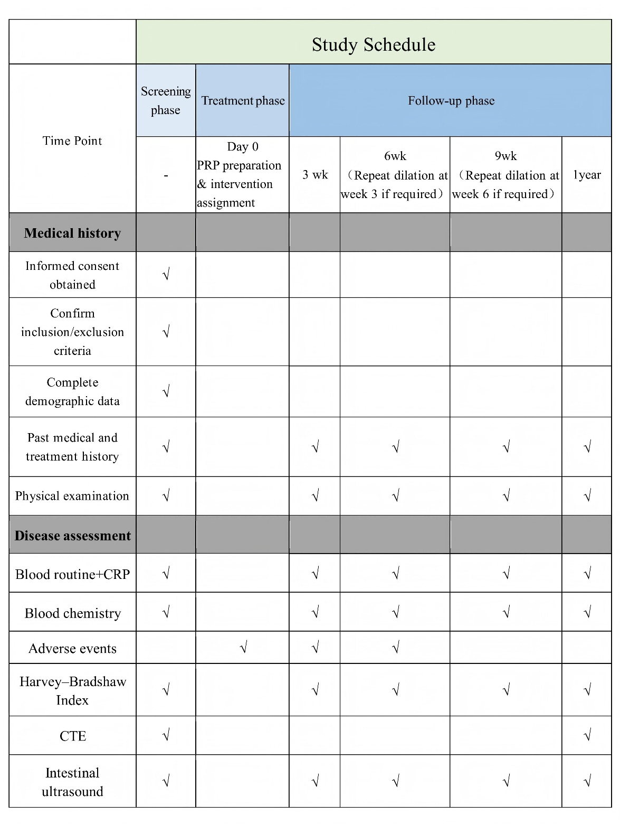
Figure S1 Study schedule

Statistical Analysis
Continuous, normally distributed variables are presented as mean ± standard deviation (SD). Non-normally distributed continuous variables are reported as median (inter-quartile range, IQR). Categorical data are given as n (%). All analyses were performed with SPSS version 22 (IBM Corp., Boston, MA, USA).
Stricture-free survival was defined as the interval from the first endoscopic intervention until endoscopic restenosis (inability to pass a 10.5-mm colonoscope) or surgical resection for colonic stricture. Surgery-free survival was defined as the interval from the first endoscopic intervention until surgery due to stricture or perforation.

Supplementary tables
Table S1 The laboratory results of the patients
 | All  (n=29) | Low-concentration (n=15) | High-concentration  (n=14)
CRP (mg/L), median (IQR) | 1.35 (1.93) | 1.29 (2.13) | 1.36 (1.98)
ALB (g/L), median (IQR) | 42.63 (4.19) | 42.95 (5.16) | 42.05 (3.26)
Hb (g/L), median (IQR) | 132 (25) | 129 (37) | 134 (23)
Platelet (10E9/L), median (IQR) | 263 (85) | 263 (116) | 267 (64)
Neutrophils (10E9/L), median (IQR) | 3.26 (1.77) | 2.94 (1.71) | 3.49 (2.25)
Monocytes (10E9/L), median (IQR) | 0.38 (0.16) | 0.39 (0.15) | 0.36 (0.17)
Lymphocytes (10E9/L), median (IQR) | 1.45 (0.96) | 1.68 (1.07) | 1.29 (0.96)
PRP, platelet-rich plasma; CRP, C-reactive protein; ALB, albumin; Hb, hemoglobin; IQR, inter-quartile range

References
1. Lu Y, Yang T, Li J, Sun J. Endoscopic balloon dilation with injection of platelet-rich plasma in management of recurrent stenosis in a patient with Crohn disease (with video). Gastrointest Endosc. 2025. DOI: 10.1016/j.gie.2025.06.033.
2. Cotton PB. Outcomes of endoscopy procedures: struggling towards definitions. Gastrointest Endosc. 1994;40:514-518. DOI: 10.1016/s0016-5107(94)70228-4.

