Social environments shape repertoire composition but not repertoire size in close-range chimpanzee communication

Angèle Lombrey^{1,*}, Adriana Luna Martinez^{1,2}, Nick Dannenmann¹, Ulrich Knief ⁴, Claudia Wilke⁵, Katie Slocombe⁵, Marlen Fröhlich^{1,3,*}

¹Paleoanthropology Section, Institute for Archaeological Sciences, Department of Geosciences, University of Tübingen, Tübingen, Germany
²Development and Evolution of Cognition Research Group, Max Planck Institute of Animal Behavior, Konstanz, Germany
³DFG Centre for Advanced Studies ‘Words Bones, Genes, Tools’, University of Tübingen, Tübingen, Germany
⁴Evolutionary Biology and Ecology, Institute of Biology I (Zoology), University of Freiburg, Freiburg, Germany
⁵Department of Psychology, University of York, York, UK

*Address for correspondence (Tel: +49 (0) 7071 29 76458; E-mail: angele.lombrey@uni-tuebingen.de (Angèle Lombrey), marlen.froehlich@uni-tuebingen.de (Marlen Fröhlich)

Table S1: Information on group composition
Research setting | Social group | Number of subjects | Number of male subjects | Number of female subjects | Number of juveniles | Total group size
Captive | A | 13 | 2 | 11 | 8 | 21
Captive | B | 6 | 1 | 5 | 0 | 6
Captive | L | 30 | 13 | 17 | 3 | 33
Semi-wild | C2 | 29 | 8 | 21 | 27 | 56
Semi-wild | C4 | 9 | 5 | 4 | 4 | 13
Wild | K | 27 | 11 | 16 | 26 | 53

Table S2: Subject information and sample size per subject represented by the amount of coded signal utterances
Subject | Group | Setting | Sex | Age | Group size | Number of interaction partners | Sample size | Number of social goals
Alex | B | Captive | M | 21 | 6 | 5 | 88 | 6
Bambari | A | Captive | F | 21 | 21 | 11 | 57 | 11
Big Brown | K | Wild | M | 49 | 53 | 20 | 45 | 5
Bobby | C4 | Sanctuary | M | 28 | 13 | 10 | 30 | 9
Bud | K | Wild | M | 20 | 53 | 28 | 123 | 10
Carol | C2 | Sanctuary | F | 25 | 56 | 16 | 89 | 11
Commander | C4 | Sanctuary | M | 22 | 13 | 12 | 139 | 11
Corry | A | Captive | F | 45 | 21 | 20 | 236 | 13
Daisy | C2 | Sanctuary | F | 17 | 56 | 24 | 89 | 12
David | C2 | Sanctuary | M | 20 | 56 | 24 | 140 | 12
Daza | B | Captive | F | 36 | 6 | 5 | 85 | 10
Debbie | C2 | Sanctuary | F | 20 | 56 | 31 | 134 | 11
Diana | C2 | Sanctuary | F | 31 | 56 | 15 | 29 | 5
Diz | C2 | Sanctuary | F | 14 | 56 | 24 | 75 | 13
Dolly | C2 | Sanctuary | F | 25 | 56 | 38 | 270 | 15
Donald | L | Captive | M | 28 | 33 | 19 | 52 | 11
Dora | C2 | Sanctuary | F | 33 | 56 | 18 | 126 | 8
Dorien | A | Captive | F | 41 | 21 | 8 | 46 | 11
Doug | C2 | Sanctuary | M | 19 | 56 | 31 | 83 | 10
Eslom | K | Wild | M | 21 | 53 | 25 | 39 | 5
Espe | L | Captive | F | 31 | 33 | 26 | 118 | 12
Fetz | L | Captive | M | 16 | 33 | 26 | 49 | 14
Fraukje | A | Captive | F | 45 | 21 | 15 | 69 | 12
Frodo | A | Captive | M | 28 | 21 | 17 | 140 | 11
Garibal | L | Captive | M | 26 | 33 | 21 | 38 | 9
Gartenzwerg | L | Captive | F | 39 | 33 | 23 | 134 | 12
Girlie | L | Captive | F | 18 | 33 | 19 | 41 | 9
Gregor | L | Captive | M | 33 | 33 | 28 | 97 | 13
Ignaz | L | Captive | M | 33 | 33 | 23 | 29 | 9
Jack | C4 | Sanctuary | M | 13 | 13 | 12 | 151 | 10
Jeudi | B | Captive | F | 56 | 6 | 5 | 34 | 6
John | C2 | Sanctuary | M | 15 | 56 | 22 | 83 | 9
Johnny | K | Wild | M | 40 | 53 | 19 | 35 | 5
Judy | C2 | Sanctuary | F | 26 | 56 | 23 | 93 | 13
Kathy | C4 | Sanctuary | F | 23 | 13 | 10 | 71 | 9
Kisha | A | Captive | F | 18 | 21 | 14 | 78 | 12
Lanjo | K | Wild | M | 20 | 53 | 28 | 100 | 8
Leona | K | Wild | F | 18 | 53 | 14 | 43 | 10
Lia | K | Wild | F | 33 | 53 | 18 | 91 | 10
Lindi | L | Captive | F | 26 | 33 | 16 | 33 | 6
Little Jane | C2 | Sanctuary | F | 37 | 56 | 37 | 224 | 13
Maggie | C2 | Sanctuary | F | 36 | 56 | 27 | 54 | 11
Maja | A | Captive | F | 35 | 21 | 16 | 208 | 15
Makoku | K | Wild | M | 33 | 53 | 20 | 83 | 5
Malia | L | Captive | F | 16 | 33 | 22 | 91 | 7
Masya | C2 | Sanctuary | F | 31 | 56 | 25 | 50 | 7
MaxC | C2 | Sanctuary | M | 15 | 56 | 22 | 39 | 9
MaxL | L | Captive | M | 26 | 33 | 27 | 73 | 12
Michelle | K | Wild | F | 18 | 53 | 14 | 40 | 11
Mickey | C2 | Sanctuary | M | 34 | 56 | 31 | 97 | 11
Misha | C2 | Sanctuary | F | 34 | 56 | 21 | 91 | 10
Moyo | C2 | Sanctuary | M | 14 | 56 | 36 | 85 | 12
Nana | L | Captive | F | 26 | 33 | 15 | 60 | 7
Natascha | A | Captive | F | 41 | 21 | 14 | 53 | 9
Nikki | C2 | Sanctuary | F | 24 | 56 | 19 | 69 | 10
Nina | C2 | Sanctuary | F | 19 | 56 | 20 | 59 | 6
Noel | C2 | Sanctuary | F | 45 | 56 | 22 | 74 | 9
Outamba | K | Wild | F | 36 | 53 | 18 | 53 | 8
Pan | C2 | Sanctuary | M | 33 | 56 | 28 | 58 | 8
Panya | L | Captive | F | 16 | 33 | 13 | 25 | 8
Para | L | Captive | F | 24 | 33 | 15 | 61 | 9
Paul | L | Captive | M | 31 | 33 | 22 | 42 | 11
Paulinchen | L | Captive | F | 34 | 33 | 12 | 42 | 8
Pippa | C2 | Sanctuary | F | 33 | 56 | 18 | 105 | 7
Quinto | K | Wild | F | 23 | 53 | 15 | 28 | 8
Riet | A | Captive | F | 44 | 21 | 9 | 35 | 10
Sandra | A | Captive | F | 28 | 21 | 13 | 107 | 12
Scholzi | L | Captive | F | 35 | 33 | 21 | 53 | 11
Scholzon | L | Captive | M | 23 | 33 | 22 | 50 | 10
Sinkie | C4 | Sanctuary | M | 28 | 13 | 7 | 35 | 9
Special | K | Wild | F | 15 | 53 | 23 | 97 | 7
Swela | A | Captive | F | 26 | 21 | 14 | 218 | 11
Tai | A | Captive | F | 19 | 21 | 17 | 132 | 13
Tenkere | K | Wild | F | 17 | 53 | 14 | 37 | 8
Tess | C2 | Sanctuary | F | 23 | 56 | 31 | 214 | 12
Tilly | C2 | Sanctuary | F | 21 | 56 | 33 | 169 | 15
Tongo | K | Wild | F | 35 | 53 | 20 | 106 | 8
Toto | L | Captive | M | 42 | 33 | 20 | 38 | 10
Tripoli | K | Wild | F | 16 | 53 | 17 | 61 | 8
Trixie | C2 | Sanctuary | F | 32 | 56 | 24 | 66 | 9
Tuber | K | Wild | M | 15 | 53 | 10 | 44 | 5
Tuke | K | Wild | M | 16 | 53 | 27 | 123 | 11
Val | C4 | Sanctuary | M | 22 | 13 | 11 | 191 | 10
Violet | C2 | Sanctuary | F | 31 | 56 | 39 | 182 | 13
Vis | C2 | Sanctuary | M | 18 | 56 | 32 | 53 | 11
Wangari | K | Wild | F | 24 | 53 | 17 | 48 | 10
Wazlaw | L | Captive | M | 31 | 33 | 21 | 56 | 13
Wilma | K | Wild | F | 25 | 53 | 13 | 85 | 11
Yogi | K | Wild | M | 42 | 53 | 18 | 73 | 6
Zicklein | L | Captive | F | 23 | 33 | 17 | 51 | 8
Zina | L | Captive | F | 18 | 33 | 15 | 30 | 10
Zira | B | Captive | F | 24 | 6 | 4 | 30 | 7
Zora | L | Captive | F | 13 | 33 | 19 | 68 | 9

Table S3: Definition of the modifiers used in the BORIS coding scheme (S: signaller; R: recipient).
Modifier | Definition
Co-occurring signal types | Combination with another signal type (multiple choice)
no | no
yes - plus facial | combination with facial expression
yes - plus facial fixed | obligatory combination with facial expression
yes - plus manual | combination with manual gesture
yes - plus body | combination with bodily, non-manual gesture
yes - plus vocal | combination with vocalization
yes - plus vocal fixed | obligatory combination with vocalization
NA | unknown due to poor visibility
Social goal | Apparent aim of S, based on Cartmill & Byrne 2010 and Hobaiter & Byrne 2014
Acquire object | R gives signaller object, e.g. food item
Attend to spec location | R adjusts behaviour to focus attention on indicated location
Climb on me | R (infant) climbs on signaller’s body
Dominance | R acknowledges that S is higher ranking
Affiliation/greeting | R reacts in an apparently affiliative way
Follow me - sex | R follows S, usually in consortship
Move away | R moves away from signaller
Move closer | R moves closer to signaller
Sexual attention | R responds sexually
Seek reassurance | S want R to reassure them
Give reassurance | S want R to calm down
Reposition body | R moves (and hold) body into indicated position
Start grooming | S wants R to groom them
Start play | play between signaller and recipient
Stop action | R either ceases current behaviour or change behaviour to direct it toward another individual
Travel with me | R travels together with S
Tolerance | S signals in a submissive way, no particular behavioural outcome is looked for
Other
NA | unknown
Recipient | Recipient ID  Single choice: only dyadic communicative acts are considered - broad behaviour (e.g. vocalizations) for which one precise recipient cannot be identified are not included

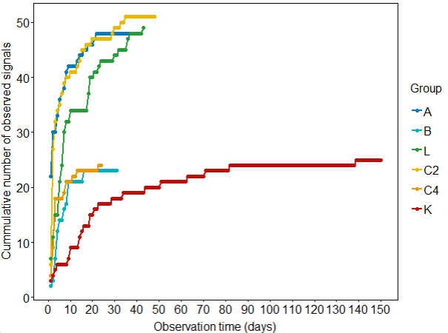
Figure S1: Cumulative communicative repertoire per study group
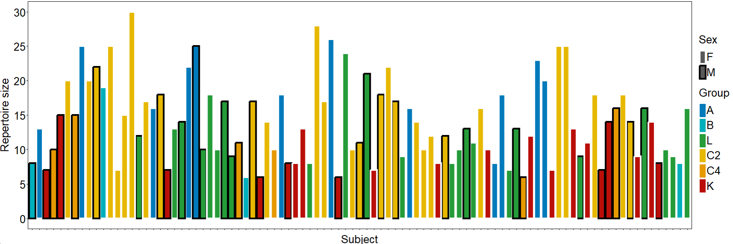
Figure S2: Repertoire size per individual across all groups and settings
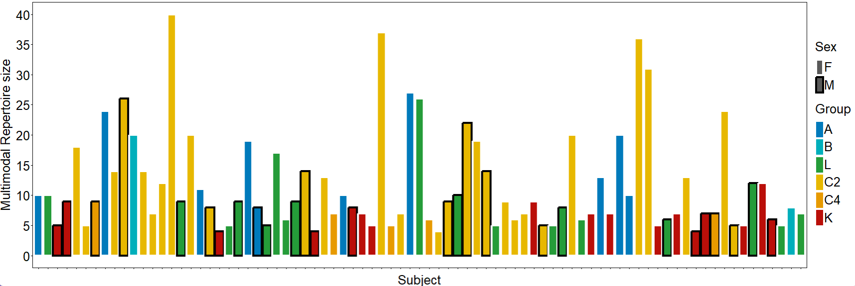
Figure S3: Multicomponent repertoire size per individual across all groups and settings
Table S4: Fixed effect estimates for both repertoire variables
Fixed effects | Estimate | Std. Error | t value | Pr
Signal repertoire size
(Intercept) | 0.572 | 0.281 | 2.037 | 0.062
Age | -0.002 | 0.002 | -0.968 | 0.336
SexM | -0.021 | 0.051 | -0.403 | 0.688
SettingSanctuary | -0.087 | 0.187 | -0.463 | 0.696
SettingWild | -0.277 | 0.302 | -0.918 | 0.481
NbInteractionPartners | 0.003 | 0.006 | 0.485 | 0.629
NbAdultMales | 0.002 | 0.022 | 0.074 | 0.948
TotComActs | 0.373 | 0.052 | 7.183 | 2.62e-10
ASOsize | 0.047 | 0.012 | 3.730 | 3.47e-4
Multicomponent repertoire size
(Intercept) | -0.057 | 0.401 | -0.142 | 0.888
Age | 0.003 | 0.004 | 0.626 | 0.534
SexM | -0.148 | 0.083 | -1.776 | 0.080
SettingSanctuary | -0.018 | 0.232 | -0.076 | 0.948
SettingWild | -0.267 | 0.364 | -0.732 | 0.573
NbInteractionPartners | -0.001 | 0.008 | -0.157 | 0.876
NbAdultMales | -0.010 | 0.028 | -0.352 | 0.759
TotComActs | 0.422 | 0.082 | 5.121 | 2.49e-06
ASOsize | 0.136 | 0.020 | 6.791 | 2.97e-09

Table S5: Permutation matrices outputs for the group comparison of within-group and -setting Dice coefficients
Group/Setting contrast | Significant fraction of rarefaction replicates for signal repertoire overlap | Significant fraction of rarefaction replicates for multicomponent repertoire overlap
A-B | 0.71 | -
A-C2 | 0 | 0.03
A-C4 | 0 | -
A-L | 0.19 | 0.04
A-K | 0 | 0.02
B-C2 | 0.69 | -
B-C4 | 0.85 | -
B-L | 0.08 | -
B-K | 0.86 | -
C2-C4 | 0 | -
C2-L | 0.59 | 0
C2-K | 0 | 0
C4-L | 0.37 | -
C4-K | 0 | -
L-K | 0.51 | 0
Zoo-Sanctuary | 0.04 | 0.28
Zoo-Wild | 0.54 | 0
Sanctuary-Wild | 0 | 0

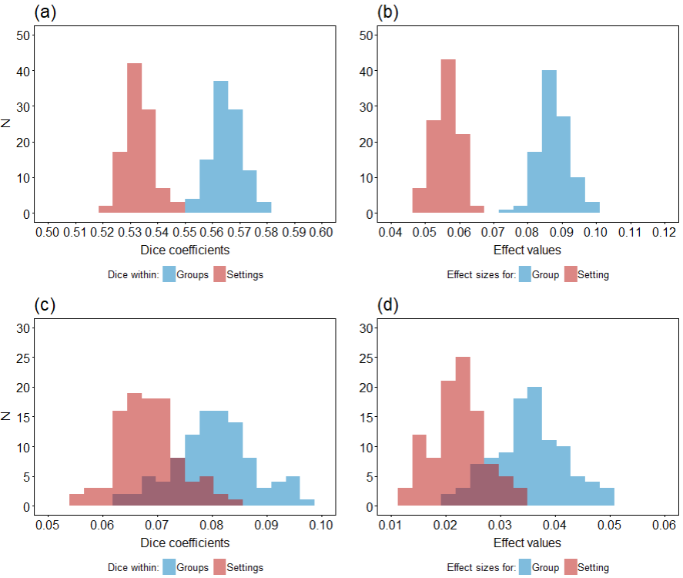
Figure S4: Distribution of Dice coefficients for within-category comparison (a, c) and effect sizes (b, d) over the 100 rarefaction for groups (a, b) and settings (c, d). The effects sizes represent the difference between mean Dice coefficients within groups and settings and mean Dice coefficients across groups and settings (i.e. Dice_{Within} – Dice_{Between}).

