Figure S1. FTIR spectra of adsorbents A–H corresponding to: (A) B5, (B) B10, (C) B20, (D) B40, (E) OM4, (F) OM8, (G) MRM, and (H) PM199.

The spectra show typical clay mineral bands, including O–H stretching (~3400 cm⁻¹), H–O–H bending (~1630 cm⁻¹), and Si–O stretching (~1000–1030 cm⁻¹), as well as C–H stretching bands (2920–2850 cm⁻¹) indicative of organic functionalization.
Table S1. Physicochemical properties of the selected antibiotics.
 | Structure | Molecular Mass  (g/mol) | Molecular  formula | pK_{a} | Log K_{w}
AMX | 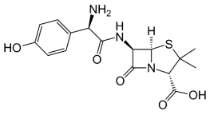 | 356.4 | C₁₆H₁₉N₃O₅S | 2.4 (carboxyl)  7.4 (amino)  9.6 (phenolic) | 0.87
TMP | 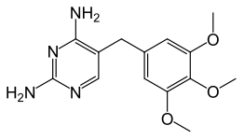 | 290.3 | C₁₄H₁₈N₄O₃ | 7.12 | 0.91
OFL | 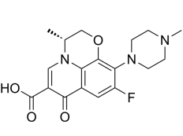 | 361.4 | C₁₈H₂₀FN₃O₄ | 5.97 (carboxylic acid)  9.28 (piperizinyl ring) | -0.39
CIP | 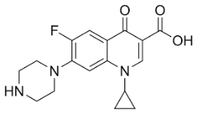 | 331.3 | C₁₇H₁₈FN₃O₃ | 6.09 (carboxylic acid group)  8.74 (nitrogen on piperazinyl ring) | 0.28
TCN | 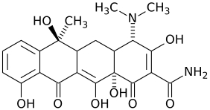 | 444.4 | C₂₂H₂₄N₂O₈ | 3.3 (enolic group)  7.7 (phenolic group)  9.7 (dimethylamino group) | -1.37
SMZ | 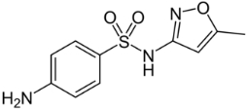 | 253.3 | C₁₀H₁₁N₃O₃S | 1.6 (aniline group)  5.7 (sulfonamide group) | 0.89
CLDM | 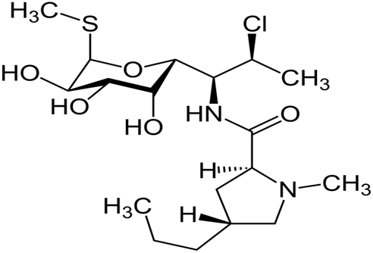 | 425.0 | C₁₈H₃₃ClN₂O₅S | 7.6 (amino group) | 2.16
AZM | 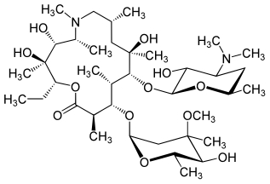 | 749.0 | C₃₈H₇₂N₂O₁₂ | 8.5 (dimethylamino group)  9.5 (amine on desonamine group) | 4.02

Table S2A. Chromatographic conditions for UHPLC analysis.
Parameter | Condition
Column | HILIC, HSS T3 (1.8 µm, 2.1 x 100 mm)
Column temperature | 40 °C
Injection volume | 10 µL
Flow rate | 0.25 mL min⁻¹
Mobile phase A | Water + 0.2% formic acid
Mobile phase B | Methanol
Gradient program | 70% A (0–1.5 min), 60% A (3.0 min), 15% A (4.0 min), 0% A (8.0 min), returned to initial conditions (70% A) at 8.1 min and maintained until 10 min for column re-equilibration
Run time | 10 min

Table S2B. Retention times, monitored ions and validation parameters of the UHPLC–MS analytical method.
 | SIM ion  (m/z) | Retention time  (min) | Calibration range (mg L⁻¹) | Regression equation | R² | LOD  (mg L⁻¹) | LOQ  (mg L⁻¹)
AMX | 349 | 1.54 | 1–10 | y = 0.0909x − 0.0294 | 0.994 | 0.05 | 0.20
TMP | 291 | 2.16 | 0.1-10 | y = 1.4437x + 0.0706 | 0.992 | 0.04 | 0.13
OFL | 362 | 2.60 | 2-10 | y = 0.9622x + 0.0138 | 0.993 | 0.52 | 1.58
TCN | 445 | 2.93 | 0.5-10 | y = 0.3995x – 0.0132 | 0.993 | 0.10 | 0.30
CIP | 332 | 3.17 | 0.5-10 | y = 0.5505x – 0.0906 | 0.994 | 0.08 | 0.25
SMZ | 254 | 3.65 | 0.5-10 | y = 0.2981x – 0.0284 | 0.994 | 0.17 | 0.52
AZM | 375 | 5.93 | 0.1-5 | y = 2.1751x + 0.0158 | 0.989 | 0.50 | 1.54
CLDM | 425 | 6.17 | 0.1-10 | y = 1.4874x – 0.0716 | 0.997 | 0.71 | 2.20
CIN | 250 | 7.01
Table S3. Kinetic models applied to describe single-component adsorption experiments.
Model | Non-linear equation | Parameters | Units | References
Pseudo-first-order (PFO) | $$q_{t}=q_{e}\left(1-e^{-k_{1}t}\right)$$ | q_{e}, 𝑘₁ | q_{e} (mg g⁻¹)  𝑘₁ (min⁻¹) | Tran et al., 2017  Wang and Guo, 2020  Musah et al., 2022  Revellame et al., 2020  Chu et al. 2025
Pseudo-second-order (PSO) | $$q_{t}=\frac{q_{e}^{2}⋅k_{2}t}{1+q_{e}k_{2}t}$$ | q_{e}, 𝑘₂ | q_{e} (mg g⁻¹)  k₂ (g mg⁻¹ min⁻¹)
Mixed PFO - PSO | $$q_{t}=q_{e1}\left(1-e^{-k_{1}t}\right)+\frac{q_{e2}^{2}⋅k_{2}t}{1+q_{e2}k_{2}t}$$ | q_{e1}, 𝑘₁  q_{e2}, 𝑘₂ | q_{e1}, q_{e2} (mg g⁻¹)  𝑘₁ (min⁻¹)  k₂ (g mg⁻¹ min⁻¹)
Weber-Morris (WM) | $$q_{t}=k_{i}t^{1/2}+C$$ | k_{i}, C | k_{i} (mg g⁻¹ min⁻½)  C (mg g⁻¹)
Elovich (E) | $$q_{t}=\frac{1}{β}ln (1+αβt)$$ | α, β | α (mg g⁻¹ min⁻¹),  β (g mg⁻¹)
Where: q_{t} = amount of contaminant adsorbed per unit mass of adsorbent at time t; q_{e} = amount adsorbed at equilibrium; q_{e1}, q_{e2} = adsorption capacities at equilibrium corresponding to the pseudo-first-order and pseudo-second-order mechanisms, respectively; k₁ = pseudo-first-order rate constant; k₂= pseudo-second-order rate constant; k_{i} = intraparticle diffusion rate constant; C = constant related to the boundary layer thickness; α = initial adsorption rate; β = Elovich desorption constant, related to the activation energy and surface coverage.

Table S4. Non-linear adsorption isotherm models applied in this study.
Model | Non-linear equation | Parameters | Units | References
Langmuir | $$q_{e}=\frac{q_{max}K_{L}C_{e}}{1+K_{L}C_{e}}$$ | q_{max,} K_{L,} C_{e} | q_{max}: (mg g⁻¹), K_{L}: (L mg⁻¹) C_{e}: (mg L⁻¹⁾ | Ayawei et al., 2017  Mozaffari Majd et al., 2022  Murphy et al., 2023
Freundlich | $$q_{e}=K_{F} C_{e}^{1/n}$$ | K_{F}, C_{e}, n | K_{F}: (mg g⁻¹) (L mg⁻¹)^{1/n}  C_{e}: (mg L⁻¹⁾  n: dimensionless
Sips (Langmuir-Freundlich) | $$q_{e}=\frac{q_{max}{(K_{S}C_{e})}^{n}}{1+{(K_{S}C_{e})}^{n}}$$ | q_{max}, K_{S,} n | q_{max}: mg g⁻¹, K_{S}: (L mg⁻¹)  n: dimensionless
Where: q_{e} = amount of contaminant adsorbed per unit mass of adsorbent at equilibrium; C_{e} = equilibrium concentration of the contaminant in solution; q_{max} = maximum adsorption capacity; K_{L} = Langmuir constant related to the affinity of binding sites; K_{F} = Freundlich constant related to adsorption capacity; n = heterogeneity factor; K_{S} = Sips constant.

Table S5. Mathematical expressions of selected adsorption isotherm models applied in this study.
Model | Mathematical expressions | References
Original SRS model (Sheindorf–Rebhun–Sheintuch) | 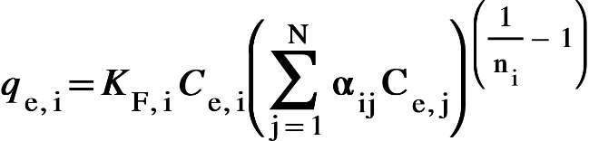 | Sheindorf et al., 1981  Amrutha et al., 2023
Global Freundlich model | 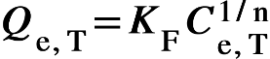 | Cela-Dablanca et al., 2025

Where:
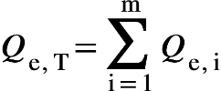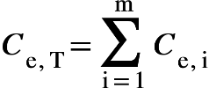
q_{e,i} = equilibrium adsorption capacity of component 𝑖
𝐶_{𝑒,i} = equilibrium concentration of component 𝑖
𝐾_{𝐹,i} = Freundlich adsorption constant for component 𝑖
𝑛_{i}, n = heterogeneity parameter (dimensionless)
α_{i,𝑗} = interaction coefficient between solutes i and 𝑗, (α_{i,i} = 1; α_{j,i} = 1/α_{i,j})
𝑄_{𝑒,𝑇} = total adsorbed amount
𝐶_{𝑒,𝑇} = total equilibrium concentration
m = number of components in the system

