Supporting Information
Health and Functional Trajectories and Newly Reported Chronic Lung Disease in Postmenopausal Chinese Women: A Longitudinal Cohort Study
Ling Lin¹, Qingmei Xu¹*
Supplementary Material 2: Additional Figures
The figures in this file document trajectory classification certainty and the stability of adjusted associations under alternative analytic restrictions.

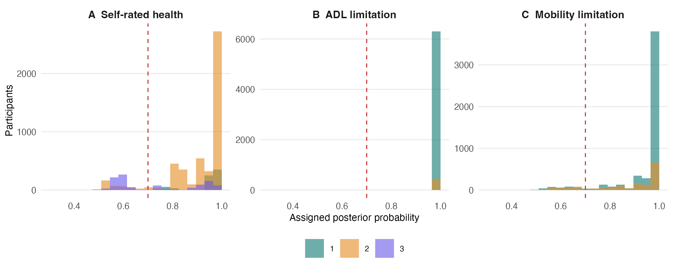
Supplementary Figure S2. Distribution of assigned posterior probabilities in the selected trajectory models.
Note. The dashed line indicates the predefined 0.70 threshold used in a sensitivity analysis. Histograms are shown separately by assigned class.

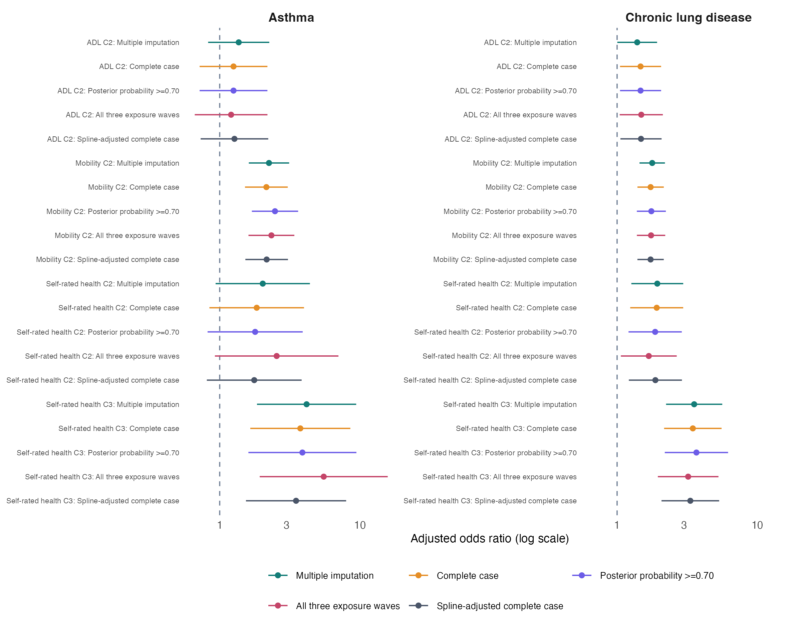
Supplementary Figure S3. Main and sensitivity estimates for newly reported chronic lung disease and asthma.
Note. Points are adjusted odds ratios and horizontal lines are 95% confidence intervals. The axis is logarithmic. Main estimates used multiple imputation. All sensitivity analyses used complete covariate cases; further restrictions concerned posterior probability, exposure-wave completeness, or nonlinear age and body mass index adjustment with categorical condition count.

