SUPPORTING INFORMATION FOR:

Ghirlandi, S., Hoff, T., Böcher, C., Sprecher, B., Pohya, A. & Peck, D. Material Flow Analysis of Titanium Metal in European Aviation: Circular Economy Strategies for reduced import dependence, Journal of Industrial Ecology.

The supplementary information of this article provides additional figures relevant to the results that however are out of its strict scope.

SI1. Structure and evolution of EU titanium trade by product category and trading partner in 2019 and 2024 (data:UN Comtrade)
Original data for this figure are available in Supplementary 2.4 - Trade 2019 - 2024
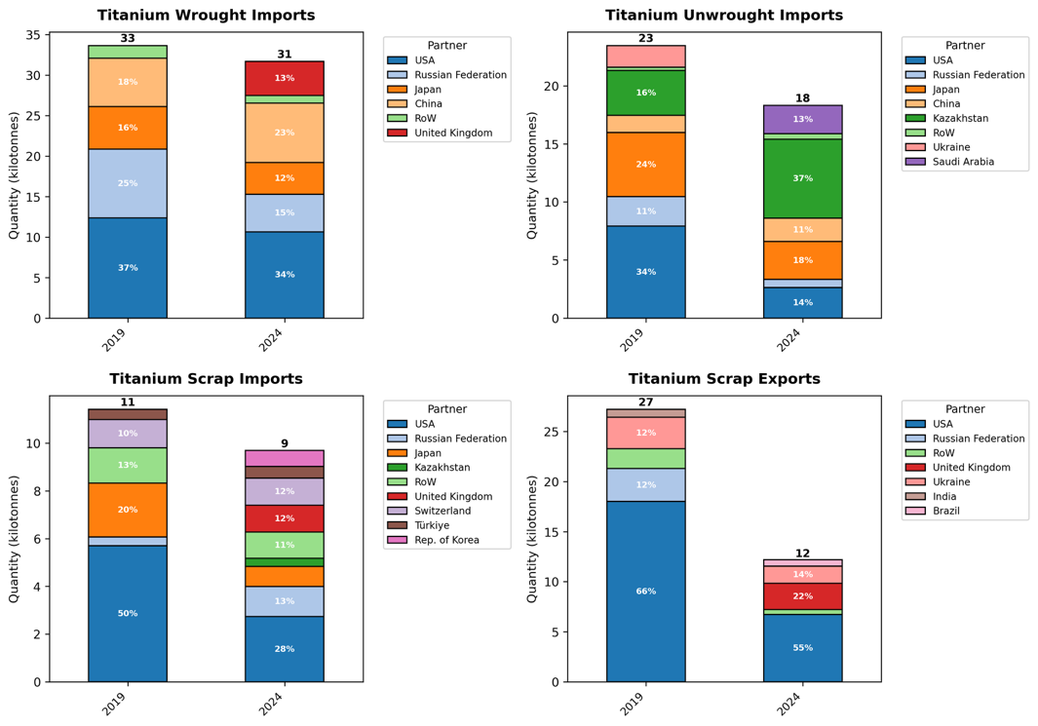

SI2. Share of EU fleet titanium stock by aircraft titanium content class, 2000–2040. The post-2024 structural shift reflects the progressive entry of next-generation, titanium-intensive widebody aircraft into the EU fleet.
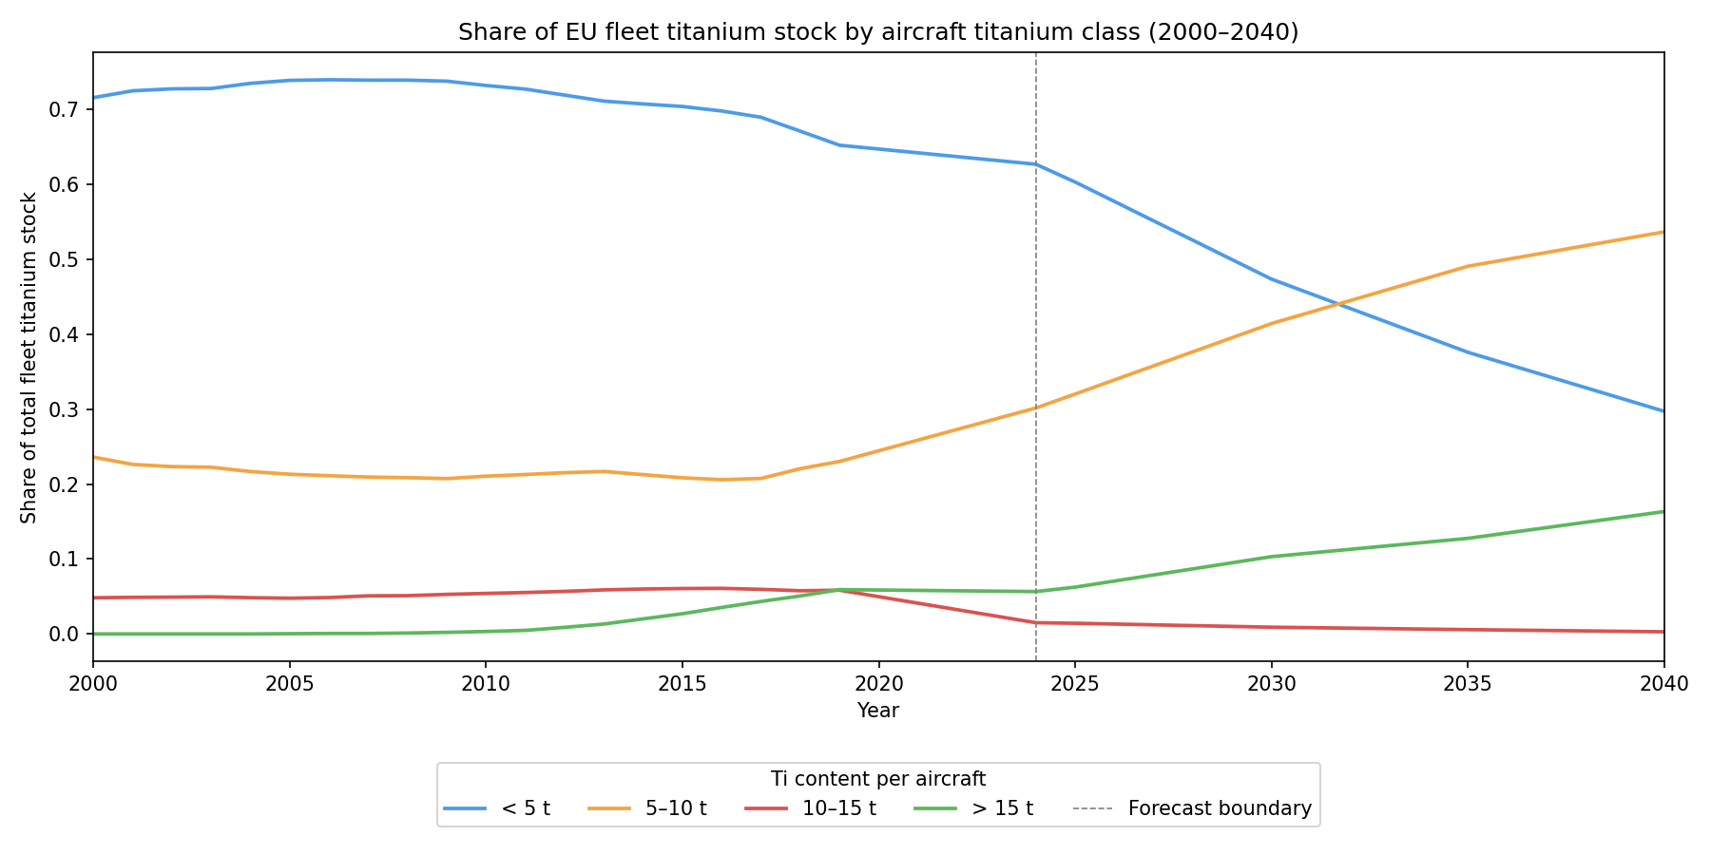

SI3. Annual import reduction by seven scenarios, 2025–2040 (kt/year).
