Niosome-Based Supramolecular Solvents: Aligning Analytical Efficiency with Green Chemistry Criteria

Alejandro Pulido-Zurera¹, Noelia Caballero-Casero^{1*} & Soledad Rubio¹

¹Department of Analytical Chemistry, Institute of Chemistry for Energy and the Environment (IQUEMA), University of Córdoba, 14071, Córdoba, Spain

* Corresponding author.
Phone: +34 957 212441 (N. Caballero-Casero)
E-mail address: a42caasn@uco.es

Pulido-Zurera ORCID: 0009-0004-6490-7581
Caballero-Casero ORCID: 0000-0002-0662-1815
Rubio ORCID: 0000-0002-9128-4787

Acknowledgements
This work was supported by MCIU/AEI/10.13039/501100011033 and FEDER, UE (grant PID2023-149488OB-I00). Pulido-Zurera acknowledges the support of the UCO-RYC2023-045005-I reinforcement grant funded by the University of Cordoba. Caballero-Casero acknowledges the grant RYC2023-045005-I, funded by MICIU/AEI/10.13039/501100011033 and by ESF+.

TABLE OF CONTENTS
Section S1. Chemicals, raw material, and apparatus…………………………… | 3
Section S2. Global parameter determination…………………………………… | 4
Table S1. Multiple Reaction Monitoring (MRM) transitions and parameters for LC-MS/MS determination of phenolic acids and flavonoids……………………. | 6
Table S2. Density of bioSUPRASs prepared under different synthesis conditions by varying Na₂SO₄ concentration (M), Span 40 content (%, w/v), and 1-propanol proportion (%, v/v). Values are expressed as mean ( 𝑥̄ ) ± standard deviation (SD) (n = 3)……………………………………………………………………………… | 10
Table S3. Total phenolic content (TPC), total flavonoid content (TFC), and total carotenoid (TCC) content obtained during optimization of the sample-to-bioSUPRAS……………………………………………………………………….. | 12
Table S4. Comparison of total phenolic (TPC), total flavonoid (TFC), and total carotenoid (TCC) contents obtained by bioSUPRAS and conventional solvent-based extraction procedures……………………………………………………….. | 13
Figure S1. Chemical structure of sorbitan monopalmitate (Span 40)……………. | 14
Figure S2. Agreement between experimentally measured and predicted bioSUPRAS volumes……………………………………………………………… | 15
Figure S3. Effect of bioSUPRAS synthesis conditions on water content. (A) Variation of water content with 1-propanol proportion (60–80%, v/v) at a constant Na₂SO₄ concentration (0.14 M). (B) Variation of water content with Na₂SO₄ concentration (0.14–0.40 M) at a constant 1-propanol/water ratio (60/40, v/v). Orange and blue curves correspond to systems containing 0.10 and 0.16% (w/v) Span 40, respectively………………………………………………………. | 16
Figure S4. General scheme of bioactives extraction from Morus alba L. leaves by using span 40-based bioSUPRAS…………………………………………………. | 17
Figure S5. Effect of bioSUPRAS composition on (A) total phenolic content (TPC), (B) total flavonoid content (TFC), and (C) total carotenoid content (TCC) extracted from white mulberry leaves. BioSUPRASs were prepared at a constant Na₂SO₄ concentration (0.20 M) using 0.10–0.20% (w/v) Span 40 and 60–80% (v/v) 1-propanol. Blue, orange, and green bars correspond to 60, 70, and 80% (v/v) 1-propanol, respectively……………………………………………………... | 18
Figure S6. Effect of vortex-assisted extraction time on the recovery of bioactive compounds from white mulberry leaves, expressed as total phenolic, total flavonoid, and total carotenoid contents…………………………………………... | 19

Section S1. Chemicals, raw material, and apparatus
Chemicals and Reagents
Chemicals and reagents were used as received and solutions were prepared according to the manufacturers’ instructions unless otherwise specified. The following reagents were supplied by Sigma-Aldrich (Saint Louis, USA): Sodium sulphate (Na₂SO₄), sodium benzoate, sodium citrate, potassium sorbate, sorbitan monopalmitate (Span 40), Folin-Ciocalteu reagent, aluminium trichloride (AlCl₃), sodium carbonate, 6-hydroxy-2,5,7,8-tetramethyl-chromane-2-carboxylic acid (TROLOX), Dulbecco’s phosphate buffered saline (PBS), 2,2-azino-bis(3- ethylbenzothiazoline-6-sulfonic acid) diammonium salt (ABTS), potassium persulfate (K₂S₂O₈), α,α-diphenyl-β-picrylhydrazyl (DPPH), gallic acid, ferulic acid, chlorogenic acid, syringic acid, caffeic acid, vanillic acid, vanillin, p-coumaric acid, and rosmarinic acid. Flavonoids standard mixtures were supplied by MetaSci (Toronto, Canada). The standards used in this study were acacetin, apigenin, baicalin, daidzein, diosmetin, diosmin, epicatechin, epigallocatechin gallate, fisetin, hesperetin, neohesperidin, neohesperidin dihydrochalcone, isoliquiritigenin, kaempferol, luteolin, mangiferin, morin, naringenin, naringin, naringin dihydrochalcone, oxyresveratrol, phloretin, phloridzin, piceatannol, polydatin, puerarin, quercetin, resveratrol, rutin, taxifolin, chalcone, and piceid. 1-propanol, 2-propanol, methanol (MeOH), ethanol (EtOH), glycerine, sodium chloride, dichloromethane (DCM) and hydrochloric acid were supplied by PanReac Applichem (Barcelona, Spain). The purified water was obtained from a Milli-Q water purification system of Merck Millipore (Madrid, Spain).
Raw material and pretreatment
White mulberry (Morus alba L.) leaves were collected in Aguilar de la Frontera (Córdoba, Spain; 37°29′04.4″ N, 4°41′00.7″ W) in October 2025. The leaves were washed with distilled water to remove surface residues and dried at 45 °C for 15 days. The dried leaves were ground to obtain a fine, visually homogeneous powder, which was stored in closed containers at room temperature in the dark until analysis.
Apparatus
The apparatus used in this study included a REAX Top multi-tube shaker (Heidolph, Schwabach, Germany), a precision digital calliper (Unión Ferretera, Asturias, Spain), an analytical balance ABJ 80-4NM (Kern-Sohn, Stuttgart, Germany), a Karl-Fischer coulometer equipped with a diaphragm generator electrode (Metrohm, Herisau, Switzerland), a V-10 Plus spectrophotometer (Labbox, Barcelona, Spain), a Centrofriger BLT (J.P SELECTA, Barcelona, Spain) and a Lyoquest-55 freeze dryer equipped with a vacuum pump (Tesltar, Terrassa, Spain). Cryo-SEM and TEM analyses were performed using a Zeiss EVO LS 15 and a Zeiss Libra 120, respectively (Zeiss, Oberkochen, Germany), A Digitheat-TFT drying and sterilization oven (J.P. SELECTA, Barcelona, Spain) and an MO 3200 grinder (Orbegozo, Murcia, Spain) were also used.
Section S2. Global parameter determination
TPC was determined by the Folin-Ciocalteu method [1], using gallic acid (GA) (10-300 mg/L) for calibration. The assay mixture consisted of 50 µL of bioSUPRAS extract previously diluted with 2 mL of methanol, 1.5 mL of distilled water, 100 µL of Folin-Ciocalteu reagent (0.1 N), and 300 µL of 20% (w/v) Na₂CO₃. Absorbance was measured at 760 nm after 90 min in the dark, and TPC was expressed as mg gallic acid equivalents (GAE)/100 g dry weight (DW). TFC was determined by the AlCl₃ colorimetric method [2] using quercetin (1-25 mg/L) for calibration. BioSUPRAS extract (100 µL) was diluted with 5 mL of methanol, and 970 µL of the diluted extract was used for the assay with 970 µL of a freshly prepared methanolic solution containing 2% (w/v) AlCl₃ and 5% (v/v) acetic acid. After 10 min in the dark, absorbance was measured at 430 nm, and TFC was expressed as mg quercetin equivalents (QE)/100 g DW. TCC was determined according to Lichtenthaler and Wellburn [3] with slight modifications. BioSUPRAS extract (34 µL) was diluted with 5 mL of methanol, and absorbance was measured at 470, 652, and 665 nm. Chlorophyll a (Chl A), chlorophyll b (Chl B), and total carotenoid (Caro) contents were calculated with equations 1-3:
(Eq.1 ) $Chl A \left(\frac{mg}{L}\right)=15.65* {Abs}_{665}-7.34* {Abs}_{652}$
(Eq. 2) $Chl B \left(\frac{mg}{L}\right)=27.05* {Abs}_{652}-15.28* {Abs}_{665}$
(Eq. 3) $Caro \left(\frac{mg}{L}\right)= \frac{1000 * {Abs}_{470}-1.63 * Chl A-104.9 * Chl B}{245}$

References
[1] Singleton VL, Orthofer R, Lamuela-Raventós RM (1999) [14] Analysis of total phenols and other oxidation substrates and antioxidants by means of folin-ciocalteu reagent. Methods Enzymol 299:152–178. https://doi.org/10.1016/S0076-6879(99)99017-1
[2] Chang C-C, Yang M-H, Wen H-M, et al (2020) Estimation of total flavonoid content in propolis by two complementary colometric methods. J Food Drug Anal 10:3. https://doi.org/10.38212/2224-6614.2748
[3] Lichtenthaler HK, Wellburn AR (1983) Determinations of total carotenoids and chlorophylls a and b of leaf extracts in different solvents. Biochem Soc Trans 11:591–592. https://doi.org/10.1042/BST0110591

Table S1. Multiple Reaction Monitoring (MRM) transitions and parameters for targeted LC-MS/MS analysis of phenolic acids and flavonoids
Compound name | Precursor ion | Product ions |  | Fragmentor (V) | Collision Energy (V)
Flavonoids
Acacetin | 283.2 | 267.9 | Quantifier | -100 | -30
Acacetin | 283.2 | 283.0 | Qualifier | -100 | -30
Apigenin | 269.0 | 117.0 | Quantifier | -100 | -45
Apigenin | 269.0 | 157.0 | Qualifier | -100 | -45
Baicalin | 447.0 | 271.0 | Quantifier | +100 | +25
Baicalin | 447.0 | 123.0 | Qualifier | +100 | +25
Daidzein | 253.0 | 91.0 | Quantifier | -100 | -25
Daidzein | 253.0 | 132.0 | Qualifier | -100 | -25
Diosmetin | 299.2 | 283.4 | Quantifier | -100 | -20
Diosmetin | 299.2 | 252.8 | Qualifier | -100 | -10
Diosmin | 607.0 | 299.2 | Quantifier | -100 | -30
Diosmin | 607.0 | 283.7 | Qualifier | -100 | -45
Epicathechin | 289.1 | 245.0 | Quantifier | -100 | -20
Epicathechin | 289.1 | 203.0 | Qualifier | -100 | -20
Epigallocatechin gallate | 457.0 | 305.1 | Quantifier | -100 | -25
Epigallocatechin gallate | 457.0 | 169.0 | Qualifier | -100 | -25
Fisetin | 285.0 | 133.0 | Quantifier | -100 | -32
Fisetin | 285.0 | 121.0 | Qualifier | -100 | -20
Hesperetin | 301.0 | 164.0 | Quantifier | -100 | -23
Hesperetin | 301.0 | 136.0 | Qualifier | -100 | -25
Neohesperidin | 609.0 | 325.0 | Qualifier | -100 | -35
Neohesperidin | 609.0 | 301.0 | Quantifier | -100 | -15
Neohesperidin dihydrochalcone | 611.2 | 302.9 | Qualifier | -100 | -35
Neohesperidin dihydrochalcone | 611.2 | 165.9 | Quantifier | -100 | -45
Isoliquitiregin | 255.0 | 135.0 | Qualifier | -100 | -15
Isoliquitiregin | 255.0 | 119.0 | Quantifier | -100 | -15
Kaempferol | 285.1 | 143.0 | Qualifier | -130 | -40
Kaempferol | 285.1 | 133.2 | Quantifier | -100 | -32
Luteolin | 285.1 | 133.2 | Quantifier | -100 | -32
Luteolin | 285.1 | 151.0 | Qualifier | -100 | -10
Mangiferin | 421.1 | 301.1 | Quantifier | -100 | -20
Mangiferin | 421.1 | 220.7 | Qualifier | -100 | -20
Morin | 300.9 | 151.1 | Quantifier | -100 | -25
Morin | 300.9 | 172.2 | Qualifier | -100 | -15
Naringenin | 271.0 | 151.0 | Qualifier | -100 | -34
Naringenin | 271.0 | 119.9 | Quantifier | -100 | -42
Naringin | 579.0 | 271.0 | Quantifier | -200 | -35
Naringin | 579.0 | 151.0 | Qualifier | -100 | -20
Naringin dihydrochalcone | 581.2 | 273.0 | Quantifier | -100 | -25
Oxyresveratrol | 243.1 | 175.1 | Qualifier | -100 | -25
Oxyresveratrol | 243.1 | 159.0 | Quantifier | -100 | -15
Phloretin | 273.0 | 167.1 | Quantifier | -100 | -10
Phloretin | 273.0 | 119.0 | Qualifier | -100 | -10
Phloridzin | 435.1 | 227.0 | Quantifier | -100 | -15
Phloridzin | 435.1 | 273.0 | Quantifier | -100 | -15
Piceatannol | 243.0 | 201.0 | Qualifier | -100 | -20
Piceatannol | 243.0 | 159.0 | Quantifier | -100 | -25
Polydatin | 389.1 | 227.0 | Quantifier | -100 | -10
Puerarin | 415.0 | 267.0 | Quantifier | -100 | -20
Puerarin | 415.0 | 295.0 | Qualifier | -100 | -20
Quercetin | 301.0 | 179.0 | Qualifier | -100 | -20
Quercetin | 301.0 | 151.0 | Quantifier | -100 | -20
Resveratrol | 227.0 | 185.0 | Qualifier | -100 | -25
Resveratrol | 227.0 | 143.0 | Quantifier | -100 | -20
Rutin | 609.1 | 300.0 | Quantifier | -100 | -20
Rutin | 609.1 | 271.0 | Qualifier | -100 | -20
Taxifolin | 303.0 | 285.0 | Quantifier | -100 | -20
Taxifolin | 303.0 | 125.0 | Qualifier | -100 | -20
Chalcone | 209.2 | 120.0 | Qualifier | -100 | -15
Chalcone | 209.2 | 104.0 | Quantifier | -100 | -15
Piceid | 389.1 | 227.1 | Quantifier | -100 | -20
Phenolic acids
Chlorogenic acid | 353.0 | 191.0 | Quantifier | -100 | -16
Chlorogenic acid | 353.0 | 179.0 | Qualifier | -100 | -24
Ferulic acid | 193.0 | 178.0 | Quantifier | -100 | -15
Ferulic acid | 193.0 | 134.0 | Qualifier | -100 | -15
Caffeic acid | 179.0 | 135.0 | Quantifier | -100 | -16
Caffeic acid | 179.0 | 107.0 | Qualifier | -100 | -24
Gallic acid | 169.0 | 125.0 | Quantifier | -100 | -9
Gallic acid | 169.0 | 97.0 | Qualifier | -100 | -20
p-coumaric acid | 163.0 | 119.0 | Quantifier | -100 | -10
p-coumaric acid | 163.0 | 93.0 | Qualifier | -100 | -28
Rosmarinic acid | 359.3 | 161.1 | Quantifier | -100 | -14
Rosmarinic acid | 359.3 | 197.0 | Qualifier | -100 | -16

Table S2. Density of bioSUPRAS prepared under different synthesis conditions by varying Na₂SO₄ concentration (M), Span 40 content (%, w/v), and 1-propanol proportion (%, v/v). Values are expressed as mean (𝑥̄) ± standard deviation (SD) (n = 3).
Na₂SO₄ (M) | % Span 40 (w/v) | % 1-propanol (v/v) | Density (g/mol)  (𝑥̄ ± SD) (n=3)
0.21 | 0.1 | 60 | 0.824 ± 0.002
0.21 | 0.1 | 80 | 0.793 ± 0.002
0.28 | 0.1 | 60 | 0.848 ± 0.002
0.28 | 0.1 | 70 | 0.803 ± 0.002
0.28 | 0.1 | 80 | 0.792 ± 0.002
0.49 | 0.1 | 70 | 0.785 ± 0.002
0.56 | 0.1 | 40 | 0.840 ± 0.002
0.63 | 0.1 | 60 | 0.847 ± 0.002
0.84 | 0.1 | 60 | 0.836 ± 0.002
0.42 | 0.1 | 60 | 0.863 ± 0.002
1.13 | 0.1 | 60 | 0.828 ± 0.002
0.70 | 0.1 | 30 | 0.846 ± 0.002
0.84 | 0.1 | 30 | 0.843 ± 0.003
1.20 | 0.1 | 30 | 0.842 ± 0.003
0.14 | 0.15 | 60 | 0.844 ± 0.002
0.28 | 0.15 | 60 | 0.811 ± 0.002
0.28 | 0.15 | 70 | 0.803 ± 0.002
0.28 | 0.15 | 80 | 0.791 ± 0.002
0.35 | 0.15 | 75 | 0.793 ± 0.002
0.35 | 0.15 | 70 | 0.802 ± 0.003
0.42 | 0.15 | 80 | 0.786 ± 0.003
0.49 | 0.15 | 70 | 0.800 ± 0.002
0.42 | 0.15 | 80 | 0.779 ± 0.002
0.35 | 0.15 | 60 | 0.806 ± 0.002
0.42 | 0.15 | 60 | 0.804 ± 0.003
0.14 | 0.15 | 60 | 0.851 ± 0.003
0.84 | 0.15 | 30 | 0.853 ± 0.002
0.21 | 0.2 | 70 | 0.798 ± 0.002
0.21 | 0.2 | 80 | 0.781 ± 0.002
0.21 | 0.2 | 60 | 0.810 ± 0.002
0.14 | 0.2 | 60 | 0.855 ± 0.002
0.14 | 0.2 | 70 | 0.808 ± 0.002
0.14 | 0.2 | 80 | 0.802 ± 0.002
0.21 | 0.2 | 60 | 0.811 ± 0.002
0.21 | 0.2 | 70 | 0.816 ± 0.002
0.21 | 0.2 | 80 | 0.792 ± 0.002
0.42 | 0.2 | 60 | 0.877 ± 0.002
1.20 | 0.2 | 30 | 0.830 ± 0.002

Table S3. Total phenolic content (TPC), total flavonoid content (TFC), and total carotenoid (TCC) content obtained during optimization of the sample-to-bioSUPRAS ratio.
Volume of bioSUPRAS (mL) | TPC | TFC | TCC
Volume of bioSUPRAS (mL) | mg GAE/100g DW | mg QE/100g DW | mg carotenoids/100g DW
0,4 | 1120±20 | 478±20 | 53±1
0,5 | 1140±60 | 617±10 | 51±3
0,6 | 1410±20 | 557±40 | 55±4
0,7 | 1470±60 | 542±50 | 49±5
0,8 | 1510±40 | 507±20 | 55±2
0,9 | 1820±260 | 538±30 | 52±3
1 | 1670±100 | 519±50 | 54±10
1,1 | 1660±130 | 534±20 | 49±5
1,2 | 1765±130 | 541±10 | 53±10
1,3 | 1780±100 | 588±10 | 56±10
1,4 | 1940±130 | 568±10 | 51±10
1,5 | 2030±160 | 531±24 | 54±1
1,6 | 1930±200 | 494±10 | 51±1
1,7 | 1955±100 | 490±30 | 53±5
1,8 | 1860±280 | 530±70 | 49±10

Table S4. Comparison of total phenolic (TPC), total flavonoid (TFC), and total carotenoid (TCC) contents obtained by bioSUPRAS and conventional solvent-based extraction procedures.

 | TPC | TFC | TCC
Solvents | mg GAE/100g DW | mg QE/100g DW | mg carotenoids/100g DW
Ethanol extraction | 1049±36 | 412±44 | 44±5
Ethanol ultrasound extraction-assisted | 1145±36 | 429±22 | 50±1
1-propanol extraction | 932±54 | 334±56 | 40±5
bioSUPRAS extraction | 2030±160 | 531±24 | 54±1

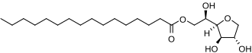

Figure S1. Chemical structure of sorbitan monopalmitate (Span 40)

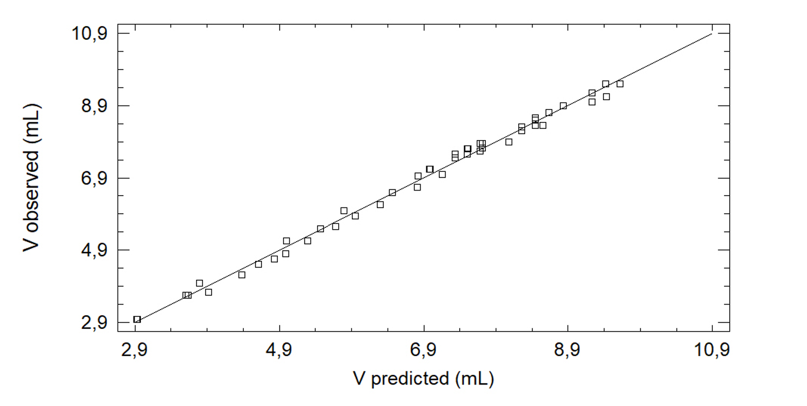
Figure S2. Agreement between experimentally measured and predicted bioSUPRAS volumes.

A)
B)

Figure S3. Effect of synthesis conditions on the water content in the bioSUPRAS. (A) Variation of water content with 1-propanol proportion (60–80%, v/v) at a constant Na₂SO₄ concentration (0.14 M). (B) Variation of water content with Na₂SO₄ concentration (0.14–0.40 M) at a constant 1-propanol/water ratio (60/40, v/v). Orange and blue curves correspond to systems containing 0.10 and 0.16% (w/v) Span 40, respectively.

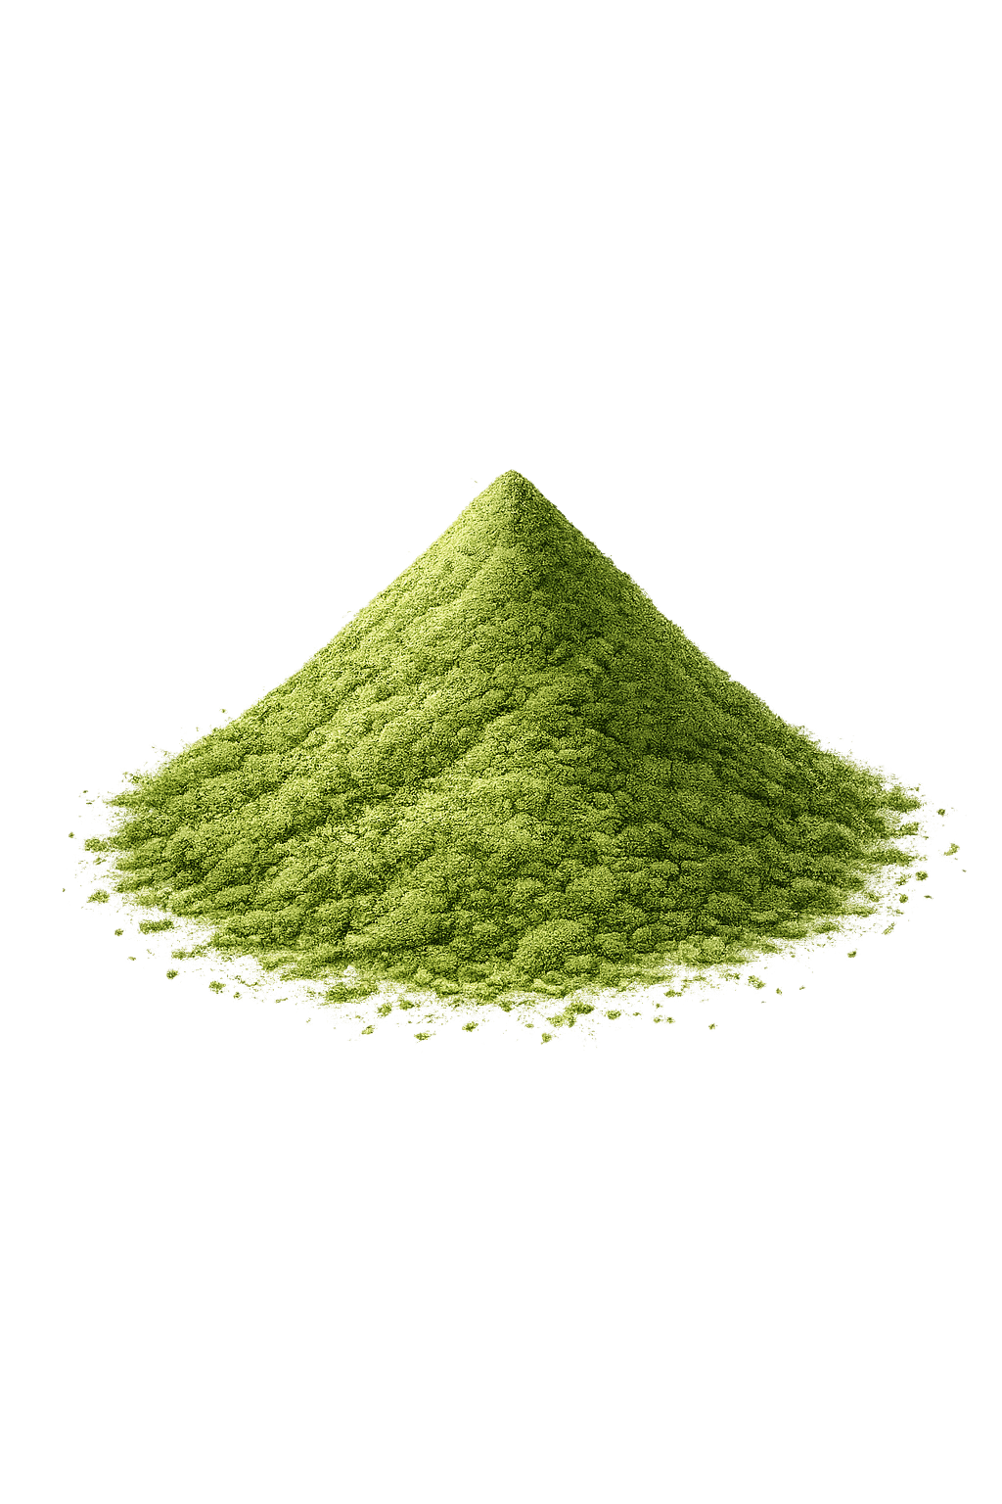

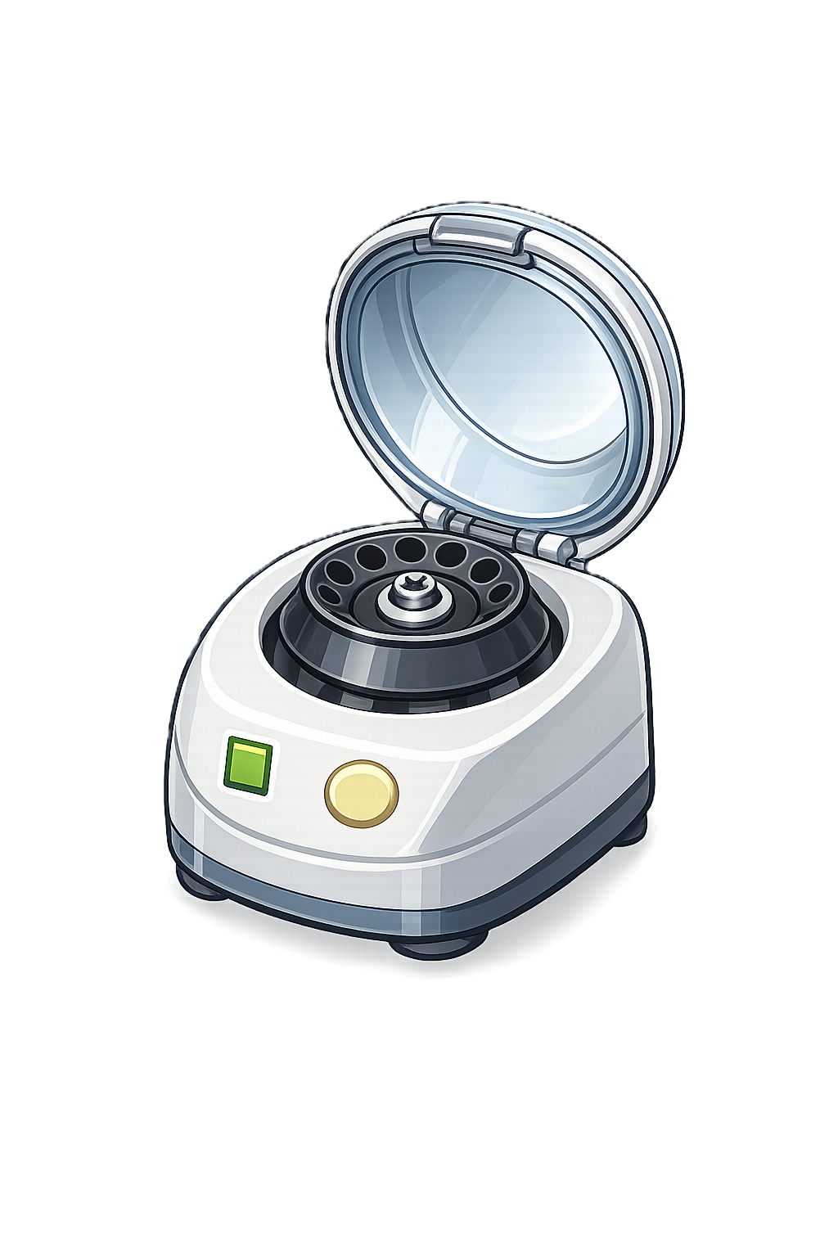
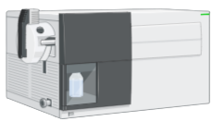
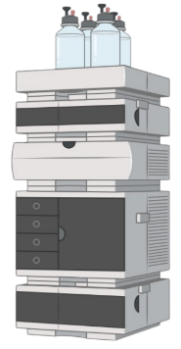
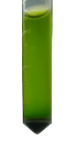
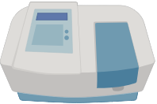
0.1 g of powdered sample
1. bioSUPRAS-based extraction
2. Determination
Vortex-shaking
(10 min, 3000 rpm)
Centrifugation
(10 min, 8000g)
+
1.5 ml of bioSUPRAS
Bioactive-rich SUPRAS extract
Total phenolic content (TPC)
Total flavonoid content (TFC)
Total carotenoid content (TCC)
Quantification by LC-MS/MS of bioactive compounds (Agilent 6420 series)

Figure S4. General scheme for the extraction of bioactives from Morus alba L. leaves using a Span 40-based bioSUPRAS.

A)

B)

C)

Figure S5. Effect of bioSUPRAS composition on (A) total phenolic content (TPC), (B) total flavonoid content (TFC), and (C) total carotenoid content (TCC) extracted from white mulberry leaves. BioSUPRASs were prepared at a constant Na₂SO₄ concentration (0.20 M) using 0.10–0.20% (w/v) Span 40 and 60–80% (v/v) 1-propanol. Blue, orange, and green bars correspond to 60, 70, and 80% (v/v) 1-propanol, respectively.

Figure S6. Effect of vortex-assisted extraction time on the recovery of bioactive compounds from white mulberry leaves, expressed as total phenolic, total flavonoid, and total carotenoid contents.

