Table 4. Chemical structures, molecular formulas, and physicochemical properties relevant to the extraction of the investigated phenolic compounds.
Compound | Chemical structure | Molecular formula | Molecular weigh; g/mol | CAS number | ªlog P | ªH-bond donors | ªH-bond acceptors | Retention time (min) | Equation | Linearity (R²) | mg of compound/ L SUPRAS (n=3)(𝑥̄ ± SD) | mg of compound/ 100g DW  (𝑥̄ ± SD)
Flavonoids
Fisetin | 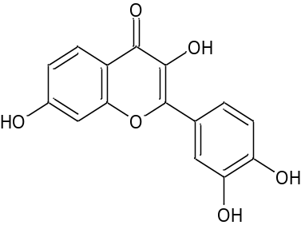 | C₁₅H₁₀O₆ | 286.24 | 528-48-3 | 2 | 4 | 6 | 20.5 | y=198x+ 20 | 0.9973 | 1.60 ± 0.05 | 23.8 ± 0.7
Neohesperidin | 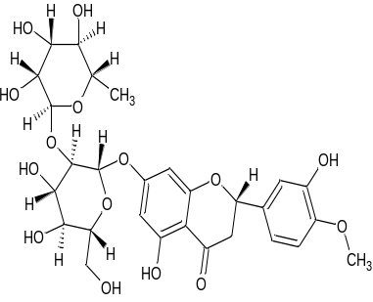 | C₂₈H₃₄O₁₅ | 610.60 | 13241-33-3 | -0.5 | 8 | 15 | 16.7 | y=1965x + 20 | 0.9960 | 2.20 ± 0.01 | 33.3 ± 0.3
Luteolin | 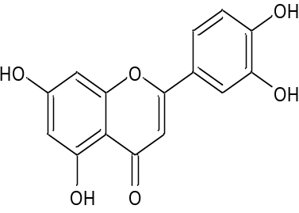 | C₁₅H₁₀O₆ | 286.20 | 491-70-3 | 1.4 | 4 | 6 | 20.5 | y=2043x + 300 | 0.9950 | 1.6 ± 0.1 | 24 ± 2
Morin | 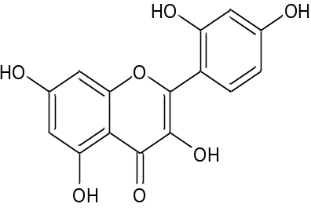 | C₁₅H₁₀O₇ | 302.20 | 480-16-0 | 1.5 | 5 | 7 | 19.2 | y=3980x + 400 | 0.9949 | 0.090 ± 0.005 | 1.3 ± 0.1
Oxyresveratrol | 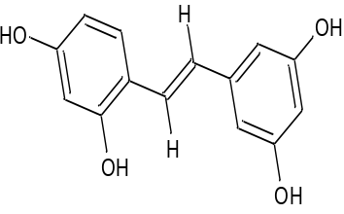 | C₁₄H₁₂O₄ | 244.20 | 29700-22-9 | 2.8 | 4 | 4 | 15.6 | y=308x + 14 | 0.9992 | 2.0 ± 0.1 | 30 ± 2
Phloridzin | 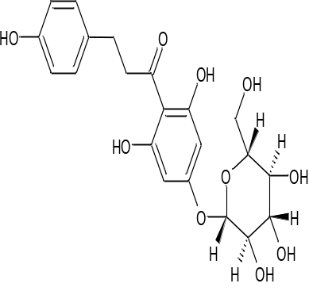 | C₂₁H₂₄O₁₀ | 436.40 | 4192-90-9 | 1.2 | 7 | 10 | 17.2 | y=5910x + 156 | 0.9992 | 0.25 ± 0.01 | 3.9 ± 0.2
Piceatannol | 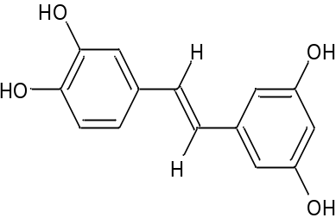 | C₁₄H₁₂O₄ | 244.20 | 10083-24-6 | 2.9 | 4 | 4 | 15.2 | y=1030x - 67.3 | 0.9989 | 0.405 ± 0.005 | 6.1 ± 0.1
Rutin | 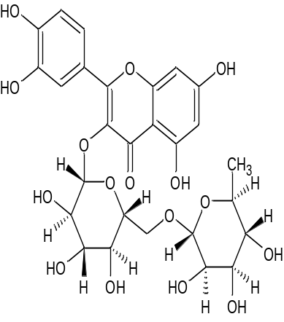 | C₂₇H₃₀O₁₆ | 610.50 | 153-18-4 | -1.3 | 10 | 16 | 16.8 | y=285x + 30 | 0.9919 | 5.4 ± 0.1 | 82 ± 2
Taxifolin | 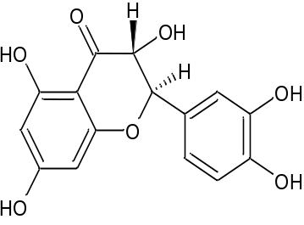 | C₁₅H₁₂O | 304.20 | 480-18-2 | 1.5 | 5 | 7 | 14.5 | y=492x + 64 | 0.9988 | 0.55 ± 0.03 | 8.1 ± 0.5
Phenolic acids
Chlorogenic acid | 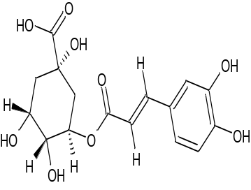 | C₁₆H₁₈O₉ | 354.30 | 327-97-9 | -0.4 | 6 | 9 | 10.6 | y=2457x + 588 | 0.9975 | 3.0 ± 0.1 | 44 ± 2
ª Values obtained from PubChem (https://pubchem.ncbi.nlm.nih.gov/)

