Supplimentarey Table -1: Pharmaconet score of ER ligand obtained from the virtual screening calculation against the agonist and antagonist conformation structure of ERα.

Agonist Pharmacophore (PDB: 1ERE) |  | Antagonist Pharmacophore (PDB: 6CHZ)
Compound | PharmacoNetScore | Compund | PharmacoNetScore
Lasofoxifene | 204.6875 | C3R | 136.7621
Clomifene | 194.3441 | Clomifene | 127.101
Fulvestrant | 170.3751 | Fulvestrant | 96.9014
C3R | 169.4248 | Lasofoxifene | 90.9607
Tamoxifen | 165.159 | Ormeloxifene | 83.594
Toremifene | 157.4084 | Raloxifene | 82.0564
Ospemifene | 157.2658 | Tamoxifen | 80.2242
Miroestrol | 148.215 | Toremifene | 80.109
ediol | 141.8442 | Ospemifene | 69.9301
Raloxifene | 137.3004 | Cyclofenil | 69.2035
Coumestrol | 132.9885 | ediol | 62.6529
Ormeloxifene | 127.5122 | Miroestrol | 55.5818
Cyclofenil | 125.7018 | Genistein | 51.3224
Diadzein | 113.8629 | Formononetin | 48.9656
Formononetin | 113.856 | Diadzein | 48.962
Resveratrol | 96.727 | Coumestrol | 45.5396
Genistein | 80.4138 | Resveratrol | 40.8032

Supplimentary Table-2: Binding free energy of C3R binding to the agonist and antagonist conformations of ERα ligand binding domains, and cavity volume of the respective structures.
Target | Agonist PDB ID | Agonist (kcal/mol) | Cavity volume (Å³) | Antagonist PDB ID | Antagonist (kcal/mol) | Cavity volume (Å³)
ERα | 1ERE | -7.3 | 476 | 6CHZ | -8.2 | 1228

Target | Agonist PDB ID | Agonist (kcal/mol) | Cavity volume (Å³)
ERβ | 1QKM | +6.9 | 365
Supplimentary Table-3: Binding free energy of C3R binding to the agonist conformations of ERβ ligand binding domains, and cavity volume of the respective structures.

Supplimentary Figures
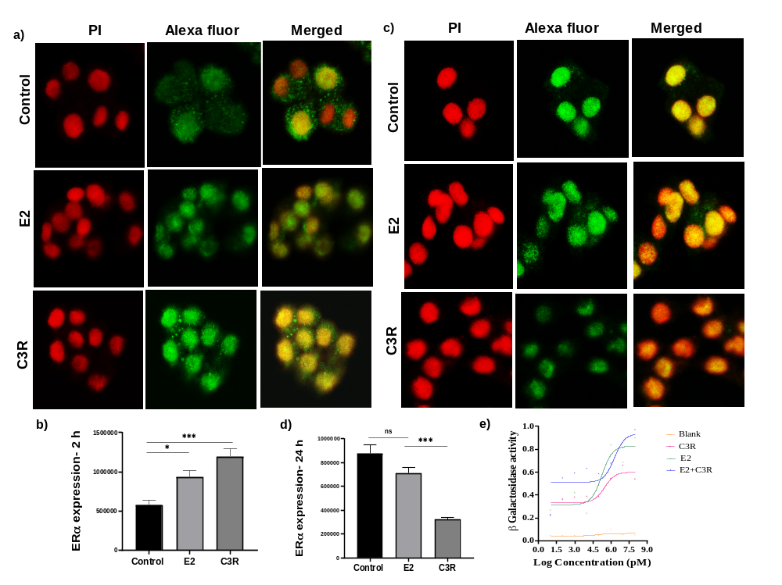
-
Supplimentary Figure-1: Time depandant activation and expression of ERα in T47D cells.
Confocal images showing the nuclear and cytoplasmic expression of ERα in T47D cells a) at early treatment with C3R b)Bar graph shows the total expression of ER α in both at early treatment with C3R. c) Confocal images showing the nuclear and cytoplasmic expression of ERα in T47D cells at late treatment with C3R by by 40X objective and d) Bar graph shows the total expression of ER α at late treatment with C3R (mean ± SEM, ***P < 0.001 , *P < 0.05). e) Agonistic activity of C3R to human estrogen receptor α in Yeast reporter assay(YES) (β-Gal expression).

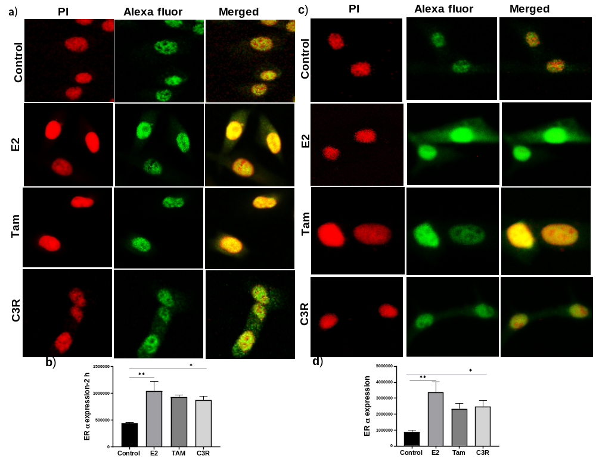
Supplimentary Figure-2- C3R and Tamoxifen exhibited ER-α agonistic activity in MG-63 osteosarcoma cells at both early and late pre-treatment time points.
Confocal images showing the nuclear and cytoplasmic expression of ERα in MG-63 cells a) at early treatment with C3R b) Bar graph shows the total ER α expression at early treatment with C3R in MG-63 cells c) Confocal images showing the nuclear and cytoplasmic expression of ERα in MG-63 cells at late treatment with C3R by by 40X objective d) Bar graph shows the total ER α expression at late treatment with C3R in MG-63 cells (mean ± SEM, **P < 0.01 , *P < 0.05)

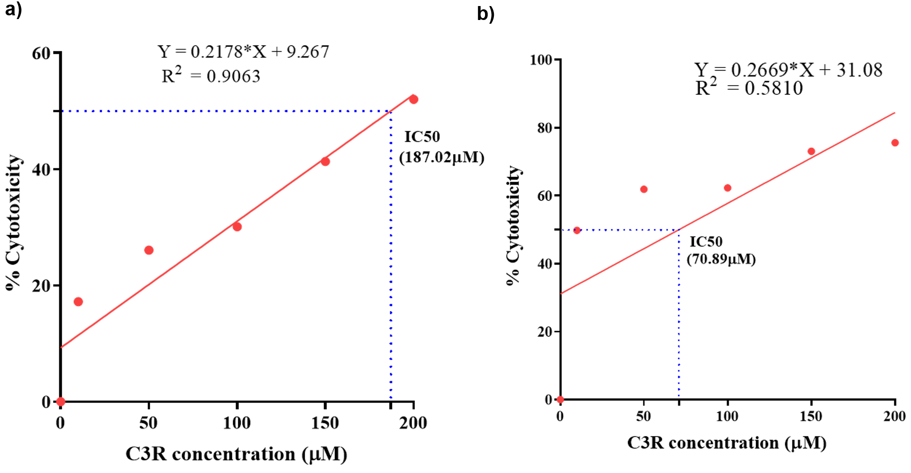

Supplementary Figure 3. Determination of IC50 of C3R in MCF-7 and T47D cells using MTT assay.
(a) Dose-response curve of C3R in MCF-7 cells at concentrations of 10, 50, 100, 150, and 200 µM showing the IC50 (187.02 µM) (b) Dose-response curve of C3R in T47D showing IC50 (70.89 µM) . The IC50 were calculated using linear regression (y = mx + c, where y = % cell viability, m = slope, x = C3R concentration, and c = y-intercept).

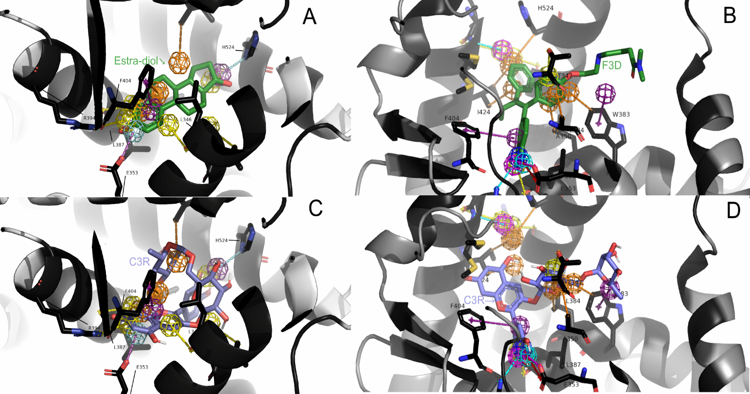
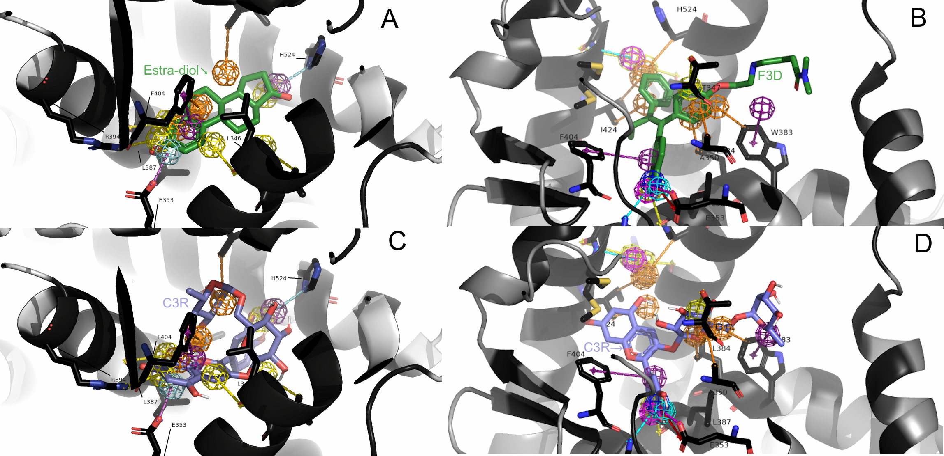
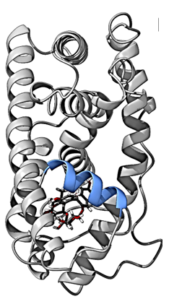
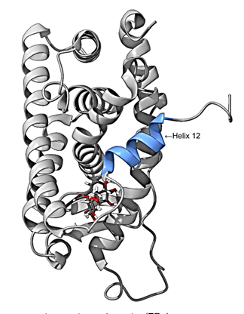
a)
b)
d)
c)
d)

Supplimantary Figure-3 : Representation of pharmacophore model of ER ligand binding domains
a: estra-diol bound to ERα in Agonist conformation, b: ER antagonist H3B-9224 bound to the Antagonist conformation of ERα, The pharmacophore features are coloured as follows: Oarnge:Hydrophobic; Magenta: Aromatic; Cyan: Hbond donor; Yellow; Halogen bond acceptors; Navy Blue: Hbond acceptor. The experimental structures are represented as green sticks, and C3R structure is represented as blue sticks. Fig_. Docked complexes of C3R bound to ligand binding domain of ERα in agonist conformation (c) and antagonist conformation (d).

