Appendix-I Supplementary Data
Table S1: Compound List
Compound ID | SMILES
IMPHY000449 | CC(=CCOc1c2ccoc2cc2c1ccc(=O)o2)CC1OC(=O)C(=C1)C
IMPHY003757 | C/C(=CCOc1c2occc2cc2c1oc(=O)cc2)/CC1C=C(C(=O)O1)C
IMPHY005428 | COc1c2ccc(=O)oc2cc2c1cco2
IMPHY001745 | O=C(C(C)C)Cc1c(OCC(C(O)(C)C)O)ccc2c1oc(=O)cc2
IMPHY008465 | O=C(C(C)C)Cc1c(OCC2OC2(C)C)ccc2c1oc(=O)cc2
IMPHY000879 | COc1ccc2c(c1CC(=O)C(C)C)oc(=O)cc2
IMPHY009650 | COc1ccc2c(c1CC(C(=C)C)O)oc(=O)cc2

Table S2: Physicochemical Properties
Compound | Formula | MW | #Heavy | #Aromatic | Csp3 | RotB | HBA | HBD | MR | TPSA
IMPHY000449 | C21H18O6 | 366.36 | 27 | 13 | 0.24 | 5 | 6 | 0 | 100.23 | 78.88
IMPHY003757 | C21H18O6 | 366.36 | 27 | 13 | 0.24 | 5 | 6 | 0 | 100.23 | 78.88
IMPHY005428 | C12H8O4 | 216.19 | 16 | 13 | 0.08 | 1 | 4 | 0 | 58.75 | 52.58
IMPHY001745 | C19H24O6 | 348.39 | 25 | 10 | 0.47 | 7 | 6 | 2 | 94.96 | 96.97
IMPHY008465 | C19H22O5 | 330.37 | 24 | 10 | 0.47 | 6 | 5 | 0 | 91.61 | 69.04
IMPHY000879 | C15H16O4 | 260.29 | 19 | 10 | 0.33 | 4 | 4 | 0 | 73.37 | 56.51
IMPHY009650 | C15H16O4 | 260.29 | 19 | 10 | 0.27 | 4 | 4 | 1 | 73.86 | 59.67

Table S3: Partitioning & Solubility
Compound | iLOGP | XLOGP3 | WLOGP | MLOGP | Silicos-IT LogP | Consensus LogP | ESOL LogS | ESOL Sol (mg/ml) | Ali LogS | Silicos-IT Sol (mg/ml) | Silicos-IT Class
IMPHY000449 | 3.47 | 3.73 | 4.13 | 2.33 | 4.49 | 3.63 | -4.49 | 0.0119 | -5.08 | 0.000276 | Poorly soluble
IMPHY003757 | 3.54 | 3.8 | 4.13 | 2.33 | 4.49 | 3.66 | -4.53 | 0.0108 | -5.15 | 0.000276 | Poorly soluble
IMPHY005428 | 2.29 | 1.93 | 2.55 | 1.18 | 2.88 | 2.16 | -2.93 | 0.253 | -2.66 | 0.00501 | Moderately soluble
IMPHY001745 | 2.78 | 1.86 | 2.07 | 1.1 | 3.64 | 2.29 | -3.01 | 0.344 | -3.52 | 0.00843 | Moderately soluble
IMPHY008465 | 3.08 | 2.85 | 3.12 | 1.91 | 4.86 | 3.16 | -3.6 | 0.0837 | -3.96 | 0.000615 | Moderately soluble
IMPHY000879 | 2.44 | 2.54 | 2.57 | 1.78 | 3.73 | 2.61 | -3.18 | 0.172 | -3.37 | 0.00314 | Moderately soluble
IMPHY009650 | 2.47 | 2.76 | 2.28 | 1.78 | 3.42 | 2.54 | -3.32 | 0.125 | -3.67 | 0.00915 | Moderately soluble

Table S4: Pharmacokinetics (ADME)
Compound | GI abs | BBB | P-gp | CYP1A2 | CYP2C19 | CYP2C9 | CYP2D6 | CYP3A4 | log Kp
IMPHY000449 | High | No | No | Yes | Yes | Yes | No | Yes | -5.89
IMPHY003757 | High | No | No | Yes | Yes | Yes | No | Yes | -5.84
IMPHY005428 | High | Yes | No | Yes | No | No | No | No | -6.25
IMPHY001745 | High | No | Yes | No | No | No | No | No | -7.1
IMPHY008465 | High | Yes | No | No | Yes | Yes | Yes | Yes | -6.29
IMPHY000879 | High | Yes | No | Yes | Yes | No | No | No | -6.08
IMPHY009650 | High | Yes | No | No | No | No | No | No | -5.93

Table S5: Drug-likeness & Synthetic Accessibility
Compound | Lipinski viol | Ghose viol | Veber viol | Egan viol | Muegge viol | Bioavailability | PAINS | Brenk | Leadlikeness | SA
IMPHY000449 | 0 | 0 | 0 | 0 | 0 | 0.55 | 0 | 2 | 2 | 4.12
IMPHY003757 | 0 | 0 | 0 | 0 | 0 | 0.55 | 0 | 2 | 2 | 4.11
IMPHY005428 | 0 | 0 | 0 | 0 | 0 | 0.55 | 0 | 1 | 1 | 2.9
IMPHY001745 | 0 | 0 | 0 | 0 | 0 | 0.55 | 0 | 1 | 0 | 4.14
IMPHY008465 | 0 | 0 | 0 | 0 | 0 | 0.55 | 0 | 2 | 0 | 4.06
IMPHY000879 | 0 | 0 | 0 | 0 | 0 | 0.55 | 0 | 1 | 0 | 3.06
IMPHY009650 | 0 | 0 | 0 | 0 | 0 | 0.55 | 0 | 2 | 0 | 3.51

Table S6: Network results
Parameters | C-T | D-T | C-T-D
Clustering coefficient | 0 | 0 | 0
Connected components | 2 | 1 | 2
Network diameter | 1 | 1 | 1
Network radius | 1 | 1 | 1
Shoetest paths | 2542(0%) | 466(2%) | 3008(0%)
Characteristic path length: | 1 | 1 | 1
Avg. number of neighbors | 6.185 | 7.008 | 7.17
Number of nodes | 8.22 | 133 | 839
Multi-edge node pairs | 1256 | 0 | 0
Analysis time(sec) | 0.295 | 0.029 | 0.704

Table S7: Top entity based on degree of C-T-D network.
Sl No | Average Shortest Path Length | Betweenness Centrality | Closeness Centrality | Clustering Coefficient | Degree | Eccentricity | Matching Attribute | Radiality
1 | 1.000000 | 0.041074 | 1.000000 | 0.506073 | 39 | 1 | IMPHY005428 | 1.000000
2 | 1.000000 | 0.041074 | 1.000000 | 0.506073 | 39 | 1 | IMPHY008915 | 1.000000
3 | 1.000000 | 0.041074 | 1.000000 | 0.506073 | 39 | 1 | IMPHY014906 | 1.000000
4 | 1.000000 | 0.041074 | 1.000000 | 0.506073 | 39 | 1 | IMPHY014885 | 1.000000
5 | 1.000000 | 0.041074 | 1.000000 | 0.506073 | 39 | 1 | IMPHY012586 | 1.000000
6 | 1.000000 | 0.041074 | 1.000000 | 0.506073 | 39 | 1 | IMPHY011938 | 1.000000
7 | 1.000000 | 0.041074 | 1.000000 | 0.506073 | 39 | 1 | IMPHY010516 | 1.000000
8 | 1.000000 | 0.041074 | 1.000000 | 0.506073 | 39 | 1 | IMPHY005074 | 1.000000
9 | 1.000000 | 0.041074 | 1.000000 | 0.506073 | 39 | 1 | IMPHY000045 | 1.000000
10 | 1.000000 | 0.041074 | 1.000000 | 0.506073 | 39 | 1 | IMPHY001134 | 1.000000
11 | 1.000000 | 0.041074 | 1.000000 | 0.506073 | 39 | 1 | IMPHY004940 | 1.000000
12 | 1.205128 | 0.020693 | 0.829787 | 0.591398 | 31 | 2 | EGFR | 0.897436
13 | 1.205128 | 0.020693 | 0.829787 | 0.591398 | 31 | 2 | PIK3CA | 0.897436
14 | 1.666667 | 0.000056 | 0.600000 | 0.987179 | 13 | 2 | IMPHY009650 | 0.666667
15 | 1.666667 | 0.000056 | 0.600000 | 0.987179 | 13 | 2 | Pathways in cancer | 0.666667
16 | 1.666667 | 0.000056 | 0.600000 | 0.987179 | 13 | 2 | IMPHY000449 | 0.666667
17 | 1.666667 | 0.000056 | 0.600000 | 0.987179 | 13 | 2 | IMPHY003993 | 0.666667
18 | 1.666667 | 0.000056 | 0.600000 | 0.987179 | 13 | 2 | Breast cancer | 0.666667
19 | 1.666667 | 0.000056 | 0.600000 | 0.987179 | 13 | 2 | PD-L1 expression and PD-1 checkpoint pathway in cancer | 0.666667
20 | 1.666667 | 0.000056 | 0.600000 | 0.987179 | 13 | 2 | IMPHY002840 | 0.666667
21 | 1.666667 | 0.000056 | 0.600000 | 0.987179 | 13 | 2 | Central carbon metabolism in cancer | 0.666667
22 | 1.666667 | 0.000056 | 0.600000 | 0.987179 | 13 | 2 | IMPHY008465 | 0.666667
23 | 1.666667 | 0.000056 | 0.600000 | 0.987179 | 13 | 2 | Proteoglycans in cancer | 0.666667
24 | 1.666667 | 0.000056 | 0.600000 | 0.987179 | 13 | 2 | Prostate cancer | 0.666667
25 | 1.666667 | 0.000056 | 0.600000 | 0.987179 | 13 | 2 | MicroRNAs in cancer | 0.666667
26 | 1.666667 | 0.000056 | 0.600000 | 0.987179 | 13 | 2 | IMPHY016921 | 0.666667
27 | 1.692308 | 0.000000 | 0.590909 | 1.000000 | 12 | 2 | IMPHY008913 | 0.653846
28 | 1.692308 | 0.000000 | 0.590909 | 1.000000 | 12 | 2 | IMPHY008914 | 0.653846
29 | 1.692308 | 0.000000 | 0.590909 | 1.000000 | 12 | 2 | IMPHY013007 | 0.653846
30 | 1.692308 | 0.000000 | 0.590909 | 1.000000 | 12 | 2 | IMPHY003757 | 0.653846
31 | 1.692308 | 0.000000 | 0.590909 | 1.000000 | 12 | 2 | IMPHY004423 | 0.653846
32 | 1.692308 | 0.000000 | 0.590909 | 1.000000 | 12 | 2 | IMPHY003373 | 0.653846
33 | 1.692308 | 0.000000 | 0.590909 | 1.000000 | 12 | 2 | IMPHY001745 | 0.653846
34 | 1.692308 | 0.000000 | 0.590909 | 1.000000 | 12 | 2 | IMPHY000879 | 0.653846
35 | 1.692308 | 0.000000 | 0.590909 | 1.000000 | 12 | 2 | IMPHY005587 | 0.653846
36 | 1.692308 | 0.000000 | 0.590909 | 1.000000 | 12 | 2 | IMPHY013173 | 0.653846
37 | 1.692308 | 0.000000 | 0.590909 | 1.000000 | 12 | 2 | IMPHY006381 | 0.653846
38 | 1.692308 | 0.000000 | 0.590909 | 1.000000 | 12 | 2 | IMPHY007198 | 0.653846
39 | 1.692308 | 0.000000 | 0.590909 | 1.000000 | 12 | 2 | IMPHY007590 | 0.653846
40 | 1.692308 | 0.000000 | 0.590909 | 1.000000 | 12 | 2 | IMPHY012352 | 0.653846

Table S8: List of Compounds targeting- EGFR
Drug Target
S.N. | Target Name | PDB ID, Resolution
01 | EGFR | 1M17, 2.69 A
Natural Product
S.N. | IMPPAT ID | Name
C1 | IMPHY000449 | Anisolactone
C2 | IMPHY001745 | Triphasiol
C3 | IMPHY003757 | 9-[(E)-3-methyl-4-(4-methyl-5-oxo-2H-furan-2-yl)but-2-enoxy]furo[3,2-g]chromen-7-one
C4 | IMPHY008465 | Isoponcimarin
C5 | IMPHY009650 | Auraptenol
C6 | IMPHY000879 | Isomeranzin
C7 | IMPHY005428 | Bergapten
Reference, Co-crystallized ligand | AQ4999

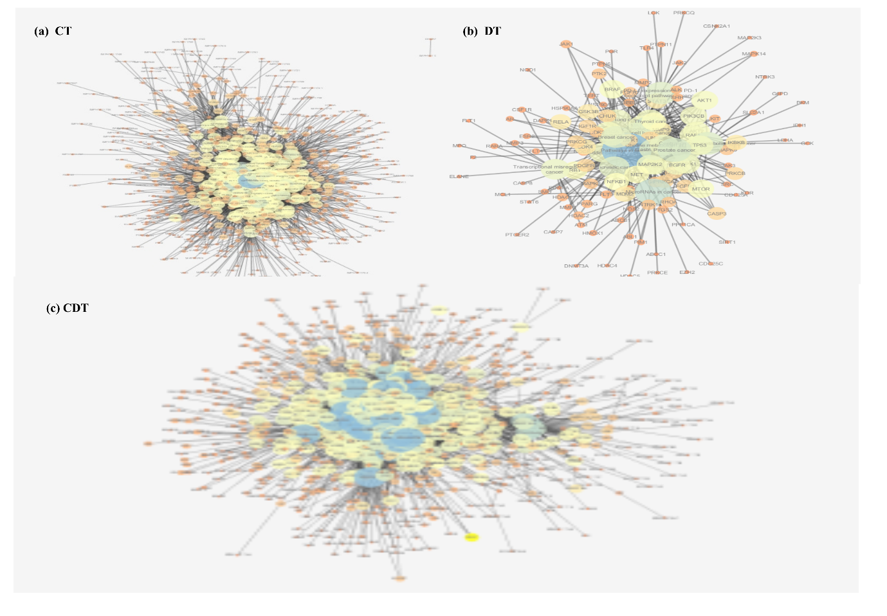
Figure S1: Construction of C-T(a), D-T(b) and C-T-D(c) network.
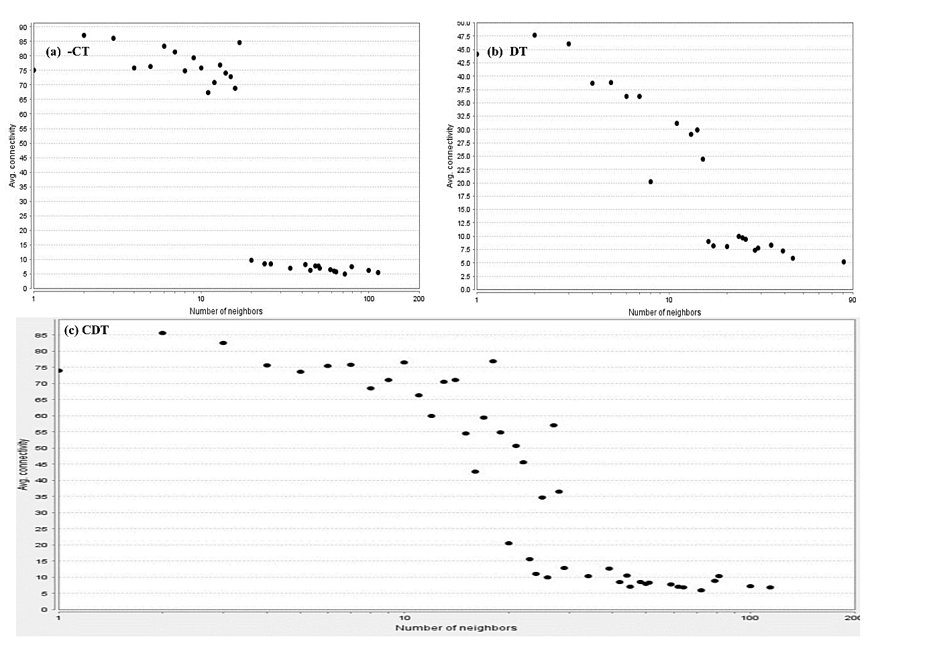Figure S2: Network parameters showing the indegree distribution of the networks: (a) C–T, (b) D–T, and (c) C–T–D.
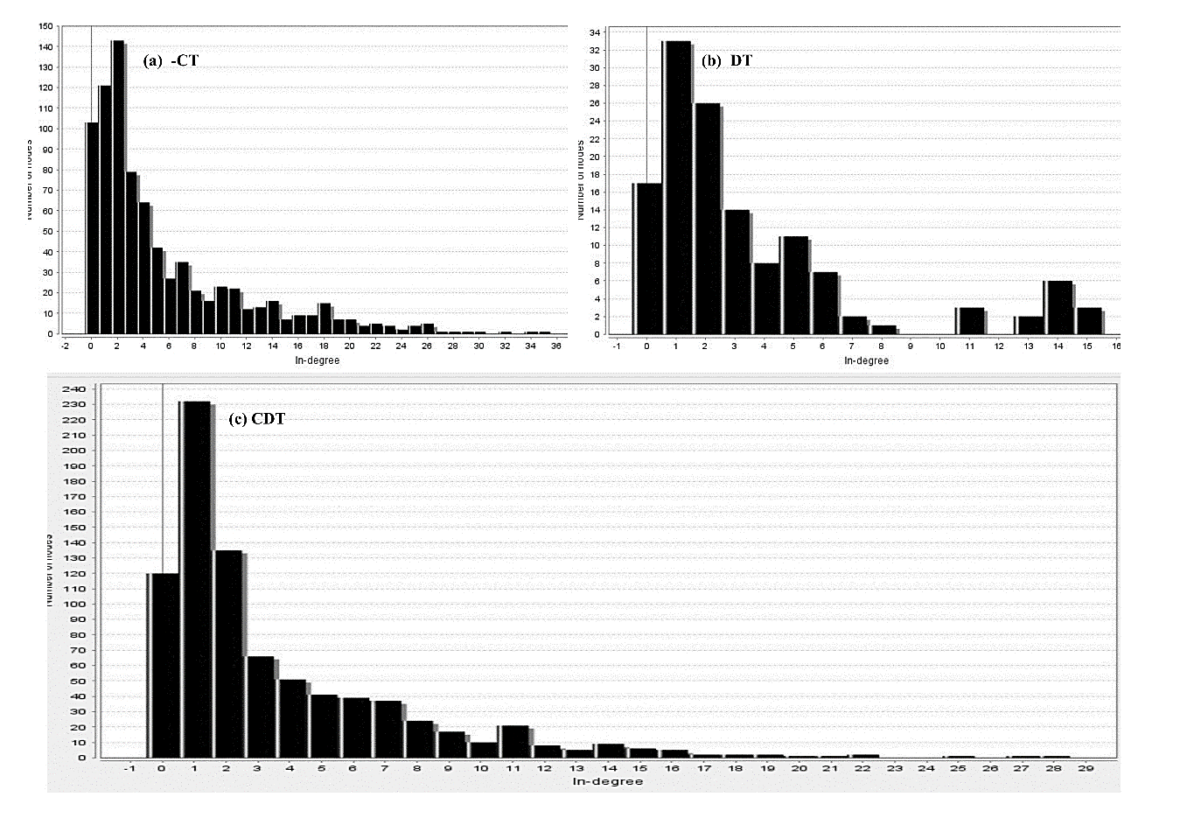
Figure S3: Network showing the Neighbourhood of the networks: (a)D-T (b)C-T, (c) C-T-D

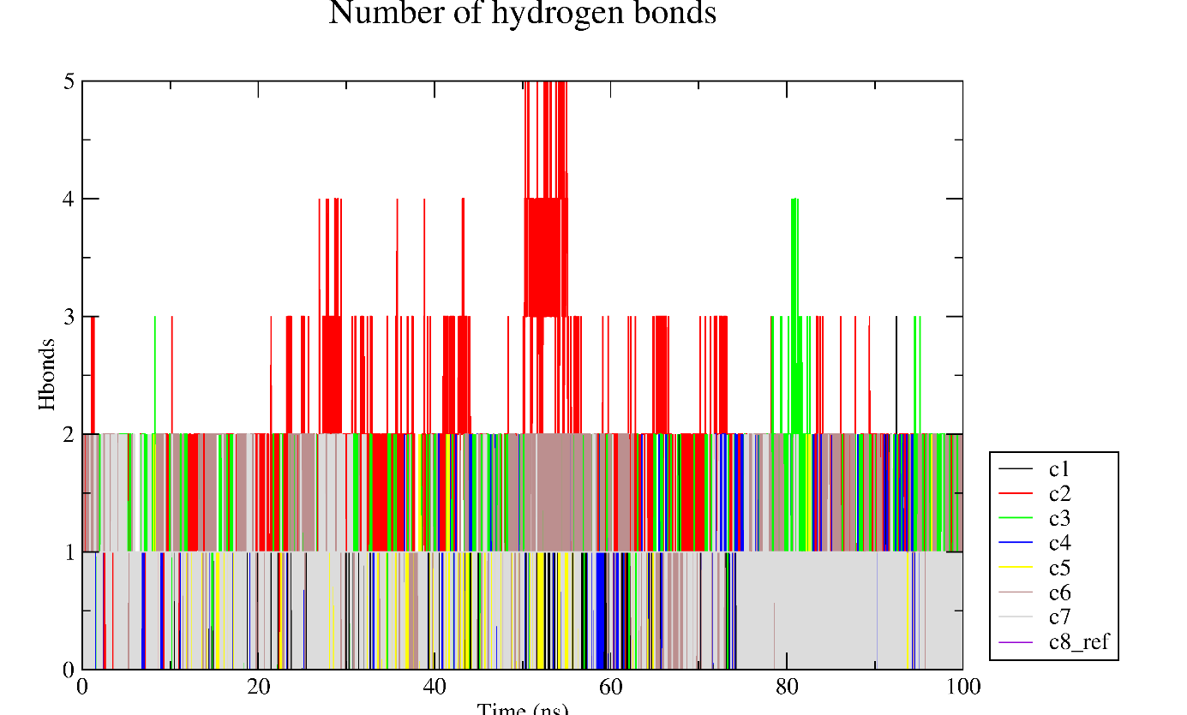
Figure S4: Hbond interactions during 100 ns MDS
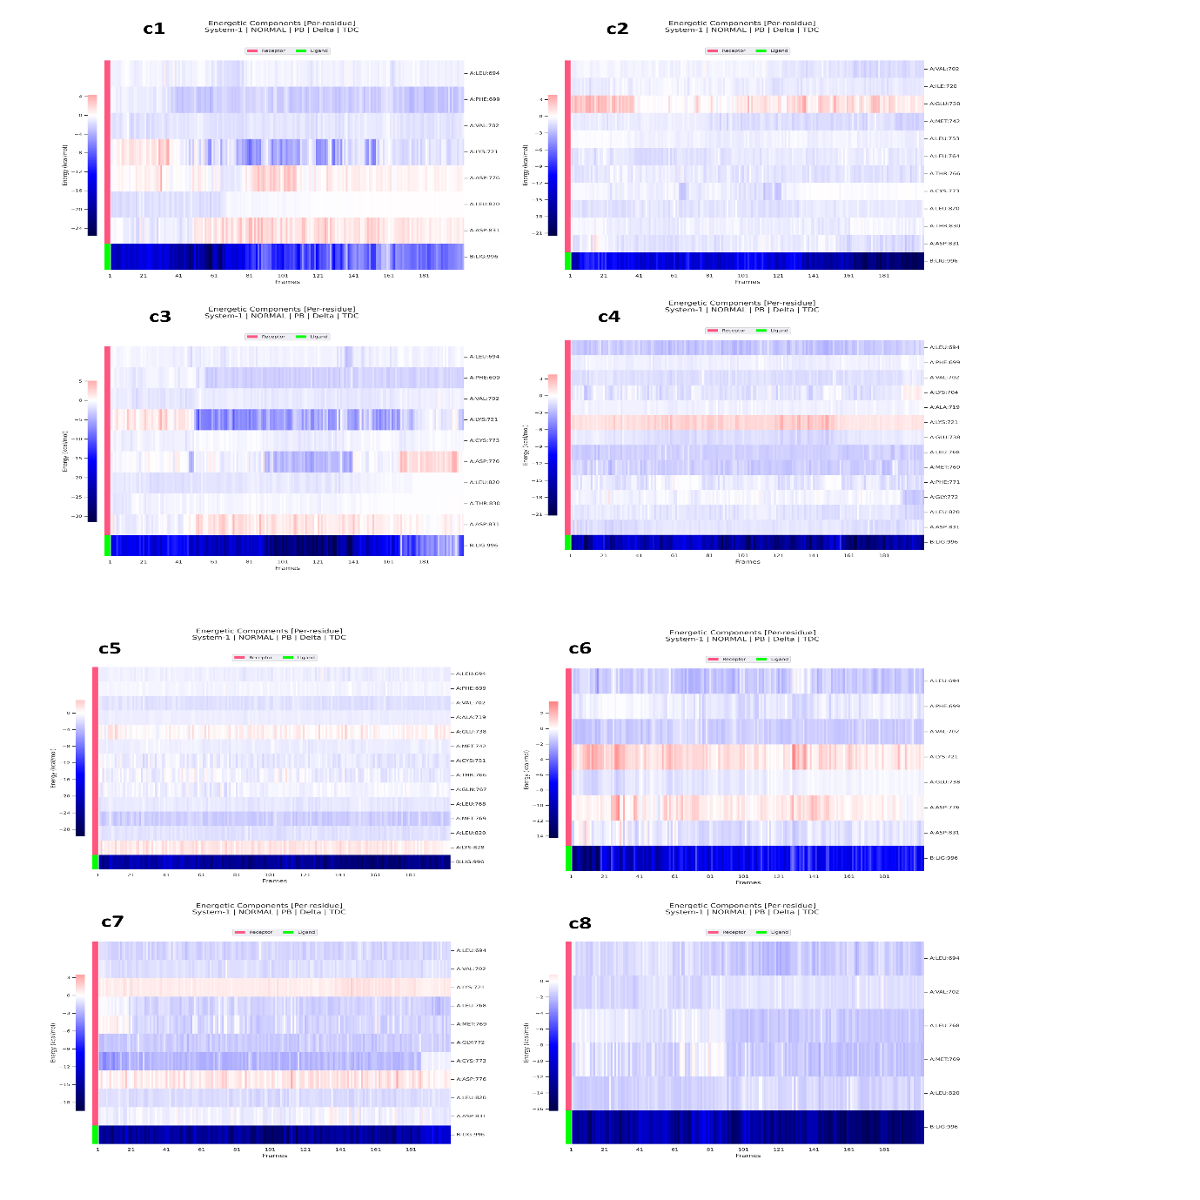
Figure S5: Per residue decomposition- MMPBSA outcome.

