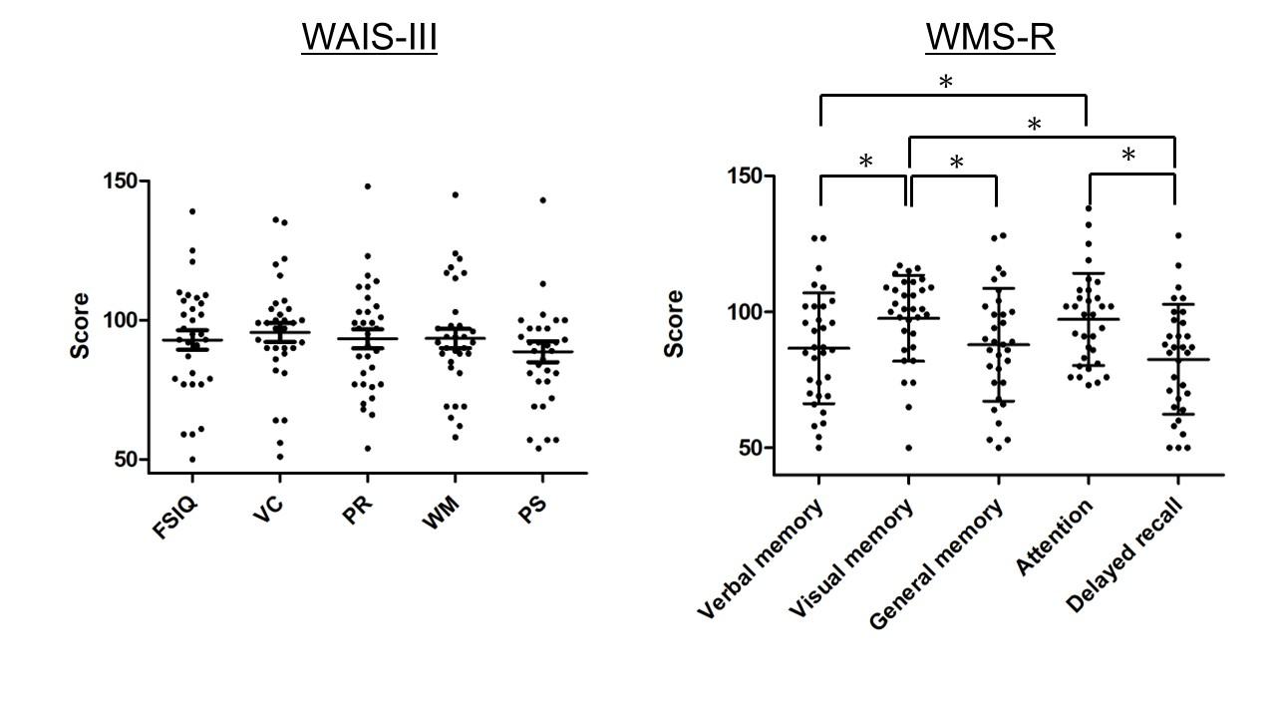
Supplementary Figure 1. Score distribution of the Wechsler Adult Intelligence Score-Third Edition (WAIS-III) and the Wechsler Memory Score-Revised Edition (WMS-R). FSIQ, full-scale intelligence quotient; VC, verbal comprehension; PR, perceptual reasoning; WM, working memory; PS, processing speed; A paired t-test was performed to compare WAIS-III and WMS-R indices with Bonferroni correction.*p < 0.05

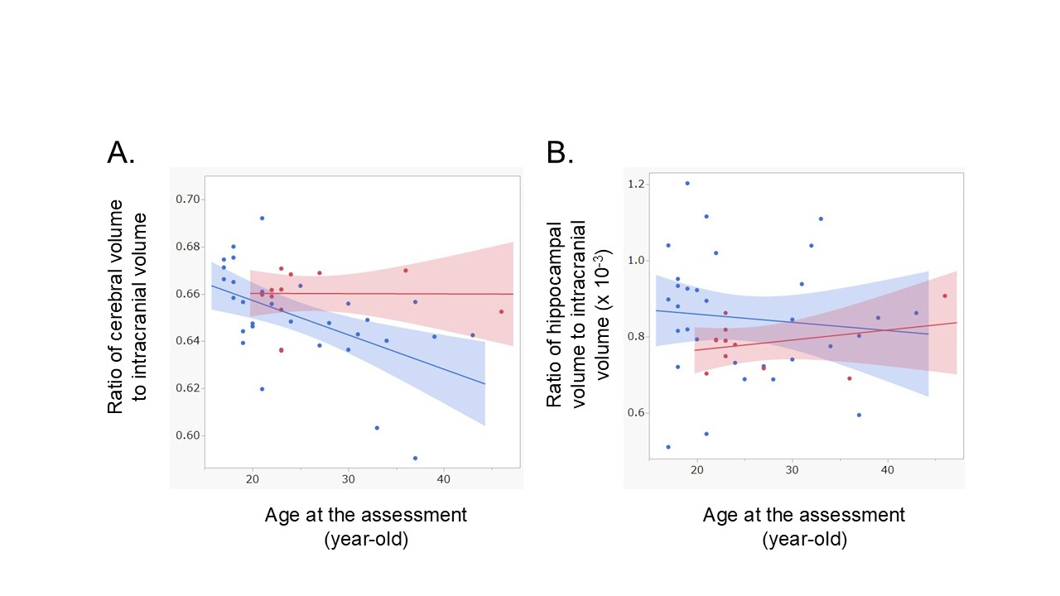
Supplementary Figure 2. Scatter plot with linear regression and 95% confidence interval demonstrating the association between the cerebral volume (A) and hippocampal volume (B) ratio to the intracranial volume and age at the assessment in patients with germinoma (blue) and healthy controls.

