Supplemental Table 1. Comparison of multivariate regression models incorporating fundoscopic grading, pRNFL thickness, and AONSD for the prediction of elevated CSF-OP (≥25cmH₂O).
 | OR (95% CI) | p-value | OR (95% CI) | p-value | OR (95% CI) | p-value
Age ≤ 40 years | 3.37 (1.21–10.04) | 0.023 | 4.61 (1.50–15.74) | 0.010 | 4.44 (1.57–13.83) | 0.007
BMI ≥ 30kg/m² | 3.44 (1.27–9.98) | 0.018 | 4.15 (1.38–14.08) | 0.015 | 3.94 (1.45–11.57) | 0.009
Frisén scale ≥ 2 | 2.78 (1.03–7.85) | 0.046 | n.a. | n.a. | n.a. | n.a.
pRNFL thickness ≥ 125µm | n.a. | n.a. | 10.49 (3.40–39.05) | <0.001 | n.a. | n.a.
AONSD ≥ 5.00mm | n.a. | n.a. | n.a. | n.a. | 2.52 (0.76–8.97) | 0.136
PGF | 0.65 (0.11–3.91) | 0.630 | 0.24 (0.03–1.88) | 0.170 | 0.55 (0.08–3.44) | 0.514
TSS | 4.61 (1.67–13.90) | 0.004 | 8.88 (2.70–35.25) | 0.001 | 4.50 (1.62–13.55) | 0.005
≥ 3 MRI signs | 4.56 (0.67–32.76) | 0.120 | 7.26 (0.85–66.91) | 0.070 | 4.70 (0.66–37.17) | 0.125
AUC (95% CI) | 0.82 (0.74–0.90) |  | 0.88 (0.81–0.95) |  | 0.82 (0.74–0.90)
AONSD: arachnoid optic nerve sheath diameter, AUC: area under the curve, BMI: body mass index, CI: confidence interval, CSF-OP: cerebrospinal fluid opening pressure, ES: empty sella, MRI: magnetic resonance imaging, OR: odds ratio, PGF: posterior globe flattening, pRNFL: peripapillary retinal nerve fibre layer, TSS: transverse sinus stenosis

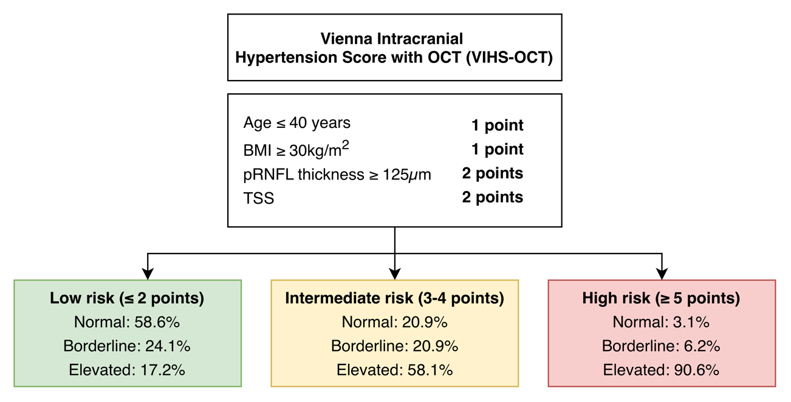
Supplemental Figure 1. Clinical application of the OCT-enhanced Vienna Intracranial Hypertension Score (VIHS-OCT) for pre-lumbar puncture risk stratification. Distribution of normal (≤20cmH₂O), borderline (>20 to <25cmH₂O), and elevated (≥25cmH₂O) CSF-OP across low- (≤2 points), intermediate- (3–4 points), and high-risk (≥5 points) VIHS-OCT categories. BMI: body mass index, CI: confidence interval, CSF-OP: cerebrospinal fluid opening pressure, OCT: optical coherence tomography, pRNFL: peripapillary retinal nerve fiber layer, TSS: transverse sinus stenosis

