Supplementary Information
County-level heterogeneity in the associations between meteorological factors and varicella incidence in Guangxi, China: a multicounty time-series study
Linlin Zhang¹†, Aihu Dong²†, Yimeng Hua¹†, Manyuan Lu¹, Qinfeng Liao¹, Guanxi Pan¹, Zhiyong Zhang ^{1,6,7,8} ,Huaxiang Lu²* and Jian Qin^{1，3，4，5**}
¹ Department of Environmental and Occupational Health, Guangxi Medical University, Nanning 530021, Guangxi Zhuang Autonomous Region, China
² Guangxi Zhuang Autonomous Region Center for Disease Prevention and Control, Nanning 530028, Guangxi Zhuang Autonomous Region, China
³ Key Laboratory of Longevity and Aging-Related Diseases of Chinese Ministry of Education, Guangxi Medical University, Nanning 530021, Guangxi Zhuang Autonomous Region, China
⁴ Guangxi Key Laboratory of Environment and Health Research, Guangxi Medical University, Nanning 530021, Guangxi Zhuang Autonomous Region, China
⁵ Guangxi Colleges and Universities Key Laboratory of Prevention and Control of Highly Prevalent Diseases, Guangxi Medical University, Nanning 530021, Guangxi Zhuang Autonomous Region, China
⁶ School of Public Health, Guilin Medical University, Guilin 541199, Guangxi Zhuang Autonomous Region, China
⁷ Guangxi Health Commission Key Laboratory of Entire Lifecycle Health and Care, Guilin Medical University, Guilin 541199, Guangxi Zhuang Autonomous Region, China
⁸ The Guangxi Key Laboratory of Environmental Exposomics and Entire Lifecycle Health, Guilin Medical University, Guilin 541199, Guangxi Zhuang Autonomous Region, China
*Corresponding authors. E-mail(s): maxpeon@hotmail.com; qinjian@gxmu.edu.cn
†These authors contributed equally to this work and share first authorship.

Supplementary Figure S1. Spearman correlations between daily varicella case counts and meteorological factors.
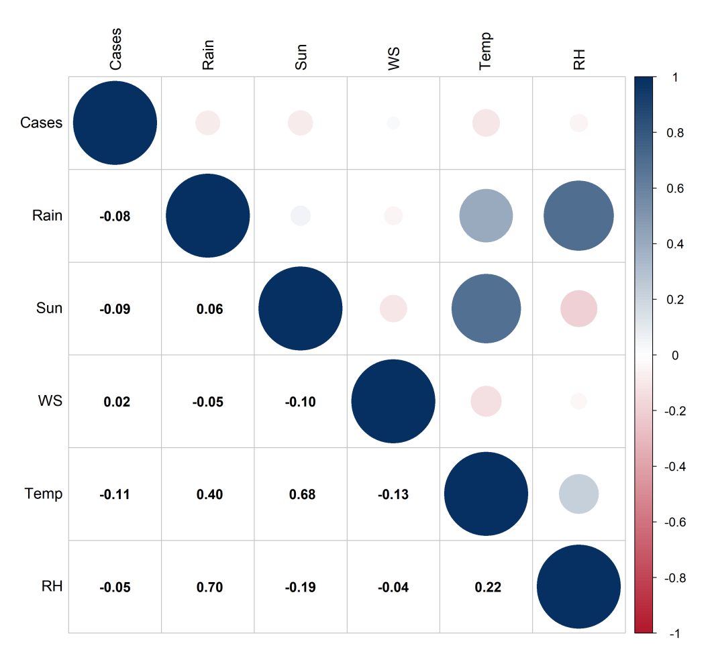
Notes: Circle size indicates the absolute magnitude of Spearman’s correlation coefficient. Blue circles indicate positive correlations and red circles indicate negative correlations. Values in the lower triangle are correlation coefficients. Cases, daily varicella case counts; Rain, rainfall; Sun, sunshine duration; WS, wind speed; Temp, mean temperature; RH, relative humidity.

Supplementary Figure S2. Annual varicella case counts and incidence rates per 100,000 population in Guangxi, China, 2010–2024.
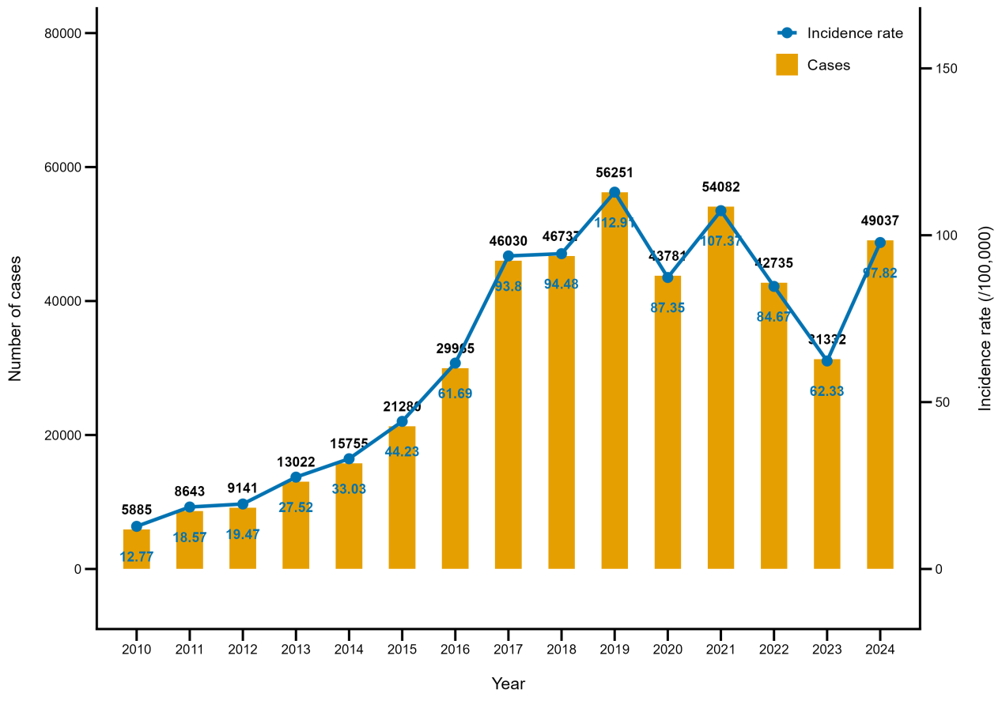
Supplementary Figure S3. Monthly seasonal indices of varicella cases in Guangxi, China, 2010–2024.
Notes: Black points and the black line represent monthly seasonal indices. The red dashed horizontal line indicates a seasonal index of 1, representing the annual average level. Values above 1 indicate months with above-average varicella activity.

Supplementary Figure S4. Two-dimensional exposure–lag–response associations between meteorological factors and varicella incidence in Guangxi, China.
Notes: Panels A–E show temperature, relative humidity, rainfall, sunshine duration, and wind speed, respectively. Colours represent RRs across exposure levels and lag days, with blue indicating RR < 1, white indicating RR = 1, and red indicating RR > 1. Black contour lines indicate RR = 1. Estimates are relative to the Guangxi-wide median of each factor.

Supplementary Figure S5. Spatial distributions of county- and district-specific BLUP-based cumulative relative risks for rainfall, sunshine duration, and wind speed at the common Guangxi-wide P5 and P95 exposure levels.
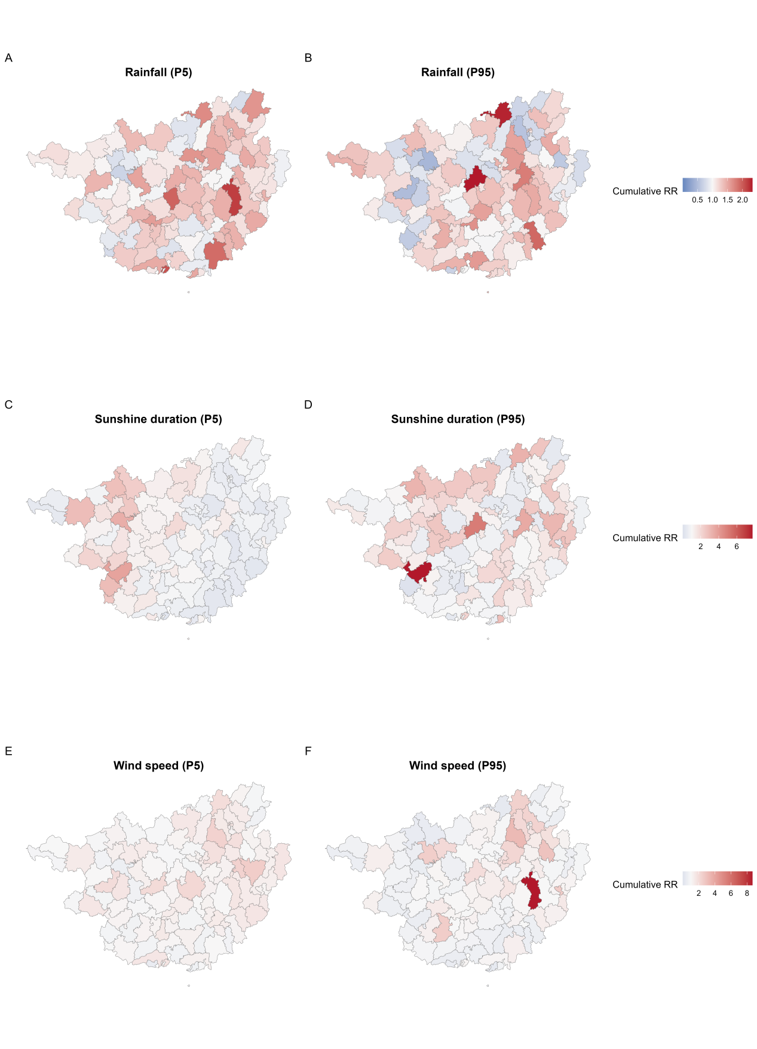Notes: Panels A and B show rainfall at P5 (0.00 mm/day) and P95 (25.38 mm/day), panels C and D show sunshine duration at P5 (2.71 h/day) and P95 (13.38 h/day), and panels E and F show wind speed at P5 (0.78 m/s) and P95 (2.99 m/s). Colours range from blue for lower RRs to red for higher RRs, with white indicating RR = 1. Estimates are cumulative RRs over lag 0–21 days relative to the corresponding Guangxi-wide median.

Supplementary Figure S6. Sensitivity analysis varying the degrees of freedom for the exposure–response dimension.
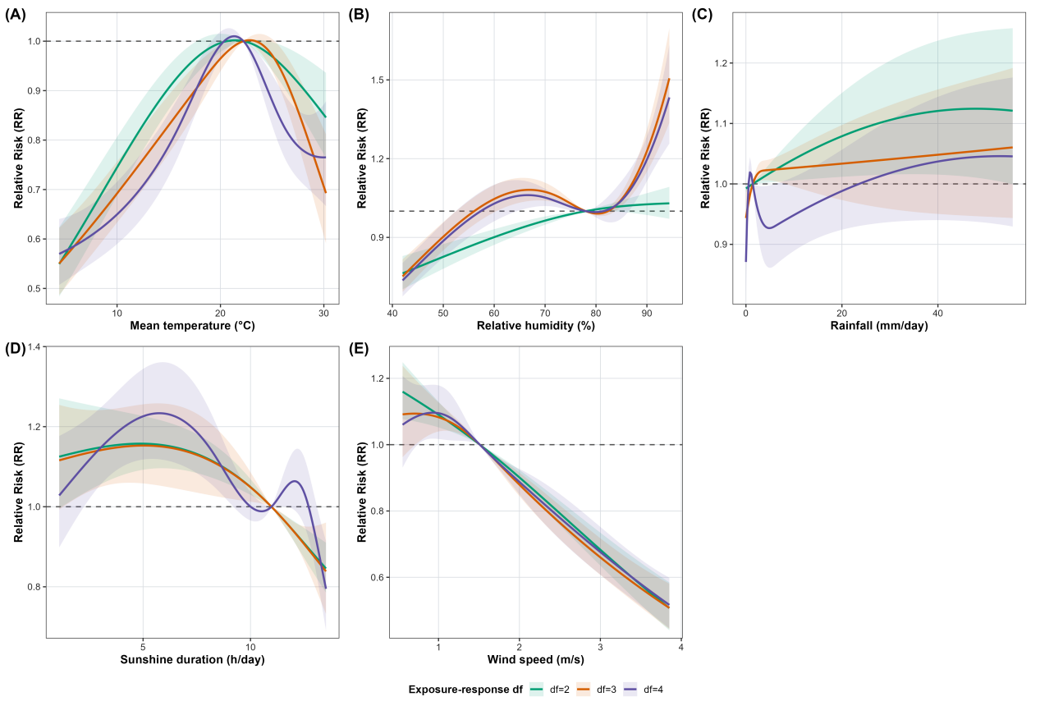
Notes: Panels A–E show temperature, relative humidity, rainfall, sunshine duration, and wind speed, respectively. Green lines and shaded areas represent models using 2 degrees of freedom, orange lines and shaded areas represent models using 3 degrees of freedom, and purple lines and shaded areas represent models using 4 degrees of freedom. Shaded areas indicate 95% CIs, and horizontal dashed lines indicate RR = 1.

Supplementary Figure S7. Sensitivity analysis varying the degrees of freedom for the lag–response dimension.
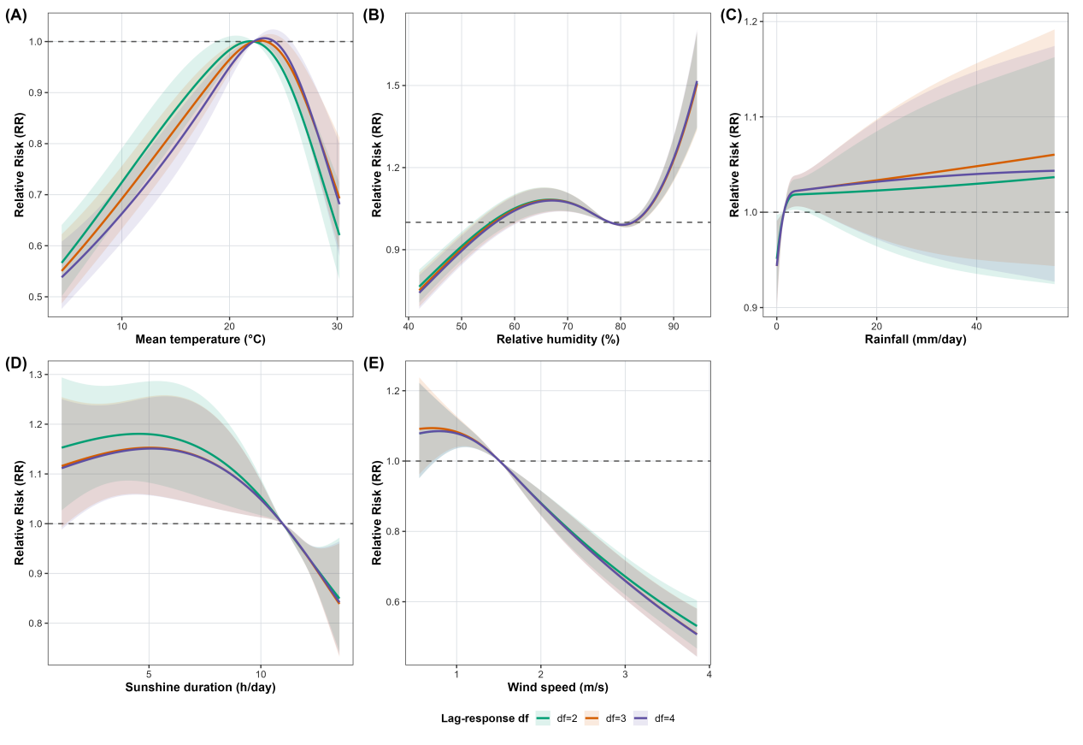
Notes: Panels A–E show temperature, relative humidity, rainfall, sunshine duration, and wind speed, respectively. Green lines and shaded areas represent models using 2 degrees of freedom, orange lines and shaded areas represent models using 3 degrees of freedom, and purple lines and shaded areas represent models using 4 degrees of freedom. Shaded areas indicate 95% CIs, and horizontal dashed lines indicate RR = 1.

Supplementary Figure S8. Sensitivity analysis varying the maximum lag period.
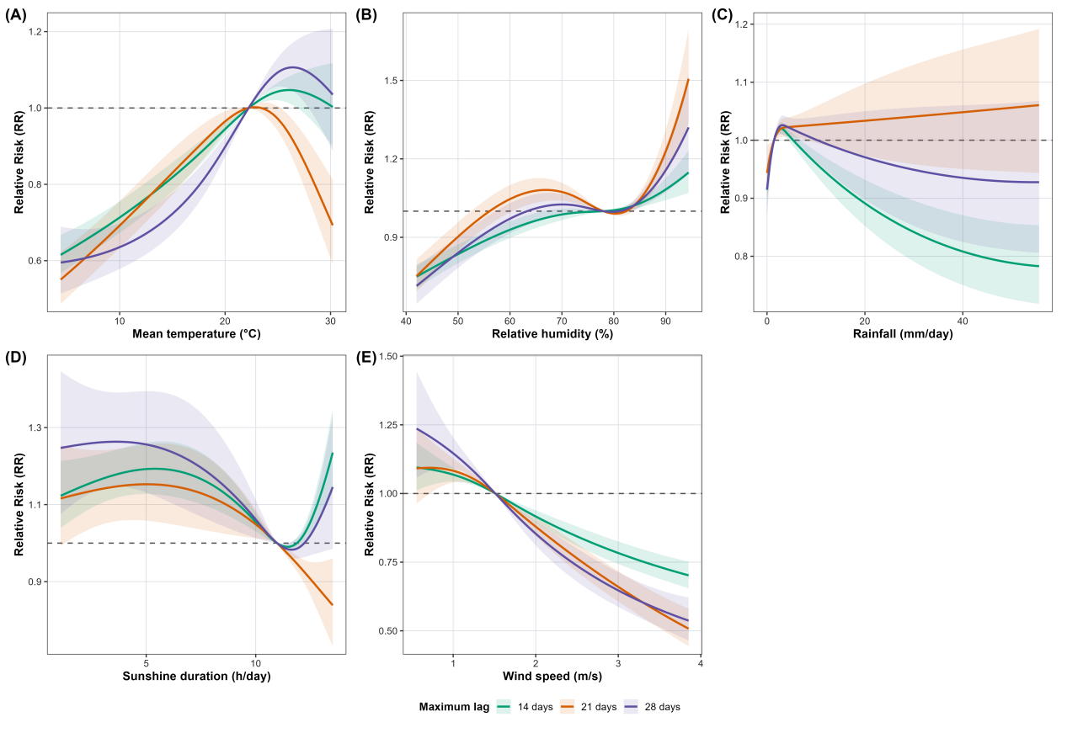
Notes: Panels A–E show temperature, relative humidity, rainfall, sunshine duration, and wind speed, respectively. Green lines and shaded areas represent models with a maximum lag of 14 days, orange lines and shaded areas represent models with a maximum lag of 21 days, and purple lines and shaded areas represent models with a maximum lag of 28 days. Shaded areas indicate 95% CIs, and horizontal dashed lines indicate RR = 1.

Supplementary Figure S9. Sensitivity analysis varying the degrees of freedom for the long-term temporal trend.

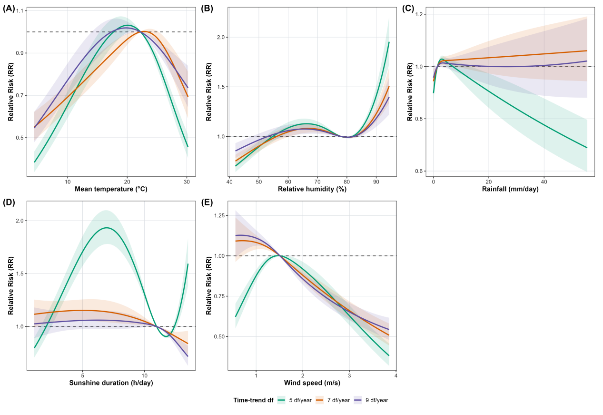
Notes: Panels A–E show temperature, relative humidity, rainfall, sunshine duration, and wind speed, respectively. Green lines and shaded areas represent models using 5 degrees of freedom per year, orange lines and shaded areas represent models using 7 degrees of freedom per year, and purple lines and shaded areas represent models using 9 degrees of freedom per year. Shaded areas indicate 95% CIs, and horizontal dashed lines indicate RR = 1.

Supplementary Table S1. P5, P50 (reference), and P95 values of meteorological factors.
Meteorological factor | P5 | Reference median | P95 | Unit
Temperature | 8.23 | 22.23 | 29.02 | °C
Relative humidity | 52.34 | 77.98 | 90.98 | %
Rainfall | 0.00 | 1.43 | 25.38 | mm/day
Sunshine duration | 2.71 | 10.97 | 13.38 | h/day
Wind speed | 0.78 | 1.51 | 2.99 | m/s

Supplementary Table S2. Cumulative relative risks at selected lag periods for P5 and P95 meteorological exposures.
Meteorological factor | Exposure level | Reference (median) | Lag 0 | Lag 0–7 | Lag 0–14 | Lag 0–21
Temperature | P5 | 22.23 | 0.950 (0.943–0.957) | 0.773 (0.746–0.802) | 0.731 (0.691–0.772) | 0.629 (0.577–0.684)
Temperature | P95 | 22.23 | 1.070 (1.059–1.080) | 1.276 (1.221–1.333) | 1.056 (0.995–1.121) | 0.816 (0.748–0.889)
Relative humidity | P5 | 77.98 | 0.971 (0.965–0.977) | 0.858 (0.835–0.882) | 0.850 (0.818–0.883) | 0.888 (0.842–0.936)
Relative humidity | P95 | 77.98 | 0.996 (0.989–1.003) | 1.006 (0.972–1.040) | 1.072 (1.019–1.127) | 1.180 (1.092–1.275)
Rainfall | P5 | 1.43 | 0.986 (0.982–0.991) | 0.915 (0.897–0.934) | 0.883 (0.857–0.911) | 0.892 (0.854–0.931)
Rainfall | P95 | 1.43 | 0.995 (0.987–1.002) | 0.908 (0.878–0.940) | 0.826 (0.787–0.867) | 0.889 (0.828–0.954)
Sunshine duration | P5 | 10.97 | 0.992 (0.986–0.999) | 1.024 (0.987–1.063) | 1.131 (1.065–1.201) | 1.140 (1.050–1.237)
Sunshine duration | P95 | 10.97 | 1.005 (0.995–1.015) | 1.101 (1.051–1.154) | 1.200 (1.116–1.291) | 1.055 (0.947–1.176)
Wind speed | P5 | 1.51 | 0.998 (0.990–1.006) | 1.022 (0.987–1.058) | 1.073 (1.022–1.127) | 1.065 (0.994–1.141)
Wind speed | P95 | 1.51 | 0.964 (0.956–0.971) | 0.800 (0.770–0.831) | 0.719 (0.680–0.760) | 0.629 (0.581–0.680)

Supplementary Table S3. Summary of county- and district-specific BLUP-based cumulative relative risks at common P5 and P95 exposure levels.
Meteorological factor | Exposure level | Median RR | Q1 | Q3 | Minimum RR | Maximum RR | 95% CI below 1, n | 95% CI above 1, n | 95% CI crossing 1, n
Temperature | P5 | 0.546 | 0.368 | 0.695 | 0.127 | 1.602 | 72 | 1 | 38
Temperature | P95 | 0.634 | 0.422 | 0.879 | 0.105 | 2.108 | 49 | 2 | 60
Relative humidity | P5 | 1.075 | 0.862 | 1.281 | 0.490 | 2.022 | 16 | 23 | 72
Relative humidity | P95 | 1.235 | 0.930 | 1.500 | 0.404 | 3.741 | 7 | 35 | 69
Rainfall | P5 | 1.154 | 1.017 | 1.388 | 0.697 | 2.167 | 1 | 44 | 66
Rainfall | P95 | 1.127 | 0.950 | 1.300 | 0.439 | 2.331 | 7 | 16 | 88
Sunshine duration | P5 | 0.845 | 0.633 | 1.271 | 0.248 | 3.752 | 32 | 20 | 59
Sunshine duration | P95 | 1.208 | 0.787 | 1.930 | 0.087 | 7.743 | 16 | 33 | 62
Wind speed | P5 | 1.205 | 0.985 | 1.453 | 0.455 | 2.572 | 3 | 35 | 73
Wind speed | P95 | 0.987 | 0.750 | 1.272 | 0.303 | 8.679 | 20 | 19 | 72

