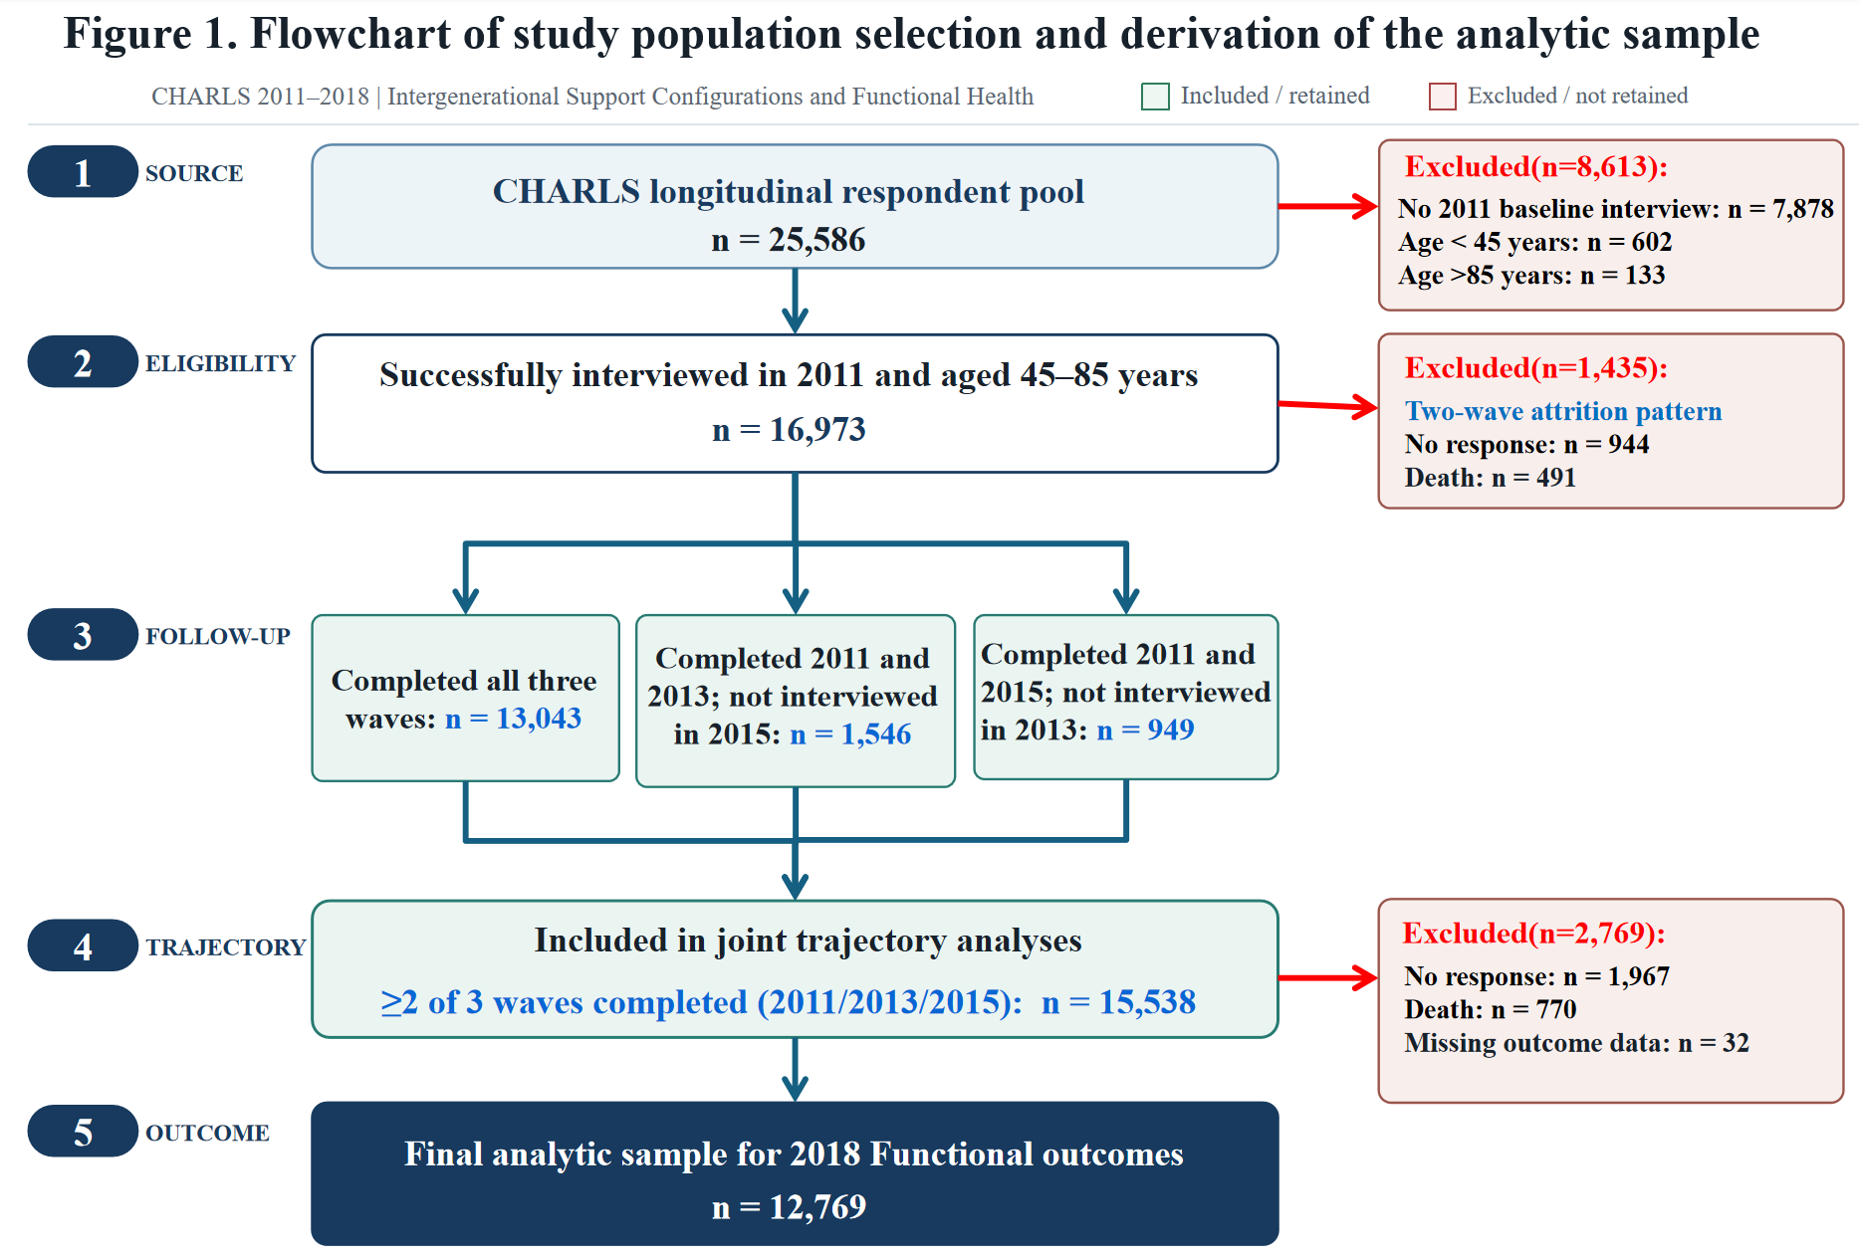
Supplementary Figure S1. Flowchart of study population selection and derivation of the analytic sample

Supplementary Table S1. Operational definitions of intergenerational support indicators
Domain | Indicator | Operational definition and coding
Financial exchange | Financial support received | The cumulative amount of financial assistance received from adult children over the past year.
Financial exchange | Financial support provided | The cumulative amount of financial assistance provided to adult children over the past year.
Care exchange | Informal care received | The cumulative number of days in the past month the respondent received assistance with basic or instrumental activities of daily living from their children, children-in-law, or grandchildren.
Care exchange | Grandchild care provided | The cumulative number of days in the past month the respondent provided care for their grandchildren.
Emotional contact | Face-to-face contact | The cumulative frequency of face-to-face interactions with all living children. The contact frequency for each child was assessed on a 9-point scale ranging from 0 (almost never) to 8 (almost every day), and the sum across all children was calculated.
Emotional contact | Remote contact | The cumulative frequency of remote contact (via phone, text messages, WeChat, mail, or email) with all living children. The contact frequency for each child was assessed on a 9-point scale ranging from 0 (almost never) to 8 (almost every day), and the sum across all children was calculated.
Note. All six indicators were transformed as ln(x + 1), where x is the untransformed aggregate. Higher values indicate larger amounts of support or more frequent contact.

Supplementary Table S2. Operational definitions of baseline covariates
Domain | Covariate | Operational definition and coding
Sociodemographic characteristics | Sex | Respondent-reported sex; 1 = male and 2 = female. Sex was included as a categorical variable.
 | Age | Age in years at baseline, calculated from the respondent’s birth year and month and the interview year and month. Age was included as a continuous variable in the primary analyses. For categorical or subgroup analyses, age was classified as 1 = 45–59 years, 2 = 60–74 years, and 3 = 75–85 years.
 | Educational attainment | Highest level of education attained; 1 = less than lower-secondary, 2 = upper-secondary/vocational training, and 3 = tertiary. Treated as a categorical variable.
 | Rural residence | Place of residence classified according to the official urban–rural statistical designation; 0 = urban and 1 = rural.
 | Marital status | Current marital or partnership status; 0 = not married or partnered and 1 = married or partnered. The category without a spouse or partner included respondents who were never married, separated, divorced, or widowed.
Family structure and circumstances | Co-residence with children | Whether the respondent lived in the same household as at least one child at baseline; 0 = not living with any child and 1 = living with at least one child.
 | Number of children | Total number of children reported by the respondent. Included as a continuous count variable.
 | Number of grandchildren cared for | Total number of grandchildren for whom the respondent provided care. Included as a continuous count variable, with 0 indicating that the respondent did not provide grandchild care.
Socioeconomic resources and social health protection | Employment status | Current employment status at baseline; 0 = not working and 1 = working. Working included engagement in paid employment, self-employment, agricultural work, or other income-generating work, as identified in the survey.
 | Total household income | Total household income aggregated across the income sources available in the survey. To reduce right skewness while retaining zero and negative values, the inverse hyperbolic sine transformation was applied: asinh(x) = ln[x + √(x² + 1)]. The transformed value was included as a continuous variable.
 | Pension income | Annual pension income aggregated across applicable public or occupational pension programs, supplementary enterprise annuities, and commercial pension insurance. The amount was transformed using (ln(x+1)) to reduce right skewness and retain observations with no pension income. Included as a continuous variable.
 | Public health insurance | Coverage by at least one government-sponsored or public health insurance program at baseline; 0 = not covered by public health insurance and 1 = covered by public health insurance. Public programs included applicable urban employee, urban resident, rural cooperative, integrated urban–rural resident, or government medical insurance schemes recorded in the survey.
Lifestyle factors | Smoking history | Indicator of whether the respondent had ever smoked tobacco; 0 = never smoked and 1 = ever smoked.
 | Drinking history | Indicator of whether the respondent had ever consumed alcoholic beverages; 0 = never drank alcohol and 1 = ever drank alcohol.
 | Social participation | Participation in at least one social activity recorded in the CHARLS social-participation module in the last month; 0 = no and 1 = yes.
Baseline health status | Instrumental activities of daily living limitations | IADL was assessed across five activities: household chores, meal preparation, grocery shopping, money management, and medication use. Each activity was scored from 0 (no difficulty) to 3 (greatest limitation), yielding a total score of 0–15, with higher scores indicating greater IADL impairment. Included as a continuous variable.
 | Activities of daily living limitations | ADL was assessed across six activities: dressing, bathing, eating, getting into or out of bed, using the toilet, and controlling urination and defecation. Each activity was scored from 0 (no difficulty) to 3 (greatest limitation), yielding a total score of 0–18, with higher scores indicating greater ADL impairment. Included as a continuous variable.
 | Depressive symptoms | Total score on the 10-item Center for Epidemiologic Studies Depression Scale, CESD-10. Each item was scored from 0 to 3, and positively worded items were reverse-coded before summation. The total score ranges from 0 to 30, with higher scores indicating more severe depressive symptoms. Included as a continuous variable.
 | Cognitive function | Assessed across episodic memory and mental status. Episodic memory comprised immediate (short-term) and delayed (long-term) recall of 10 words, yielding a score of 0–20. Mental status included temporal orientation, serial subtraction, and figure copying, yielding a score of 0–10. Total scores ranged from 0 to 30, with higher scores indicating better cognitive function. Included as a continuous variable.
 | Chronic conditions | Number of self-reported physician-diagnosed chronic conditions at baseline, including hypertension, dyslipidemia, diabetes or hyperglycemia, cancer or malignant tumor, chronic lung disease, liver disease, heart disease, stroke, kidney disease, stomach or other digestive disease, emotional or psychiatric problems, memory-related disease, arthritis or rheumatism, and asthma. The count ranges from 0 to 14, with higher values indicating a greater chronic disease burden. Included as a continuous variable.

Supplementary Table S3. Missing data for analysis variables in the overall baseline cohort (N = 16,973)
Variable | Missing, n (%)
Sex | 2(0.01)
Educational attainment | 16(0.09)
Marital status | 12(0.07)
Employment status | 395(2.33)
Smoking history | 139(0.82)
Drinking history | 150(0.88)
Social participation | 1,374(8.10)
Age | 175(1.03)
Depressive symptoms | 1,560(9.19)
Cognitive function | 5,063(29.83)
Chronic conditions | 332(1.96)

Supplementary Table S4. Baseline characteristics of participants included and not included in the final functional limitations analysis
Characteristic | Summary measure | Included  (N=12,769) | Not included  (N=4,204) | χ² / t  statistic | P | Absolute  SMD
Sex | n (%) |  |  | 45.414 | <0.001 | 0.120
Male |  | 6,057(47.44%) | 2,246(53.43%)
Female |  | 6,712(52.56%) | 1,958(46.57%)
Age (years) | Mean (SD) | 57.94(8.70) | 61.80(10.95) | -23.319 | <0.001 | 0.390
 | Median [Q1, Q3] | 57.00[51.00,63.00] | 61.00[53.00,71.00]
Educational attainment | n (%) |  |  | 158.195 | <0.001 | 0.184
Less than lower-secondary |  | 11,345(88.85%) | 3,539(84.18%)
Upper-secondary/vocational training |  | 1,260(9.87%) | 484(11.51%)
Tertiary |  | 164(1.28%) | 181(4.31%)
Rural residence | n (%) |  |  | 424.102 | <0.001 | 0.367
Urban |  | 4,611(36.11%) | 2,274(54.09%)
Rural |  | 8,158(63.89%) | 1,930(45.91%)
Marital status | n (%) |  |  | 183.017 | <0.001 | 0.227
Not married or partnered |  | 1,356(10.62%) | 782(18.60%)
Married or partnered |  | 11,413(89.38%) | 3,422(81.40%)
Co-residence with children | n (%) |  |  | 21.716 | <0.001 | 0.083
No |  | 5,039(39.46%) | 1,830(43.53%)
Yes |  | 7,730(60.54%) | 2,374(56.47%)
Number of children | Mean (SD) | 2.59(1.36) | 2.70(1.63) | -4.291 | <0.001 | 0.073
 | Median [Q1, Q3] | 2.00[2.00,3.00] | 2.00[2.00,4.00]
Number of grandchildren cared for | Mean (SD) | 0.19(0.48) | 0.13(0.38) | 8.656 | <0.001 | 0.163
 | Median [Q1, Q3] | 0.00[0.00,0.00] | 0.00[0.00,0.00]
Employment status | n (%) |  |  | 611.190 | <0.001 | 0.440
No |  | 4,130(32.34%) | 2,255(53.64%)
Yes |  | 8,639(67.66%) | 1,949(46.36%)
Smoking history | n (%) |  |  | 25.509 | <0.001 | 0.090
No |  | 7,764(60.80%) | 2,371(56.40%)
Yes |  | 5,005(39.20%) | 1,833(43.60%)
Drinking history | n (%) |  |  | 1.073 | 0.300 | 0.018
No |  | 7,763(60.80%) | 2,518(59.90%)
Yes |  | 5,006(39.20%) | 1,686(40.10%)
Social participation | n (%) |  |  | 1.942 | 0.163 | 0.025
No |  | 6,819(53.40%) | 2,297(54.64%)
Yes |  | 5,950(46.60%) | 1,907(45.36%)
Public health insurance | n (%) |  |  | 167.813 | <0.001 | 0.215
No |  | 950(7.44%) | 591(14.06%)
Yes |  | 11,819(92.56%) | 3,613(85.94%)
Total household income (asinh(x)) | Mean (SD) | 5.44(5.31) | 5.40(5.34) | 0.419 | 0.675 | 0.007
 | Median [Q1, Q3] | 7.75[0.00,10.43] | 7.50[0.00,10.60]
Pension income (ln(x)) | Mean (SD) | 1.78(3.47) | 2.82(4.17) | -16.000 | <0.001 | 0.271
 | Median [Q1, Q3] | 0.00[0.00,0.00] | 0.00[0.00,6.58]
Depressive symptoms | Mean (SD) | 8.34(6.31) | 8.60(6.52) | -2.294 | 0.022 | 0.040
 | Median [Q1, Q3] | 7.00[3.00,12.00] | 7.00[3.00,13.00]
Baseline IADL | Mean (SD) | 0.71(2.00) | 1.66(3.63) | -21.134 | <0.001 | 0.321
 | Median [Q1, Q3] | 0.00[0.00,0.00] | 0.00[0.00,1.00]
ADL | Mean (SD) | 0.40(1.38) | 0.96(2.80) | -17.149 | <0.001 | 0.254
 | Median [Q1, Q3] | 0.00[0.00,0.00] | 0.00[0.00,0.00]
Cognitive function | Mean (SD) | 14.68(4.75) | 14.46(5.08) | 2.575 | 0.010 | 0.045
 | Median [Q1, Q3] | 15.00[11.00,18.00] | 15.00[11.00,18.00]
Chronic conditions | Mean (SD) | 1.32(1.35) | 1.54(1.47) | -9.292 | <0.001 | 0.161
 | Median [Q1, Q3] | 1.00[0.00,2.00] | 1.00[0.00,2.00]
Note. Categorical variables were compared using Pearson's chi-square test; Fisher's exact test was used when >20% of expected cell counts were <5 or any expected cell count was <1. Continuous variables were compared using a two-sided pooled independent-samples t test. Absolute standardized mean differences (SMDs) use the pooled within-group SD for continuous variables and the maximum level-specific standardized difference in proportions for categorical variables. SMDs are emphasized for assessment of selection imbalance because P values are sample-size dependent.

Supplementary Table S5. Longitudinal weighting diagnostics: effective sample size, design effect, and covariate balance
Part A. Effective sample size and weight-induced design effect
Weight | N | ESS | Min ESS across MI | Max ESS across MI | Relative ESS, % | Kish DEFF | Implied CV
Survey weight only | 12769.0 | 7881.5 | 7881.5 | 7881.5 | 61.7 | 1.620 | 0.787
Survey x Stage 1 | 12769.0 | 7436.2 | 7430.7 | 7442.1 | 58.2 | 1.717 | 0.847
Survey x raw two-stage weight | 12769.0 | 6330.9 | 6216.0 | 6403.2 | 49.6 | 2.017 | 1.008
Survey x trimmed two-stage weight | 12769.0 | 6446.9 | 6392.9 | 6486.8 | 50.5 | 1.981 | 0.990
Part B. Covariate-balance summary (absolute standardized mean differences shown in percentage points)
Weighting stage | Max |SMD| before | Max |SMD| after weighting | % contrasts |SMD|<10 before | % contrasts |SMD|<10 after weighting
Stage 1: Trajectory selection | 6.59 | 2.62 | 100.0 | 100.0
Stage 2: 2018 response, within Trajectory group | 31.03 | 13.41 | 87.3 | 98.2

Supplementary Table S6. Fit indices for joint intergenerational-support trajectory models by number of groups
Intergenerational support indicators | Number of Groups | BIC | 2(BIC) | Polynomial Orders | AvePP | Smallest Group Proportion j(%)
Financial support received | 2 | -337658.1 | - | 2,2 | 0.951;  0.979 | 39.15
Financial support provided | 2 | -337658.1 | - | 2,2 | 0.951;  0.979 | 39.15
Informal care received | 2 | -337658.1 | - | 2,2 | 0.951;  0.979 | 39.15
Grandchild care provided | 2 | -337658.1 | - | 2,2 | 0.951;  0.979 | 39.15
Face-to-face contact | 2 | -337658.1 | - | 1,2 | 0.951;  0.979 | 39.15
Remote contact | 2 | -337658.1 | - | 1,2 | 0.951;  0.979 | 39.15
Financial support received | 3 | -334065.1 | 7186.0 | 2,2,2 | 0.949;  0.997;  0.932 | 26.37
Financial support provided | 3 | -334065.1 | 7186.0 | 2,2,2 | 0.949;  0.997;  0.932 | 26.37
Informal care received | 3 | -334065.1 | 7186.0 | 2,2,2 | 0.949;  0.997;  0.932 | 26.37
Grandchild care provided | 3 | -334065.1 | 7186.0 | 1,2,2 | 0.949;  0.997;  0.932 | 26.37
Face-to-face contact | 3 | -334065.1 | 7186.0 | 0,2,2 | 0.949;  0.997;  0.932 | 26.37
Remote contact | 3 | -334065.1 | 7186.0 | 0,2,2 | 0.949;  0.997;  0.932 | 26.37
Financial support received | 4 | -332595.8 | 2938.6 | 2,2,2,2 | 0.930;  0.887;  0.842;  0.938 | 16.29
Financial support provided | 4 | -332595.8 | 2938.6 | 1,2,2,2 | 0.930;  0.887;  0.842;  0.938 | 16.29
Informal care received | 4 | -332595.8 | 2938.6 | 1,1,2,1 | 0.930;  0.887;  0.842;  0.938 | 16.29
Grandchild care provided | 4 | -332595.8 | 2938.6 | 1,1,2,1 | 0.930;  0.887;  0.842;  0.938 | 16.29
Face-to-face contact | 4 | -332595.8 | 2938.6 | 0,1,2,1 | 0.930;  0.887;  0.842;  0.938 | 16.29
Remote contact | 4 | -332595.8 | 2938.6 | 0,1,2,1 | 0.930;  0.887;  0.842;  0.938 | 16.29
Financial support received | 5 | -330701.2 | 3789.2 | 2,2,2,2,2 | 0.951;  0.923;  0.838;  0.886;  0.879 | 11.25
Financial support provided | 5 | -330701.2 | 3789.2 | 2,2,2,2,2 | 0.951;  0.923;  0.838;  0.886;  0.879 | 11.25
Informal care received | 5 | -330701.2 | 3789.2 | 2,2,2,2,2 | 0.951;  0.923;  0.838;  0.886;  0.879 | 11.25
Grandchild care provided | 5 | -330701.2 | 3789.2 | 2,2,1,1,1 | 0.951;  0.923;  0.838;  0.886;  0.879 | 11.25
Face-to-face contact | 5 | -330701.2 | 3789.2 | 0,2,1,2,2 | 0.951;  0.923;  0.838;  0.886;  0.879 | 11.25
Remote contact | 5 | -330701.2 | 3789.2 | 0,2,2,2,1 | 0.951;  0.923;  0.838;  0.886;  0.879 | 11.25
Note. Abbreviations: BIC, Bayesian Information Criterion; 2ΔBIC, twice the change in BIC between adjacent models; AvePP, average posterior probability.

Supplementary Table S7. Classification diagnostics for the final five-group joint intergenerational-support trajectory model
Group | AvePP | OCC | P_{j} (%) | π_{j} (%)
1 | 0.951 | 54.68 | 27.15 | 26.07
2 | 0.923 | 29.71 | 29.40 | 28.61
3 | 0.838 | 40.73 | 10.37 | 11.25
4 | 0.886 | 57.70 | 11.86 | 11.88
5 | 0.879 | 25.45 | 21.22 | 22.19
Note. Abbreviations: AvePP, average posterior probability; OCC, odds of correct classification; P_{j}, proportion of participants assigned to group j based on maximum posterior probability;π_{j}, model-estimated probability of group membership.

Supplementary Table S8. Descriptive IADL and ADL outcomes by trajectory group
Outcome | Trajectory group | IADL |  | ADL
Outcome | Trajectory group | Estimate (95% CI) |  | Estimate (95% CI)
Mean score | 1 | 1.55(1.36,1.75) |  | 0.69(0.59,0.80)
Mean score | 2 | 1.21(1.08,1.33) |  | 0.62(0.54,0.69)
Mean score | 3 | 3.35(2.93,3.78) |  | 1.66(1.42,1.91)
Mean score | 4 | 1.52(1.20,1.83) |  | 0.72(0.58,0.86)
Mean score | 5 | 1.03(0.89,1.17) |  | 0.63(0.55,0.71)
Score > 0 proportion | 1 | 26.83(24.36,29.30) |  | 18.07(16.26,19.87)
Score > 0 proportion | 2 | 24.46(22.67,26.25) |  | 19.11(17.49,20.73)
Score > 0 proportion | 3 | 48.91(44.77,53.05) |  | 37.42(33.46,41.39)
Score > 0 proportion | 4 | 28.73(25.21,32.24) |  | 20.85(18.32,23.39)
Score > 0 proportion | 5 | 24.01(21.79,26.23) |  | 23.21(20.48,25.94)
Score ≥3 proportion | 1 | 17.73(15.68,19.78) |  | 8.11(6.94,9.28)
Score ≥3 proportion | 2 | 15.39(13.95,16.83) |  | 7.64(6.61,8.67)
Score ≥3 proportion | 3 | 37.37(33.50,41.24) |  | 22.43(19.20,25.65)
Score ≥3 proportion | 4 | 19.47(15.98,22.96) |  | 10.09(8.10,12.08)
Score ≥3 proportion | 5 | 14.53(12.79,16.27) |  | 8.50(7.19,9.82)
Score ≥5 proportion | 1 | 12.88(11.03,14.72) |  | 4.68(3.83,5.53)
Score ≥5 proportion | 2 | 9.69(8.49,10.89) |  | 3.90(3.21,4.59)
Score ≥5 proportion | 3 | 28.29(24.70,31.88) |  | 12.25(9.94,14.57)
Score ≥5 proportion | 4 | 12.86(9.27,16.45) |  | 4.85(3.12,6.59)
Score ≥5 proportion | 5 | 8.79(7.27,10.30) |  | 3.42(2.57,4.28)

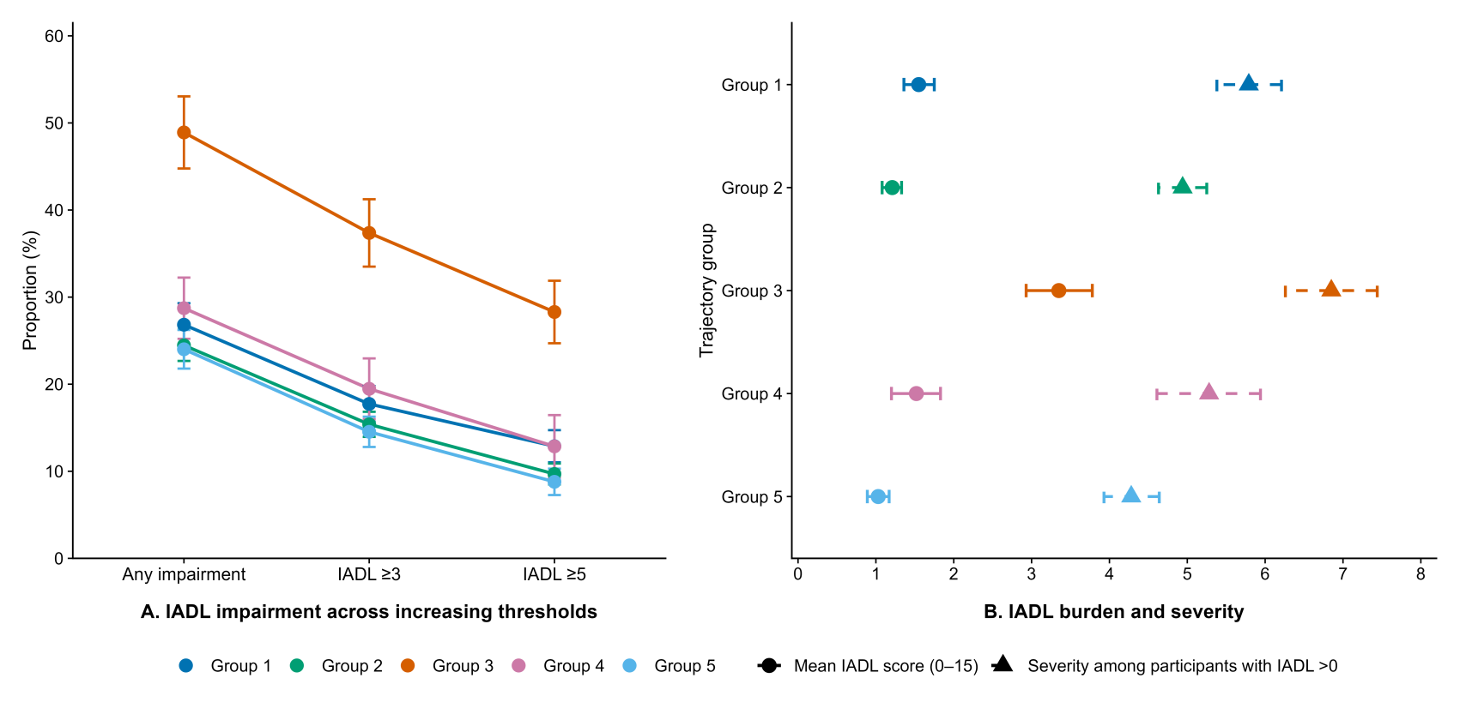
Supplementary Figure S2. Descriptive comparison of IADL outcomes across increasing impairment thresholds by trajectory group

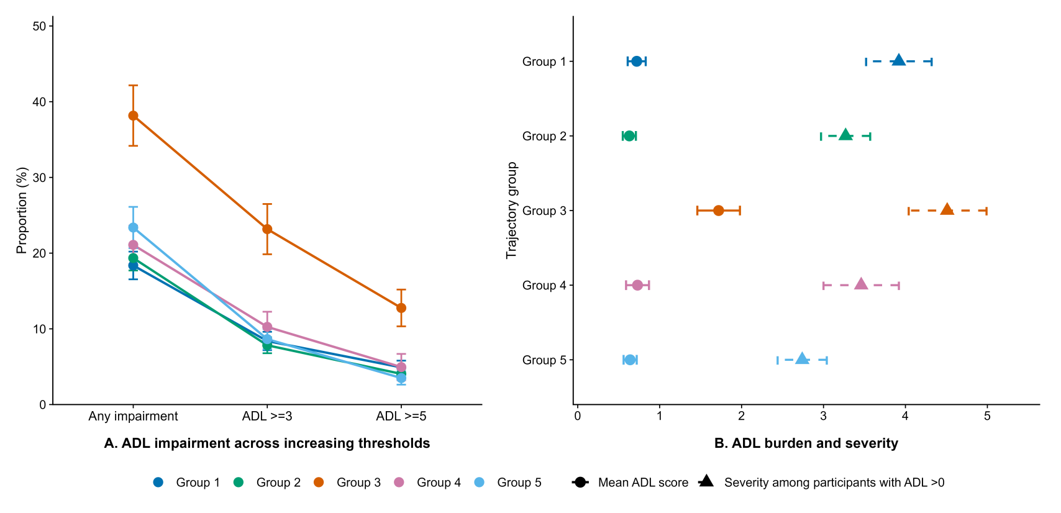Supplementary Figure S3. Descriptive comparison of ADL outcomes across increasing impairment thresholds by trajectory group

Supplementary Table S9. Primary adjusted linear regression models for IADL and ADL in 2018: complete coefficient estimates
Term | IADL |  |  |  |  | ADL
Term | Estimate | 95% CI  lower | 95% CI  upper | P |  | Estimate | 95% CI  lower | 95% CI  upper | P
Intercept | -4.418 | -5.5695 | -3.2656 | <0.001 |  | -2.045 | -2.7052 | -1.3849 | <0.001
G1 vs G 5 | 0.667 | 0.4627 | 0.8708 | <0.001 |  | 0.154 | 0.0353 | 0.2732 | 0.011
G2 vs G 5 | 0.282 | 0.0880 | 0.4755 | 0.004 |  | 0.032 | -0.0871 | 0.1516 | 0.597
G3 vs G 5 | 0.582 | 0.1966 | 0.9667 | 0.003 |  | 0.197 | -0.0397 | 0.4342 | 0.103
G4 vs G 5 | 0.573 | 0.2366 | 0.9099 | <0.001 |  | 0.130 | -0.0264 | 0.2860 | 0.103
Age(years) | 0.077 | 0.0604 | 0.0930 | <0.001 |  | 0.034 | 0.0248 | 0.0436 | <0.001
Number of grandchildren cared for | -0.207 | -0.3415 | -0.0721 | 0.003 |  | -0.113 | -0.1849 | -0.0407 | 0.002
Depressive symptoms | 0.018 | 0.0029 | 0.0328 | 0.019 |  | 0.013 | 0.0030 | 0.0222 | 0.010
Number of children | 0.072 | -0.0191 | 0.1628 | 0.122 |  | 0.051 | 0.0055 | 0.0966 | 0.028
Chronic conditions | 0.182 | 0.1256 | 0.2375 | <0.001 |  | 0.123 | 0.0822 | 0.1638 | <0.001
Cognitive function | -0.032 | -0.0582 | -0.0049 | 0.021 |  | -0.009 | -0.0218 | 0.0037 | 0.161
Co-residence with children | 0.009 | -0.1520 | 0.1704 | 0.911 |  | 0.051 | -0.0476 | 0.1497 | 0.310
Drinking history | 0.025 | -0.1686 | 0.2184 | 0.801 |  | 0.030 | -0.0702 | 0.1294 | 0.560
Public health insurance | 0.150 | -0.1406 | 0.4406 | 0.312 |  | 0.100 | -0.0623 | 0.2629 | 0.227
Total household income(asinh(x)) | 0.004 | -0.0100 | 0.0181 | 0.571 |  | -0.003 | -0.0105 | 0.0055 | 0.546
Pension income(ln(x)) | -0.056 | -0.0814 | -0.0305 | <0.001 |  | -0.025 | -0.0411 | -0.0082 | 0.003
Marital status | 0.089 | -0.3016 | 0.4800 | 0.655 |  | -0.011 | -0.1969 | 0.1750 | 0.908
ADL | 0.174 | 0.0853 | 0.2621 | <0.001 |  | 0.381 | 0.2793 | 0.4831 | <0.001
Baseline IADL | 0.448 | 0.3808 | 0.5156 | <0.001 |  | 0.133 | 0.0805 | 0.1863 | <0.001
Educational attainment(Upper-secondary/vocational training VS Less than lower-secondary) | 0.314 | -0.1335 | 0.7604 | 0.169 |  | 0.079 | -0.2016 | 0.3587 | 0.583
Educational attainment(Tertiary VS Less than lower-secondary) | 0.359 | -0.0955 | 0.8138 | 0.122 |  | 0.087 | -0.1852 | 0.3597 | 0.530
Female | 0.083 | -0.1663 | 0.3329 | 0.513 |  | 0.061 | -0.0861 | 0.2082 | 0.416
Rural residence | 0.015 | -0.1714 | 0.2021 | 0.872 |  | 0.010 | -0.0926 | 0.1127 | 0.848
Smoking history | -0.025 | -0.2765 | 0.2271 | 0.848 |  | 0.016 | -0.1193 | 0.1520 | 0.813
Social participation | 0.151 | -0.0025 | 0.3043 | 0.054 |  | 0.105 | 0.0172 | 0.1918 | 0.019
Employment status | 0.544 | 0.3652 | 0.7231 | <0.001 |  | 0.261 | 0.1586 | 0.3632 | <0.001

Supplementary Table S10. Associations of trajectory groups with IADL and ADL under alternative outcome specifications
Outcome | Comparison | IADL |  |  |  | ADL
Outcome | Comparison | Effect (95% CI) | Unadjusted P | Holm-adjusted P |  | Effect (95% CI) | Unadjusted P | Holm-adjusted P
Score > 0 | G1 vs G5 | 1.452(1.217,1.731) | <0.001 | <0.001 |  | 0.904(0.766,1.068) | 0.236 | 1.000
Score > 0 | G2 vs G5 | 1.127(0.946,1.342) | 0.182 | 0.909 |  | 0.885(0.751,1.043) | 0.145 | 1.000
Score > 0 | G3 vs G5 | 1.289(1.011,1.642) | 0.040 | 0.242 |  | 0.929(0.738,1.170) | 0.531 | 1.000
Score > 0 | G4 vs G5 | 1.446(1.125,1.857) | 0.004 | 0.032 |  | 0.909(0.729,1.132) | 0.393 | 1.000
Score ≥3 | G1 vs G5 | 1.499(1.211,1.855) | <0.001 | 0.002 |  | 1.010(0.776,1.315) | 0.939 | 1.000
Score ≥3 | G2 vs G5 | 1.127(0.915,1.387) | 0.262 | 1.000 |  | 0.874(0.675,1.133) | 0.309 | 1.000
Score ≥3 | G3 vs G5 | 1.267(0.984,1.632) | 0.067 | 0.402 |  | 1.222(0.888,1.680) | 0.218 | 1.000
Score ≥3 | G4 vs G5 | 1.583(1.153,2.174) | 0.004 | 0.036 |  | 1.301(0.946,1.789) | 0.105 | 0.737
Score ≥5 | G1 vs G5 | 1.816(1.393,2.367) | <0.001 | <0.001 |  | 1.343(0.913,1.976) | 0.134 | 0.944
Score ≥5 | G2 vs G5 | 1.159(0.882,1.522) | 0.289 | 1.000 |  | 0.997(0.697,1.426) | 0.986 | 1.000
Score ≥5 | G3 vs G5 | 1.335(0.966,1.844) | 0.080 | 0.432 |  | 1.232(0.816,1.861) | 0.320 | 1.000
Score ≥5 | G4 vs G5 | 1.729(1.104,2.708) | 0.017 | 0.133 |  | 1.534(0.897,2.623) | 0.118 | 0.944
Ordinal logistic | G1 vs G5 | 1.546(1.302,1.837) | <0.001 | <0.001 |  | 0.955(0.813,1.121) | 0.573 | 1.000
Ordinal logistic | G2 vs G5 | 1.165(0.978,1.388) | 0.088 | 0.438 |  | 0.897(0.762,1.056) | 0.192 | 1.000
Ordinal logistic | G3 vs G5 | 1.315(1.051,1.645) | 0.017 | 0.116 |  | 0.966(0.775,1.204) | 0.759 | 1.000
Ordinal logistic | G4 vs G5 | 1.531(1.187,1.974) | 0.001 | 0.008 |  | 0.961(0.776,1.191) | 0.719 | 1.000

Supplementary Table S11. Pairwise comparisons among trajectory groups for continuous IADL and ADL scores
Comparison | IADL |  |  |  | ADL
Comparison | Adjusted mean difference | Unadjusted P | Holm-adjusted P |  | Adjusted mean difference | Unadjusted P | Holm-adjusted P
G 1 vs G 2 | 0.385(0.226,0.544) | <0.001 | <0.001 |  | 0.122(0.022,0.223) | 0.017 | 0.156
G 1 vs G 3 | 0.085(-0.328,0.498) | 0.686 | 1.000 |  | -0.043(-0.295,0.209) | 0.738 | 1.000
G 1 vs G 4 | 0.093(-0.217,0.404) | 0.554 | 1.000 |  | 0.024(-0.133,0.182) | 0.760 | 1.000
G 1 vs G 5 | 0.667(0.463,0.871) | <0.001 | <0.001 |  | 0.154(0.035,0.273) | 0.011 | 0.111
G 2 vs G 3 | -0.300(-0.685,0.085) | 0.127 | 0.507 |  | -0.165(-0.400,0.070) | 0.168 | 1.000
G 2 vs G 4 | -0.291(-0.607,0.024) | 0.070 | 0.350 |  | -0.098(-0.252,0.056) | 0.214 | 1.000
G 2 vs G 5 | 0.282(0.088,0.475) | 0.004 | 0.026 |  | 0.032(-0.087,0.152) | 0.597 | 1.000
G 3 vs G 4 | 0.008(-0.500,0.517) | 0.974 | 1.000 |  | 0.067(-0.197,0.332) | 0.617 | 1.000
G 3 vs G 5 | 0.582(0.197,0.967) | 0.003 | 0.021 |  | 0.197(-0.040,0.434) | 0.103 | 0.822
G 4 vs G 5 | 0.573(0.237,0.910) | <0.001 | 0.007 |  | 0.130(-0.026,0.286) | 0.103 | 0.822

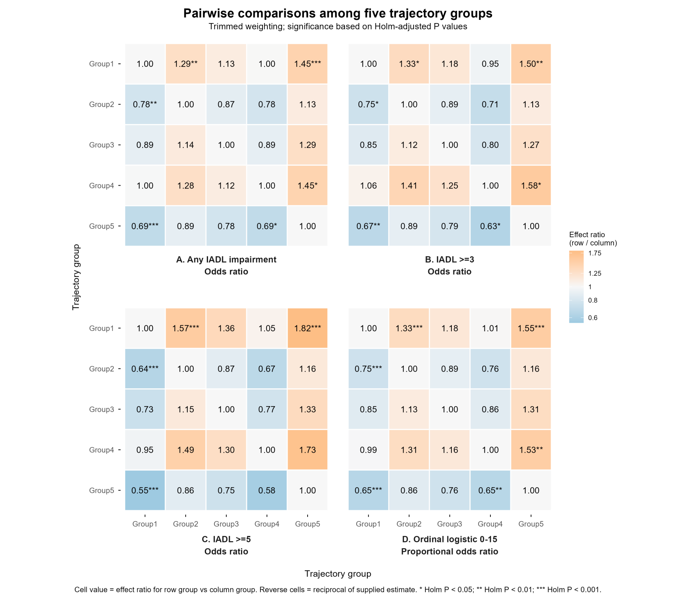
Supplementary Figure S4. Pairwise comparisons among trajectory groups across alternative IADL outcome specifications

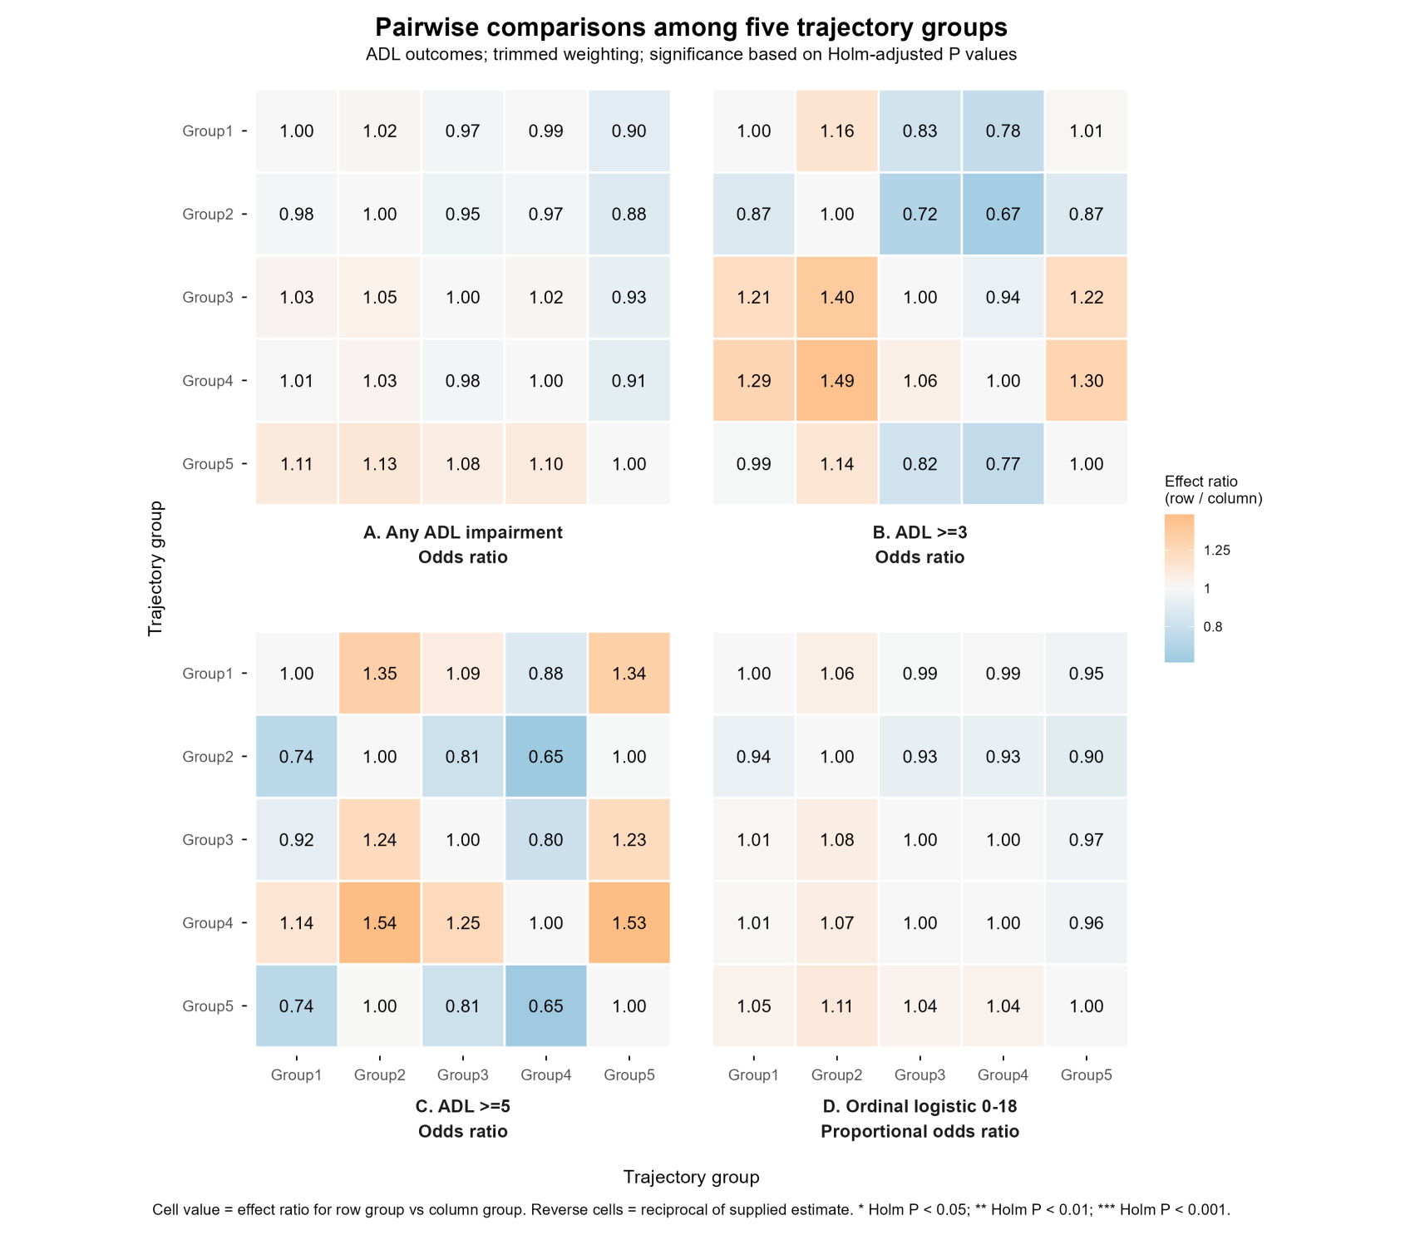

Supplementary Figure S5. Pairwise comparisons among trajectory groups across alternative ADL outcome specifications

Supplementary Table S12. Incident IADL and ADL limitations by trajectory group among participants without corresponding baseline functional limitations
Group | IADL |  |  |  | ADL
Group | N | Score >0 | Score >0 (%) |  | N | Score >0 | Score >0 (%)
1 | 2,718 | 567 | 19.97 |  | 2,938 | 423 | 13.97
2 | 3,195 | 612 | 18.07 |  | 3,392 | 535 | 14.75
3 | 767 | 297 | 38.33 |  | 843 | 246 | 28.50
4 | 1,214 | 291 | 24.51 |  | 1,287 | 224 | 16.63
5 | 2,358 | 497 | 19.46 |  | 2,407 | 456 | 19.09

Supplementary Table S13. Associations of trajectory groups with IADL and ADL among participants without corresponding baseline functional limitations
Model | Comparison | IADL |  |  |  | ADL
Model | Comparison | Effect (95% CI) | Unadjusted P | Holm-adjusted P |  | Effect (95% CI) | Unadjusted P | Holm-adjusted P
Score > 0 | G1 vs G5 | 1.334(1.167,1.526) | <0.001 | <0.001 |  | 0.946(0.779,1.149) | 0.576 | 1.000
Score > 0 | G2 vs G5 | 1.105(0.957,1.276) | 0.173 | 0.866 |  | 0.926(0.768,1.115) | 0.416 | 1.000
Score > 0 | G3 vs G5 | 1.225(1.025,1.465) | 0.026 | 0.154 |  | 0.871(0.660,1.149) | 0.328 | 1.000
Score > 0 | G4 vs G5 | 1.452(1.185,1.778) | <0.001 | 0.003 |  | 0.930(0.712,1.215) | 0.595 | 1.000
Score ≥3 | G1 vs G5 | 1.668(1.308,2.127) | <0.001 | <0.001 |  | 1.058(0.751,1.491) | 0.746 | 1.000
Score ≥3 | G2 vs G5 | 1.242(0.961,1.605) | 0.097 | 0.487 |  | 0.951(0.680,1.328) | 0.767 | 1.000
Score ≥3 | G3 vs G5 | 1.497(1.097,2.045) | 0.011 | 0.067 |  | 1.213(0.793,1.856) | 0.373 | 1.000
Score ≥3 | G4 vs G5 | 2.061(1.416,3.000) | <0.001 | 0.001 |  | 1.521(1.008,2.293) | 0.045 | 0.409
Score ≥5 | G1 vs G5 | 2.250(1.636,3.095) | <0.001 | <0.001 |  | 1.471(0.839,2.577) | 0.178 | 1.000
Score ≥5 | G2 vs G5 | 1.353(0.946,1.935) | 0.098 | 0.491 |  | 1.075(0.635,1.817) | 0.788 | 1.000
Score ≥5 | G3 vs G5 | 1.616(1.075,2.429) | 0.021 | 0.127 |  | 1.350(0.762,2.391) | 0.304 | 1.000
Score ≥5 | G4 vs G5 | 2.460(1.426,4.243) | 0.001 | 0.010 |  | 2.172(1.082,4.359) | 0.029 | 0.263
Ordinal logistic | G1 vs G5 | 1.645(1.357,1.994) | <0.001 | <0.001 |  | 0.978(0.804,1.191) | 0.828 | 1.000
Ordinal logistic | G2 vs G5 | 1.211(0.984,1.489) | 0.070 | 0.350 |  | 0.927(0.768,1.120) | 0.432 | 1.000
Ordinal logistic | G3 vs G5 | 1.495(1.132,1.975) | 0.005 | 0.029 |  | 0.914(0.696,1.201) | 0.519 | 1.000
Ordinal logistic | G4 vs G5 | 1.831(1.343,2.497) | <0.001 | 0.001 |  | 1.000(0.768,1.302) | 1.000 | 1.000

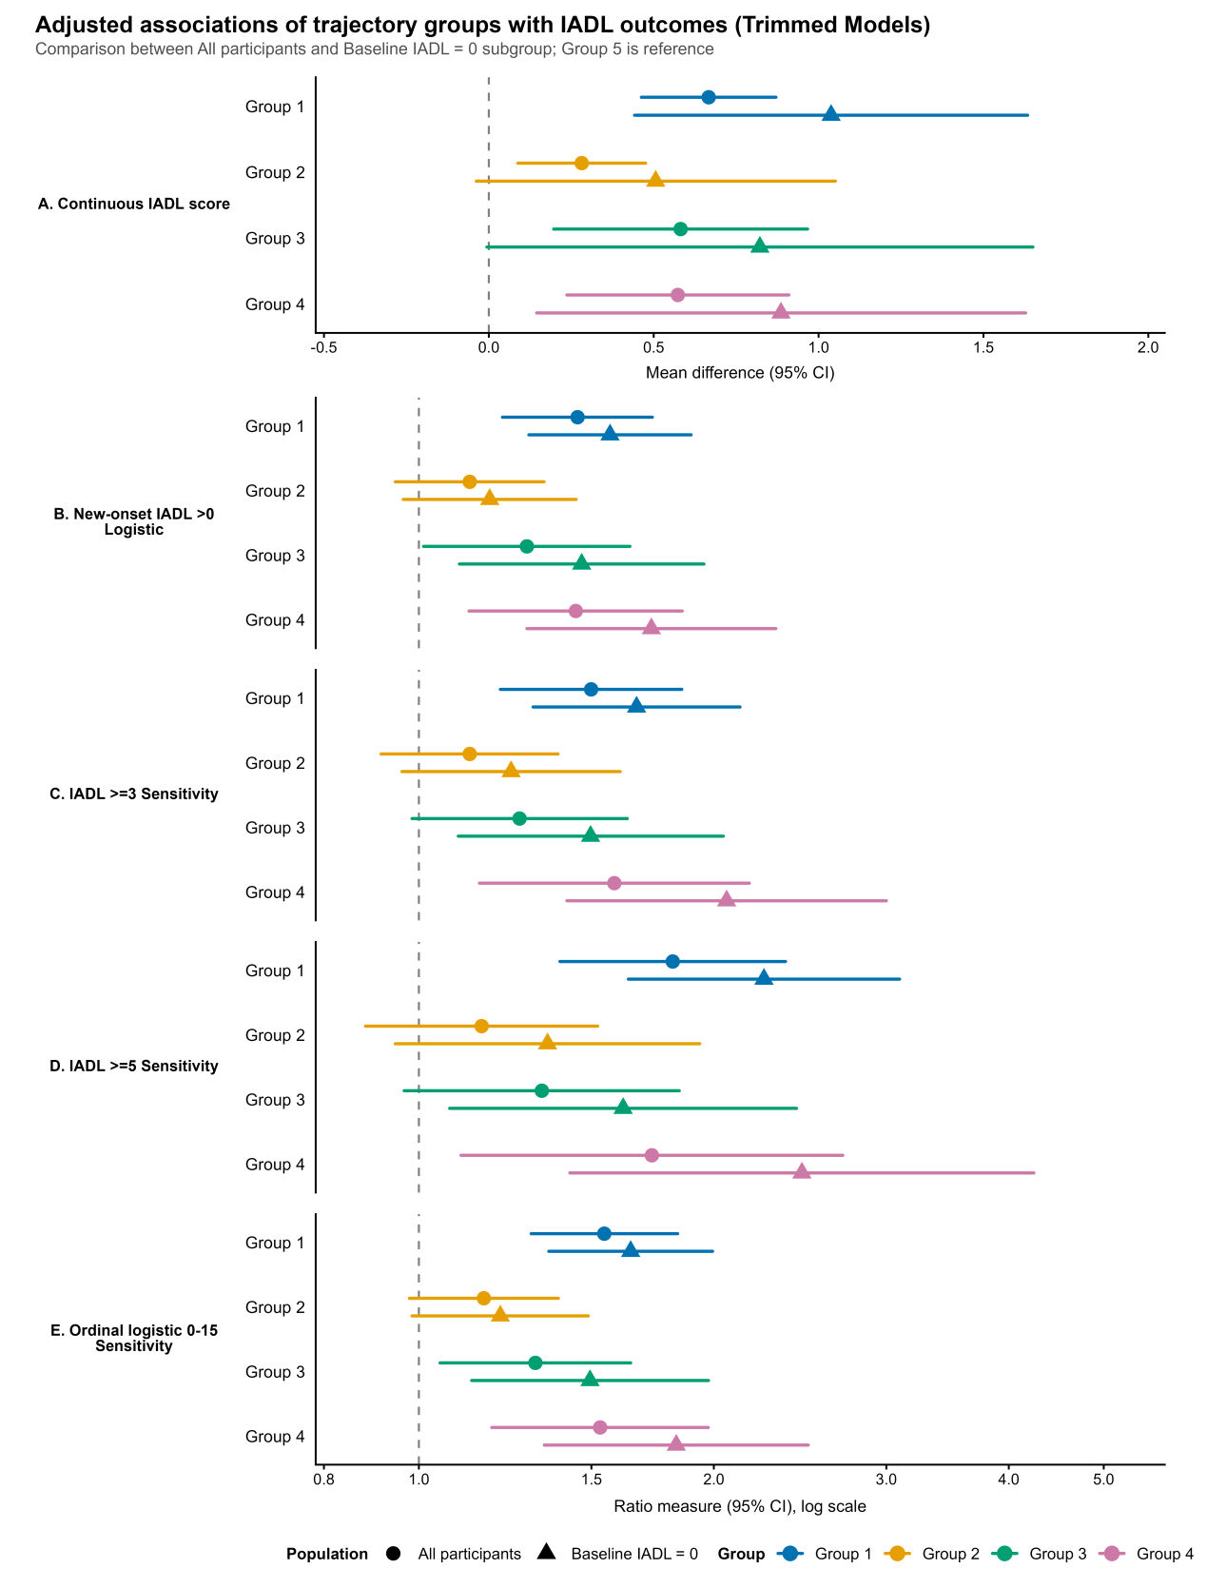

Supplementary Figure S6. Comparison of IADL associations in the full analytic sample and among participants without baseline IADL limitations

Supplementary Table S14. Continuous IADL and ADL associations across trajectory-classification uncertainty methods
Comparison | IADL |  |  |  | ADL
Comparison | MAP | BCH | PPW |  | MAP | BCH | PPW
G1 vs G5 | 0.667 (0.463, 0.871)*** | 0.798 (0.563, 1.034)*** | 0.613 (0.423, 0.804)*** |  | 0.154(0.035,0.273) | 0.194(0.057,0.331) | 0.147(0.035,0.259)
G2 vs G5 | 0.282 (0.088, 0.476)** | 0.396 (0.155, 0.637)** | 0.225 (0.055, 0.396)* |  | 0.032(-0.087,0.152) | 0.063(-0.085,0.212) | 0.029(-0.073,0.132)
G3 vs G5 | 0.582 (0.197, 0.967)** | 0.924 (0.291, 1.558)** | 0.423 (0.166, 0.679)** |  | 0.197(-0.040,0.434) | 0.313(-0.070,0.695) | 0.142(-0.015,0.299)
G4 vs G5 | 0.573 (0.237, 0.910)*** | 0.711 (0.314, 1.109)*** | 0.469 (0.193, 0.746)*** |  | 0.130(-0.026,0.286) | 0.164(-0.023,0.352) | 0.112(-0.022,0.246)
Note. Values are mean differences with 95% confidence intervals (CIs). *: P <0.05; **: P <0.01; ***: P <0.001. MAP, maximum a posteriori classification; BCH, Bolck–Croon–Hagenaars correction; PPW, posterior probability weighting. Estimates were obtained using the trimmed-weight specification and pooled across 20 multiply imputed datasets using Rubin’s rules.

Supplementary Table S15. Sensitivity analyses of continuous IADL and ADL associations under alternative weighting specifications
Weighting | Comparison | IADL |  |  |  | ADL
Weighting | Comparison | Adjusted mean  difference(95%CI) | Unadjusted P | Holm-adjusted P |  | Adjusted mean  difference(95%CI) | Unadjusted P | Holm-adjusted P
Unweighted | G1 vs G5 | 0.47(0.33,0.61) | <0.001 | <0.001 |  | 0.13(0.03,0.23) | 0.011 | 0.090
Unweighted | G2 vs G5 | 0.17(0.04,0.29) | 0.010 | 0.041 |  | 0.02(-0.07,0.11) | 0.687 | 1.000
Unweighted | G3 vs G5 | 0.64(0.40,0.87) | <0.001 | <0.001 |  | 0.25(0.06,0.44) | 0.010 | 0.088
Unweighted | G4 vs G5 | 0.26(0.11,0.42) | 0.001 | 0.006 |  | 0.06(-0.05,0.18) | 0.290 | 1.000
Weighted - untrimmed | G1 vs G5 | 0.69(0.48,0.90) | <0.001 | <0.001 |  | 0.15(0.04,0.27) | 0.011 | 0.111
Weighted - untrimmed | G2 vs G5 | 0.30(0.108,0.50) | 0.003 | 0.021 |  | 0.03(-0.09,0.15) | 0.597 | 1.000
Weighted - untrimmed | G3 vs G5 | 0.58(0.19,0.98) | 0.004 | 0.024 |  | 0.20(-0.04,0.43) | 0.103 | 0.822
Weighted - untrimmed | G4 vs G5 | 0.62(0.26,0.98) | 0.001 | 0.006 |  | 0.13(-0.03,0.29) | 0.103 | 0.822
Weighted - trimmed | G1 vs G5 | 0.67(0.46,0.87) | <0.001 | <0.001 |  | 0.15(0.04,0.27) | 0.011 | 0.111
Weighted - trimmed | G2 vs G5 | 0.28(0.09,0.48) | 0.004 | 0.026 |  | 0.03(-0.09,0.15) | 0.597 | 1.000
Weighted - trimmed | G3 vs G5 | 0.58(0.20,0.97) | 0.003 | 0.021 |  | 0.20(-0.04,0.43) | 0.103 | 0.822
Weighted - trimmed | G4 vs G5 | 0.57(0.24,0.91) | <0.001 | 0.007 |  | 0.13(-0.03,0.29) | 0.103 | 0.822

Supplementary Table S16. Subgroup analyses of associations between intergenerational-support trajectories and IADL and ADL in 2018
Stratified Variable | Subgroup | Comparison | IADL |  |  |  | ADL
Stratified Variable | Subgroup | Comparison | Adjusted mean  difference (95% CI) | P | P for  interaction |  | Adjusted mean  difference (95% CI) | P | P for  interaction
Sex | Male | G1 vs G5 | 0.805(0.509,1.101) | <0.001 | 0.082 |  | 0.305(0.122,0.487) | 0.001 | 0.152
 |  | G2 vs G5 | 0.345(0.095,0.595) | 0.007 |  |  | 0.084(-0.056,0.224) | 0.237
 |  | G3 vs G5 | 0.792(0.168,1.416) | 0.013 |  |  | 0.182(-0.148,0.512) | 0.278
 |  | G4 vs G5 | 0.805(0.237,1.372) | 0.006 |  |  | 0.284(0.001,0.567) | 0.049
 | Female | G1 vs G5 | 0.445(0.186,0.705) | <0.001 |  |  | 0.036(-0.126,0.198) | 0.664
 |  | G2 vs G5 | 0.213(-0.052,0.478) | 0.115 |  |  | -0.011(-0.175,0.152) | 0.891
 |  | G3 vs G5 | 0.483(0.018,0.947) | 0.042 |  |  | 0.217(-0.074,0.508) | 0.143
 |  | G4 vs G5 | 0.244(-0.026,0.514) | 0.076 |  |  | -0.027(-0.187,0.134) | 0.744
Age | 45-59 years | G1 vs G5 | 0.194(0.007,0.381) | 0.043 | 0.001 |  | -0.015(-0.120,0.091) | 0.785 | <0.001
 |  | G2 vs G5 | -0.030(-0.199,0.138) | 0.725 |  |  | -0.055(-0.155,0.044) | 0.275
 |  | G3 vs G5 | 0.221(-0.284,0.725) | 0.390 |  |  | 0.150(-0.096,0.397) | 0.231
 |  | G4 vs G5 | 0.078(-0.121,0.277) | 0.442 |  |  | -0.035(-0.147,0.077) | 0.538
 | 60-74 years | G1 vs G5 | 0.906(0.470,1.342) | <0.001 |  |  | 0.238(-0.025,0.502) | 0.076
 |  | G2 vs G5 | 0.451(0.105,0.797) | 0.011 |  |  | 0.017(-0.194,0.229) | 0.872
 |  | G3 vs G5 | 0.499(0.089,0.908) | 0.017 |  |  | 0.252(-0.040,0.543) | 0.091
 |  | G4 vs G5 | 1.163(0.429,1.897) | 0.002 |  |  | 0.391(0.013,0.768) | 0.042
 | 75-85 years | G1 vs G5 | 3.386(1.375,5.397) | 0.001 |  |  | 1.780(0.450,3.110) | 0.009
 |  | G2 vs G5 | 1.755(0.001,3.509) | 0.050 |  |  | 0.623(-0.746,1.991) | 0.372
 |  | G3 vs G5 | 1.908(0.585,3.231) | 0.005 |  |  | 0.458(-0.461,1.378) | 0.328
 |  | G4 vs G5 | 0.663(-1.518,2.845) | 0.550 |  |  | -0.134(-1.455,1.187) | 0.842
Educational attainment | Less than lower-secondary | G1 vs G5 | 0.634(0.419,0.850) | <0.001 | <0.001 |  | 0.148(0.019,0.278) | 0.025 | <0.001
 |  | G2 vs G5 | 0.227(0.023,0.430) | 0.029 |  |  | 0.013(-0.121,0.147) | 0.847
 |  | G3 vs G5 | 0.591(0.181,1.001) | 0.005 |  |  | 0.171(-0.075,0.418) | 0.172
 |  | G4 vs G5 | 0.579(0.209,0.949) | 0.002 |  |  | 0.125(-0.046,0.297) | 0.152
 | Upper-secondary/vocational training | G1 vs G5 | 0.654(0.193,1.115) | 0.006 |  |  | 0.097(-0.193,0.386) | 0.513
 |  | G2 vs G5 | 0.494(0.022,0.966) | 0.040 |  |  | 0.064(-0.183,0.310) | 0.612
 |  | G3 vs G5 | 1.164(-0.144,2.472) | 0.081 |  |  | 0.805(-0.396,2.006) | 0.189
 |  | G4 vs G5 | 0.248(-0.175,0.672) | 0.250 |  |  | 0.047(-0.273,0.366) | 0.774
 | Tertiary | G1 vs G5 | 0.960(-0.593,2.512) | 0.225 |  |  | 0.819(-0.507,2.146) | 0.225
 |  | G2 vs G5 | 1.301(0.296,2.307) | 0.011 |  |  | 0.678(-0.084,1.440) | 0.081
 |  | G3 vs G5 | -1.138(-2.091,-0.186) | 0.019 |  |  | -0.495(-1.075,0.085) | 0.094
 |  | G4 vs G5 | 0.926(0.091,1.762) | 0.030 |  |  | 0.361(-0.228,0.951) | 0.229
Rural residence | Urban | G1 vs G5 | 0.942(0.574,1.309) | <0.001 | 0.122 |  | 0.310(0.083,0.538) | 0.008 | 0.209
 |  | G2 vs G5 | 0.515(0.169,0.861) | 0.004 |  |  | 0.157(-0.081,0.394) | 0.195
 |  | G3 vs G5 | 0.688(0.045,1.330) | 0.036 |  |  | 0.299(-0.117,0.715) | 0.158
 |  | G4 vs G5 | 0.990(0.391,1.589) | 0.001 |  |  | 0.330(0.032,0.627) | 0.03
 | Rural | G1 vs G5 | 0.407(0.212,0.602) | <0.001 |  |  | 0.072(-0.059,0.204) | 0.279
 |  | G2 vs G5 | 0.101(-0.086,0.289) | 0.288 |  |  | -0.038(-0.158,0.082) | 0.532
 |  | G3 vs G5 | 0.561(0.176,0.945) | 0.004 |  |  | 0.147(-0.111,0.406) | 0.263
 |  | G4 vs G5 | 0.184(-0.026,0.393) | 0.085 |  |  | -0.001(-0.152,0.151) | 0.993
Marital status | Not married or partnered | G1 vs G5 | 0.361(-0.571,1.294) | 0.447 | 0.607 |  | -0.447(-0.986,0.092) | 0.104 | 0.383
 |  | G2 vs G5 | 0.306(-0.562,1.175) | 0.488 |  |  | -0.073(-0.572,0.427) | 0.776
 |  | G3 vs G5 | 0.718(0.057,1.379) | 0.033 |  |  | 0.349(-0.031,0.729) | 0.072
 |  | G4 vs G5 | 1.291(-1.396,3.978) | 0.346 |  |  | 0.303(-0.954,1.560) | 0.636
 | Married or partnered | G1 vs G5 | 0.613(0.415,0.810) | <0.001 |  |  | 0.160(0.039,0.281) | 0.01
 |  | G2 vs G5 | 0.221(0.042,0.401) | 0.016 |  |  | 0.024(-0.094,0.142) | 0.694
 |  | G3 vs G5 | 0.458(0.041,0.875) | 0.031 |  |  | 0.128(-0.133,0.389) | 0.335
 |  | G4 vs G5 | 0.461(0.206,0.716) | <0.001 |  |  | 0.116(-0.034,0.265) | 0.128
Co-residence with children | No | G1 vs G5 | 0.819(0.477,1.161) | <0.001 | 0.443 |  | 0.242(0.016,0.468) | 0.036 | 0.163
 |  | G2 vs G5 | 0.318(0.007,0.629) | 0.045 |  |  | 0.058(-0.130,0.246) | 0.546
 |  | G3 vs G5 | 0.492(0.035,0.948) | 0.035 |  |  | 0.236(-0.054,0.527) | 0.11
 |  | G4 vs G5 | 0.844(0.296,1.392) | 0.003 |  |  | 0.252(-0.005,0.509) | 0.054
 | Yes | G1 vs G5 | 0.505(0.253,0.758) | <0.001 |  |  | 0.041(-0.100,0.181) | 0.571
 |  | G2 vs G5 | 0.207(-0.019,0.433) | 0.073 |  |  | -0.042(-0.192,0.107) | 0.578
 |  | G3 vs G5 | 0.720(0.103,1.338) | 0.022 |  |  | 0.158(-0.193,0.510) | 0.377
 |  | G4 vs G5 | 0.281(-0.018,0.580) | 0.065 |  |  | 0.009(-0.166,0.184) | 0.921
Employment status | No | G1 vs G5 | 1.096(0.664,1.528) | <0.001 | 0.038 |  | 0.370(0.086,0.655) | 0.011 | 0.177
 |  | G2 vs G5 | 0.528(0.111,0.944) | 0.013 |  |  | 0.145(-0.155,0.446) | 0.343
 |  | G3 vs G5 | 0.638(0.047,1.229) | 0.034 |  |  | 0.157(-0.235,0.549) | 0.432
 |  | G4 vs G5 | 0.662(0.089,1.234) | 0.024 |  |  | 0.177(-0.173,0.527) | 0.32
 | Yes | G1 vs G5 | 0.318(0.140,0.497) | <0.001 |  |  | 0.017(-0.084,0.118) | 0.745
 |  | G2 vs G5 | 0.090(-0.079,0.259) | 0.297 |  |  | -0.044(-0.135,0.048) | 0.35
 |  | G3 vs G5 | 0.543(0.173,0.912) | 0.004 |  |  | 0.235(0.019,0.452) | 0.033
 |  | G4 vs G5 | 0.446(0.060,0.832) | 0.024 |  |  | 0.088(-0.061,0.236) | 0.247
Smoking history | No | G1 vs G5 | 0.516(0.246,0.787) | <0.001 | 0.078 |  | 0.075(-0.094,0.243) | 0.384 | 0.491
 |  | G2 vs G5 | 0.224(-0.032,0.480) | 0.086 |  |  | 0.014(-0.151,0.179) | 0.87
 |  | G3 vs G5 | 0.361(-0.094,0.816) | 0.119 |  |  | 0.214(-0.094,0.522) | 0.172
 |  | G4 vs G5 | 0.472(0.115,0.829) | 0.010 |  |  | 0.082(-0.116,0.279) | 0.416
 | Yes | G1 vs G5 | 0.740(0.450,1.029) | <0.001 |  |  | 0.276(0.092,0.461) | 0.003
 |  | G2 vs G5 | 0.330(0.059,0.601) | 0.017 |  |  | 0.065(-0.085,0.214) | 0.397
 |  | G3 vs G5 | 0.963(0.345,1.581) | 0.002 |  |  | 0.143(-0.195,0.482) | 0.405
 |  | G4 vs G5 | 0.599(0.075,1.122) | 0.025 |  |  | 0.184(-0.053,0.422) | 0.128
Drinking history | No | G1 vs G5 | 0.681(0.409,0.954) | <0.001 | 0.336 |  | 0.141(-0.030,0.312) | 0.105 | 0.346
 |  | G2 vs G5 | 0.418(0.148,0.689) | 0.003 |  |  | 0.073(-0.096,0.243) | 0.397
 |  | G3 vs G5 | 0.462(-0.021,0.946) | 0.061 |  |  | 0.123(-0.166,0.411) | 0.404
 |  | G4 vs G5 | 0.622(0.191,1.052) | 0.005 |  |  | 0.079(-0.098,0.256) | 0.381
 | Yes | G1 vs G5 | 0.599(0.272,0.925) | <0.001 |  |  | 0.183(-0.003,0.370) | 0.054
 |  | G2 vs G5 | 0.082(-0.188,0.352) | 0.550 |  |  | -0.026(-0.166,0.114) | 0.711
 |  | G3 vs G5 | 0.842(0.207,1.477) | 0.009 |  |  | 0.334(-0.023,0.692) | 0.066
 |  | G4 vs G5 | 0.439(-0.068,0.945) | 0.090 |  |  | 0.210(-0.093,0.513) | 0.174
Social participation | No | G1 vs G5 | 0.729(0.444,1.014) | <0.001 | 0.036 |  | 0.255(0.089,0.421) | 0.003 | 0.058
 |  | G2 vs G5 | 0.405(0.134,0.676) | 0.004 |  |  | 0.118(-0.047,0.283) | 0.16
 |  | G3 vs G5 | 1.044(0.538,1.550) | <0.001 |  |  | 0.364(0.045,0.683) | 0.026
 |  | G4 vs G5 | 0.482(0.171,0.793) | 0.002 |  |  | 0.089(-0.070,0.248) | 0.274
 | Yes | G1 vs G5 | 0.564(0.251,0.876) | <0.001 |  |  | 0.049(-0.145,0.242) | 0.623
 |  | G2 vs G5 | 0.178(-0.107,0.463) | 0.220 |  |  | -0.049(-0.209,0.111) | 0.547
 |  | G3 vs G5 | 0.039(-0.492,0.571) | 0.884 |  |  | 0.017(-0.286,0.320) | 0.911
 |  | G4 vs G5 | 0.658(0.096,1.220) | 0.022 |  |  | 0.174(-0.094,0.442) | 0.203
Public health insurance | No | G1 vs G5 | 0.294(-0.347,0.934) | 0.368 | 0.833 |  | 0.269(-0.070,0.609) | 0.119 | 0.414
 |  | G2 vs G5 | 0.209(-0.499,0.917) | 0.563 |  |  | 0.108(-0.252,0.468) | 0.556
 |  | G3 vs G5 | 0.778(-0.731,2.288) | 0.311 |  |  | 0.682(-0.288,1.653) | 0.168
 |  | G4 vs G5 | 0.462(-0.205,1.129) | 0.174 |  |  | 0.524(0.029,1.019) | 0.038
 | Yes | G1 vs G5 | 0.673(0.460,0.887) | <0.001 |  |  | 0.138(0.007,0.268) | 0.038
 |  | G2 vs G5 | 0.295(0.100,0.489) | 0.003 |  |  | 0.026(-0.095,0.146) | 0.677
 |  | G3 vs G5 | 0.573(0.179,0.966) | 0.004 |  |  | 0.173(-0.053,0.398) | 0.134
 |  | G4 vs G5 | 0.574(0.197,0.951) | 0.003 |  |  | 0.098(-0.074,0.271) | 0.262
Note. Complex-survey linear regression of IADL and ADL; estimates pooled across multiply imputed data sets using Rubin rules. Estimates are adjusted mean differences in IADL and ADL; comparison P values are not multiplicity-adjusted. For each stratified analysis, the stratifying variable itself is removed from the covariate adjustment set; all other primary-model covariates are retained. P for interaction is an omnibus Rubin-pooled multivariate Wald-F test for trajectory group by the stratifying variable.

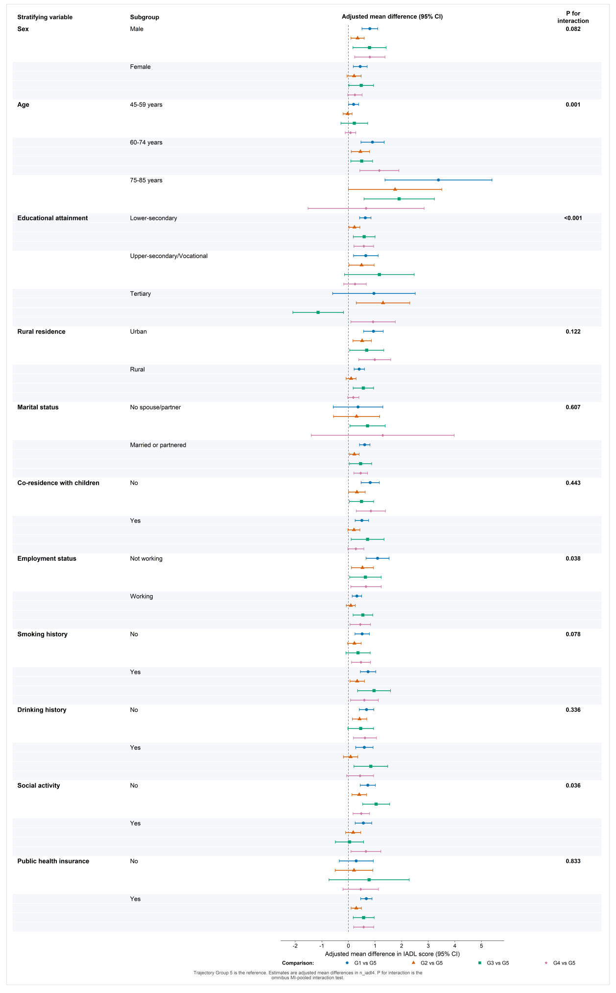
Supplementary Figure S7. Subgroup analyses of associations between intergenerational-support trajectories and IADL in 2018
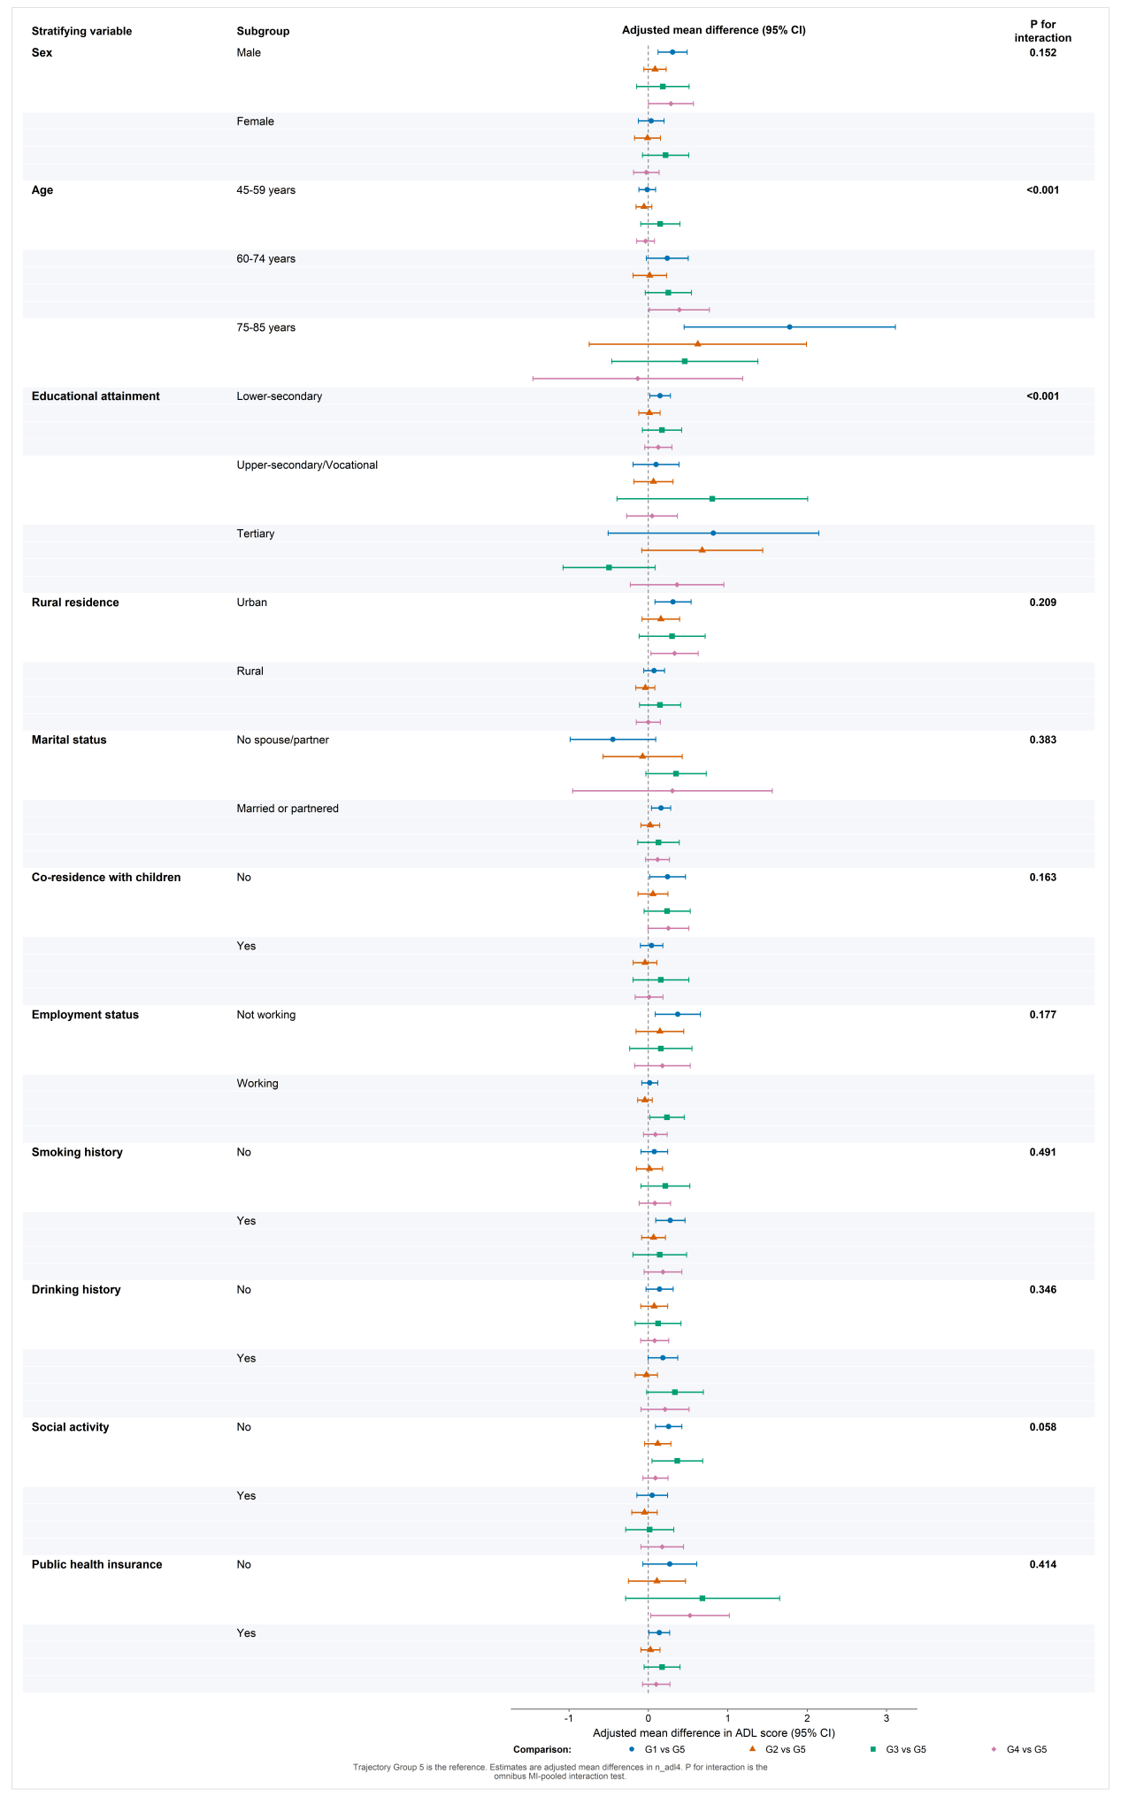
Supplementary Figure S8. Subgroup analyses of associations between intergenerational-support trajectories and ADL in 2018

Supplementary Table S17. Mediation analysis of the association between trajectory groups and IADL
Trajectory  comparison | Path a  a (SE) |  | Path a  95% CI |  |  | Path b  b (SE) |  |  | Path b  95% CI |  |  | Total effect c  (95% CI) |  |  | Direct effect c'  (95% CI) |  |  | Indirect effect a*b  (SE) | Indirect effect  95% CI | Indirect effect  P
Employment status
G 1 vs G 5 | -0.073(0.016) |  |  | [-0.105,-0.041] |  |  | -0.655(0.078) |  |  | [-0.809,-0.502] |  |  | 0.667[0.463,0.871] |  |  | 0.619[0.417,0.821] |  | 0.048(0.012) | [0.024,0.071] | <0.001
G 2 vs G 5 | -0.017(0.014) |  |  | [-0.045,0.011] |  |  | -0.655(0.078) |  |  | [-0.809,-0.502] |  |  | 0.282[0.088,0.476] |  |  | 0.271[0.079,0.463] |  | 0.011(0.009) | [-0.007,0.029] | 0.241
G 3 vs G 5 | -0.038(0.019) |  |  | [-0.075,-0.000] |  |  | -0.655(0.078) |  |  | [-0.809,-0.502] |  |  | 0.582[0.197,0.967] |  |  | 0.557[0.174,0.940] |  | 0.025(0.013) | [-0.000,0.050] | 0.053
G 4 vs G 5 | -0.039(0.023) |  |  | [-0.084,0.006] |  |  | -0.655(0.078) |  |  | [-0.809,-0.502] |  |  | 0.573[0.237,0.910] |  |  | 0.548[0.220,0.875] |  | 0.026(0.015) | [-0.005,0.056] | 0.097
Pension income
G 1 vs G 5 | -0.261(0.140) |  | [-0.535,0.014] |  |  | -0.036(0.010) |  |  | [-0.056,-0.015] |  |  | 0.667[0.463,0.871] |  |  | 0.657[0.455,0.860] |  |  | 0.009(0.006) | [-0.002,0.021] | 0.102
G 2 vs G 5 | -0.038(0.125) |  | [-0.282,0.206] |  |  | -0.036(0.010) |  |  | [-0.056,-0.015] |  |  | 0.282[0.088,0.476] |  |  | 0.280[0.086,0.475] |  |  | 0.001(0.004) | [-0.007,0.010] | 0.763
G 3 vs G 5 | -0.569(0.222) |  | [-1.005,-0.134] |  |  | -0.036(0.010) |  |  | [-0.056,-0.015] |  |  | 0.582[0.197,0.967] |  |  | 0.561[0.175,0.947] |  |  | 0.020(0.010) | [0.001,0.040] | 0.040
G 4 vs G 5 | -0.129(0.178) |  | [-0.479,0.221] |  |  | -0.036(0.010) |  |  | [-0.056,-0.015] |  |  | 0.573[0.237,0.910] |  |  | 0.569[0.233,0.904] |  |  | 0.005(0.007) | [-0.008,0.017] | 0.480
Cognitive function
G 1 vs G 5 | -0.912(0.179) |  | [-1.266,-0.559] |  |  | -0.058(0.012) |  |  | [-0.082,-0.034] |  |  | 0.667[0.463,0.871] |  |  | 0.613[0.410,0.817] |  |  | 0.053(0.016) | [0.022,0.085] | <0.001
G 2 vs G 5 | -0.372(0.165) |  | [-0.699,-0.045] |  |  | -0.058(0.012) |  |  | [-0.082,-0.034] |  |  | 0.282[0.088,0.476] |  |  | 0.260[0.067,0.452] |  |  | 0.022(0.011) | [0.000,0.043] | 0.048
G 3 vs G 5 | -0.307(0.270) |  | [-0.840,0.226] |  |  | -0.058(0.012) |  |  | [-0.082,-0.034] |  |  | 0.582[0.197,0.967] |  |  | 0.564[0.184,0.944] |  |  | 0.018(0.016) | [-0.014,0.050] | 0.277
G 4 vs G 5 | -0.600(0.239) |  | [-1.074,-0.127] |  |  | -0.058(0.012) |  |  | [-0.082,-0.034] |  |  | 0.573[0.237,0.910] |  |  | 0.538[0.207,0.869] |  |  | 0.035(0.016) | [0.003,0.067] | 0.030
Depressive symptoms
G 1 vs G 5 |  | -0.554(0.197) |  |  | [-0.940,-0.167] |  |  | 0.063(0.008) |  |  | [0.047,0.080] |  |  | 0.667[0.463,0.871] |  |  | 0.702[0.498,0.906] | -0.035(0.013) | [-0.061,-0.009] | 0.009
G 2 vs G 5 |  | -0.028(0.217) |  |  | [-0.453,0.398] |  |  | 0.063(0.008) |  |  | [0.047,0.080] |  |  | 0.282[0.088,0.476] |  |  | 0.283[0.091,0.476] | -0.002(0.014) | [-0.029,0.025] | 0.900
G 3 vs G 5 |  | -0.060(0.361) |  |  | [-0.772,0.652] |  |  | 0.063(0.008) |  |  | [0.047,0.080] |  |  | 0.582[0.197,0.967] |  |  | 0.586[0.207,0.964] | -0.004(0.023) | [-0.049,0.041] | 0.866
G 4 vs G 5 |  | -0.612(0.248) |  |  | [-1.098,-0.125] |  |  | 0.063(0.008) |  |  | [0.047,0.080] |  |  | 0.573[0.237,0.910] |  |  | 0.612[0.274,0.950] | -0.039(0.017) | [-0.071,-0.006] | 0.020

