Supplementary Figures

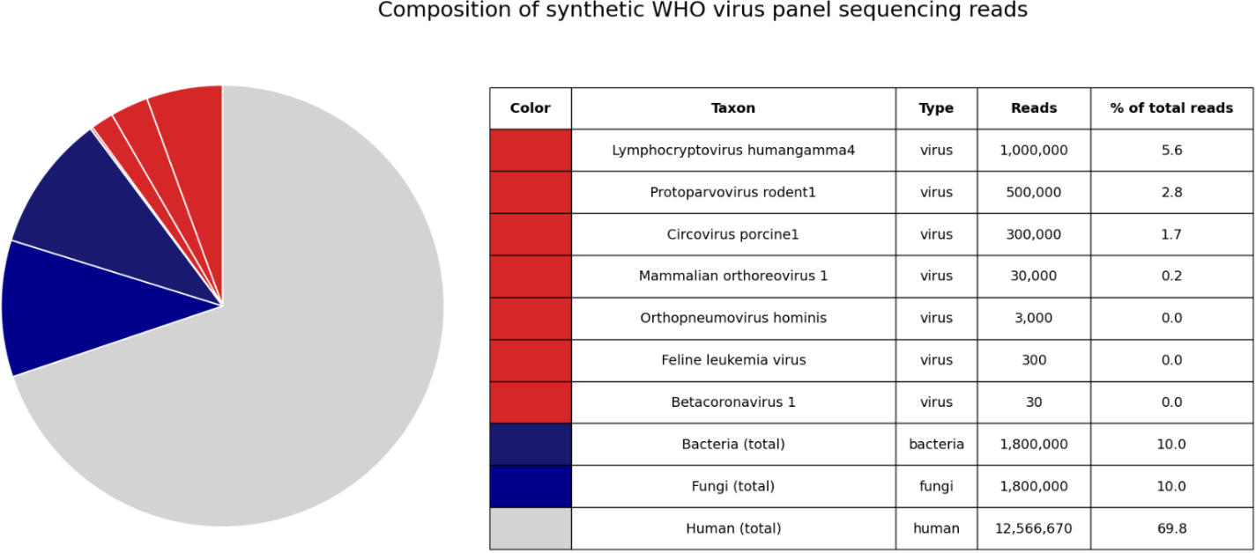
Supplementary Figure 1 | Composition of the dataset from the viral coinfection scenario (18 million paired-end reads) consisting of seven viruses, bacteria, fungi and human sequences. Each bacterial and fungal group contains four species with 450,000 reads per species.

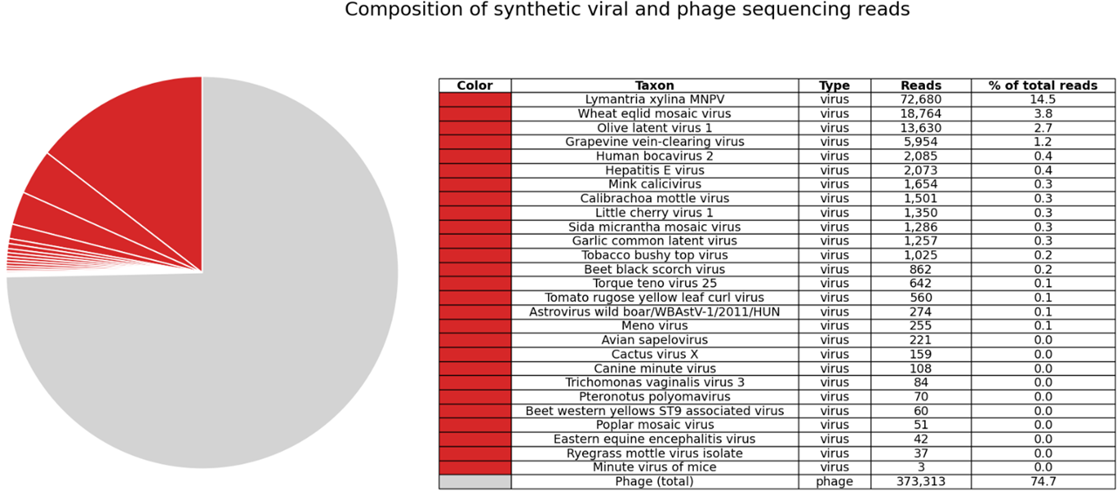
Supplementary Figure 2 | Composition of the synthetic sample (environmental virome scenario) taken from ¹³ comprising 27 eukaryote-associated viruses (type: virus) in phage background (type: phage). In total, 500,000 paired-end reads were simulated.
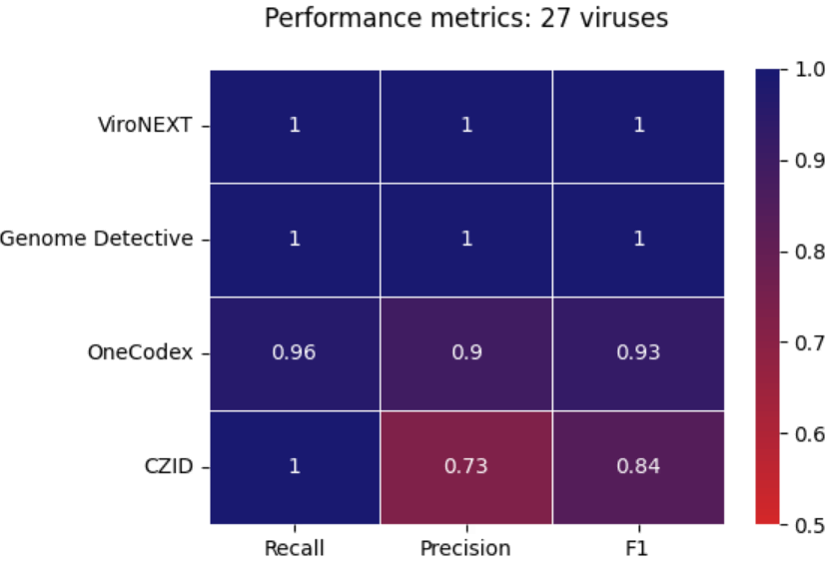
Supplementary Figure 3 | Overview of performance metrics of ViroNEXT, Genome Detective, One Codex and Chan Zuckerberg ID (CZID) based on the synthetic dataset of LaPierre et al. (2019) ¹³ consisting of 27 viral species at different concentrations in phage background.

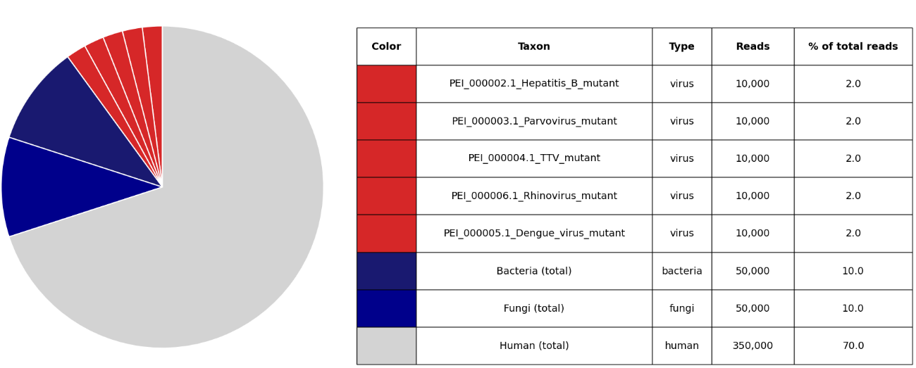
Supplementary Figure 4 | Composition of the dataset from the diagnostic escape scenario, including reads from synthetically generated viruses (type: virus), host background (type: human) and contaminating reads (type: bacteria and fungi).
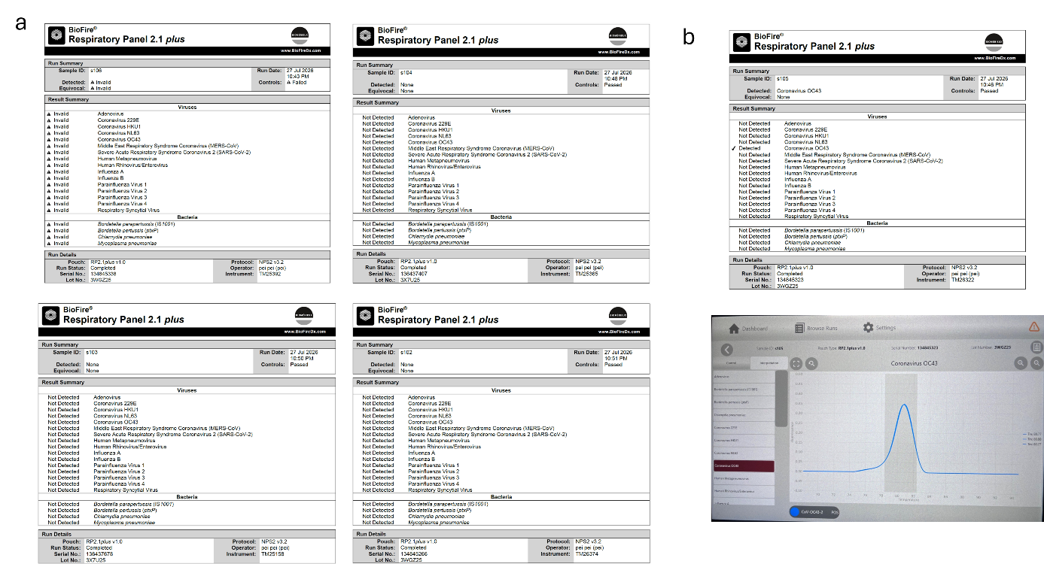
Supplementary Figure 5 | Results of the WHO spike in respiratory panel from IVD PCR multiplex for respiratory infections. The spiked samples are named s106,s105, s104, s103,1and s102 as a reference of their concentration from 10⁶ to 10² GE/mL respectively. a) results report of invalid (spike concentration 10⁶ GE/mL) and negative (spike concentration 10⁴-10² GE/mL) to any respiratory virus including Coronavirus OC43. b) report of the positive results (spike concentration 10⁵ GE/mL) and melting curve for Coronavirus OC43.

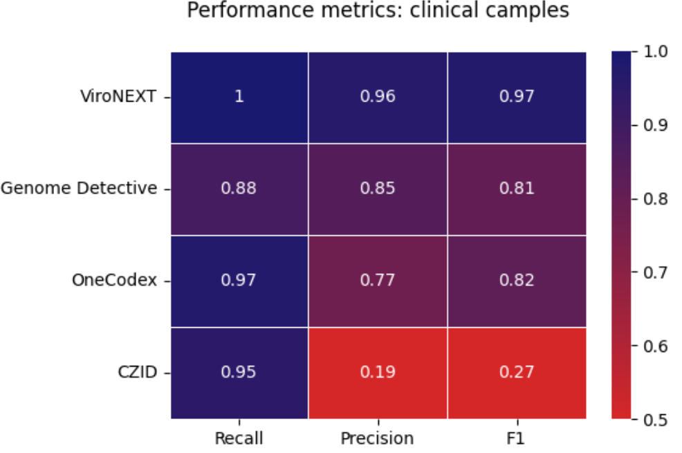
Supplementary Figure 6 | Overview of performance metrics of ViroNEXT, Genome Detective, One Codex and Chan Zuckerberg ID (CZID) based on the datasets of de Vries et al. (2021) ⁴³. The dataset contained 13 samples from cerebrospinal fluid, brain biopsies, nasopharyngeal swabs, nasal washings, bronchoalveolar lavage and plasma from patients with encephalitis or respiratory symptoms. Performance metrics in the graph constitute the average of all 13 samples.

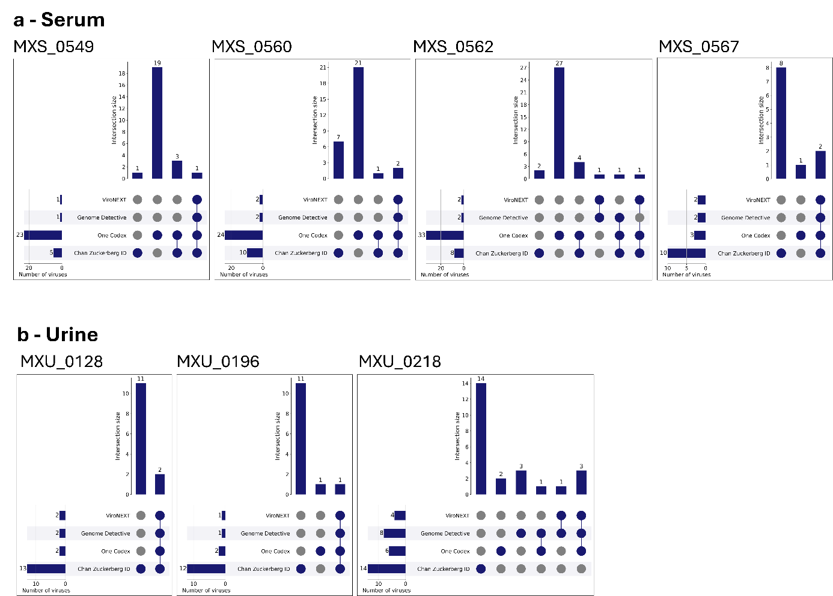
Supplementary Figure 7 | Cross-pipeline concordance of viral assignments across clinical samples.
UpSet plots summarizing the overlap of viral species assignments generated by ViroNEXT, Genome Detective, One Codex, and CZID across (a) serum and (b) urine samples of the Zik01 cohort. Horizontal bars indicate the total number of viral assignments per pipeline, whereas vertical bars represent the number of shared or unique assignments for each pipeline combination indicated by connected dots below.

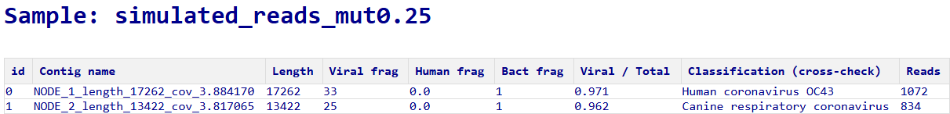
Supplementary Figure 8 | ML-based detection of simulated divergent Betacoronavirus 1 sequences. ViroNEXT report showing viral contigs recovered from 1,000 simulated paired-end read pairs with 20% sequence divergence from the Betacoronavirus 1 reference genome. The table displays contig length, numbers of fragments classified as viral, human or bacterial, the proportion of viral fragments, cross-check classification and the number of individual reads mapped to each contig; paired-end mates are counted separately.

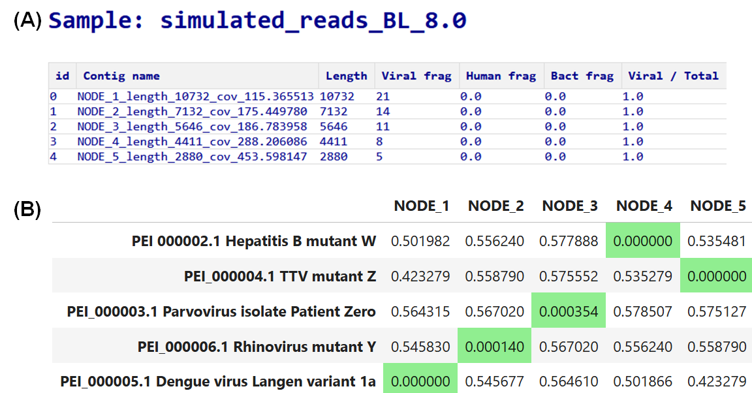
Supplementary Figure 9 | Assignment of contigs predicted as viral by the machine-learning branch. (A) Extract from the pipeline report summarizing contig names, lengths and classification metrics. The machine-learning branch detected five contigs as novel viral candidates in the simulated dataset. (B) Distance matrix showing sequence dissimilarity between these contigs and the corresponding divergent virus reference genomes. Minimal distances (in green) indicate that NODE_1, NODE_2, NODE_3, NODE_4 and NODE_5 derive from the Dengue, Rhinovirus, Parvovirus, Hepatitis B and Torque teno, respectively.

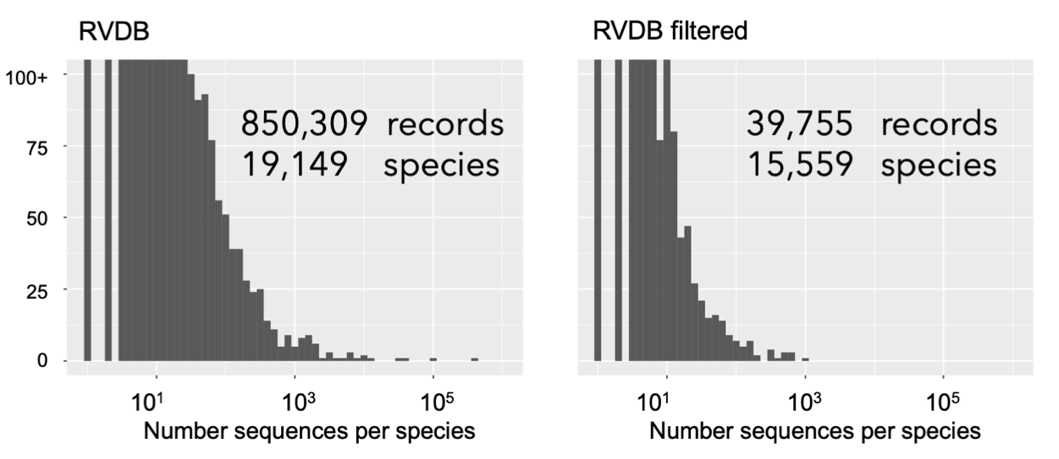
Supplementary Figure 10 | Viral genomes distribution in RVDB and custom filtered RVDB

Supplementary Tables

Supplementary Table 1 | Reference viruses used in this study
Virus | Common name | Genome type | Genome architecture | Envelope | Genome Size
Lymphocryptovirus humangamma4 | Epstein Barr Virus (EBV) | dsDNA | Linear | Enveloped | 172.3 kbp
Feline leukemia virus | Feline Leukemia Virus (FeLV) | ssRNA | Linear, diploid | Enveloped | 8.5 kbp
Orthopneumovirus hominis | Respiratory Sincytial Virus (RSV) | ssRNA(-) | Linear | Enveloped | 15.2 kbp
Mammalian orthoreovirus 1 | Reovirus type 1 (MRV-1) | dsRNA | Segmented ¹ | Non-enveloped | 23.5 kbp
Circovirus porcine1 | Porcine Circovirus (PCV) | ssDNA | Circular | Non-enveloped | 1.8 kbp
Betacoronavirus 1 | Coronavirus OC43 (HCoV-OC43) | ssRNA(+) | Linear | Enveloped | 30.7 kbp
Protoparvovirus rodent1 | Minute Virus of Mice (MVM) | ssDNA | Linear | Non-enveloped | 5.1 kbp
¹ L3 segment was selected for our study

Supplementary Table 2 | Nucleotide sequence similarity (%) between synthetic divergent taxa at maximum simulated divergence and their nearest known relatives
Closest relative | Sequence similarity (%)
Rhinovirus A | 60.6
Hepatitis B | 52.1
Dengue | 58.9
TTV | 45.2
Human Parvovirus B19 | 82.0

Supplementary Table 3 | Limit of detection (LOD) of ViroNEXT and comparator workflows in the adenovirus background spike-in dataset. The LOD was defined as the lowest viral concentration (genome equivalents per milliliter, GE/mL) at which the corresponding virus was successfully detected. Spike-in samples consisted of seven viruses diluted in an adenovirus background (10⁹ GE/mL). Values indicate the lowest concentration at which each workflow reported the expected viral taxon. FLV, Feline leukemia virus; RSV, Respiratory syncytial virus; MVM, Minute virus of mice; PCV, Porcine circovirus; EBV, Epstein-Barr virus; REO, Reovirus. Values denoted as >10⁵ indicate that the virus was not detected at the highest dilution tested.
Virus | ViroNEXT |  | Genome Detective | One Codex | CZ ID
Betacoronavirus 1 ¹ | 10⁵ |  | >10⁵ | >10⁵ | 10⁵
FeLV | 10⁴ |  | 10⁴ | 10⁵ | 10³
RSV | 10⁴ |  | 10⁴ | 10⁴ | 10³
MVM | 10³ |  | 10³ | 10⁴ | 10³
PCV | 10³ |  | 10² | 10³ | 10⁴
EBV | 10³ |  | 10³ | 10⁴ | 10²
MRV-1 | 10² |  | 10³ | 10⁵ | 10²
¹ Reduced recall of Betacoronavirus 1 in all pipelines is likely due to samples degradation (see discussion, Supplementary Figure 5)

Supplementary Table 4 | Composition of the multi-virus spike-in dataset. Species included in the experimental multi-virus spike-in dataset are listed together with their common names, abbreviations and origin.
Species name | Common name (abbr.) | Origin
Alphainfluenzavirus influenzae | Influenza A virus (IAV) | Cell culture
Betapolyomavirus macacae | Simian virus 40 (SV40) | Cell culture
Bocaparvovirus ungulate1 | Bovine parvovirus (BPV) | Cell culture
Cardiovirus A | Encephalomyocarditis virus (EMCV) | Cell culture
Chikungunya virus | Chikungunya virus (CHIKV) | Standard
Enterovirus C | Poliovirus (Polio) | Cell culture
Enterovirus F | Bovine enterovirus (BEV) | Cell culture
Hepacivirus hominis | Hepatitis C virus (HCV) | Standard
Hepatitis B | Hepatitis B virus (HBV) | Standard
Hepatitis E virus | Hepatitis E virus (HEV) | Standard
Hepatovirus A | Hepatitis A virus (HAV) | Standard
Orthobunyavirus Schmallenbergense | Schmallenberg virus (SBV) | Cell culture
Orthoflavivirus nilense | West Nile virus (WNV) | Standard
Orthoflavivirus usutuense | Usutu virus (USUV) | Cell culture
Orthoflavivirus zikaense | Zika virus (ZIKV) | Standard
Pestivirus bovis | Bovine viral diarrhea virus (BVDV) | Cell culture
Protoparvovirus ungulate 1 | Porcine parvovirus (PPV) | Cell culture
Semliki Forest virus | Semliki Forest virus (SFV) | Cell culture
Simplexvirus humanalpha 1 | Herpes simplex virus 1 (HSV-1) | Cell culture
Varicellovirus suidalpha 1 | Pseudorabies virus (PRV) | Cell culture
Vesicular stomatitis virus | Vesicular stomatitis virus (VSV) | Cell culture

Supplementary Table 5 | Descriptive statistics of false-positive virus assignments generated by each evaluated pipeline. False-positive assignments were summarized across all samples with evaluable results for each pipeline. The table summarizes the number of evaluated samples (n), mean, standard deviation (SD), median, first and third quartiles (Q1 and Q3), interquartile range (IQR), minimum and maximum number of false-positive assignments, and the number of samples with zero false-positive assignments.
Pipeline | n | Mean | SD | Median | Q1 | Q3 | IQR | Min. | Max. | Samples with zero false positives
ViroNEXT | 27 | 0.33 | 0.88 | 0 | 0 | 0 | 0 | 0 | 4 | 22
Genome Detective | 24 | 2.42 | 3.45 | 1 | 0 | 3 | 3 | 0 | 11 | 9
One Codex | 21 | 2.29 | 1.35 | 2 | 1 | 3 | 2 | 0 | 4 | 2
CZID | 27 | 91.7 | 40.5 | 85 | 71.5 | 107 | 35.5 | 23 | 196 | 0

Supplementary Table 6 | Pairwise comparison of false-positive assignment rates between pipelines using the negative-binomial generalized linear mixed-effects model. Pairwise comparisons were performed using estimated marginal means from the fitted GLMM and are reported as rate ratios (RR) with 95% confidence intervals. Rate ratios represent the false-positive rate of the first pipeline relative to the second pipeline. P values were adjusted for multiple comparisons using the Holm method. Values below one indicate fewer false-positive assignments for the first pipeline.
Comparison | RR | 95% CI | Holm-adjusted P value
ViroNEXT / Genome Detective | 0.143 | 0.054–0.378 | <0.001
ViroNEXT / One Codex | 0.156 | 0.058–0.417 | <0.001
ViroNEXT / CZID | 0.00347 | 0.0014–0.0086 | <0.001
Genome Detective / One Codex | 1.085 | 0.614–1.918 | 0.706
Genome Detective / CZID | 0.0242 | 0.0158–0.0372 | <0.001
One Codex / CZID | 0.0223 | 0.0143–0.0349 | <0.001

Supplementary Table 7 | Validation of the negative-binomial GLMM and sensitivity analysis of pipeline differences. Model assumptions were evaluated using simulated residual diagnostics implemented in the DHARMa R package. Tests included residual dispersion, zero inflation, and residual uniformity. No significant deviations from model assumptions were detected. As an independent non-parametric sensitivity analysis, pipeline differences were assessed using Friedman’s test on samples with evaluable results for all four pipelines, followed by paired Wilcoxon signed-rank tests with Holm correction.
Analysis | Test statistic | Degrees of freedom | P value | Interpretation
Residual dispersion | Dispersion = 0.681 | – | 0.330 | No evidence of residual overdispersion
Zero inflation | Observed/simulated zero ratio = 1.21 | – | 0.118 | No significant excess of zero counts
Residual uniformity | KS statistic = 0.097 | – | 0.286 | Residual distribution consistent with model assumptions
Pipeline effect (GLMM likelihood-ratio test) | χ² = 193.1 | 3 | <2.2 × 10⁻¹⁶ | Pipeline significantly affects false-positive counts
Friedman sensitivity analysis | χ² = 50.34 | 3 | 6.76 × 10⁻¹¹ | Pipeline differences confirmed by non-parametric analysis

Supplementary Table 8 | Overview of clinical samples obtained from the previously published benchmarking study de Vries et al. (2021) ⁴³. Clinical presentation, sample type, detected viruses and sample identifiers are shown for the 13 clinical metagenomic datasets included in this study
Disease | Sample number | Sample type | Detected viruses | Sample name
Encephalitis | 1 | CSF | HHV-6 | cs019
 | 2 | CSF (capture probes) | HHV-6 | cs032
 | 3 | CSF (capture probes) | EBV | cs001
 | 4 | CSF (capture probes) | Enterovirus | cs010
 | 5 | Brain biopsy | Mumps | GOSHmeta1
 | 6 | Brain biopsy | CoV-OC43 | GOSHmeta2
 | 7 | Brain biopsy | Astrovirus VA1 | GOSHmeta3
Respiratory disease | 8 | NP swab | Inf-A | cs014
 | 9 | NP swab | PIV-3 | cs054
 | 10 | NP swab | CoV-NL63 | cs106
 | 11 | BAL | CoV-NL63,  CoV-HKU-1 | cs063
 | 12 | Nasal wash | CoV-HKU-1 | cs080
Fever | 13 | Plasma | Adenovirus,  EBV | cs021
CSF: cerebrospinal fluid, NP: nasopharyngeal swabs, BAL: bronchoalveolar lavage

Supplementary Table 9 | PCR Validation. qPCR results from the arbovirus cohort samples.
Virus tested | Sample |  | Results
Human betaherpesvirus 7 | MXS_0549 |  | Negative
 | MXS_0562 |  | Negative
Human betaherpesvirus 5 (Cytomegalovirus) | MXS_0549 |  | Negative
 | MXS_0652 |  | Negative
Human gammaherpesvirus 4 (Epstein Barr Virus) | MXS_0562 |  | Negative
 | MXS_0549 |  | Negative
Rhinovirus A | MXS_0560 |  | Negative

