Supporting Information
Coconut Shell Biochar as a Sustainable Amendment for Soil Quality and Tomato (Solanum lycopersicum L.) Plant Growth
Meenu Yadav¹, Anu Kumari¹, Rishi Mittal² and Rachna Bhateria¹*
¹Department of Environmental Sciences, Maharshi Dayanand University, Rohtak-124001, Haryana (India)
² Department of Applied Science and Humanities, I.T.S Engineering College, Greater Noida 201310, Uttar Pradesh (India)
Corresponding Author email: rachna.env@mdurohtak.ac.in 1*

S1: Biochar characterization techniques
The pH and electrical conductivity (EC) were measured with a pH/EC meter (LMPH-10, Labman Instruments/ LMCM-20, Harrier Enterprises). CEC was measured using ammonium acetate method (Nguyen and Lehmann 2009). The biochar was also characterized in terms of macronutrients such as nitrogen (N), phosphorus (P), magnesium (Mg), calcium (Ca), sulfur (S) and potassium (K); micronutrients, such a copper (Cu), iron (Fe), zinc (Zn), manganese (Mn).
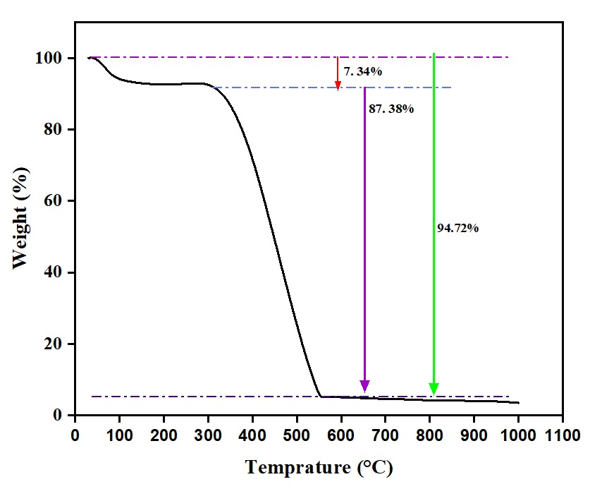

Figure S1: TGA of CSB.

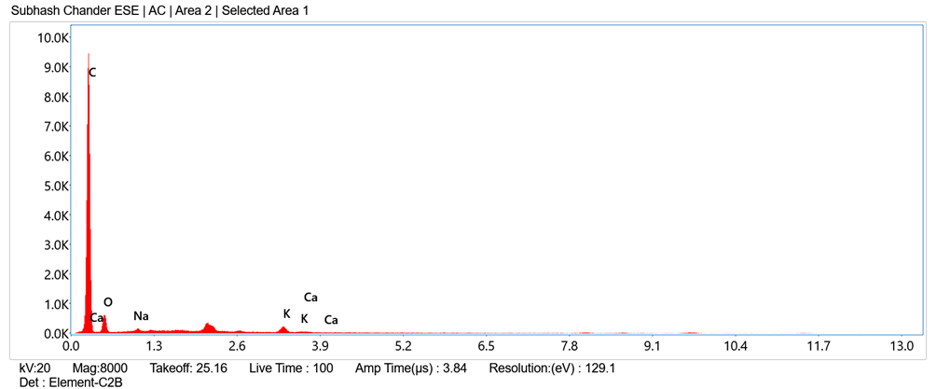
Figure S2: EDX of CSB.

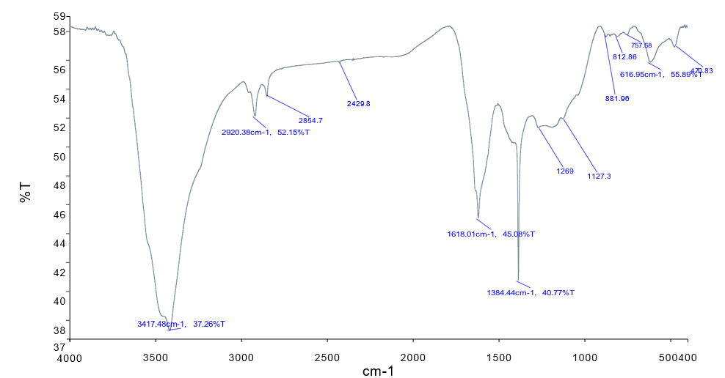
Figure S3: FTIR Spectra of CSB.
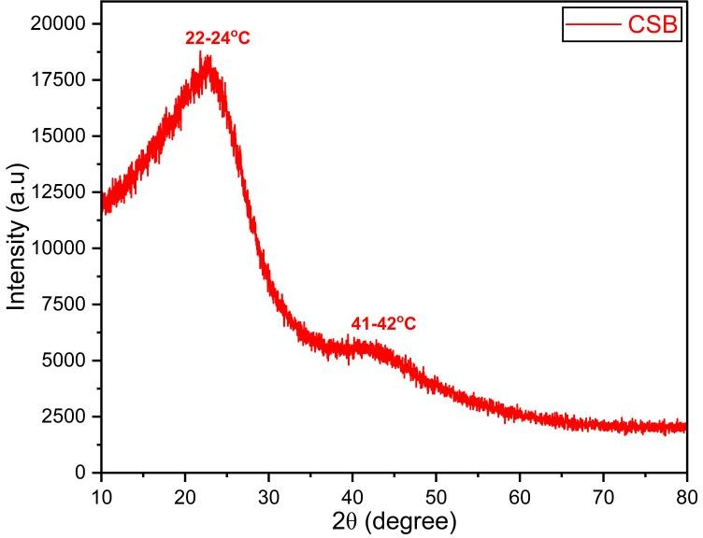
Figure S4: XRD of CSB.

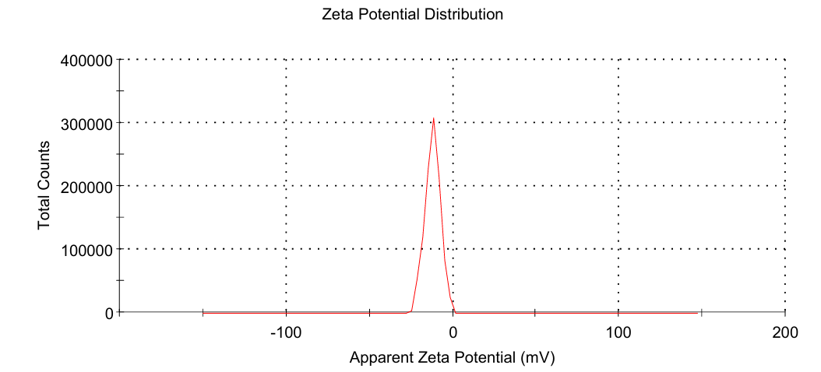
Figure S5: Zeta potential of CSB.
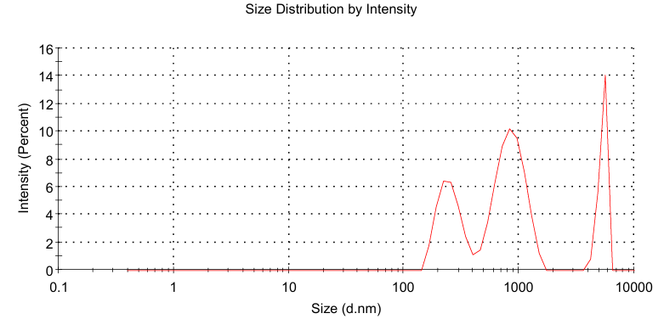
Figure S6: Particle size analysis of CSB.
S2: Soil sample analysis
Soil samples were analyzed for physicochemical properties including nutrient contents such as Nitrogen (N) Phosphorus (P), Potassium (K), Calcium (Ca), Magnesium (Mg), Sulfur (S), Zinc (Zn), Iron (Fe), Copper (Cu) and Boron (B) using standard methods. 5 g of 2-mm sieved soil was weighted and shaken for 24 h with 50 mL deionized water. Soil pH was measured in soil–water (w/v, 1:10) suspensions using a pH meter (HM Digital, 200). The soil solution was then centrifuged afterwards filtered using a Whatman 42 filter paper, and the EC was determined using an EC meter (Harrier Enterprises, LMCM-20). Bulk density of soil was estimated using core sampler method. CEC was determined by using ammonium acetate extract as described by Nguyen and Lehmann (2009). Organic carbon (%) was analyzed by wet oxidation method. Organic matter content was determined by multiplying organic carbon percentage to a factor of 1.72. WHC and moisture content (MC) were determined by keen box and Gravimetric/oven-dry method respectively.
Table S1: One-way ANOVA summary table for characteristics under study.
S. no. | Characteristics | F values | p values
 | pH | 1.02 | 0.4324
 | Electric conductivity (μS) | 1116.00 | < 0.0001
 | Water holding capacity (%) | 25.70 | 0.0002
 | Moisture content (%) | 64.25 | < 0.0001
 | Organic carbon (%) | 29.86 | 0.0001
 | Cation exchange capacity (meq/100g) | 55.61 | < 0.0001
 | Organic matter (%) | 82.73 | < 0.0001
 | Chlorophyll content (mg) | 21.82 | 0.0003
 | Plant height (cm) | 22.09 | 0.0003
 | Branches (nos.) | 1.90 | 0.2081
 | Shoot length (cm) | 38.47 | < 0.0001
 | Root length (cm) | 99.44 | < 0.0001
 | Shoot fresh weight (g) | 191.30 | < 0.0001
 | Root fresh weight (g) | 418.70 | < 0.0001
 | Leaves (nos.) | 74.00 | < 0.0001
 | Fruit yield (g) | 4522.00 | < 0.0001
 | Root dry weight (g) | 93.54 | < 0.0001
 | Shoot dry weight (g) | 556.50 | < 0.0001
 | Internodal distance (cm) | 47.38 | < 0.0001
 | Calcium (ppm) | 105.20 | < 0.0001
 | Magnesium (mg/kg) | 402.40 | < 0.0001
 | Sulfur (mg/kg) | 40.83 | < 0.0001
 | Phosphorus (kg/ha) | 118.90 | < 0.0001
 | Potassium (kg/ha) | 326.70 | < 0.0001
 | Nitrogen (kg/ha) | 65.44 | < 0.0001
 | Zinc (mg/kg) | 37.95 | < 0.0001
 | Iron (mg/kg) | 51.75 | < 0.0001
 | Copper (mg/kg) | 339.70 | < 0.0001
 | Boron (mg/kg) | 1.20 | 0.3687

Table S2: Compared p values of multiple treatment levels with controls using Tukey's honest significant difference test.
S. no. | Characteristics | Control vs.
S. no. | Characteristics | BC-2% | BC-4% | BC-6%
 | pH | 0.8108 | 0.5156 | 0.4395
 | Electric conductivity (μS) | 0.0435 | <0.0001 | <0.0001
 | Water holding capacity (%) | 0.0008 | 0.0021 | 0.0002
 | Moisture content (%) | 0.0706 | 0.0005 | <0.0001
 | Organic carbon (%) | 0.0064 | 0.0015 | <0.0001
 | Cation exchange capacity (meq/100g) | 0.0039 | <0.0001 | <0.0001
 | Organic matter (%) | 0.0002 | <0.0001 | <0.0001
 | Chlorophyll content (mg) | 0.0076 | 0.0013 | 0.0003
 | Plant height (cm) | 0.0012 | 0.2302 | 0.0005
 | Branches (nos.) | 0.8638 | >0.9999 | 0.4550
 | Shoot length (cm) | 0.5174 | 0.8452 | 0.0001
 | Root length (cm) | <0.0001 | <0.0001 | 0.0033
 | Shoot fresh weight (g) | 0.1756 | 0.0027 | <0.0001
 | Root fresh weight (g) | <0.0001 | <0.0001 | <0.0001
 | Leaves (nos.) | <0.0001 | 0.0001 | <0.0001
 | Fruit yield (g) | <0.0001 | <0.0001 | <0.0001
 | Root dry weight (g) | <0.0001 | 0.0028 | <0.0001
 | Shoot dry weight (g) | <0.0001 | <0.0001 | <0.0001
 | Internodal distance (cm) | 0.0024 | 0.0029 | 0.0191
 | Calcium (ppm) | <0.0001 | 0.9983 | 0.0526
 | Magnesium (mg/kg) | <0.0001 | <0.0001 | <0.0001
 | Sulfur (mg/kg) | 0.0027 | 0.8757 | 0.0023
 | Phosphorus (kg/ha) | <0.0001 | <0.0001 | <0.0001
 | Potassium (kg/ha) | <0.0001 | <0.0001 | <0.0001
 | Nitrogen (kg/ha) | 0.0390 | 0.9953 | <0.0001
 | Zinc (mg/kg) | 0.0036 | 0.0326 | 0.0025
 | Iron (mg/kg) | 0.0002 | <0.0001 | <0.0001
 | Copper (mg/kg) | <0.0001 | <0.0001 | <0.0001
 | Boron (mg/kg) | 0.3611 | 0.9842 | 0.7270

