Supplementary methods and provenance evidence
This supplement accompanies the reanalysis of blood transcriptomic overlap between major depressive disorder and experimental sleep restriction. It documents sample reconstruction and the distinction between recovered historical materials and the executable analyses reported in the main manuscript. Detailed sample records and numerical results are supplied in the accompanying data files.

Historical quality control in GSE98793
The original publication reported exclusion of 22 arrays, leaving 113 MDD cases and 57 controls [1]. Cole and colleagues subsequently described removing the same number of previously failed arrays [2]. The public GSE98793 series contains 192 arrays, including the samples excluded from the source analysis.
The Cambridge Apollo record for the Cole publication listed seven original attachments. The recovered CODE_doku_wiki.txt [3] reads a tab-separated file named sample_IDs.csv and retains ID values for which keep equals zero. The dependency was absent from the listed attachments, and the code contains no GSM accessions. Without the file and its mapping to expression-matrix columns, neither the sample identifiers nor their exclusion status could be authenticated. The ID field must not be assumed to contain GSM strings rather than column indices.
The recovered code was 196679 bytes, with SHA-256 540431e4e38ce10d899c8e4c80c26d8690b039b088130dec5eb1d19b1d1aacba. Its MD5 matched the repository value of 516ac3d3aaeb5e8be7e70fd7c6b51ddd. A quantile-normalization call in the archived code does not assign its return value to the expression object. The file alone therefore cannot establish whether normalization was applied during the original execution.

Archived reconstruction of the 22 exclusions
An earlier project archive contained a 22-array list and its generating Python code. Stored raw-distance diagnostics flagged 21 arrays, comprising 14 MDD cases and seven controls. The code then selected GSM2612131 from other diagnostic failures to match the published target of 15 excluded cases and seven excluded controls. The resulting denominator was thus partly imposed by the reconstruction rule. This list was not used in the current analyses.
The full archived diagnostic union contained 24 arrays. The reconstructed 22-array list and the present nine-array processed-expression QC list overlapped only at GSM2612131. The complete 192-array provenance ledger and the separately labelled unauthenticated 22-array extract are included with the code and source evidence. Archived raw-array metrics were inspected but not recomputed. Recovering the archived bytes establishes the identity of those materials, not the validity of their historical QC assignments.

Independent processed expression diagnostics
The independent QC analysis used the deposited 54675-probe matrix. Each array was assessed by its total mean absolute distance from the other arrays and its Kolmogorov–Smirnov distance from the pooled empirical expression distribution. The upper Tukey hinge plus 1.5 interquartile ranges was used for each diagnostic, and the union determined the sensitivity exclusions. The procedure did not use diagnosis to set thresholds or target counts.
A separate reconstruction of the three generic arrayQualityMetrics diagnostics on the processed matrix used a fixed seed and the historical R sampling rule implemented in the supplied script. The distance diagnostic flagged five arrays, the distribution diagnostic flagged eight and the MA diagnostic flagged none; their union contained nine arrays. These matched the independent sensitivity exclusions. Neither procedure authenticates the original 22 exclusions or substitutes for the unavailable raw-array QC report. Figure S1 shows the nine flags in the complete gene-level principal-component space.

Sleep titles and pairing
The GSE39445 parser accepted both Subject_AF####_SE/SR_T# and AF####_SE/SR_T# title formats. Eleven deposited arrays used the latter format. Participant identifiers inferred from these titles were checked against the available records; no conflicting explicit participant identifier was found. Characteristics were parsed within each sample rather than read from a fixed metadata-row position.
Pairing by participant and nominal sampling index produced 189 SR–SE pairs from 22 participants. All pairs had equal recorded hours awake. AF0112 had four pairs and failed the minimum-five-pair criterion, leaving 21 participants and 185 pairs. AF0033 contributed seven eligible pairs. Restricting titles to the Subject_ prefix produced 180 pairs before participant eligibility filtering and 173 pairs from 20 participants afterwards. That restriction is an intentionally incomplete diagnostic comparison, not an alternative valid eligibility rule.
Of all 189 nominal-time pairs, 72 had identical recorded circadian phase and 117 had the SR phase three hours below the SE phase. AF0182 SE T4 (GSM969076) and T5 (GSM969077) both recorded phase −3. The main temporal model preserved these deposited values. Excluding AF0182 retained 179 pairs from 20 participants. Exact-phase matching excluded the two ambiguous SE records before pairing and retained 166 pairs from 20 participants after the same eligibility threshold. This last comparison does not also match hours awake.

Temporal and combined association models
For gene g, the temporal model fitted the paired difference D as the sum of ten sampling-index effects, a coefficient for the SR-minus-SE difference in sin(2πphase/24), a coefficient for the corresponding cosine difference, and an error term. limma duplicateCorrelation supplied the consensus within-participant correlation. The target contrast was the unweighted mean of the ten sampling-index coefficients. Nine contrasts against the first index formed the joint heterogeneity test. The design matrices, contrast weights and metadata for each fitted model are provided as tab-separated files.
For each common gene, the signed Stouffer statistic was (zMDD + zsleep)/√2, where each component normal score used its two-sided P value and effect sign. The partial-conjunction P value was max(PMDD, Psleep). Both P-value families were adjusted across all 16180 common genes before filtering for concordant effect directions. Component-study significance in the main tables uses adjustment over the complete eligible gene universe of that study, not only the common genes. This distinction explains why component-study significance and adjusted partial-conjunction significance cannot be inferred from the Stouffer count alone.
The 25 model combinations cross five MDD definitions with five sleep definitions. The MDD definitions are the non-GAD and pooled contrasts in all 192 samples, the corresponding contrasts after independent QC, and the non-GAD contrast after independent QC plus renormalization. The sleep definitions are nominal-time participant means, the time-and-phase model, that model omitting AF0182, exact-phase participant means and the diagnostic title restriction. All models are reported irrespective of their significant-gene counts.

Historical script identity and numerical verification
The archived manifest named reproduce_transcriptomics.py and reported SHA-256 dc51847809003ba9c058f8cce7f03076fe98a12c9df0ba3874f5373d4c9d72ab. A search of 11 available archives covered 562 members, including 53 Python entries with duplicates. No member had that filename or digest. This search does not establish that the file never existed.
The recovered older transcriptomics.py has SHA-256 0d0fde0233e21c3dd435842e39b6a64361f09fd37a28bf8b59ef5b23fa54e170. It accepts both sleep-title formats. Comparison with standard limma on identical MDD, participant-mean sleep and adjusted clinical-insomnia inputs yielded the coefficient and moderated-t agreement reported in the main manuscript. The recovered older file and the missing later file must not be treated as the same implementation.

Perturbation outputs and reproducibility scope
Archived perturbation-query outputs were generated using an earlier 52-gene list. They were excluded from the current therapeutic interpretation and were not relabelled as outputs for the 134-gene or 617-gene lists. No new perturbation screen or biological validation was conducted.
The current code and results reproduce the specified analyses of the deposited matrices. Source URLs, checksums, annotation snapshots, sample ledgers and software versions are supplied so that input identity and the present calculations can be checked independently. The unavailable historical QC dependency and exact later Python script limit reconstruction of earlier analyses, not execution of the explicitly defined current models.

References
1. Leday GGR, Vértes PE, Richardson S, Greene JR, Regan T, Khan S, et al. Replicable and coupled changes in innate and adaptive immune gene expression in two case-control studies of blood microarrays in major depressive disorder. Biol Psychiatry. 2018;83:70–80. doi:10.1016/j.biopsych.2017.01.021.
2. Cole JJ, McColl A, Shaw R, Lynall ME, Cowen PJ, de Boer P, et al. No evidence for differential gene expression in major depressive disorder PBMCs, but robust evidence of elevated biological ageing. Transl Psychiatry. 2021;11:404. doi:10.1038/s41398-021-01506-4.
3. Cole JJ, et al. Accompanying code for No evidence for differential gene expression in major depressive disorder PBMCs, but robust evidence of elevated biological ageing. Cambridge Apollo. https://doi.org/10.17863/CAM.70892. Accessed 8 September 2026.

Supplementary figure
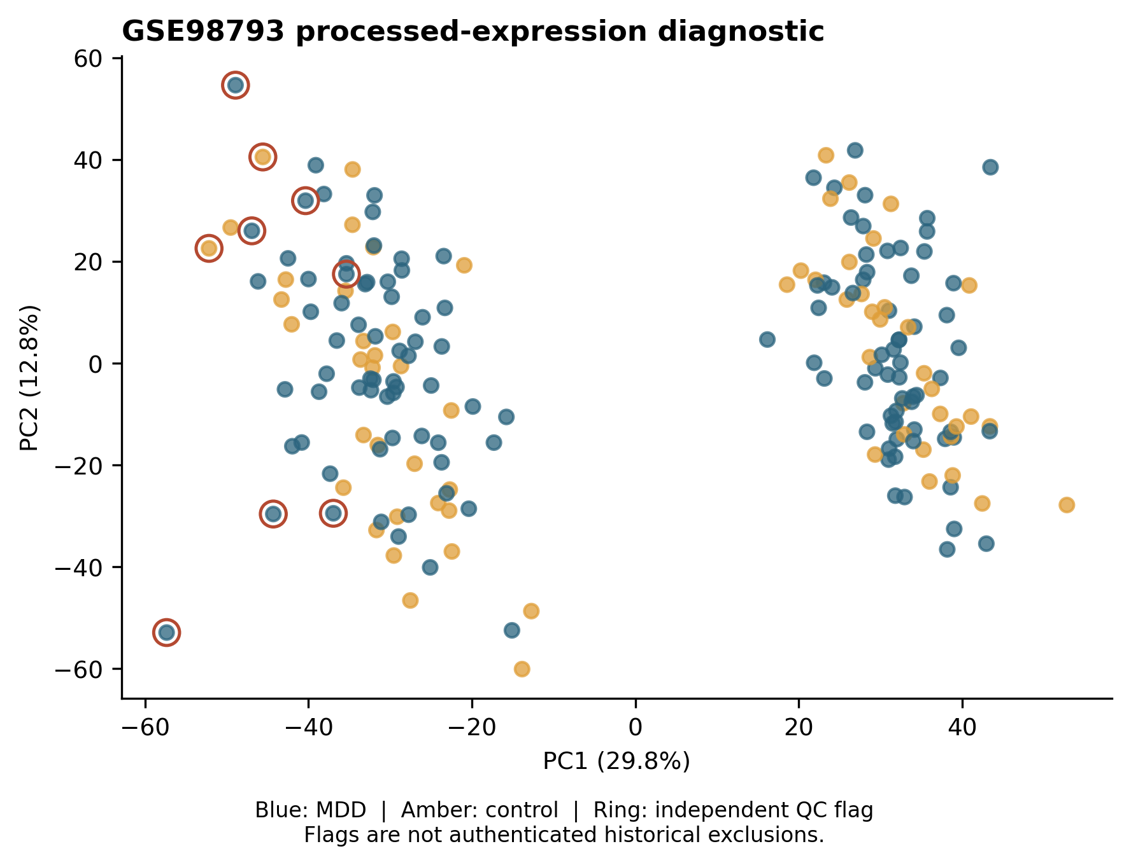
Figure S1. Processed expression quality diagnostics in the MDD dataset. Principal components were calculated from the complete gene-level matrix. Rings indicate the nine arrays flagged by the independent processed-expression rule. The plot shows all 192 deposited samples. These flags are distinct from, and do not authenticate, the original 22 QC exclusions.

