Supplemental Information

Alkyl-Chain Engineering and Synergistic Annealing Enable Enhanced Performance in Non-Fullerene Organic Solar Cells
Kai Wang,^{1,}* Bo Zhang,^{2,}** Jun Huang,^{3,}***
¹ Xuzhou College of Industrial Technology, Xuzhou 221140, China
2College of Materials Science and Engineering & Hubei Key Laboratory of Photoelectronic Conversion Materials and Device,
Hubei Normal University, Huangshi 435002, China
³ Jiangsu Sidike New Materials Science and Technology Co., Ltd., Suqian 223900, China

Materials
Unless otherwise stated, all the solvents and chemicals were obtained commercially and were used without further purification.
Synthesis Of Monomers
Synthesis of monomers Compounds 1, 2 and 3 were synthesized as follows:
6-bromoindoline-2,3-dione (1 equiv) and potassium carbonate (2.5 equiv) were added to the reaction flask, followed by evacuation and purging with inert gas. Anhydrous DMF and tetrahydrofuran were then introduced, and 1-bromooctane was slowly added dropwise to the flask. The reaction was allowed to proceed overnight at 50 °C. Subsequently, extraction was performed using dichloromethane and water, the combined organic phases were dried over anhydrous magnesium sulfate. After the removal of dichloromethane by rotary evaporation, Compounds 1 was isolated and purified via column chromatography. Compound 2 and Compound 3 were synthesized similarly as described above for Compound 1 except that 1-Bromo-2-ethylhexane and 1-bromobutane were used instead of 1-bromooctane.
Compound M1, M2 and M3 were synthesized as follows:
Compound 4 (1 equiv) and compound 1 (2.5 equiv) were added to the reaction flask. After three cycles of pump-refill with inert gas, add anhydrous toluene and the catalyst Pd(PPh₃)₄ (5 % equiv). The mixture is heated to 125 °C and allowed to react overnight. After cooling to room temperature, the mixture is extracted with chloroform and deionized water. The combined organic phases are dried over anhydrous magnesium sulfate, the solvent is removed under reduced pressure, and the residue is purified by column chromatography to afford the target compound M1.M2 and M3 were synthesized similarly as described above for M1 except that Compound 2 and Compound 3 were used instead of Compound 1.
Synthesis of WH7, WH11,WH17 were synthesized as follows:
The compound intermediates M1 (1 equiv) and 2-(3-ethyl-4-oxothiazolidin-2-ylidene)malononitrile (5 equiv) were added to the reaction flask. After performing three pump-refill cycles with inert gas, add chloroform to the system. The mixture is stirred for 5 minutes, then several drops of triethylamine are added, and the reaction is allowed to proceed overnight at room temperature. The resulting mixture is extracted with chloroform and deionized water, the combined organic phases are dried over anhydrous magnesium sulfate. After removing chloroform under reduced pressure, the residue is purified by column chromatography to afford the target product WH7. WH11 and WH17 were synthesized similarly as described above for M1 except that M2 and M3 were used instead of M1.

The ¹H NMR spectra and ¹³C NMR spectra of WH7 are shown in Figure S6 and Figure S7.
WH7:¹H NMR (400 MHz, CDCl₃, 298 K): 8.83 (s, 1H), 7.48 (d, 1H), 7.41 (s, 1H), 7.35 (d, 1H), 7.23 (d, 4H), 7.13 (d, 4H), 7.03 (s, 1H), 4.33 (q, 2H), 3.81 (t, 2H), 2.58 (t, 4H), 1.72 (m, 2H), 1.60 (t, 4H), 1.45-1.19 (m, 25H), 0.84 (m, 9H). ¹³C NMR (100 MHz, CDCl₃, 298 K): 182.18, 159.05, 157.80, 154.20, 151.91, 145.52, 144.59, 144.04, 142.17, 141.24, 135.61, 128.70, 127.96, 122.23, 120.08, 118.07, 116.23, 106.06, 63.37, 40.37, 35.72, 31.90, 31.86, 31.52, 29.32, 29.30, 29.27, 27.56, 27.03, 22.77, 22.74, 14.24. (Note: some peaks overlapped in ¹³C NMR). HRMS m/z calcd. for (C₁₁₂H₁₂₂O₄N₈S₄) : 1770.84664, found: 1770.85162.
The ¹H NMR spectra and ¹³C NMR spectra of WH11 are shown in Figure S8 and Figure S9.
WH11:¹H NMR (400 MHz, CDCl₃, 298 K): 8.83 (s, 1H), 7.49 (d, 1H), 7.40 (s, 1H), 7.35 (d, 1H), 7.22 (d, 4H), 7.12 (d, 4H), 7.03 (s, 1H), 4.30 (q, 2H), 3.70 (m, 2H), 2,58 (t, 4H), 1.83 (m, 1H), 1.60 (m, 4H), 1.46-1.22 (m, 26H), 0.97 (t, 3H), 0.87 (m, 6H). ¹³C NMR (100 MHz, CDCl₃, 298 K): 166.58, 166.32, 164.13, 156.06, 152.38, 144.65, 144.50, 141.59, 140.38, 139.77, 138.22, 133.94, 128.03, 126.99, 126.72, 126.32, 122.37, 119.60, 117.99, 117.10, 116.25, 110.83, 110.63, 103.89, 75.82, 75.71, 75.50, 75.19, 61.66, 55.83, 43.14, 38.63, 36.29, 34.06, 30.20, 29.87, 29.17, 28.19, 27.64, 27.19, 22.63, 21.49, 21.09, 12.64, 12.60, 12.56, 9.19. (Note: some peaks overlapped in ¹³C NMR). HRMS: HRMS m/z calcd. for (C₁₁₂H₁₂₂O₄N₈S₄) : 1770.84664, found: 1770.84839.
The ¹H NMR spectra and ¹³C NMR spectra of WH17 are shown in Figure S10 and Figure S11.
WH17: ¹H NMR (400 MHz, CDCl₃, 298 K): 8.84 (s, 1H), 7.48 (d, 1H), 7.42 (s, 1H), 7.35 (d, 1H), 7.23 (d, 4H), 7.13 (d, 4H), 7.03 (s, 1H), 4.33 (q, 2H), 3.82 (t, 2H), 2.58 (t, 4H), 1.70 (m, 2H), 1.63-1.17(m, 21H), 0.98 (t, 3H), 0.87 (t, 6H). ¹³C NMR (100 MHz, CDCl₃, 298 K): 167.95, 165.79, 157.72, 154.08, 146.31, 145.75, 143.27, 142.06, 141.41, 139.96, 135.58, 129.78, 128.66, 128.44, 128.02, 123.99, 121.31, 119.78, 118.82, 112.47, 112.28, 105.24, 63.33, 57.52, 40.54, 40.32, 35.73, 31.86, 31.54, 29.84, 29.31, 22.75, 20.32, 14.30, 14.26, 13.84. (Note: some peaks overlapped in ¹³C NMR). HRMS m/z calcd. for (C₁₀₄H₁₀₆O₄N₈S₄) : 1658.72144, found: 1658.72302.

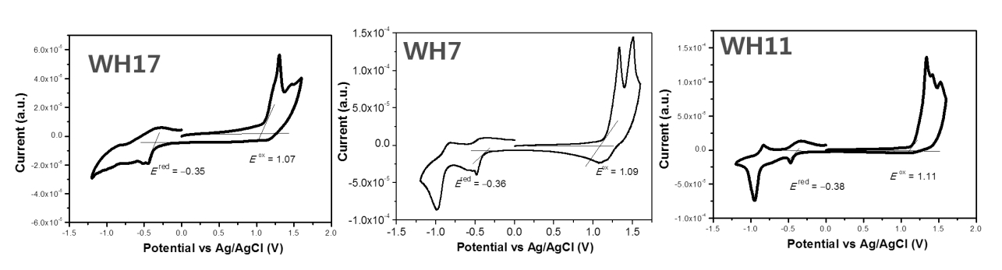
Figure S1. The CV curves of WH17, WH7, WH11.

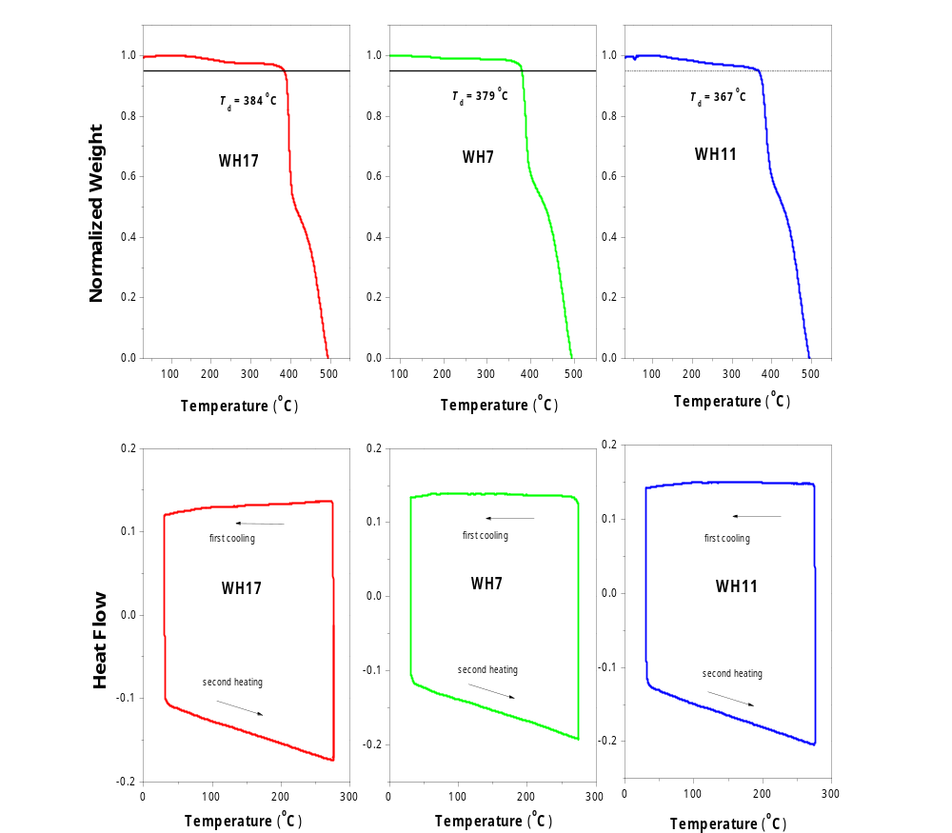
Figure S2. (A) The TGA curves of WH17, WH7, WH11. (B) The DSC curves of WH17, WH7, WH11.

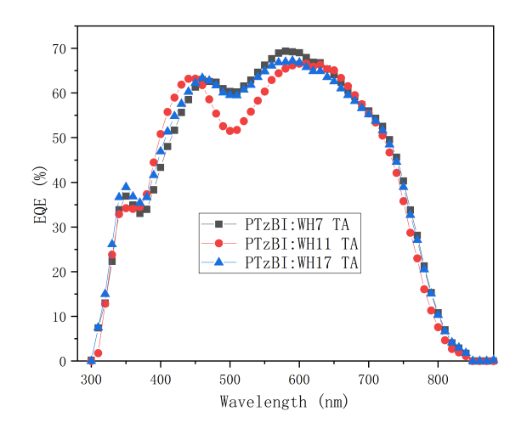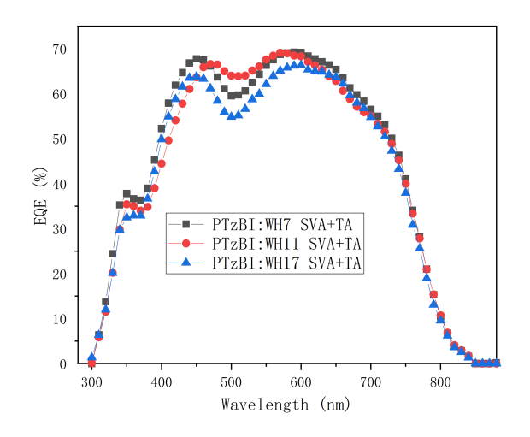
Figure S3. (A) The EQE curves of devices with TA.(B) The DSC curves of devices with TA and SVA

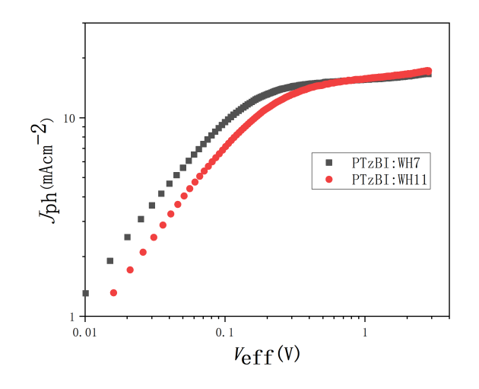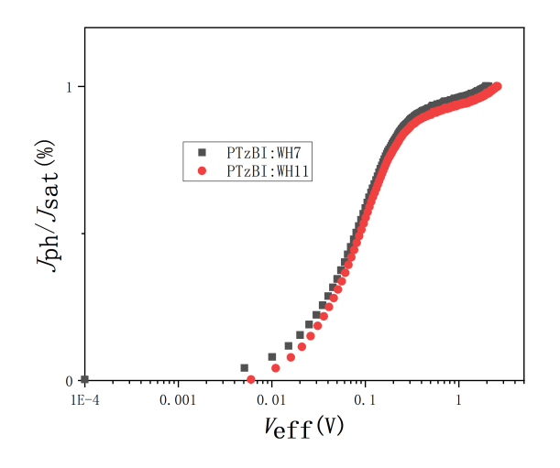
Figure S4. (A) Jph − Veff characteristics of the optimum devices with TA and SVA; (B) Jph/Jsat − Veff characteristics of the optimum devices with TA and SVA.

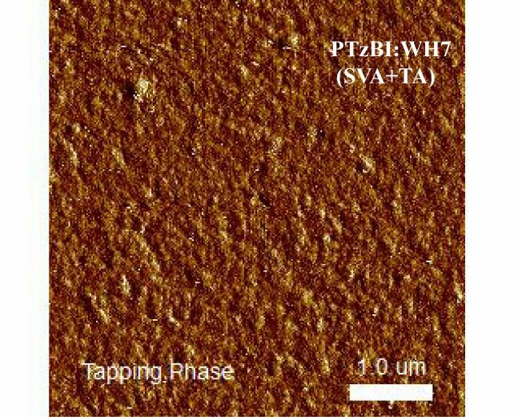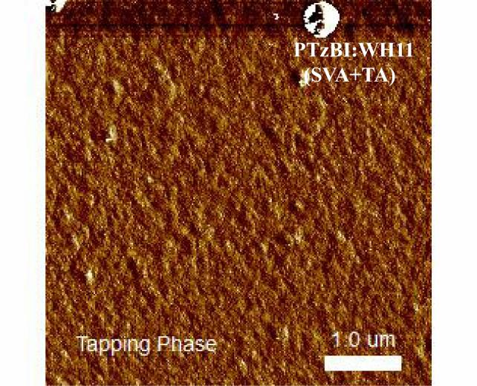
Figure S5. (A) AFM phase images of the PTzBI:WH7 blend film; (B) AFM phase images of the PTzBI:WH11 blend film.
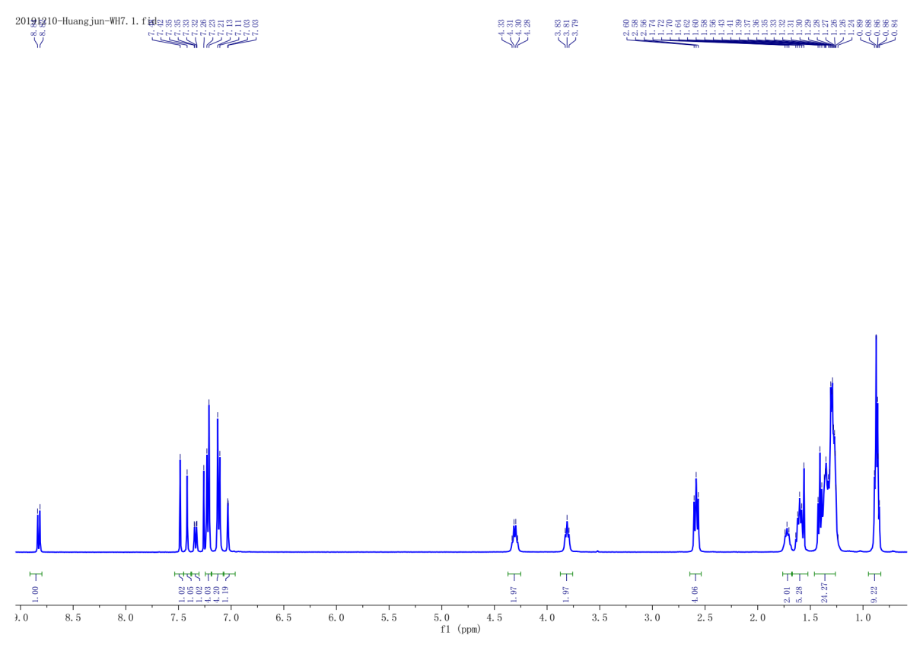
Figure S6. The ¹H NMR spectra of WH7 .
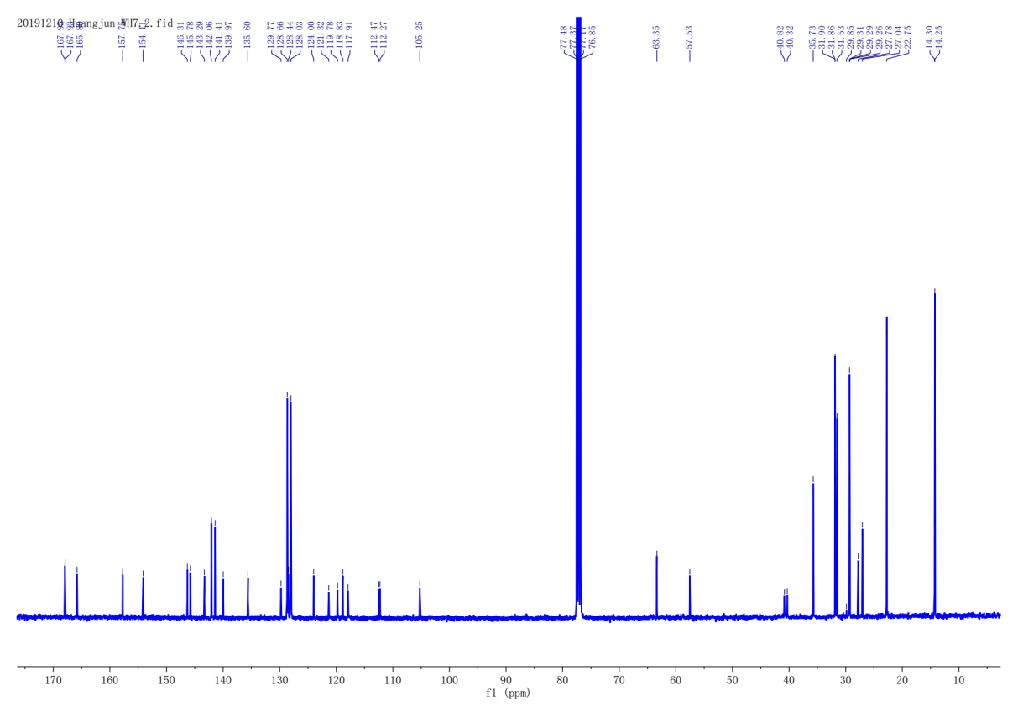
Figure S7. The ¹³C NMR spectra of WH7 .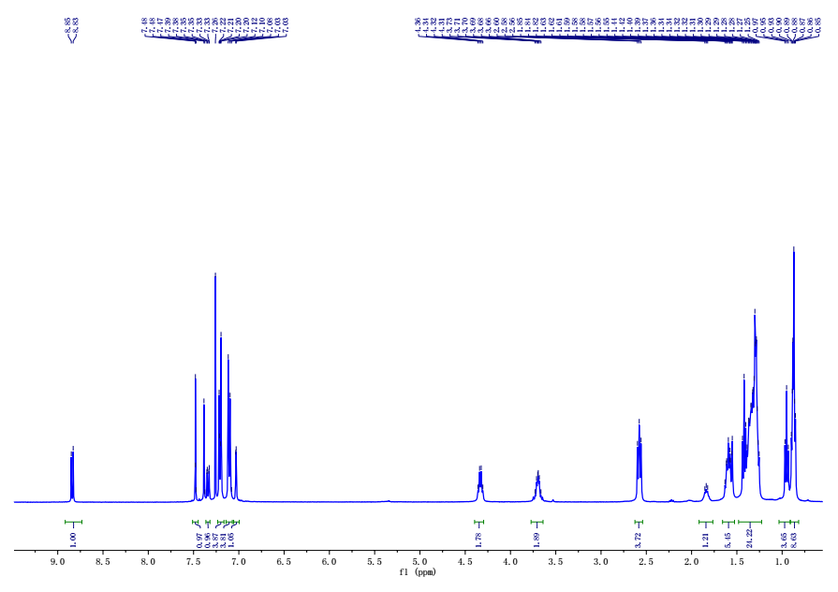
Figure S8. The ¹H NMR spectra of WH11 .
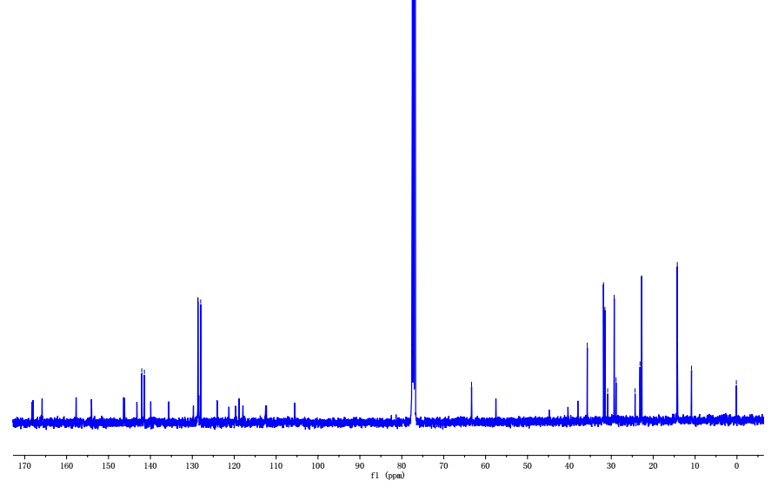
Figure S9. The ¹³C NMR spectra of WH11 .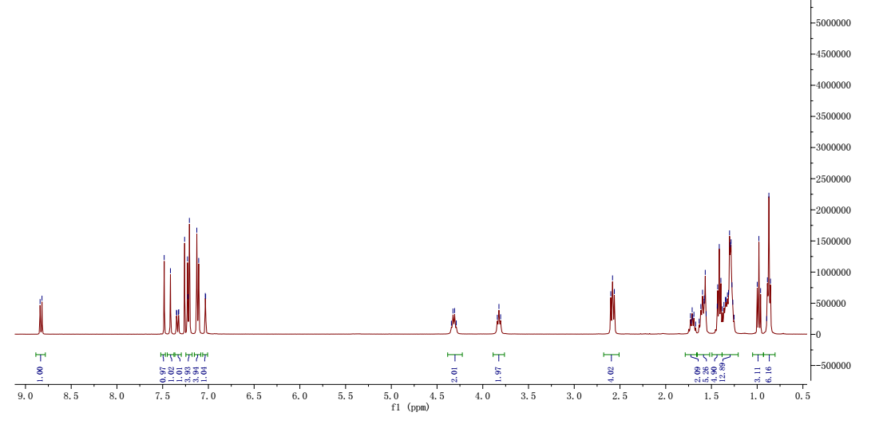
Figure S10. The ¹H NMR spectra of WH17 .
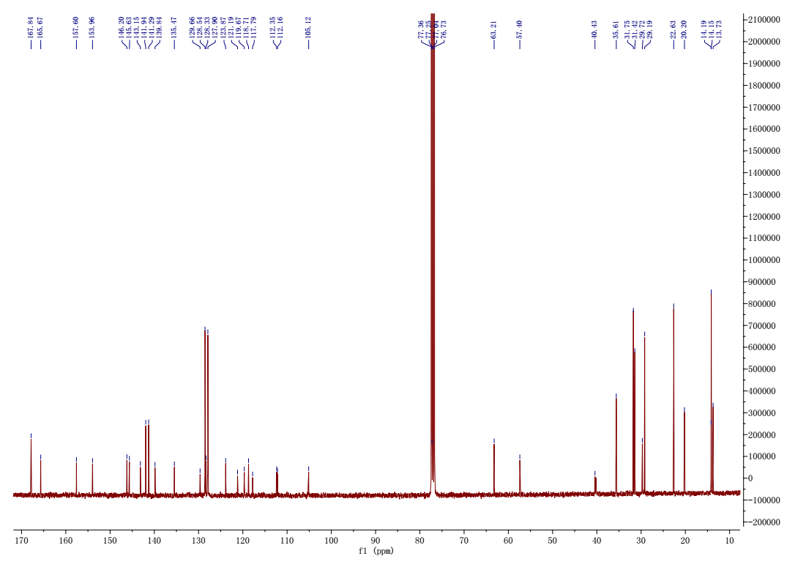
Figure S11. The ¹³C NMR spectra of WH17 .

Figure S12. J-V curves of the optimized solar cells based on PTzBI:WH7 (a) before and after CB vapor annealing. (b) with different solvents SVA treatment.

Table S1. The photovoltaic data of PTzBI:WH7 solar cells with different donor/acceptor ratios. All data were obtained under illumination of AM 1.5G (100mW cm-2) light source

D:Aratio  (wt/wt) | V_{oc} (V) | J_{sc} (mA/cm²) | FF (%) | PCE (%)
1:1 | 0.78 | 15.65 | 56.30 | 6.89
1:1.5 | 0.79 | 16.04 | 63.33 | 8.02

