Supplementary Figure

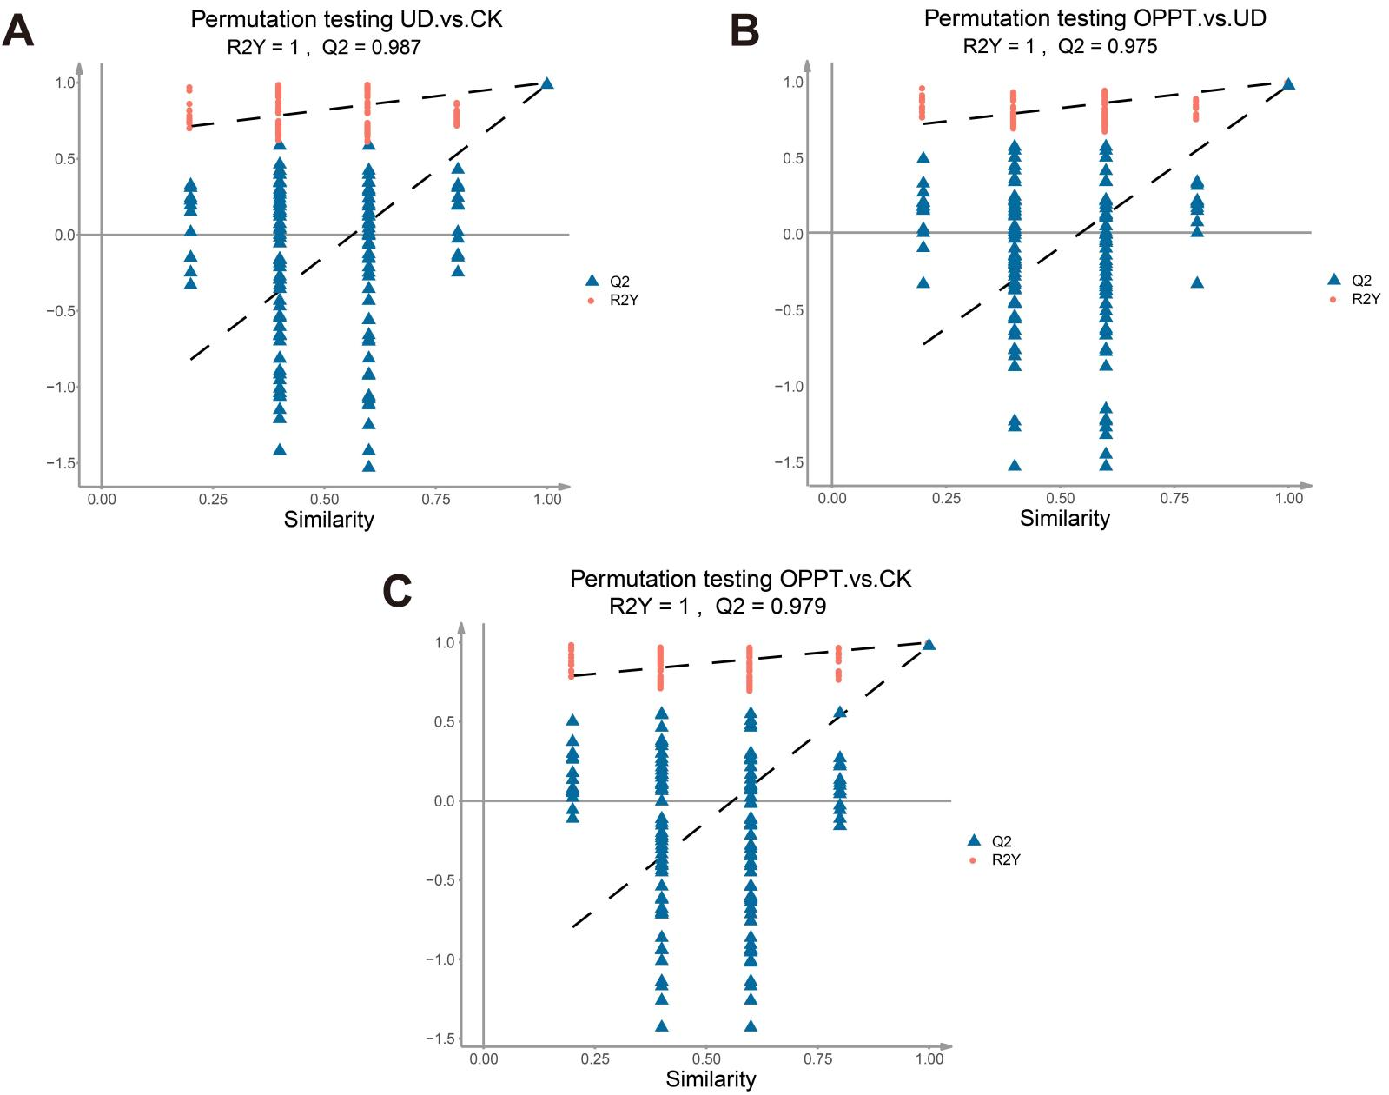
Figure S1. Orthogonal partial least squares discriminant analysis (OPLS-DA). (A) OPLS-DA analysis of the UD vs CK group. (B) OPLS-DA analysis of the OPPT vs UD group. (C) OPLS-DA analysis of the OPPT vs CK group. CK group: untreated healthy control group; UD group: untreated diseased group; OPPT group: OPPT-treated healthy group. (n=5).

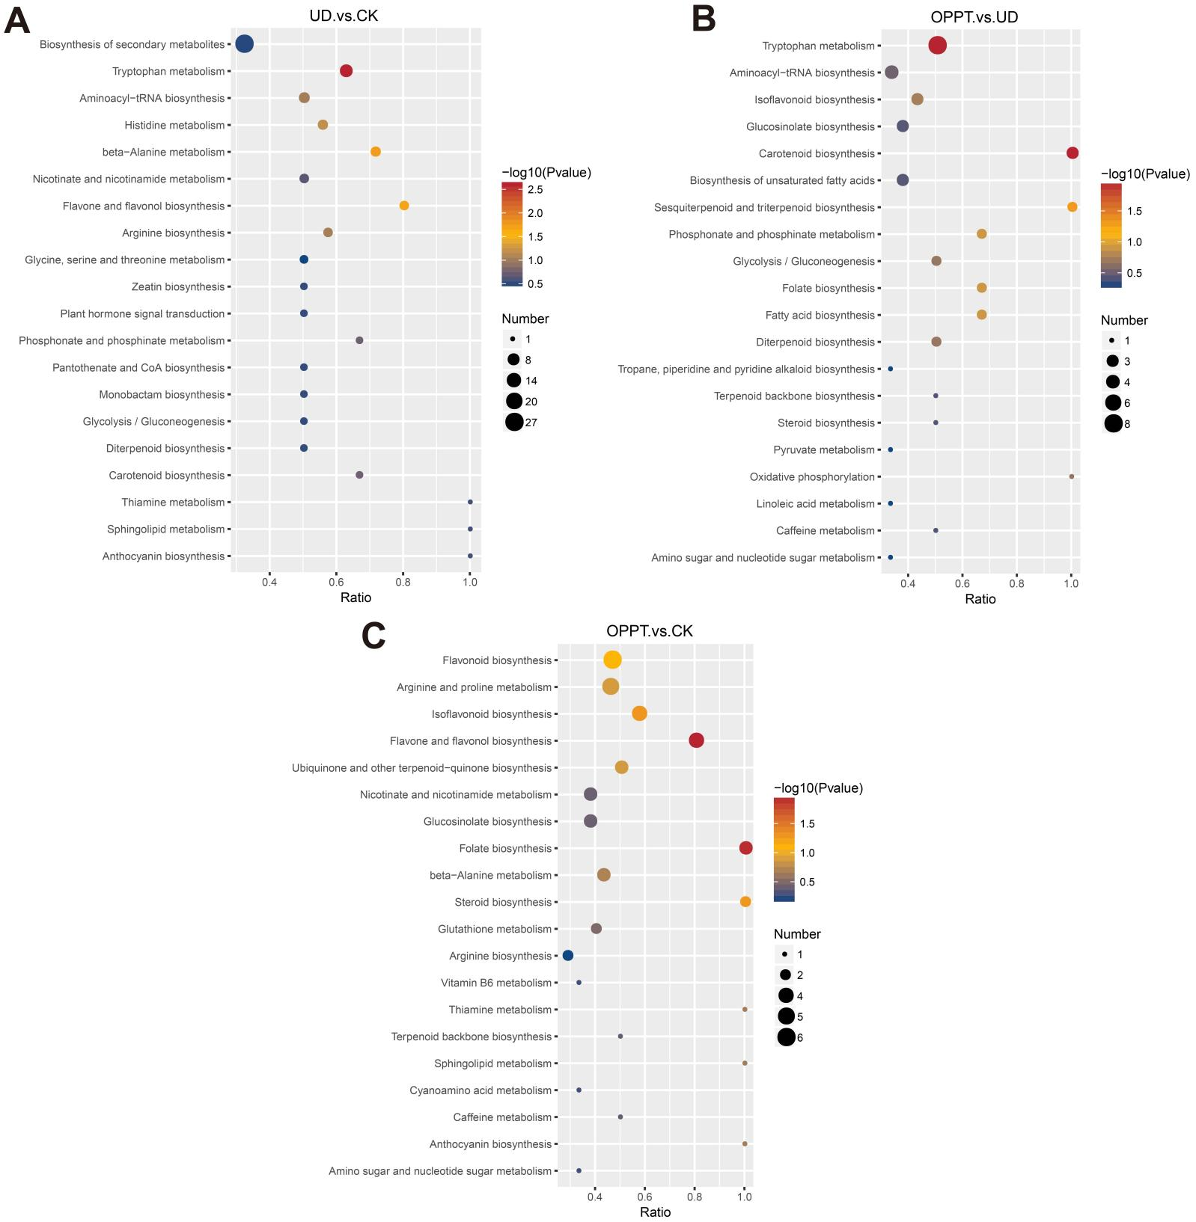
Figure S2. KEGG pathway enrichment analysis of DAMs. (A–C) KEGG enrichment of DAMs in the top 20 pathways for the UD vs CK group (A), OPPT vs UD group (B), and OPPT vs CK group (C), respectively. CK group: untreated healthy control group; UD group: untreated diseased group; OPPT group: OPPT-treated healthy group. (n=5).

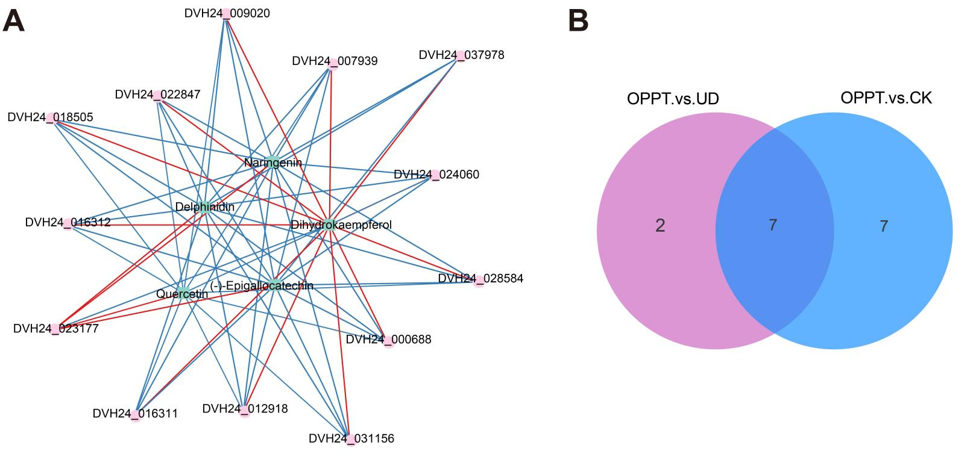
Figure S3. Network analysis of DEGs and DAMs in apple fruits. (A) Correlation network analysis of DEGs and DAMs in the Flavonoid biosynthesis pathway between the OPPT group and the CK group. (B) Venn diagram analysis of DEGs in the Flavonoid biosynthesis pathway between the two comparison groups (OPPT vs UD and OPPT vs CK). Red squares represent differential genes, blue circles represent differential metabolites, red lines represent positive correlations, and blue lines represent negative correlations. CK group: untreated healthy control group; UD group: untreated diseased group; OPPT group: OPPT-treated healthy group.

