Mini-dose group
High-dose group

MP 20mg/kg/d，maximum ≤1g/d
MP 6mg/kg/d，maximum ≤500mg/d

intravenous infusion for 3 consecutive days as 1 course, with 2 courses and interval of 1 week

Basic therapy:GC combined with MMF and conventional drugs medications

Interval courses, oral prednisone acetate was given at 2 mg/kg/day (maximum≤60 mg/d). Completion of pulse therapy, sequential oral treatment with full-dose prednisone acetate was given. Dose tapering was initiated after 4 consecutive weeks. Total course was 9-12 months.

Figure 1 Treatment protocol diagram

150 children with IgAVN ranging from May 2017 to May 2026
28 cases were excluded due to incomplete clinical data, other primary or secondary kidney diseases or history of GC

122 cases were included (n = 122)

Based on the dosage of GC treatment

Mini-dose MP pulse therapy group (n = 46)
High-dose MP pulse therapy group (n = 76)

Clinical data and laboratory results were collected at 1, 3, 6 and 12 months

Statistical analysis and conclusions

Figure 2 Study flow diagram

A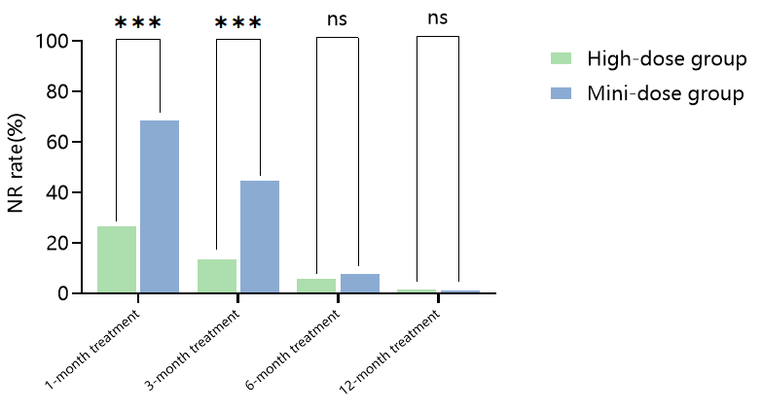 B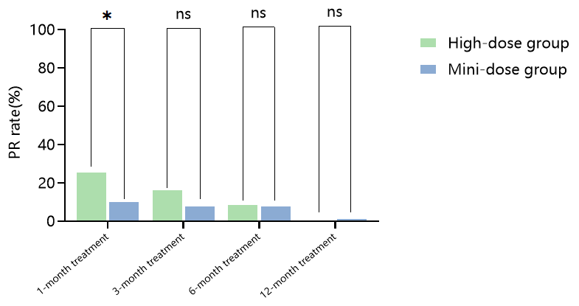
C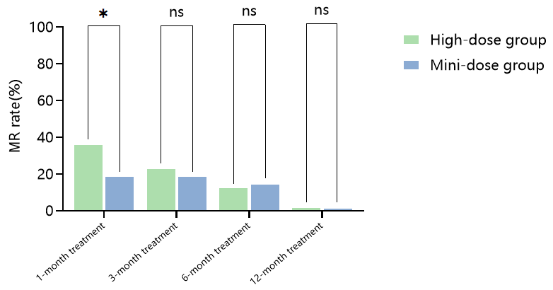 D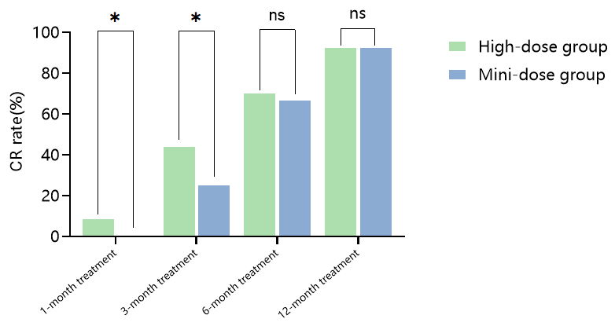
E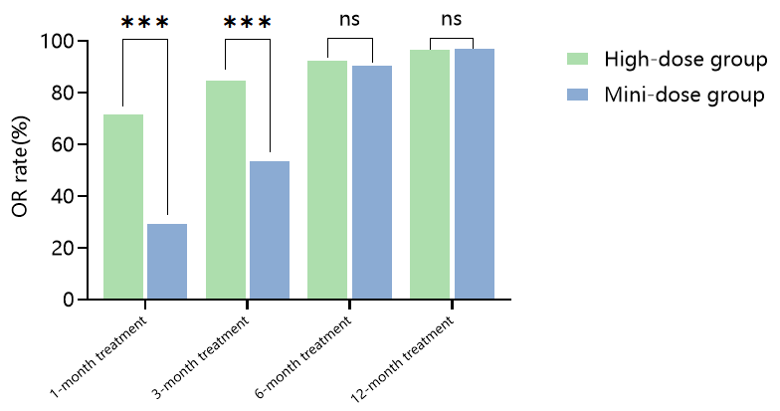
Figure 3 A-E Distribution of remission rates and overall response rates at different treatment time points in the two groups of pediatric patients

A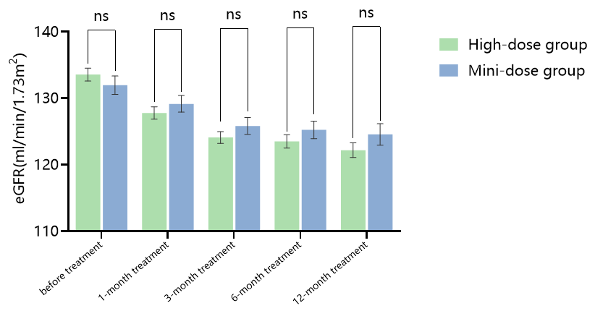 B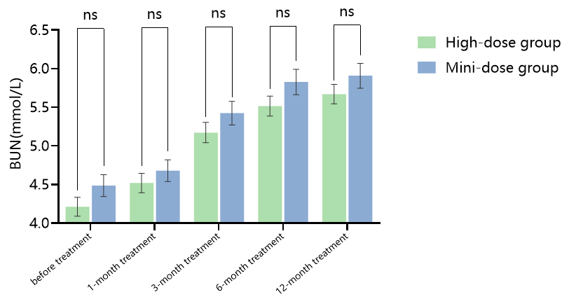
C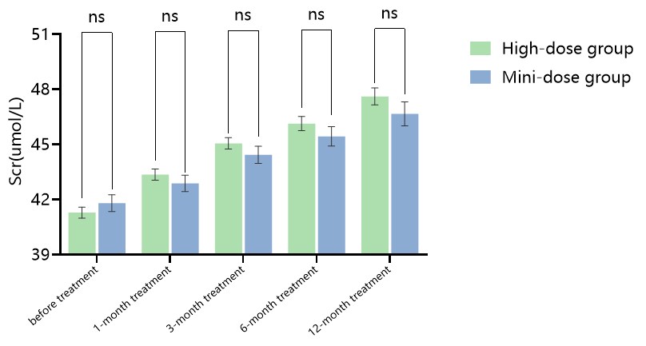 D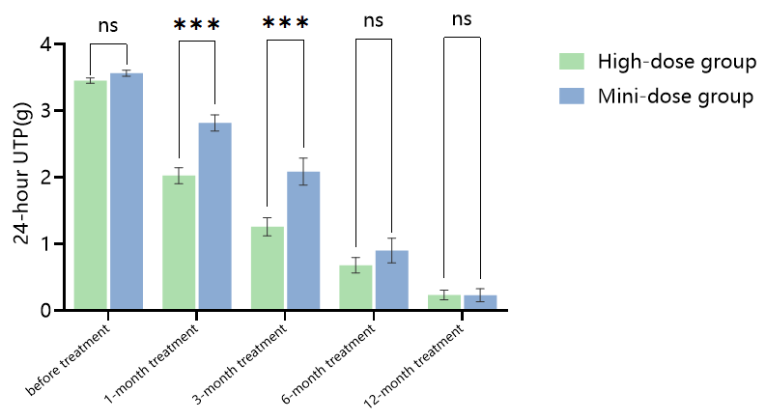
E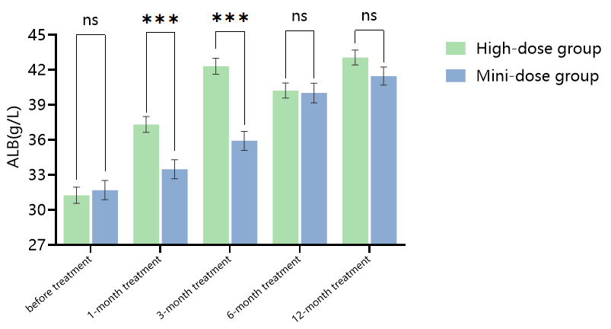 F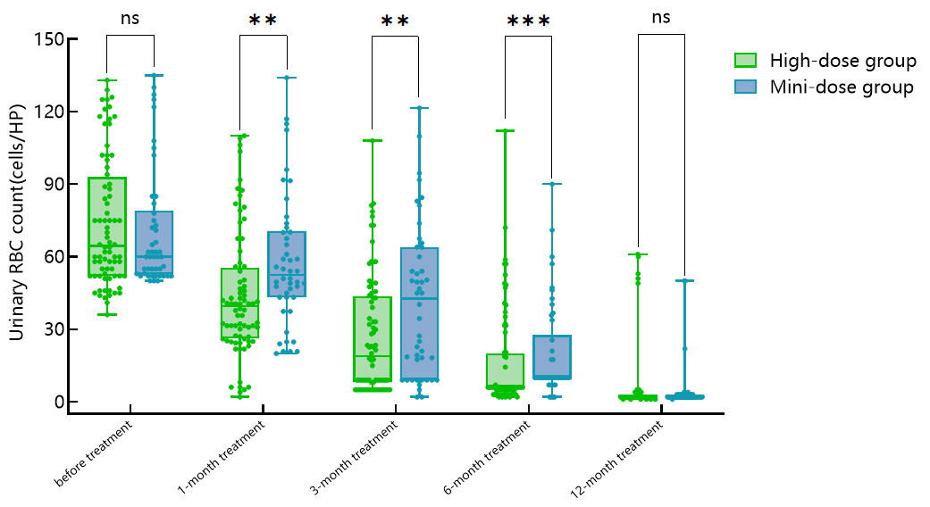
Figure 4 Clinical symptoms and renal function indicators in the two groups before and after treatment

A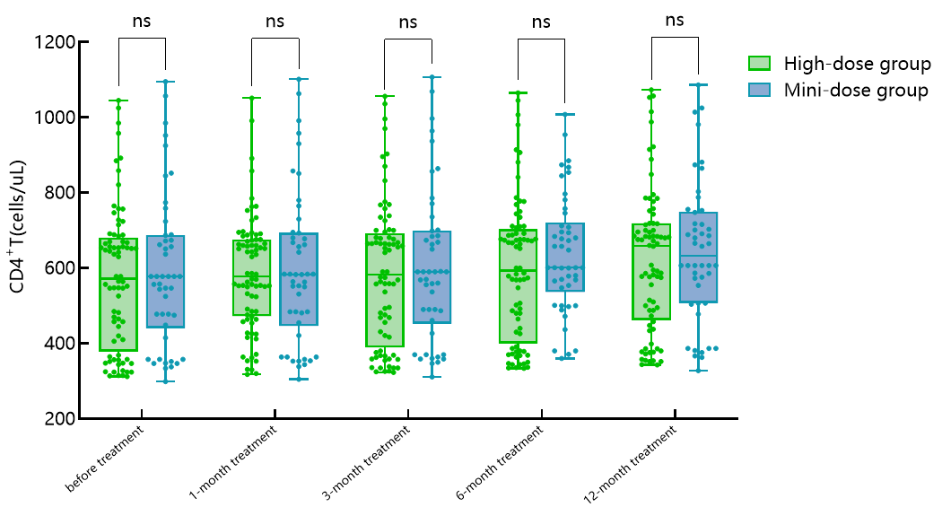 B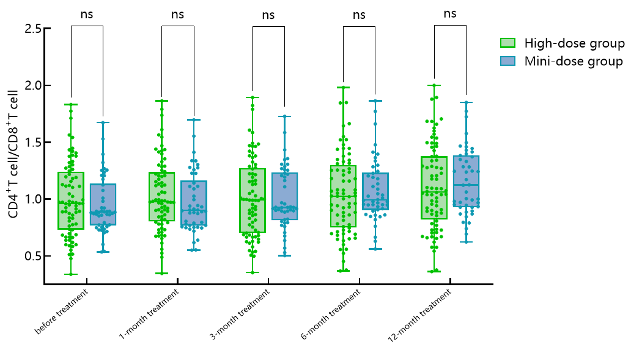
C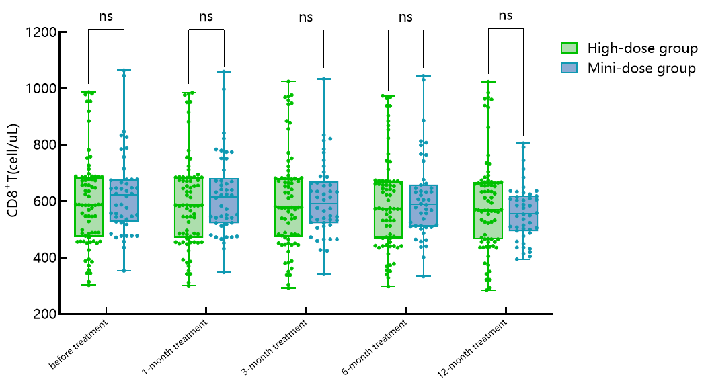
Figure 5 Distribution of lymphocyte subsets in the two groups before and after treatment

A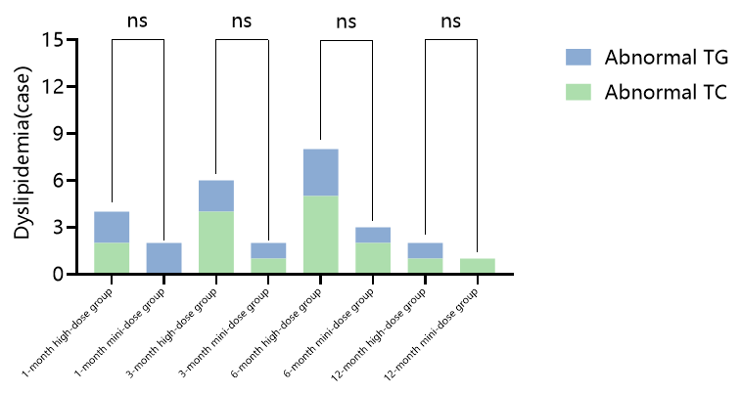 B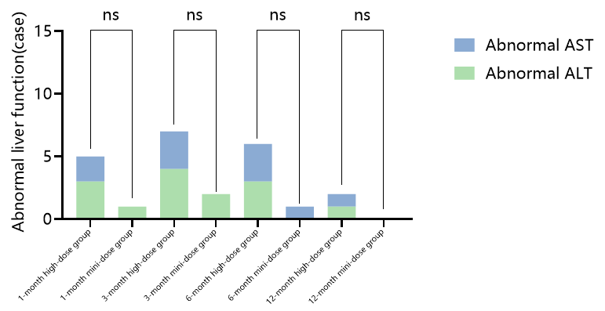
C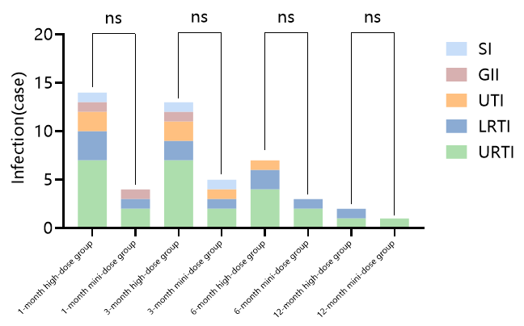 D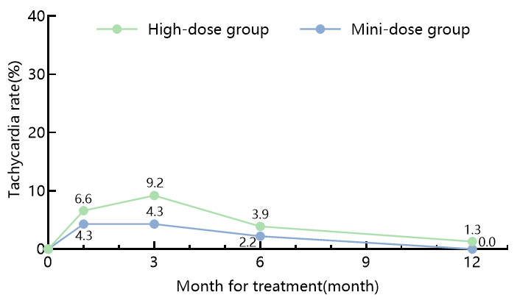
E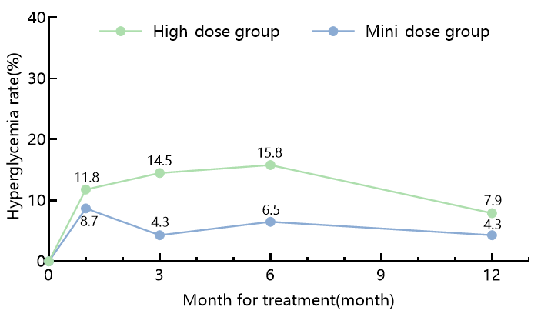 F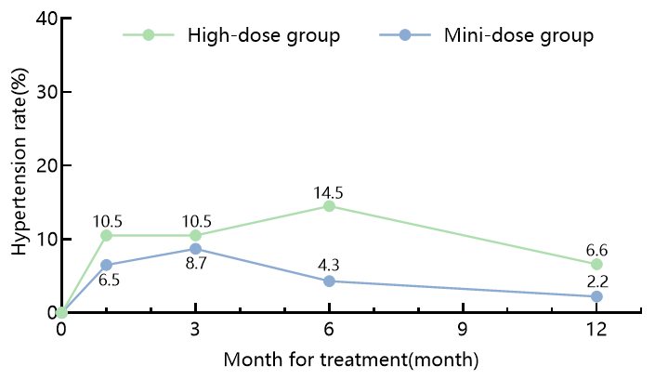
G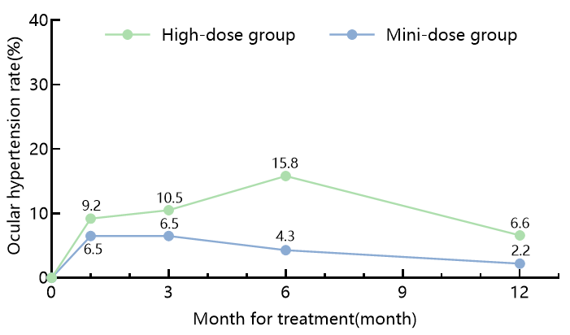 H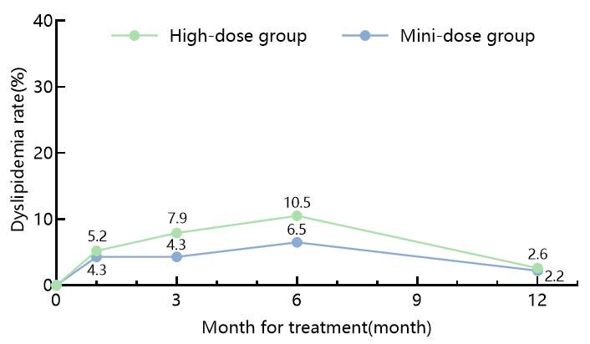
I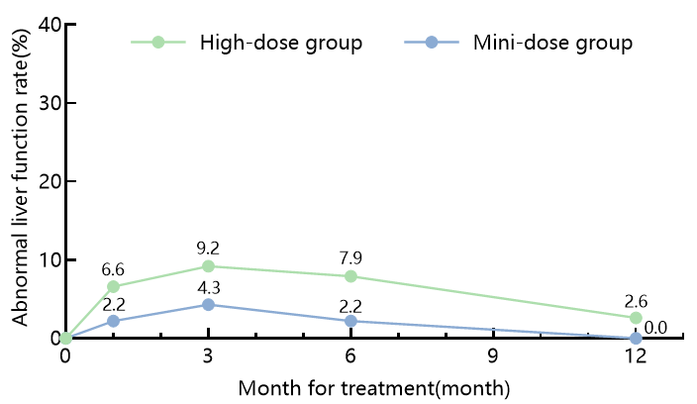 J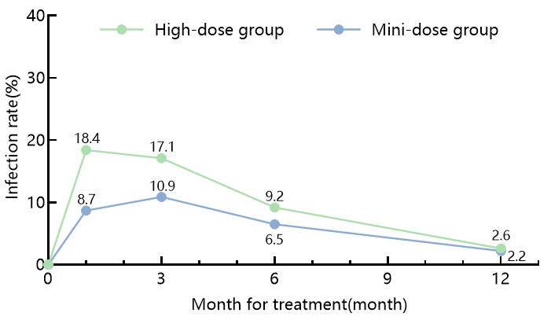
Figure 6 Comparison of adverse reactions between the two groups before and after treatment

Table 1 Comparison of demographic and physiological data between two groups of pediatric patients with IgAVN[n(%),‾x±s]
Indicator | High-dose group(n=76) | Mini-dose group(n=46) | χ²/t | P
Sex/(case) |  |  | 0.06 | 0.810
Male | 33(43.42) | 21(45.65)
Famale | 43(56.58) | 25(54.35)
Height/(cm) | 150.49±3.66 | 150.37±3.57 | 0.17 | 0.863
Weight/(kg) | 43.67±3.96 | 42.28±3.95 | 1.88 | 0.063
Age/(岁) | 11.81±1.85 | 11.51±1.92 | 0.86 | 0.393
FBG/(mmol/L) | 4.93±0.42 | 4.85±0.41 | 1.01 | 0.316
SBP/(mmHg) | 113.43±4.30 | 113.00±4.10 | 0.55 | 0.583
DBP/(mmHg) | 73.37±5.02 | 72.22±5.21 | 1.21 | 0.229
IOP/(mmHg) | 13.83±2.23 | 13.50±2.17 | 0.80 | 0.426

Tabke 2 Comparison of kidney parameters between the two groups of pediatric patients with IgAVN[M(P₂₅,P₇₅),n(%),‾x±s]
Indicator | High-dose group(n=60) | Mini-dose group(n=62) | t/Z/χ² | P
24-hour UTP/(g) | 3.45±0.35 | 3.57±0.31 | -1.79 | 0.076
Urinary RBC count/(cells/HP) | 64.50(52.00,91.00) | 60.00(53.00,77.25) | -0.40 | 0.688
Scr/(umol/L) | 41.29±2.60 | 41.80±3.06 | -0.99 | 0.324
BUN/(mmol/L) | 4.21±1.06 | 4.49±0.96 | -1.44 | 0.153
ALB/(g/L) | 31.26±6.02 | 31.70±5.59 | -0.40 | 0.688
eGFR(ml/min/1.73m²) | 133.55±8.45 | 131.96±9.39 | 0.97 | 0.335
Pathology/(case) |  |  | 0.01 | 0.922
IIIa | 34(44.74) | 21(45.65)
IIIb | 42(55.26) | 25(54.35)

Table 3 Comparison of biochemical indicators between the two groups of pediatric patients with IgAVN(‾x±s)
Indicator | High-dose group(n=60) | Mini-dose group(n=62) | t | P
ALT(U/L) | 14.80±2.31 | 14.41±2.32 | 0.90 | 0.369
AST(U/L) | 19.80±3.02 | 19.33±3.01 | 0.85 | 0.399
TC(mmol/L) | 4.35±0.55 | 4.22±0.57 | 1.23 | 0.221
TG(mmol/L) | 1.15±0.22 | 1.09±0.24 | 1.40 | 0.164

Table 4 Comparison of lymphocyte subset parameters between the two groups of pediatric patients with IgAVN[M(P₂₅,P₇₅)]
Indicator | High-dose group(n=60) | Mini-dose group(n=62) | Z | P
CD4⁺T(个/ul) | 571.50(396.75,673.75) | 578.00(455.50,683.75) | -0.38 | 0.704
CD8⁺T(个/ul) | 588.00(476.50,686.25) | 622.50(530.25,677.25) | -0.77 | 0.439
CD4⁺T/CD8⁺T | 0.96(0.73,1.23) | 0.88(0.77,1.11) | -0.85 | 0.397

Table 5 Comparison of treatment efficacy between the two groups of pediatric patients with IgAVN[n(%)]
Group | case | CR | MR | PR | NR | ORR(%)
1-month treatment
High-dose group | 76 | 7(9.2%) | 28(36.8%) | 20(26.3%) | 21(27.6%) | 72.4%
Mini-dose group | 46 | 0(0.0%) | 9(19.6%) | 5(10.9%) | 32(69.6%) | 30.4%
χ² |  | 4.495 | 4.048 | 4.196 | 20.508 | 20.508
P |  | 0.034 | 0.044 | 0.041 | ＜0.001 | ＜0.001
3-month treatment
High-dose group | 76 | 34(44.7%) | 18(23.7%) | 13(17.1%) | 11(14.5%) | 85.5%
Mini-dose group | 46 | 12(26.1%) | 9(19.6%) | 4(8.7%) | 21(45.7%) | 54.3%
χ² |  | 4.243 | 0.282 | 1.690 | 14.396 | 14.396
P |  | 0.039 | 0.595 | 0.194 | ＜0.001 | ＜0.001
6-month treatment
High-dose group | 76 | 54(71.1%) | 10(13.2%) | 7(9.2%) | 5(6.6%) | 93.4%
Mini-dose group | 46 | 31(67.4%) | 7(15.2%) | 4(8.7%) | 4(8.7%) | 91.3%
χ² |  | 0.182 | 0.101 | 0.009 | 0.188 | 0.188
P |  | 0.670 | 0.750 | 0.923 | 0.665 | 0.665
12-month treatment
High-dose group | 76 | 71(93.4%) | 2(2.6%) | 1(1.3%) | 2(2.6%) | 97.4%
Mini-dose group | 46 | 43(93.5%) | 1(2.2%) | 1(2.2%) | 1(2.2%) | 97.8%
χ² |  | 0.000 | 0.025 | 0.131 | 0.025 | 0.025
P |  | 0.990 | 0.874 | 0.718 | 0.874 | 0.874

Table 6 Comparison of renal-related indicators between the two groups of children[M(P₂₅,P₇₅),‾x±s]
Indicator | Time | High-dose group(n=60) | Mini-dose group(n=62) | t/Z | P
24-hour UTP(g) | Before treatment | 3.45±0.35 | 3.57±0.31 | -1.79 | 0.076
 | 1-month treatment | 2.03±1.05 | 2.82±0.82 | -4.64 | ＜0.001
 | 3-month treatment | 1.26±1.19 | 2.09±1.37 | -3.52 | ＜0.001
 | 6-month treatment | 0.68±1.01 | 0.90±1.26 | -1.06 | 0.291
 | 12-month treatment | 0.24±0.63 | 0.23±0.66 | 0.04 | 0.971
Urinary RBC count  (cells/HP) | Before treatment | 64.50(52.00,91.00) | 60.00(53.00,77.25) | -0.40 | 0.688
 | 1-month treatment | 39.50(26.67,54.47) | 52.50(43.20,70.15) | -3.11 | 0.002
 | 3-month treatment | 18.97(8.00,43.25) | 42.65(11.12,62.92) | -2.77 | 0.006
 | 6-month treatment | 6.00(5.00,19.20) | 10.00(10.00,24.41) | -3.72 | ＜0.001
 | 12-month treatment | 2.00(2.00,3.00) | 2.00(2.00,3.00) | -0.90 | 0.367
ALB(g/L) | Before treatment | 31.26±6.02 | 31.70±5.59 | -0.40 | 0.688
 | 1-month treatment | 37.33±5.95 | 33.48±5.50 | 3.55 | ＜0.001
 | 3-month treatment | 42.31±5.94 | 35.92±5.52 | 5.91 | ＜0.001
 | 6-month treatment | 40.23±5.56 | 40.02±5.73 | 0.20 | 0.839
 | 12-month treatment | 43.06±5.57 | 41.47±5.23 | 1.56 | 0.121
Scr(umol/L) | Before treatment | 39.29±2.60 | 39.80±3.06 | -0.99 | 0.324
 | 1-month treatment | 43.36±2.67 | 42.88±3.01 | 0.92 | 0.360
 | 3-month treatment | 45.06±2.70 | 44.43±3.15 | 1.16 | 0.248
 | 6-month treatment | 46.14±3.34 | 45.44±3.58 | 1.09 | 0.278
 | 12-month treatment | 47.61±4.01 | 46.67±4.43 | 1.21 | 0.228
BUN(mmol/L) | Before treatment | 4.21±1.06 | 4.49±0.96 | -1.44 | 0.153
 | 1-month treatment | 4.52±1.09 | 4.68±0.96 | -0.82 | 0.414
 | 3-month treatment | 5.17±1.15 | 5.42±1.04 | -1.22 | 0.225
 | 6-month treatment | 5.51±1.12 | 5.83±1.12 | -1.49 | 0.139
 | 12-month treatment | 5.67±1.10 | 5.91±1.09 | -1.16 | 0.249
eGFR(ml/min) | Before treatment | 133.55±8.45 | 131.96±9.39 | 0.97 | 0.335
 | 1-month treatment | 127.77±8.12 | 129.15±8.46 | -0.89 | 0.375
 | 3-month treatment | 124.09±7.67 | 125.82±8.61 | -1.15 | 0.251
 | 6-month treatment | 123.51±8.66 | 125.24±8.93 | -1.06 | 0.293
 | 12-month treatment | 122.18±9.62 | 124.55±10.96 | -1.25 | 0.214
Table 7 Comparison of lymphocyte subsets between the two groups at different observation time points[M(P₂₅，P₇₅)，n(%)]
Indicator |  | Time | High-dose group(n=60) | Mini-dose group(n=62) | Z | P
CD4⁺T(个/ul) | Before treatment |  | 571.50(396.75,673.75) | 578.00(455.50,683.75) | -0.38 | 0.704
 | 1-month treatment |  | 577.50(474.75,674.50) | 583.00(461.50,689.75) | -0.03 | 0.977
 | 3-month treatment |  | 583.00(407.75,684.75) | 590.00(467.50,695.75) | -0.47 | 0.640
 | 6-month treatment |  | 593.50(417.25,695.75) | 601.00(549.50,711.25) | -1.39 | 0.164
 | 12-month treatment |  | 659.00(469.25,718.25) | 632.50(518.75,740.50) | -0.69 | 0.492
CD8⁺T(个/ul) | Before treatment |  | 588.00(476.50,686.25) | 622.50(530.25,677.25) | -0.77 | 0.439
 | 1-month treatment |  | 586.00(473.50,684.00) | 617.50(523.25,673.00) | -0.76 | 0.447
 | 3-month treatment |  | 579.00(477.25,681.25) | 591.50(524.25,665.25) | -0.23 | 0.820
 | 6-month treatment |  | 575.00(469.75,671.25) | 590.00(510.75,655.25) | -0.24 | 0.812
 | 12-month treatment |  | 571.00(466.00,666.50) | 556.50(497.00,618.25) | -1.10 | 0.271
CD4/CD8 | Before treatment |  | 0.96(0.73,1.23) | 0.88(0.77,1.11) | -0.85 | 0.397
 | 1-month treatment |  | 0.98(0.81,1.23) | 0.90(0.77,1.13) | -1.29 | 0.196
 | 3-month treatment |  | 0.99(0.71,1.27) | 0.93(0.82,1.23) | -0.12 | 0.901
 | 6-month treatment |  | 1.03(0.76,1.28) | 0.99(0.91,1.22) | -0.51 | 0.610
 | 12-month treatment |  | 1.06(0.84,1.38) | 1.12(0.93,1.38) | -0.76 | 0.445

Table 8 Comparison of prognosis between the two groups[n(%)]
Group | Case | Prognosis grade A | Prognosis grade B | Relapse
High-dose group | 67 | 55(82.1) | 12(17.9) | 7(10.4)
Mini-dose group | 43 | 36(83.7) | 7(16.3) | 4(9.3)
χ² |  | 0.049 | 0.049 | 0.038
P |  | 0.825 | 0.825 | 0.845

Table 9 Adverse reactions in the two groups of children[n(%)]
Type of adverse reactions | 1-month treatment |  |  |  | 3-month treatment |  |  |  | 6-month treatment |  |  |  | 12-month treatment
Type of adverse reactions | High-dose group | Mini-dose group | χ² | P | High-dose group | Mini-dose group | χ² | P | High-dose group | Mini-dose group | χ² | P | High-dose group | Mini-dose group | χ² | P
Infection | 14 | 4 | 2.155 | 0.142 | 13 | 5 | 0.886 | 0.347 | 7 | 3 | 0.275 | 0.600 | 2 | 1 | 0.025 | 0.874
URTI | 7 | 2 |  |  | 7 | 2 |  |  | 4 | 2 |  |  | 1 | 1
LRTI | 3 | 1 |  |  | 2 | 1 |  |  | 2 | 1 |  |  | 1 | 0
UTI | 2 | 0 |  |  | 2 | 1 |  |  | 1 | 0 |  |  | 0 | 0
GII | 1 | 1 |  |  | 1 | 0 |  |  | 0 | 0 |  |  | 0 | 0
SI | 1 | 0 |  |  | 1 | 1 |  |  | 0 | 0 |  |  | 0 | 0
Abnormal liver function | 5 | 1 | 1.189 | 0.276 | 7 | 2 | 0.992 | 0.319 | 6 | 1 | 1.734 | 0.188 | 2 | 0 | 1.231 | 0.267
ALT | 3 | 1 |  |  | 4 | 2 |  |  | 3 | 0 |  |  | 1 | 0
AST | 2 | 0 |  |  | 3 | 0 |  |  | 3 | 1 |  |  | 1 | 0
Dyslipidemia | 4 | 2 | 0.051 | 0.821 | 6 | 2 | 0.588 | 0.443 | 8 | 3 | 0.560 | 0.454 | 2 | 1 | 0.025 | 0.874
TC | 2 | 0 |  |  | 4 | 1 |  |  | 5 | 2 |  |  | 1 | 1
TG | 2 | 2 |  |  | 2 | 1 |  |  | 3 | 1 |  |  | 1 | 0
Ocular hypertension | 7 | 3 | 0.270 | 0.600 | 8 | 3 | 0.088 | 0.766 | 12 | 2 | 3.693 | 0.055 | 5 | 1 | 1.189 | 0.276
Hypertension | 8 | 3 | 0.560 | 0.454 | 8 | 4 | 0.108 | 0.742 | 11 | 2 | 3.086 | 0.079 | 5 | 1 | 1.189 | 0.276
Hyperglycemia | 9 | 4 | 0.298 | 0.585 | 11 | 2 | 3.086 | 0.079 | 12 | 3 | 2.282 | 0.131 | 6 | 2 | 0.588 | 0.443
Tachycardia | 5 | 2 | 0.264 | 0.608 | 7 | 2 | 0.992 | 0.319 | 3 | 1 | 0.284 | 0.594 | 1 | 0 | 0.610 | 0.435

