Supplementary Information
Emotional distress predicts later problematic digital use in adolescents

Contents
1. Supplementary Notes
2. Supplementary Tables (Tables S1–S18)
3. Supplementary Figures (Figures S1–S20)

1. Supplementary Notes

N1. Domain-level strength and temporal directionality share an emotional peak
At the coarse six-domain level, baseline domain strength and longitudinal net directionality both ranked emotional distress first and physical activity last (descriptive Spearman rho = 0.71 across six domains; Table S14). The remaining domain ranks differed, and the item-level minimum dominating set (MDS) analysis identified diet, SDQ and emotional items rather than a domain-level emotional core. The shared emotional peak therefore coexists with a separation between item-level structural coverage and longitudinal prediction.

N2. Exploratory CLPN–DAG directional comparison
The longitudinal CLPN net directionality and the cross-sectional Bayesian DAG net out-degree were positively associated across six paired domains (Pearson r = 0.750, df = 4, two-sided P = 0.086; bootstrap 95% CI, −0.604 to 0.995; Spearman ρ = 0.618, two-sided P = 0.191; exact two-sided permutation P = 0.0778; Table S15). Leave-one-domain-out correlations remained positive (r = 0.603 to 0.892; Table S16), and DASS and ISI shared the highest Bayesian net out-degree (+2). DASS occupied the leading CLPN net source position. All DAG skeleton edges were reversible in the CPDAG, and both analyses used SEARCH data. The comparison is therefore exploratory, within-sample and non-causal.

N3. Estimator sensitivity of the structural-control solution
Estimator analyses define the sensitivity of the item-level structural-control solution (Table S17, Figure S20). In the primary cross-validated graphical Lasso network (density = 0.518), exhaustive enumeration identified 10 minimum dominating sets of size three; DIET22, SDQ18 and DASS14 ranked first, second and third by control frequency (0.60, 0.50 and 0.40, respectively). Sparser EBICglasso networks (density = 0.246–0.284) expanded the MDS to five or six nodes and altered control-node membership, while the positive-edge network retained DIET22 as a leading control node. These analyses therefore define estimator sensitivity rather than demonstrating invariant control-node identity.

N4. Construct-level longitudinal validation in the UK Millennium Cohort Study
Three findings define the construct-level MCS analysis (Table S7, Figure S14). First, social-media use occupied the strongest CLPN net sink position, and gaming also occupied a CLPN net sink position. Second, self-reported internalising distress occupied a CLPN net source position; its direct paths to later social-media use and gaming were negative. Third, hyperactivity/inattention occupied the leading CLPN net source position, and conduct problems also occupied a CLPN net source position. Both externalising domains showed positive paths to the two screen-related outcomes. MCS reproduced the CLPN net sink positions of screen-related behaviours and expanded the set of psychological domains occupying CLPN net source positions.

2. Supplementary Tables
Supplementary Table S1. Analytic samples
Sample | Role | N | Composition | Network nodes
Baseline (Wave 1) | Full cross-sectional network | 10,356 | 52.2% male; mean age 13.96 (SD 2.42) | 104 items / 6 domains
Longitudinal matched | Wave 1 ↔ Wave 3 (~1 yr), CLPN | 6,092 | matched on de-identified hash key | 6 domain scores
GMP/MHQ young adults | Cross-sectional construct-level triangulation | 147,506 | 18–24 y; pooled multinational sample | 6 mapped domains
MCS (UK) matched | External longitudinal analysis | 9,520 (CLPN 7,838) | age 14 → 17; UK Millennium Cohort Study (SN 8156/8682) | 6 comparable constructs

Supplementary Table S2. Measurement instruments and item structure (baseline cohort)
Domain | Instrument | Items used | Response scale | Reliability (α) | Role in network
Problematic internet/digital-media use | Chen Internet Addiction Scale, revised (CIAS-R) | 26 | 1–4 | 0.971 | 26 nodes
Emotional distress | Depression Anxiety Stress Scales (DASS-21) | 21 | 0–3 | 0.941 | 21 nodes
Broad SDQ difficulties | Strengths and Difficulties Questionnaire (SDQ) | 25 core items | 0–2 | 0.697 | 25 nodes
Insomnia | Insomnia Severity Index (ISI) | 7 | 0–4 | 0.888 | 7 nodes
Disordered eating | Eating-behaviour questionnaire (DIET) | 21 (item 3 excluded) | mixed | 0.544 | 21 nodes
Physical activity | Activity questionnaire (ACT) | 4 (items 5–6 excluded) | ordinal | 0.622 | 4 nodes
Total |  | 104 |  |  | 104 nodes
The six SDQ impact-supplement items (items 26-31) were excluded because they assess duration, distress and functional impact of overall difficulties rather than individual symptoms. The broad-difficulties domain was represented by a study-specific composite of all 25 core SDQ items. Items 7, 11, 14, 21 and 25 were reverse-scored, while prosocial items 1, 4, 9, 17 and 20 retained their original direction. The composite is not equivalent to the standard 20-item SDQ total difficulties score, and higher values do not uniformly indicate greater difficulties. The nonparanormal transform was applied to all items before network estimation. Sample Cronbach's alpha values were calculated from baseline item scores (N = 10,356). DIET and ACT showed limited internal consistency, and SDQ was borderline; interpret these domains accordingly.

Supplementary Table S3. Baseline network and control metrics (N = 10,356)
Metric | Value | Interpretation
Nodes / Edges | 104 / 2,777 | Full six-domain symptom network
Density | 0.518 | Densely interconnected
Diameter / Mean shortest path | 2 / 1.482 | Short graph distances
Clustering / Modularity | 0.559 / 0.443 | High local clustering; clear module structure
Global efficiency / strength | 0.759 / 0.607 | Efficient global information transfer
Global average controllability | 1.555 | Ease of steering towards easy-to-reach states
Global modal controllability | 0.929 | Ability to steer towards hard-to-reach states
MDS size / equivalent solutions | 3 / 10 | Three-node MDS solutions; 10 equivalent solutions
DIET22 control frequency (CF) | 0.60 | “worried by others about eating too much”
SDQ18 control frequency (CF) | 0.50 | “often lies or cheats”
DASS14 control frequency (CF) | 0.40 | “intolerant of anything keeping me from my task”
None of the three leading structural-control nodes ranked among the highest-strength nodes, confirming that structural control is distinct from node centrality.

Supplementary Table S4. Directional profile of the SEARCH cohort (CLPN and Bayesian DAG)
Domain | CLPN net directionality | 95% CI | Temporal role | Bayesian DAG net
DASS | +0.249 | [0.086, 0.418] | source | +2
ISI | +0.061 | [−0.091, 0.217] | ns | +2
CIAS | −0.061 | [−0.161, 0.051] | ns | 0
DIET | −0.014 | [−0.137, 0.108] | ns | −2
SDQ | −0.090 | [−0.189, −0.003] | sink | −1
ACT | −0.145 | [−0.218, −0.060] | sink | −1
DASS lies on the net source positions in both the longitudinal CLPN and the exploratory baseline Bayesian graph. Across six paired domains, the method-level association was positive but imprecisely estimated (Pearson r = 0.750, df = 4, two-sided P = 0.086; bootstrap 95% CI, −0.604 to 0.995).

Supplementary Table S5. Full cross-lagged coefficient matrix, SEARCH cohort (N = 6,092)
W1 ↓ / W3 → | CIAS→ | DASS→ | SDQ→ | DIET→ | ISI→ | ACT→
CIAS | 0.440 | 0.079 | -0.011 | 0.082 | 0.081 | -0.050
DASS | 0.160 | 0.423 | 0.120 | 0.108 | 0.151 | -0.056
SDQ | -0.029 | 0.050 | 0.314 | 0.016 | 0.004 | 0.062
DIET | 0.073 | 0.059 | 0.047 | 0.218 | 0.061 | 0.052
ISI | 0.060 | 0.150 | 0.070 | 0.074 | 0.402 | -0.018
ACT | -0.041 | -0.010 | -0.002 | 0.027 | 0.014 | 0.293
Rows are Wave-1 predictors; columns are Wave-3 outcomes. Diagonal entries are autoregressions; coefficients are standardised (HC3 robust).

Supplementary Table S6. Full cross-lagged coefficient matrix, Millennium Cohort Study (N = 7,838)
Age14 ↓ / Age17 → | Internalising | Conduct | Hyperactivity | Peer | SocialMedia | Gaming
Internalising | 0.458 | 0.019 | 0.026 | 0.084 | -0.013 | -0.045
Conduct | 0.014 | 0.480 | 0.110 | 0.074 | 0.080 | 0.060
Hyperactivity | -0.001 | 0.134 | 0.564 | 0.052 | 0.112 | 0.137
Peer | 0.056 | 0.030 | 0.059 | 0.501 | -0.063 | -0.021
SocialMedia | 0.012 | 0.038 | 0.007 | -0.046 | 0.213 | 0.003
Gaming | 0 | 0.018 | 0.056 | 0.054 | 0.050 | 0.276
Rows are age-14 predictors; columns are age-17 outcomes.

Supplementary Table S7. Millennium Cohort Study net temporal directionality
Construct | Net (out − in) | 95% CI | Role
Hyperactivity | +0.177 | [0.105, 0.255] | source
Internalising (self-report) | +0.105 | [0.023, 0.154] | source
Conduct | +0.098 | [0.015, 0.191] | source
Peer | −0.080 | [−0.161, −0.004] | sink
Gaming | −0.089 | [−0.149, −0.020] | sink
Social-media use | −0.211 | [−0.260, −0.139] | strongest sink
Social-media use is the strongest CLPN net sink position and gaming is also net sink position. Self-reported internalising distress, hyperactivity/inattention and conduct problems are net source position, with hyperactivity/inattention the leading net source.

Supplementary Table S8. Community detection across six algorithms
Algorithm | k | ARI vs domains | NMI vs domains
Louvain | 7 | 0.727 | 0.843
Leiden | 6 | 0.724 | 0.837
Walktrap | 7 | 0.615 | 0.780
Spinglass | 7 | 0.727 | 0.843
FastGreedy | 7 | 0.727 | 0.843
Infomap | 7 | 0.666 | 0.823
Agreement of each algorithm's partition with the six a-priori health domains.

Supplementary Table S9. Most stable directed edges, Bayesian DAG (200 bootstraps)
Directed edge | Bootstrap frequency (200×)
CIAS→ACT | 0.970
DASS→SDQ | 0.910
CIAS→DIET | 0.905
DASS→DIET | 0.855
DASS→CIAS | 0.850
DASS→ISI | 0.625
ISI→CIAS | 0.525
CIAS→ISI | 0.470
CIAS→SDQ | 0.440
ISI→DASS | 0.375
CIAS→DASS | 0.150
SDQ→CIAS | 0.125
DASS has several bootstrap-stable outgoing edges. Edge orientations remain exploratory because all skeleton edges are reversible in the CPDAG.

Supplementary Table S10. Principal-component loadings of node-level metrics
Metric | PC1 | PC2 | PC3
strength | 0.182 | 0.458 | 0.131
closeness_centrality | 0.419 | 0.024 | 0.042
betweenness_centrality | 0.403 | -0.051 | 0.157
eigenvector_centrality | 0.411 | 0.056 | -0.030
average_controllability | 0.109 | 0.476 | 0.057
modal_controllability | 0.102 | -0.330 | 0.302
control_frequency | 0.185 | -0.093 | 0.415
participation_coefficient | 0.274 | -0.013 | -0.298
EI1 | -0.140 | 0.445 | 0.227
EI2 | -0.146 | 0.444 | 0.216
bridge_strength | 0.343 | 0.120 | -0.202
bridge_betweenness | 0.403 | -0.052 | 0.158
control_energy_log | -0.085 | -0.165 | 0.660
Control frequency loads on an independent component, separate from traditional centrality and from strength/influence.

Supplementary Table S11. Bayesian DAG net out-degree by model
Domain | Tertile DAG | Continuous Gaussian BN
CIAS | +0 | -3
DASS | +2 | +3
SDQ | -1 | -1
DIET | -2 | -4
ISI | +2 | +4
ACT | -1 | +1
Positive = net source; negative = net sink. DASS is a net source and diet a net sink in both models.

Supplementary Table S12. Baseline comparison, matched longitudinal subsample vs unmatched remainder
Domain | Matched mean (N=6,092) | Unmatched mean (N=4,264) | Standardised mean difference
CIAS | 42.21 | 47.54 | -0.351
DASS | 8.39 | 11.94 | -0.350
SDQ | 18.79 | 19.73 | -0.178
DIET | 20.34 | 21.73 | -0.257
ISI | 4.32 | 5.84 | -0.308
ACT | 10.63 | 10.18 | +0.098
Standardised mean difference is Cohen's d (matched minus unmatched); the retained subsample has modestly lower symptom levels.

Supplementary Table S13. Sensitivity analyses of SEARCH net directionality and school-cluster-robust inference for cross-domain paths.
S13a. Net directionality under alternative model specifications
Domain | Primary  model | Bonferroni-significant paths only | Age-, sex- and  grade-adjusted model | Five-domain model  excluding DIET
CIAS | −0.061 | −0.043 | −0.079 | −0.082
DASS | 0.249 | 0.202 | 0.276 | 0.202
SDQ | −0.090 | −0.079 | −0.096 | −0.054
DIET | −0.014 | 0.055 | −0.007 | —
ISI | 0.061 | −0.013 | 0.049 | 0.030
ACT | −0.145 | −0.123 | −0.142 | −0.096
Net directionality under four specifications: the primary model, Bonferroni-significant paths only, adjustment for age, sex and grade, and a five-domain model excluding DIET. Net directionality was defined as absolute outgoing minus incoming cross-domain strength, excluding autoregressive paths. All models included 6,092 participants, and DASS had the largest positive value throughout.
S13b. Cross-domain paths with school-cluster-robust inference
Predictor  Wave 1 | Outcome  Wave 3 | β | Cluster  SE | 95% CI | t  (df = 9) | P | Bonferroni  P | N | Schools
CIAS | DASS | 0.0786 | 0.0309 | 0.0086 to 0.1486 | 2.540 | 0.031713 | 0.951380 | 6,092 | 10
CIAS | SDQ | −0.0110 | 0.0167 | −0.0488 to 0.0268 | −0.656 | 0.528519 | 1.000000 | 6,092 | 10
CIAS | DIET | 0.0817 | 0.0410 | −0.0110 to 0.1744 | 1.994 | 0.077277 | 1.000000 | 6,092 | 10
CIAS | ISI | 0.0808 | 0.0327 | 0.0069 to 0.1547 | 2.473 | 0.035406 | 1.000000 | 6,092 | 10
CIAS | ACT | −0.0498 | 0.0133 | −0.0799 to −0.0197 | −3.738 | 0.004641 | 0.139222 | 6,092 | 10
DASS | CIAS | 0.1600 | 0.0371 | 0.0760 to 0.2440 | 4.307 | 0.001969 | 0.059081 | 6,092 | 10
DASS | SDQ | 0.1200 | 0.0420 | 0.0249 to 0.2150 | 2.856 | 0.018905 | 0.567164 | 6,092 | 10
DASS | DIET | 0.1076 | 0.0297 | 0.0404 to 0.1749 | 3.622 | 0.005551 | 0.166519 | 6,092 | 10
DASS | ISI | 0.1511 | 0.0328 | 0.0769 to 0.2253 | 4.607 | 0.001278 | 0.038330 | 6,092 | 10
DASS | ACT | −0.0563 | 0.0247 | −0.1123 to −0.0003 | −2.276 | 0.048893 | 1.000000 | 6,092 | 10
SDQ | CIAS | −0.0290 | 0.0183 | −0.0704 to 0.0123 | −1.588 | 0.146656 | 1.000000 | 6,092 | 10
SDQ | DASS | 0.0496 | 0.0101 | 0.0268 to 0.0724 | 4.916 | 0.000829 | 0.024865 | 6,092 | 10
SDQ | DIET | 0.0156 | 0.0140 | −0.0161 to 0.0473 | 1.114 | 0.294025 | 1.000000 | 6,092 | 10
SDQ | ISI | 0.0044 | 0.0171 | −0.0343 to 0.0431 | 0.257 | 0.803027 | 1.000000 | 6,092 | 10
SDQ | ACT | 0.0620 | 0.0089 | 0.0418 to 0.0822 | 6.951 | 6.68e-05 | 0.002003 | 6,092 | 10
DIET | CIAS | 0.0731 | 0.0121 | 0.0457 to 0.1004 | 6.048 | 0.000191 | 0.005732 | 6,092 | 10
DIET | DASS | 0.0585 | 0.0217 | 0.0095 to 0.1076 | 2.698 | 0.024461 | 0.733816 | 6,092 | 10
DIET | SDQ | 0.0474 | 0.0146 | 0.0144 to 0.0805 | 3.244 | 0.010089 | 0.302674 | 6,092 | 10
DIET | ISI | 0.0613 | 0.0180 | 0.0206 to 0.1020 | 3.409 | 0.007765 | 0.232941 | 6,092 | 10
DIET | ACT | 0.0516 | 0.0168 | 0.0135 to 0.0896 | 3.067 | 0.013414 | 0.402430 | 6,092 | 10
ISI | CIAS | 0.0603 | 0.0208 | 0.0133 to 0.1073 | 2.900 | 0.017590 | 0.527713 | 6,092 | 10
ISI | DASS | 0.1498 | 0.0171 | 0.1111 to 0.1885 | 8.757 | 1.07e-05 | 0.000320 | 6,092 | 10
ISI | SDQ | 0.0702 | 0.0140 | 0.0385 to 0.1019 | 5.008 | 0.000731 | 0.021930 | 6,092 | 10
ISI | DIET | 0.0739 | 0.0183 | 0.0325 to 0.1152 | 4.044 | 0.002912 | 0.087362 | 6,092 | 10
ISI | ACT | −0.0176 | 0.0203 | −0.0636 to 0.0283 | −0.868 | 0.407740 | 1.000000 | 6,092 | 10
ACT | CIAS | −0.0406 | 0.0235 | −0.0937 to 0.0125 | −1.730 | 0.117763 | 1.000000 | 6,092 | 10
ACT | DASS | −0.0099 | 0.0214 | −0.0583 to 0.0385 | −0.463 | 0.654606 | 1.000000 | 6,092 | 10
ACT | SDQ | −0.0017 | 0.0180 | −0.0425 to 0.0391 | −0.096 | 0.925676 | 1.000000 | 6,092 | 10
ACT | DIET | 0.0267 | 0.0218 | −0.0226 to 0.0761 | 1.225 | 0.251500 | 1.000000 | 6,092 | 10
ACT | ISI | 0.0137 | 0.0164 | −0.0233 to 0.0508 | 0.839 | 0.423280 | 1.000000 | 6,092 | 10
School-cluster-robust inference for all 30 cross-domain paths in the original six-domain model. CR1 standard errors were clustered across 10 baseline schools; 95% confidence intervals and two-sided P values used t(9), with Bonferroni correction across 30 paths. This model did not include age, sex or grade. Normal-reference results are provided in Supplementary Data 1.

Supplementary Table S14. Domain-level structural strength versus net cross-lagged directionality
Domain | Baseline domain strength | CLPN net directionality | Structural rank | Temporal rank
CIAS | 0.965 | -0.061 | 2 | 4
DASS | 1.388 | 0.249 | 1 | 1
SDQ | 0.732 | -0.09 | 4 | 5
DIET | 0.512 | -0.014 | 5 | 3
ISI | 0.781 | 0.061 | 3 | 2
ACT | 0.412 | -0.145 | 6 | 6
Aggregated to six domains, baseline domain strength and CLPN net directionality both ranked DASS first and ACT last; ranks of the remaining domains differed (Spearman ρ = 0.71 across six domains).

Supplementary Table S15. Exploratory CLPN–DAG directional comparison
statistic | value
Number of paired domain-level estimates | 6
Pearson r | 0.750
Pearson df | 4
Pearson P (two-sided) | 0.086
Pearson bootstrap 95% CI | −0.604 to 0.995
Spearman ρ | 0.618
Spearman P (two-sided) | 0.191
Exact Pearson permutation P (two-sided; 720 permutations) | 0.0778
Paired bootstrap attempts | 5,000
Across six paired domain-level estimates, Pearson r = 0.750 (df = 4, two-sided P = 0.086; bootstrap 95% CI, −0.604 to 0.995), Spearman ρ = 0.618 (two-sided P = 0.191), and the exact two-sided Pearson permutation P was 0.0778.

Supplementary Table S16. Leave-one-domain-out CLPN–DAG correlation
dropped | r_without
CIAS | 0.768
DASS | 0.603
SDQ | 0.726
DIET | 0.892
ISI | 0.791
ACT | 0.731
Leave-one-domain-out correlations remain positive (r = 0.603-0.892), but the comparison contains only six domains and is not an independent replication.

Supplementary Table S17. Estimator sensitivity of the MDS solution
Network | Density | MDS size | DIET22 CF | DIET22 rank | DASS14 CF | DASS14 rank | SDQ18 CF | SDQ18 rank
EBIC γ=0.0 | 0.284 | 5 | 0.25 | 8 | 0.0 | 100 | 0.25 | 6
EBIC γ=0.25 | 0.267 | 6 | 0.0 | 101 | 0.083 | 24 | 0.05 | 48
EBIC γ=0.5 | 0.246 | 6 | 0.15 | 14 | 0.067 | 33 | 0.217 | 7
Primary CV-glasso | 0.518 | 3 | 0.600 | 1 | 0.400 | 3 | 0.500 | 2
CV positive-edges-only | 0.335 | 5 | 0.2 | 2 | 0.167 | 4 | 0.15 | 7
In the primary cross-validated graphical Lasso network (density = 0.518), exhaustive enumeration identified 10 minimum dominating sets of size three. DIET22, SDQ18 and DASS14 ranked first, second and third by control frequency (0.60, 0.50 and 0.40, respectively). For the sensitivity networks, control frequencies were estimated across 60 randomised optimal MDS solutions and therefore quantify estimator sensitivity rather than exact replication of the primary solution.

Supplementary Table S18. Machine-readable files accompanying this supplement
File | Content
clpn_coefficients.csv | Full 6×6 cross-lagged coefficient matrix
clpn_pvalues.csv | Corresponding p-values
clpn_directionality.csv | Net directionality + bootstrap CIs
bn_domain_edges.json | Bayesian DAG edge list
bn_edge_stability.csv | Directed-edge bootstrap frequencies
directed_convergence.csv | CLPN vs. DAG per-domain net directionality
community_multimethod_summary.csv | ARI/NMI for six algorithms
community_evolution_table.csv | Cross-wave community assignments
community_node_stability.csv | Bootstrap co-assignment per node
extended_node_metrics.csv | 14 node-level metrics (104 nodes)
method_convergence_corr.csv | Spearman correlations among metrics
method_pca_loadings.csv | PCA loadings (PC1–PC3)
target_controllability.csv | Exact target-set coverage values used in Supplementary Figure S6
driver_stability.csv | 300-bootstrap control-node selection/CF
lambda_sensitivity.csv | Density/MDS across λ = 0.04–0.10
knockout_efficiency.csv | Efficiency under four attack orderings
dynamics_summary.csv | Steady-state activation by module
mhq_network_pcor.csv | MHQ six-domain partial-correlation matrix
scale_crosswalk.csv | 104-node Wave-1↔Wave-3 crosswalk
mcs_clpn_coefficients.csv | MCS 6×6 cross-lagged coefficient matrix
mcs_clpn_directionality.csv | MCS net directionality + bootstrap CIs
clpn_sensitivity.csv | CLPN net directionality under alternative edge/domain definitions
network_estimation_robustness.csv | Estimator-specific density, MDS size and control-frequency summaries
supplementary_table_s13a.csv | Four CLPN net directionality specifications reported in Supplementary Table S13a
all_30_school_cluster_paths.csv | School-cluster-robust inference for all 30 cross-domain paths reported in Supplementary Table S13b

3. Supplementary Figures
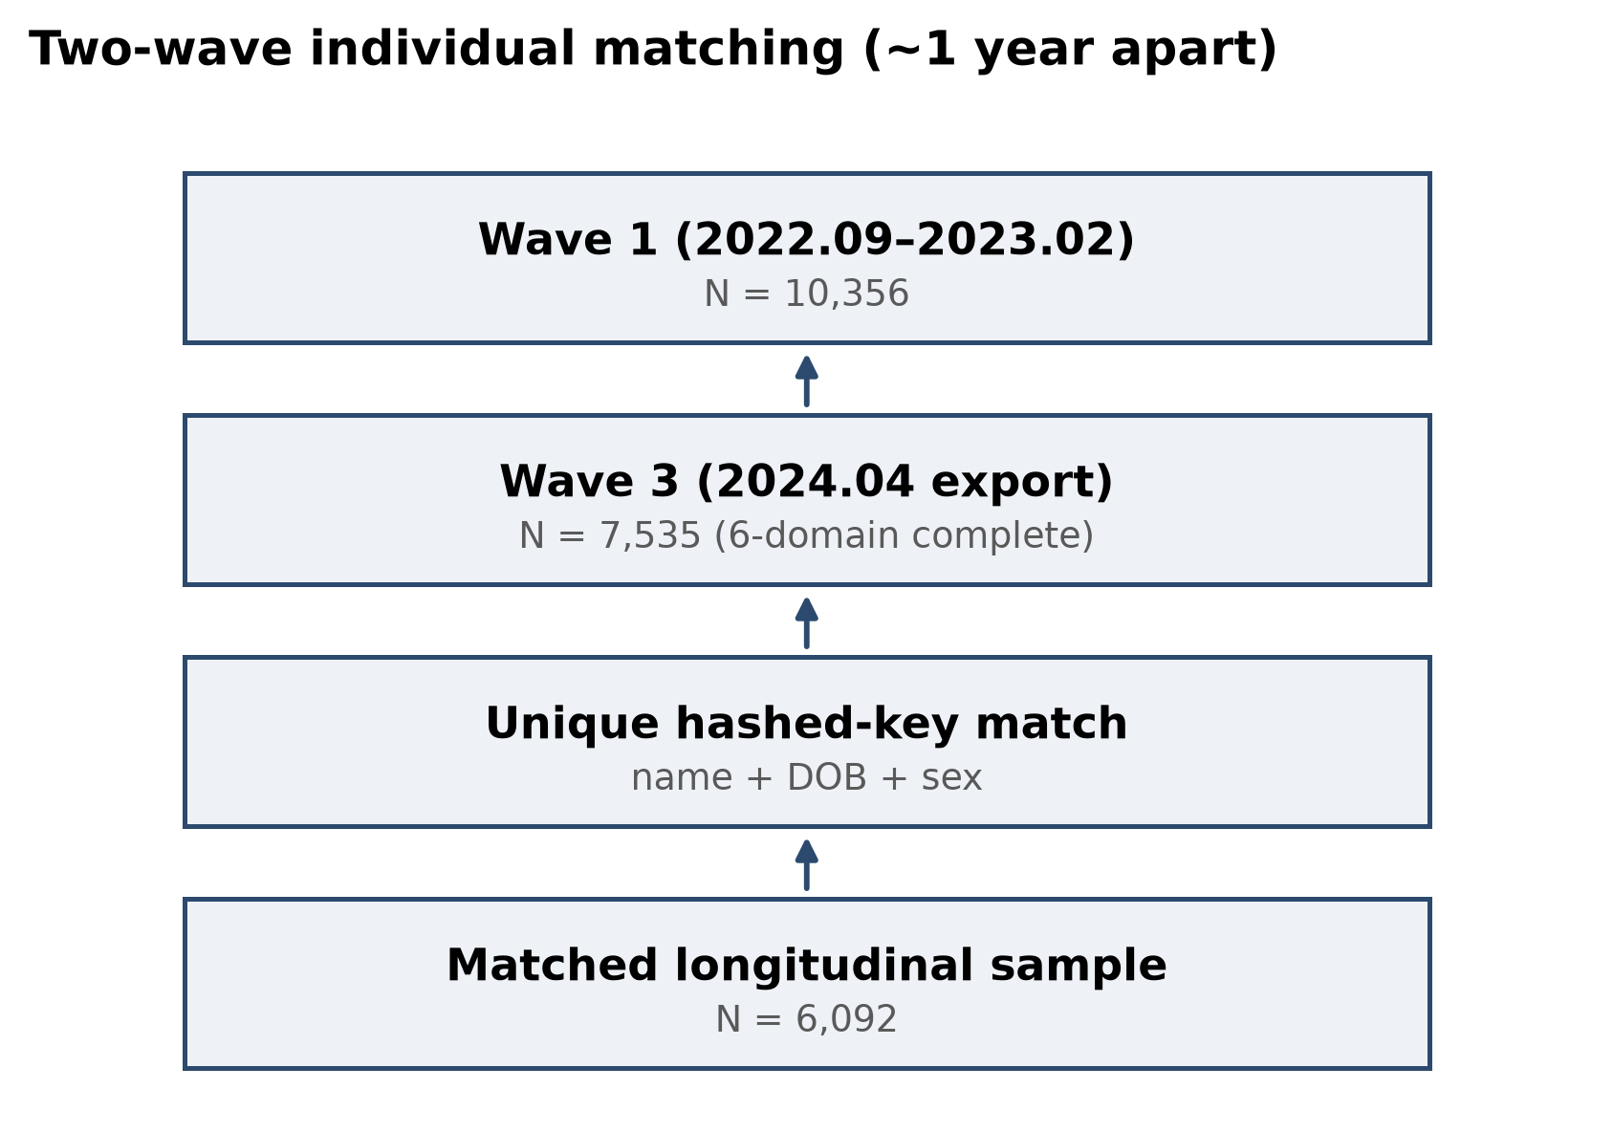
Supplementary Figure S1. Two-wave matching flow. From Wave 1 (N = 10,356) through the Wave-3 six-domain-complete export to the hashed-key-matched longitudinal sample (N = 6,092). DOB, date of birth; arrows indicate the direction of record matching.

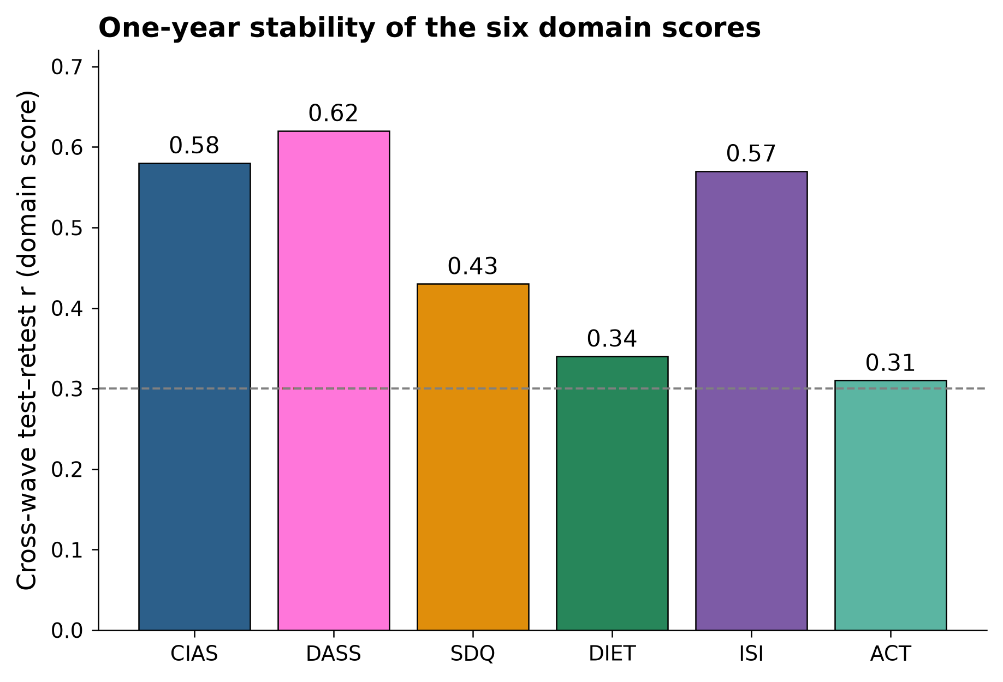
Supplementary Figure S2. One-year domain-score test–retest stability. Cross-wave correlation of each domain score over the one-year interval.
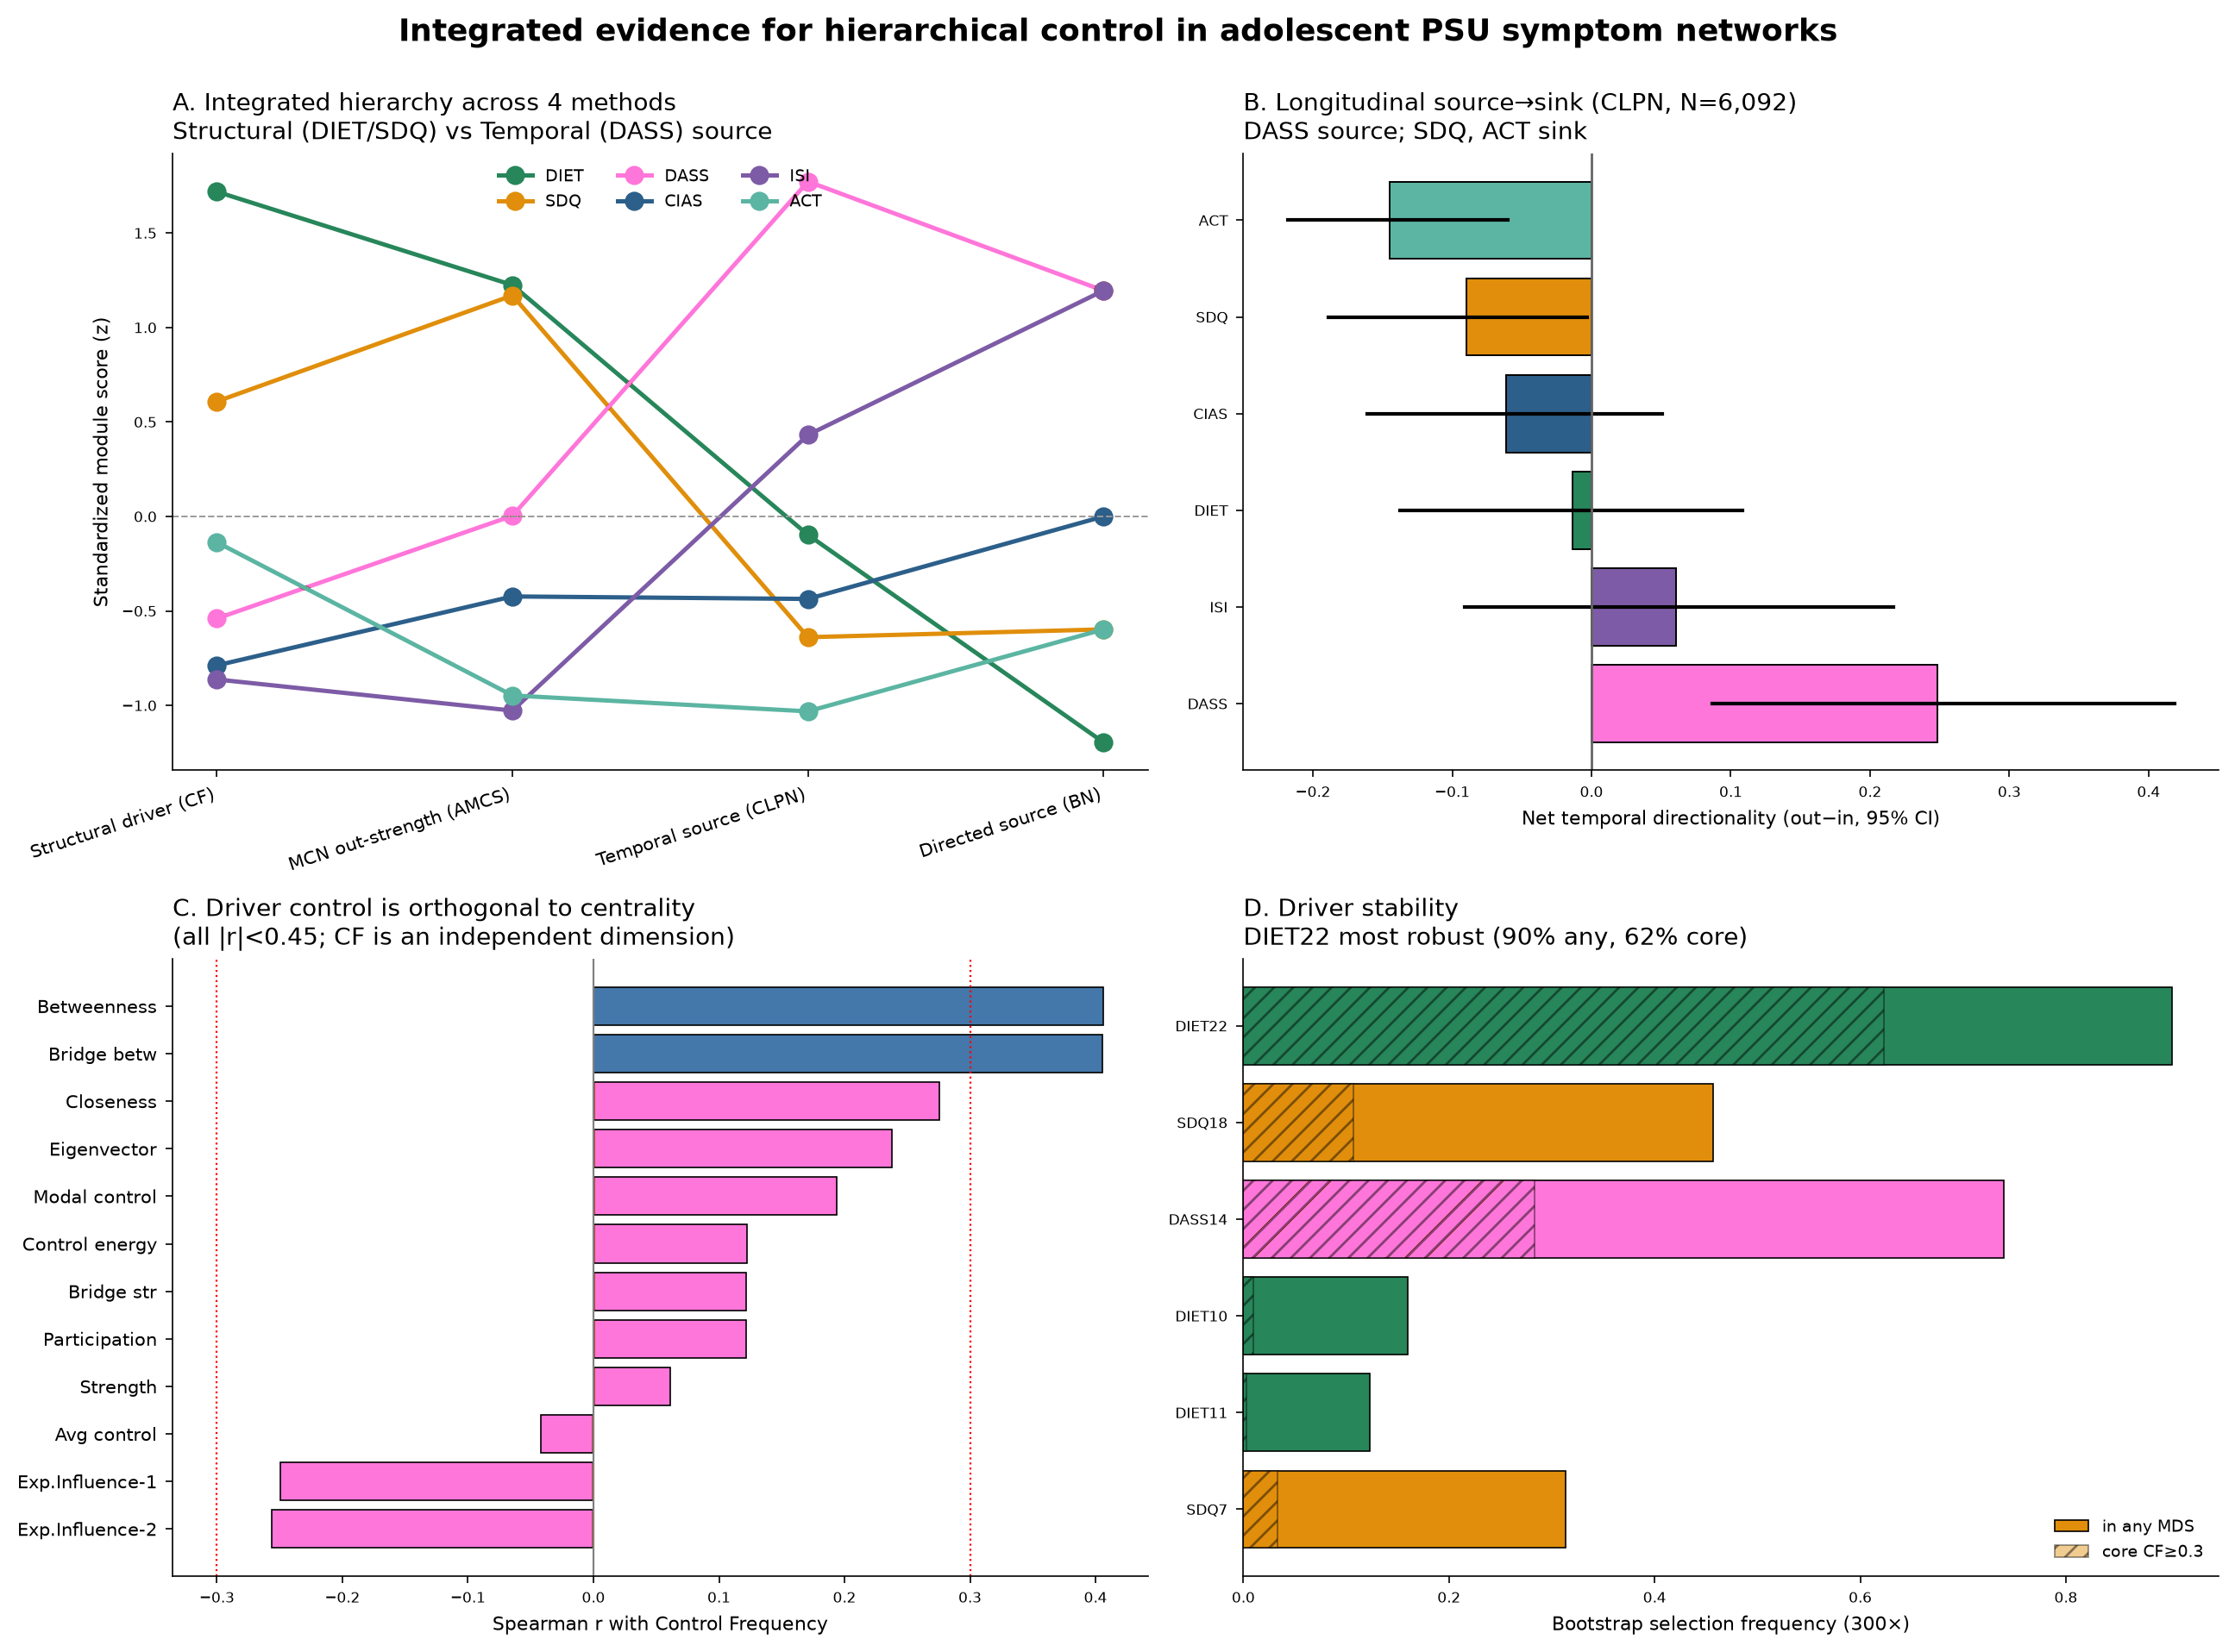
Supplementary Figure S3. Comparison across non-equivalent network metrics. (a) Standardised module scores across four hierarchy definitions (MDS control frequency, average module control strength (AMCS), CLPN net directionality, Bayesian net out-degree). (b) Longitudinal net directionality with 95% CI. (c) Control frequency versus every traditional centrality metric (all |r| < 0.45). (d) Bootstrap control-node stability; DIET22 was the most stable. In the embedded figure title, “PSU” denotes generalised problematic internet and digital-media use assessed with the Chen Internet Addiction Scale–Revised (CIAS-R), rather than smartphone-specific use. CF, control frequency; AMCS, average module control strength; MCN, module control network; CLPN, cross-lagged panel network; BN, Bayesian network; MDS, minimum dominating set; CI, confidence interval. Hatched segments indicate CF ≥ 0.30, and full bars indicate selection into any MDS. Red dotted lines in c mark correlations of ±0.30. In the embedded figure, “driver” is a graph-theoretic label for a structural-control node identified by MDS membership or control frequency; it does not indicate causal or longitudinal influence.
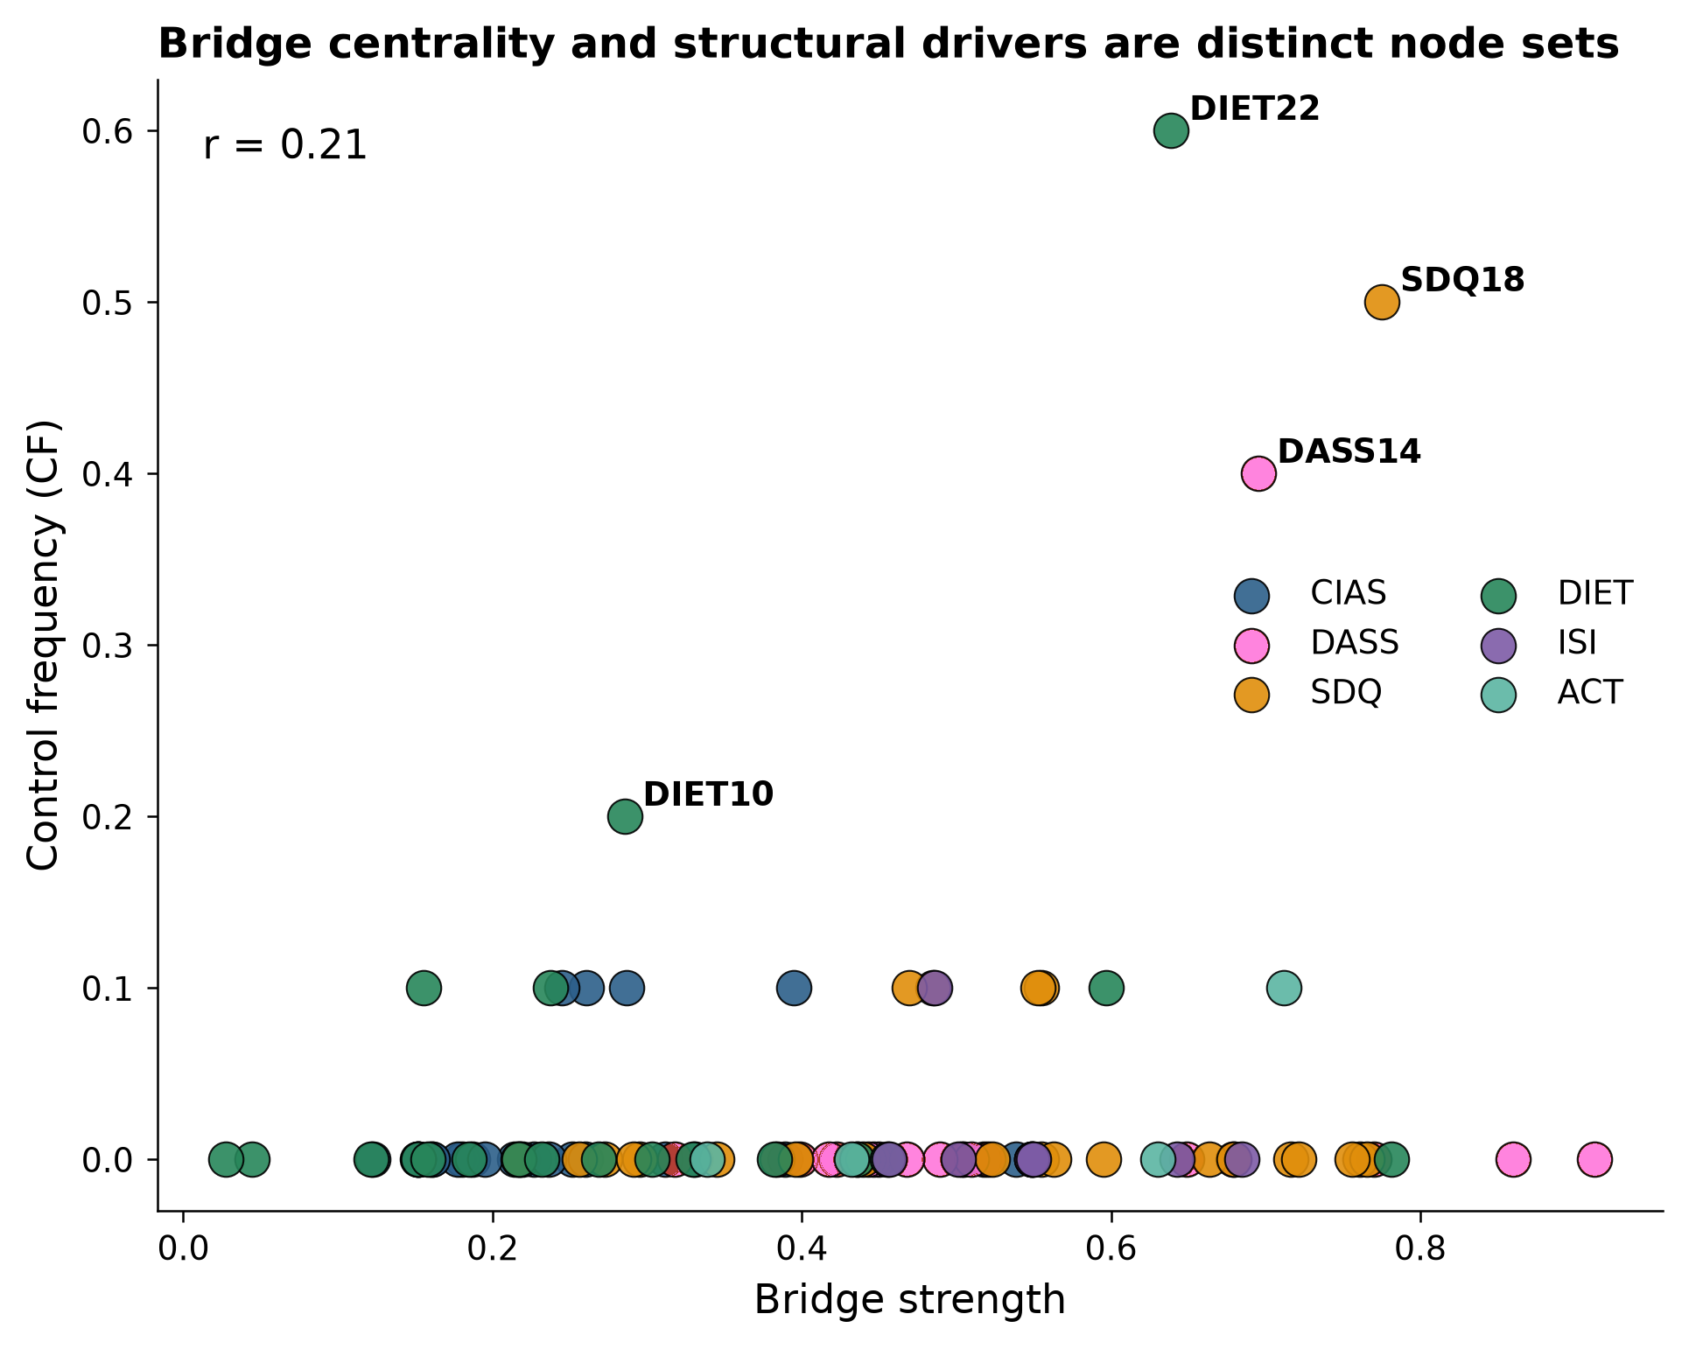
Supplementary Figure S4. Bridge strength versus control frequency: bridge-centrality nodes and structural-control nodes are distinct (r = 0.21). CF, control frequency.
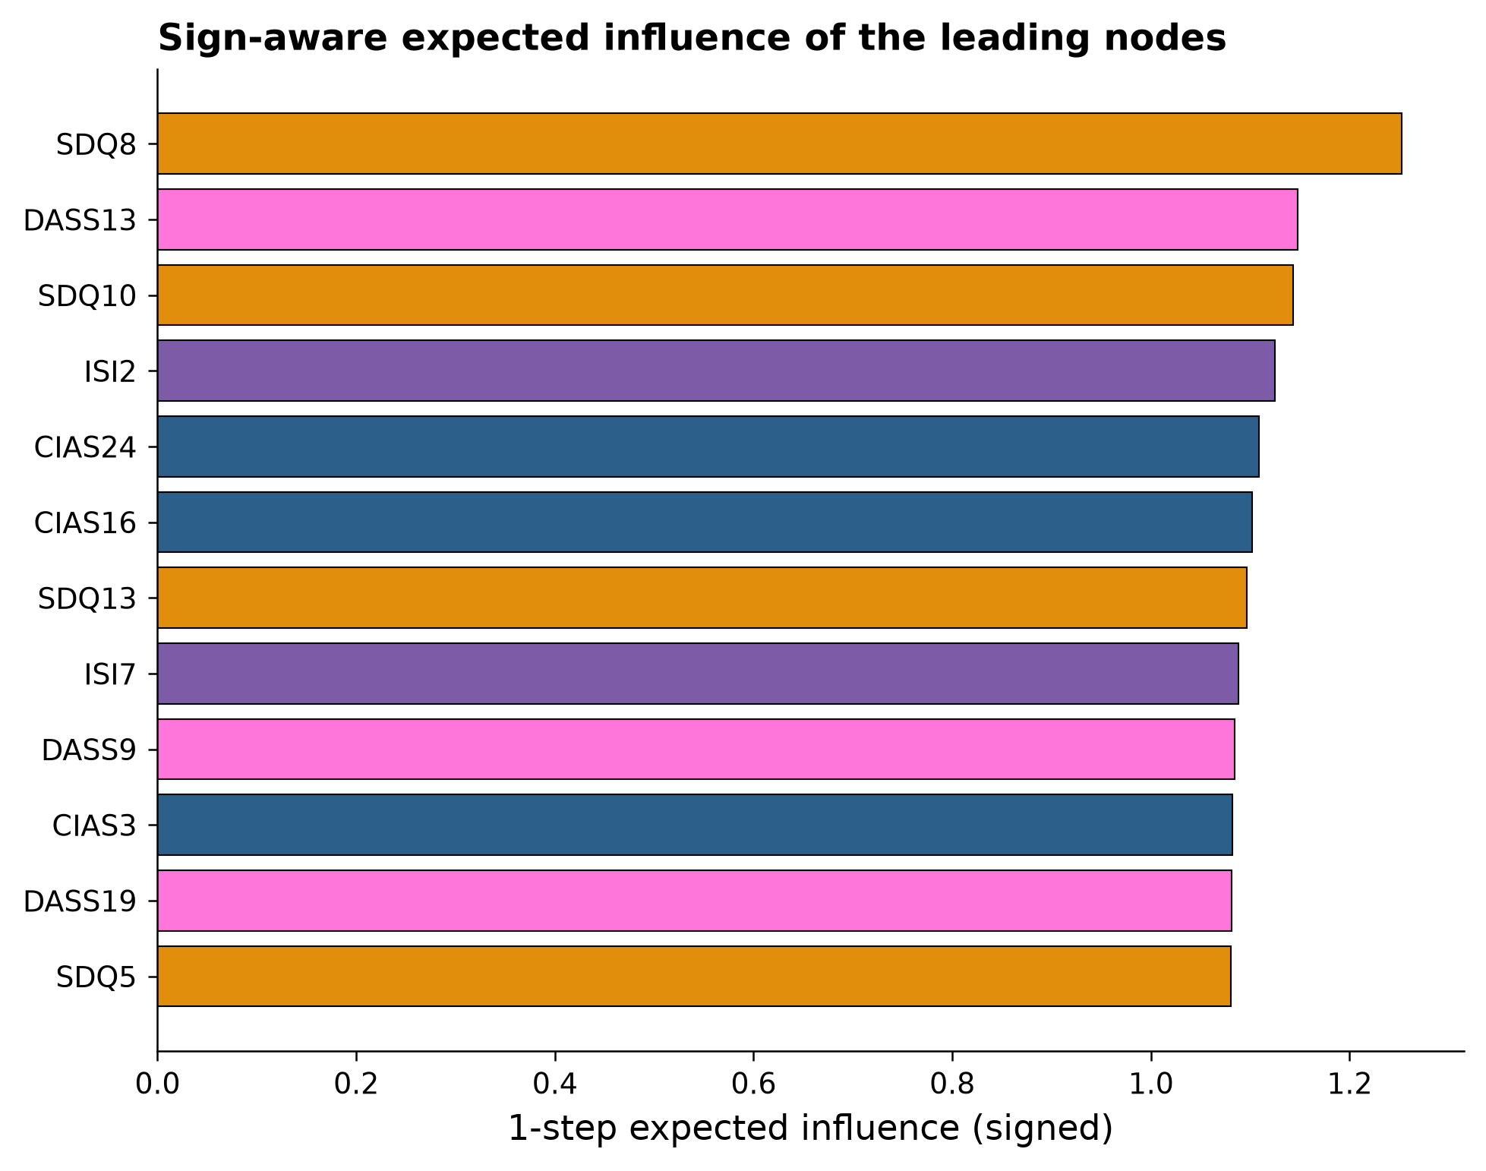
Supplementary Figure S5. One-step signed expected influence of the highest-ranked nodes.

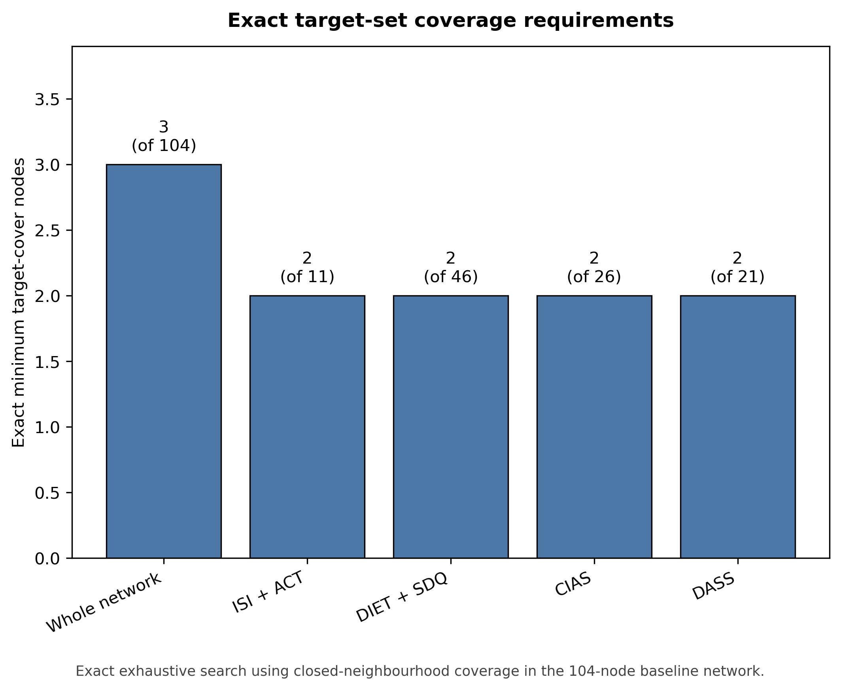
Supplementary Figure S6. Exact target-set coverage in the 104-node baseline network. Bars show the exact minimum number of selected nodes whose closed neighbourhoods cover all nodes in each specified target set. Candidate cover nodes could be selected from anywhere in the network. Values above the bars give the minimum number of selected nodes, with the number of target nodes shown in parentheses. CIAS denotes generalised problematic internet and digital-media use assessed with the CIAS-R. The full network required three nodes. Each selected target subset required two. This graph-theoretic coverage measure does not imply causal or clinical control.
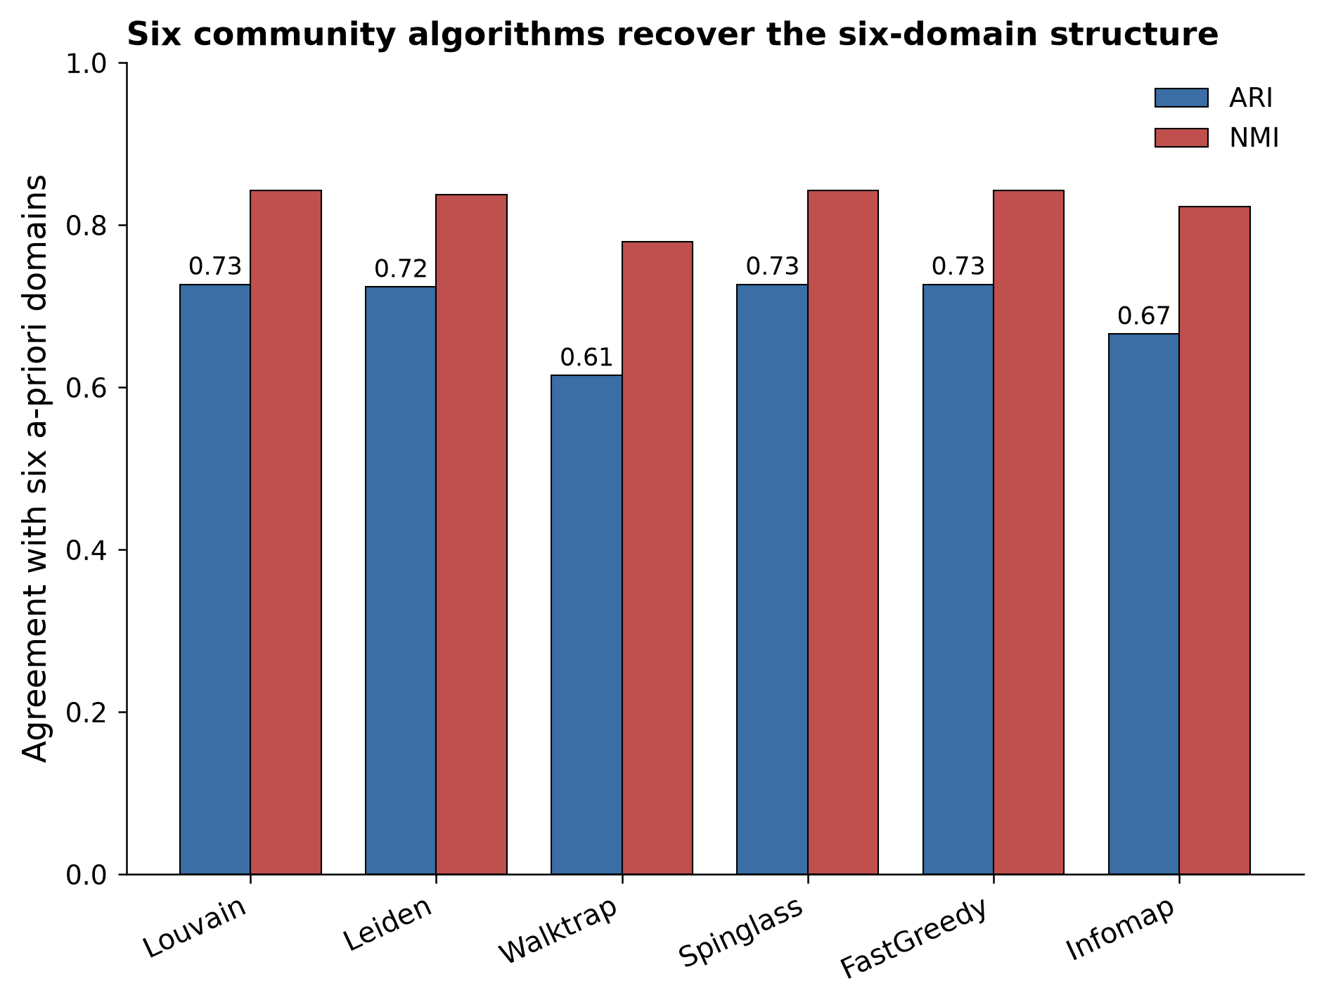
Supplementary Figure S7. Community-algorithm agreement: six community-detection algorithms recover the six a-priori domains (ARI, NMI). ARI, adjusted Rand index; NMI, normalised mutual information.

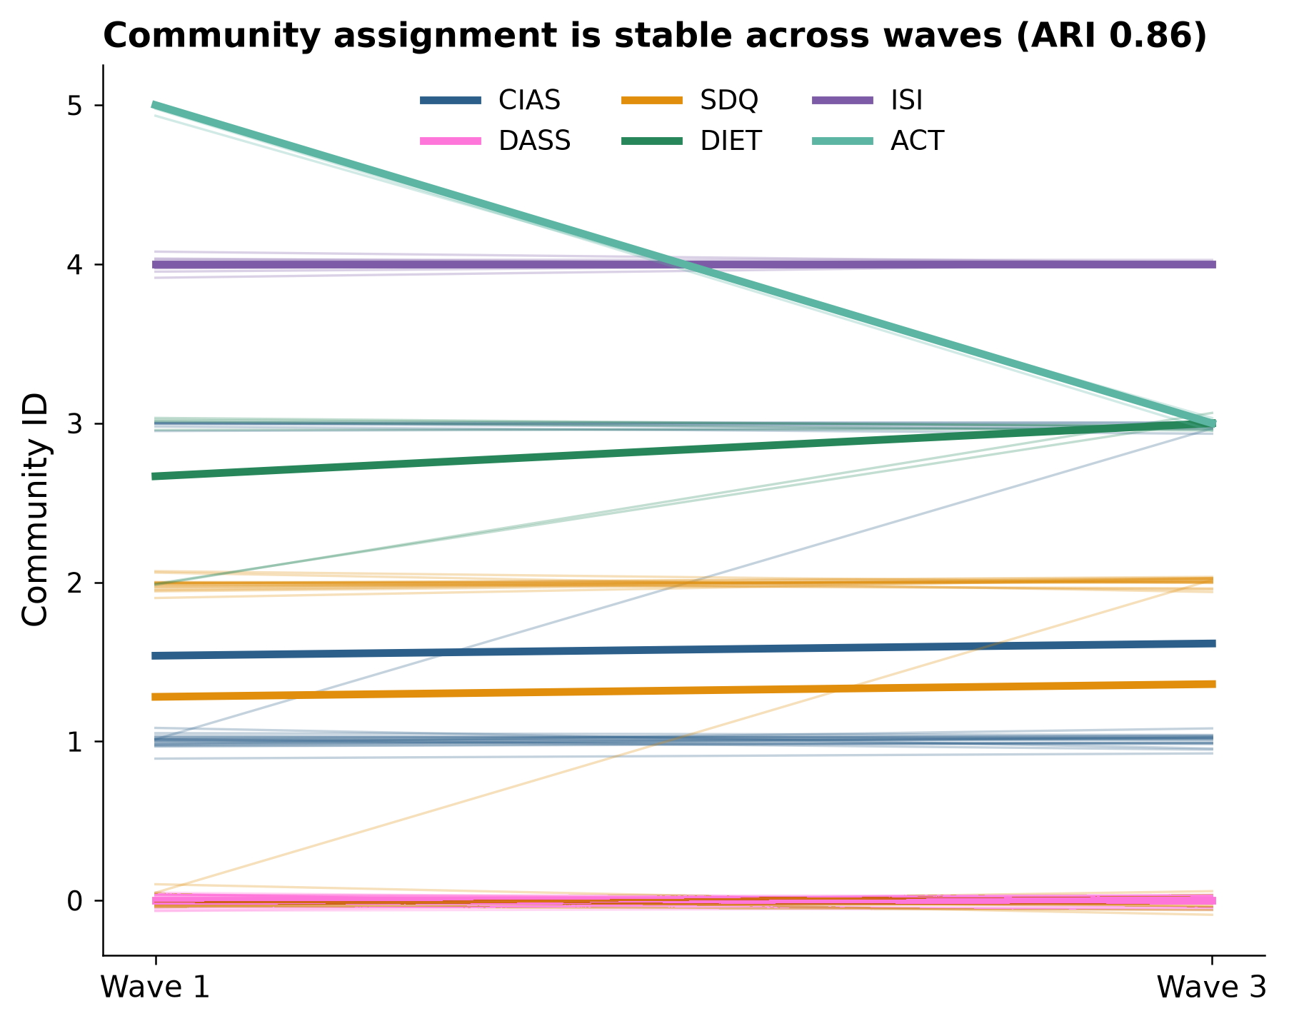
Supplementary Figure S8. Cross-wave community evolution (ARI 0.86; 8 of 89 nodes moved). ARI, adjusted Rand index. Thin lines represent individual nodes and thick lines represent domain-level mean trajectories; community IDs are categorical labels without ordinal meaning.
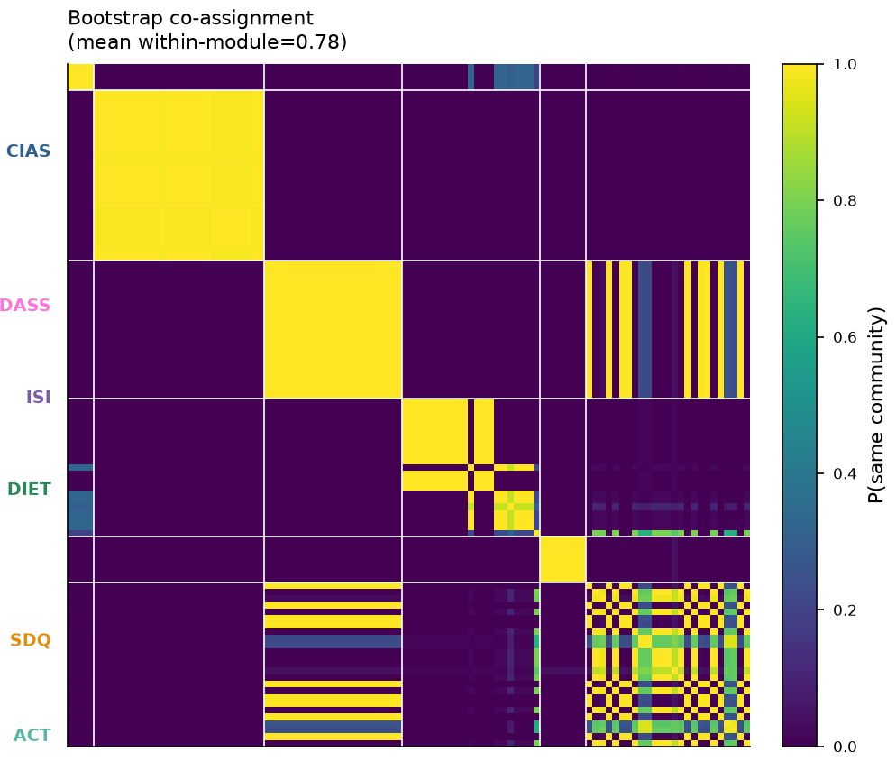
Supplementary Figure S9. Bootstrap co-assignment matrix (mean within-module probability 0.78). Colours indicate bootstrap co-assignment probability from 0 to 1; white boundaries delineate the six prespecified domains. P, probability.
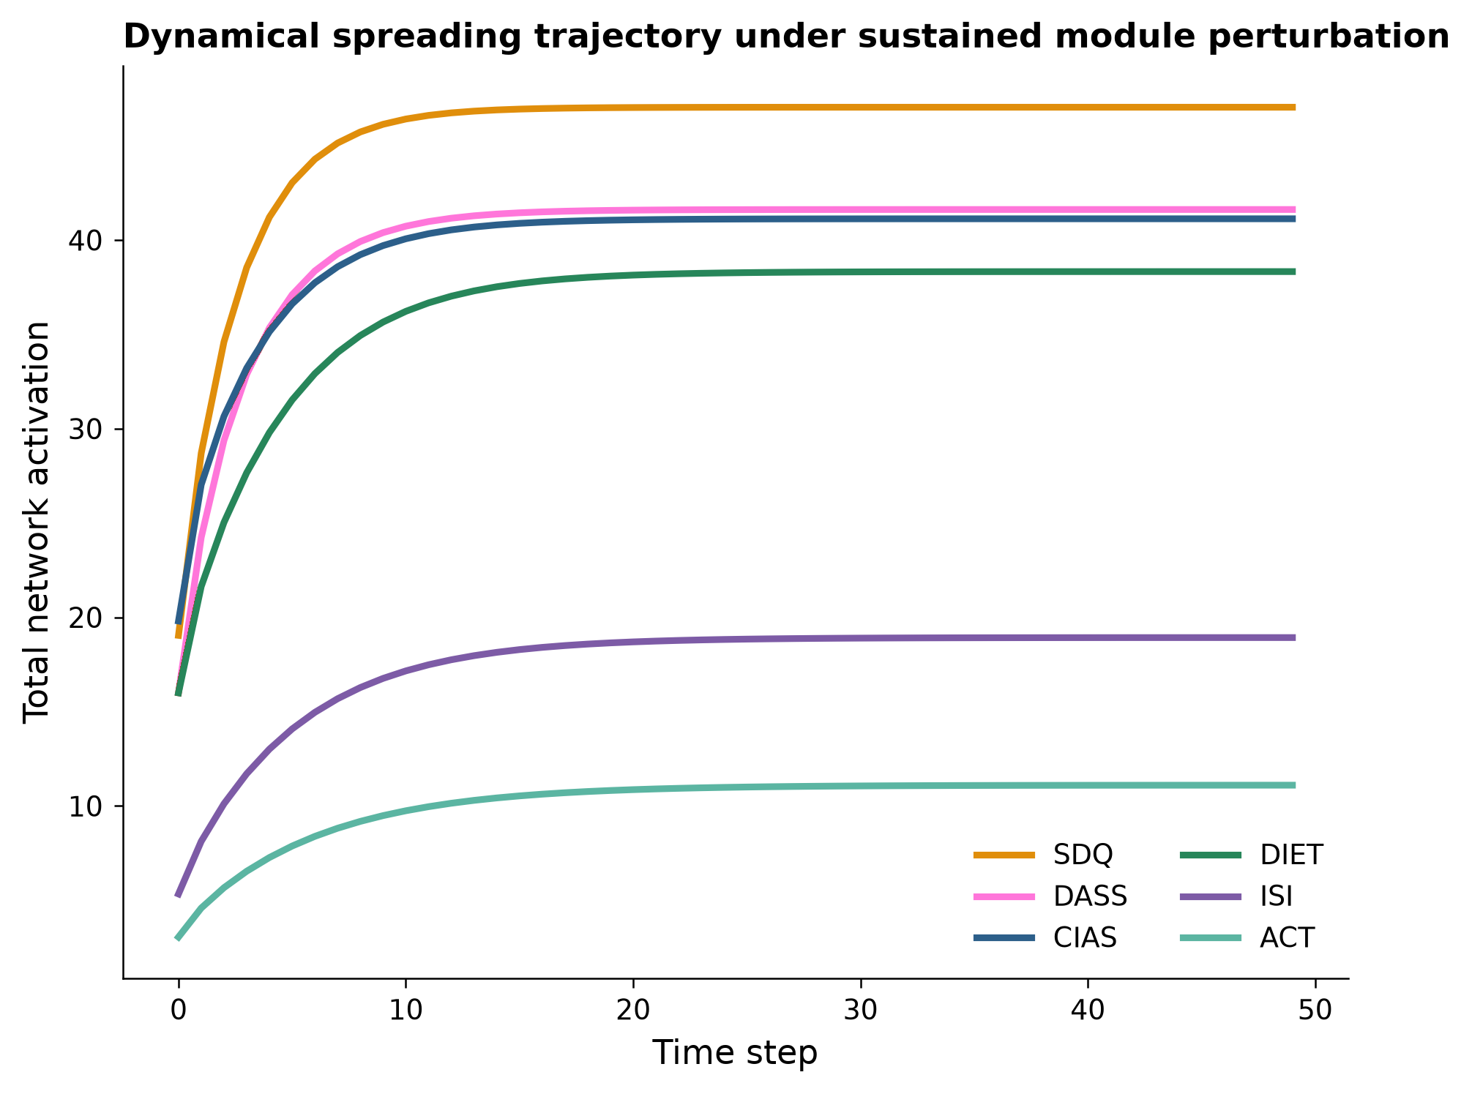
Supplementary Figure S10. Dynamical spreading trajectory: total network activation over time under sustained perturbation of each module.
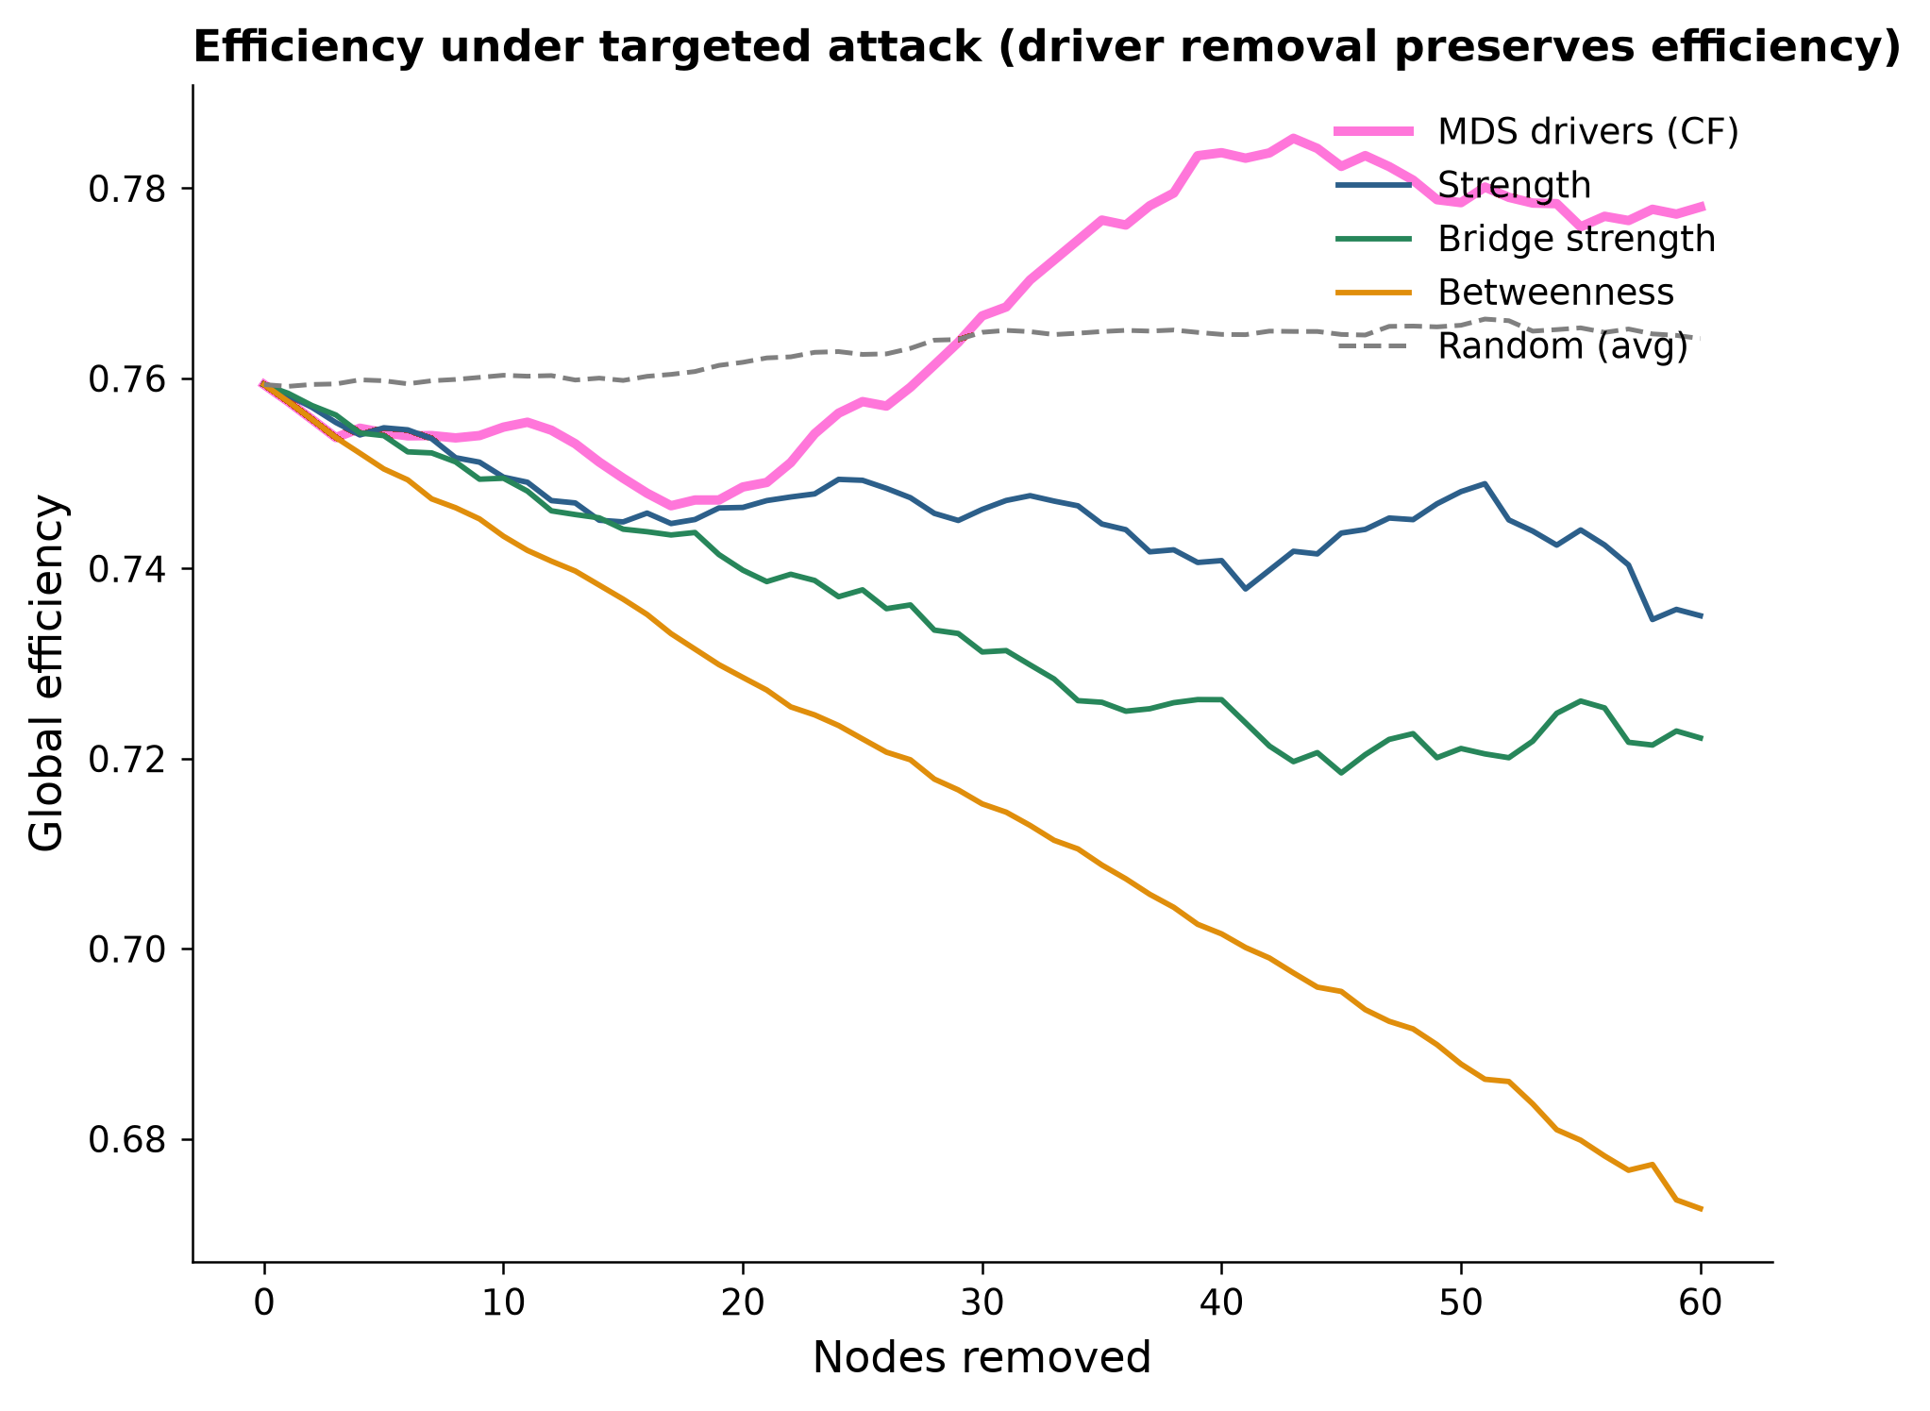
Supplementary Figure S11. Global efficiency as nodes are removed by different importance metrics.
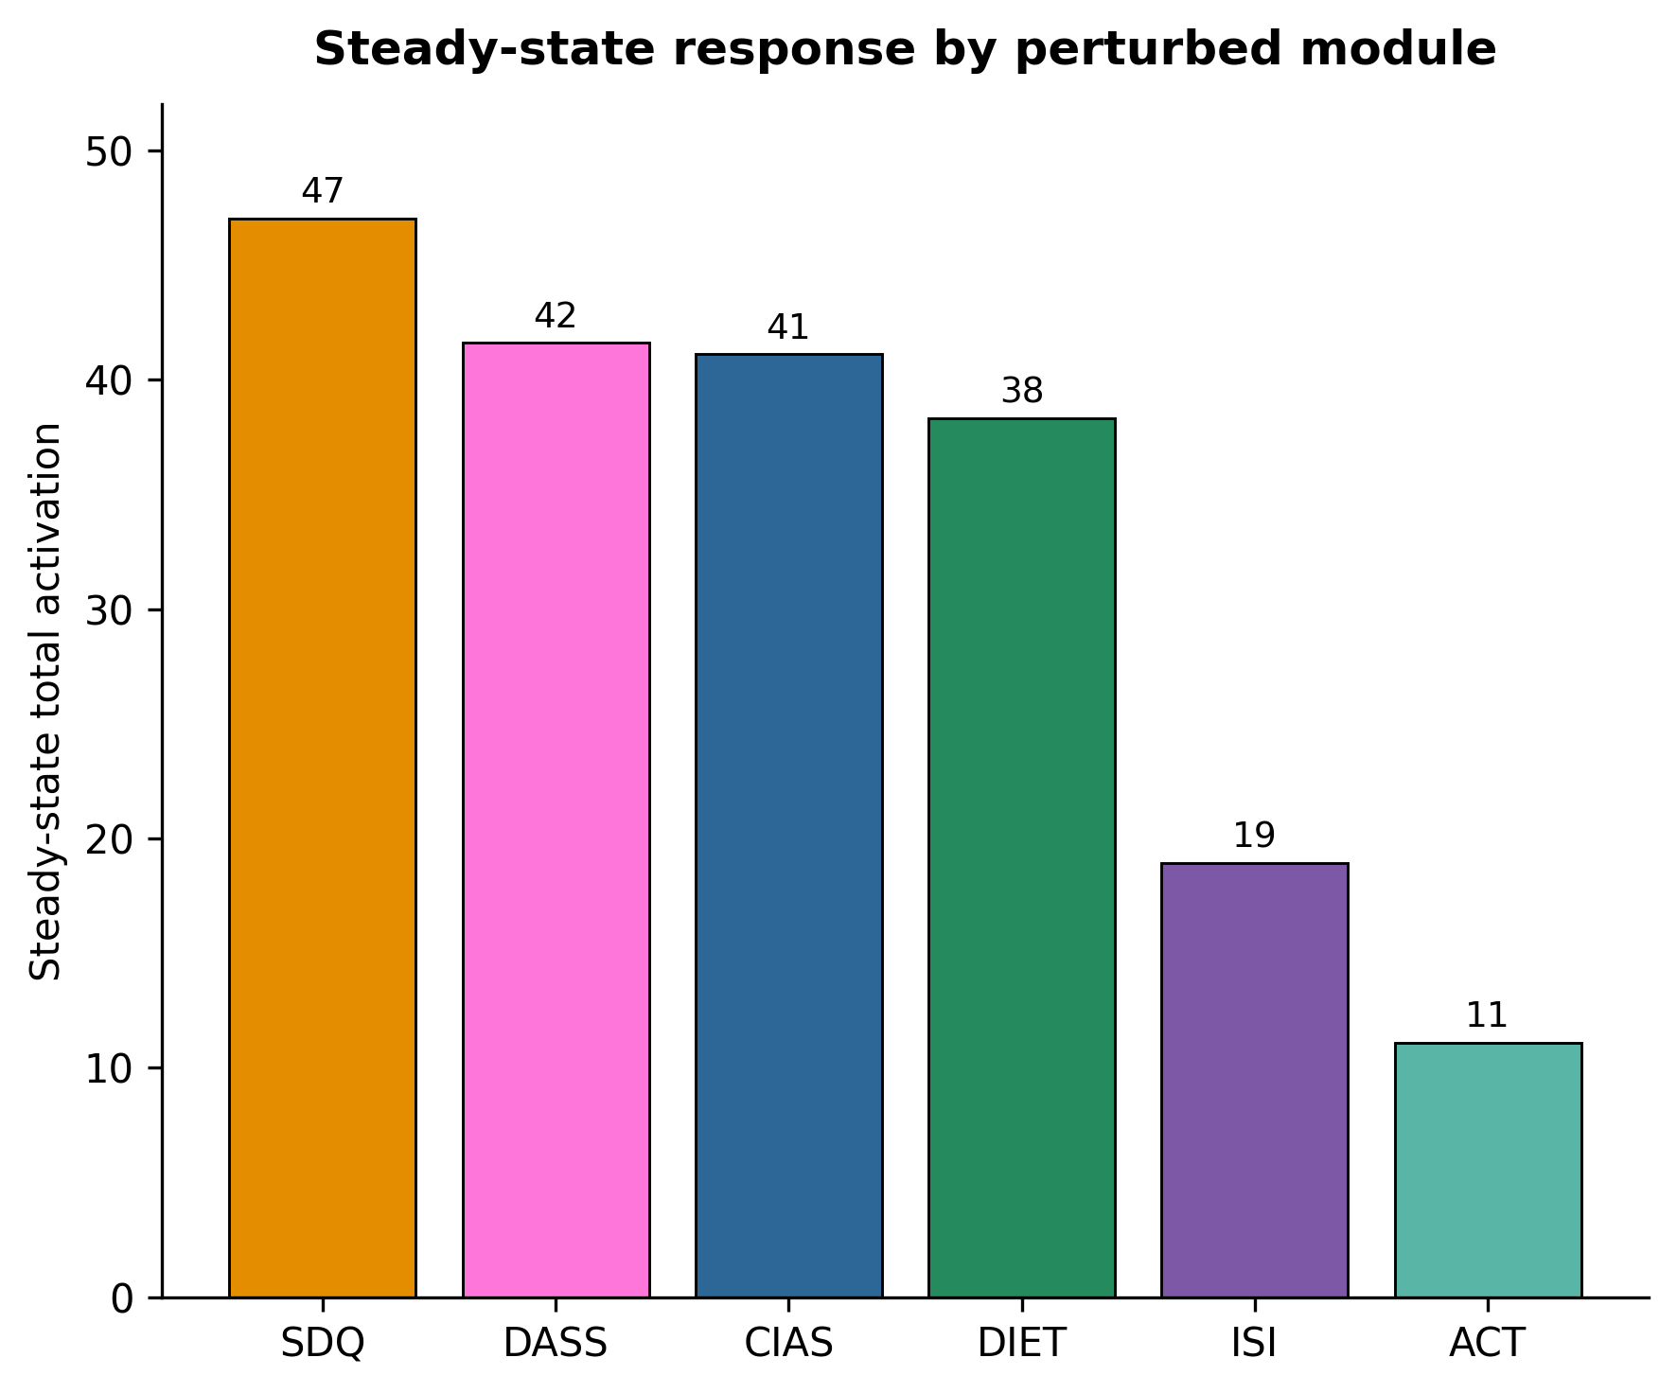
Supplementary Figure S12. Steady-state activation under sustained module perturbation. SDQ and DASS inputs produce greater total activation than ISI and ACT inputs in the specified nonlinear propagation model.
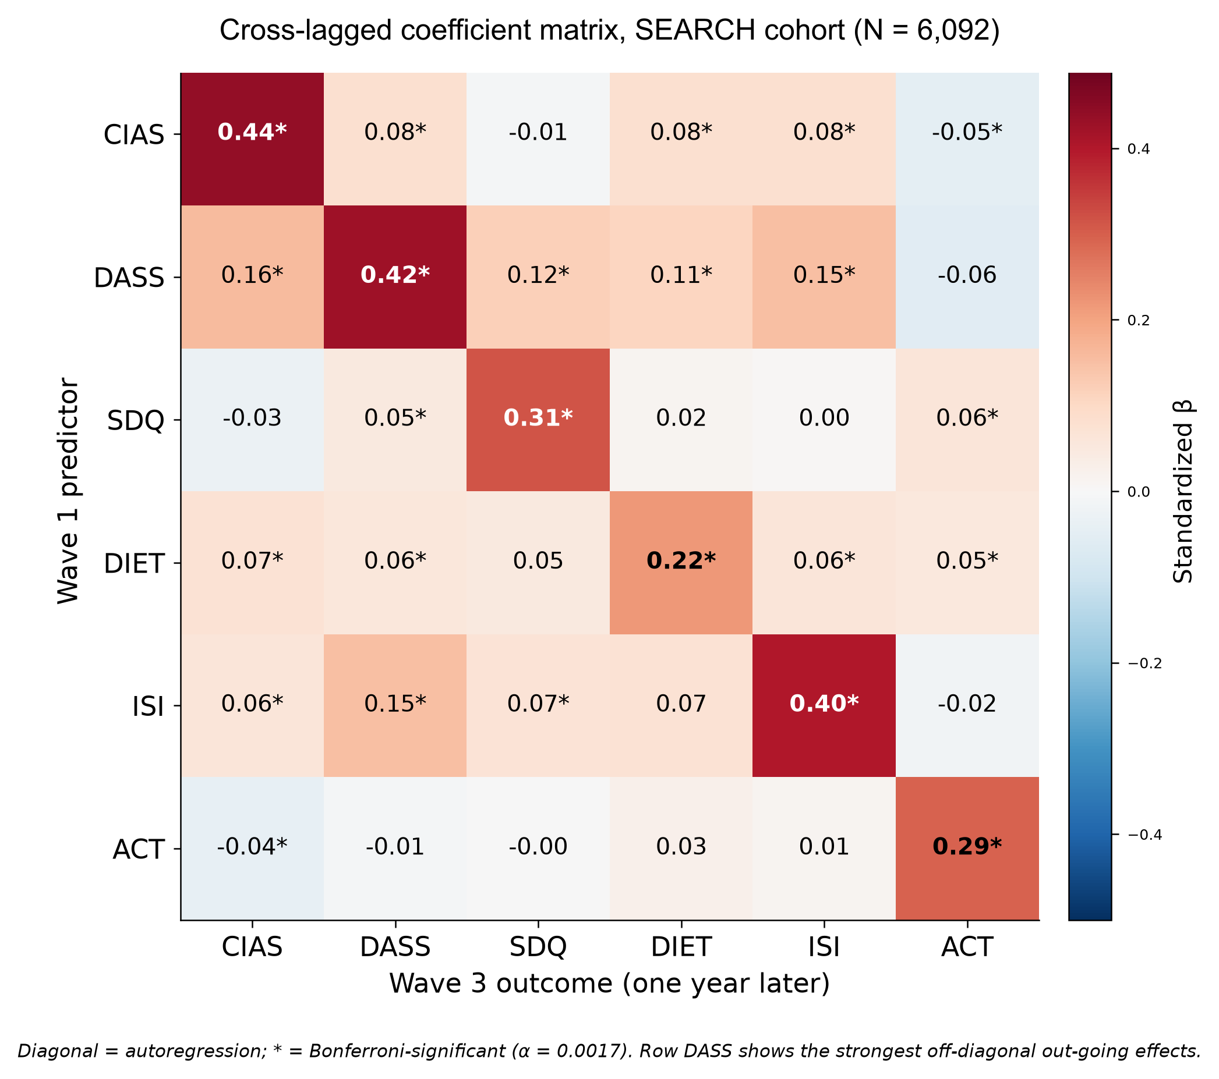
Supplementary Figure S13. Full cross-lagged coefficient matrix, SEARCH cohort (N = 6,092). Rows are Wave-1 predictors, columns are Wave-3 outcomes one year later. Diagonal entries are autoregressions; asterisks mark Bonferroni-significant coefficients (α = 0.0017). The DASS row carries the strongest off-diagonal outgoing effects, consistent with emotional distress occupying the leading CLPN net source position. Warm and blue cells indicate positive and negative coefficients, respectively.
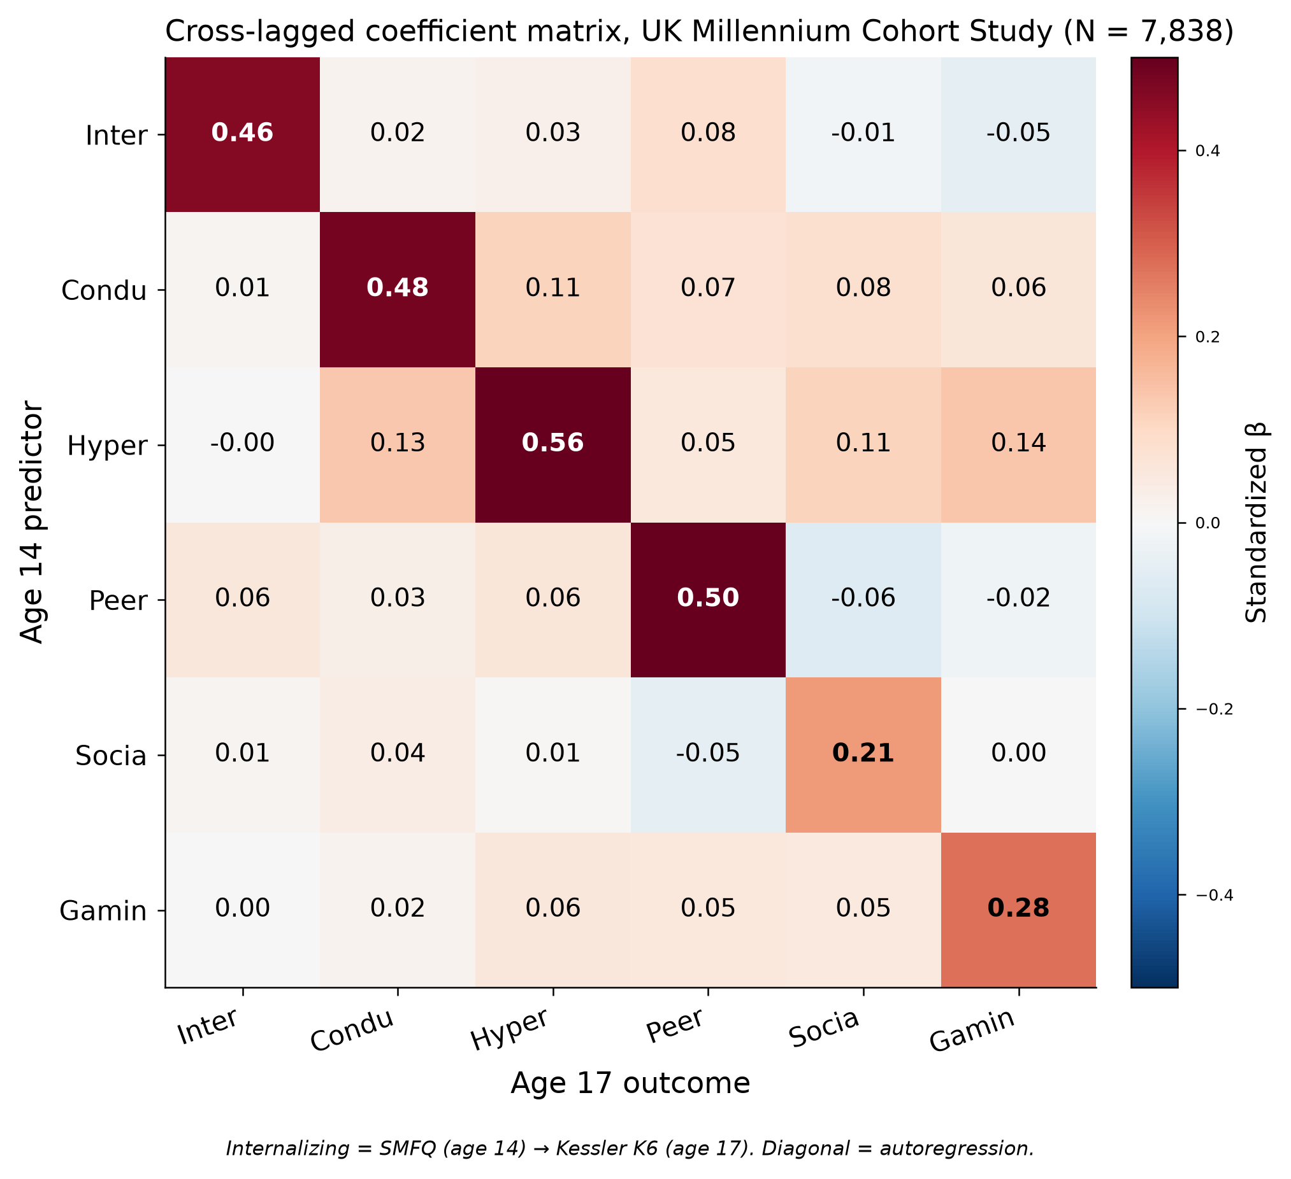
Supplementary Figure S14. Full cross-lagged coefficient matrix, UK Millennium Cohort Study (N = 7,838). SMFQ, Short Mood and Feelings Questionnaire; K6, six-item Kessler Psychological Distress Scale; β, standardised cross-lagged coefficient. Warm and blue cells indicate positive and negative coefficients, respectively. Rows are age-14 predictors, columns are age-17 outcomes. Internalising distress is measured by the SMFQ at age 14 and the Kessler K6 at age 17. Social-media use and gaming occupied CLPN net sink positions. Self-reported internalising distress, hyperactivity/inattention and conduct problems occupied CLPN net source positions. Positive paths to both screen-related outcomes originated from hyperactivity/inattention and conduct problems.
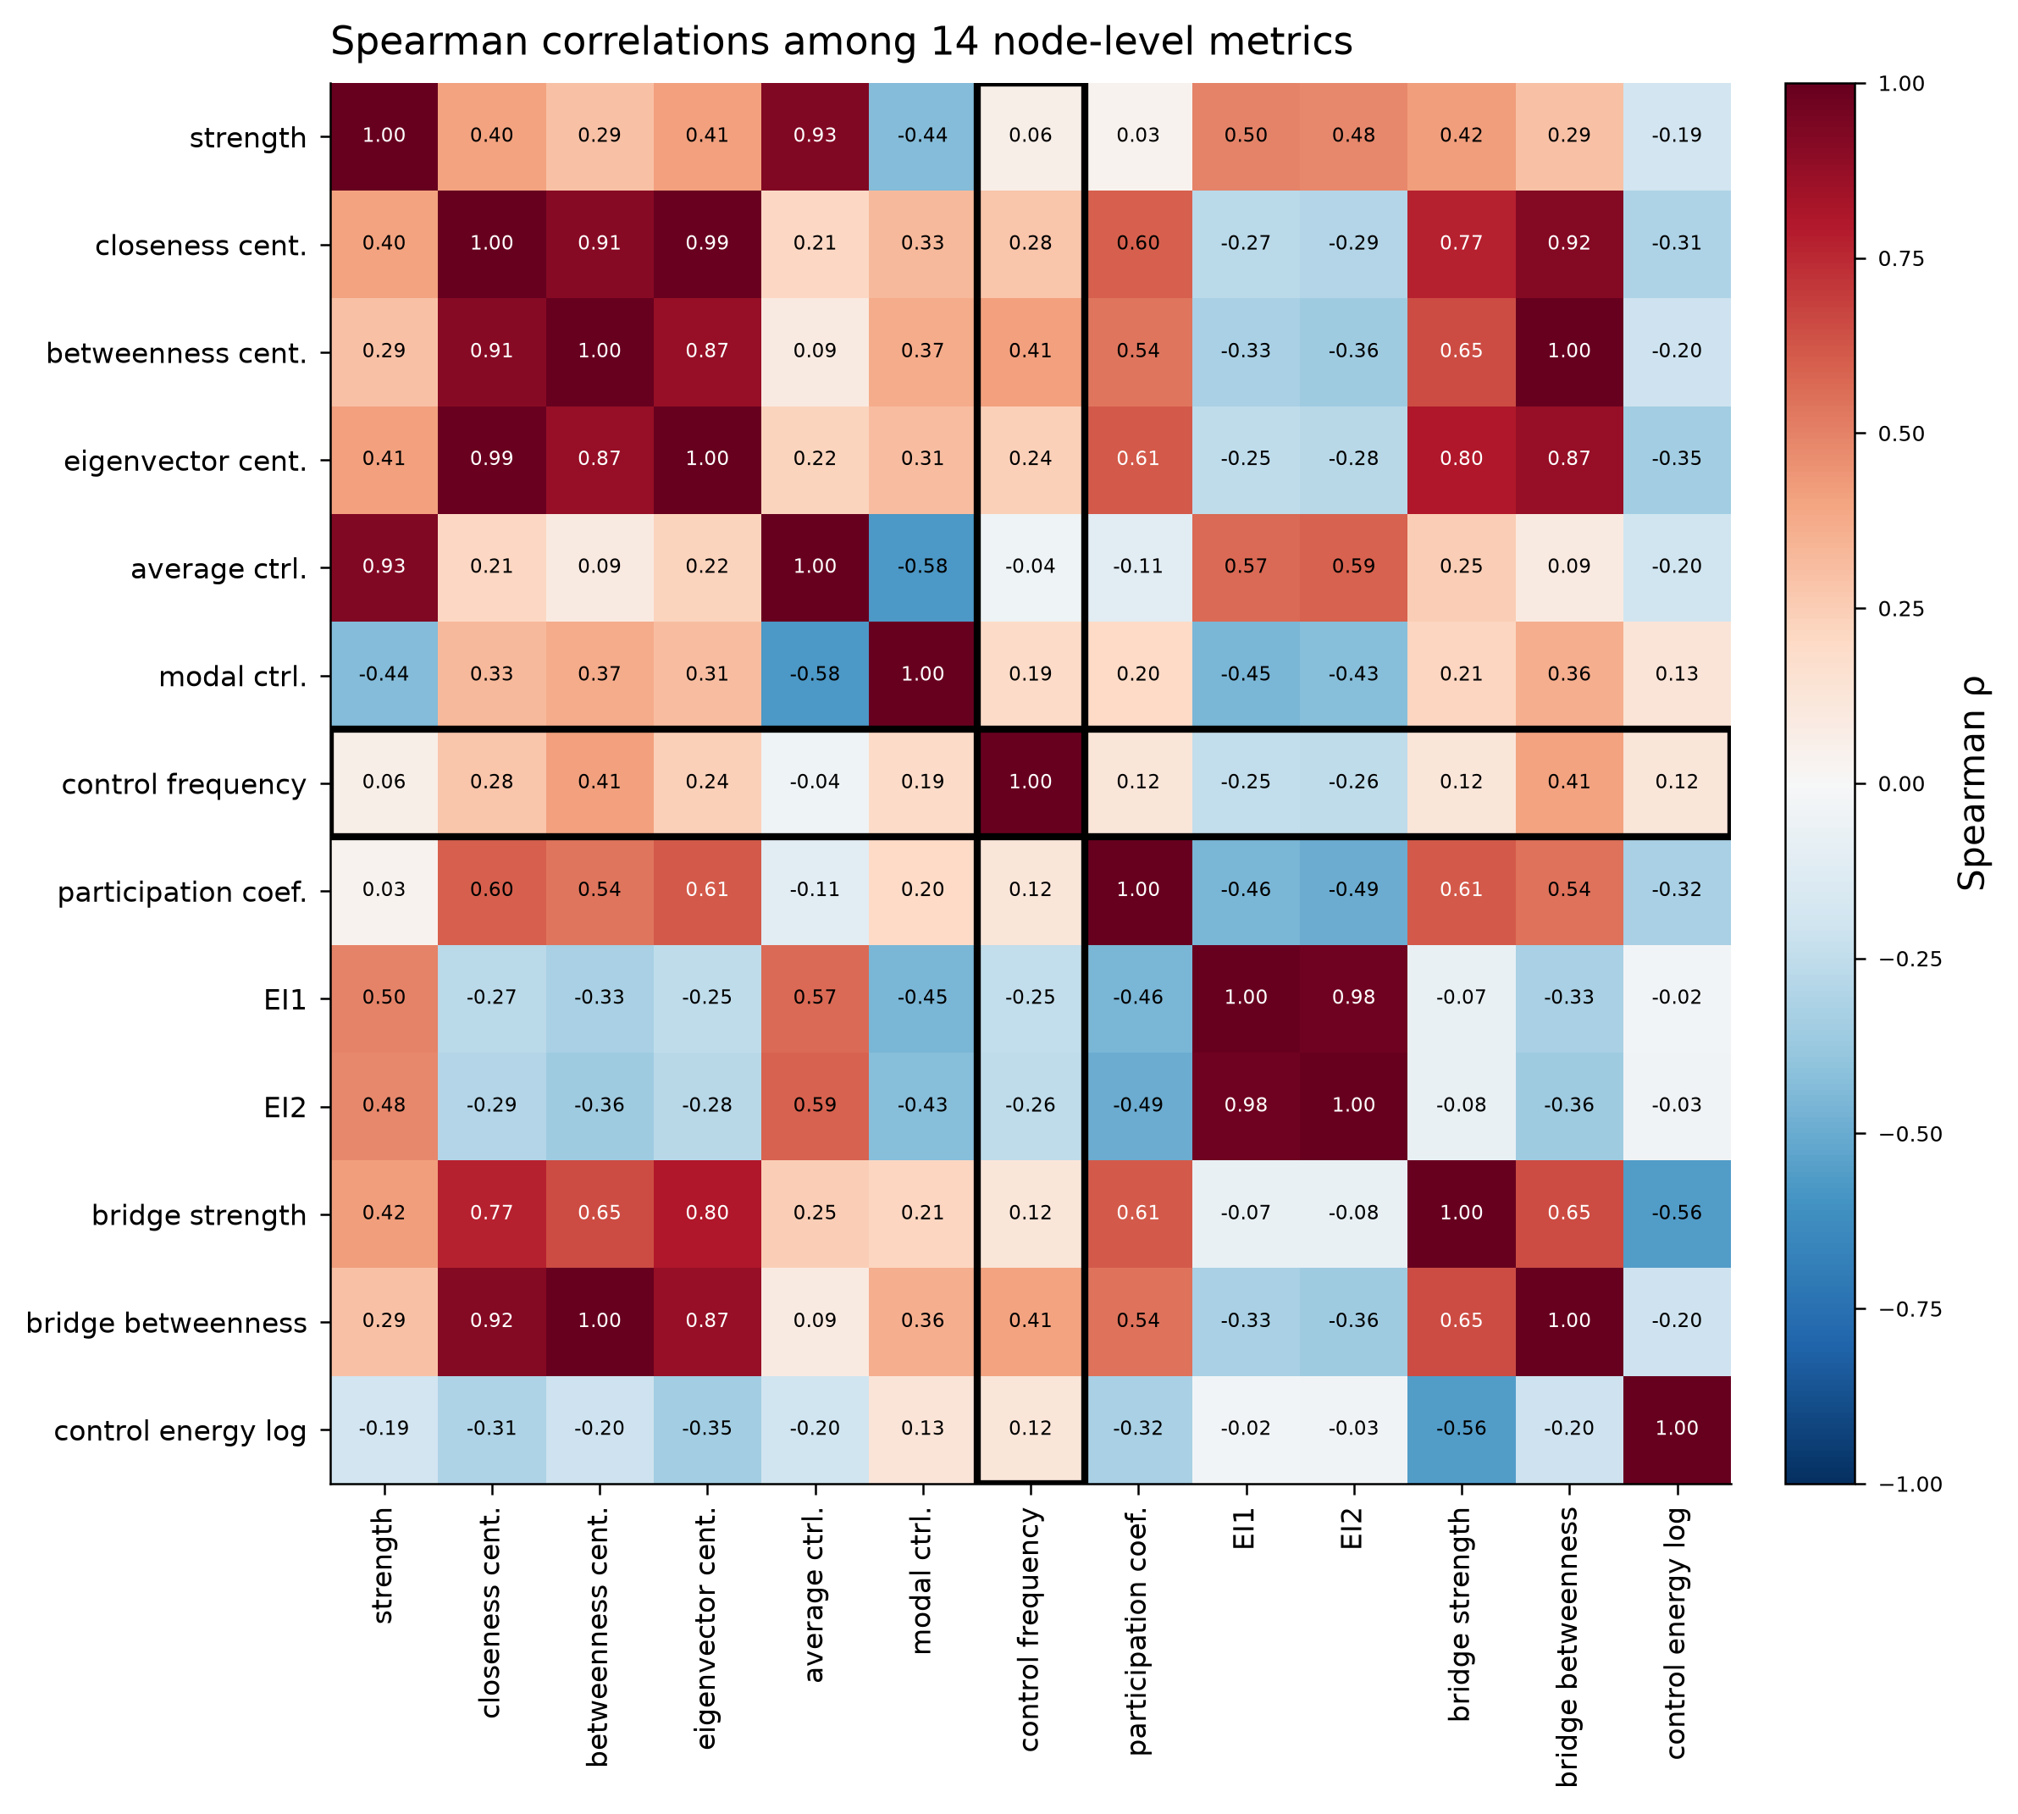
Supplementary Figure S15. Spearman correlations among 14 node-level metrics (104 nodes). The control-frequency row and column (boxed) are weakly correlated with every traditional centrality metric, confirming that structural control is a distinct dimension. Warm and blue cells indicate positive and negative correlations, respectively.
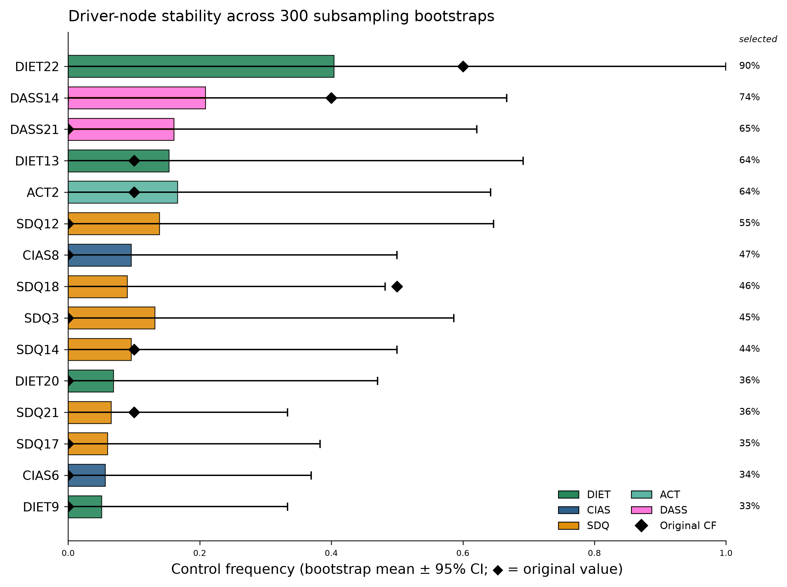
Supplementary Figure S16. Control-node stability across 300 subsampling bootstraps. Bars show the bootstrap mean control frequency, whiskers the 95% CI, and diamonds the original value; right-hand percentages are the fraction of resamples selecting each node into any minimum dominating set. DIET22 had the highest selection frequency across resamples, followed by DASS14. In the embedded figure, “driver” is a graph-theoretic label for a structural-control node identified by MDS membership or control frequency; it does not indicate causal or longitudinal influence.
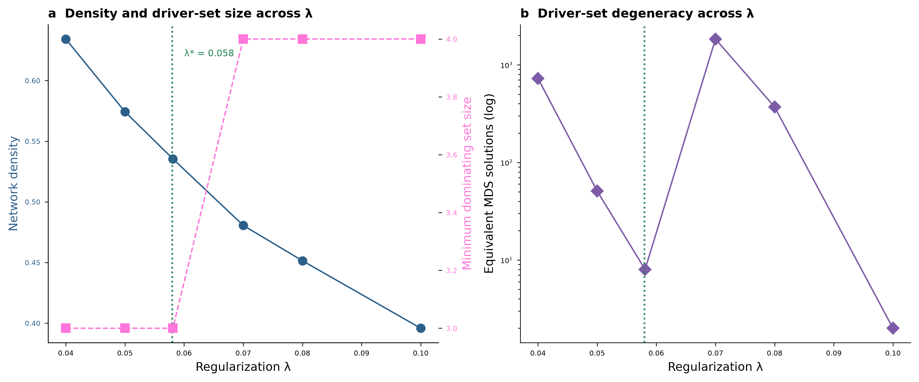
Supplementary Figure S17. Regularisation sensitivity of the network and MDS solution. (a) Network density and MDS size across the regularisation path, with the cross-validated lambda* = 0.058 marked. (b) Number of equivalent MDS solutions across lambda (log scale). Several leading nodes recur between lambda = 0.04 and 0.08, while set size and membership vary across the wider path. In the embedded figure, “driver” is a graph-theoretic label for a structural-control node identified by MDS membership or control frequency; it does not indicate causal or longitudinal influence.
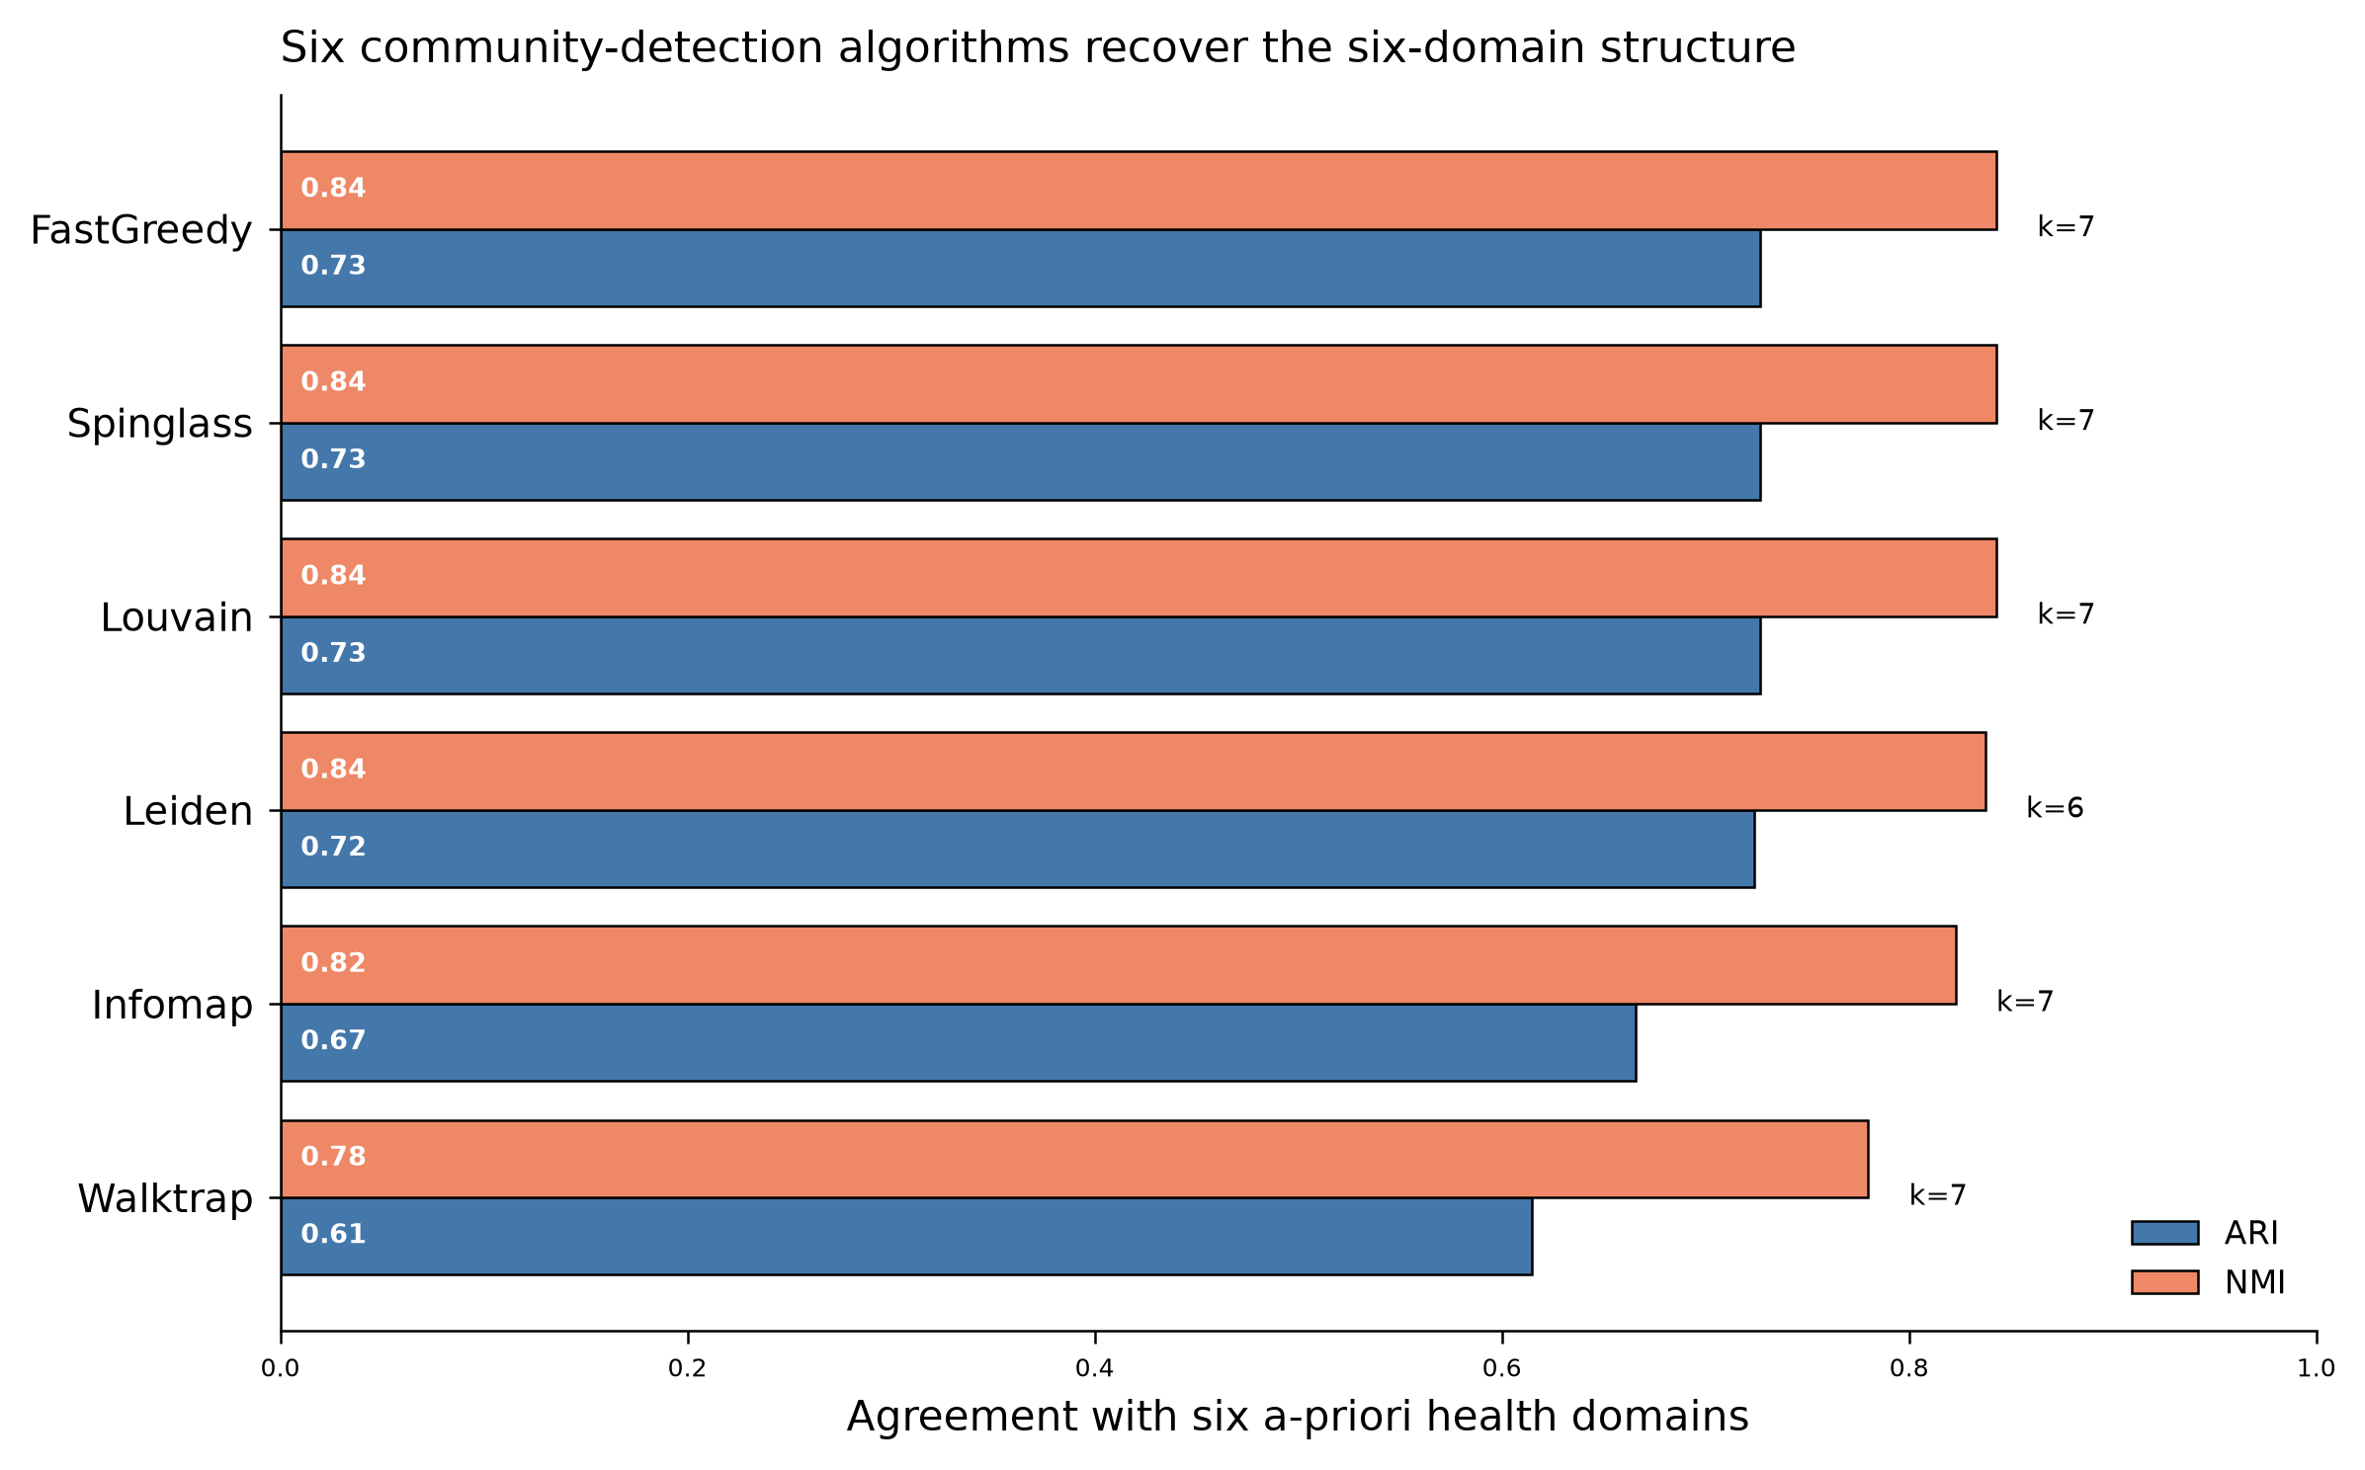
Supplementary Figure S18. Community partitions were broadly aligned with the six prespecified domains. Leiden returned six communities, whereas the other five algorithms returned seven. ARI and NMI between each algorithm's data-driven partition and the six a-priori domains; k is the number of communities returned. Leiden returns exactly six communities.
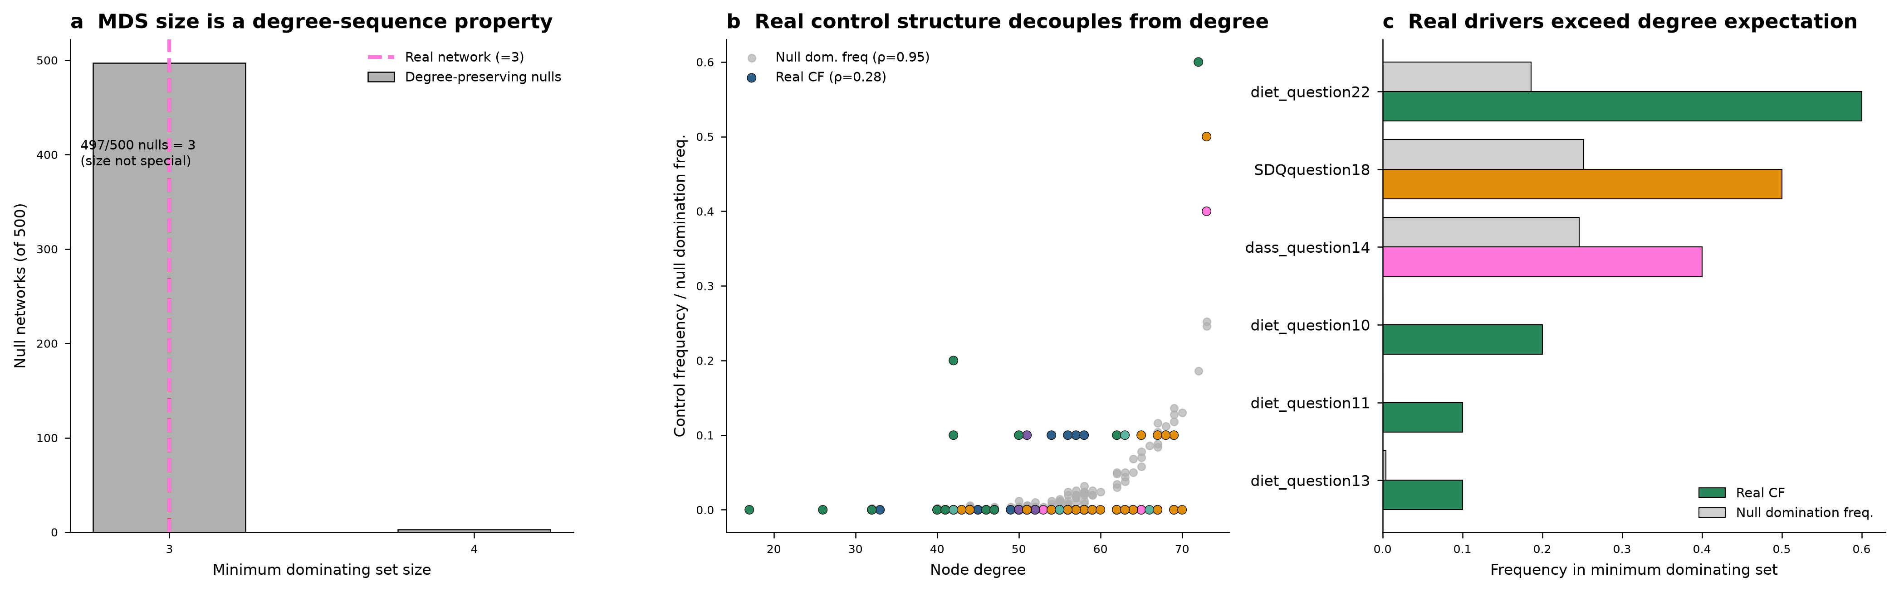
Supplementary Figure S19. MDS size follows the degree sequence while node frequencies differ from degree-matched expectations. (a) Across 500 degree-preserving null networks the MDS size of 3 is a property of the degree sequence (497/500). (b) Null domination frequency is almost fully determined by degree (grey; ρ = 0.95), whereas real control frequency is only weakly related to degree (coloured; ρ = 0.28). (c) The leading control nodes entered minimum dominating sets more frequently than expected under degree-preserving randomisation. In the embedded figure, “driver” is a graph-theoretic label for a structural-control node identified by MDS membership or control frequency; it does not indicate causal or longitudinal influence.

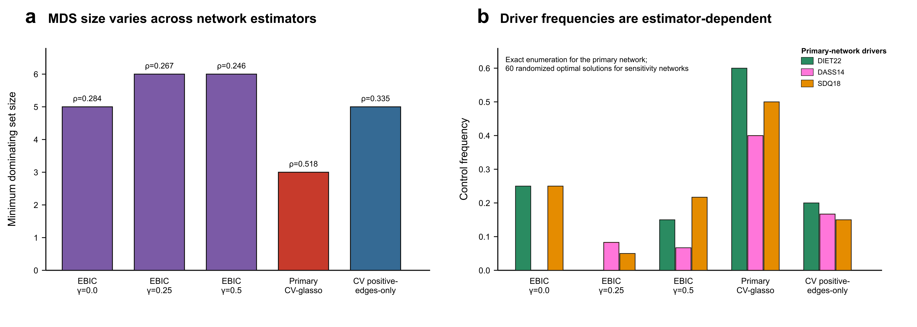
Supplementary Figure S20. Estimator sensitivity of the structural-control solution. (a) The MDS size is three in the primary cross-validated graphical Lasso network (density = 0.518) and increases to five or six in the sparser EBICglasso and positive-edge sensitivity networks. (b) Control frequencies of the three primary-network control nodes across estimators. Primary-network values are based on exhaustive enumeration of all 10 minimum dominating sets; sensitivity-network values are estimates from 60 randomised optimal solutions. The variation across estimators indicates that control-node identity is not invariant to network estimation. In the embedded figure, “driver” is a graph-theoretic label for a structural-control node identified by MDS membership or control frequency; it does not indicate causal or longitudinal influence.

