Table 1: Lesions and Diagnoses Confirmed by Small Bowel Endoscopy (N=78)
Hemorrhage of the digestive tract | Diseases | Patients | Small intestine ulcer  (non-hemorrhagic) | Diseases | Patients
Hemorrhage of the digestive tract | Small intestinal vascular malformation | 15 | Small intestine ulcer  (non-hemorrhagic) | Non-specific ulcer | 10
Hemorrhage of the digestive tract | Small intestine ulcers related to NSAID use | 10 | Small intestine ulcer  (non-hemorrhagic) | Behcet disease | 1
Hemorrhage of the digestive tract | Meckel’s diverticulum | 8 | Small intestine ulcer  (non-hemorrhagic) | Crohn’s disease of the small intestine | 2
Hemorrhage of the digestive tract | Jejunal stromal tumor | 4 | Small intestine ulcer  (non-hemorrhagic) | Small intestine ulcers related to NSAID use | 7
Small intestine tumors  (non-hemorrhagic) | Diseases | Patients | Other | Diseases | Patients
Small intestine tumors  (non-hemorrhagic) | Intestinal adenocarcinoma | 3 | Other | Foreign body in the small intestine | 5
Small intestine tumors  (non-hemorrhagic) | Adenoma | 5 | Other | Loss of small intestine protein | 1
Small intestine tumors  (non-hemorrhagic) | Lymphadenoma | 1 | Other | Lymphangiectasia of the small intestine | 3
Small intestine tumors  (non-hemorrhagic) | Carcinoma Metastatic | 1 | Other
Small intestine tumors  (non-hemorrhagic) | Interstitial | 2 | Other
NSAID = non-steroidal anti-inflammatory drug.
Table 1 Lesions and diagnoses confirmed by small-bowel endoscopy (N=78)
This table summarizes the disease spectrum of 78 patients with detected lesions. It lists the categories and case numbers of hemorrhagic, ulcerative, neoplastic and other small-intestinal disorders, and reflects the disease distribution of enrolled subjects.

Table 2: Relationship between Docking and Lesion Detection Rates
Variable | Patients | Confirmed diagnosis n (%) | Undetermined diagnosis n (%) | χ² | P
Docking | 48 | 38 (79.2) | 10 (21.3) | 9.336 | 0.002
No docking | 77 | 40 (51.9) | 37 (48.1) | 9.336 | 0.002
Table 2 Relationship between DBE docking status and lesion-detection rates
The table compares the proportions of confirmed and undetermined diagnoses between the docking and non-docking groups. Statistical results reveal a significant inter-group difference in lesion-detection rates, verifying that successful docking improves diagnostic yield for small-intestinal lesions.

Table 3: Analysis of Double-Balloon Enteroscopy Examination Results and Pathological Detection Rates
 |  | Patients (n) | Lesions detected (n) | Pathological detection rate (%) | Significance | P
Overall |  | 125 | 78 | 62.4 | - | -
 | Docking | 48 | 38 | 79.2
 | Non-docking | 77 | 40 | 51.9
Comparison of overall lesion detection rates | Docking group vs.Non-docking group |  |  |  | χ²=7.885 | 0.005
Lesion detection rates across different diseases
Unexplained gastrointestinal bleeding | Docking group | 23 | 22 | 95.6 | χ²=5.165 | 0.023
 | Non-docking group | 20 | 14 | 70.0 | χ²=5.165 | 0.023
Small intestine ulcers | Docking group | 17 | 13 | 76.5 | χ²=1.081 | 0.298
 | Non-docking group | 12 | 7 | 58.3 | χ²=1.081 | 0.298
Small intestine tumors | Docking group | 3 | 3 | 100.0 | Differences were not statistically significant | 0.218
 | Non-docking group | 14 | 9 | 64.3 | Differences were not statistically significant | 0.218
Other diseases | Docking group | 5 | 0 | 0.0 | - | -
 | Non-docking group | 31 | 9 | 29.0
Subgroup analysis | Groups | Patients (n) | Hospital length of stay | Adverse events | Hospitalization expenses | P
 | Docking group | 48 | Differences were not statistically significant | Differences were not statistically significant | Differences were not statistically significant | >0.05
 | Non-docking group | 77
Table 3 Analysis of DBE examination outcomes and lesion-detection rates
This table aggregates case numbers, lesion-detection rates and P-values for the overall cohort, docking/non-docking subgroups, and individual disease subgroups. It further compares length of hospital stay, adverse-event incidence and hospitalization costs, comprehensively evaluating the diagnostic impact, safety and economic indicators of successful DBE docking.

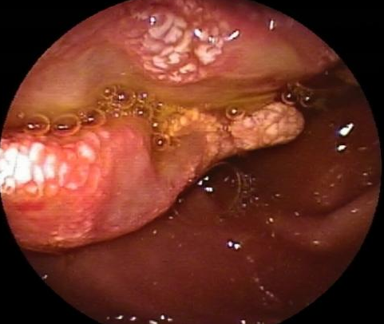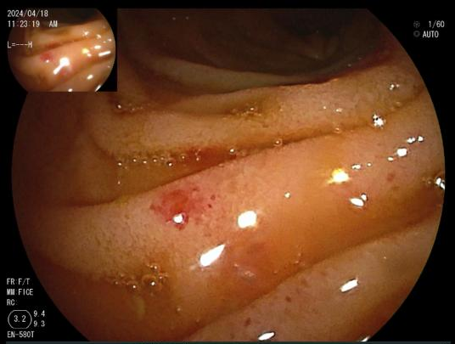
Figure 1 Figure 2
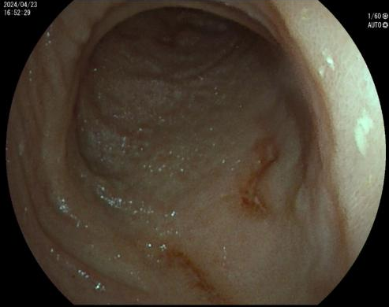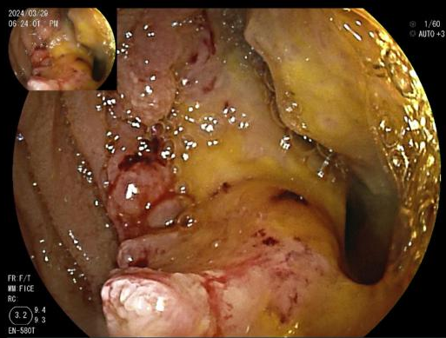
Figure 3 Figure 4
Figure 1: Small intestine lymphoma
Figure 2: Small intestine telangiectasia
Figure 3: Small intestine ulcer
Figure 4: Small intestine adenocarcinoma
Figure 1 Small-intestinal lymphoma
Endoscopic image of small-intestinal lymphoma obtained by double-balloon enteroscopy (DBE). It demonstrates the endoscopic morphology of small-intestinal neoplastic lesions enrolled in this study and provides visual endoscopic evidence for the tumor subgroup.
Figure 2 Small-intestinal telangiectasia
DBE image of small-intestinal telangiectasia. This lesion represents a common cause of obscure gastrointestinal bleeding in the present study and intuitively shows the endoscopic appearance of bleeding-origin foci.
Figure 3 Small-intestinal ulcer
DBE image of small-intestinal ulcer. Corresponding to the small-intestinal ulcer subgroup in this research, it presents the endoscopic morphology of target ulcerative lesions.
Figure 4 Small-intestinal adenocarcinoma
DBE image of small-intestinal adenocarcinoma, a malignant small-intestinal tumor. It supplies typical visual endoscopic data for the tumor subgroup.

