Supplementary

Iron isotopes constrain sources and cycling in the global ocean
Weijie Ke¹, Alessandro Tagliabue², Ruifeng Zhang^{1*}

¹State Key Laboratory of Submarine Geoscience, Key Laboratory of Polar Ecosystem and Climate Change, School of Oceanography, Shanghai Jiao Tong University, Shanghai, China.
²School of Environmental Sciences, University of Liverpool, Liverpool, UK.
*Corresponding author: Ruifeng Zhang (ruifengzhang@sjtu.edu.cn)

Supplementary Fig.1
Global distribution and basin-scale zonal structure of dFe predicted by the ensemble model. The ensemble prediction represents the combined output of the XGBoost, Random Forest, and LightGBM models. The upper panels show global dFe distributions at depths of 10, 1000, 2500, and 4000 m. The lower panels show zonal-averaged meridional sections of predicted dFe in the Atlantic, Pacific, and Indian oceans as a function of latitude and depth. Contour lines indicate spatial gradients in dFe concentration. Dissolved Fe concentrations are expressed in nmol kg⁻¹.

Supplementary Fig.2
Global distribution and basin-scale zonal structure of δ⁵⁶Fe predicted by the ensemble model. The ensemble prediction represents the combined output of the XGBoost, Random Forest, and LightGBM models. The upper panels show global δ⁵⁶Fe distributions at depths of 10, 1000, 2500, and 4000 m. The lower panels show zonal-averaged meridional sections of predicted δ⁵⁶Fe in the Atlantic, Pacific, and Indian oceans as a function of latitude and depth. Contour lines indicate spatial gradients in dFe concentration. δ⁵⁶Fe values are expressed as per mil (‰) deviations of the ⁵⁶Fe/⁵⁴Fe ratio relative to the IRMM-014 standard.

Supplementary Fig.3
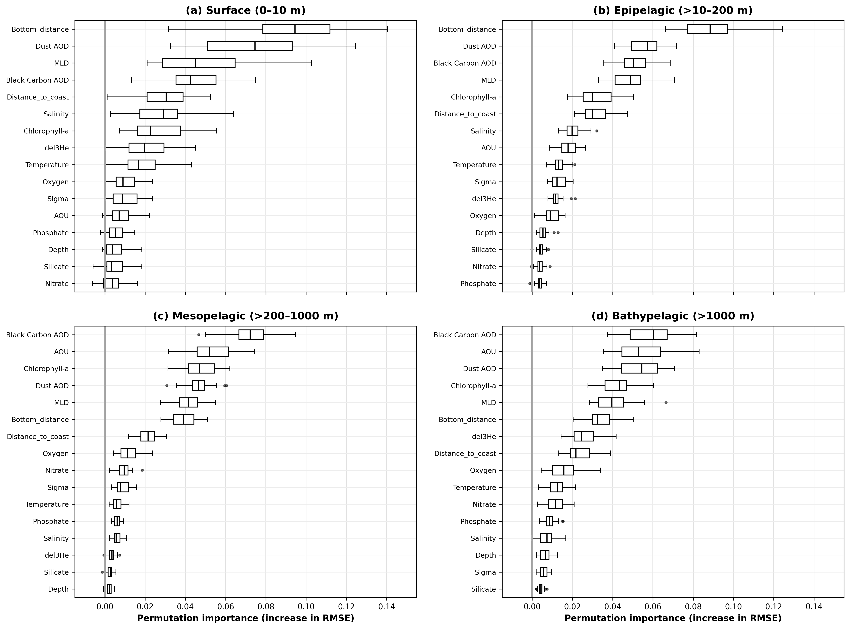
Depth-dependent permutation importance of environmental predictors for ensemble-model predictions of dissolved Fe concentration. Predictor importance was quantified as the increase in root mean square error (RMSE) after randomly permuting each predictor in the ensemble of XGBoost, Random Forest and LightGBM models. Results are shown for four depth intervals: (a) surface waters (0–10 m), (b) the epipelagic zone (10–200 m), (c) the mesopelagic zone (200–1000 m), and (d) the bathypelagic zone (>1000 m). Predictors within each panel are ordered according to their median permutation importance. Larger positive increases in RMSE indicate a greater contribution of the predictor to model performance, whereas values close to or below zero indicate limited predictive importance. Boxes represent the interquartile range, central lines indicate medians, whiskers extend to 1.5 times the interquartile range, and points denote outliers. Changes in RMSE are expressed in nmol kg⁻¹.

Supplementary Fig.4
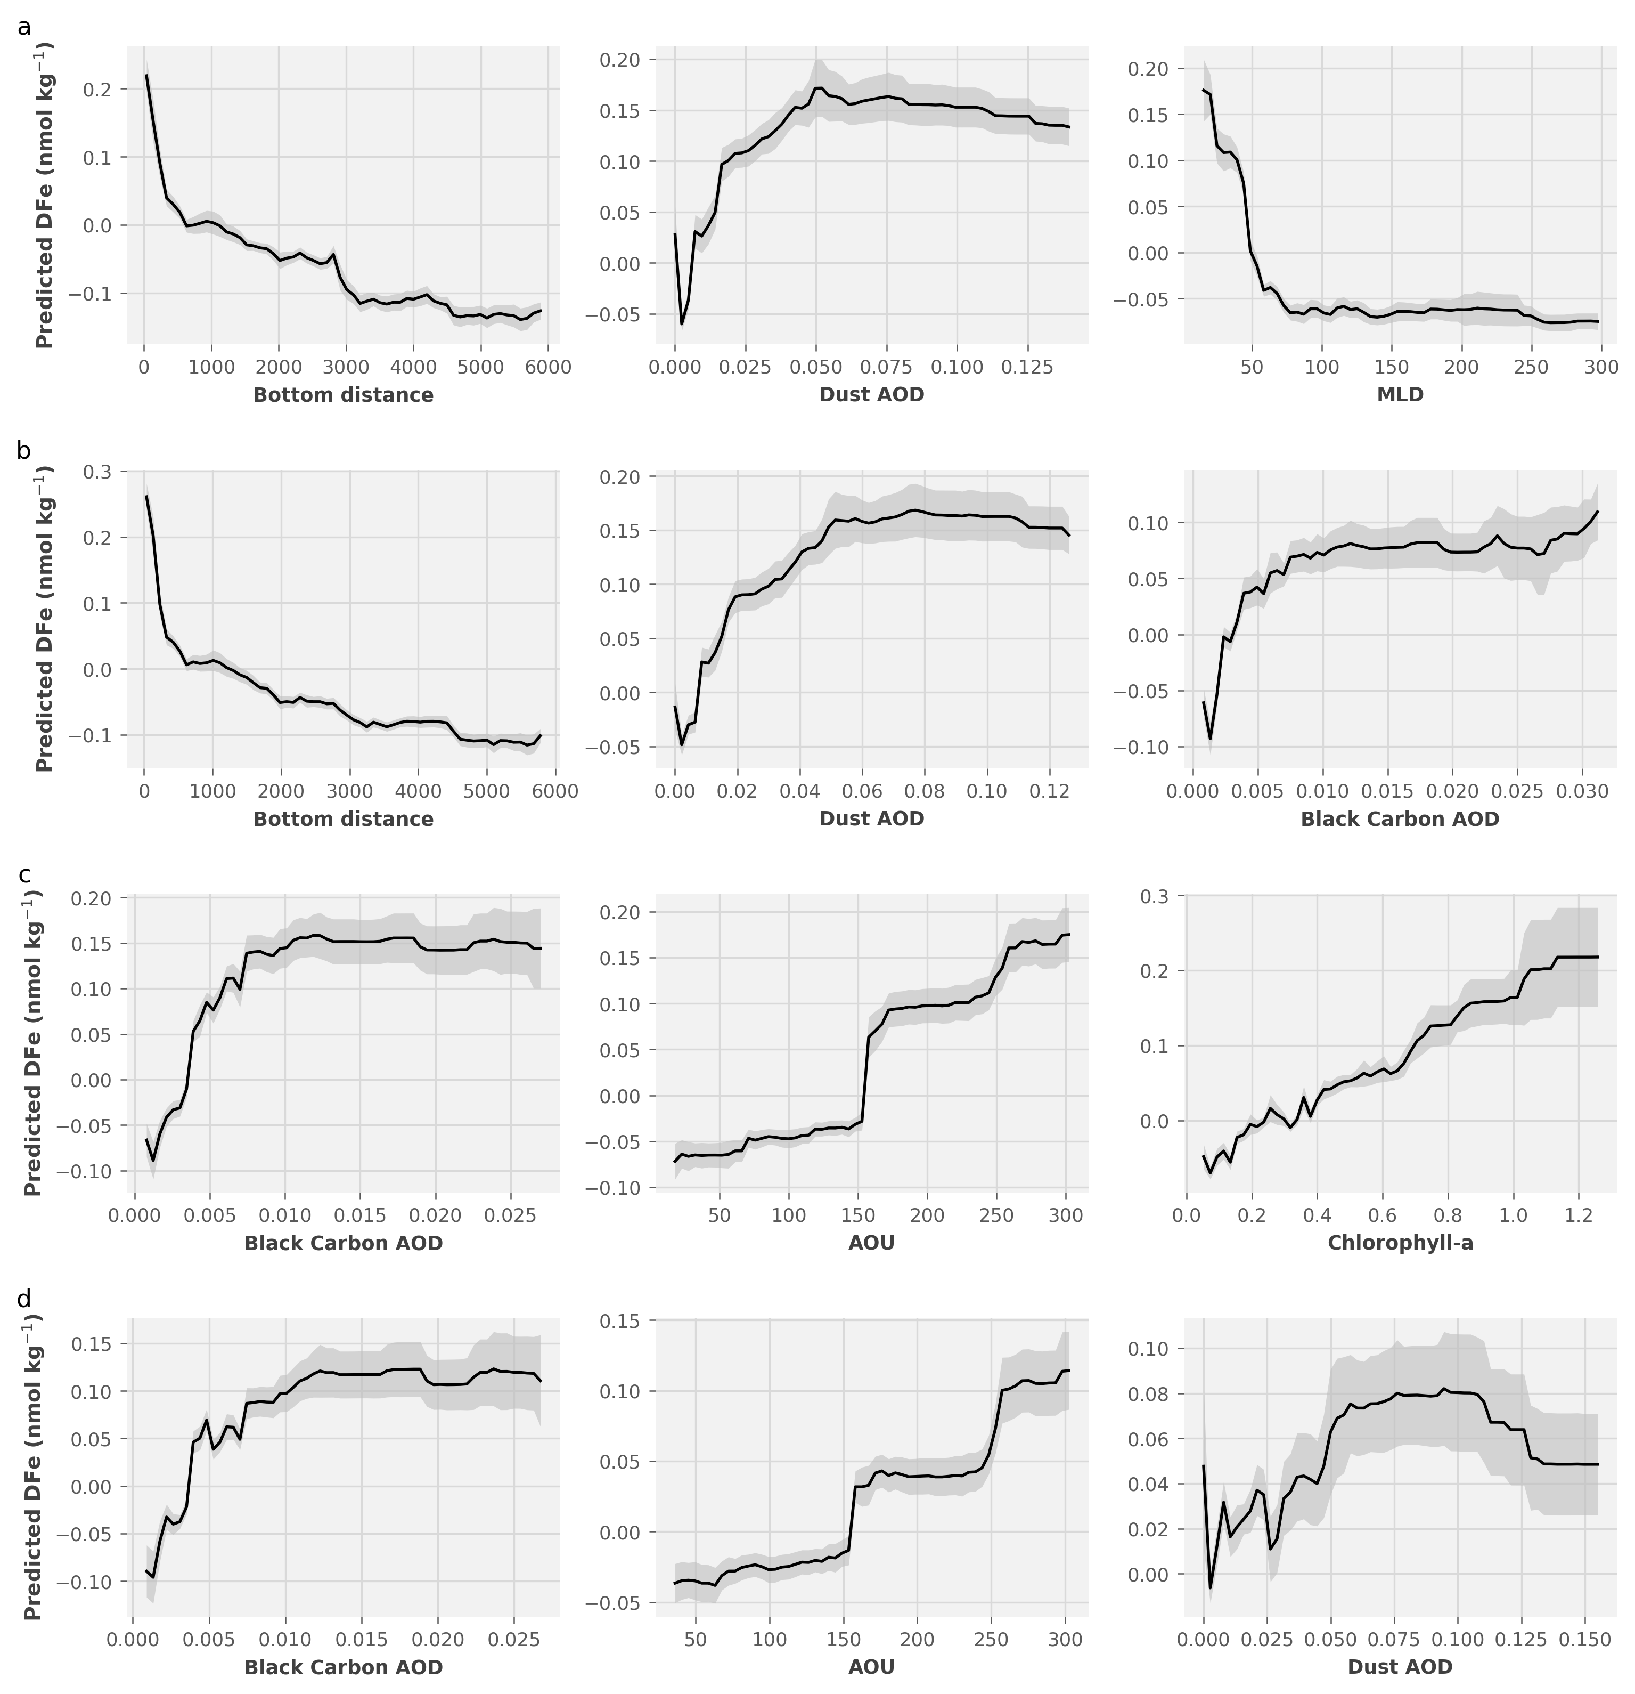
Depth-dependent conditional prediction profiles of the dominant environmental controls on dissolved Fe concentrations predicted by the ensemble model. Results are shown for (a) surface waters (0–10 m), (b) the epipelagic zone (10–200 m), (c) the mesopelagic zone (200–1000 m), and (d) the bathypelagic zone (>1000 m). For each depth interval, conditional prediction profiles are presented for the three predictors with the highest permutation importance. Black lines show the dissolved Fe response predicted by XGBoost, Random Forest and LightGBM ensemble models as each predictor varies, whereas gray envelopes represent the associated prediction variability. Predicted dissolved Fe concentrations are expressed in nmol kg⁻¹.

Supplementary Fig.5
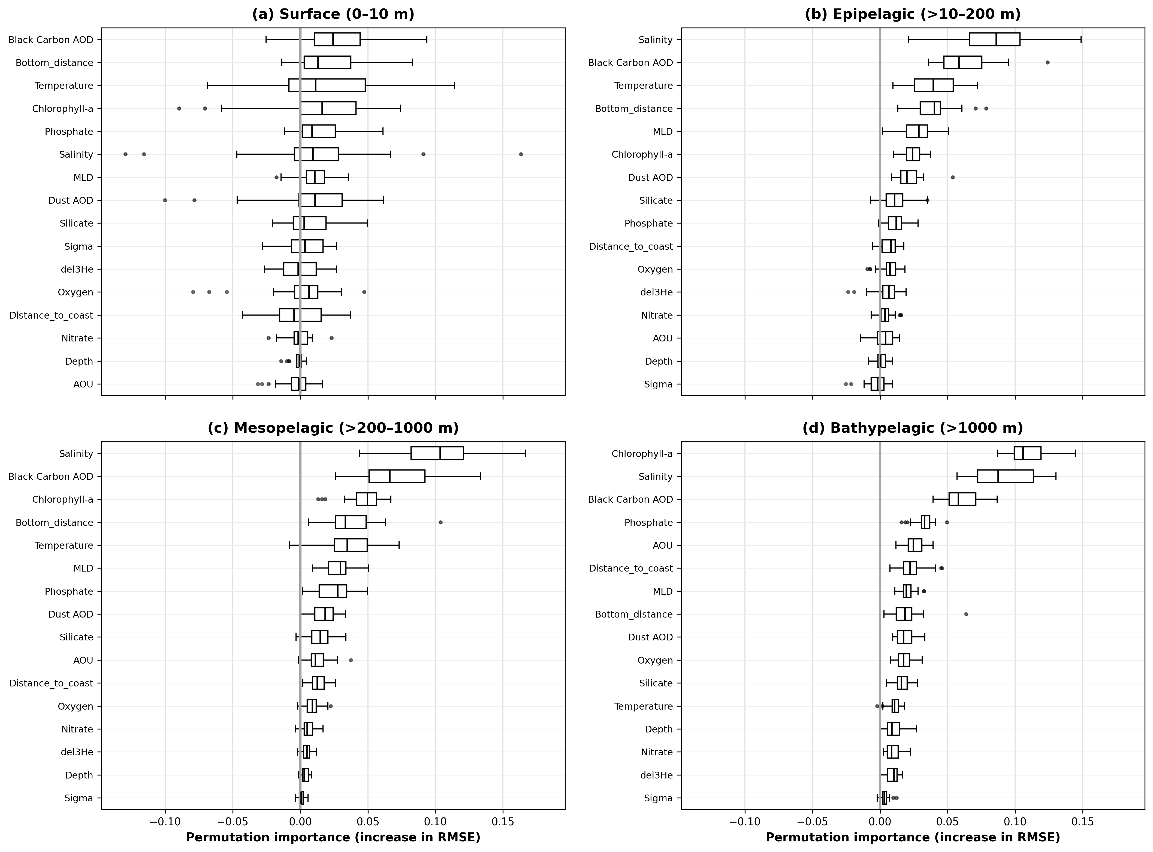
Depth-dependent permutation importance of environmental predictors for ensemble-model predictions of dissolved δ⁵⁶Fe. Predictor importance was quantified as the increase in root mean square error (RMSE) after randomly permuting each predictor in the ensemble of XGBoost, Random Forest and LightGBM models. Results are shown for four depth intervals: (a) surface waters (0–10 m), (b) the epipelagic zone (10–200 m), (c) the mesopelagic zone (200–1000 m), and (d) the bathypelagic zone (>1000 m). Predictors within each panel are ordered by their median permutation importance. Larger positive increases in RMSE indicate a greater contribution of the predictor to model performance, whereas values close to or below zero indicate limited predictive importance. Boxes represent the interquartile range, central lines indicate medians, whiskers extend to 1.5 times the interquartile range, and points denote outliers. Changes in RMSE are expressed in per mil (‰) δ⁵⁶Fe units.

Supplementary Fig.6
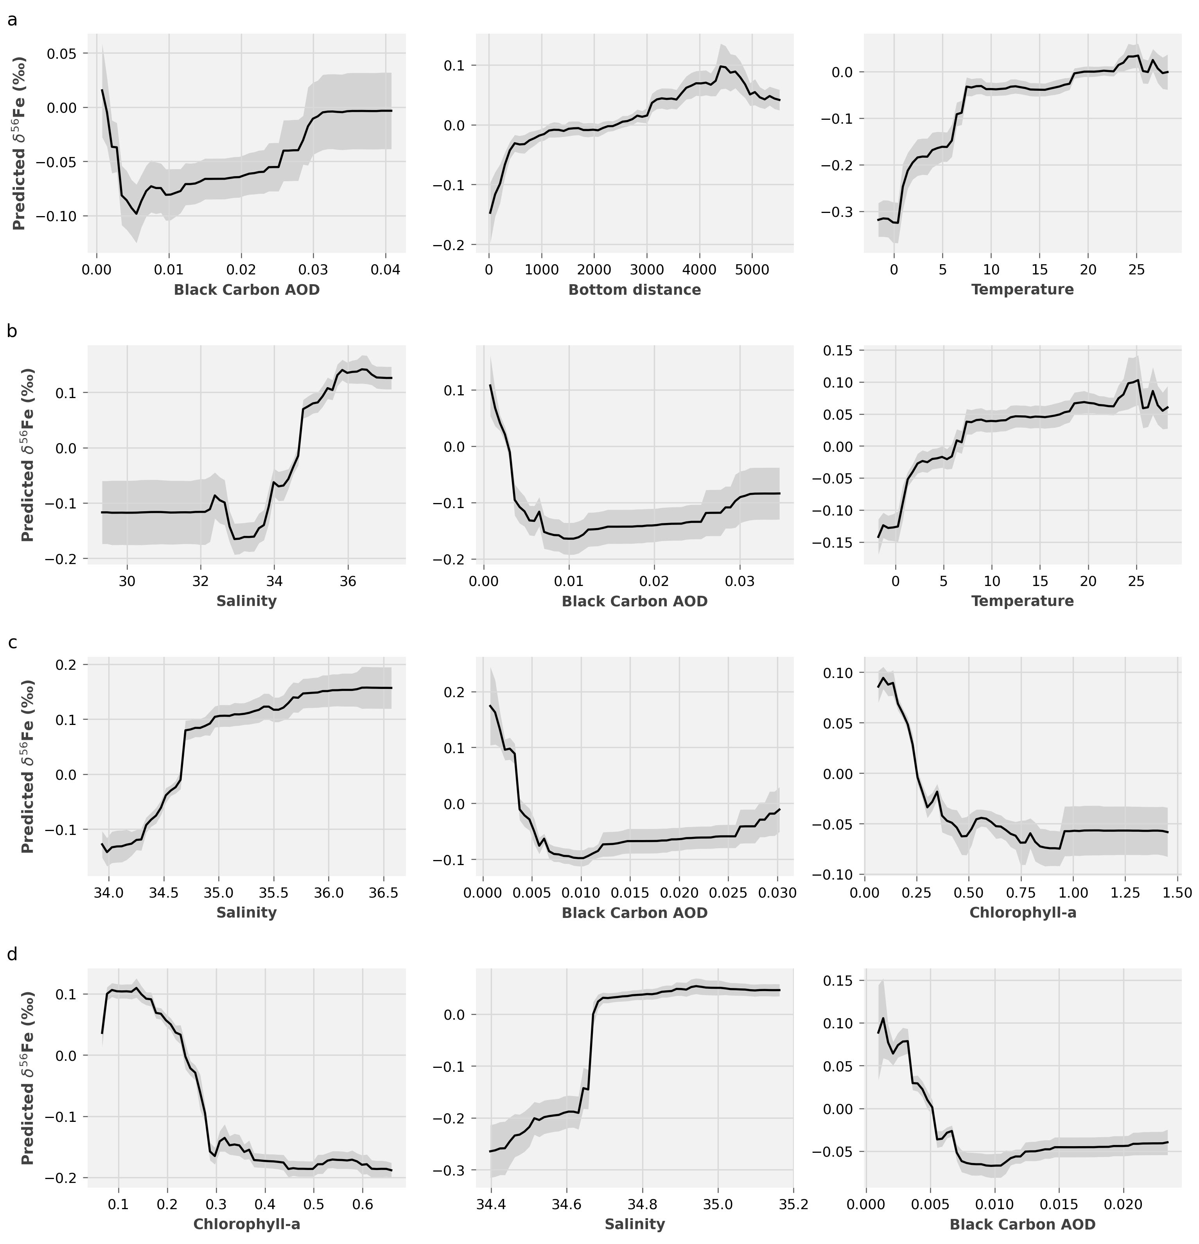
Depth-dependent conditional prediction profiles of the principal environmental controls on dissolved δ⁵⁶Fe predicted by the ensemble model. Results are shown for (a) surface waters (0–10 m), (b) the epipelagic zone (10–200 m), (c) the mesopelagic zone (200–1000 m), and (d) the bathypelagic zone (>1000 m). For each depth interval, profiles are presented for the three predictors with the highest permutation importance. Black lines show the ensemble-predicted δ⁵⁶Fe response as each predictor varies, while the other predictors are held at their observed values; gray envelopes indicate the associated prediction uncertainty. The ensemble combines predictions from XGBoost, Random Forest and LightGBM.

Supplementary Fig.7
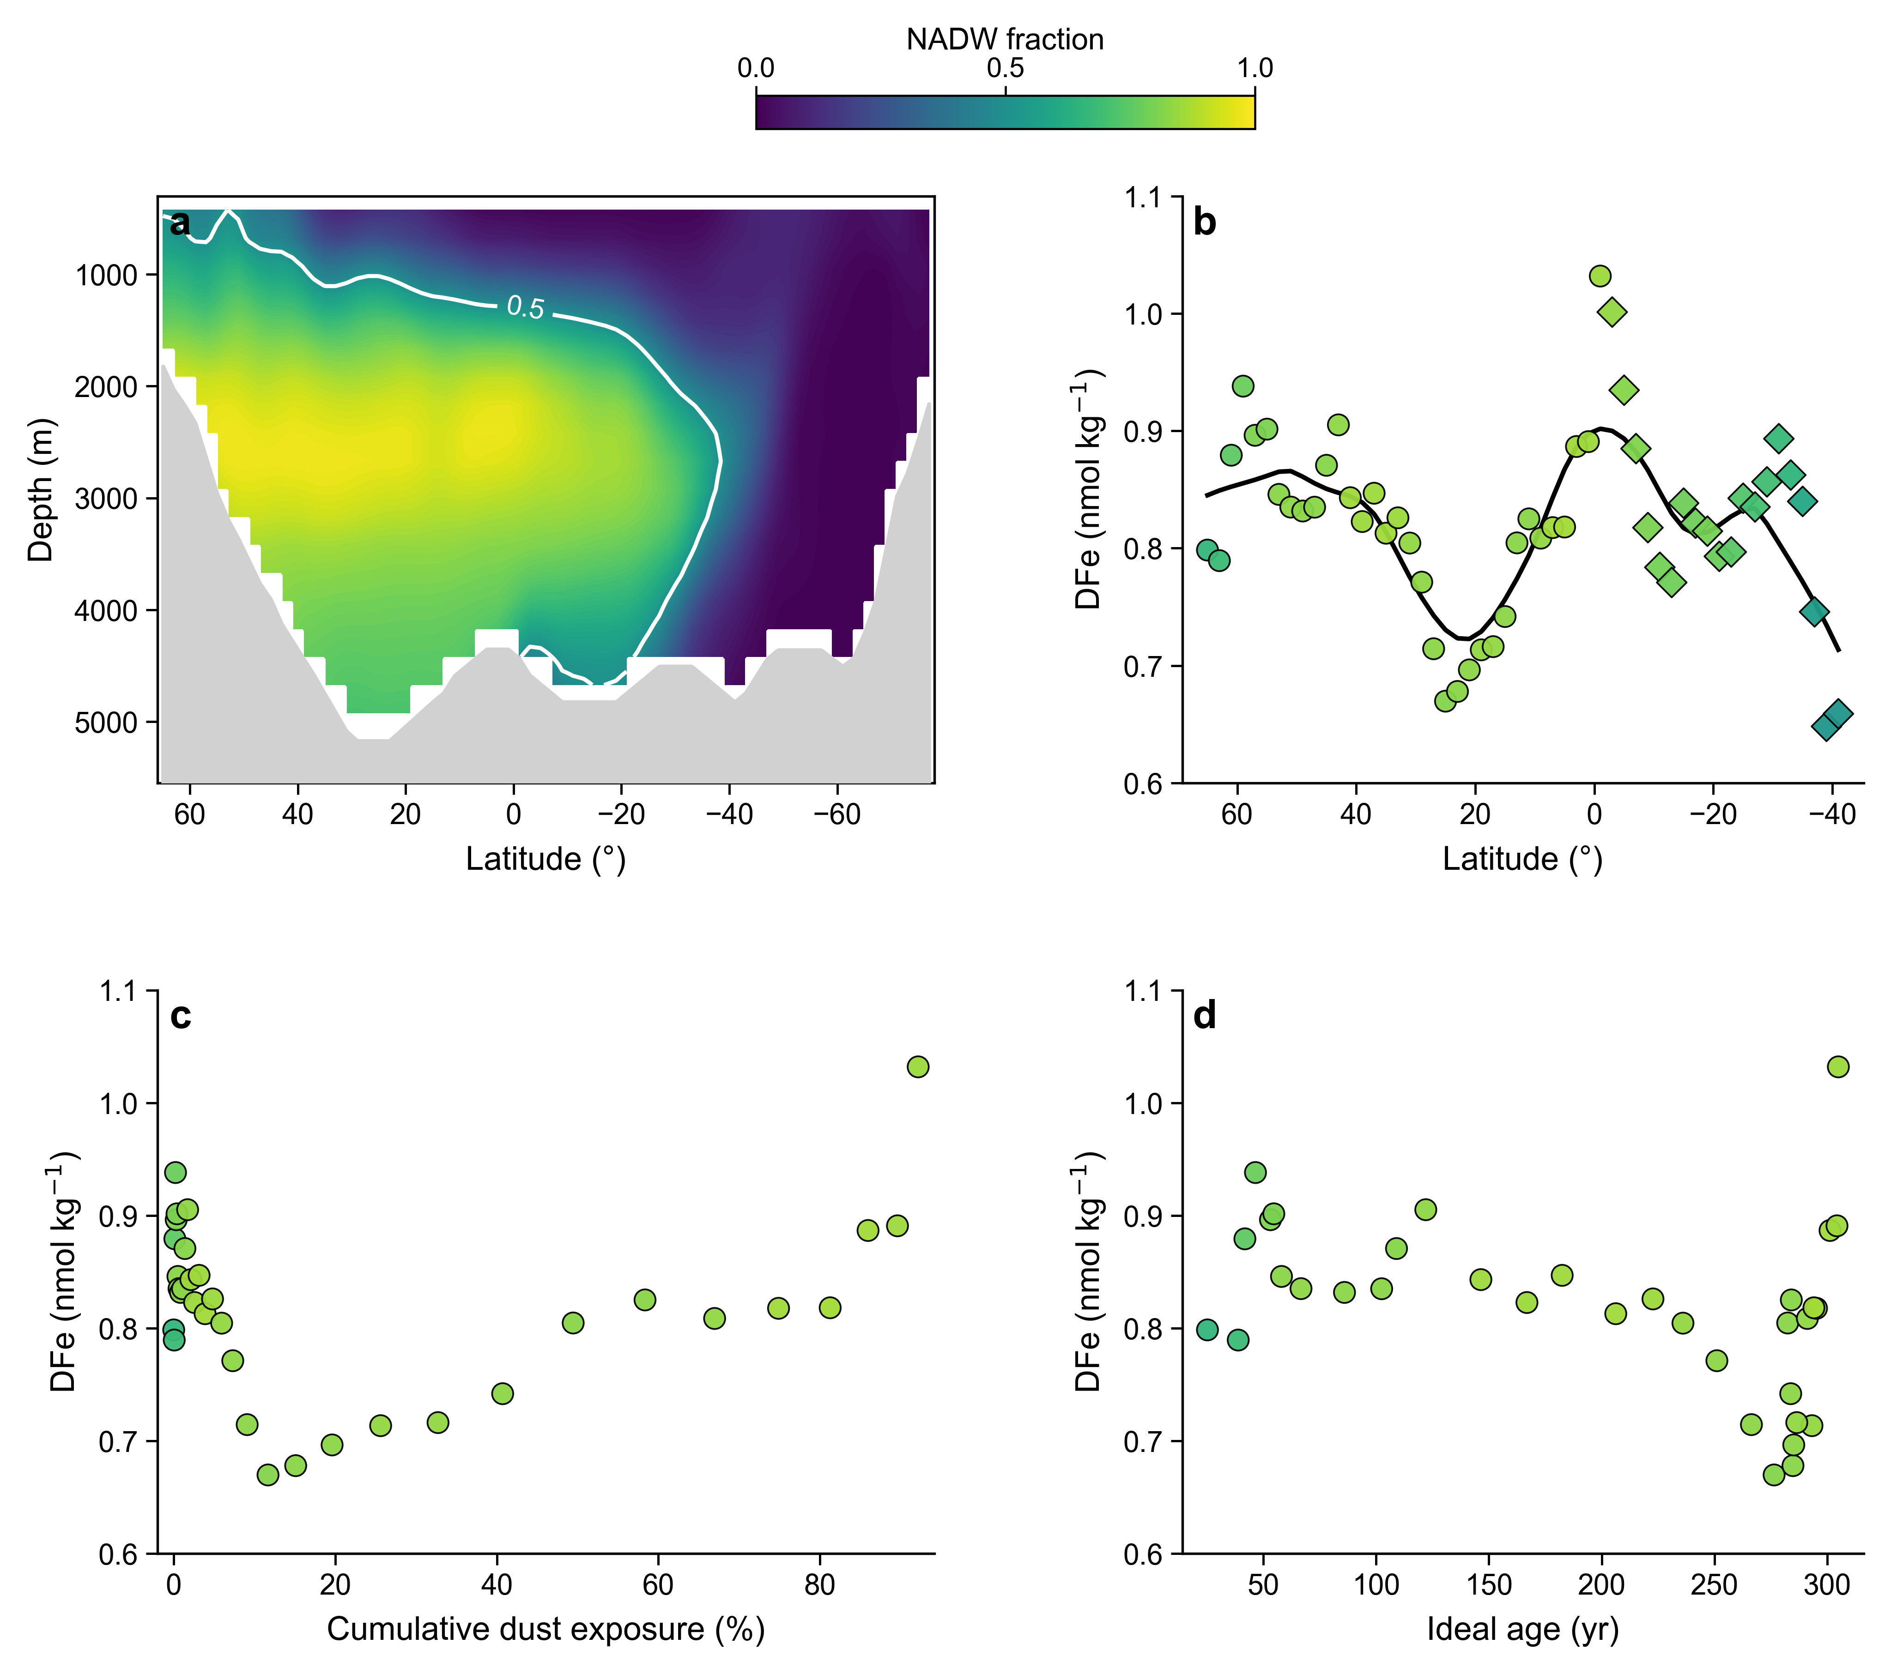
Dissolved Fe concentration along the NADW pathway. (a) Latitude–depth distribution of the North Atlantic Deep Water (NADW) fraction in the Atlantic Ocean, with the white contour marking a NADW fraction of 0.5. (b) DFe concentrations along the NADW pathway as a function of latitude; the black curve shows the smoothed along-pathway trend. (c) DFe concentration as a function of cumulative dust exposure along the pathway. (d) DFe concentration as a function of ideal age along the NADW pathway. The weak and non-monotonic variation in DFe contrasts with the more systematic evolution of δ⁵⁶DFe along the same pathway.

Supplementary Fig.8
Global distribution and basin-scale zonal structure of preformed dFe calculated by the OCIM model. The upper panels show the global distributions of preformed dFe at depths of 10, 1000, 2500, and 4000 m. The lower panels show zonal-averaged meridional sections of preformed dFe in the Atlantic, Pacific, and Indian oceans as functions of latitude and depth. Contour lines indicate spatial gradients in preformed Fe concentration. Preformed dFe concentrations are expressed in nmol kg⁻¹.

Supplementary Fig.9
Global distribution and basin-scale zonal structure of preformed δ⁵⁶Fe calculated by the OCIM model. The upper panels show the global distributions of preformed δ⁵⁶Fe at depths of 10, 1000, 2500, and 4000 m. The lower panels show zonal-averaged meridional sections of preformed δ⁵⁶Fe in the Atlantic, Pacific, and Indian oceans as functions of latitude and depth. Contour lines indicate spatial gradients in the isotopic composition. Gray areas denote land or the seafloor, whereas white areas indicate ocean regions without model estimates at the corresponding depth.

Supplementary Fig.10
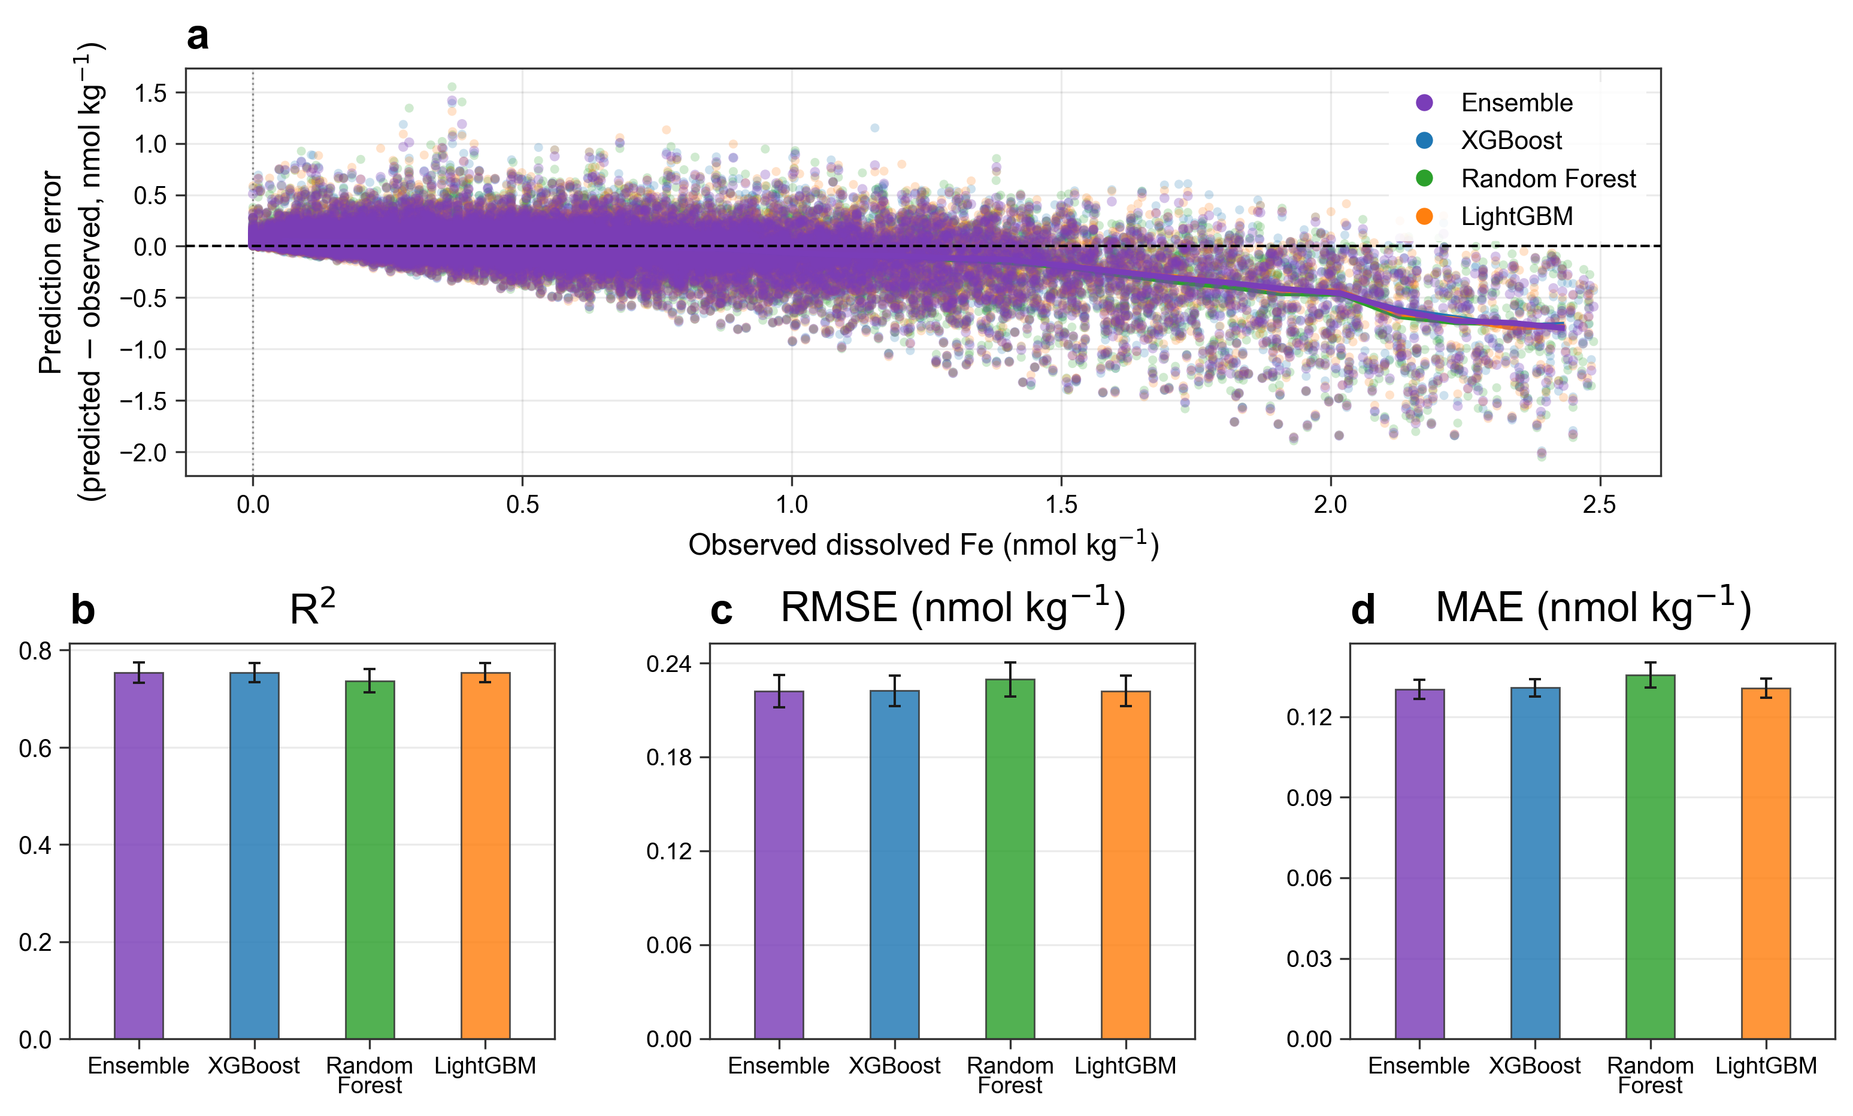
Performance of the machine-learning models in predicting dissolved Fe (dFe). (a) Prediction errors, calculated as predicted minus observed dFe, plotted against the observed dFe concentrations for the ensemble, XGBoost, Random Forest, and LightGBM models. The horizontal dashed line denotes zero prediction error. (b–d) Model performance evaluated using the coefficient of determination (R²), root mean square error (RMSE), and mean absolute error (MAE), respectively. Bars show the mean performance metrics, and error bars indicate their associated variability. RMSE and MAE are reported in nmol kg⁻¹.

Supplementary Fig.11
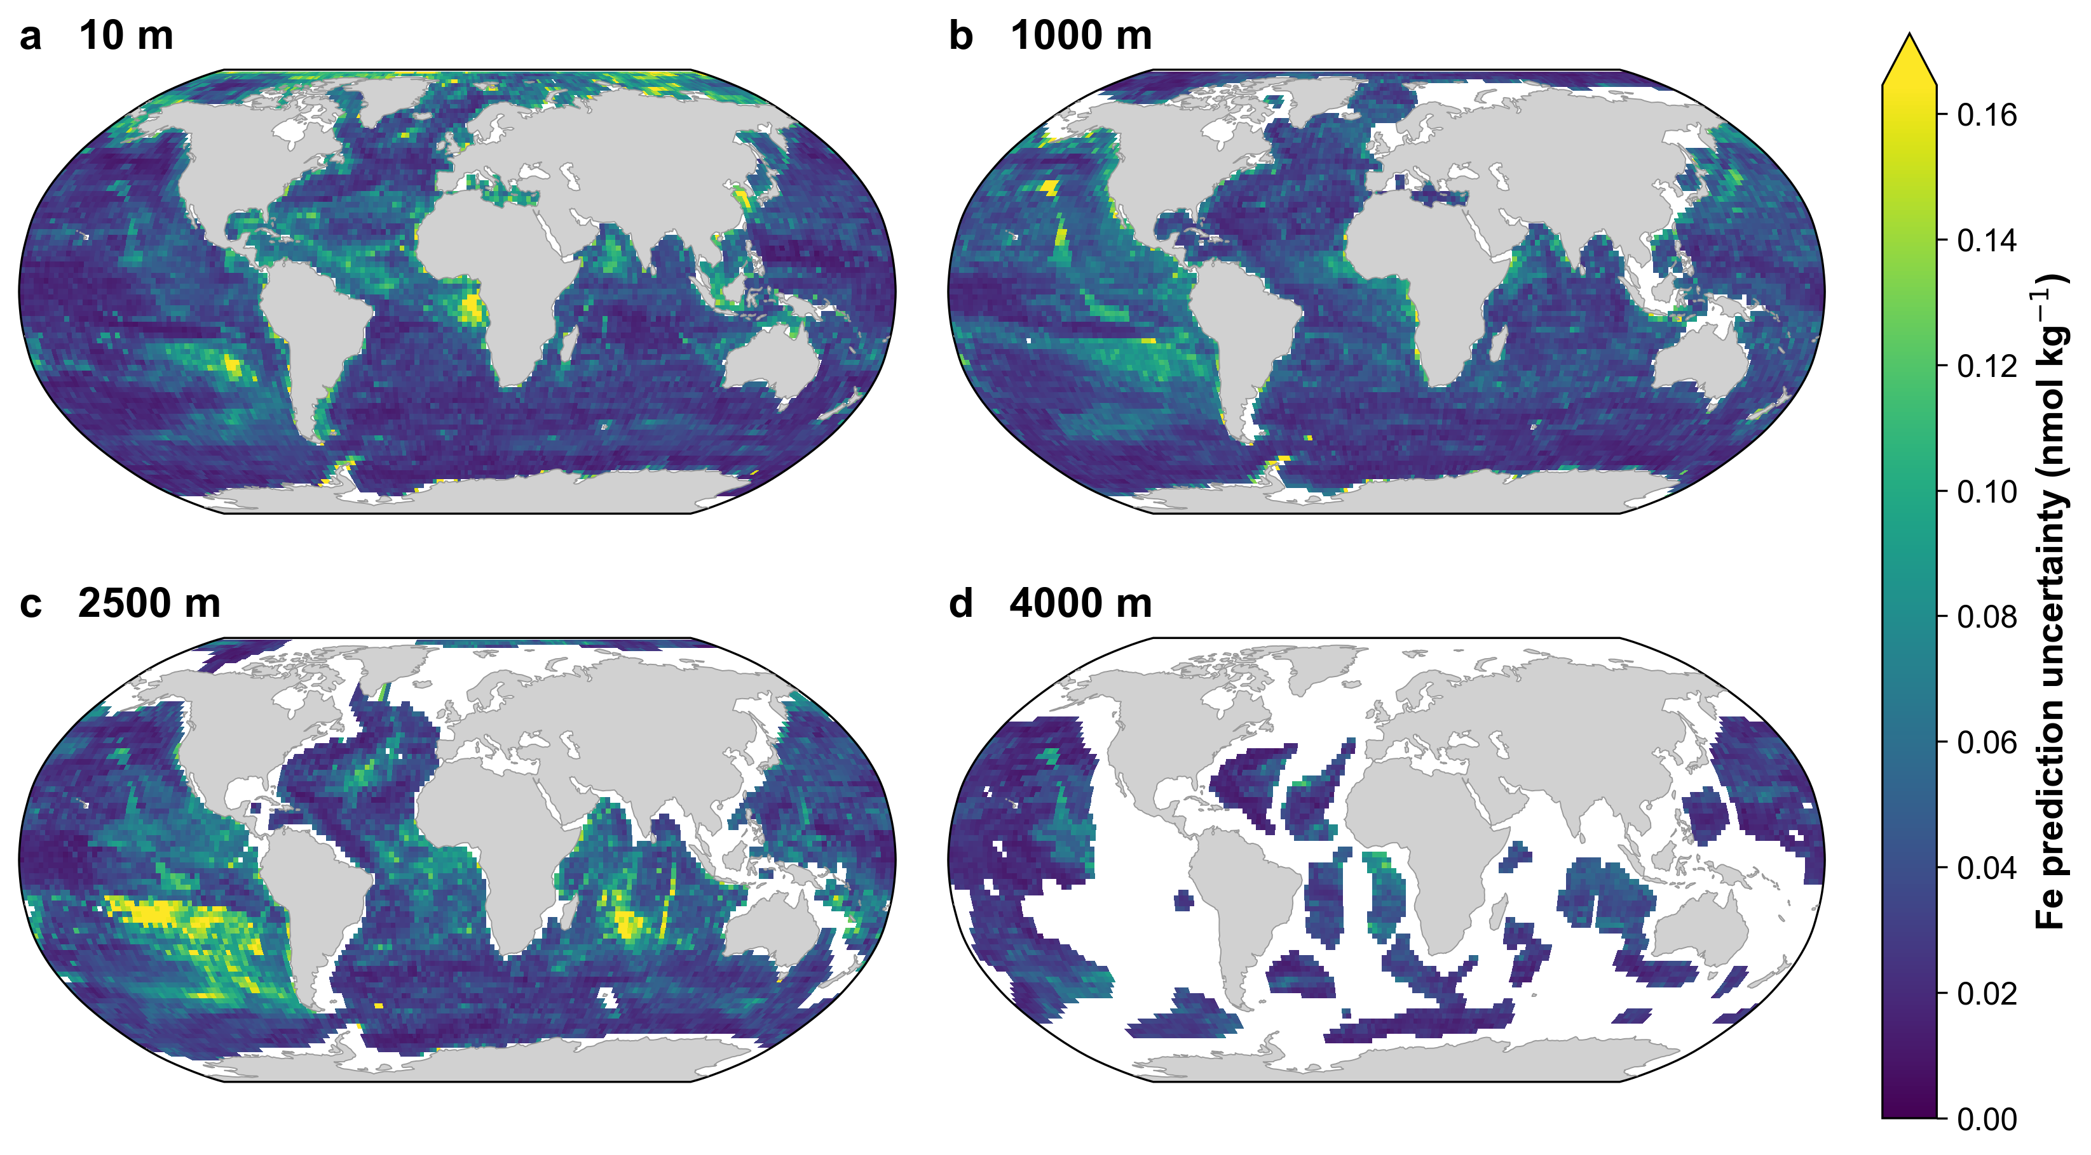
Global distribution of dFe prediction uncertainty derived from the ensemble model. The ensemble combines predictions from XGBoost and LightGBM models. Global maps show the ensemble-derived prediction uncertainty at depths of (a) 10 m, (b) 1000 m, (c) 2500 m, and (d) 4000 m. Prediction uncertainty is expressed in nmol kg⁻¹.

Supplementary Fig.12
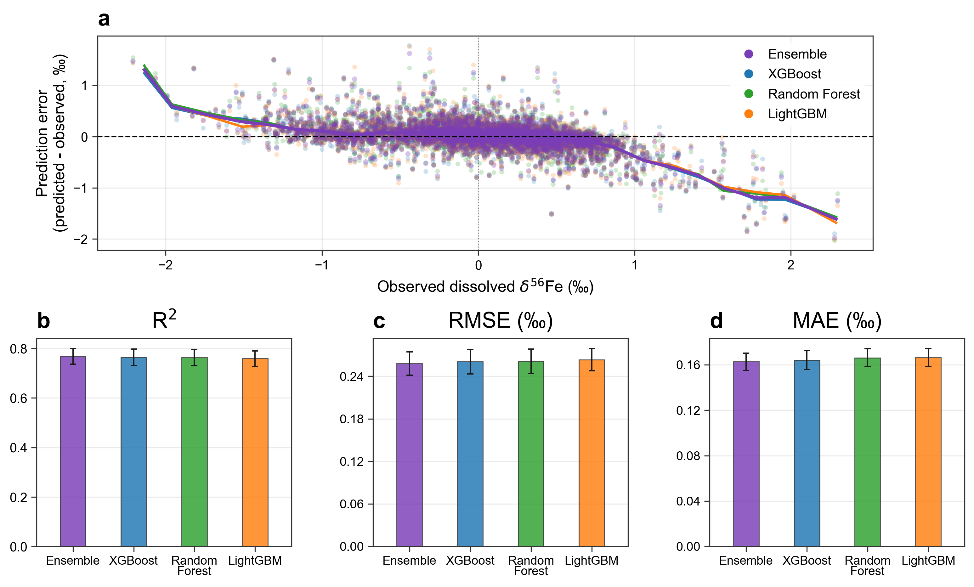
Performance of the machine-learning models in predicting dissolved iron isotope composition (δ⁵⁶Fe). (A) Prediction errors, calculated as predicted minus observed δ⁵⁶Fe, plotted against the observed δ⁵⁶Fe for the ensemble, XGBoost, Random Forest, and LightGBM models. The horizontal dashed line denotes zero prediction error. (B–D) Model performance evaluated using the coefficient of determination (R²), root mean square error (RMSE), and mean absolute error (MAE), respectively. Bars show the mean performance metrics, and error bars indicate their associated variability. RMSE and MAE are reported in permil (‰).

Supplementary Fig.13
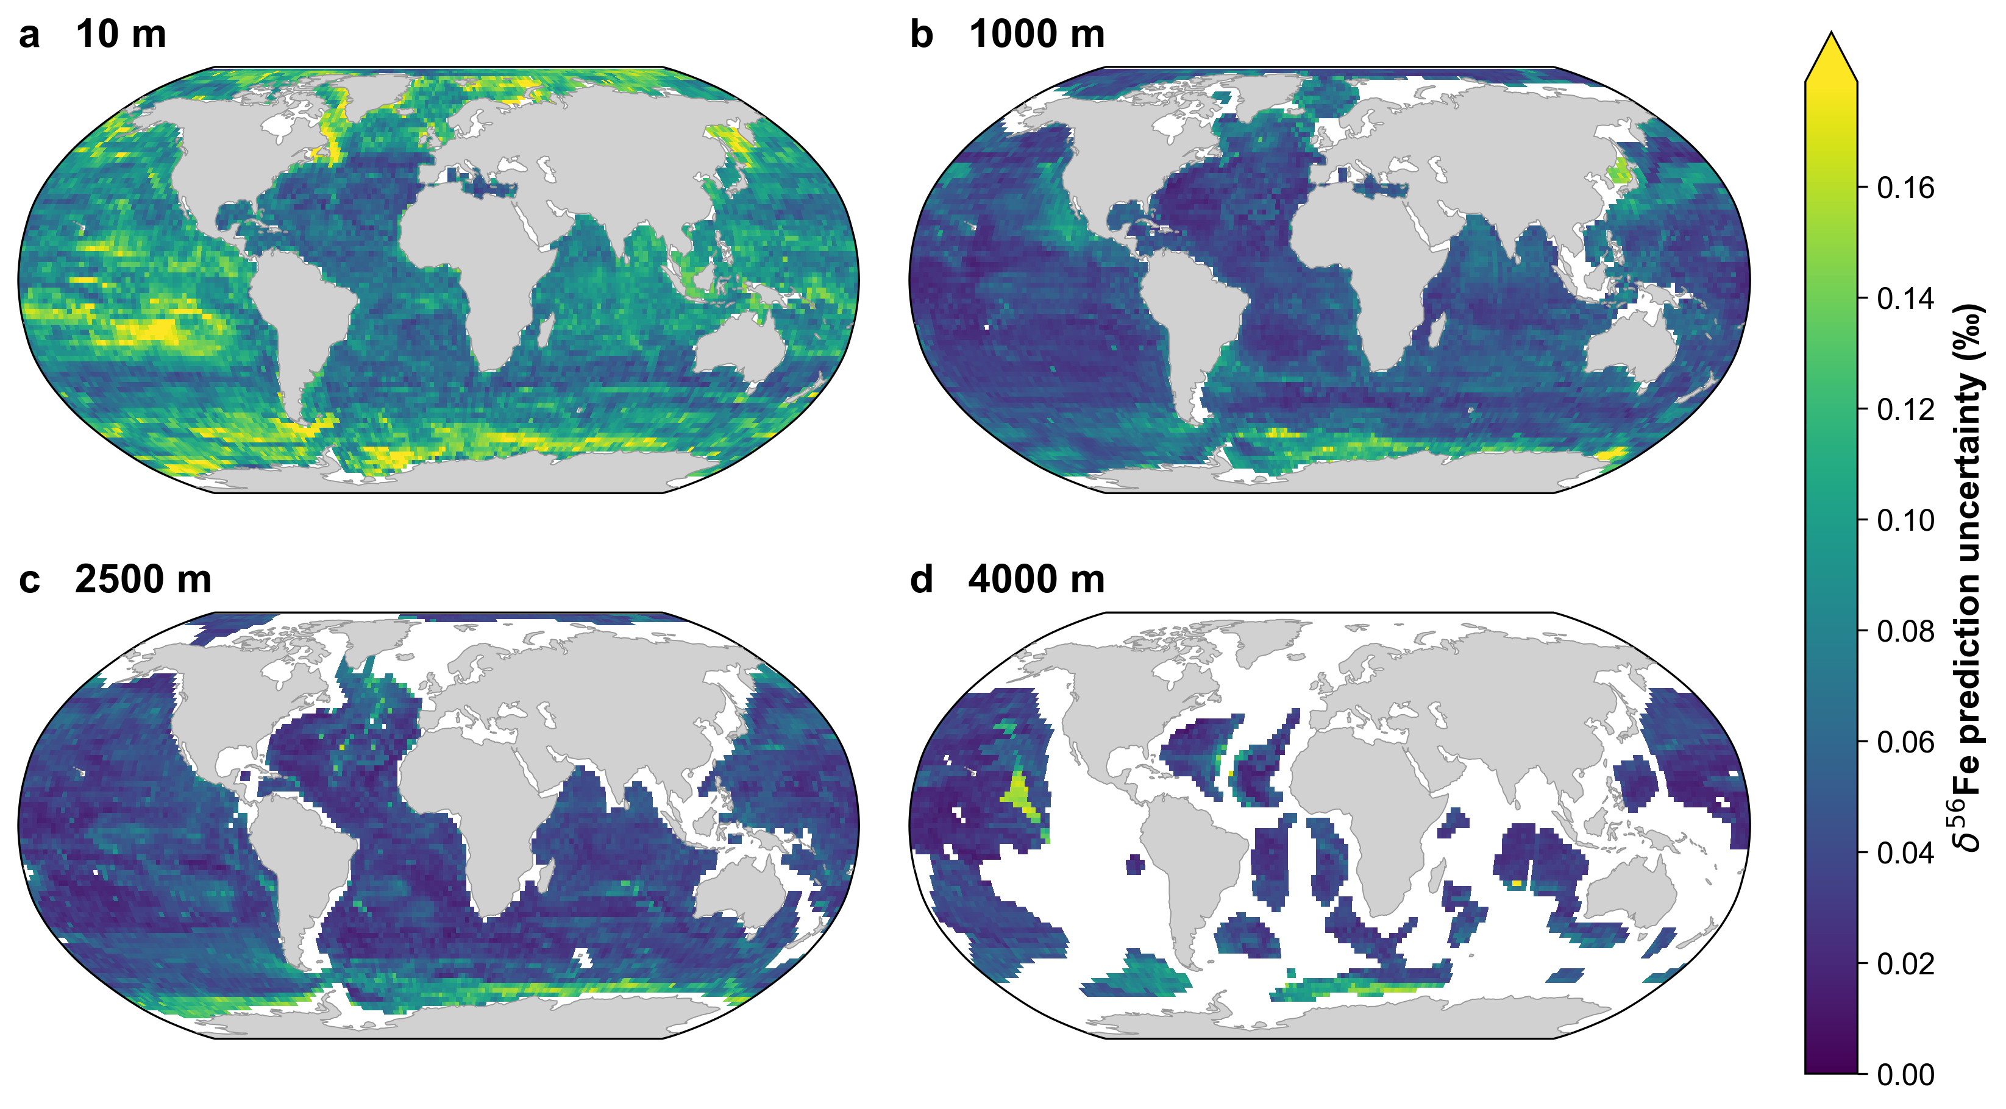
Global distribution of δ⁵⁶Fe prediction uncertainty derived from the ensemble model. The ensemble combines predictions from XGBoost, Random Forest, and LightGBM models. Global maps show the ensemble-derived prediction uncertainty at depths of (a) 10 m, (b) 1000 m, (c) 2500 m, and (d) 4000 m. Prediction uncertainty is expressed in permil (‰).

Supplementary Fig.14
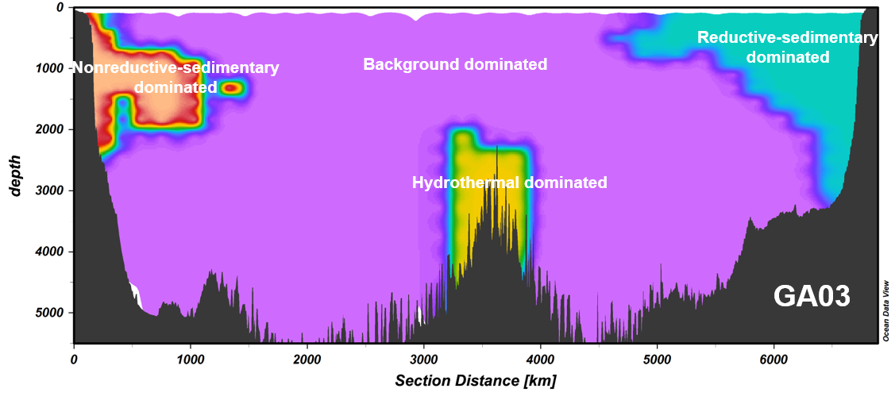
Fe source-dominated domains along the GA03 GEOTRACES transect. Colors indicate background, hydrothermal, reductive sedimentary, and non-reductive sedimentary domains identified using the classification framework described in Methods. Dark gray denotes seafloor bathymetry.

Supplementary Fig.15
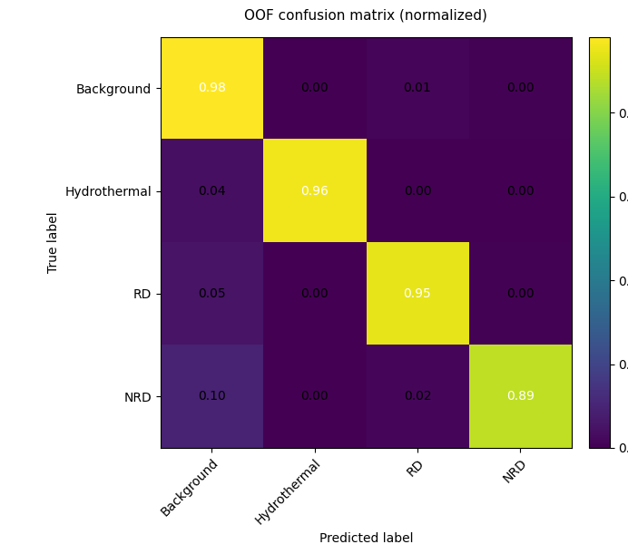
Normalized confusion matrix for independent validation of the Fe source-domain classifier. Rows represent true source-domain labels and columns represent predicted labels. Values show the proportion of samples in each true class assigned to the four source-domain categories.

