Supplementary materials for

Active Silicon-Impeded Arsenic Accumulation in Rice and Reshaped Rhizosphere Microbial Communities Enabled by Novel Rice Husk Ash

Wenjun Gong^{a,b}, Shihao Zhu^{a,b}, Jingmin Yang^{a,b}, Xin Wang^{a,b*}, Delai Zhong^{c*},

Bo Peng^{a,b}

ª School of Geographical Sciences, Hunan Normal University, Changsha 410081,China

^{b} Institute of Interdisciplinary Studies, Hunan Normal University, Changsha 410081,China

^{c} Key Laboratory of the Three Gorges Reservoir Region’s Eco-environment, Ministry of Education, College of Environment and Ecology, Chongqing University, Chongqing 400044, China

* Corresponding authors: wangxin@hunnu.edu.cn (X. Wang), delai.zhong@cqu.edu.cn (Dr. D. Z.)

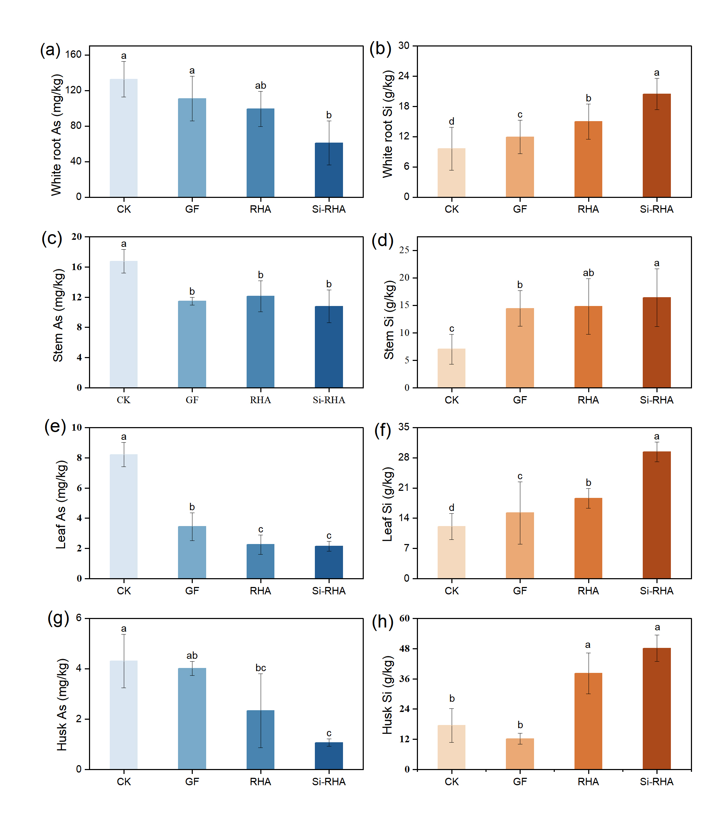

Fig. S1. Effect of Si amendments on As and Si contents in various organs of rice.
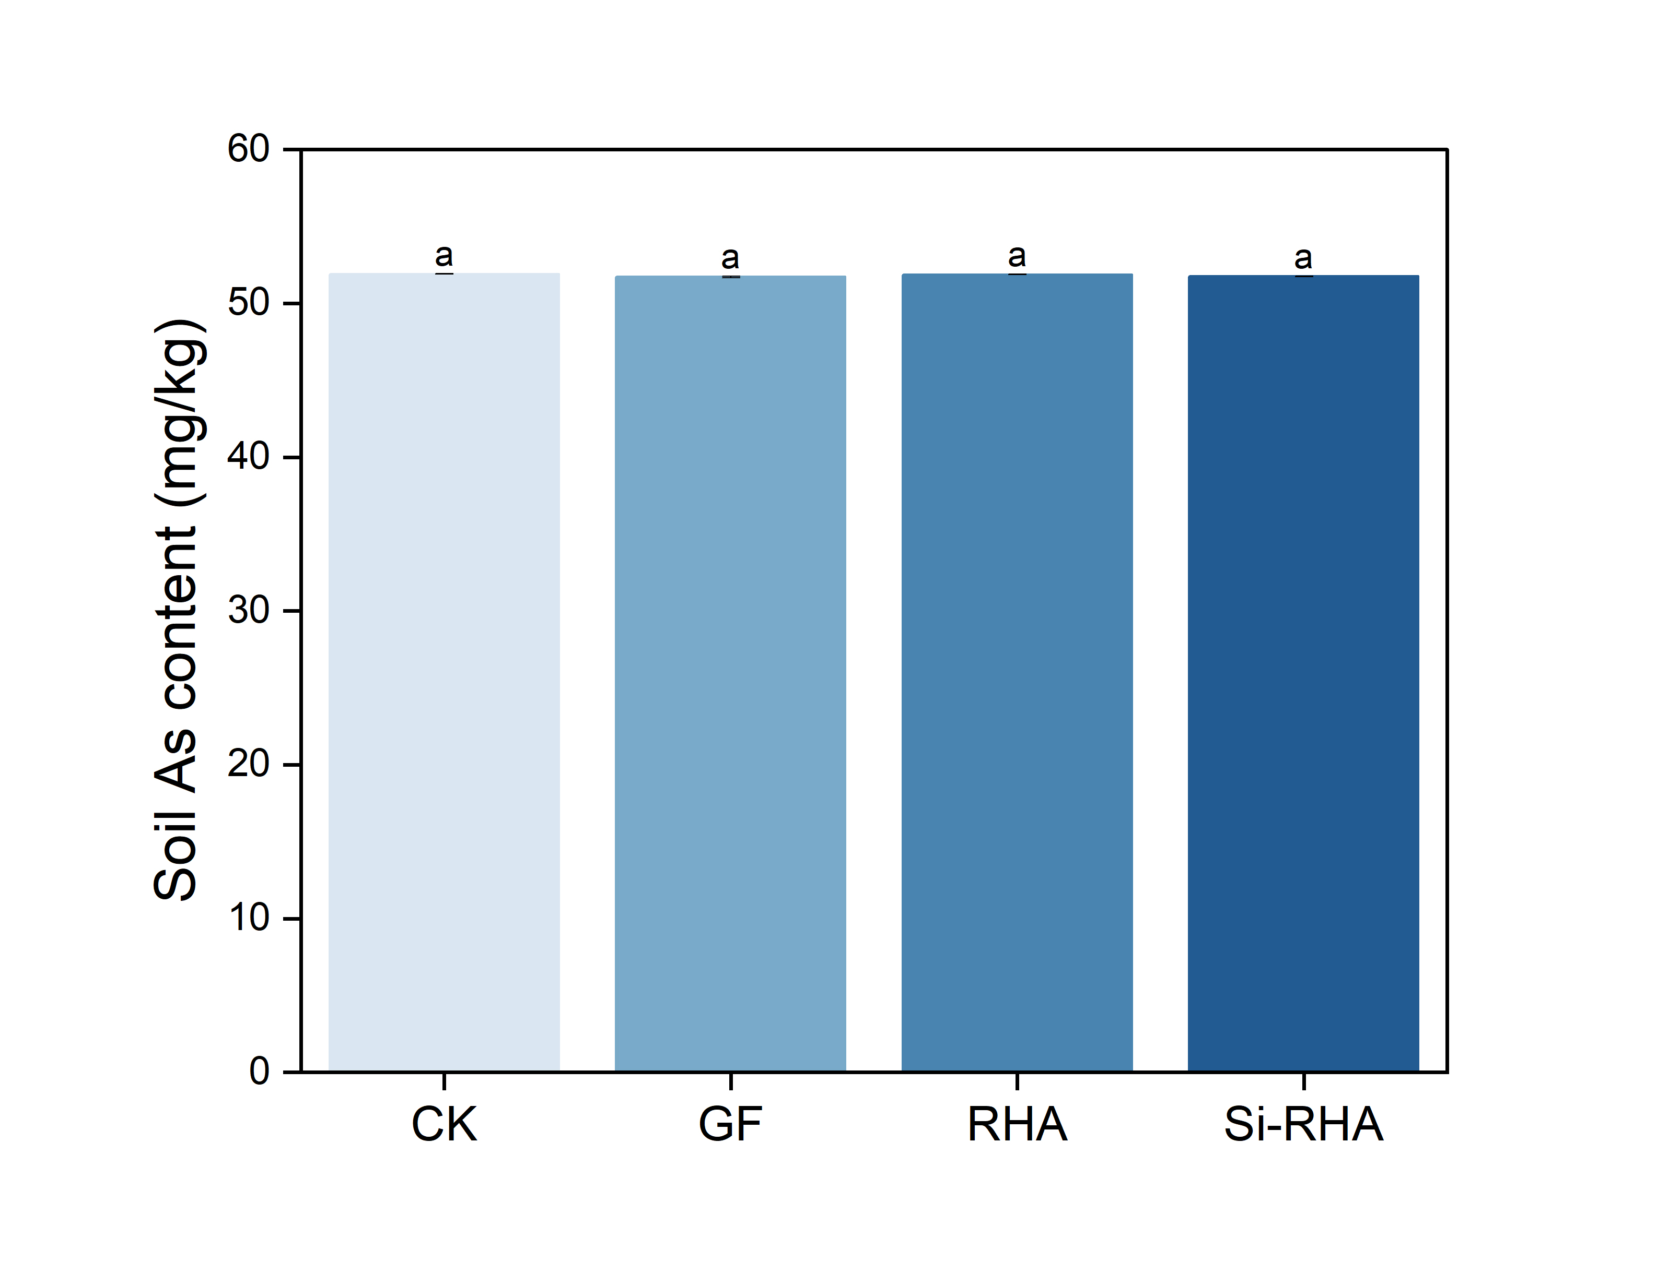

Fig. S2. Effect of Si amendments on total As content in soil.

Table S1 Basic physicochemical properties of paddy soils used in this work.
Parameter | Value
Soil pH | 5.60
Available Si (mg/kg) | 23.78
Total As (mg/kg) | 51.82
Available As (mg/kg) | 4.23
Total Fe (g/kg) | 23.68
Available Fe (g/kg) | 0.30
Total Mn (mg/kg) | 108.00
Available Mn (mg/kg) | 9.03
Total Zn (mg/kg) | 131.75
Available Zn (mg/kg) | 2.67

Table S2 Sequencing data of rhizosphere soil samples subjected to various Si amendment treatments.
Treatment | Valid sequences | OTU count
CK | 58,322 | 1,031
GF | 57,389 | 589
RHA | 55,239 | 873
Si-RHA | 56,078 | 1,087
Note: Data in the table represent the sequencing results of one representative biological replicate per treatment.

Table S3 Correlation analysis of soil effective Si and Si content in various tissues of rice.
Relevance | Soil effective Si | root Si content | Stem Si content | Leaf Si content | Si content of grain hull | Si content of brown rice
Soil effective Si | 1.000 | 0.414 | 0.439 | 0.518 | 0.741* | 0.837**
* indicates significant correlation at the P < 0.05 level. ** indicates highly significant correlation at the P <0.01 level.

Table S4 Effect of different Si amendment treatments on soil Fe activation.
Treatment | Content
CK | 0.32±0.05
GF | 0.39±0.04
RHA | 0.21±0.03
Si-RHA | 0.26±0.01

