Supplemental Material

Table S1: Reference genomes used in this study
Species | Bioproject | Accession | Reference
Exaiptasia pallida | PRJNA261862 | GCA_001417965.1 | (Baumgarten et al. 2015)
Acropora millepora | PRJNA633778 | GCA_013753865.1 | (Fuller et al. 2020)
Bombus terrestris | PRJNA45869 | GCA_000214255.1 | (Sadd et al. 2015)
Ceratina calcarata | PRJNA299559 | GCA_001652005.1 | (Rehan et al. 2016)
Ooceraea biroi | PRJNA420369 | GCA_003672135.1 | (McKenzie and Kronauer 2018)
Bombyx mori | PRJDA20217 | GCF_000151625.1 | (Xia et al. 2008)
Stylophora pistillata | PRJDA20217 | GCA_002571385.1 | (Voolstra et al. 2017)

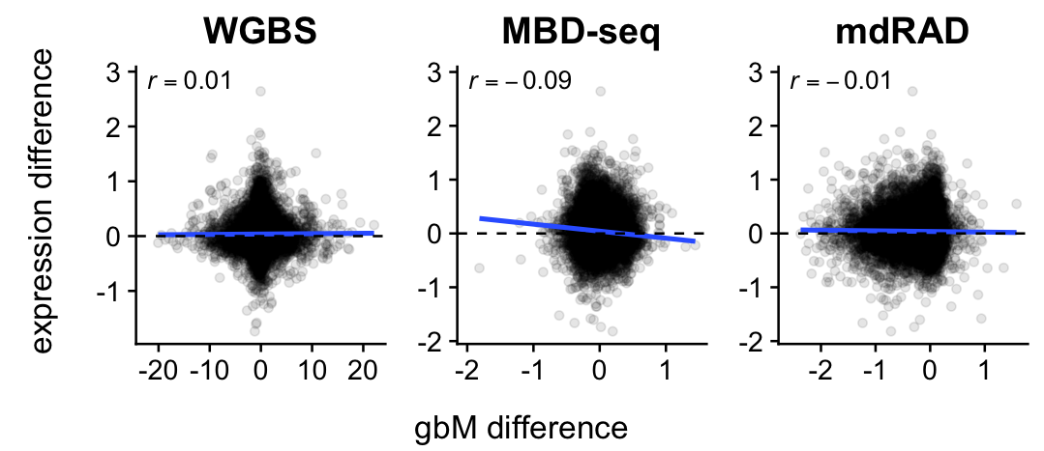
Figure S1: gbM and transcriptional differences between polyp types in A. millepora show no reproducible relationship. The title of each panel indicates the assay used to measure gbM differences. All axes are on the log₂ scale.

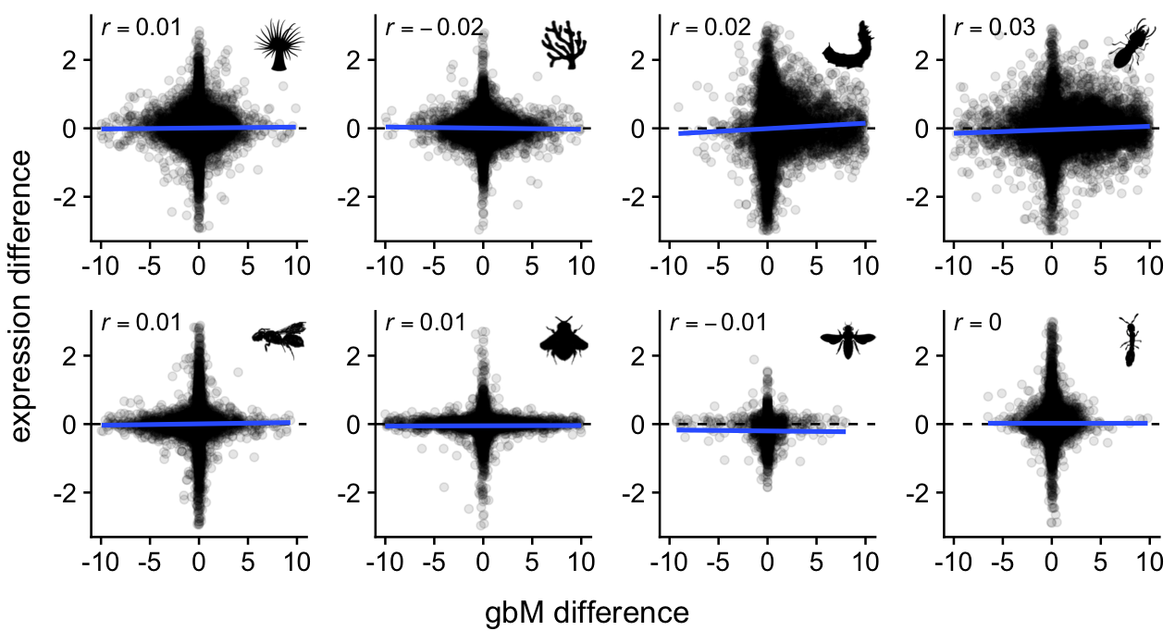
Figure S2: gbM and transcriptional differences between experimental conditions show little or no relationship. The contrasts for each study are given in Figure 1. All axes are on the log₂ scale.

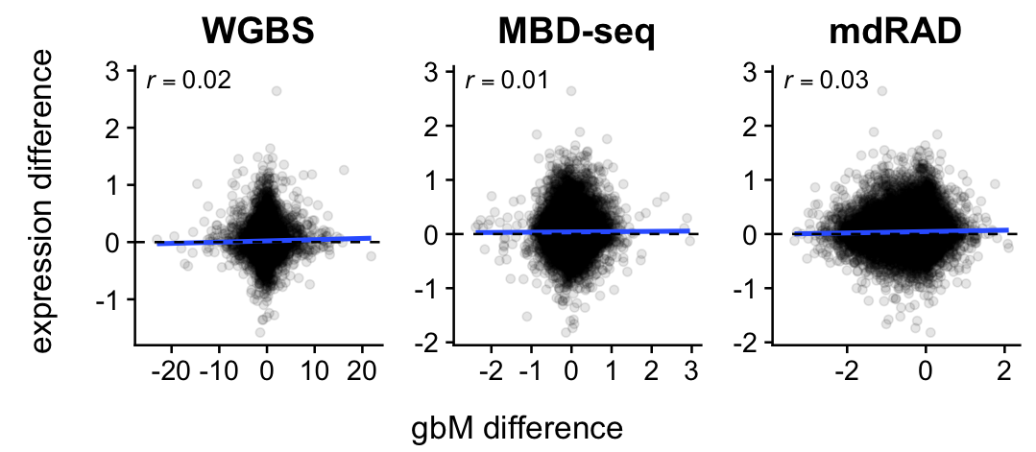
Figure S3: Promoter methylation and transcriptional differences between polyp types in A. millepora show no relationship.

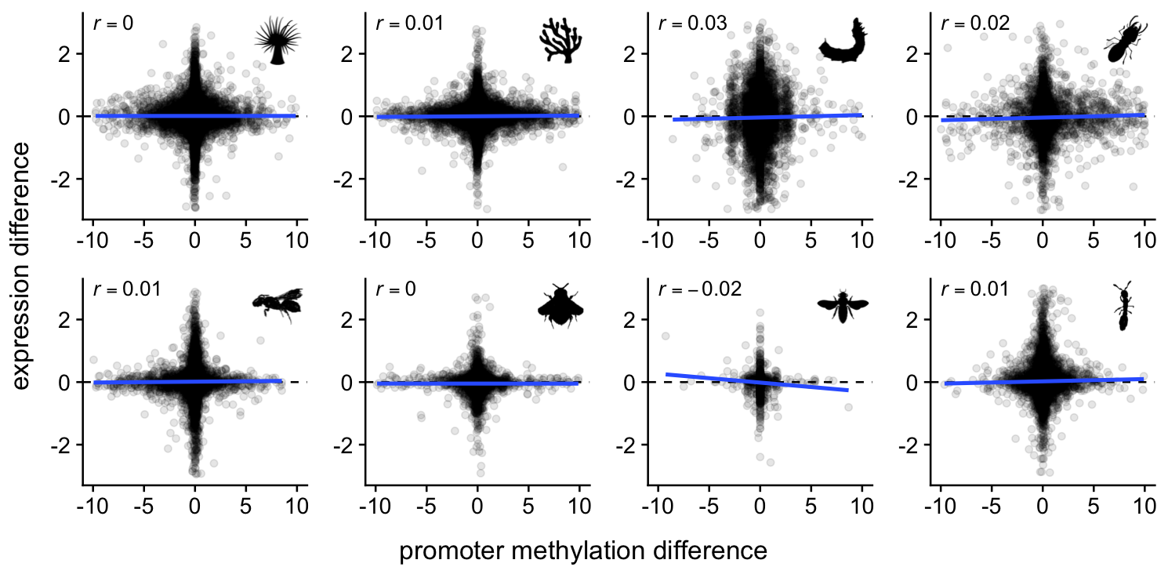
Figure S4: Promoter methylation and transcriptional differences between experimental conditions show no relationship.
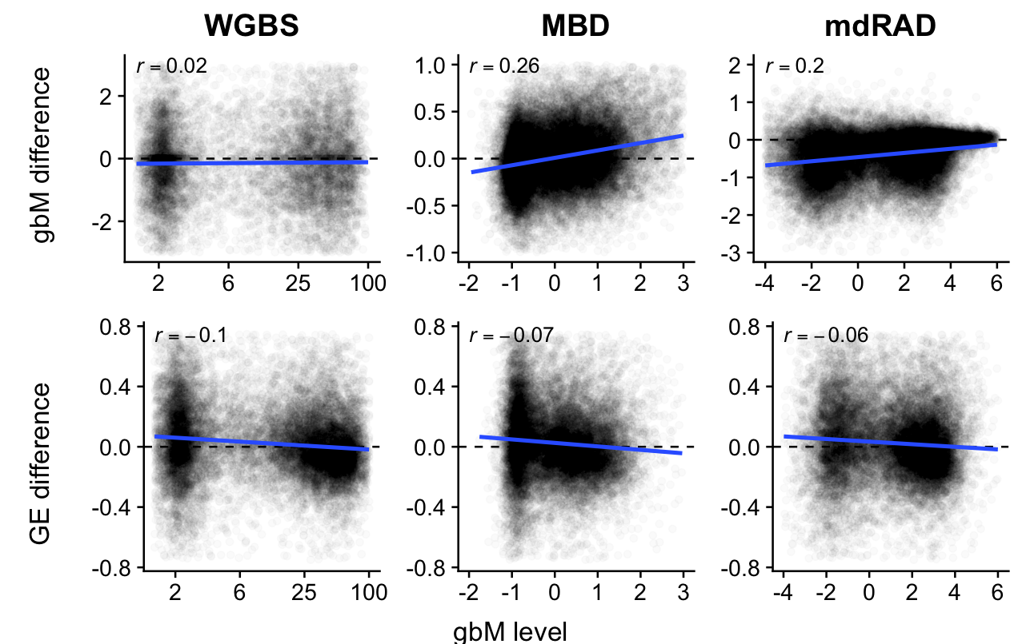
Figure S5: Relationships between differential gbM and gene expression between A. millepora polyp types and baseline gbM level. X axes show baseline gbM level. Y axes shows differential gbM between polyp types (top panels) and differential transcription between polyp types (bottom panels). Top panels: Differential gbM between polyp types was linked with baseline gbM level for the MBD-seq and mdRAD datasets, but not for WGBS. Bottom panels: For all three methylation datasets, the low gbM class of genes was somewhat upregulated in axial compared to radial polyps, and the high gbM class was somewhat downregulated.
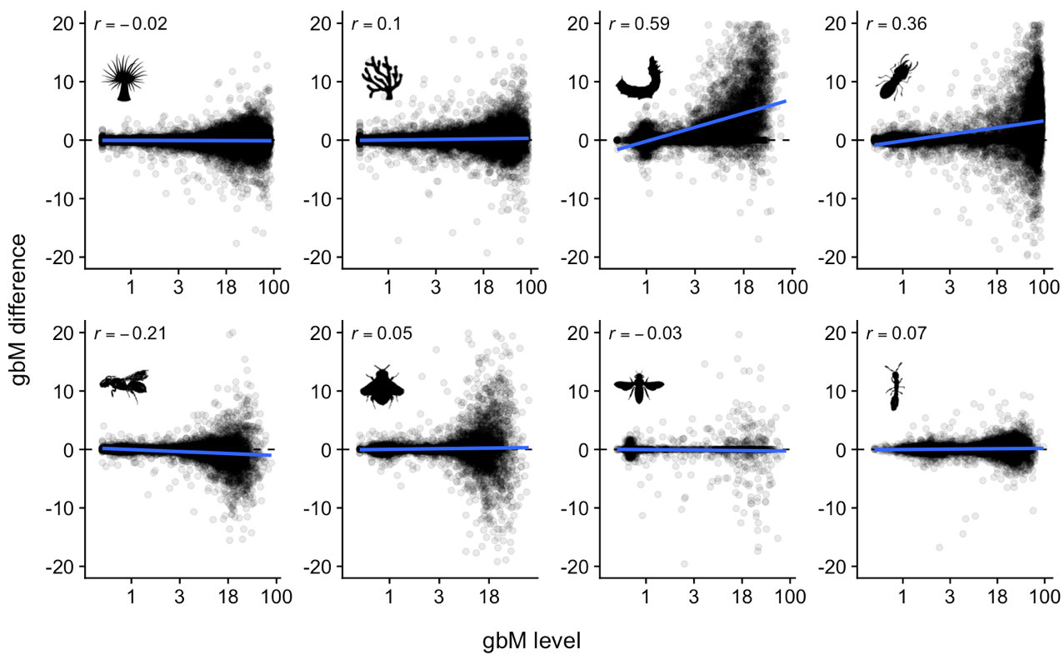
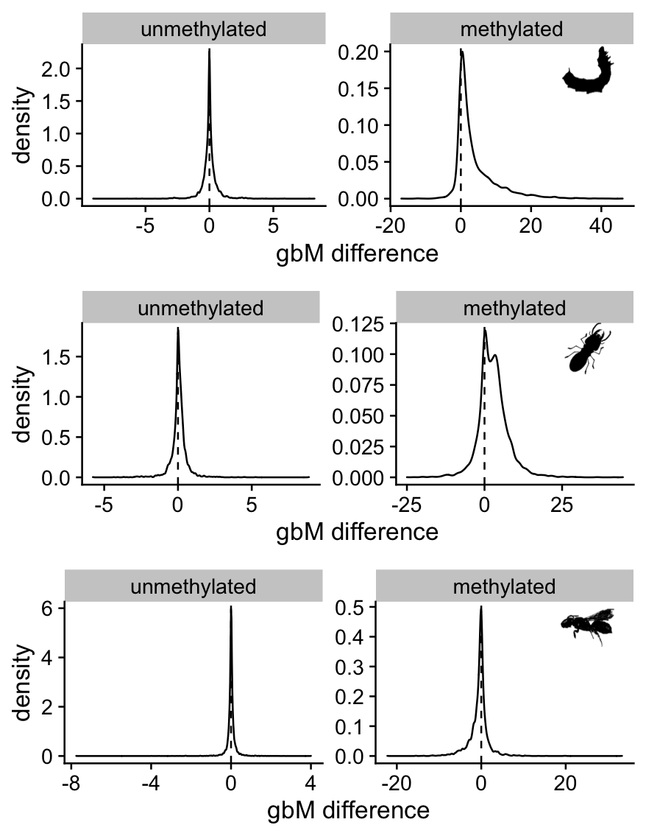
Figure S6: Scatterplots of gbM change against mean gbM level. Only three studies (Silkworm, Termite, and Carpenter bee) showed changes in methylation between conditions based on gbM class. Density plots of methylation change for the two classes show the change was specific to the high gbM class.
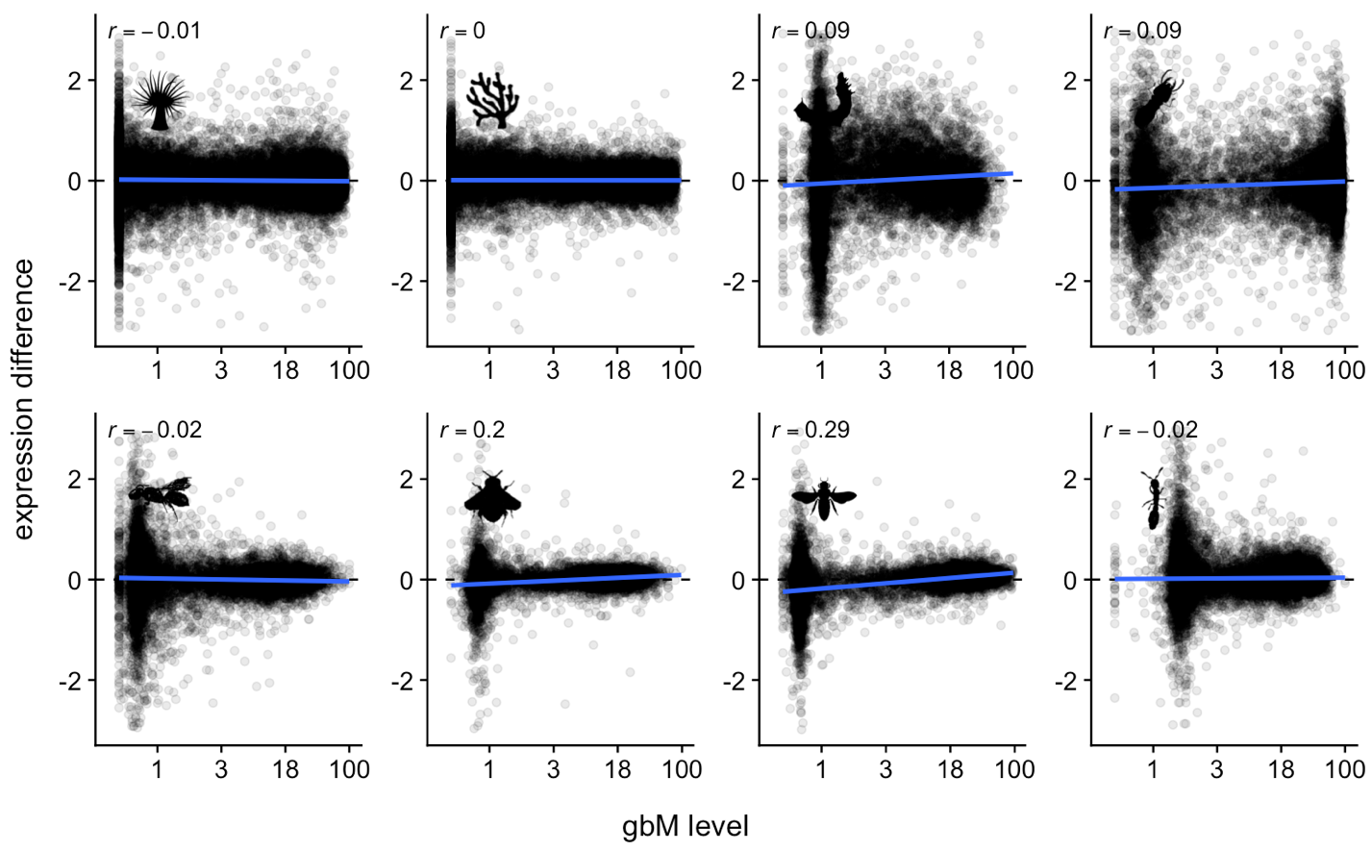
Figure S7: Scatterplots of transcriptional change against mean gbM level. Only two studies (bumblebee and honeybee) showed changes in transcription based on gbM class. These two are shown in greater detail in Figure 4. Note that these were distinct from the studies showing class-level changes in gbM (Figure S6).

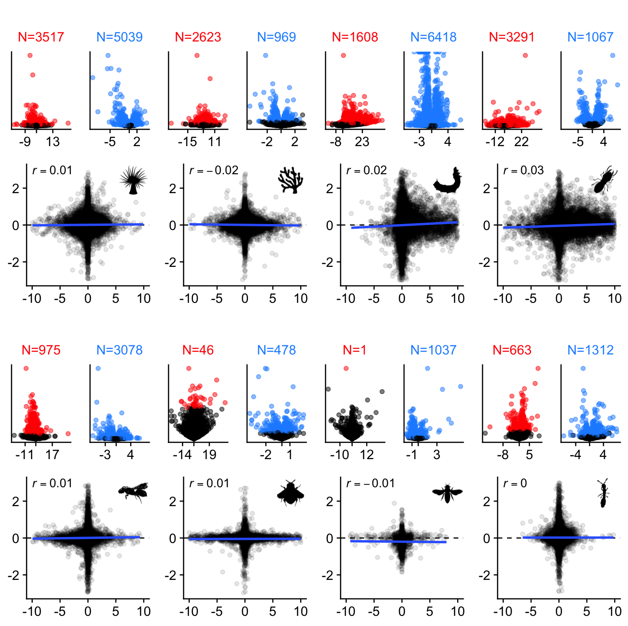
Figure S8: gbM and transcriptional differences between experimental conditions show little or no relationship. Each pair of volcano plots is associated with the scatterplot below. The first volcano plot shows differences in gbM, with significant genes (q-value from MethylKit < 0.1) shown in red. The second shows differences in transcription, with significant genes in blue (FDR < 0.1). The count of significant genes is given above each volcano plot. The scatterplots are the same as those shown in Figure 5, with expression differences on the Y axis and gbM differences on the X. The contrasts for each study are given in Figure 1.

