Supplementary Information

Spatial location, not traits of parents, impact reproductive success in two highly mobile Vulnerable species

Accessing nests
To access Polytelis spp. nests, we employed single rope climbing techniques to climb trees and assess nesting hollows. Nests were inspected either with a torch or a 3m long inspection camera. Nests were deemed suitable for trapping if we could accurately assess the contents of the nest to confirm the age of nestlings (e.g., eyes open, able to thermoregulate), and if the structures around the hollow entrance facilitated trapping; we avoided nests with large, uneven entrances, sharp shards of bark, or other obstructions.

Trapping details
To trap adult regent and superb parrots at their nest hollows, we constructed traps from prawn nets held open by a wire ring constructed to match the size and shape of the nest hollow. We attached a string to the wire ring which was then run to the ground to allow the trap to be pulled closed. We monitored traps continuously until the adult bird entered the hollow. After allowing the parent several minutes to feed nestlings, the trap was closed from the ground and a climber immediately ascended to remove the adult bird from the trap. We placed captured adults into a soft calico bag for processing.
To safeguard breeding birds, we deployed traps for a maximum of 6 hours and removed all traps at least 2 hours prior to sunset to allow parents time to provision their chicks. If trapping attempts were unsuccessful, we observed a minimum interval of 3 days before attempting capture at the same nest. All traps and equipment were removed immediately upon successful capture to minimise disturbance. All nets and equipment were cleaned with a commercial disinfectant prior to re-use.

GPS tag settings
We scheduled the GoTel GTW 2012 tags to record location data twice daily at 10:30 and 14:30 ACST and the GoTel GTW 3217 tags to record location data hourly during daylight hours (from 4:30–16:30 ACST during our study). Both tags were set to record environmental every 2 hours and to transmit data every three days at 14:30 or 16:30 ACST. We scheduled ‘boost mode’ to collect location fixes every 10 minutes when battery was above 4.02 V, every five minutes when battery was above 4.07 V (with a transmission every hour), and every minute when voltage exceeded 4.10 V. Additionally, when tag speed exceeded 5.00 m s⁻¹ (18 km h⁻¹), flight was recorded at approximately 1-minute intervals until either the speed dropped below 2.00 m s⁻¹ (7.2 km h⁻¹) or battery dropped below 3.97 V (3.95 V for the GTW3217).

Attachment details
We attached GPS tags using three strips of Tesa® marine cloth tape secured to layers of feathers on the birds back (Figures S2, S3). The first strip was placed directly below the base of the neck, adjacent to the wings. We then repeated this process with two additional strips beneath lower layers of feathers so the strips of tape partially overlapped. Small cable ties were incorporated between the tape layers. Once in place and secured, we trimmed the tape strips to size and folded everything together to create a base plate. The GPS tag was then secured to the base plate using two small cable ties. GPS tags were positioned so the antennae pointed posteriorly along the back and upper tail. We trimmed any excess tape or feathers that might block the solar panel. All attachment components (tape, cable ties) weighed approximately 1.5-1.8g.

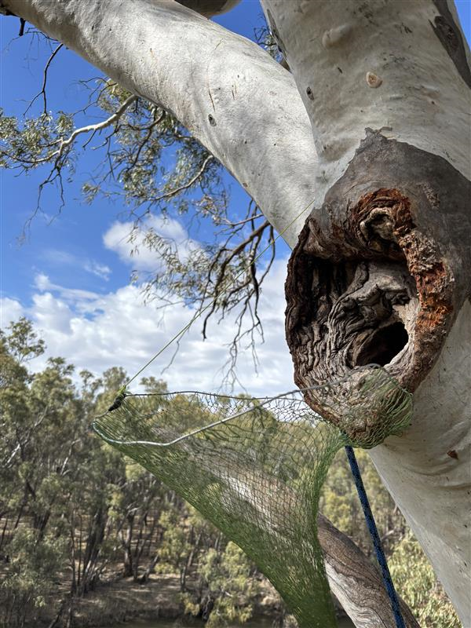 | 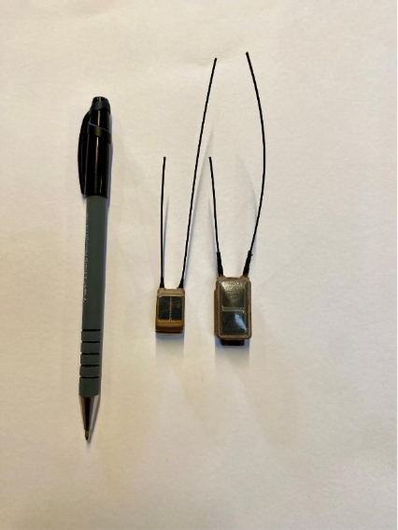
Figure S1: [left] a trap set at a superb parrot hollow; the trap is currently in the open position. [right] photos of the Lotek GoTel GTW2012 (left) and GoTel GTW3217 (right) used in this study. The GTW2012 weighed between 3.0–3.5g, and the larger GTW3217 weighed between 5.4–5.1g.

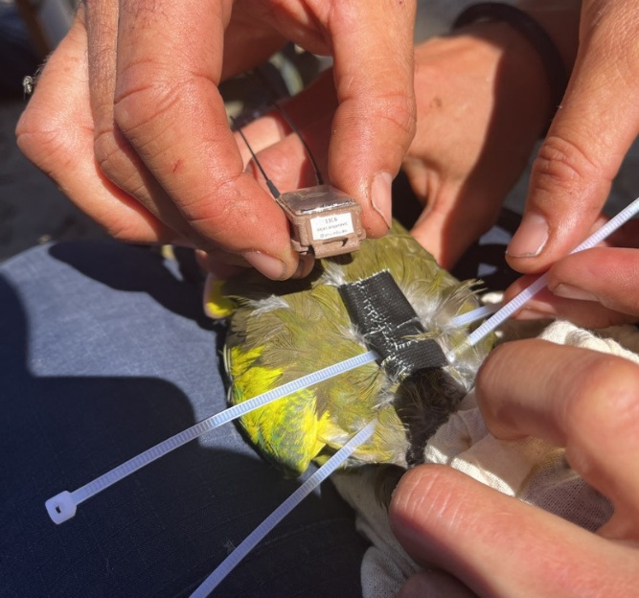 | 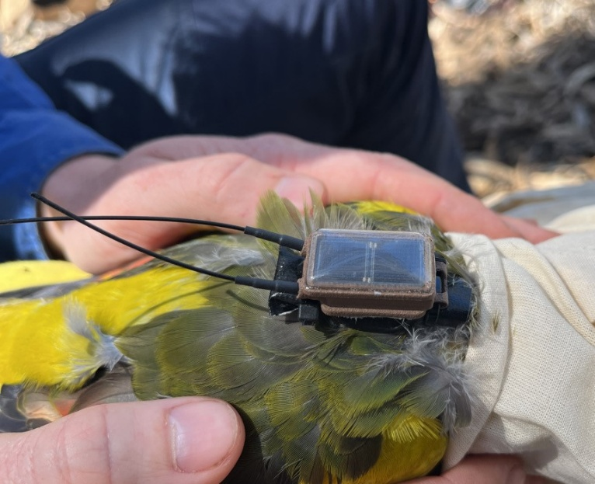
Figure S2: Photos showing the process of attaching a GPS tag to an adult regent parrot. [left] the base plate has been constructed with tape on the feathers of the back, and the cable ties are about to be used to secure the tag to the base plate. Note that the cable ties are positioned between the tape and the feather attachment points. Thus, they are sitting loosely and can be slid around, enabling cinching of the tag to the baseplate and positioning of the head of the cable tie in a position that is out of the way. [right] a tag has been attached to a regent parrot and is ready for release. At this point, all loose ends of tape and cable tie ends have been removed; feathers that might obstruct the solar panels have been trimmed away. Note the tag is positioned to sit in the middle of the mantle/upper back at about the level of the shoulders.
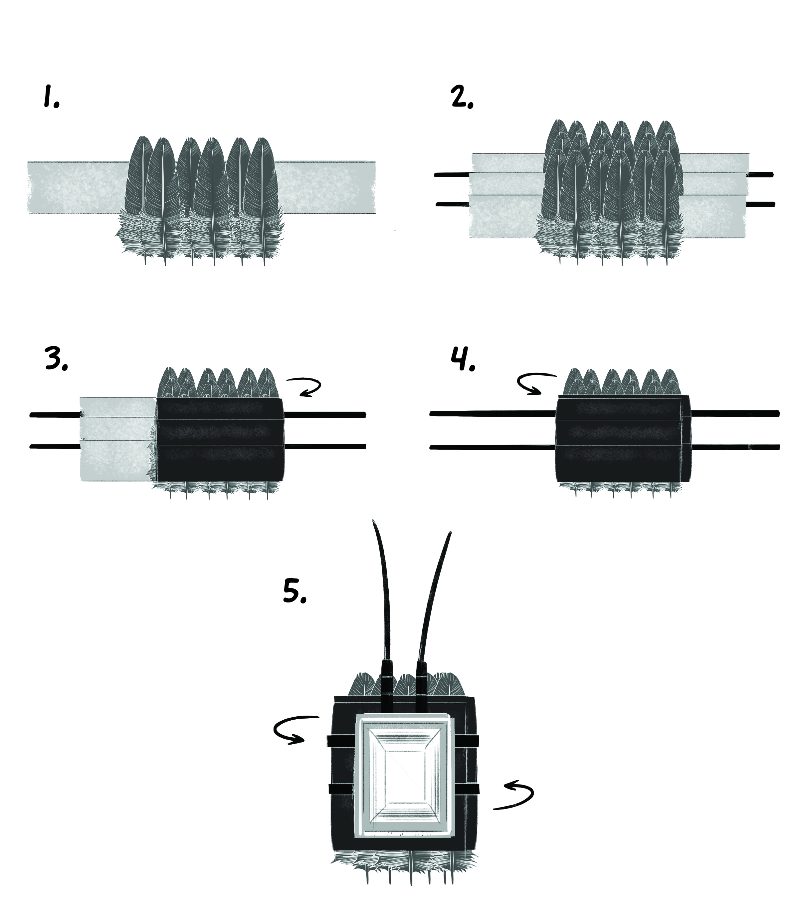
Figure S3: A schematic detailing the basics of the tag attachment mechanism used throughout this study. Small strips of tape were laid underneath three successive clumps of back feathers positioned so that the tape (sticky-side up) would attach both to the feathers and the preceding strip of tape (steps 1–3). All three layers of taped feathers are then secured into a ‘base plate’ by folding the overhanging sides of the tape back onto itself (steps 3–4). Cable ties were incorporated into the strips of tape (steps 1–2; cable ties were placed between the skin and the tape so that they were loosely incorporated into the subsequent base plate but were not stuck down). The tag is then placed directly to the base plate, and secured there using the cable ties. Tape and cable ties were trimmed to reduce impact on the birds’ movements. Figure prepared by E. Percival.

Body condition

Nestlings
We utilised methods described in Cobden, Stojanovic (1) to fit quadratic relationships between nestling body mass (g) and wing length (mm) and calculate a value of nestling body condition (g). Summary outputs of the two models are included in Table S1 below. Plots are shown in Figure S4a, b)
Table S1: Summary model outputs for the preferred quadratic relationship for calculating nestling body condition (g) for (a) regent and (b) superb parrots.
a. | Regent parrot: nestling body mass (g) ~ wing length (mm) + wing length (mm)²
Coefficients |  | Estimate | Std. Error | t-value | Pr (>|t|)
Intercept |  | 9.831103 | 9.062555 | 1.085 | 0.279
Wing length (mm) |  | 1.973125 | 0.199580 | 9.886 | < 2e-16 ***
Wing length (mm)² |  | -0.005602 | 0.001012 | -5.535 | 9.48e-08 ***
b. | Superb parrot: nestling body mass (g) ~ wing length (mm) + wing length (mm)²
Coefficients |  | Estimate | Std. Error | t-value | Pr (>|t|)
Intercept |  | 8.9846591 | 8.4090788 | 1.068 | 0.286
Wing length (mm) |  | 2.2358221 | 0.1580072 | 14.150 | <2e-16 ***
Wing length (mm)² |  | -0.0086212 | 0.0007179 | -12.009 | <2e-16 ***

Signif. codes: 0 ‘***’ 0.001 ‘**’ 0.01 ‘*’ 0.05 ‘.’ 0.1 ‘ ’ 1

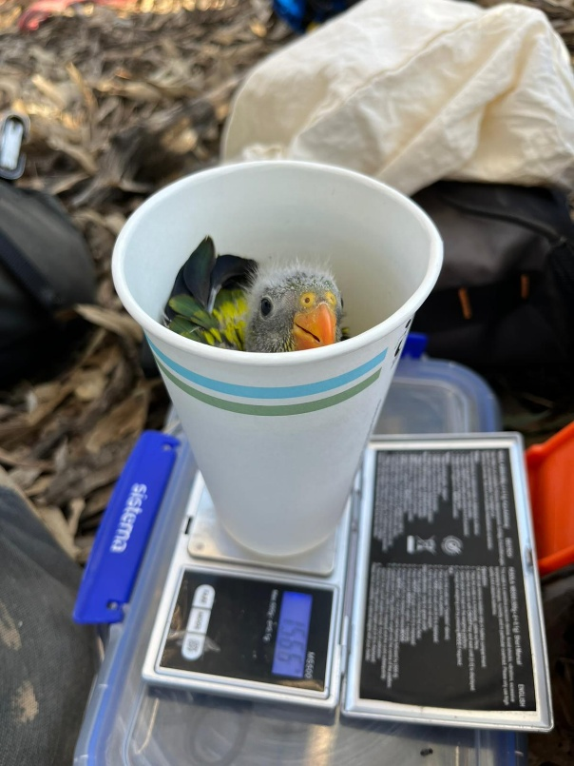 | 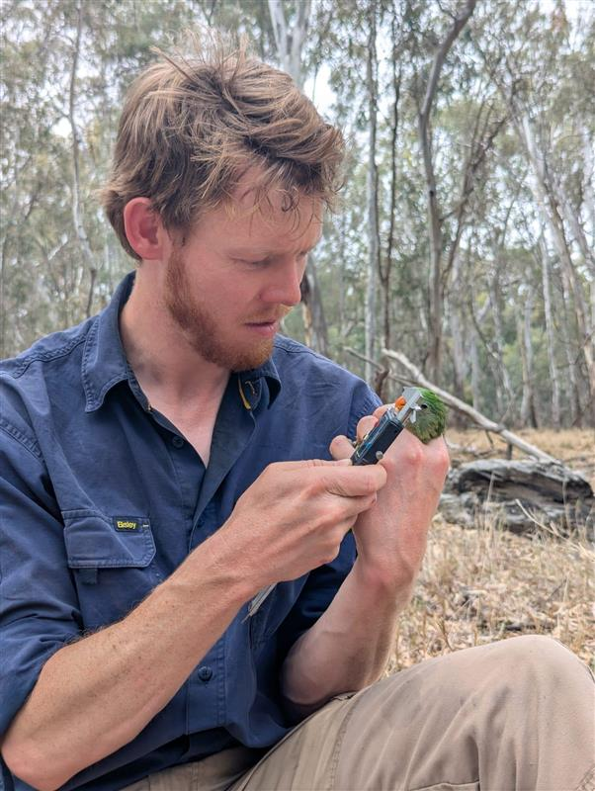
Figure S4: photos showing collection of morphometric data for regent and superb parrot nestlings. [right] a regent parrot nestling gets weighed. Photo by AR. [left] one of the authors (AR) collects morphometric data on a superb parrot nestling. Photo by MC.

Adult birds
To fit a metric of adult body condition, we fit linear models to adult body mass (g) and wing length (mm) data for regent and superb parrots. For both species, the best supported model was a linear model with a single term of wing length (mm). Inclusion of other variables (including sex) weakened model fit. Summary outputs of the two preferred models are shown in Table S2, and the corresponding plots are show in Figure S4c, d.
Table S2: model summary outputs for the preferred models of adult body condition for regent parrots (a) and superb parrots (b).
a. | Regent parrot: adult body mass (g) ~ wing length (mm)
Coefficients |  | Estimate | Std. Error | t-value | Pr (>|t|)
Intercept |  | 77.4692 | 36.3813 | 2.129 | 0.03608*
Wing length (mm) |  | 0.5417 | 0.1865 | 2.905 | 0.00467**

b. | Superb parrot: adult body mass (g) ~ wing length(mm)
Coefficients |  | Estimate | Std. Error | t-value | Pr (>|t|)
Intercept |  | 80.9143 | 45.3856 | 1.783 | 0.0805 .
Wing length (mm) |  | 0.3737 | 0.2433 | 1.536 | 0.1307
Signif. codes: 0 ‘***’ 0.001 ‘**’ 0.01 ‘*’ 0.05 ‘.’ 0.1 ‘ ’ 1

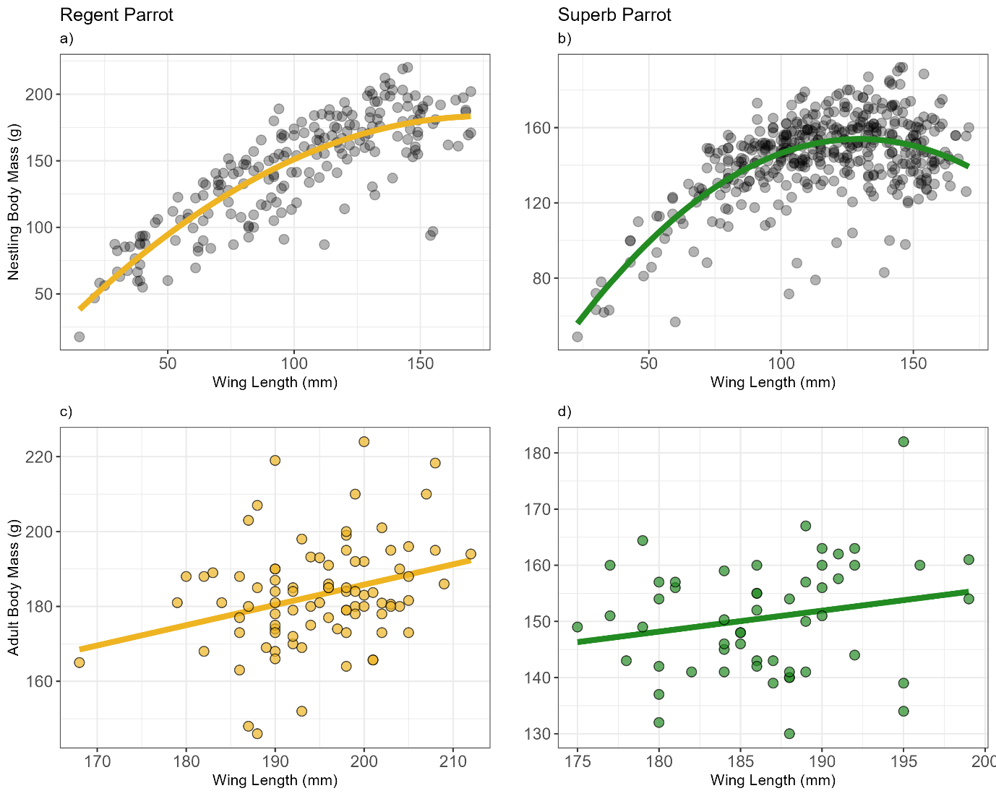

Figure S5: [top] modelled quadratic relationships between wing length (mm) and body mass (g) for nestling (a) regent and (b) superb parrots. Points represent individual nestlings from 4 (regent) or 6 (superb) years of data. [bottom] the best supported linear models for body condition index for adult (c) regent and (d) superb parrots. The best supported model for both species contained a single term of wing length. Residuals are calculated by subtracting each individual’s weight against the modelled value.

Telemetry data

Location of study sites
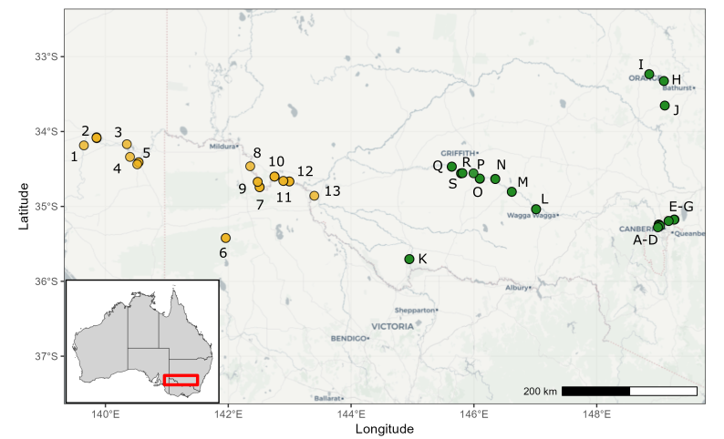
Figure S6: locations of 32 regent parrot (yellow) and 75 superb parrot (green) nests found in the 2025 field season. Regent parrot nesting sites are coded numerically; superb parrot nesting sites are coded alphabetically. Codes refer to sites listed in Table S3 and S4 below. The exact location of nesting sites has been removed due to the sensitive nature of parrot breeding locations

Model fitting in the ctmm package
The ctmm.select() function in the ‘ctmm’ package (2) conducts a search over continuous-time movement models based on initial guess parameters. The core candidate setoff models considered includes (below) and considers that each of the candidate models can be isotropic (same spatial variance in all directions) or anisotropic (elliptical home range). Therefore the function considers 6-8 candidate models for each individual tag.
- IID - Independent, identically distributed – uncorrelated positions
- OU – Ornstein-Uhlenbeck – autocorrelated position only
- OUF – OU Foraging – autocorrelated position and velocity
- OUf – a reduced case of OUF where the velocity timescale cannot be well resolved separately from the position timescale

.
Table S3: a full list of all GPS tags deployed on breeding regent and superb parrots. Tag ID corresponds to a unique tag identifier and ‘site code’ corresponds to the map above. Start and end dates refer to the deployment date and the end of the tracking period. Tracking periods ended either when the tag fell off, stopped transmission, or breeding ceased. Total days and total points refer to the total number of days of movement data collected during the breeding period, and the total number of location points collected during that time period. Estimated 95% breeding range sizes (HR est) are provided (in km²) along with upper (HR High) and lower (HR Low) 95% estimates. Area denotes the effective sample size for breeding range estimates. One regent parrot tag (2c00001381) did not have enough location data to generate an estimated range size and was dropped from the analysis. Model refers to the preferred movement model from the ctmm.select() function (see above for full list of considered models) and ‘nest data’ denotes whether the individual was included in the nest level analysis (Y) or not (N).
Tag ID | Species | Sex | Tag Model | Site Code | Start Date | End Date | N Days | N Points | HR low | HR est | HR high | Area | Model | Nest data
2c0000137c | Regent | M | GTW 3217 | Regent site 3 | 9/10/2025 | 17/10/2025 | 8 | 246 | 129.7 | 176.6 | 230.5 | 47.0 | OUF anisotropic | Y
2c0000135a | Regent | F | GTW 3217 | Regent site 4 | 12/10/2025 | 23/10/2025 | 11 | 276 | 56.6 | 71.8 | 88.7 | 76.2 | OUF anisotropic | Y
2c00000c40 | Regent | M | GTW 3217 | Regent site 12 | 13/10/2025 | 3/11/2025 | 21 | 404 | 82.5 | 107.5 | 135.7 | 62.6 | OUF anisotropic | Y
2c00000c41 | Regent | M | GTW 3217 | Regent site 12 | 13/10/2025 | 15/10/2025 | 2 | 92 | 11.8 | 41.6 | 89.8 | 4.2 | OU anisotropic | Y
2c00000c4c | Regent | M | GTW 3217 | Regent site 12 | 13/10/2025 | 21/10/2025 | 8 | 153 | 35.9 | 64.4 | 101.0 | 14.8 | OUF anisotropic | Y
2c00000df2 | Regent | M | GTW 3217 | Regent site 12 | 10/10/2025 | 19/10/2025 | 9 | 62 | 86.0 | 140.1 | 207.2 | 20.4 | OU anisotropic | N
2c00000ddd | Regent | M | GTW 3217 | Regent site 10 | 8/10/2025 | 22/10/2025 | 14 | 259 | 63.4 | 84.2 | 108.0 | 54.5 | OUF anisotropic | N
2c00000e1b | Regent | M | GTW 3217 | Regent site 10 | 8/10/2025 | 3/11/2025 | 26 | 324 | 50.9 | 61.4 | 72.9 | 119.6 | OUF anisotropic | Y
2c00000e26 | Regent | M | GTW 3217 | Regent site 10 | 14/10/2025 | 30/10/2025 | 16 | 459 | 46.1 | 65.3 | 87.8 | 37.5 | OUF anisotropic | Y
2c00000e32 | Regent | M | GTW 3217 | Regent site 10 | 14/10/2025 | 6/11/2025 | 23 | 484 | 58.5 | 74.9 | 93.3 | 71.3 | OUF anisotropic | Y
2c00000c43 | Regent | M | GTW 3217 | Regent site 7 | 12/10/2025 | 30/10/2025 | 18 | 483 | 177.7 | 266.0 | 371.8 | 28.7 | OUF anisotropic | Y
2c00000e20 | Regent | M | GTW 3217 | Regent site 7 | 12/10/2025 | 15/11/2025 | 34 | 641 | 65.6 | 81.4 | 98.9 | 91.6 | OUF anisotropic | Y
2c00000e22 | Regent | M | GTW 3217 | Regent site 7 | 14/10/2025 | 9/11/2025 | 26 | 519 | 41.5 | 53.2 | 66.5 | 69.7 | OU anisotropic | Y
2c00001154 | Regent | F | GTW 3217 | Regent site 5 | 7/10/2025 | 26/10/2025 | 19 | 200 | 14.3 | 20.9 | 28.7 | 31.9 | OUF anisotropic | Y
2c000011c6 | Regent | F | GTW 3217 | Regent site 5 | 7/10/2025 | 21/10/2025 | 14 | 178 | 51.9 | 70.0 | 90.7 | 49.8 | OUF anisotropic | Y
2c00000ddc | Regent | M | GTW 3217 | Regent site 8 | 7/10/2025 | 17/10/2025 | 10 | 170 | 31.8 | 43.8 | 57.8 | 43.4 | OU anisotropic | N
2c00000dfd | Regent | F | GTW 3217 | Regent site 8 | 7/10/2025 | 13/10/2025 | 6 | 67 | 0.2 | 0.6 | 1.3 | 4.7 | OU anisotropic | Y
2c0000115d | Regent | M | GTW 3217 | Regent site 6 | 15/10/2025 | 3/11/2025 | 19 | 400 | 57.9 | 68.0 | 78.9 | 162.1 | OU anisotropic | N
2c00001203 | Regent | M | GTW 3217 | Regent site 2 | 8/10/2025 | 28/11/2025 | 20 | 322 | 97.0 | 128.8 | 165.1 | 54.8 | OUF anisotropic | Y
2c00001381 | Regent | F | GTW 3217 | Regent site 2 | 8/10/2025 | 12/10/2025 | 4 | 9 | NA | NA | NA | NA | NA | N
2c00000c42 | Regent | M | GTW 3217 | Regent site 11 | 9/10/2025 | 13/10/2025 | 4 | 56 | 15.2 | 39.8 | 76.1 | 6.4 | OU anisotropic | N
2c00000def | Regent | M | GTW 3217 | Regent site 11 | 9/10/2025 | 12/10/2025 | 3 | 76 | 1.3 | 15.3 | 46.0 | 1.6 | OU anisotropic | Y
2c000011cd | Regent | M | GTW 3217 | Regent site 1 | 10/10/2025 | 22/11/2025 | 43 | 579 | 246.3 | 320.8 | 405.0 | 62.6 | OUF anisotropic | Y
2c00000c45 | Regent | M | GTW 3217 | Regent site 13 | 15/10/2025 | 5/11/2025 | 21 | 225 | 52.7 | 67.8 | 84.7 | 68.9 | OUF anisotropic | Y
2c00001372 | Superb | F | GTW 3217 | Superb site L | 9/11/2025 | 16/11/2025 | 7 | 272 | 3.4 | 6.9 | 11.6 | 10.8 | OU anisotropic | Y
2c0000115c | Superb | M | GTW 2012 | Superb site L | 9/11/2025 | 27/11/2025 | 18 | 149 | 6.9 | 8.6 | 10.5 | 89.8 | OU anisotropic | Y
2c000011b2 | Superb | F | GTW 2012 | Superb site L | 6/11/2025 | 8/12/2025 | 32 | 175 | 9.7 | 13.2 | 17.3 | 45.6 | OU anisotropic | Y
2c000011ca | Superb | M | GTW 3217 | Superb site H | 25/11/2025 | 3/12/2025 | 8 | 103 | 11.1 | 14.5 | 18.4 | 61.2 | OUF anisotropic | N
2c000011f8 | Superb | F | GTW 3217 | Superb site H | 27/11/2025 | 11/12/2025 | 14 | 219 | 5.5 | 6.8 | 8.2 | 100.1 | OUF anisotropic | Y
2c00001204 | Superb | F | GTW 3217 | Superb site H | 25/11/2025 | 9/12/2025 | 14 | 347 | 47.7 | 58.2 | 69.9 | 105.9 | OUF anisotropic | Y
2c000012e6 | Superb | M | GTW 3217 | Superb site M | 12/11/2025 | 27/11/2025 | 15 | 410 | 17.1 | 21.6 | 26.7 | 77.2 | OU anisotropic | Y
2c000013cd | Superb | F | GTW 3217 | Superb site M | 12/11/2025 | 28/11/2025 | 16 | 585 | 8.8 | 11.2 | 13.9 | 75.2 | OU anisotropic | Y
2c0000117a | Superb | M | GTW 3217 | Superb site I | 27/11/2025 | 7/12/2025 | 10 | 241 | 53.1 | 74.6 | 99.6 | 39.5 | OUF anisotropic | Y
2c00001358 | Superb | F | GTW 3217 | Superb site P | 11/11/2025 | 13/11/2025 | 2 | 77 | 52.2 | 169.2 | 353.6 | 4.7 | OU anisotropic | Y
2c00001150 | Superb | F | GTW 3217 | Superb site P | 10/11/2025 | 13/11/2025 | 3 | 136 | 86.0 | 123.6 | 167.8 | 34.9 | OUF anisotropic | N
2c000011dd | Superb | M | GTW 3217 | Superb site P | 11/11/2025 | 18/11/2025 | 7 | 207 | 206.4 | 335.9 | 496.5 | 20.4 | OUF anisotropic | Y
2c0000135e | Superb | M | GTW 3217 | Superb site P | 10/11/2025 | 19/11/2025 | 9 | 278 | 192.8 | 289.0 | 404.2 | 28.5 | OUF anisotropic | Y
2c0000117e | Superb | M | GTW 2012 | Superb site P | 10/11/2025 | 20/11/2025 | 10 | 128 | 101.3 | 145.1 | 196.8 | 35.3 | OUF anisotropic | Y
2c00001383 | Superb | F | GTW 3217 | Superb site P | 11/11/2025 | 24/11/2025 | 13 | 303 | 201.4 | 315.0 | 453.7 | 23.8 | OUF anisotropic | Y
2c000012f6 | Superb | M | GTW 3217 | Superb site O | 8/11/2025 | 14/11/2025 | 6 | 256 | 57.3 | 87.3 | 123.5 | 26.5 | OUF anisotropic | N
2c00001382 | Superb | M | GTW 3217 | Superb site O | 8/11/2025 | 17/11/2025 | 9 | 232 | 43.8 | 63.4 | 86.6 | 33.6 | OUF anisotropic | Y
2c000011f2 | Superb | F | GTW 3217 | Superb site O | 8/11/2025 | 20/11/2025 | 12 | 517 | 16.3 | 23.6 | 32.1 | 33.8 | OU anisotropic | Y
2c00000e1c | Superb | F | GTW 3217 | Superb site Q | 13/11/2025 | 15/11/2025 | 2 | 32 | 7.8 | 17.4 | 30.7 | 8.6 | OUf anisotropic | Y
2c00000df3 | Superb | F | GTW 3217 | Superb site Q | 13/11/2025 | 19/11/2025 | 6 | 143 | 48.2 | 90.1 | 144.9 | 13.2 | IID anisotropic | Y
2c00000e31 | Superb | F | GTW 3217 | Superb site Q | 13/11/2025 | 29/11/2025 | 16 | 279 | 22.7 | 30.5 | 39.5 | 51.1 | OUF anisotropic | Y
2c000012e9 | Superb | M | GTW 3217 | Superb site K | 7/11/2025 | 26/11/2025 | 19 | 614 | 78.5 | 96.3 | 115.8 | 101.9 | OUF anisotropic | Y
2c0000130e | Superb | M | GTW 3217 | Superb site K | 6/11/2025 | 2/12/2025 | 26 | 713 | 83.2 | 102.6 | 123.9 | 97.7 | OUF anisotropic | Y
2c0000137e | Superb | F | GTW 3217 | Superb site J | 27/11/2025 | 7/12/2025 | 10 | 169 | 11.4 | 13.3 | 15.4 | 168.0 | OU anisotropic | Y
2c000012f7 | Superb | M | GTW 2012 | Superb site A | 18/11/2025 | 23/11/2025 | 5 | 59 | 31.8 | 43.3 | 56.5 | 47.0 | OUf anisotropic | Y
2c000012f8 | Superb | F | GTW 3217 | Superb site A | 18/11/2025 | 25/11/2025 | 7 | 140 | 11.5 | 16.3 | 21.8 | 38.5 | OU anisotropic | Y
2c000012f3 | Superb | M | GTW 3217 | Superb site A | 18/11/2025 | 5/12/2025 | 17 | 241 | 22.7 | 26.5 | 30.6 | 171.2 | OUF anisotropic | Y
2c00001177 | Superb | M | GTW 3217 | Superb site C | 21/11/2025 | 12/12/2025 | 21 | 504 | 40.4 | 47.0 | 54.1 | 179.3 | OUF anisotropic | Y
2c00000e24 | Superb | M | GTW 3217 | Superb site N | 12/11/2025 | 16/11/2025 | 4 | 106 | 10.4 | 17.9 | 27.5 | 16.6 | OUF anisotropic | Y
2c000012e3 | Superb | M | GTW 3217 | Superb site N | 12/11/2025 | 24/11/2025 | 12 | 402 | 115.7 | 169.1 | 232.5 | 32.0 | OUF anisotropic | Y
2c00001161 | Superb | F | GTW 3217 | Superb site E | 20/11/2025 | 25/11/2025 | 5 | 130 | 7.4 | 14.8 | 24.7 | 11.0 | OUF anisotropic | Y
2c000011de | Superb | M | GTW 3217 | Superb site E | 20/11/2025 | 26/11/2025 | 6 | 130 | 10.6 | 16.8 | 24.5 | 22.5 | OU anisotropic | Y
2c00001160 | Superb | M | GTW 3217 | Superb site E | 20/11/2025 | 29/11/2025 | 9 | 242 | 22.8 | 28.1 | 33.9 | 97.9 | OUf | Y
2c00001186 | Superb | M | GTW 3217 | Superb site E | 21/11/2025 | 4/12/2025 | 13 | 276 | 3.8 | 4.8 | 6.0 | 70.7 | OU anisotropic | Y

Geographic groups
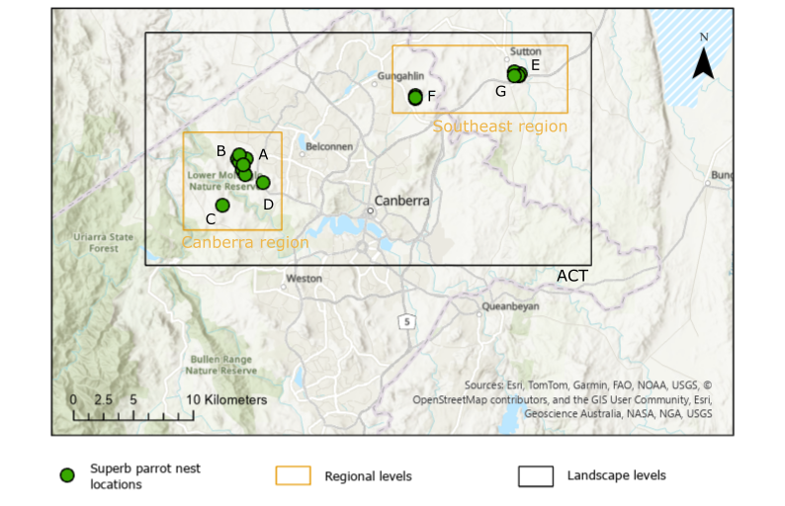
Figure S7: example geographic groups showing superb parrot nests in the ACT region. At the local level, we included each individual nesting site. In this example, n = 7 sites, labelled A–G above. Sites are labelled alphabetically and correspond to Table S4 below. We then grouped nearby sites into regions (n = 2 regions; ‘Canberra’ and ‘Southeast’) and grouped regions into landscapes (n = 1; ‘ACT’). For clarity, we provide a single example of a restricted geographic area. See Table S4 below for a full list of sites, regions, and landscape groupings for both superb and regent parrots. Site names are also plotted above at Figure S6.

Table S4: a full list of superb and regent parrot nesting site locations and total number of nests. Region and Landscape refer to geographic groupings used in our modelling steps to examine geographic variation in reproductive success.
Code | n nests | Region | Landscape
Superb site A | 6 | Canberra | ACT
Superb site B | 4 | Canberra | ACT
Superb site C | 2 | Canberra | ACT
Superb site D | 1 | Canberra | ACT
Superb site E | 5 | Southeast | ACT
Superb site F | 5 | Southeast | ACT
Superb site G | 1 | Southeast | ACT
Superb site H | 3 | Central Tablelands | Central Tablelands
Superb site I | 3 | Central Tablelands | Central Tablelands
Superb site J | 2 | Central Tablelands | Central Tablelands
Superb site K | 4 | Murray Valley | Murray Valley
Superb site L | 5 | Eastern Riverina | Eastern Riverina
Superb site M | 4 | Eastern Riverina | Eastern Riverina
Superb site N | 7 | Central Riverina | Eastern Riverina
Superb site O | 9 | Central Riverina | Western Riverina
Superb site P | 6 | Western Riverina | Western Riverina
Superb site Q | 5 | Western Riverina | Western Riverina
Superb site R | 1 | Western Riverina | Western Riverina
Superb site S | 2 | Western Riverina | Western Riverina
Code | n nests | Region | Landscape
Regent site 1 | 1 | Western SA | Riverland
Regent site 2 | 5 | Western SA | Riverland
Regent site 3 | 1 | Eastern SA | Riverland
Regent site 4 | 1 | Eastern SA | Riverland
Regent site 5 | 3 | Eastern SA | Riverland
Regent site 6 | 2 | Victoria | Central
Regent site 7 | 3 | Victoria | Central
Regent site 8 | 1 | Western NSW | Central
Regent site 9 | 2 | Western NSW | Central
Regent site 10 | 7 | Central NSW | Eastern
Regent site 11 | 2 | Eastern NSW | Eastern
Regent site 12 | 3 | Eastern NSW | Eastern
Regent site 13 | 1 | Eastern NSW | Eastern

Tracking data

Interactive maps
GPS tracking data has been uploaded to Movebank; please see project ID: 9012761200 and ID: 9012962947. Exact location data and site names have been removed from this manuscript due to the sensitive nature of parrot breeding sites.
To visualise tracking data and approximate breeding ranges, we include links to interactive html maps below. Due to the geographic scale of the study area and overlap of many individual tracks, interactive maps present the best way to visualise the data used in this study. Note that not all tags presented in the maps were included in all aspects of the study (see Table S4).
Link to superb data: https://reri17parrots-superbparrotmap1.netlify.app/
Link to regent data: https://reri17parrots-regentparrotmap2.netlify.app/
Password for both: RERIParrots!

Pairwise comparison – adult breeding ranges
Below we present two tables showing pairwise comparisons (p-values) of breeding ranges sizes by preferred geographic groups. Superb parrots are shown by ‘region’ and regent parrots are shown by ‘site’.

Table S5: pairwise comparisons (p-values) of estimated adult breeding ranges for superb parrots by geographic regions. The table is symmetrical, and numbers in bold denote statistical significance at p<0.05.
 | Murray | Western Riverina | Central Riverina | Eastern Riverina | Canberra | Central Tablelands | Southeast
Murray | -- | 5.6E-02 | 3.2E-01 | 2.0E-15 | 1.5E-04 | 3.6E-01 | 1.0E-03
Western Riverina | 5.6E-02 | -- | 1.0E-01 | 1.6E-12 | 7.9E-05 | 2.7E-01 | 2.3E-04
Central Riverina | 3.2E-01 | 1.0E-01 | -- | 1.3E-05 | 5.0E-02 | 4.0E-01 | 1.2E-02
Eastern Riverina | 2.0E-15 | 1.6E-12 | 1.3E-05 | -- | 6.8E-04 | 1.9E-01 | 2.5E-01
Canberra | 1.5E-04 | 7.9E-05 | 5.0E-02 | 6.8E-04 | -- | 5.8E-01 | 1.0E-01
Central Tablelands | 3.6E-01 | 2.7E-01 | 4.0E-01 | 1.9E-01 | 5.8E-01 | -- | 2.7E-01
Southeast | 1.0E-03 | 2.3E-04 | 1.2E-02 | 2.5E-01 | 1.0E-01 | 2.7E-01 | --

Table S6: pairwise comparisons (p-values) of estimated adult breeding ranges for regent parrots by nesting site. Site names correspond to the table (Table S3) and map (Figure S5:) above. The table is symmetrical, and numbers in bold denote statistical significance at p<0.05.
 | Regent site 1 | Regent site 2 | Regent site 3 | Regent site 4 | Regent site 5 | Regent site 6 | Regent site 7 | Regent site 8 | Regent site 10 | Regent site 11 | Regent site 12 | Regent site 13
Regent site 1 | - | 8.4E-07 | 1.3E-03 | 4.1E-18 | 1.6E-39 | 2.1E-29 | 1.3E-18 | 1.2E-22 | 3.4E-36 | 4.9E-06 | 6.8E-13 | 4.4E-18
Regent site 2 | 8.4E-07 | - | 5.6E-02 | 4.2E-04 | 7.5E-08 | 8.4E-06 | 3.7E-02 | 5.3E-09 | 3.8E-06 | 2.2E-03 | 1.1E-01 | 1.8E-04
Regent site 3 | 1.3E-03 | 5.6E-02 | - | 3.7E-07 | 1.3E-13 | 2.4E-10 | 7.9E-05 | 1.4E-12 | 2.3E-11 | 3.3E-04 | 1.2E-03 | 1.5E-07
Regent site 4 | 4.1E-18 | 4.2E-04 | 3.7E-07 | - | 1.3E-01 | 3.4E-01 | 1.1E-02 | 9.3E-04 | 4.0E-01 | 4.8E-02 | 6.6E-03 | 3.7E-01
Regent site 5 | 1.6E-39 | 7.5E-08 | 1.3E-13 | 1.3E-01 | - | 1.9E-01 | 7.2E-07 | 3.7E-03 | 9.8E-02 | 8.6E-02 | 2.2E-06 | 2.6E-01
Regent site 6 | 2.1E-29 | 8.4E-06 | 2.4E-10 | 3.4E-01 | 1.9E-01 | - | 2.5E-04 | 1.0E-03 | 4.0E-01 | 5.9E-02 | 2.4E-04 | 5.0E-01
Regent site 7 | 1.3E-18 | 3.7E-02 | 7.9E-05 | 1.1E-02 | 7.2E-07 | 2.5E-04 | - | 1.6E-07 | 8.0E-05 | 8.7E-03 | 3.1E-01 | 4.8E-03
Regent site 8 | 1.2E-22 | 5.3E-09 | 1.4E-12 | 9.3E-04 | 3.7E-03 | 1.0E-03 | 1.6E-07 | - | 4.1E-04 | 4.0E-01 | 1.2E-07 | 2.7E-03
Regent site 10 | 3.4E-36 | 3.8E-06 | 2.3E-11 | 4.0E-01 | 9.8E-02 | 4.0E-01 | 8.0E-05 | 4.1E-04 | - | 5.2E-02 | 1.2E-04 | 4.3E-01
Regent site 11 | 4.9E-06 | 2.2E-03 | 3.3E-04 | 4.8E-02 | 8.6E-02 | 5.9E-02 | 8.7E-03 | 4.0E-01 | 5.2E-02 | - | 6.6E-03 | 6.3E-02
Regent site 12 | 6.8E-13 | 1.1E-01 | 1.2E-03 | 6.6E-03 | 2.2E-06 | 2.4E-04 | 3.1E-01 | 1.2E-07 | 1.2E-04 | 6.6E-03 | - | 3.0E-03
Regent site 13 | 4.4E-18 | 1.8E-04 | 1.5E-07 | 3.7E-01 | 2.6E-01 | 5.0E-01 | 4.8E-03 | 2.7E-03 | 4.3E-01 | 6.3E-02 | 3.0E-03 | -

References
1. Cobden M, Stojanovic D, Rayner L, Heinsohn R, Manning AD. High nest survival, but variable reproductive output in the Superb Parrot (Polytelis swainsonii). Emu - Austral Ornithology. 2023;123(1):14–23.
2. Fleming CH, Calabrese JM. ctmm: Continuous-Time Movement Modelling. R package. 1.3.0 ed. New York: Springer-Verlag; 2025.

