Supplemental Material – Manuscript: “Topographic and temporal controls override lithology in the development of deep regolith profiles in an active temperate margin” Vergara et al., submitted September 2026.
SM-I: – Introduction
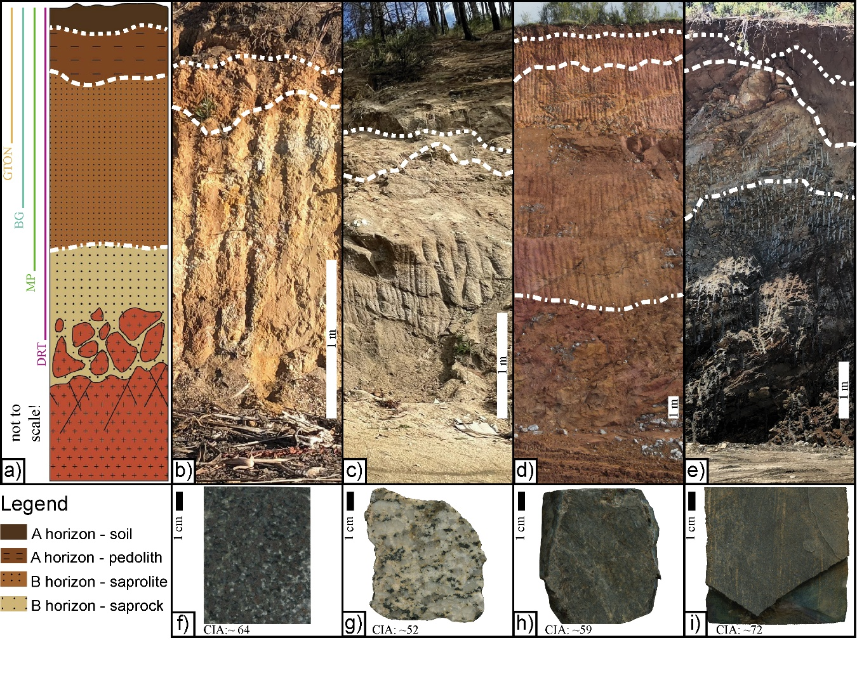
Figure SM-I1: Examples of regolith developed in the study area, its vertical extensions, and its bedrock textures. a) Schematic regolith profile showing the weathering column. Color vertical lines located on the left side of the schematic indicate the vertical extent of the regolith profiles presented in panels B, C, E, and D, respectively. The orange line corresponds to GTON, the sky-blue to BG, the green to MP, and the purple to DRT. Modified from [1]. b) Biotite-garnet tonalite (GTON). c) Biotite granite (BG). d) Biotite diorite (DRT). e) Micaceous schist - metapelite (MP). Dashed lines in each profile represent the horizon separation for each case as reference. f) – i) Examples of hand sample for each lithology, with its CIA as reference.
SM-R: Results
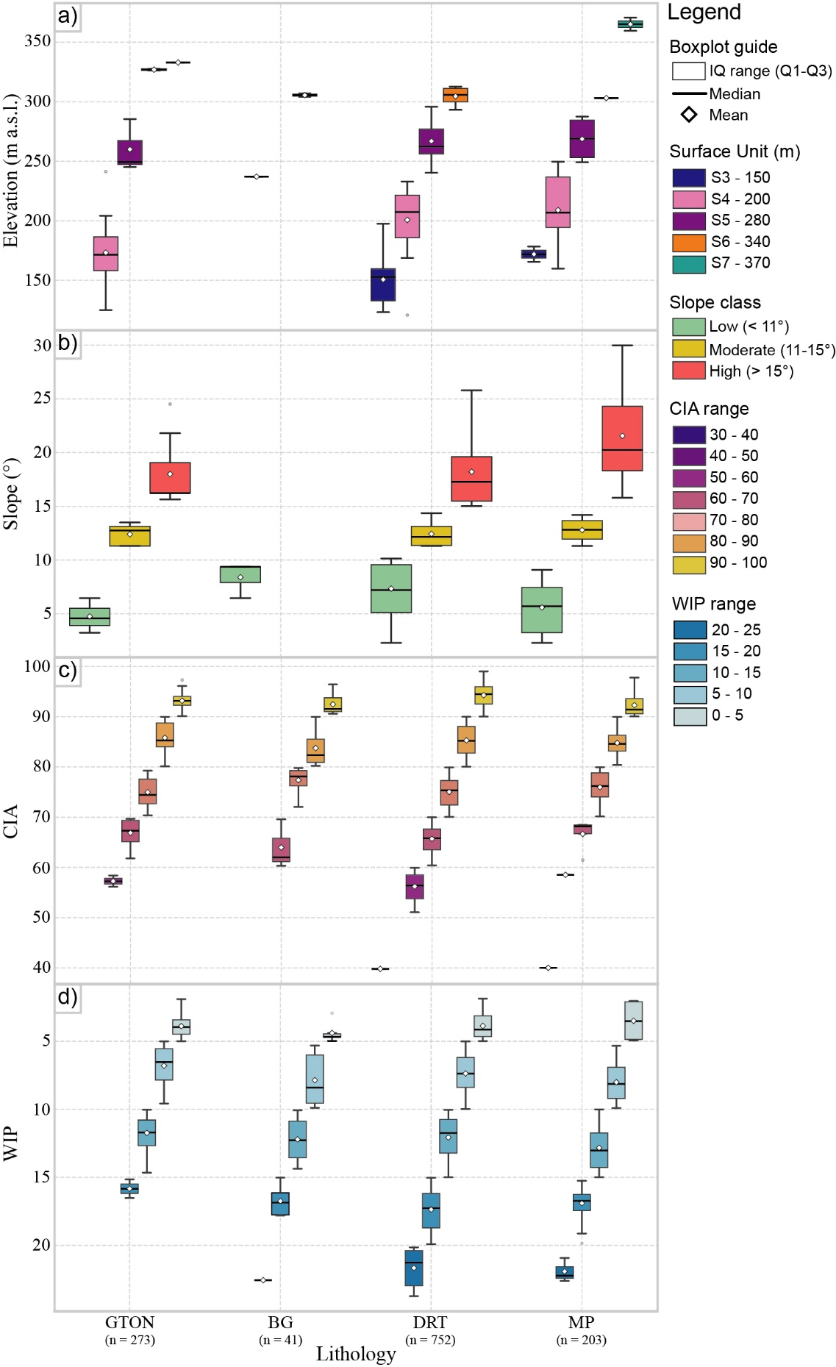
Figure SM-R4.1: Descriptive statistics boxplots result for different parameters across lithologies (GTON, BG, DRT, and MP). a) Elevation (m a.s.l.) according to identified surfaces S1-S7. b) slope classes (°). c) Chemical Index of Alteration (CIA) ranges. d) Weathering Index of Parker (WIP) ranges. Boxes represent the interquartile range (Q1–Q3), the central line indicates the median, diamond correspond to the mean, and whiskers show data dispersion. Points beyond the whiskers represent outliers. Colors denote discrete classes of each variable according to the ranges defined in the legend. Sample size (n) for each lithology is indicated along the x-axis.

Table SM-R4.2: Statistical evaluation of topographic and lithological controls on regolith thickness. Panel A presents non-parametric tests (Spearman's rank correlation and Mann-Whitney U) evaluating slope as a primary control on regolith preservation. Panel B details post-hoc pairwise comparisons between the main lithologies (DRT, GTON, MP) using a Bonferroni-corrected significance level (α = 0.0083). Panel C assesses the localized effect of lithology within specific geomorphic surfaces (S4 and S5) using the non-parametric test Kruskal-Wallis H.
Panel A: Bivariate Correlations (Topographic Control)
Hypothesis Tested | Statistical Test | Statistic | p-value | Significance
H0: Global Slope vs. Thickness | Spearman's rank correlation | ρ = -0,26 | 0.0052 | Significant
H1: Low Slope (<11°) vs. Rest | Mann-Whitney U | U = 1974.0 | 0.0073 | Significant
H2: High Slope (>15°) vs. Rest | Mann-Whitney U | U = 1025.5 | 0.0193 | Significant

Panel B: Global Lithological Pairwise Comparisons
Lithological pair tested | Statistical Test | Statistic | p-value | Significance ($α=0.0083$)*
DRT (n = 69) vs GTON (n = 19) | Mann-Whitney U | U = 444.5 | 0.0328 | Not significant; trend
DRT (n = 69) vs MP (n = 23) | Mann-Whitney U | U = 1026.5 | 0.0360 | Not significant; trend
GTON (n = 19) vs MP (n = 23) | Mann-Whitney U | U = 349.5 | 0.0010 | Significant

Panel C: Surface-Specific Lithological Control
Geomorphic Surface | Statistical Test | Statistic | p-value | Local lithological control
Surface S4 (~200 m a.s.l., n=48) | Kruskal-Wallis | H = 15.500 | 0.0004 | Significant
Surface S5 (~280 m a.s.l., n=36) | Kruskal-Wallis | H = 0.090 | 0.9559 | Not significant

Methodological notes: Non-parametric tests (Spearman's rank correlation, Mann-Whitney U, and Kruskal-Wallis H) were selected due to the non-normal distribution typical of natural regolith thickness and geomorphological data.
*Significance level for pairwise lithological comparisons (Panel B) was adjusted using the Bonferroni correction for multiple testing to strictly control the Type I error rate (α = 0.05/6 pairs = 0.0083). Given that the sample size (n = 3) for BG is very small and therefore not representative, the BG pair results are not statistically significant and therefore are not shown in the table. However, they were considered for the α calculation.
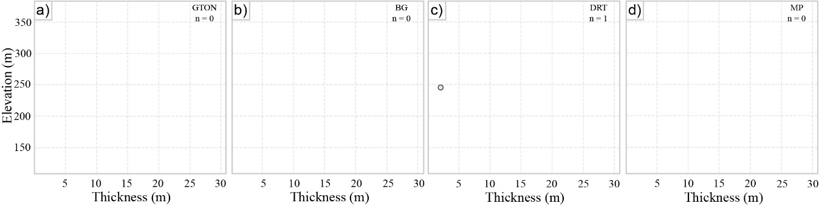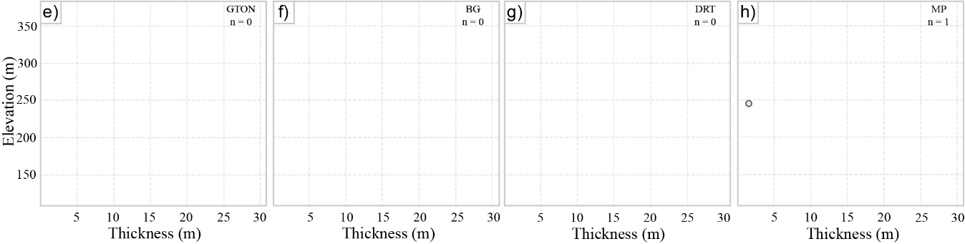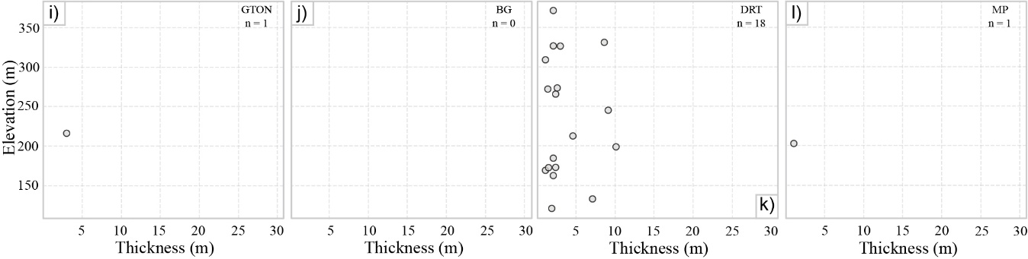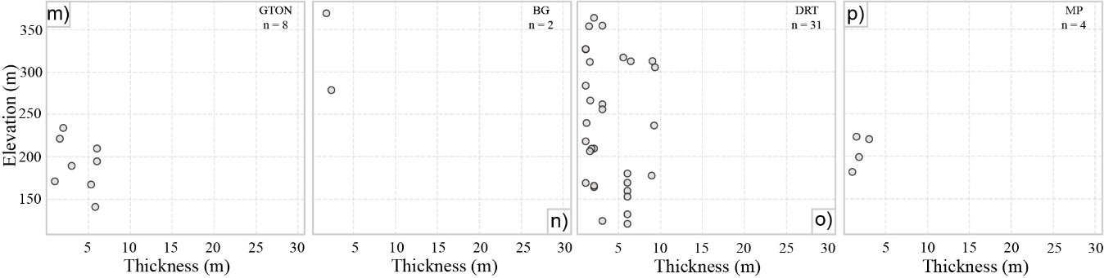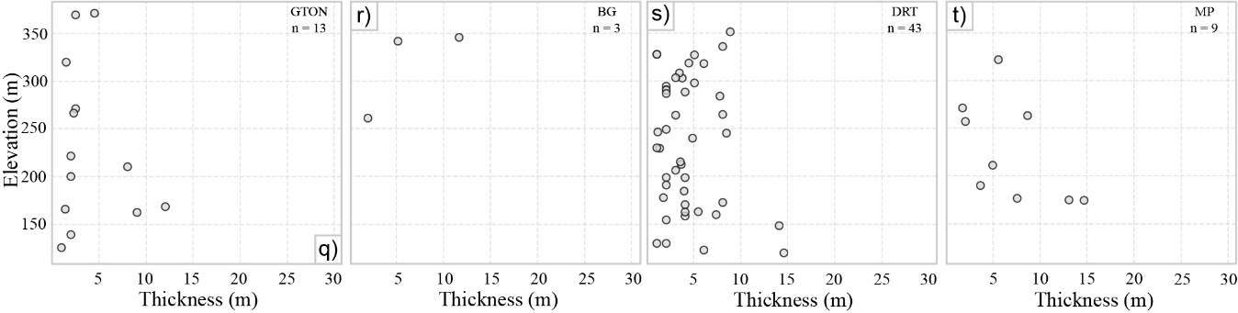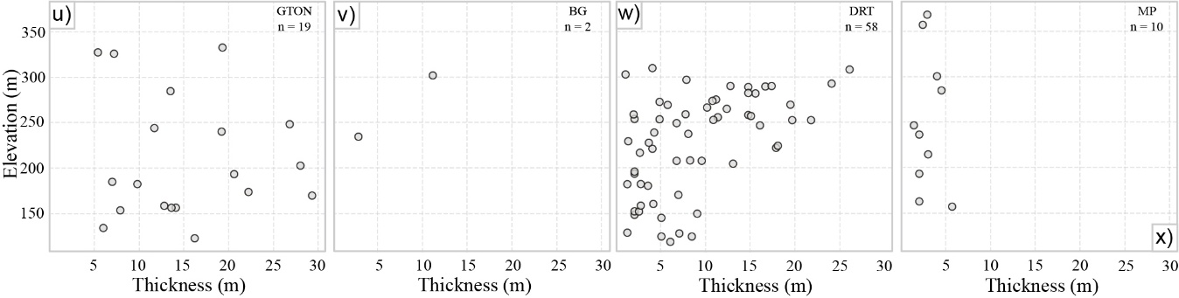
Figure SM-R4.3: Regolith-profile CIA results. (a-g) Scatter plots of sample elevation (m a.s.l.) versus regolith thickness (m) for samples with CIA values 30-40 (a-d), 40-50 (e-h), 50-60 (i-l), 60-70 (m-p), 70-80 (q-t), 90-100(u-x), shown separately for GTON, BG, DRT, and MP in each column. Regolith thickness shows a general tendency to increase with elevation. The total number of samples ‘n’ and lithology code are shown in the upper-right corner of each panel.

Table SM-R4.4: Statistical evaluation of potential immobile elements across elevation domains. Statistical comparison of candidate immobile elements between regolith profiles in S1-S3 and regolith profiles in S4-s7.
Element | N | Statistical test | Statistic | p-value | Significance
Zr | 1243 | Kruskal–Wallis H | H = 15.136 | 1.00 × 10⁻⁴ | Significant
Ti | 1244 | Kruskal–Wallis H | H = 1.121 | 0.28965 | Not significant
Al | 1243 | Kruskal–Wallis H | H = 15.556 | 8.01 × 10⁻⁵ | Significant
Th | 1243 | Kruskal–Wallis H | H = 25.711 | 3.97 × 10⁻⁷ | Significant
Nb | 1243 | Kruskal–Wallis H | H = 19.000 | 1.31 × 10⁻⁵ | Significant
Hf | 1243 | Kruskal–Wallis H | H = 12.181 | 4.83 × 10⁻⁴ | Significant

Methodological note: Samples were divided into two elevation domains according to the surfaces mapping S1-S3 and S4-S7 to evaluate whether candidate reference elements exhibit systematic compositional differences with elevation. The Kruskal-Wallis H test was used because the distributions are non-normal. Ti is the only tested element showing no statistically significant difference between the two elevation groups (p = 0.28965), with identical median values in both groups. In contrast, all other evaluated elements show statistically significant differences between elevation domains. This supports the use of Ti as the reference element for the mass-balance calculations.

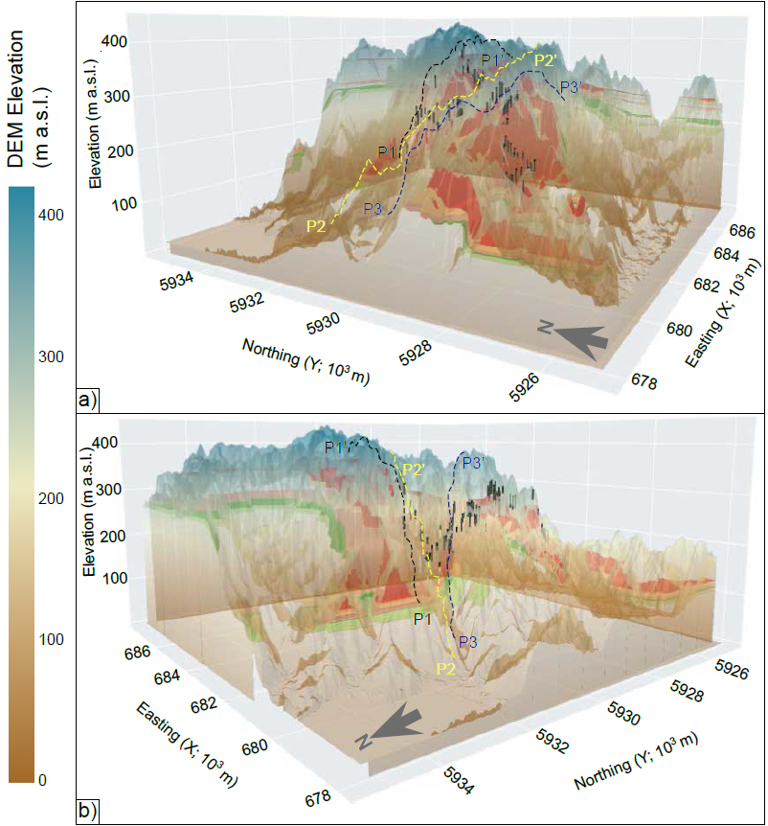
Figure SM-R4.5: Three-dimensional interpolated model of the weathering front. (a-b) DEM-based relief is integrated with interpolated CIA values. Color planes and lines show subsurface CIA ranges and spatial continuity of deep regolith; black vertical lines mark profiles.
SM-M: Methodology
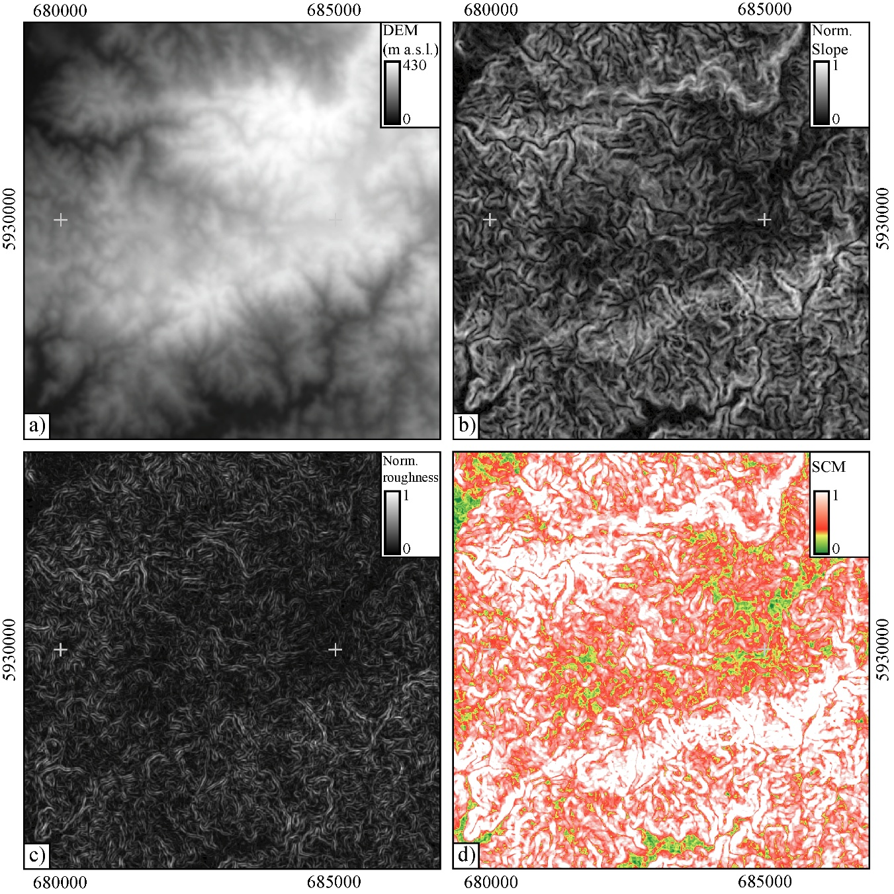
Figure SM-M3.1: SCM methodology application on the study area (Bowles and Cowgill, 2012). a) DEM of the study area. b) Normalized slope of the study area. c) Normalized roughness of the study area. d) SCM applied to the study area. Values near 0 indicate low slope and low roughness (i.e. low-slope flat surfaces).

Note: part of the raw dataset supporting this article is subject to confidentiality agreements. Consequently, the raw geochemical and spatial data are not included in the supplementary material. However, the parameters and structure of the dataset processed in this research follow the standard for geochemistry datasets.

REFERENCES CITED
[1] Li, M.Y.H., Zhao, W.W., Zhou, M.F., 2017, Nature of parent rocks, mineralization styles and ore genesis of regolith-hosted REE deposits in South China: An integrated genetic model: Journal of Asian Earth Sciences, v. 148, p. 65–95, DOI: 10.1016/j.jseaes.2017.08.004.

